OS ORANGE 2 REPORT
Building PES-VCS — A Version Control System from Scratch

NAME : P MANAS SIDDHARDHA
SRN : PES1UG24AM186

PHASE 1:

Screenshot 1A

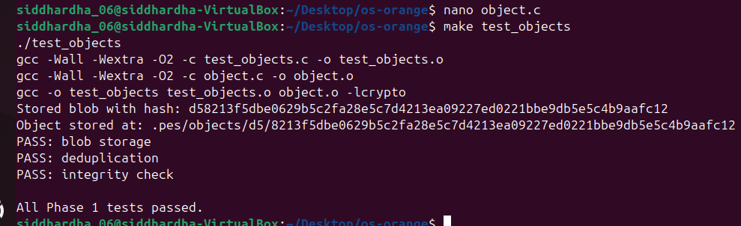

Screenshot 1B


PHASE 2:

Screenshot 2A

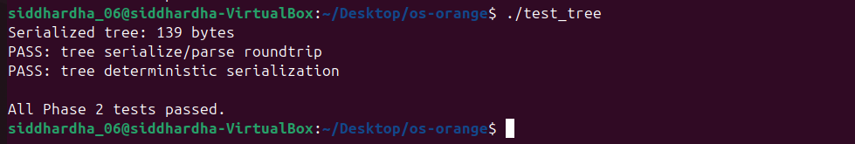
Screenshot 2B

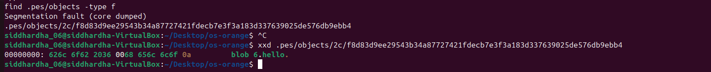

PHASE 3:

Screenshot 3A


Screenshot 3B

PHASE 4:
Screenshot 4A

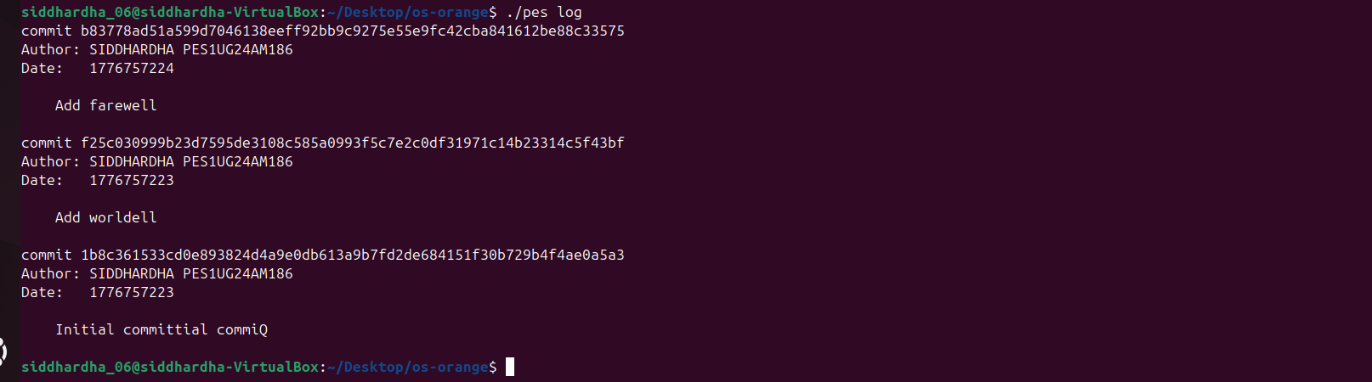

Screenshot 4B
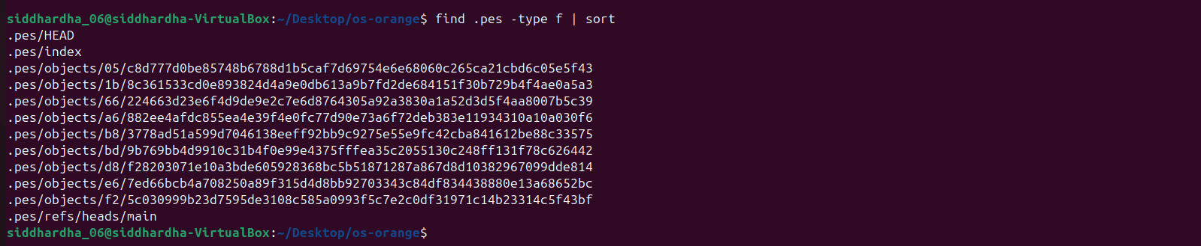

Screenshot 4C

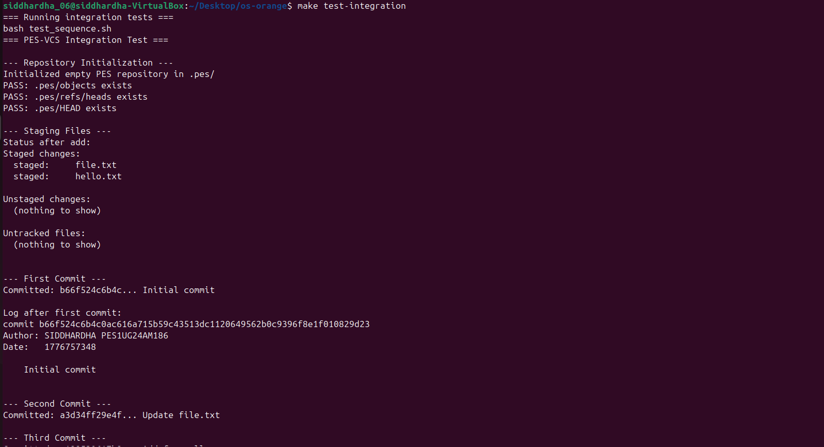
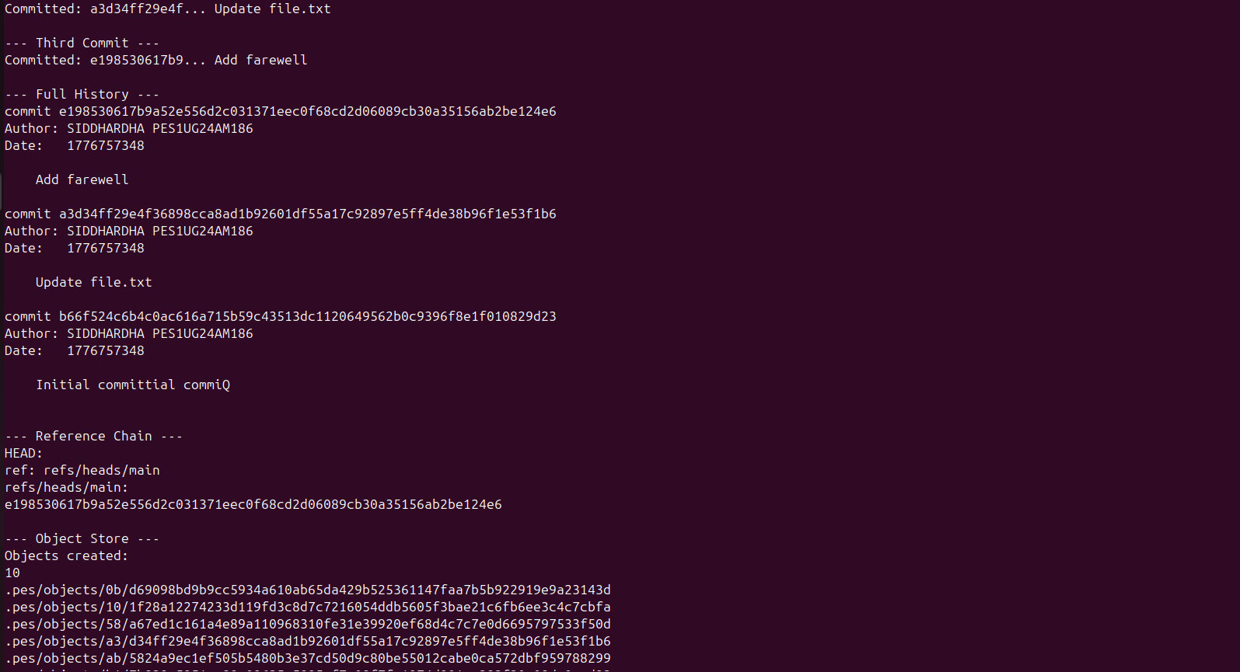

PES-VCS LAB REPORT - ANALYSIS QUESTIONS

Phase 5: Branching and Checkout

Q5.1: How would you implement pes checkout <branch>?

To implement pes checkout <branch>, the following steps are needed:

1. Read the target branch file from .pes/refs/heads/<branch> to get the commit hash.
2. Read the commit object to get its tree hash.
3. Walk the tree recursively and restore every file in the working directory to match the tree's blobs.
4. Update .pes/HEAD to contain ref: refs/heads/<branch>.

What makes this complex:
- You must delete files that exist in the current branch but not in the target branch.
- You must create directories that don't exist yet.
- If the user has uncommitted changes, you risk overwriting their work.
- You need to update the index to match the new branch's tree so status works correctly.

Q5.2: How would you detect a dirty working directory conflict?

To detect conflicts before switching branches:

1. For each file in the current index, compute the SHA-256 of the file on disk.
2. Compare it to the hash stored in the index entry.
3. If they differ, the file has uncommitted local changes.
4. Check if that same file differs between the two branches' trees.
5. If both are true, the file is locally modified AND differs between branches, so refuse checkout and report the conflict.

This only requires the index and object store, no extra metadata needed.

Q5.3: What happens in detached HEAD state?

When HEAD contains a commit hash directly instead of a branch reference (for example, ref: refs/heads/main), you are in detached HEAD state.

If you make commits in this state:
- New commits are created and chained correctly with parent pointers.
- HEAD is updated to point to the new commit hash directly.
- However, no branch pointer is updated, so these commits are not reachable from any branch.

To recover these commits, a user can:
1. Note the commit hash shown after each commit command.
2. Create a new branch pointing to that hash: git branch recovery <hash>.
3. Or use git reflog (in real Git) to find recent commit hashes.

Without doing this, the commits become unreachable and will eventually be deleted by garbage collection.

Phase 6: Garbage Collection

Q6.1: Algorithm to find and delete unreachable objects

Algorithm (Mark and Sweep):

1. Mark phase: Start from all branch refs in .pes/refs/heads/. For each branch, walk the commit chain. For each commit, record its tree hash. For each tree, recursively record all blob and subtree hashes. Use a hash set (for example, a hash table keyed by the 64-character hex hash) to track all reachable object IDs.

2. Sweep phase: Walk all files under .pes/objects/. For each file, reconstruct its hash from the path. If the hash is not in the reachable set, delete the file.

Data structure: A hash set of 64-character hex strings is ideal, offering O(1) average lookup and insertion.

Estimate for 100,000 commits, 50 branches:
- Each commit references 1 tree; each tree references approximately 10 blobs on average.
- Total objects visited is approximately 100,000 commits plus 100,000 trees plus approximately 500,000 blobs, totaling approximately 700,000 objects.
- Starting from 50 branches, the walk converges quickly since commits share history.

Q6.2: Race condition between GC and concurrent commit

The race condition:

1. A commit operation runs tree_from_index() and creates new blob objects in the store.
2. Before the commit object is written (and before HEAD is updated), GC runs.
3. GC scans all refs, and the new blobs are not yet reachable from any ref.
4. GC deletes the new blobs as unreachable.
5. The commit operation then writes the commit object referencing the now-deleted blobs.
6. The repository is now corrupt, with the commit pointing to missing objects.

How Git avoids this:
- Git uses a grace period, where objects newer than 14 days are never deleted by GC, giving in-progress operations time to complete.
- Git also writes a FETCH_HEAD or lock file during operations to signal that a transaction is in progress.
- The object is written to disk before any ref points to it, so a partial commit leaves orphan objects (harmless) rather than missing ones.
- GC uses file modification timestamps to skip recently created objects.

