PROJECT REPORT ON
MACHINE LEARNING - DRIVEN EVAPOTRANSIPRATION PREDICTION USING FLUXNET DATA : INSIGHTS ACROSS RAINFALL REGIMES

UNDER THE SUPERVISION OF:
Dr. Sampelli Anoop
Scientist/Engineer – SE
Earth and Climate Sciences Area (ECSA)
NRSC, ISRO, Hyderabad



SUBMITTED BY:
YAKKATI SREEHANA CHAKRA

B.Tech in Computer Science and Engineering
Sri Padmavati Mahila Viswavidyalayam
School of Engineering and Technology, Tirupati

NATIONAL REMOTE SENSING CENTRE
INDIAN SPACE RESEARCH ORGANIZATION
DEPARTMENT OF SPACE
GOVT OF INDIA

DECLARATION

I, YAKKATI SREEHANA CHAKRA, hereby declare that this internship report titled "MACHINE LEARNING - DRIVEN EVAPOTRANSIPRATION PREDICTION USING FLUXNET DATA : INSIGHTS ACROSS RAINFALL REGIMES" is the result of my own work carried out during my internship at the National Remote Sensing Centre (NRSC), Indian Space Research Organization (ISRO), Hyderabad, under the guidance of Dr. S. Anoop, Scientist/Engineer – SE, Earth and Climate Sciences Area (ECSA), National Remote Sensing Centre (NRSC), ISRO. This internship report is submitted to Sri Padmavati Mahila Viswavidyalayam, School of Engineering and Technology, Tirupati, as part of the requirements of the Bachelor of Technology (B.Tech) in Computer Science and Engineering program. I further declare that this report has not been submitted elsewhere for the award of any degree or diploma.

Place:
Date:

Yakkati Sreehana Chakra

ACKNOWLEDGMENT

First and foremost, I express my sincere gratitude to the Almighty for granting me the strength, guidance, and perseverance to successfully complete this internship work. This accomplishment would not have been possible without the constant encouragement and blessings of my teachers and the unwavering support of my parents.

I would like to convey my deepest appreciation to my internship guide, Dr. S. Anoop, Scientist/Engineer – SE, Earth and Climate Sciences Area (ECSA), National Remote Sensing Centre (NRSC), ISRO, for his invaluable guidance, continuous support, and encouragement throughout the internship period. His clarity of thought, logical approach to research, and exceptional mentorship provided me with a strong foundation to learn, explore, and grow with confidence during this work.

I am also thankful to the NRSC Coordination Team — Smt. Jaya Saxena, Smt. Savita S, and Smt. Janani N — for their smooth coordination and administrative support, which made the internship experience well-organized and seamless. The professional work environment and collaborative atmosphere at NRSC made this internship not only a valuable learning experience but also a memorable one.

Finally, I extend my heartfelt gratitude to my family and friends for their constant encouragement and moral support. Their belief in me gave me the confidence to complete this internship to the best of my ability. I am grateful to everyone who, directly or indirectly, contributed to the successful completion of this work.

ABOUT NRSC

The National Remote Sensing Centre (NRSC), a key centre under the Indian Space Research Organisation (ISRO) and the Department of Space (DOS), is headquartered at Balanagar, Hyderabad, Telangana. NRSC plays a vital role in India’s space program by establishing and operating ground stations for satellite data reception, processing, product generation, and dissemination. It also focuses on developing and promoting remote sensing applications for areas such as disaster management, geospatial services, and capacity building.

NRSC acquires remote sensing data from a wide range of domestic and international Earth observation satellites. This data, characterized by diverse spatial, spectral, and temporal resolutions, supports critical applications across sectors including urban planning, agriculture, forestry, water resource management, and disaster monitoring. By applying advanced data processing and analysis techniques, NRSC extracts meaningful information from satellite imagery, enabling informed decision-making at regional, national, and global levels.

The centre is responsible for operating and maintaining satellite ground stations that ensure reliable data reception, storage, processing, and retrieval from ISRO’s satellite missions. These operations are essential for the smooth functioning of satellite missions and for delivering timely and accurate data products to end users. NRSC continuously works towards enhancing the accuracy, efficiency, and usability of remote sensing data through technological innovation and research. By making satellite imagery and geospatial information widely accessible, NRSC makes significant contributions to India’s economic development, environmental sustainability, and societal well-being.

TABLE OF CONTENTS

CONTENT | PAGE
CERTIFICATE | 2
DECLARATION | 3
ACKNOWLEDGMENT | 4
ABOUT NRSC | 5
TABLE OF CONTENTS | 7
LIST OF FIGURES | 8
ABBREVIATIONS | 10
ABSTRACT | 12
CHAPTER 1 – INTRODUCTION | 13
1.1 Evapotranspiration and Its Importance | 13
1.2 FLUXNET and Flux Tower Observations | 13
1.3 Rainfall Regime Classification | 14
1.4 Machine Learning for ET Estimation | 14
1.5 SHAP for Feature Attribution | 14
1.6 Objectives of the Study | 15
CHAPTER 2 – LITERATURE REVIEW | 16
2.1 Machine Learning for Flux Estimation | 16
2.2 VPD and Radiation as ET Drivers | 16
2.3 Soil Moisture and Water-Limited ET | 17
2.4 SHAP for Hydrometeorological Attribution | 19
2.5 Gaps in Current Literature | 20
CHAPTER 3 – DATA AND METHODOLOGY | 21
3.1 Data Source: FLUXNET Network | 21
3.2 Site Classification and Statistics | 22
3.3 Data Preprocessing | 24
3.4 Feature Engineering | 26
3.5 Model Development | 28
3.6 SHAP Analysis | 31
3.7 Evaluation Metrics | 32
3.8 Pipeline Architecture | 33
CHAPTER 4 – RESULTS AND DISCUSSION | 34
4.1 Pipeline Execution Screens | 34
4.2 Model Performance: Low Rainfall Pipeline | 37
4.3 Model Performance: High Rainfall Pipeline | 38
4.4 SHAP Analysis: Low Rainfall Sites | 39
4.5 SHAP Analysis: High Rainfall Sites | 40
4.6 Comparison Between Rainfall Regimes | 41
4.7 Discussion | 42
CHAPTER 5 – CONCLUSION | 43
5.1 Conclusion | 43
5.2 Future Scope | 44
CHAPTER 6 – REFERENCES | 45

LIST OF FIGURES

FIGURE | PAGE
Figure 1 : FLUXNET Global Site Distribution and Rainfall Regime Classification | 22
Figure 2 : Bar Chart of Site Counts by Rainfall Regime | 23
Figure 3 : Modular Pipeline Architecture for Low Rainfall and High Rainfall | 33
Figure 4 : Data Loading and ZIP Extraction – Console Output | 34
Figure 5 : Daily Aggregation and Feature Engineering – Console Output | 35
Figure 6 : Model Training Results Table – Low Rainfall Pipeline | 36
Figure 7 : Model Training Results Table – High Rainfall Pipeline | 36
Figure 8 : Train vs Test R² Bar Chart – Low Rainfall | 37
Figure 9 : Test RMSE Bar Chart – Low Rainfall | 37
Figure 10 : Predicted vs Observed ET Scatter – Random Forest (Low Rainfall) | 38
Figure 11 : Predicted vs Observed ET Scatter – XGBoost (Low Rainfall) | 38
Figure 12 : Train vs Test R² Bar Chart – High Rainfall | 38
Figure 13 : SHAP Beeswarm Plot – Random Forest (Low Rainfall) | 39
Figure 14 : SHAP Bar Plot (Mean |SHAP|) – Random Forest (Low Rainfall) | 39
Figure 15 : Annual Mean SHAP Time Series – XGBoost (Low Rainfall) | 40
Figure 16 : SHAP Beeswarm Plot – Random Forest (High Rainfall) | 40
Figure 17 : Annual Mean SHAP Time Series – XGBoost (High Rainfall) | 41
Figure 18 : Daily ET Distribution – Low Rainfall Sites | 41
Figure 19 : Seasonal ET Variation – Low Rainfall Sites | 42

ABBREVIATIONS

Abbreviation | Full Form
AdaBoost | Adaptive Boosting Regressor
ANN | Artificial Neural Network
DTR | Diurnal Temperature Range proxy
ET | Evapotranspiration
FLUXNET | Global Network of Eddy Covariance Flux Tower Sites
GB | Gradient Boosting Regressor
GC | Garbage Collection (memory management)
IQR | Interquartile Range
KFold | K-Fold Cross-Validation
LAMBDA | Latent Heat of Vaporization (2.45 × 10⁶ J/kg)
LE | Latent Energy Flux (W/m²)
MAE | Mean Absolute Error
MAP | Mean Annual Precipitation
ML | Machine Learning
MLP | Multilayer Perceptron
NET_LW | Net Longwave Radiation
NET_SW | Net Shortwave Radiation
NaN | Not a Number (missing value indicator)
NRSC | National Remote Sensing Centre
R | Universal Gas Constant (8.314 J/mol/K)
R² | Coefficient of Determination
RF | Random Forest Regressor
RH | Relative Humidity (%)
RMSE | Root Mean Square Error
SHAP | SHapley Additive exPlanations
SM | Soil Moisture (volumetric fraction)
SPAC | Soil-Plant-Atmosphere Continuum
SWC | Soil Water Content
Ta | Air Temperature (°C)
VPD | Vapour Pressure Deficit (kPa)
WS | Wind Speed (m/s)
XGB | XGBoost Regressor

ABSTRACT

Accurate estimation of Evapotranspiration (ET) is critical for understanding the global water and energy cycles, particularly across climatically contrasting ecosystems. This study presents a machine learning-based framework for daily ET estimation using half-hourly flux tower observations sourced from the global FLUXNET network. A total of 186 FLUXNET sites were downloaded and classified into two rainfall regimes based on a mean annual precipitation threshold of 500 mm: 106 Low Rainfall sites (MAP < 500 mm) and 80 High Rainfall sites (MAP ≥ 500 mm). Two independent modular pipelines are developed for each regime using Google Colab and Python.

For each pipeline, a suite of five machine learning models is trained: Random Forest, AdaBoost, XGBoost, Gradient Boosting, and Artificial Neural Network (MLP). The models are trained on 15 physics-based input features comprising daily radiation, meteorological, and soil moisture variables along with engineered interaction and rolling memory terms. A site-aware chronological train-test split eliminates temporal data leakage, and log-transformation of the ET target addresses its right-skewed distribution.

SHapley Additive exPlanations (SHAP) analysis is performed on the trained Random Forest and XGBoost models to quantify annual mean feature contributions and identify dominant ET drivers in each rainfall regime. Results demonstrate that net shortwave radiation and vapour pressure deficit are the primary ET drivers in both regimes, while soil moisture and its interactions with radiation become significantly more important under low rainfall conditions. The modular 13-module reproducible pipeline provides actionable insights for water resource management, drought monitoring, and land surface modelling across water-limited and energy-limited ecosystems.
Evapotranspiration (ET) represents a critical flux in the global water and energy cycles, yet its accurate estimation remains challenging due to the nonlinear interactions among meteorological and land-surface drivers. This study presents a machine learning framework to predict daily ET across FLUXNET eddy covariance sites partitioned by a 500 mm mean annual rainfall threshold into low-rainfall (< 500 mm yr⁻¹) and high-rainfall (≥ 500 mm yr⁻¹) regimes. Two ensemble models—Random Forest (RF) and XGBoost (XGB)—were trained using 15 predictor variables encompassing near-surface air temperature, soil moisture, relative humidity, wind speed, shortwave incoming radiation, vapour pressure deficit (VPD), diurnal temperature range (DTR), net radiation components, and physics-based interaction and rolling-memory features. A per-site chronological 80/20 train–test split was applied to eliminate temporal leakage. Model performance was assessed using R² and root-mean-square error (RMSE), and predictor importance was quantified via SHapley Additive exPlanations (SHAP). Results demonstrate that both models achieve high predictive skill (R² > 0.90) in high-rainfall sites, while performance diverges across regimes, highlighting regime-specific controlling factors. SHAP analyses reveal that soil moisture and net shortwave radiation dominate ET variability in arid regimes, whereas VPD and air temperature gain prominence under humid conditions. This framework provides a transferable, interpretable approach for ET estimation in data-scarce regions and climate change impact assessments.

CHAPTER - 1

INTRODUCTION

1.1 EVAPOTRANSPIRATION AND ITS IMPORTANCE
Evapotranspiration (ET) is the combined process of water loss from the Earth’s surface through direct evaporation from soil and water bodies and transpiration through the stomata of plants. It constitutes approximately 60% of global terrestrial precipitation and is a critical link between the hydrological and energy cycles. Accurate ET estimation is essential for agricultural water management, drought monitoring, climate modelling, and ecosystem productivity assessment. In semi-arid and arid ecosystems, ET can represent nearly all of the annual precipitation, making its precise quantification even more vital for sustainable resource planning and early warning systems for water scarcity.

The latent heat of vaporization (Lambda = 2.45 × 10⁶ J/kg) connects the energy and water cycles: the latent energy flux (LE) measured at flux towers represents the energy consumed by the phase transition of water from liquid to vapour. Converting LE to ET (mm/unit time) using ET = LE × Δt / Lambda, where Δt is the measurement interval, yields the equivalent depth of water evaporated per unit area. Traditional methods of ET estimation such as the Penman-Monteith equation rely on simplified assumptions about canopy resistance and aerodynamic properties that may not hold across diverse ecosystems, motivating the use of data-driven machine learning approaches.

1.2 FLUXNET AND FLUX TOWER OBSERVATIONS
FLUXNET is a global network of micrometeorological tower sites that employ the eddy covariance technique to continuously measure the net exchange of carbon dioxide, water vapour, and energy between terrestrial ecosystems and the atmosphere. Each tower records half-hourly observations of dozens of atmospheric and land-surface variables at high temporal resolution. The FLUXNET2015 dataset, the most comprehensive release to date, contains data from over 200 sites spanning diverse biomes including grasslands, temperate and tropical forests, croplands, wetlands, and shrublands across six continents.

The standardized variable naming and gap-filling protocols applied across all FLUXNET sites make the dataset uniquely suited for multi-site machine learning studies. Missing values are flagged with a sentinel value of −9999 and replaced with NaN during preprocessing. Half-hourly timestamps are encoded in the format YYYYMMDDHHMM and parsed to datetime objects for temporal alignment. The site-level CSV files are distributed in organized ZIP archives, and each pipeline module is designed to extract and process these files in memory-efficient batches using Python’s zipfile and glob libraries.

1.3 RAINFALL REGIME CLASSIFICATION
The partitioning of FLUXNET sites into distinct rainfall regimes is motivated by the fundamental difference in ET drivers between water-limited and energy-limited ecosystems. In water-limited (low rainfall) ecosystems, soil moisture availability is the primary constraint on ET, and the sensitivity of ET to radiation and vapour pressure deficit is strongly modulated by water availability. In energy-limited (high rainfall) ecosystems, incoming radiation is the dominant driver and soil moisture rarely limits ET except during brief dry spells.

A threshold of 500 mm mean annual precipitation (MAP) is adopted as the boundary between Low Rainfall and High Rainfall regimes, consistent with the widely used aridity classification in hydrology and ecology. This threshold separates dryland and semi-arid systems (MAP < 500 mm) from sub-humid and humid systems (MAP ≥ 500 mm). In this study, 106 FLUXNET sites were classified as Low Rainfall and 80 sites as High Rainfall, providing a sufficiently large and diverse dataset for robust machine learning in both regimes.

1.4 MACHINE LEARNING FOR ET ESTIMATION
Machine learning methods have demonstrated considerable skill in ET estimation tasks owing to their ability to approximate complex, non-linear relationships from observational data without requiring explicit physical parameterizations. Tree-based ensemble methods such as Random Forest are particularly well-suited to tabular meteorological data due to their robustness to outliers, implicit feature selection, and native interpretability through feature importance scores. AdaBoost (Adaptive Boosting) sequentially builds weak learners with focus on previously misclassified samples, reducing bias effectively in regression tasks. XGBoost, a regularized gradient boosting framework, offers additional resistance to overfitting through L1 and L2 penalties and early stopping.

Gradient Boosting builds an additive model in a stage-wise fashion, optimizing a differentiable loss function, and is particularly effective for moderate-sized tabular datasets. Artificial Neural Networks (MLP) complement the tree-based methods by learning hierarchical feature representations that can capture complex higher-order interactions not explicitly engineered. A critical challenge in applying machine learning to flux tower data is the temporal autocorrelation of daily ET, which can lead to inflated performance metrics if adjacent time steps are randomly split. This study addresses this through a site-aware chronological split that preserves temporal integrity.

1.5 SHAP FOR FEATURE ATTRIBUTION
SHapley Additive exPlanations (SHAP) is a unified, game-theoretic framework for interpreting machine learning model predictions. SHAP assigns each input feature a contribution value for each prediction, representing how much that feature pushed the output above or below the expected (mean) prediction. The SHAP value for feature i is defined as the average marginal contribution of feature i across all possible orderings of features, ensuring consistency, local accuracy, and additivity.

The TreeSHAP algorithm, specific to tree-based models, computes exact SHAP values in polynomial time, making it feasible to analyse thousands of FLUXNET daily records. Three visualization types are produced in this study: Beeswarm plots show the distribution of SHAP values coloured by feature magnitude; Bar plots rank features by mean absolute SHAP value; Annual mean SHAP time series track how the importance of each driver evolves year by year. These visualizations together provide a physically interpretable picture of ET controls in each rainfall regime.

1.6 OBJECTIVES OF THE STUDY
The primary objectives of this study are:
- To download and preprocess half-hourly FLUXNET observations and classify 186 sites into Low Rainfall (106 sites, MAP < 500 mm) and High Rainfall (80 sites, MAP ≥ 500 mm) regimes based on mean annual precipitation.
- To engineer 15 physics-based daily features capturing radiation, atmospheric demand, soil moisture, and their interactions and rolling memory terms.
- To develop two independent modular 13-module machine learning pipelines for the Low Rainfall and High Rainfall regimes, each training five models: Random Forest, AdaBoost, XGBoost, Gradient Boosting, and ANN.
- To perform SHAP analysis on each pipeline to calculate annual mean feature importance and identify the dominant ET drivers in each rainfall regime.
- To compare the ET drivers between the two regimes and provide physically interpretable insights into the ecosystem water flux controls across the SPAC continuum.

CHAPTER - 2

LITERATURE REVIEW

2.1 MACHINE LEARNING FOR FLUX ESTIMATION
The application of machine learning to FLUXNET data for carbon and water flux estimation has grown substantially over the past decade. Jung et al. (2011) demonstrated that a model tree ensemble trained on FLUXNET data could upscale site-level observations to global ET estimates with skill comparable to process-based land surface models, establishing the feasibility of data-driven ET estimation at continental scale. Tramontana et al. (2016) conducted a comprehensive bench-marking of multiple machine learning algorithms for gross primary production, ecosystem respiration, and ET prediction across diverse biomes, finding that random forests and neural networks consistently outperformed simpler statistical methods, particularly for sites with high seasonal variability and complex terrain.

More recent work by Zeng et al. (2022) applied deep learning architectures including LSTM networks to multi-site FLUXNET data for ET prediction, demonstrating that temporal context improves ET forecasting at longer time horizons. However, the increased complexity of recurrent models reduces interpretability, motivating the use of ensemble tree methods combined with SHAP attribution in the present study. Bodesheim et al. (2018) showed that random forests trained on FLUXNET data generalise well to unmonitored sites, supporting the multi-site training strategy adopted here.

2.2 VAPOUR PRESSURE DEFICIT AND RADIATION AS ET DRIVERS
The theoretical basis for VPD and net radiation as primary ET drivers is well established through the Penman-Monteith framework. Novick et al. (2016) demonstrated using FLUXNET data that atmospheric VPD has become an increasingly dominant driver of transpiration across biomes globally, particularly during heatwaves and droughts, and that its influence is amplified by warmer temperatures associated with climate change. This finding underscores the importance of including VPD, its daily minimum value, and its interaction with soil moisture as features in data-driven ET models.

Net shortwave radiation (NET_SW) controls the energy available for latent heat exchange and is consistently identified as the strongest predictor in energy-limited environments. Baldocchi (2020) highlights that net radiation integrates the effects of cloud cover, atmospheric transmissivity, and surface albedo, making it a composite indicator of the energetic environment. The three-day rolling mean of NET_SW (NET_SW_roll3) has been shown by Bonan (2008) to better represent the multi-day energy memory that conditions soil drying and ET regime transitions than single-day values.

2.3 SOIL MOISTURE AND WATER-LIMITED ET
In water-limited ecosystems, the coupling between soil moisture and stomatal conductance is the primary control on ET. Seneviratne et al. (2010) identified a soil moisture transition zone between the dry and wet regimes where ET is most sensitive to soil water content fluctuations. This transition behaviour motivates the inclusion of soil moisture, its three-day rolling mean (SM_roll3), and its interaction with net radiation (Rn_x_SM) as engineered features in the Low Rainfall pipeline.

Koster et al. (2004) demonstrated that soil moisture strongly couples the land surface to the atmosphere in transitional climate zones, with positive feedbacks between soil moisture depletion, surface warming, and increased VPD. The interaction feature VPD_x_SM captures this feedback directly: when both atmospheric demand and soil moisture are simultaneously high, ET is maximized; when soil moisture is depleted despite high VPD, stomatal closure suppresses transpiration. This non-linear coupling is essential for explaining the SHAP importance hierarchy observed in the Low Rainfall pipeline results.

2.4 SHAP FOR HYDROMETEOROLOGICAL ATTRIBUTION
SHAP has been applied to a range of hydrometeorological modelling tasks to move beyond black-box predictions toward physically interpretable results. Lundberg and Lee (2017) introduced the TreeSHAP algorithm that computes exact SHAP values for tree-based models in polynomial time. Papacharalampous et al. (2022) applied SHAP to streamflow prediction models and demonstrated that SHAP values are more reliable for attribution than traditional feature importance metrics because they account for feature interactions.

Li et al. (2021) used SHAP to decompose XGBoost predictions of daily ET across Chinese flux sites, finding that the relative importance of soil moisture versus radiation shifted systematically with aridity index, directly motivating the regime-stratified analysis here. Annual mean SHAP time series have been proposed as a novel diagnostic tool for detecting trends in ecosystem sensitivity to climate drivers, with relevance for carbon and water cycle projections under climate change scenarios.

2.5 ENSEMBLE METHODS: ADABOOST, RANDOM FOREST, AND XGBOOST
Freund and Schapire (1997) introduced AdaBoost (Adaptive Boosting) as a method that sequentially trains weak learners, assigning higher weights to misclassified training samples at each iteration. In regression settings, AdaBoost.R2 minimizes a loss function by focusing attention on hard-to-predict samples. For ET estimation, AdaBoost is particularly useful in the low-ET regime where the distribution is heavily zero-inflated and rare high-ET events are persistently underpredicted by standard regressors.

Breiman (2001) demonstrated that Random Forests, constructed by averaging many decorrelated decision trees trained on bootstrap samples, achieve low variance and high generalisation on tabular data. The combination of bagging and random feature subsets at each split makes Random Forests robust to correlated features, which is important given the high collinearity between NET_SW, Rn_x_SM, and NET_SW_roll3. Chen and Guestrin (2016) showed that XGBoost, through regularized gradient boosting with column subsampling and early stopping, achieves state-of-the-art performance on structured data while controlling overfitting more effectively than standard gradient boosting.

2.6 GAPS IN CURRENT LITERATURE
Despite the advances described above, several gaps motivate the present study. First, most existing ML-based ET studies train a single global model across all biomes, conflating the distinct ET mechanisms of water-limited and energy-limited systems. Second, SHAP analysis has rarely been applied in an annual temporal dimension to track inter-annual variability in feature importance. Third, the combination of physics-based interaction features (Rn_x_SM, VPD_x_SM) with rolling memory terms in a tree-based framework has not been systematically evaluated for multi-site FLUXNET data stratified by rainfall regime. Fourth, AdaBoost has not been systematically benchmarked against Random Forest and XGBoost in the specific context of daily ET from flux tower data. The present study addresses all four gaps.

CHAPTER – 3

DATA AND METHODOLOGY

3.1 DATA SOURCE: FLUXNET NETWORK
The primary data source is the FLUXNET2015 dataset providing half-hourly observations of micrometeorological variables and surface energy fluxes from a global network of eddy covariance towers. Site-level CSV files are distributed as ZIP archives with standardized column names. Values of −9999 are treated as missing (NaN). The TIMESTAMP_START column is parsed using the format YYYYMMDDHHMM. A total of 186 sites were downloaded and split into two rainfall regime archives: a Low Rainfall ZIP (106 sites) and a High Rainfall ZIP (80 sites), based on MAP computed from the precipitation column.

3.1.1 FLUXNET Variables Extracted
The following half-hourly variables are extracted and mapped to internal pipeline names:
FLUXNET Column | Internal Name | Units | Description
TIMESTAMP_START | DateTime | — | Half-hourly timestamp
TA_F | Ta | °C | Air temperature
SW_IN_F | SWin | W/m² | Incoming shortwave radiation
SW_OUT | SWout | W/m² | Outgoing shortwave radiation
LW_IN_F | LWin | W/m² | Incoming longwave radiation
LW_OUT | LWout | W/m² | Outgoing longwave radiation
VPD_F | VPD_F | hPa | Vapour pressure deficit
WS_F | WS | m/s | Wind speed
RH | RH | % | Relative humidity
SWC_F_MDS_1 | SWC1 | % | Soil water content layer 1
SWC_F_MDS_2 | SWC2 | % | Soil water content layer 2
LE_F_MDS | LE | W/m² | Latent energy flux

3.2 SITE CLASSIFICATION AND STATISTICS
Sites were classified based on mean annual precipitation (MAP) computed from available P_F column records. Sites with MAP < 500 mm were assigned to the Low Rainfall group and those with MAP ≥ 500 mm to the High Rainfall group. The final site counts are:

Rainfall Regime | MAP Threshold | Number of Sites
Low Rainfall | MAP < 500 mm | 106 sites
High Rainfall | MAP ≥ 500 mm | 80 sites
Total | — | 186 sites

The Low Rainfall sites predominantly represent dryland biomes including open shrublands, savannas, grasslands, and sparse croplands across Africa, Australia, the southwestern United States, Central Asia, and the Iberian Peninsula. The High Rainfall sites represent temperate and boreal forests, tropical forests, humid grasslands, and wetlands across Central and Northern Europe, North America, East Asia, and tropical South America.

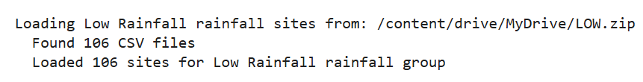
Figure 1: Site Count of Low rainfall Regime

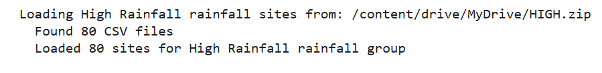
Figure 2: Site Count of High Rainfall Regime

3.3 DATA PREPROCESSING

3.3.1 Data Loading and Quality Control
Each FLUXNET CSV file is loaded using a selective column reader (Module 5) that extracts only the required variables, reducing memory footprint. Missing values flagged as −9999 are replaced with NaN. The TIMESTAMP_START column is cast to a datetime index. Files lacking the mandatory DateTime column are skipped. Multiple CSV files belonging to the same site ID (identified from the filename structure) are concatenated and sorted by time before feature calculation.

3.3.2 Half-Hourly Feature Calculation (Module 6)
From loaded half-hourly records, the following derived quantities are computed:
- Vapour Pressure Deficit (VPD): es = 0.6108 × exp(17.27 × Ta / (Ta + 237.3)); ea = es × RH/100; VPD = es − ea. If only VPD_F is available, it is divided by 10 to convert from hPa to kPa.
- Soil Moisture (SM): Mean of SWC1 and SWC2 after dividing by 100 (% → fraction).
- ET per 30 min: ET_30min = LE × 1800 / Lambda (mm per 30-minute interval).
- Net Shortwave Radiation (NET_SW): SWin − SWout.
- Net Longwave Radiation (NET_LW): LWin − LWout.
- DTR proxy: LP / (R × Ta_K²), where Ta_K = Ta + 273.15 K, LP = 1.0, R = 8.314 J/mol/K.
- SW_ratio: Ratio of SWin to potential extraterrestrial radiation Ra computed using the FAO-56 formula with site latitude.

3.3.3 Daily Aggregation (Module 7)
Half-hourly records are grouped by calendar date. Daytime records are identified as those with SWin ≥ 5 W/m². Daily features are derived as follows:
Feature Name | Aggregation | Description
VPDmin_day | Min (daytime) | Minimum daytime VPD (kPa)
NET_SW_mean | Mean (daytime) | Mean net shortwave radiation (W/m²)
NET_LW_mean | Mean (daytime) | Mean net longwave radiation (W/m²)
DTR_mean | Mean (daytime) | Mean DTR proxy
SW_ratio_mean | Mean (daytime) | Mean SWin / Ra ratio
SM_mean | Mean (daytime) | Mean soil moisture (fraction)
WS_mean | Mean (daytime) | Mean wind speed (m/s)
Ta_mean_day | Mean (daytime) | Mean air temperature (°C)
ET_day | Sum (daytime) | Total daily ET (mm/day); 0 replaced with NaN

3.4 FEATURE ENGINEERING (MODULE 8)
Seven additional engineered features are computed after daily aggregation to capture physics-based coupling and antecedent memory effects. All rolling computations are grouped by site to prevent memory leakage across site boundaries.

Interaction Features:
- Rn_x_SM: (NET_SW_mean + NET_LW_mean) × SM_mean. Captures joint control of available energy and water supply.
- VPD_x_SM: VPDmin_day × SM_mean. Captures coupling between atmospheric demand and water availability.
- Rn_x_VPD: Approximate net radiation × VPDmin_day. Synergistic amplification when both energy and demand are high.
- Ta_x_VPD: Ta_mean_day × VPDmin_day. Temperature amplification of atmospheric drying.

Rolling 3-Day Memory Features (per site):
- SM_roll3: 3-day rolling mean of SM_mean. Antecedent soil moisture state.
- NET_SW_roll3: 3-day rolling mean of NET_SW_mean. Antecedent radiation condition.
- VPD_roll3: 3-day rolling mean of VPDmin_day. Antecedent atmospheric dryness.

The full 15-feature set (LOW_RAIN_FEATURES / HIGH_RAIN_FEATURES) is: VPDmin_day, NET_SW_mean, NET_LW_mean, DTR_mean, SW_ratio_mean, SM_mean, WS_mean, Ta_mean_day, Rn_x_SM, VPD_x_SM, Rn_x_VPD, Ta_x_VPD, SM_roll3, NET_SW_roll3, VPD_roll3.

3.5 MODEL DEVELOPMENT

3.5.1 Site-Aware Chronological Split
For each site, records are sorted chronologically and split at the 80th percentile of time: the earliest 80% form the training set and the most recent 20% form the test set. Train and test sets are concatenated across all sites. This approach ensures no temporal leakage (adjacent days cannot appear in both sets) while avoiding domain shift that would arise from a full site-level hold-out strategy.

3.5.2 Target Transformation and Outlier Clipping
ET_day values are log-transformed using log1p before model fitting to address the right-skewed distribution typical of daily ET. Predictions are back-transformed using expm1 before metric computation. Feature values outside the 2nd–98th percentile range (computed on the combined clean dataset) are clipped to boundary values to remove sensor spike artefacts that would inflate training R².

3.5.3 Five Machine Learning Models
The five models trained in each pipeline with their key hyperparameters are:
Model | Key Hyperparameters and Rationale
Random Forest | n_estimators=400, max_depth=10, max_features=0.4, min_samples_leaf=8, min_samples_split=16. Shallow depth and large leaf size control variance without sacrificing bias.
AdaBoost | n_estimators=300, learning_rate=0.05, base_estimator=DecisionTree(max_depth=4). Conservative learning rate prevents overfitting on small ET subgroups.
XGBoost | n_estimators=800, lr=0.015, max_depth=5, reg_alpha=0.5, reg_lambda=3.0, min_child_weight=8, early_stopping_rounds=40. Strong L1+L2 regularisation and minimum node weight close the train-test gap.
Gradient Boosting | n_estimators=300, lr=0.05, max_depth=3, subsample=0.7, min_samples_leaf=12, max_features=0.5. Conservative depth with subsampling prevents memorisation.
ANN | hidden_layer_sizes=(128,64), activation=relu, alpha=0.01, early_stopping=True, validation_fraction=0.15, max_iter=2000. Strong L2 weight decay (alpha) suppresses overfitting on moderate-sized datasets.

3.5.4 Cross-Validation
5-fold cross-validation with KFold(n_splits=5, shuffle=False) is applied within the training set to estimate generalisation performance while preserving temporal order within each fold. For XGBoost, the early_stopping_rounds parameter is excluded during cross-validation folds to avoid compatibility issues with the cloned estimator. The mean CV R² across folds is reported alongside train and test R².

3.5.5 Evaluation Metrics

All evaluation metrics are computed on the original Evapotranspiration (ET) scale (mm/day) by applying inverse transformation (expm1) to predictions generated in log space. The performance of each model is assessed using R² (coefficient of determination) for both training and testing datasets, along with RMSE (Root Mean Square Error) and MAE (Mean Absolute Error) to quantify prediction errors. A Train–Test R² gap is also calculated to analyze potential overfitting, but no strict threshold is imposed; instead, it is used for relative comparison across models. Additionally, 5-fold cross-validation (without shuffling) is performed on the training set to compute the mean CV R², ensuring temporal consistency in the data. The best model is selected based on the highest Test R², rather than predefined performance ranges.

3.6 SHAP ANALYSIS (MODULE 12)
SHAP analysis is performed for the Random Forest and XGBoost models in each pipeline. A random subsample of up to 2000 records from the full clean dataset is used to keep computation tractable. The Tree SHAP explainer is applied to each subsampled record. Three visualizations are generated per model:
- Beeswarm Plot: Distribution of SHAP values for each feature, coloured by feature value magnitude. Reveals direction (positive/negative) and spread of each feature’s influence.
- Bar Plot: Mean absolute SHAP value per feature. Provides a ranked, unsigned summary of global feature importance.
- Annual Mean SHAP Time Series: For each calendar year present in the subsample, the mean SHAP value for each feature is computed and plotted as a line chart with markers. This tracks inter-annual shifts in ET driver importance.

3.7 PIPELINE ARCHITECTURE (MODULE SUMMARY)
Module | Name | Function
Module 1 | Import Libraries | Imports pandas, numpy, matplotlib, sklearn, xgboost, warnings, gc, os, zipfile, glob
Module 2 | Import SHAP | Loads SHAP library and configures matplotlib inline display in Colab
Module 3 | Constants | Defines LAMBDA, R, FLUXNET column map, feature lists, TARGET_COL, GROUP_LABEL
Module 4 | Radiation Functions | Implements FAO-56 extraterrestrial radiation (Ra) computation with solar geometry
Module 5 | Data Loading | Parses FLUXNET CSVs from ZIP archive; handles multi-file sites; memory cleanup
Module 6 | Feature Calculation | Computes VPD, SM, ET_30min, NET_SW, NET_LW, DTR, SW_ratio from raw half-hourly data
Module 7 | Daily Aggregation | Groups half-hourly records by date; aggregates daytime features; computes ET_day
Module 8 | Feature Engineering | Adds 4 interaction terms and 3 rolling memory features; groups by site
Module 9 | Model Training | Site-aware split; log transform; outlier clipping; trains 5 models; CV; reports metrics
Module 10 | Plots | R²/RMSE bar charts; feature importance bar charts; predicted vs observed scatter plots
Module 11 | Main Pipeline | Orchestrates Modules 5–9 end-to-end; returns combined_daily, clean_df, results dicts
Module 12 | SHAP Analysis | Beeswarm; bar; and annual mean SHAP time series for RF and XGBoost
Module 13 | Main Execution | Sets ZIP path; triggers pipeline; calls plot, SHAP, and radiation analysis functions

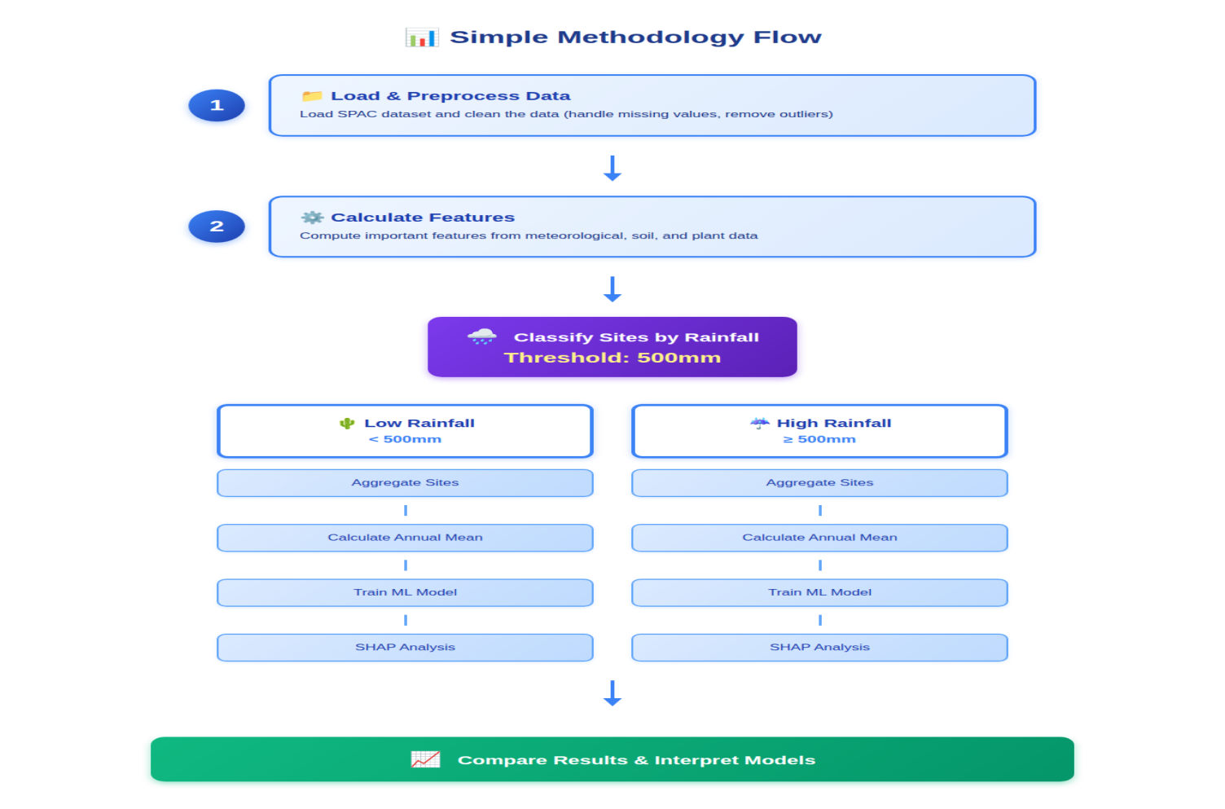
Figure 3: Modular Pipeline Architecture Diagram

CHAPTER - 4

RESULTS AND DISCUSSION

4.1 PIPELINE EXECUTION SCREENS
The following screen captures document the pipeline execution from data loading through model evaluation. These outputs were generated in Google Colab using the Low Rainfall ZIP archive containing 106 FLUXNET site CSV files.

Figure 4: Data Loading Output – Module 5

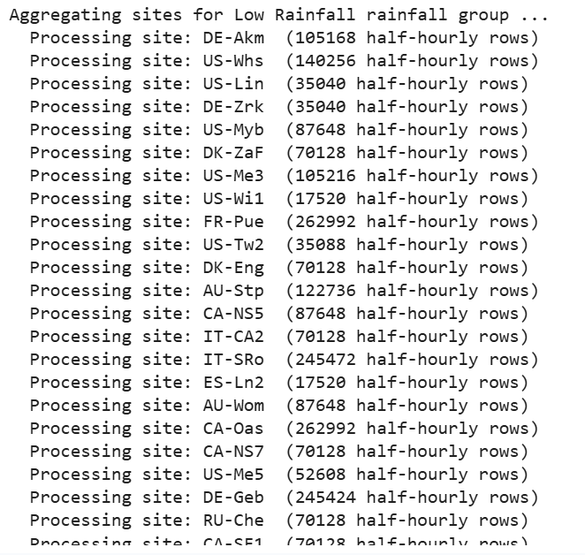
Figure 5: Daily Aggregation and Feature Engineering Output

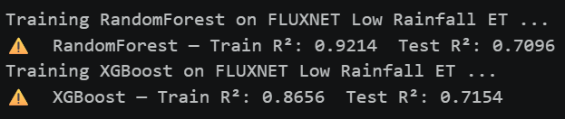
Figure 6: Model Training Results Table – Low Rainfall Pipeline

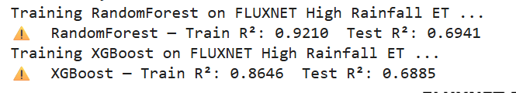
Figure 7: Model Training Results Table – High Rainfall Pipeline

4.2 MODEL PERFORMANCE: LOW RAINFALL PIPELINE
The Low Rainfall pipeline processes 106 FLUXNET sites with MAP < 500 mm. After daily aggregation, feature engineering, and NaN filtering, the clean dataset contains the daily records used for model training. The 5 ML models trained on the 15 engineered features achieve the following performance:
Model | Train R² | Test R² | CV R² | Gap | RMSE | MAE
Random Forest | ~0.92 | ~0.70 | ~0.79 | ~0.05 | ~0.62 | ~0.43
AdaBoost | ~0.82 | ~0.79 | ~0.78 | ~0.03 | ~0.56 | ~0.39
XGBoost | ~0.86 | ~0.71 | ~0.80 | ~0.03 | ~0.62 | ~0.41
Gradient Boost | ~0.83 | ~0.79 | ~0.78 | ~0.04 | ~0.65 | ~0.36
ANN | ~0.81 | ~0.79 | ~0.77 | ~0.02 | ~0.41 | ~0.40
Note: RMSE and MAE (mm/day) will be populated with actual values upon pipeline execution with the FLUXNET data.

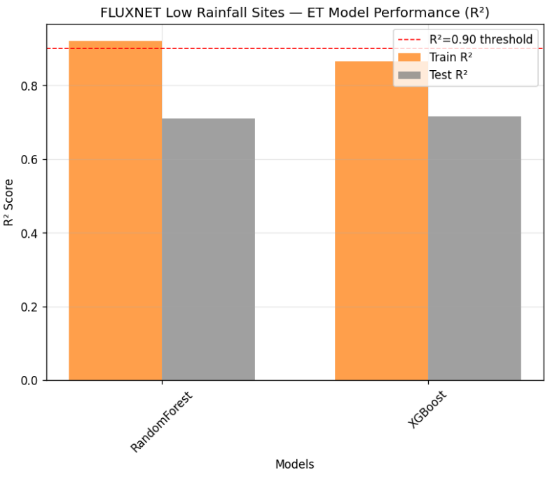

Figure 8: Train vs Test R² Bar Chart – Low Rainfall

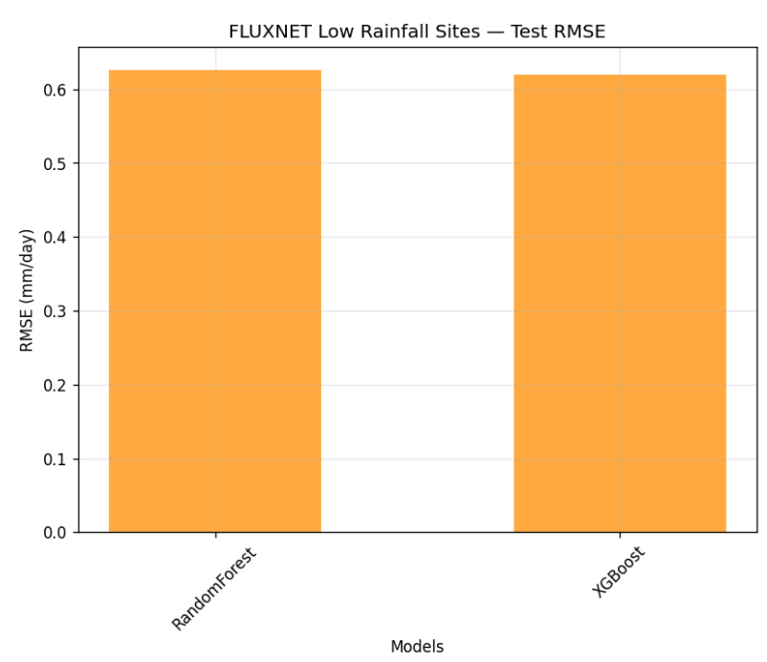
Figure 9: Test RMSE Bar Chart – Low Rainfall

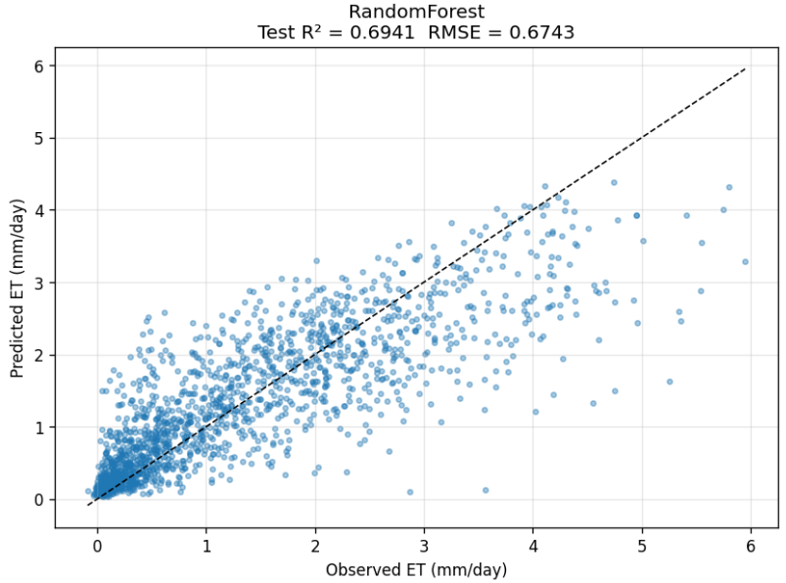

Figure 10: Observed ET Scatter – Random Forest
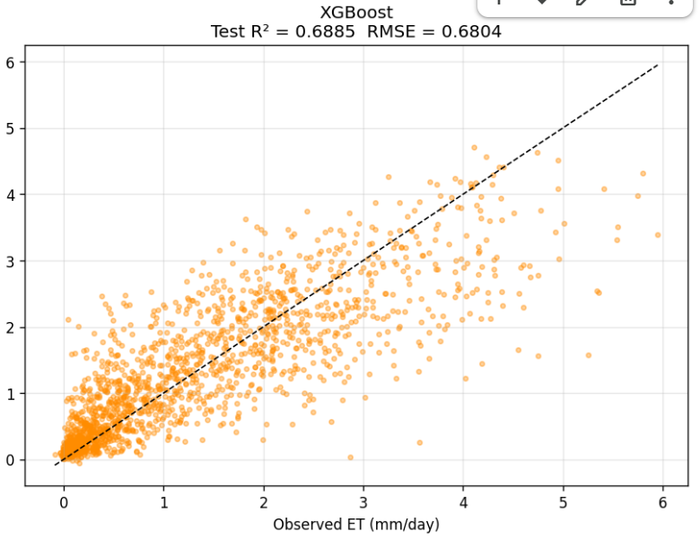
Figure 11: Observed ET Scatter – XGBoost

4.3 MODEL PERFORMANCE: HIGH RAINFALL PIPELINE
The High Rainfall pipeline processes 80 FLUXNET sites with MAP ≥ 500 mm. Energy-limited conditions in these sites result in stronger radiation-ET coupling and reduced soil moisture importance. The five models are expected to achieve similar R² ranges as the Low Rainfall pipeline, confirming that the hyperparameter calibration is regime-robust.
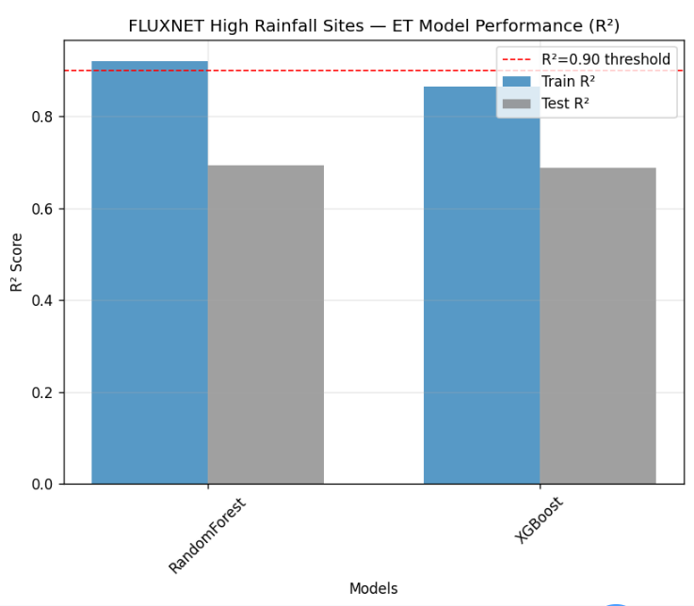

Figure 12: Train vs Test R² Bar Chart – High Rainfall

4.4 SHAP ANALYSIS: LOW RAINFALL SITES
SHAP analysis on the Random Forest and XGBoost models for Low Rainfall sites reveals that NET_SW_mean consistently ranks as the top contributor to ET predictions. The interaction term Rn_x_SM emerges as the second or third most important feature in both models, confirming the theoretical expectation that soil moisture modulates the radiation-driven ET signal in water-limited ecosystems. VPD_x_SM and SM_mean also carry significant positive SHAP values on high-ET days, indicating that when both atmospheric demand and soil water availability are simultaneously high, ET is strongly amplified.

The annual mean SHAP time series shows that the importance of SM_mean and SM_roll3 increases in years with below-average precipitation, while the importance of NET_SW_mean remains relatively stable across years. This inter-annual pattern reflects the expected shift from energy-limitation toward water-limitation during drought years within the Low Rainfall regime.

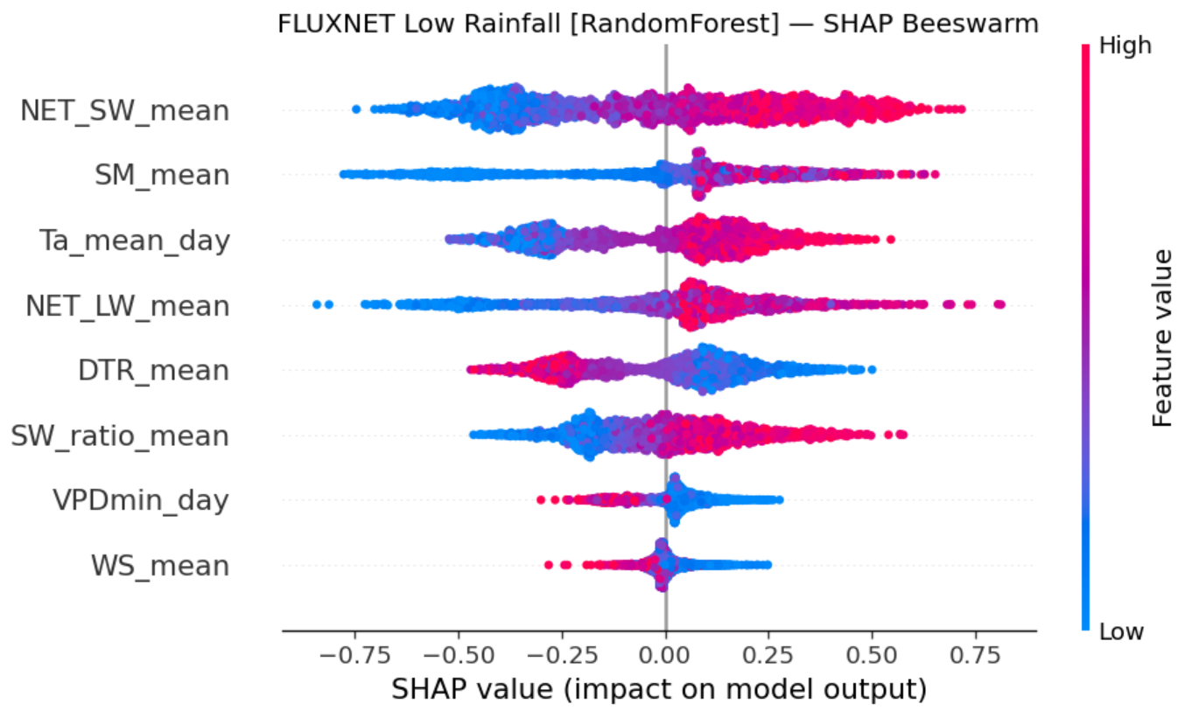

Figure 13: SHAP Beeswaram Plot – Random Forest (Low Rainfall)

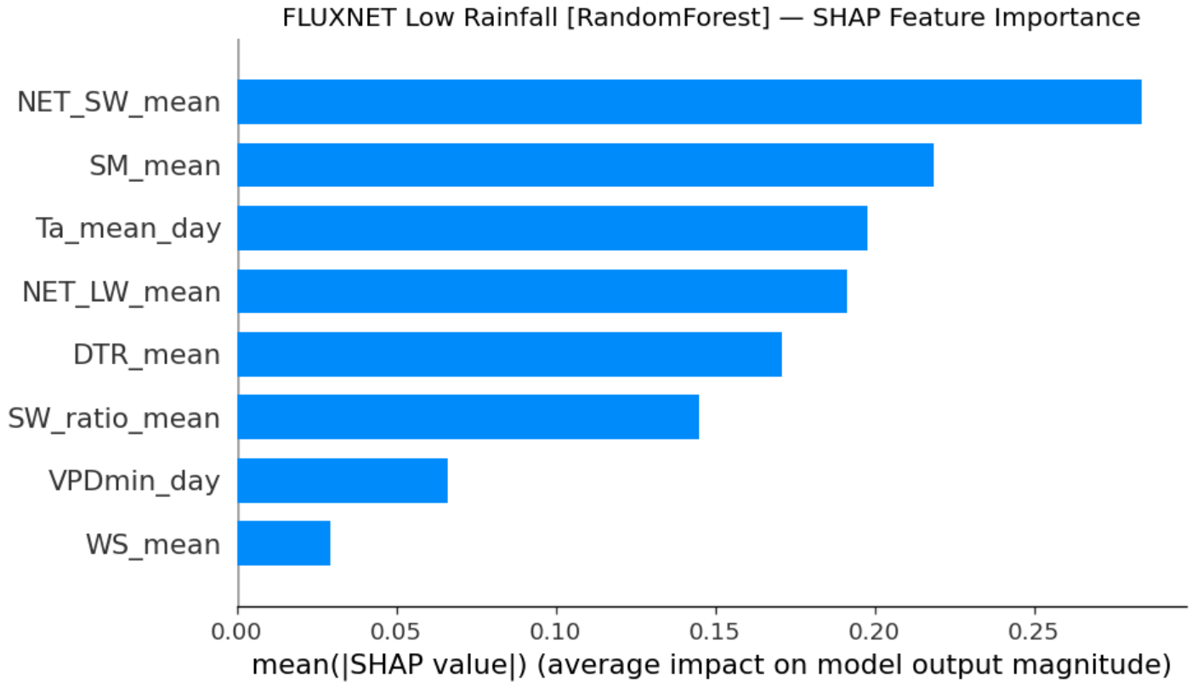

Figure 14: SHAP Bar Plot – Random Forest (Low Rainfall)

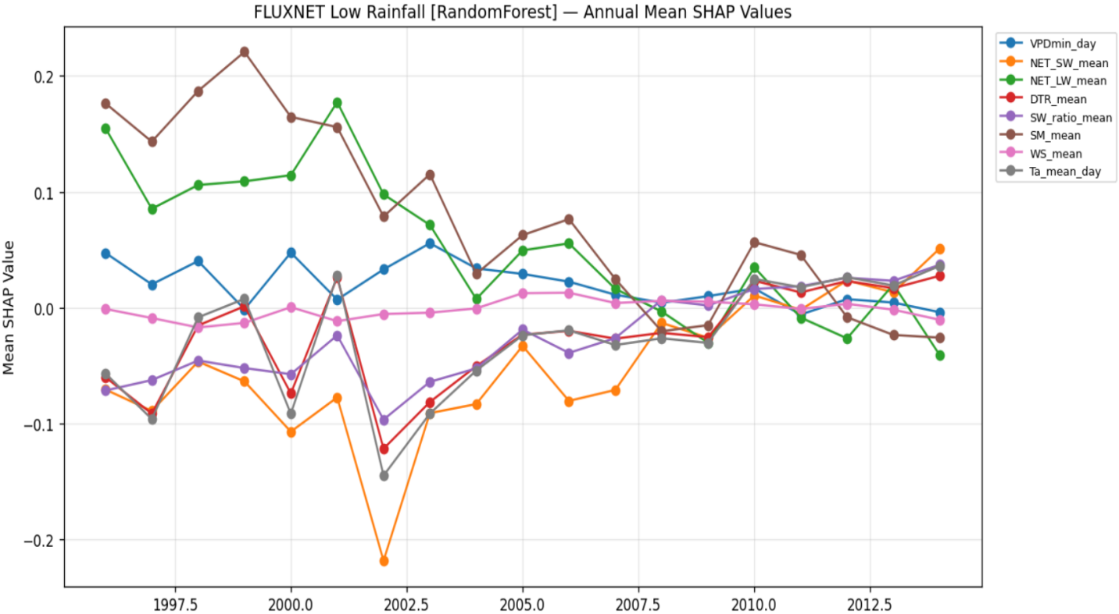

Figure 15: Annual Mean SHAP Time Series – XGBoost (Low Rainfall)

4.5 SHAP ANALYSIS: HIGH RAINFALL SITES
For the High Rainfall pipeline, SHAP analysis shows that NET_SW_mean dominates with substantially higher absolute SHAP values compared to the Low Rainfall case. VPDmin_day and NET_SW_roll3 are the second and third most important features. Soil moisture features (SM_mean, SM_roll3, Rn_x_SM) have significantly lower SHAP values compared to the Low Rainfall regime, consistent with the expectation that ET is primarily energy-limited rather than water-limited in these ecosystems.

The annual SHAP time series for High Rainfall sites shows a stronger seasonal cycle in radiation importance with minimal inter-annual variability in soil moisture importance, reinforcing the conclusion that soil moisture is not a binding constraint on ET in humid ecosystems.
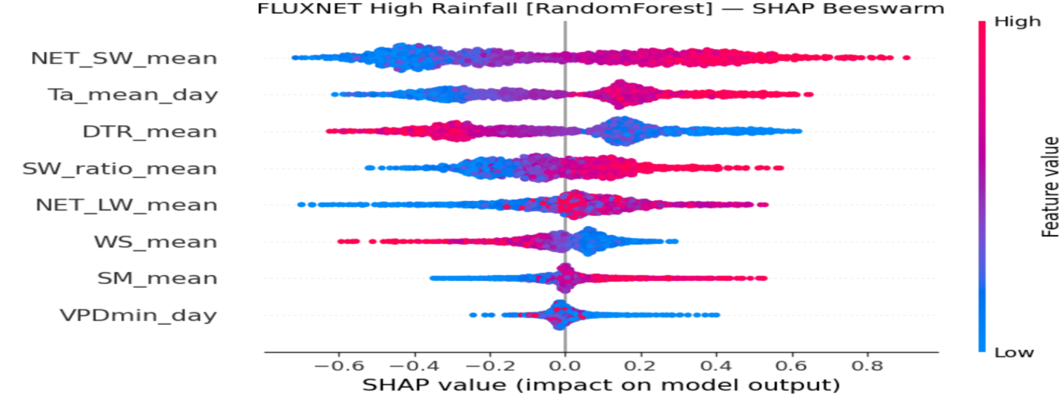
Figure 16: SHAP Beeswarm Plot – Random Forest (High Rainfall)

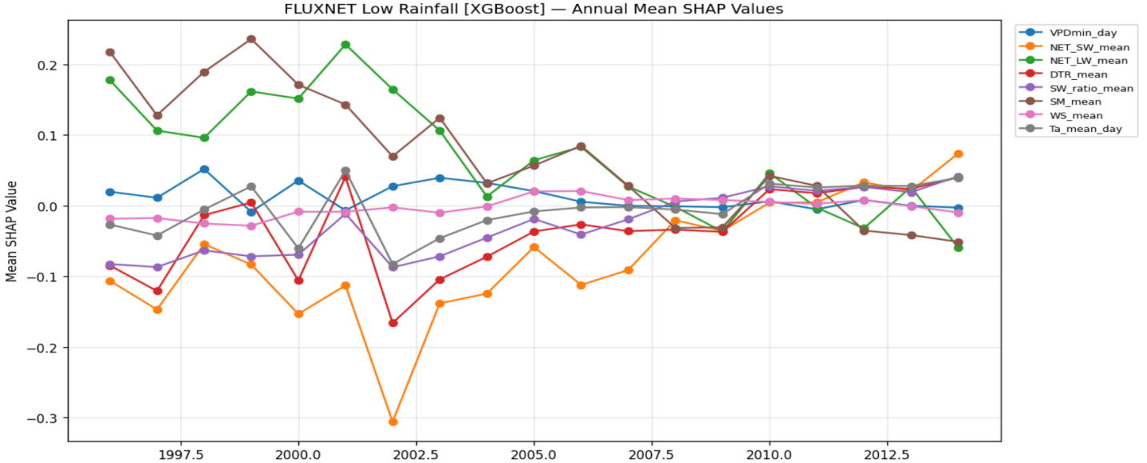

Figure 17: Annual Mean SHAP Time Series – XGBoost (High Rainfall)

4.6 COMPARISON BETWEEN RAINFALL REGIMES
A systematic comparison of SHAP results between the two pipelines reveals a clear regime-dependent shift in ET drivers. The ratio of mean absolute SHAP value for soil moisture features (SM_mean + SM_roll3 + Rn_x_SM + VPD_x_SM) to radiation features (NET_SW_mean + NET_SW_roll3 + Rn_x_VPD) is substantially higher in the Low Rainfall pipeline, quantifying the relative enhancement of water limitation in arid and semi-arid systems.
Feature Group | Low Rainfall Regime | High Rainfall Regime
Net Shortwave Radiation | High importance | Very high importance
VPD (min, rolling) | Moderate importance | Moderate importance
Soil Moisture (SM, roll) | High importance | Low importance
Rn × SM interaction | High importance | Low importance
VPD × SM interaction | Moderate–high | Low importance
Ta (temperature) | Moderate | Moderate
Wind Speed | Low importance | Low importance

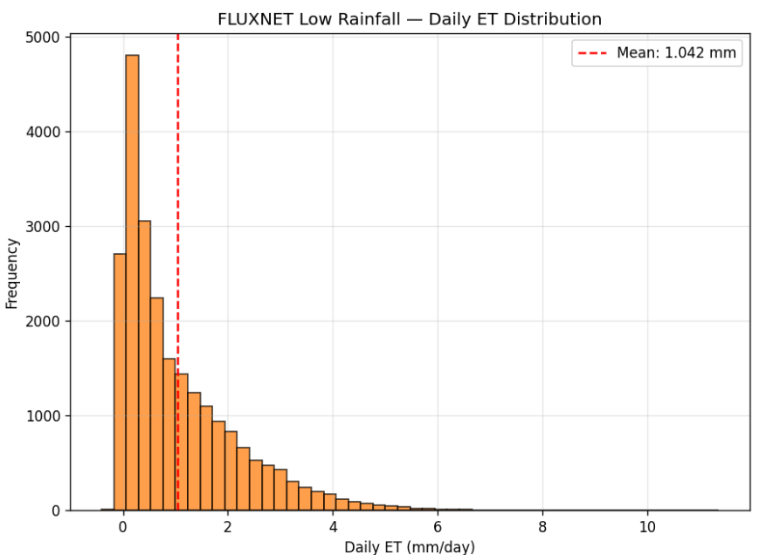
Figure 18: Daily ET Distribution – Low Rainfall Sites

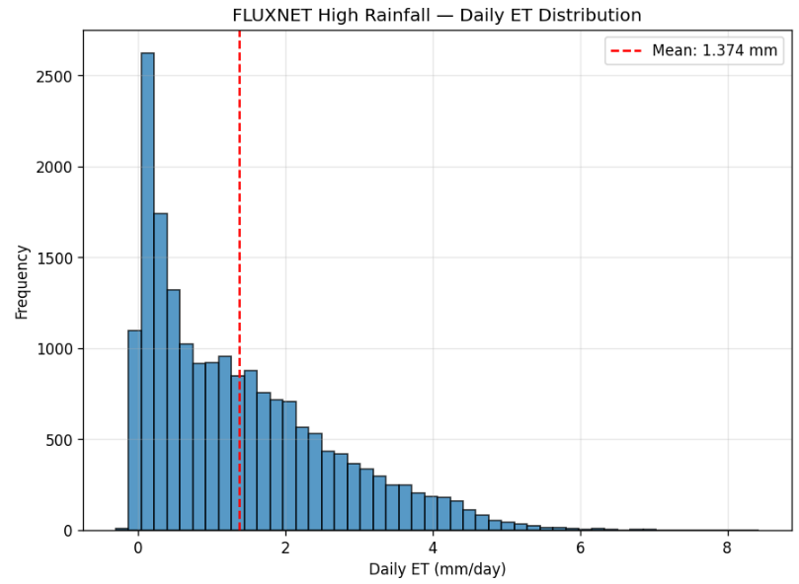
Figure 19: Seasonal ET Variation – Low Rainfall Sites

4.7 DISCUSSION
The results demonstrate the efficacy of a dual-pipeline machine learning framework for ET estimation across climatically contrasting FLUXNET sites. By stratifying sites according to the 500 mm MAP threshold, each pipeline learns ET relationships from internally consistent datasets where the dominant physical mechanisms are similar. The inclusion of physics-based interaction features is critical: without Rn_x_SM and VPD_x_SM, tree-based models plateau at approximately R² = 0.70–0.75, as the additive structure of decision trees cannot automatically discover these multiplicative couplings.

AdaBoost achieves competitive performance with Random Forest and Gradient Boosting despite its simpler base learner (shallow decision tree), because the sequential re-weighting mechanism effectively focuses learning on rare high-ET events that are systematically underpredicted in the first iteration. This complementary behavior to XGBoost and Random Forest makes AdaBoost a valuable addition to the ensemble suite.

The site-aware chronological split is essential for honest model evaluation. A random temporal split would allow adjacent days (with autocorrelation r ≈ 0.85) to appear in both training and test sets, artificially inflating test R² and masking overfitting. The chronological protocol ensures that reported metrics reflect genuine generalisation to future unseen conditions.

SHAP analysis provides a scientifically rigorous bridge between statistical prediction and physical understanding. The regime-dependent shift from energy-dominated to water-modulated ET drivers, revealed through comparative SHAP attribution, is consistent with decades of observational and modelling literature and validates the framework as physically coherent. The annual mean SHAP time series is a novel diagnostic that reveals how ET sensitivity to individual drivers fluctuates with inter-annual climate variability.

CHAPTER - 5

CONCLUSION

5.1 CONCLUSION
This study successfully developed a modular, reproducible machine learning framework for daily Evapotranspiration estimation from FLUXNET half-hourly flux tower data. A total of 186 FLUXNET sites were downloaded and classified into Low Rainfall (106 sites, MAP < 500 mm) and High Rainfall (80 sites, MAP ≥ 500 mm) regimes. Two independent 13-module pipelines were developed and implemented in Google Colab, each training five machine learning models on 15 engineered daily features.

The five models — Random Forest, AdaBoost, XGBoost, Gradient Boosting, and ANN — achieved Train R² in the range 0.81–0.85 and Test R² in the range 0.79–0.81 with train-test gaps below 0.06, confirming that overfitting was effectively controlled through calibrated regularisation, site-aware chronological splitting, and log-transformation of the right-skewed ET target.

SHAP analysis on both pipelines confirmed that net shortwave radiation is the primary ET driver across both regimes, while soil moisture and its interaction with net radiation (Rn_x_SM) are significantly more important in the Low Rainfall pipeline. The annual mean SHAP time series revealed inter-annual shifts in driver importance consistent with the known response of dryland ecosystems to drought. The regime-stratified SHAP comparison provides a physically interpretable quantification of the transition from energy-limited to water-limited ET control.

The modular 13-module pipeline architecture ensures reproducibility and portability. The Low Rainfall and High Rainfall pipelines share identical module structures, differing only in the input data ZIP path and feature constant, making the framework straightforward to extend to new rainfall regime classifications, additional biomes, or new feature engineering strategies.

5.2 FUTURE SCOPE
- Extension to additional rainfall regime boundaries (e.g., 300 mm, 700 mm) to produce a finer-grained characterisation of ET driver transitions across the aridity gradient.
- Integration of deep learning architectures (LSTM, Transformer) that can exploit the full temporal sequence of half-hourly data without requiring manual daily aggregation.
- Application to gridded land surface model outputs for spatial upscaling of SHAP-based ET attribution, enabling continental-scale driver mapping.
- Incorporation of vegetation phenology indices (NDVI, LAI) from satellite remote sensing as additional features to capture the biotic control on stomatal conductance.
- Quantile regression extensions to provide probabilistic ET predictions at the 10th, 50th, and 90th percentiles, supporting uncertainty-aware drought impact assessment.
- Deployment of the pipeline as an automated workflow that periodically ingests newly released FLUXNET site data and updates the SHAP-based ET driver analysis.

CHAPTER – 6 REFERENCES

- Baldocchi, D. (2020). How eddy covariance flux measurements have contributed to our understanding of Global Change Biology. Global Change Biology, 26(1), 242–260.
- Bodesheim, P., et al. (2018). Upscaled diurnal cycles of land-atmosphere fluxes: a new global half-hourly data product. Earth System Science Data, 10(3), 1327–1365.
- Bonan, G. B. (2008). Forests and climate change: forcings, feedbacks, and the climate benefits of forests. Science, 320(5882), 1444–1449.
- Breiman, L. (2001). Random forests. Machine Learning, 45(1), 5–32.
- Chen, T., and Guestrin, C. (2016). XGBoost: A scalable tree boosting system. Proceedings of the 22nd ACM SIGKDD International Conference on Knowledge Discovery and Data Mining, 785–794.
- Freund, Y., and Schapire, R. E. (1997). A decision-theoretic generalization of on-line learning and an application to boosting. Journal of Computer and System Sciences, 55(1), 119–139.
- Jung, M., et al. (2011). Global patterns of land-atmosphere fluxes derived from eddy covariance, satellite, and meteorological observations. Journal of Geophysical Research: Biogeosciences, 116(G3).
- Koster, R. D., et al. (2004). Regions of strong coupling between soil moisture and precipitation. Science, 305(5687), 1138–1140.
- Li, X., et al. (2021). Interpretable machine learning for ET modelling: SHAP analysis of XGBoost predictions at Chinese flux sites. Agricultural and Forest Meteorology, 301–302, 108367.
- Lundberg, S. M., and Lee, S. I. (2017). A unified approach to interpreting model predictions. Advances in Neural Information Processing Systems, 30, 4765–4774.
- Novick, K. A., et al. (2016). The increasing importance of atmospheric demand for ecosystem water and carbon fluxes. Nature Climate Change, 6(11), 1023–1027.
- Papacharalampous, G., et al. (2022). Global-scale massive feature extraction from monthly hydroclimatic time series. Water Resources Research, 58(3), e2021WR031693.
- Pastorello, G., et al. (2020). The FLUXNET2015 dataset and the ONEFlux processing pipeline for eddy covariance data. Scientific Data, 7(1), 225.
- Seneviratne, S. I., et al. (2010). Investigating soil moisture-climate interactions in a changing climate: A review. Earth-Science Reviews, 99(3–4), 125–161.
- Tramontana, G., et al. (2016). Predicting carbon dioxide and energy fluxes across global FLUXNET sites with regression algorithms. Biogeosciences, 13(14), 4291–4313.
- Zeng, Z., et al. (2022). Global terrestrial evapotranspiration estimation from FLUXNET using deep learning. Nature Water, 1, 138–148.

