# **DevOps Architecture**

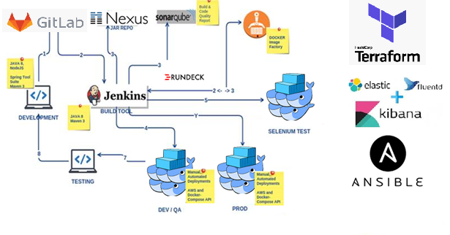

# **Deployment Environment**

root@f3b7780c11db:/# uname -a

Linux f3b7780c11db 3.10.0-862.el7.x86_64 #1 SMP Fri Apr 20 16:44:24 UTC 2018 x86_64 GNU/Linux

root@f3b7780c11db:/# cat /etc/*elease

PRETTY_NAME="Debian GNU/Linux 9 (stretch)"

NAME="Debian GNU/Linux"

VERSION_ID="9"

VERSION="9 (stretch)"

ID=debian

HOME_URL="https://www.debian.org/"

SUPPORT_URL="https://www.debian.org/support"

BUG_REPORT_URL="https://bugs.debian.org/"

root@f3b7780c11db:/#

# **CI Server - Jenkins**

**Create Docker file and Container for Jenkins**

**Build image-**

docker build -f src/main/docker/Dockerfile-Jenkins --no-cache -t jenkins-master .

**Run container**

docker-compose -f src/main/docker/jenkins-master.yml up –d

OR

docker run -p 9081:8080 -p 50000:50000 --name=jenkins-master-jenkins -v jenkins-log:/var/log/jenkins -v jenkins-data:/var/jenkins_home -v /var/run/docker.sock:/var/run/docker.sock -d jenkins-master

**Jenkins Pipeline**

Src/main/pipeline/jenkinsfile

**# Jenkins URL**

http://172.22.34.89:9081/

**#Login into Jenkins container for debugging or more details**

sudo docker exec -it a601ca9f9a96 /bin/bash

# **UMSL Application Setup**

**# Change in app.yml**

1. expose port 8081 and bind it to 8080 host port
2. Fluentd agent entry to forwarding logs from docker container to ELK

# **Application Monitoring setup**

**# Change in monitoring.yml to resolve following issue**

# Grafana Issue

t=2019-08-08T22:03:21+0000 lvl=info msg="Initializing provisioningServiceImpl" logger=server

t=2019-08-08T22:03:21+0000 lvl=eror msg="can't read datasource provisioning files from directory" logger=provisioning.datasources path=/etc/grafana/provisioning/datasources error="open /etc/grafana/provisioning/datasources: permission denied"

t=2019-08-08T22:03:21+0000 lvl=eror msg="Can't read alert notification provisioning files from directory" logger=provisioning.notifiers path=/etc/grafana/provisioning/notifiers error="open /etc/grafana/provisioning/notifiers: permission denied"

t=2019-08-08T22:03:21+0000 lvl=eror msg="can't read dashboard provisioning files from directory" logger=provisioning.dashboard path=/etc/grafana/provisioning/dashboards error="open /etc/grafana/provisioning/dashboards: permission denied"

t=2019-08-08T22:03:21+0000 lvl=info msg="Initializing Stream Manager"

t=2019-08-08T22:03:21+0000 lvl=info msg="HTTP Server Listen" logger=http.server address=0.0.0.0:3000 protocol=http subUrl= socket=

# Grafana Issue resolved

t=2019-08-11T03:37:24+0000 lvl=info msg="Initializing provisioningServiceImpl" logger=server

t=2019-08-11T03:37:24+0000 lvl=warn msg="[Deprecated] the use of basicAuthPassword field is deprecated. Please use secureJsonData.basicAuthPassword" logger=provisioning.datasources datasource name=Prometheus

t=2019-08-11T03:37:24+0000 lvl=info msg="inserting datasource from configuration " logger=provisioning.datasources name=Prometheus

t=2019-08-11T03:37:24+0000 lvl=eror msg="Can't read alert notification provisioning files from directory" logger=provisioning.notifiers path=/etc/grafana/provisioning/notifiers error="open /etc/grafana/provisioning/notifiers: no such file or directory"

t=2019-08-11T03:37:24+0000 lvl=info msg="Initializing Stream Manager"

t=2019-08-11T03:37:24+0000 lvl=info msg="HTTP Server Listen" logger=http.server address=0.0.0.0:3000 protocol=http subUrl= socket=

**Build new Grafana image from docker file**

docker build -f Dockerfile-grafana -t grafana/updated/grafana:6.2.2 .

**Change in monitoring.yml**

**grafana/grafana:6.2.2 To grafana/updated/grafana:6.2.2 .**

# **Application Logging Setup**

**# Create ELK (Elastic Search, Logstash, Kibana ) for Logging**

/src/main/docker/ELK

[root@rdeckdal01 ELK]# ls -lrth

total 12K

drwxr-xr-x 3 root root 4.0K Aug 11 09:56 fluentd

drwxr-xr-x 2 root root 4.0K Aug 11 10:03 logs

-rw-r--r-- 1 root root 769 Aug 11 10:04 docker-compose-efk.yaml

[root@rdeckdal01 ELK]#

# **Run Container**

**#Run container**

docker-compose -f src/main/docker/app.yml up -d

docker-compose -f src/main/docker/sonar.yml up -d

docker-compose -f src/main/docker/monitoring.yml up –d

docker-compose –f src/main/docker/ELK/ docker-compose-efk.yaml up -d

# **Infrastructure as code Setup**

**Terraform script location**

Src/main/IAAC/aws-umsl-dev

1. Bastion -- Code for bastion creation. Can loging to any EC2 instance through bastion
2. Dev-Ec2
3. ec2-module
4. umsl-vpc

**Terraform script execution**

1. $ terraform init
2. $ terraform plan
3. $ terraform apply
4. High-level Architecture Diagram

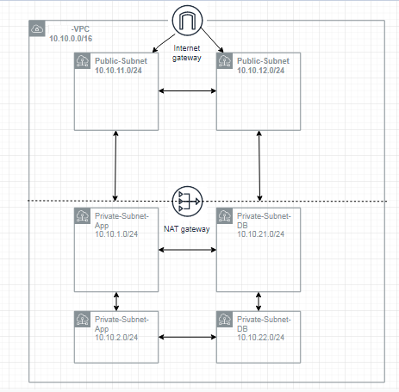

# **Screen Shot**

**USML Micro service URL-**

