Detectability of Streaked Horned Larks at on- and off-road survey locations
  - Prepared for Ecostudies Institute by John Lloyd
  - 16 March 2025

This analysis compares availability for detection of Streaked Horned Lark at on- and off-road survey locations in the Willamette Valley, Oregon during the 2024 field season. The analysis assumes a 12-minute count period (preceded by a 3-minute quiet period to allow birds to return to normal behavior after any disturbance caused by the arrival of the observer).

Methods
Unlike previous analyses that estimated the joint probability of detection from distance-sampling and removal models, this analysis considers only the availability portion of detectability (i.e., the component of detectability estimated by the removal model). I could not estimate perceptibility using distance sampling because the distance data were collected during 8-minute count intervals, which creates a mismatch in the removal data set and the distance data set. Specifically, any individual larks counted between the 13th and 16th minute of the survey have a recorded distance from the observer but are not counted in the removal data set, which ended after the 12th minute. Jointly modeling perceptibility and availability (distance and removal models, respectively) is not possible unless the counts for each data set match exactly. However, given the poor performance of the distance-sampling models in all previous analyses, this will not materially affect the conclusions drawn regarding the probability of encountering a singing lark at on- and off-road locations within the study area.

Using the R package ‘unmarked’, I estimated detectability of singing larks at on- and off-road points (as determined from the binary OffRoad factor in the dataset, where OffRoad = 0 denotes an on-road survey) using the function multinomPois. I considered two models: a null model with no covariates on detectability and a model that produced separate estimates of detectability for on- and off-road counts.

Results
The null model had the lower AIC_{c} score (528.9 versus 530.9); adding the factor covariate that indicated whether a survey was conducted on- or off-road provided no additional information. Unsurprisingly, the estimated probability of detection per interval was identical for the two models: 0.24 (95% CI = 0.10 – 0.49) and 0.24 (95% CI = 0.18 – 0.31) for on- and off-road counts, respectively.

This result is as expected given the distribution of detection times at on- and off-road point counts (Fig. 1). Although off-road counts tend to have more larks per survey, most detections at both on- and off-road counts occur during the first several minutes of a count. This suggests that the detection process is similar despite any other differences between on- and off-road survey locations.
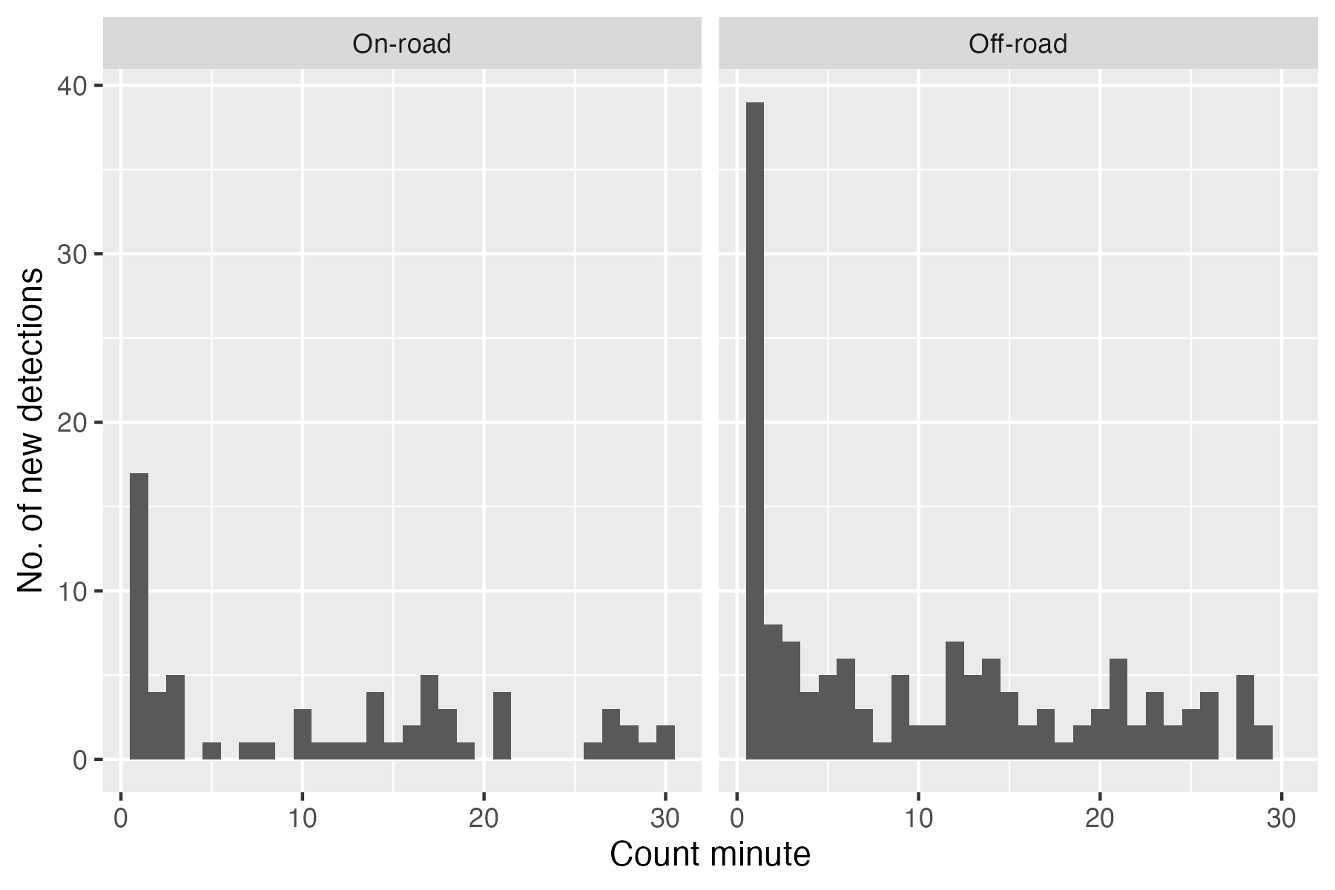
Figure 1. The distributions of time-to-detection of singing Streaked Horned Larks at on-road and off-road survey locations in the Willamette Valley of Oregon in 2024 were similar in shape—most detections occur during the first several minutes of a count—suggesting that the detection process at both types of survey location are roughly the same.

Conclusions
Based on data collected in 2025 and analyzed using removal models, availability of Streaked Horned Larks for detection by an observer does not depend on whether the count is conducted on-road or off-road.

Amundson, C.L., Royle, J.A. and Handel, C.M. 2014. A hierarchical model combining distance sampling and time removal to estimate detection probability during avian point counts. The Auk: Ornithological Advances 131: 476-494.
Kellner, K.F., Smith, A.D., Royle, J.A., Kéry, M., Belant, J.L. and Chandler, R.B. 2023. The unmarked R package: Twelve years of advances in occurrence and abundance modelling in ecology. Methods in Ecology and Evolution 14:1408-1415.
The cell probabilities for additional intervals are calculated as (1-p)^{x}p, where p = the probability of detection per interval and x represents the number of intervals considered.

