**Results**

*Variation in mercury deposition*Mercury deposition at the sampling location closest to our study site varied among years, seasonally, and as a function of the interaction between year and date (ΔAIC of the non-interactive model = 6.4) (Fig. 1). Year (p <0.001), sampling date (p < 0.001), and their interaction (p = 0.004) were all significantly associated with rates of mercury deposition.

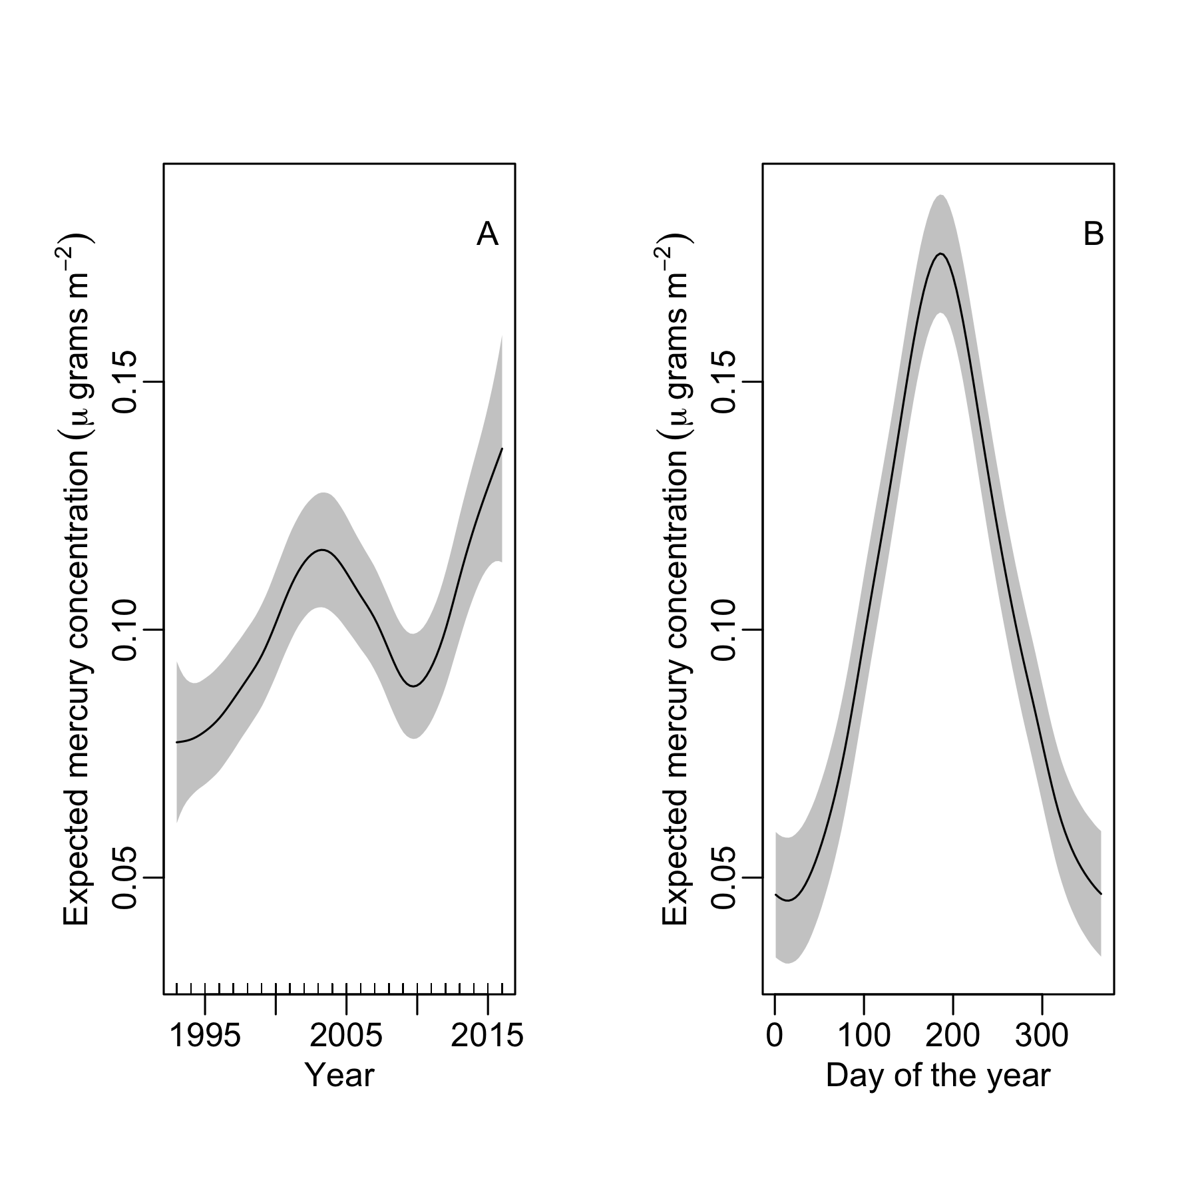

Figure 1. Model-predicted mercury deposition rates varied among years (A), with two periods of increase – 1993 – 2004 and 2011 – 2016 – and a single period of decline from 2005 – 2010. Deposition rates also varied among seasons (B), with deposition peaking in mid-summer.

*Variation in blood Hg concentrations*  
The best-supported model (i.e., with the lowest AICc) in the candidate set included an effect of sampling date, age, and sex of the individual. Fixed-effects in the best model explained ~38% of the observed variation in blood Hg levels, and the fixed- and random-effects together explained ~65% of the variation. The data did not support an effect of species (Table 1; delta AIC = 2.02). Although blood Hg concentrations varied among years, we found no evidence for any temporal trend across years. Although annual variation in blood Hg concentration was evident, adding a linear annual trend to the best model produced a negligibly higher model likelihood (Table 1, Fig. 2). Finally, despite substantial inter-annual variation in rates of atmospheric deposition of mercury, we found no evidence that the rate of mercury deposition influenced variation in blood-mercury concentrations of thrushes (Table 1).

Table 1. Model selection results for blood Hg concentrations in the blood of of Bicknell's Thush (Catharus bicknelli) and Swainson’s Thrush (Catharus ustulatus) sampled on Mount Mansfield, Vermont, USA between 2000 and 2017.

|  |  |  |  |  |  |  |
| --- | --- | --- | --- | --- | --- | --- |
| Model | | nPars | Log likelihood | ∆AIC11 | AICwt | cumltvWt |
| date1 + age2 + sex3 | | 9 | 741.8 | 0.00 | 0.28 | 0.28 |
| date + age + sex + year4 | | 10 | 742.6 | 0.70 | 0.20 | 0.48 |
| date + age + sex + year + deposition (6-mo)5 | | 10 | 742.0 | 1.79 | 0.11 | 0.59 |
| date + age + sex + year + deposition (2-yr)6 | | 10 | 742.0 | 1.87 | 0.11 | 0.71 |
| date + age + sex + species7 | | 10 | 741.9 | 2.02 | 0.10 | 0.81 |
| date + age + sex + year + deposition (3-yr)8 | | 10 | 741.8 | 2.11 | 0.10 | 0.91 |
| date + age + sex + year + deposition (1-yr)9 | | 10 | 741.8 | 2.18 | 0.09 | 1.00 |
| date | | 5 | 725.0 | 25.05 | 0.00 | 1.00 |
| linear date10 | | 4 | 721.9 | 29.24 | 0.00 | 1.00 |
| null | | 3 | 654.1 | 162.82 | 0.00 | 1.00 |
|  | 1The quadratic effect of sampling date  2Age of the individual (hatch-year, second-year, or after-second-year)  3Sex of the individual  4Year in which the sample was drawn  5Average daily deposition rate of mercury during the preceding Dec – May  6 Average daily deposition rate of mercury during the preceding two years  7 Species, either Bicknell’s Thrush or Swainson’s Thrush  8 Average daily deposition rate of mercury during the preceding three years  9 Average daily deposition rate of mercury during the preceding year (May – May)  10 The non-quadratic effect of sampling date  11 The lowest AICc value was -1461.8 | | | | | | |

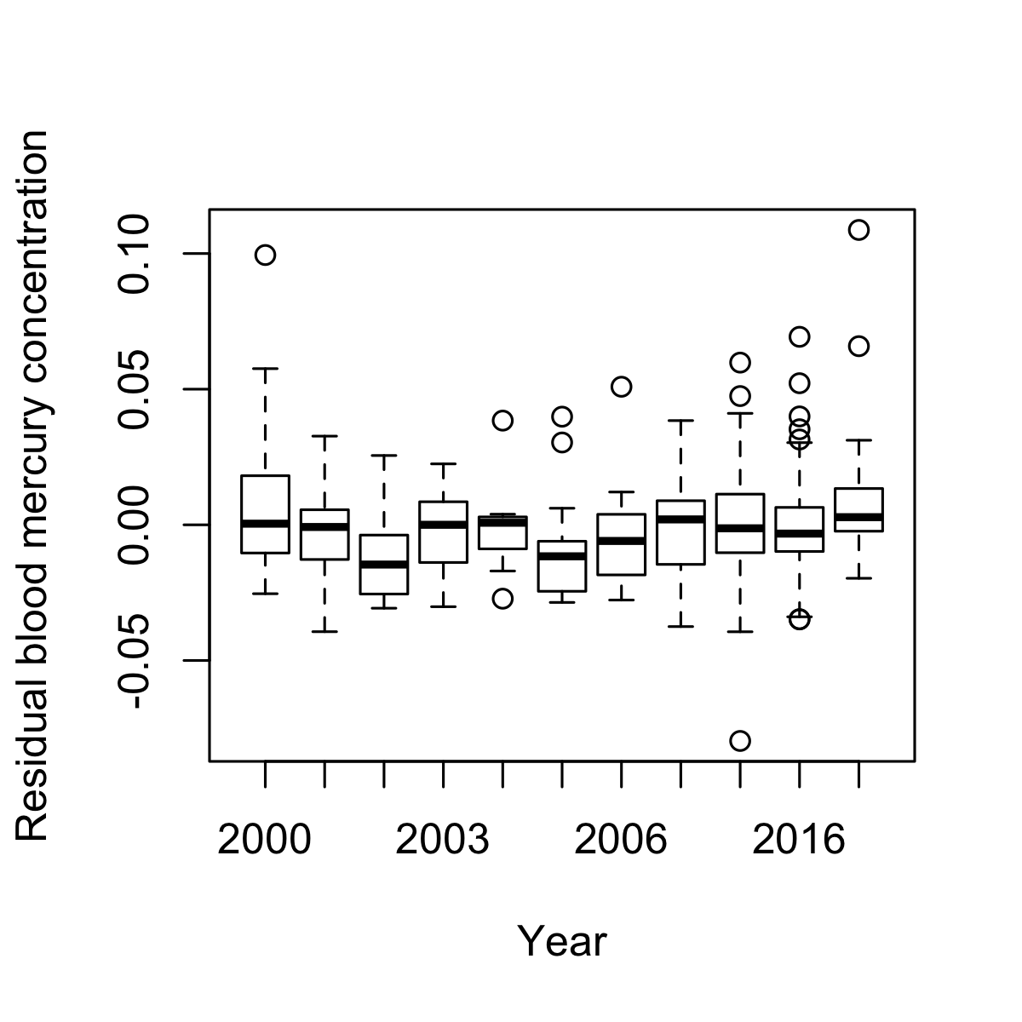

Figure 2. Residual variation in concentration of mercury in the blood of Bicknell's Thush (Catharus bicknelli) and Swainson’s Thrush (Catharus ustulatus) sampled on Mount Mansfield, Vermont, USA, after accounting for effects of age, sex, and sampling date. Boxes indicate the interquartile range, thick black lines the median value, dotted lines the range of values excluding outliers, and hollow circles outliers.



In examining the parameter estimates from the best-supported model, sampling date had the strongest effect on blood Hg concentration. Expected concentrations declined 0.076 μg/g (95% CI = 0.04 – 0.115) between the earliest sample (day 141, or 21 May) and the latest sample (day 260, or 17 September) (Fig. 3).

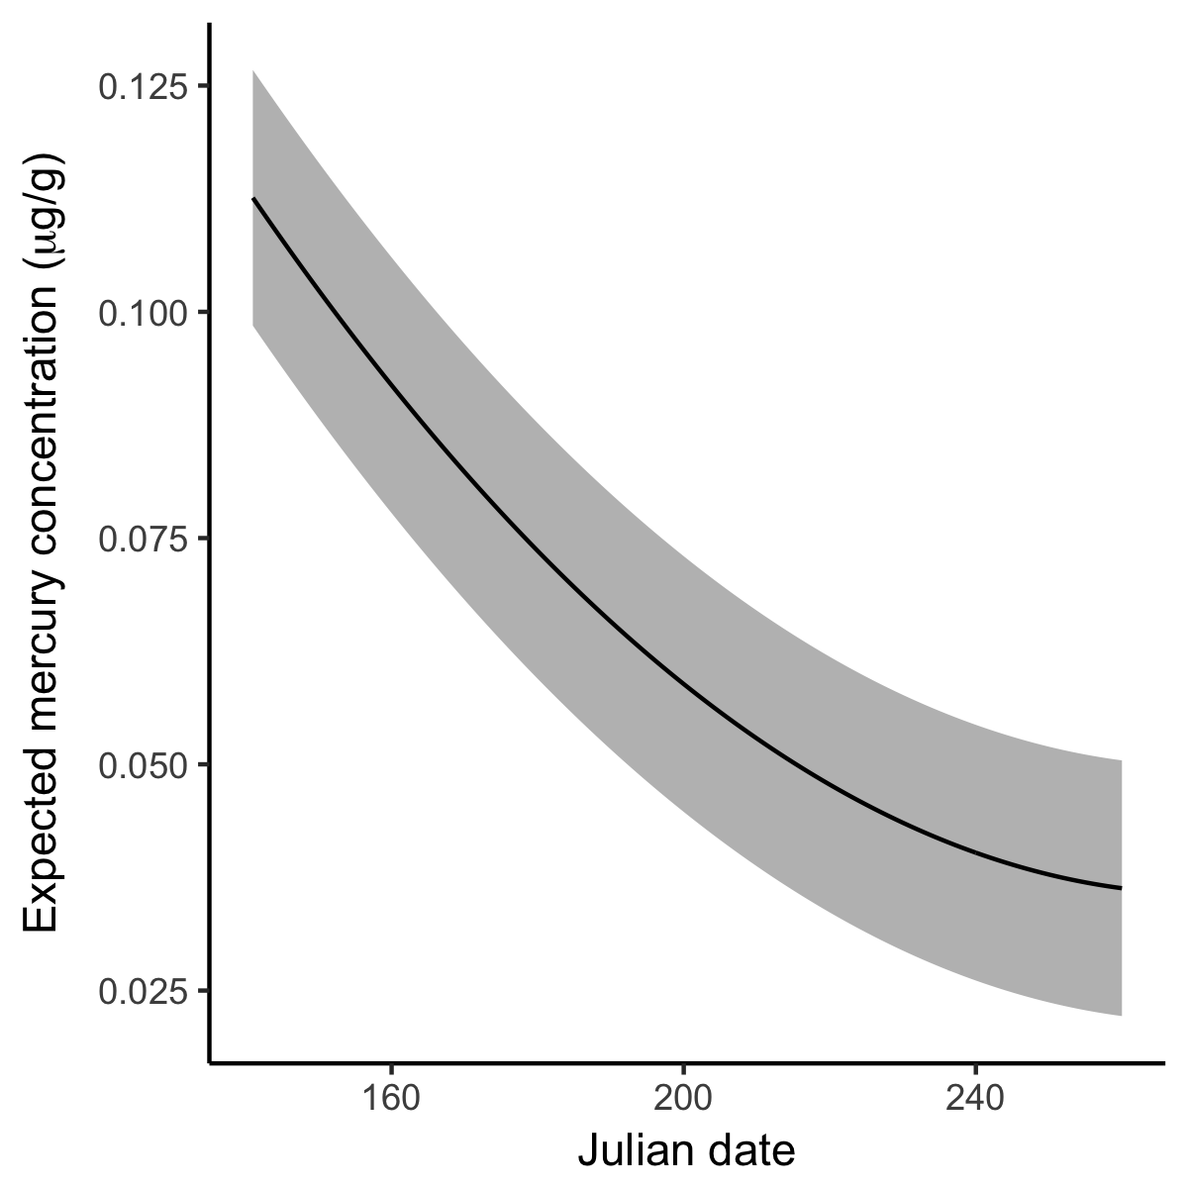

Figure 3. Expected concentrations of mercury (solid line) in the blood of Bicknell's Thush (Catharus bicknelli) and Swainson’s Thrush (Catharus ustulatus) sampled on Mount Mansfield, Vermont, USA, and averaged across all ages and sexes, declined over the course of each year. Expected values, and 95% confidence intervals (shaded grey region), were generated from the best-supported generalized linear mixed model.

The effects of age and sex on blood Hg concentrations were far weaker and more variable. Expected Hg concentrations in the blood of male thrushes was 0.010 μg/g greater than in females (95% CI = -0.0001 – 0.0197). Expected blood Hg concentrations increased with age. The oldest individuals – those > 1.5 years old – had the highest concentrations of blood Hg: 0.020 μg/g more than hatch-year individuals (95% CI = -0.0033 – 0.0442) and 0.008 μg/g more than second-year individuals (95% CI = 0.0007 -0.0156).