Mongo DB Architecture
Data is at the heart of every application, and from our experience in working with organizations ranging from startups to many Fortune 100 companies, realizing its full potential is still a significant challenge:
- Demands for higher developer productivity and faster time to market with release cycles compressed to days and weeks are being held back by traditional rigid relational data models and waterfall development.
- The inability to manage massive increases in new, rapidly changing data types – structured, semi-structured, and polymorphic data generated by new classes of web, mobile, social, and IoT applications.
- Difficulty in exploiting the wholesale shift to distributed systems and cloud computing that enable developers to access on-demand, highly scalable compute and storage infrastructure, while meeting a whole new set of regulatory demands for data sovereignty.
MongoDB responded to these challenges by creating a technology foundation that enables development teams through:
- The document data model – presenting them the best way to work with data.
- A distributed systems design – allowing them to intelligently put data where they want it.
- A unified experience that gives them the freedom to run anywhere – allowing them to future-proof their work and eliminate vendor lock-in.

The Best Way to Work with Data: The Document Model
Relational databases have a long-standing position in most organizations. This made them the default way to think about storing, using, and enriching data. But enterprises are increasingly encountering limitations of this technology. Modern applications present new challenges that stretch the limits of what’s possible with a relational database.
Through strategies such as Agile and DevOps, microservices, cloud replatforming and more, many organizations have made significant progress in refactoring and evolving application tier code to respond faster to changing business requirements. But they then find themselves hampered by the rigidity and complexity of relational databases.
Organizations need a fresh way to work with data. In order to handle the complex data of modern applications and simultaneously increase development velocity, the key is a platform that is:
- Easy, letting them work with data in a natural, intuitive way
- Flexible, so that they can adapt and make changes quickly
- Fast, delivering great performance with less code
- Versatile, supporting a wide variety of data models, relationships, and queries
MongoDB’s document model delivers these benefits for developers, making it the best way to work with data.

Easy: A Natural, Intuitive Data Model
Relational databases use a tabular data model, storing data across many tables. An application of any complexity easily requires hundreds or even thousands of tables. This sprawl occurs because of the way the tabular model treats data.
The conceptual model of application code typically resembles the real world. That is, objects in application code, including their associated data, usually correspond to real-world entities: customers or users, products, and so on. Relational databases, however, require a different structure. Because of the need to normalize data, a logical entity is typically represented in many separate parent-child tables linked by foreign keys. This data model doesn’t resemble the entity in the real world, or how that entity is expressed as an object in application code.
This difference makes it difficult for developers to reason about the underlying data model while writing code, slowing down application development; this is sometimes referred to as object- relational impedance mismatch. One workaround for this is to employ an object-relational mapping layer (ORM). But this creates its own challenges, including managing the middleware and revising the mapping whenever either the application code or the database schema changes.
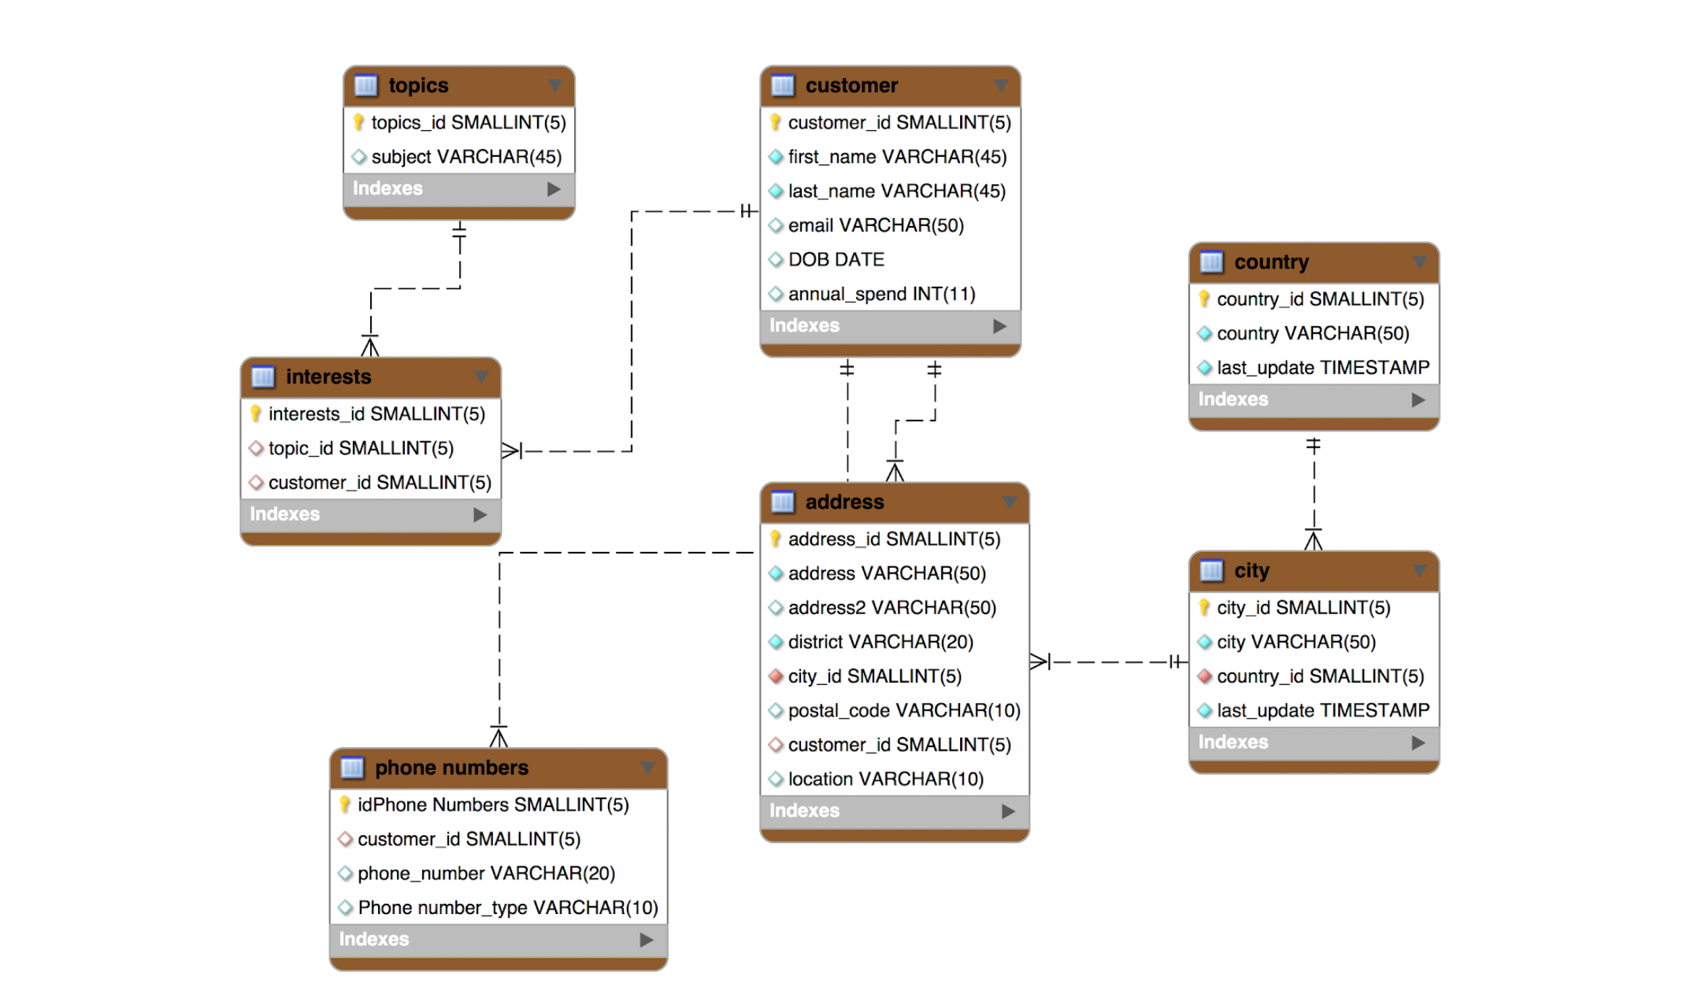
Figure 1: Modeling a customer with the relational database: data is split across multiple tables
In contrast to this tabular model, MongoDB uses a document data model. Documents are a much more natural way to describe data. They present a single data structure, with related data embedded as sub-documents and arrays. This allows documents to be closely aligned to the structure of objects in the programming language. As a result, it’s simpler and faster for developers to model how data in the application will map to data stored in the database. It also significantly reduces the barrier-to-entry for new developers who begin working on a project – for example, adding new microservices to an existing app. This JSON document demonstrates how a customer object is modeled in a single, rich document structure with nested arrays and sub-documents.
{
"name":{
"first":"Eartha",
"second":"Thompson"
},
"address":[
{
"location":"home",
"number":23,
"street":"Twin Pines",
"city":"New York",
"state":"New York",
"postalCode":"O83 1F1"
},
{
"location":"work",
"number":1,
"street":"Holy Cross",
"city":"New York",
"state":"New York",
"postalCode":"513 8U5"
}
],
"phone":[
{
"location":"mobile",
"number":"+48-675-560-3029"
},
{
"location":"work",
"number":"+48-887-222-1234"
}
],
"email":"eandrzejak0@yellowpages.com",
"annualSpend":916305.32,
"dob":"1985-02-28 07:32:58",
"interests":[
{
"interest":"XML Schema Design"
},
{
"interest":"Glazing"
}
]
}
MongoDB stores data as JSON (JavaScript Object Notation) documents in a binary representation called BSON (Binary JSON). Unlike other databases that store JSON data as simple strings and numbers, the BSON encoding extends the JSON representation to include additional types such as int, long, date, floating point, and decimal128 – the latter is especially important for high precision, lossless financial and scientific calculations. This makes it much easier for developers to process, sort, and compare data. BSON documents contain one or more fields, and each field contains a value of a specific data type, including arrays, binary data, and sub-documents.
MongoDB provides native drivers for all popular programming languages and frameworks to make development easy and natural. Supported drivers include Java, Javascript, C#/.NET, Python, Perl, PHP, Scala and others, in addition to 30+ community-developed drivers. MongoDB drivers are designed to be idiomatic for the given programming language.
MongoDB Compass, the GUI for MongoDB, makes it easy to explore and manipulate your data. Visualize the structure of data in MongoDB, run ad hoc queries and evaluate their performance, view and create indexes, build data validation rules, and more. Compass provides an intuitive interface for working with MongoDB.

Flexibile: Dynamically Adapting to Changes
The tabular data model is rigid. It was built for structured data, where each record in a table has identical columns. While it’s possible to handle polymorphism and semi-structured or unstructured data, it's clumsy, and working around the basic data limitations of the tabular model takes up development time. Furthermore, the tabular model demands that the schema be pre-defined, with any changes requiring schema migrations. Practically, this means that developers need to plan their data structure well in advance, and imposes friction to the development process when adding features or making application updates that require schema changes. This is a poor match for agile, iterative development models.
MongoDB documents are polymorphic – fields can vary from document to document within a single collection (analogous to table in a tabular database). For example, all documents that describe customers might contain the customer ID and the last date they purchased a product or service, but only some of these documents might contain the user’s social media handle, or location data from a mobile app. There is no need to declare the structure of documents to the system – documents are self-describing. If a new field needs to be added to a document, the field can be created without affecting all other documents in the system, without updating a central system catalog, and without taking the database offline.
Developers can start writing code and persist objects as they are created. And when they need to add more features, MongoDB continues to store the updated objects without the need to perform costly ALTER TABLE operations – or worse, having to redesign the schema from scratch. Even trivial changes to an existing relational data model result in a complex dependency chain – from updating ORM class-table mappings to programming language classes that have to be recompiled and code changed accordingly.

Schema Governance
While MongoDB’s flexible schema is a powerful feature, there are situations where strict guarantees on the schema’s data structure and content are required. Unlike NoSQL databases that push enforcement of these controls back into application code, MongoDB provides schema validation within the database via syntax derived from the proposed IETF JSON Schema standard.
Using schema validation, DevOps and DBA teams can define a prescribed document structure for each collection, with the database rejecting any documents that do not conform to it. Administrators have the flexibility to tune schema validation according to use case – for example, if a document fails to comply with the defined structure, it can be either be rejected or written to the collection while logging a warning message. Structure can be imposed on just a subset of fields – for example, requiring a valid customer name and address, while other fields can be freeform.
With schema validation, DBAs can apply data governance standards to their schema, while developers maintain the benefits of a flexible document model.

Fast: Great Performance
The normalization of data in the tabular model means that accessing data for an entity, such as our customer example earlier, typically requires JOINing multiple tables together. JOINs entail a performance penalty, even when optimized – which takes time, effort, and advanced SQL skills.
In MongoDB, a document is a single place for the database to read and write data for an entity. The complete document can be accessed in a single database operation that avoids the need internally to pull data from many different tables and rows. For most queries, there’s no need to JOIN multiple records. Should your application access patterns require it, MongoDB does provide the equivalent of a JOIN, the ability to $lookup between multiple collections. This is very useful for analytics workloads, but is generally not required for operational use cases.
This also simplifies query development and optimization. There’s no need to write complex code to manipulate text and values into SQL and work with multiple tables. Figure 2 illustrates the difference between using the MongoDB query language and SQL to insert a single user record, where users have multiple properties including name, all of their addresses, phone numbers, interests, and more.
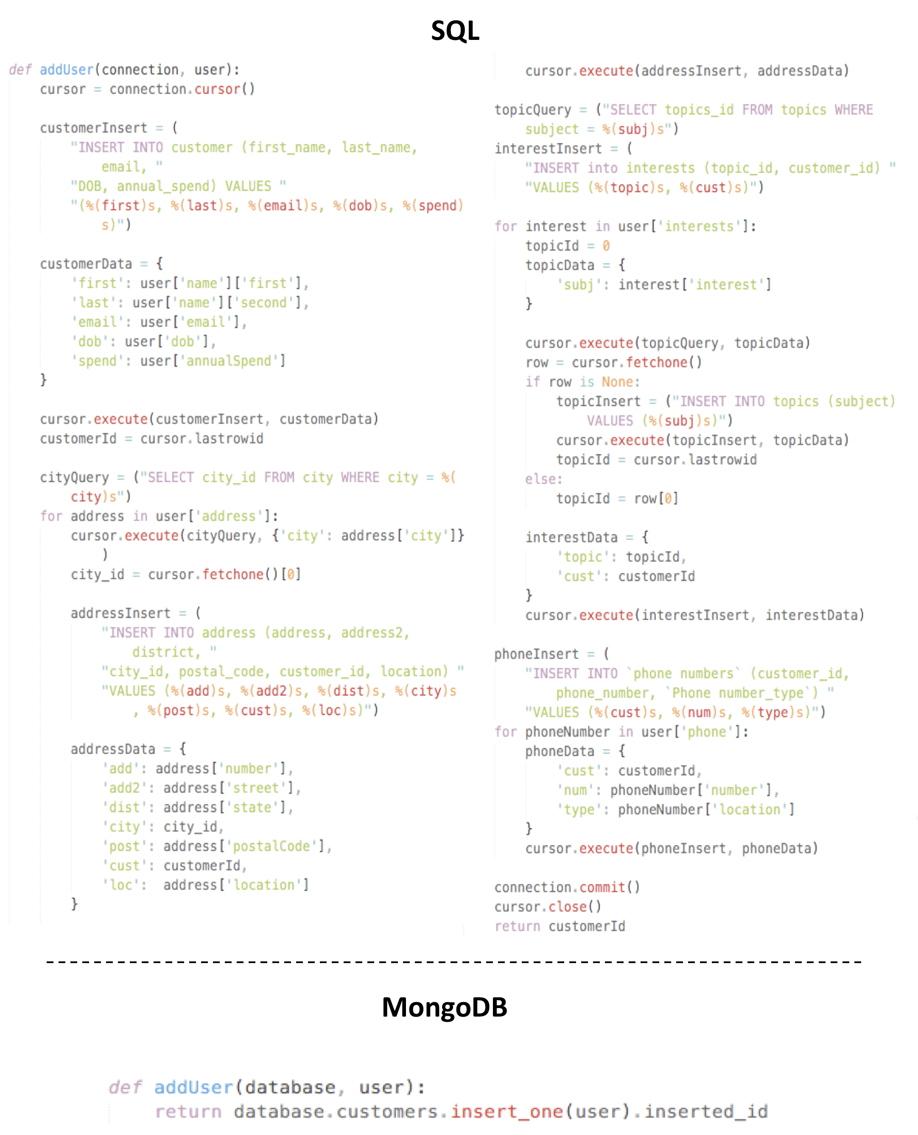
Figure 2: Comparison of SQL and MongoDB code to insert a single user

Creating Real-Time Data Pipelines with Change Streams

$lookup (aggregation)
Performs a left outer join to an unsharded collection in the same database to filter in documents from the “joined” collection for processing. To each input document, the $lookup stage adds a new array field whose elements are the matching documents from the “joined” collection. The $lookup stage passes these reshaped documents to the next stage.

Equality Match
To perform an equality match between a field from the input documents with a field from the documents of the “joined” collection, the $lookup stage has the following syntax:
{
$lookup:
{
from: <collection to join>,
localField: <field from the input documents>,
foreignField: <field from the documents of the "from" collection>,
as: <output array field>
}
}

Field | Description
from | Specifies the collection in the same database to perform the join with. The from collection cannot be sharded.
localField | Specifies the field from the documents input to the $lookup stage. $lookup performs an equality match on the localField to the foreignField from the documents of the from collection. If an input document does not contain the localField, the $lookup treats the field as having a value of null for matching purposes.  Note  If your localField is an array, you may want to add an $unwind stage to your pipeline. Otherwise, the equality condition between the localField and foreignField is foreignField: { $in: [ localField.elem1, localField.elem2, ... ] }.  See the example on this page.
foreignField | Specifies the field from the documents in the from collection. $lookup performs an equality match on the foreignField to the localField from the input documents. If a document in the from collection does not contain the foreignField, the $lookup treats the value as null for matching purposes.
as | Specifies the name of the new array field to add to the input documents. The new array field contains the matching documents from the from collection. If the specified name already exists in the input document, the existing field is overwritten.

