http://www.oracle.com/webfolder/technetwork/tutorials/obe/java/gc01/index.html

Java Overview
Java is a programming language and computing platform first released by Sun Microsystems in 1995. Java is composed of a number of key components that, as a whole, create the Java platform.

Java Runtime Environment
Java Runtime Environment (JRE) consists of the Java Virtual Machine (JVM), Java platform core classes, and supporting Java platform libraries. All three are required to run Java applications on your computer.

Java Programming Language
Java is an object-oriented programming language that includes the following features:
a) Platform Independence - Java applications are compiled into bytecode which is stored in class files and loaded in a JVM. Since applications run in a JVM, they can be run on many different operating systems and devices.
b) Object-Oriented - Java is an object-oriented language that take many of the features of C and C++ and improves upon them.
c) Automatic Garbage Collection - Java automatically allocates and deallocates memory so programs are not burdened with that task.
d) Rich Standard Library - Java includes a vast number of premade objects that can be used to perform such tasks as input/output, networking, and date manipulation.

Java Development Kit
Java Development Kit (JDK) is a collection of tools for developing Java applications. With the JDK, you can compile programs written in the Java Programming language and run them in a JVM. In addition, the JDK provides tools for packaging and distributing your applications.

The JDK and the JRE share the Java Application Programming Interfaces (Java API). The Java API is a collection of prepackaged libraries developers use to create Java applications. The Java API makes development easier by providing the tools to complete many common programming tasks including string manipulation, date/time processing, networking, and implementing data structures (e.g., lists, maps, stacks, and queues).

Java Virtual Machine
The Java Virtual Machine (JVM) is an abstract computing machine. The JVM is a program that looks like a machine to the programs written to execute in it. This way, Java programs are written to the same set of interfaces and libraries. Each JVM implementation for a specific operating system, translates the Java programming instructions into instructions and commands that run on the local operating system. This way, Java programs achieve platform independence.

The Java virtual machine knows nothing of the Java programming language, only of a particular binary format, the class file format. A class file contains Java virtual machine instructions (or bytecodes) and a symbol table, as well as other ancillary information.

For the sake of security, the Java virtual machine imposes strong syntactic and structural constraints on the code in a class file. However, any language with functionality that can be expressed in terms of a valid class file can be hosted by the Java virtual machine.

Hotspot Architecture
The HotSpot JVM possesses an architecture that supports a strong foundation of features and capabilities and supports the ability to realize high performance and massive scalability. For example, the HotSpot JVM JIT compilers generate dynamic optimizations. In other words, they make optimization decisions while the Java application is running and generate high-performing native machine instructions targeted for the underlying system architecture. In addition, through the maturing evolution and continuous engineering of its runtime environment and multithreaded garbage collector, the HotSpot JVM yields high scalability on even the largest available computer systems.
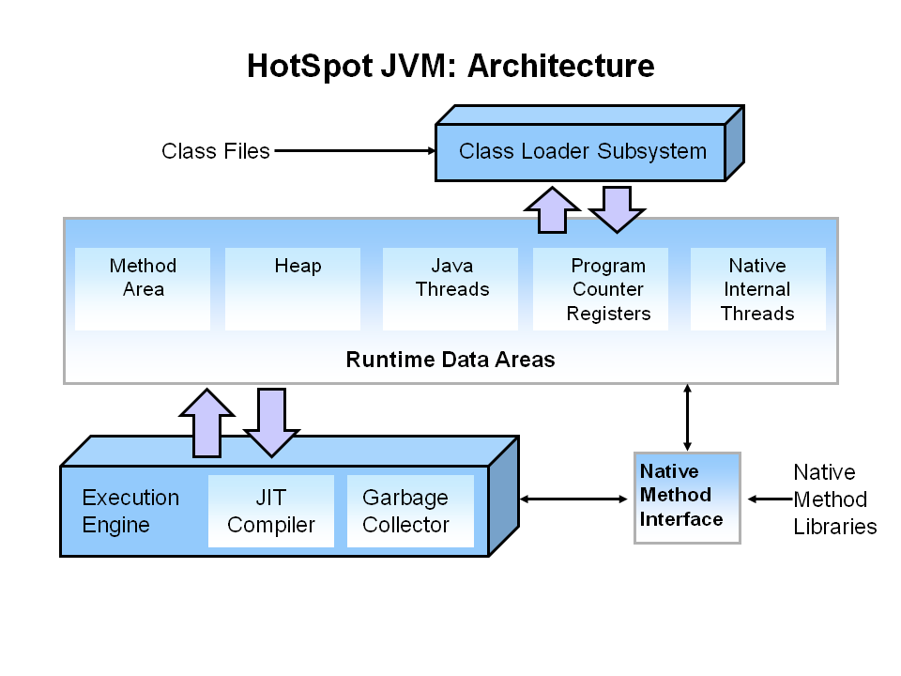
There are three components of the JVM that are focused on when tuning performance. The Heap is where your object data is stored. This area is then managed by the Garbage Collector selected at startup. Most tuning options relate to sizing the heap and choosing the most appropriate garbage collector for your situation. The JIT compiler also has a big impact on performance but rarely requires tuning with the newer versions of the JVM.

Performance Basics
Typically, when tuning a Java application, the focus is on one of two main goals: responsiveness or throughput.

Responsiveness
Responsiveness refers to how quickly an application or system responds with a requested piece of data. Examples include:
- How quickly a desktop UI responds to an event
- How fast a website returns a page
- How fast a database query is returned
For applications that focus on responsiveness, large pause times are not acceptable. The focus is on responding in short periods of time.

Throughput
Throughput focuses on maximizing the amount of work by an application in a specific period of time. Examples of how throughput might be measured include:
- The number of transactions completed in a given time.
- The number of jobs that a batch program can complete in an hour.
- The number of database queries that can be completed in an hour.
High pause times are acceptable for applications that focus on throughput. Since high throughput applications focus on benchmarks over longer periods of time, quick response time is not a consideration.

Automatic Garbage Collection
Automatic garbage collection is the process of looking at heap memory, identifying which objects are in use and which are not, and deleting the unused objects. An in use object, or a referenced object, means that some part of your program still maintains a pointer to that object. An unused object, or unreferenced object, is no longer referenced by any part of your program. So the memory used by an unreferenced object can be reclaimed.

Step 1: Marking
The first step in the process is called marking. This is where the garbage collector identifies which pieces of memory are in use and which are not.
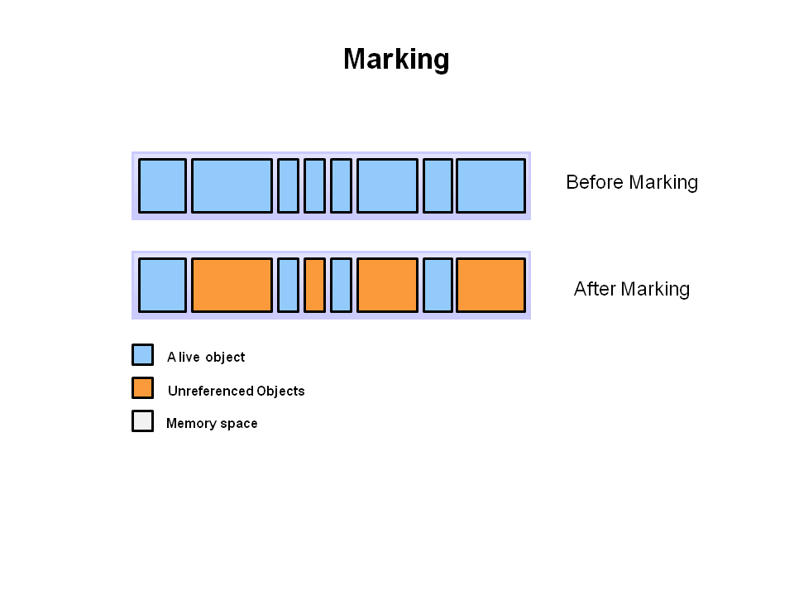
Referenced objects are shown in blue. Unreferenced objects are shown in gold. All objects are scanned in the marking phase to make this determination. This can be a very time consuming process if all objects in a system must be scanned.

Step 2: Normal Deletion
Normal deletion removes unreferenced objects leaving referenced objects and pointers to free space.
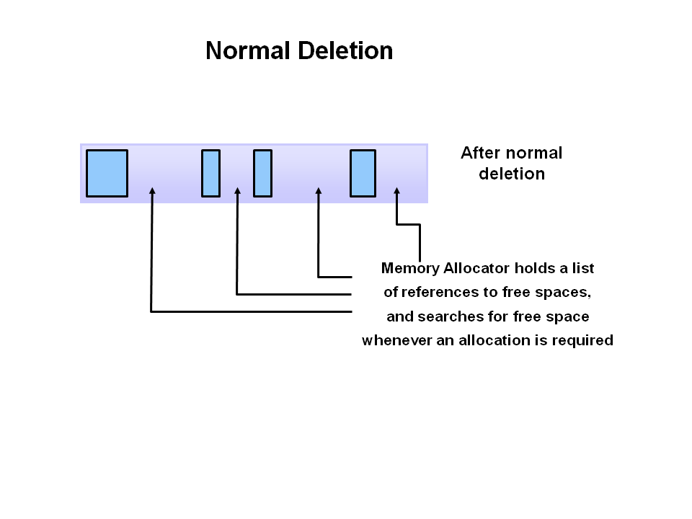
The memory allocator holds references to blocks of free space where new object can be allocated.

Step 2a: Deletion with Compacting
To further improve performance, in addition to deleting unreferenced objects, you can also compact the remaining referenced objects. By moving referenced object together, this makes new memory allocation much easier and faster.

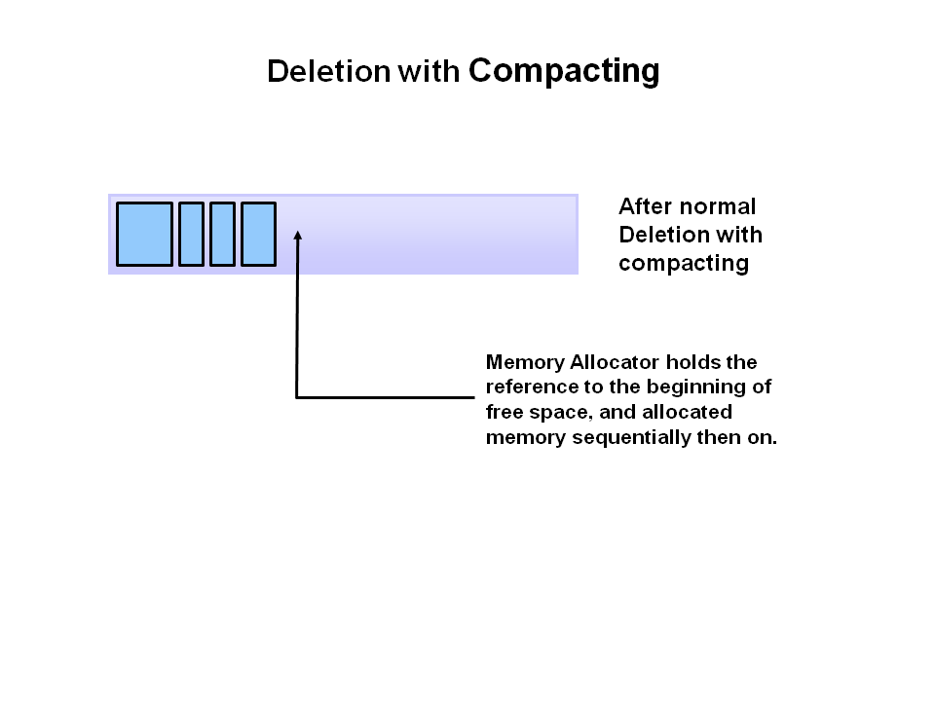
Generational Garbage Collection
As stated earlier, having to mark and compact all the objects in a JVM is inefficient. As more and more objects are allocated, the list of objects grows and grows leading to longer and longer garbage collection time. However, empirical analysis of applications has shown that most objects are short lived.
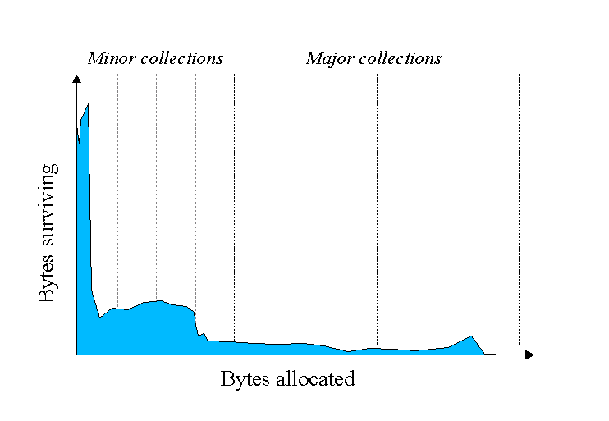
Here is an example of such data. The Y axis shows the number of bytes allocated and the X access shows the number of bytes allocated over time.
As you can see, fewer and fewer objects remain allocated over time. In fact most objects have a very short life as shown by the higher values on the left side of the graph.

JVM Generations
The information learned from the object allocation behavior can be used to enhance the performance of the JVM. Therefore, the heap is broken up into smaller parts or generations. The heap parts are: Young Generation, Old or Tenured Generation, and Permanent Generation.
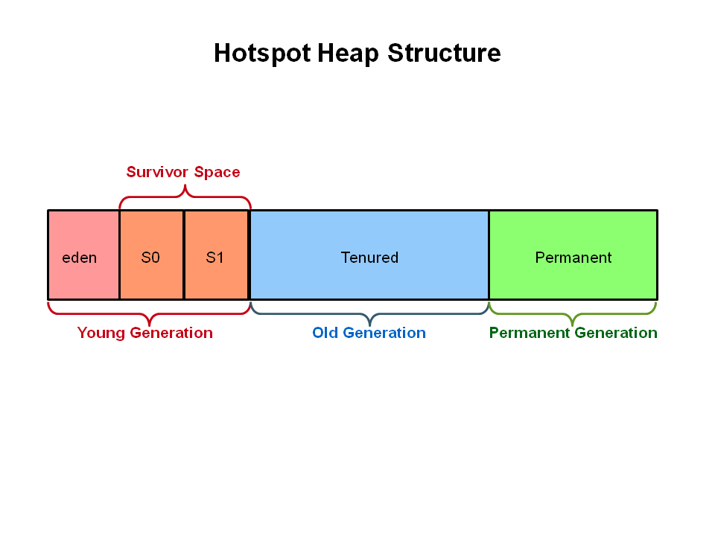
The Young Generation is where all new objects are allocated and aged. When the young generation fills up, this causes a minor garbage collection. Minor collections can be optimized assuming a high object mortality rate. A young generation full of dead objects is collected very quickly. Some surviving objects are aged and eventually move to the old generation.

Stop the World Event - All minor garbage collections are "Stop the World" events. This means that all application threads are stopped until the operation completes. Minor garbage collections are always Stop the World events.

The Old Generation is used to store long surviving objects. Typically, a threshold is set for young generation object and when that age is met, the object gets moved to the old generation. Eventually the old generation needs to be collected. This event is called a major garbage collection.

Major garbage collection are also Stop the World events. Often a major collection is much slower because it involves all live objects. So for Responsive applications, major garbage collections should be minimized. Also note, that the length of the Stop the World event for a major garbage collection is affected by the kind of garbage collector that is used for the old generation space.

The Permanent generation contains metadata required by the JVM to describe the classes and methods used in the application. The permanent generation is populated by the JVM at runtime based on classes in use by the application. In addition, Java SE library classes and methods may be stored here.

Classes may get collected (unloaded) if the JVM finds they are no longer needed and space may be needed for other classes. The permanent generation is included in a full garbage collection.

Generational Garbage Collection Process
Now that you understand why the heap is separted into different generations, it is time to look at how exactly these spaces interact. The pictures that follow walks through the object allocation and aging process in the JVM.
1. First, any new objects are allocated to the eden space. Both survivor spaces start out empty.
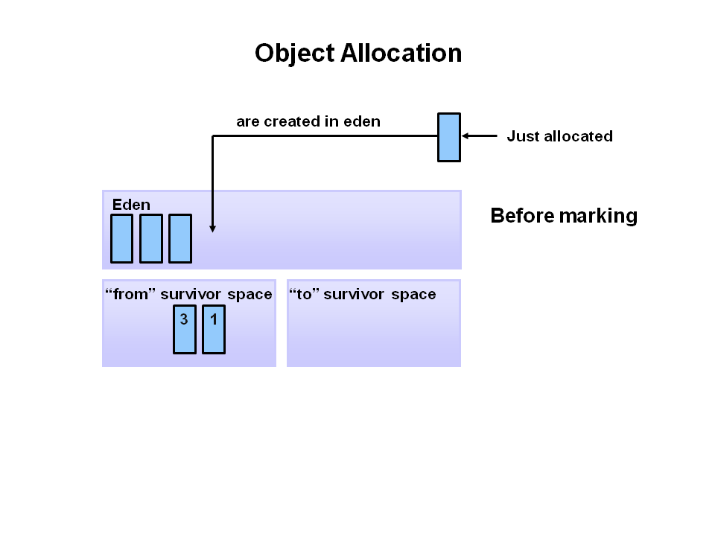
2. When the eden space fills up, a minor garbage collection is triggered.

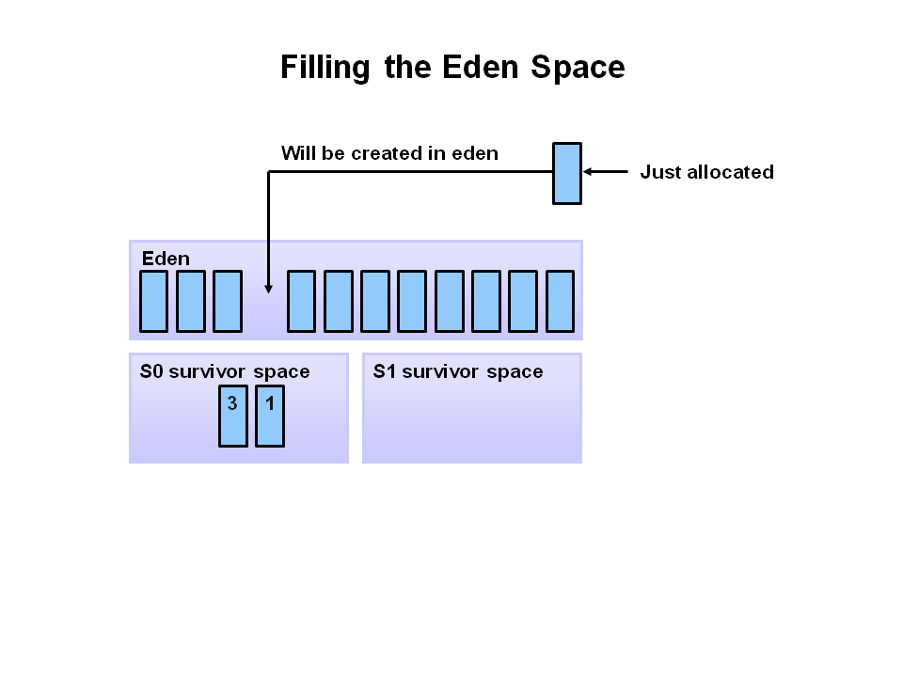

3. Referenced objects are moved to the first survivor space. Unreferenced objects are deleted when the eden space is cleared.
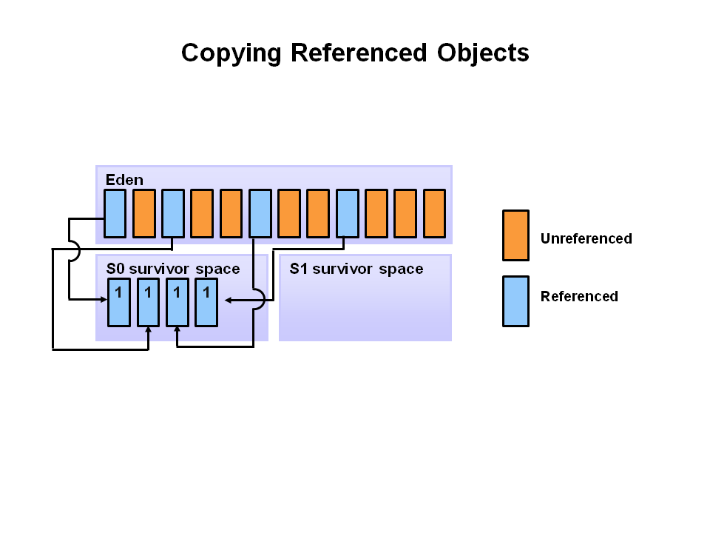
4. At the next minor GC, the same thing happens for the eden space. Unreferenced objects are deleted and referenced objects are moved to a survivor space. However, in this case, they are moved to the second survivor space (S1). In addition, objects from the last minor GC on the first survivor space (S0) have their age incremented and get moved to S1. Once all surviving objects have been moved to S1, both S0 and eden are cleared. Notice we now have differently aged object in the survivor space.
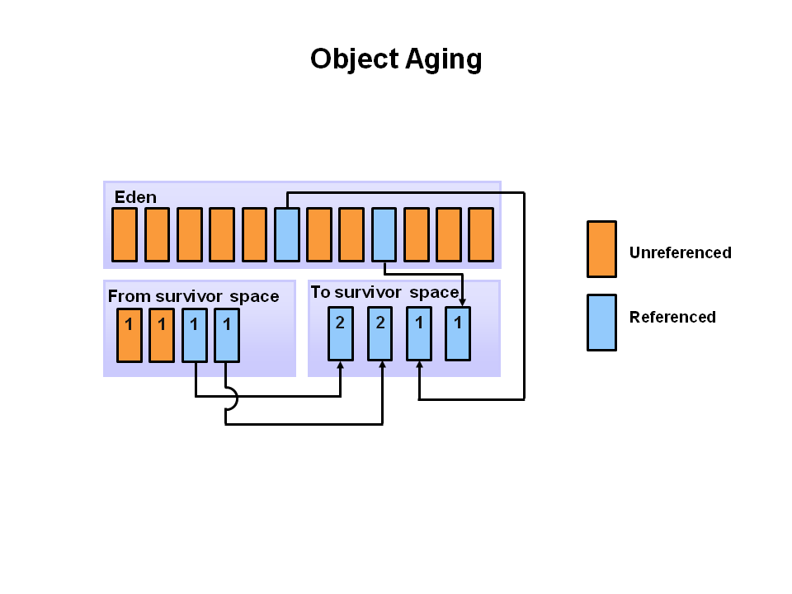

5. At the next minor GC, the same process repeats. However this time the survivor spaces switch. Referenced objects are moved to S0. Surviving objects are aged. Eden and S1 are cleared.
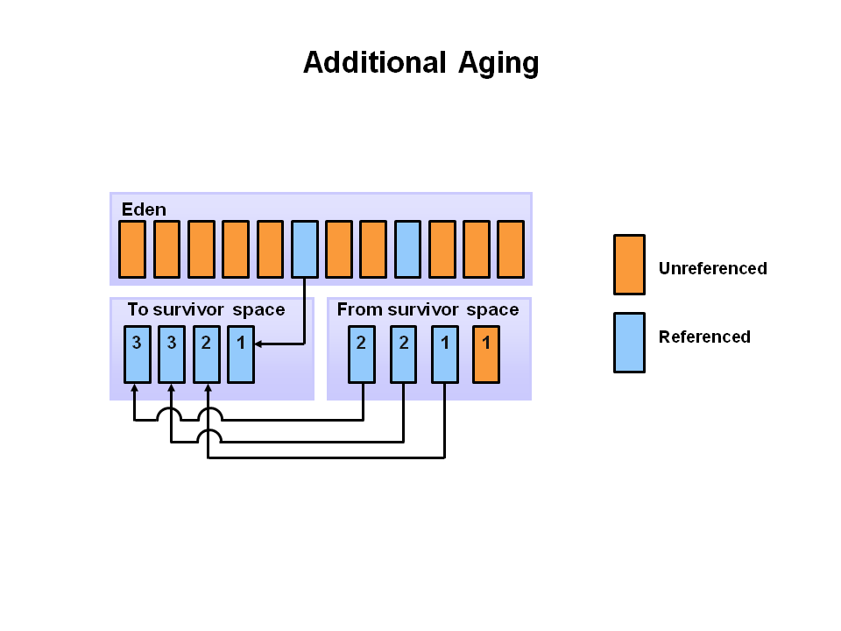
6. This slide demonstrates promotion. After a minor GC, when aged objects reach a certain age threshold (8 in this example) they are promoted from young generation to old generation.
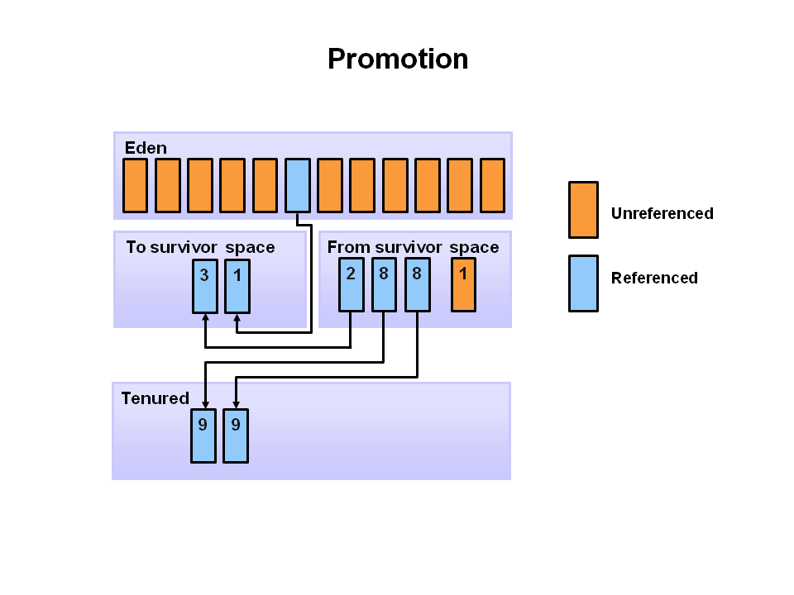
7. As minor GCs continue to occure objects will continue to be promoted to the old generation space.
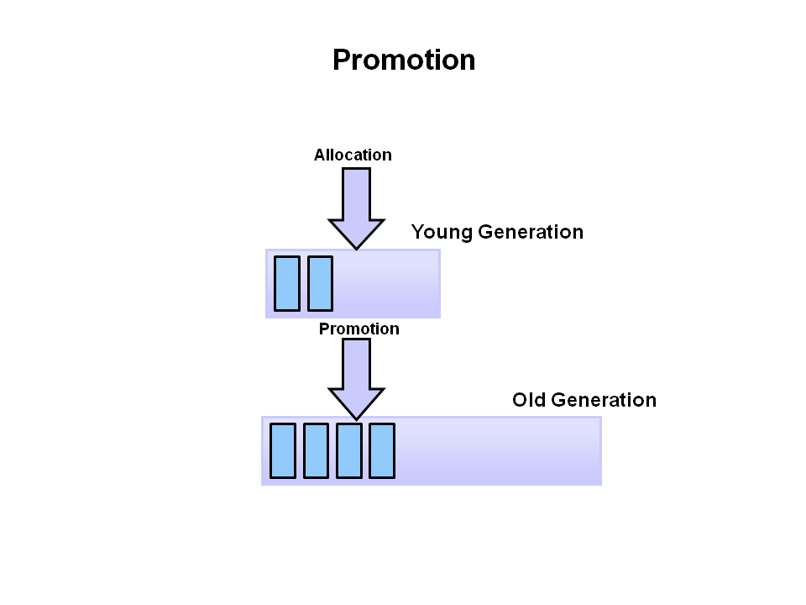
8. So that pretty much covers the entire process with the young generation. Eventually, a major GC will be performed on the old generation which cleans up and compacts that space.
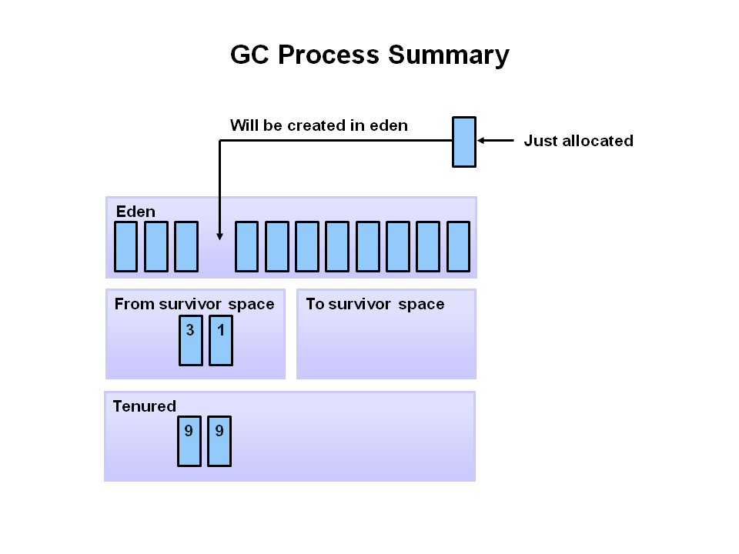

Java Garbage Collectors
In this section, we will learn about the garbage collectors available for Java and the command line switches we need to select them.

Common Heap Related Switches
Switch | Description
-Xms | Sets the initial heap size for when the JVM starts.
-Xmx | Sets the maximum heap size.
-Xmn | Sets the size of the Young Generation.
-XX:PermSize | Sets the starting size of the Permanent Generation.
-XX:MaxPermSize | Sets the maximum size of the Permanent Generation

The Serial GC
The serial collector is the default for client style machines in Java SE 5 and 6. With the serial collector, both minor and major garbage collections are done serially (using a single virtual CPU). In addition, it uses a mark-compact collection method. This method moves older memory to the beginning of the heap so that new memory allocations are made into a single continuous chunk of memory at the end of the heap. This compacting of memory makes it faster to allocate new chunks of memory to the heap.

Usage Cases
The Serial GC is the garbage collector of choice for most applications that do not have low pause time requirements and run on client-style machines. It takes advantage of only a single virtual processor for garbage collection work (therefore, its name). Still, on today's hardware, the Serial GC can efficiently manage a lot of non-trivial applications with a few hundred MBs of Java heap, with relatively short worst-case pauses (around a couple of seconds for full garbage collections).
Another popular use for the Serial GC is in environments where a high number of JVMs are run on the same machine (in some cases, more JVMs than available processors!). In such environments when a JVM does a garbage collection it is better to use only one processor to minimize the interference on the remaining JVMs, even if the garbage collection might last longer. And the Serial GC fits this trade-off nicely.
To enable the Serial Collector use: -XX:+UseSerialGC

The Parallel GC
The parallel garbage collector uses multiple threads to perform the young genertion garbage collection. By default on a host with N CPUs, the parallel garbage collector uses N garbage collector threads in the collection. The number of garbage collector threads can be controlled with command-line options: -XX:ParallelGCThreads=<desired number>
On a host with a single CPU the default garbage collector is used even if the parallel garbage collector has been requested. On a host with two CPUs the parallel garbage collector generally performs as well as the default garbage collector and a reduction in the young generation garbage collector pause times can be expected on hosts with more than two CPUs.

Usage Cases
The Parallel collector is also called a throughput collector. Since it can use multilple CPUs to speed up application throughput. This collector should be used when a lot of work need to be done and long pauses are acceptable. For example, batch processing like printing reports or bills or performing a large number of database queries.

The Parallel GC comes in two flavors -

-XX:+UseParallelGC
With thie -XX:+UseParallelGC option, we get a multi-thread young generation collector with a single-threaded old generation collector. The option also does single-threaded compaction of old generation.

-XX:+UseParallelOldGC
With the -XX:+UseParallelOldGC option, the GC is both a multithreaded young generation collector and multithreaded old generation collector. It is also a multithreaded compacting collector. HotSpot does compaction only in the old generation. Young generation in HotSpot is considered a copy collector; therefore, there is no need for compaction.

Compacting describes the act of moving objects in a way that there are no holes between objects. After a garbage collection sweep, there may be holes left between live objects. Compacting moves objects so that there are no remaining holes. It is possible that a garbage collector be a non-compacting collector. Therefore, the difference between a parallel collector and a parallel compacting collector could be the latter compacts the space after a garbage collection sweep. The former would not.

Concurrent Mark Sweep (CMS) Collector
The Concurrent Mark Sweep (CMS) collector (also referred to as the concurrent low pause collector) collects the tenured generation. It attempts to minimize the pauses due to garbage collection by doing most of the garbage collection work concurrently with the application threads. Normally the concurrent low pause collector does not copy or compact the live objects. A garbage collection is done without moving the live objects. If fragmentation becomes a problem, allocate a larger heap.
Note: CMS collector on young generation uses the same algorithm as that of the parallel collector.

Usage Cases
The CMS collector should be used for applications that require low pause times and can share resources with the garbage collector. Examples include desktop UI application that respond to events, a webserver responding to a request or a database responding to queries.
To enable the CMS Collector use: -XX:+UseConcMarkSweepGC
To set the number of threads use: -XX:ParallelCMSThreads=<desired number>

http://www.oracle.com/technetwork/tutorials/tutorials-1876574.html

The G1 Garbage Collector
The Garbage-First (G1) collector is a server-style garbage collector, targeted for multi-processor machines with large memories. It meets garbage collection (GC) pause time goals with a high probability, while achieving high throughput. The G1 garbage collector is fully supported in Oracle JDK 7 update 4 and later releases.
The G1 collector is designed for applications that:
- Can operate concurrently with applications threads like the CMS collector.
- Compact free space without lengthy GC induced pause times.
- Need more predictable GC pause durations.
- Do not want to sacrifice a lot of throughput performance.
- Do not require a much larger Java heap.
G1 is planned as the long term replacement for the Concurrent Mark-Sweep Collector (CMS). Comparing G1 with CMS, there are differences that make G1 a better solution. One difference is that G1 is a compacting collector. G1 compacts sufficiently to completely avoid the use of fine-grained free lists for allocation, and instead relies on regions. This considerably simplifies parts of the collector, and mostly eliminates potential fragmentation issues. Also, G1 offers more predictable garbage collection pauses than the CMS collector, and allows users to specify desired pause targets.

G1 Operational Overview

To enable the G1 Collector use: -XX:+UseG1GC

