Jiawei Wang
Problem 1：
a)
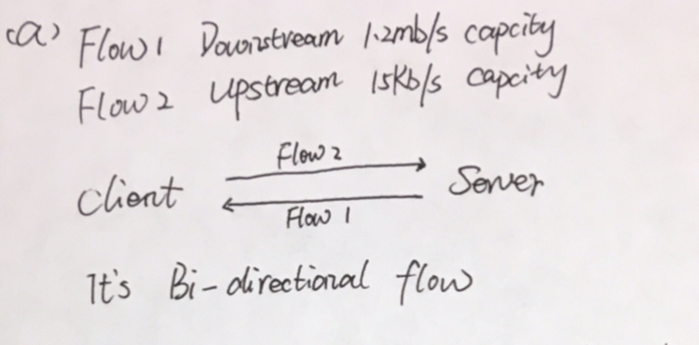
b)
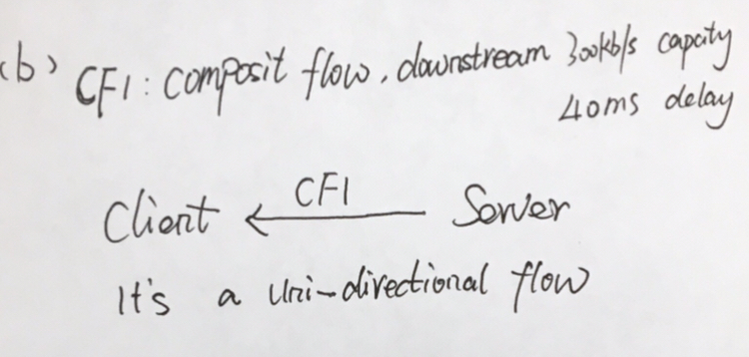
c)
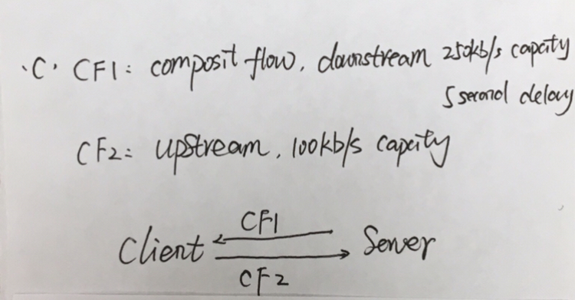
d)
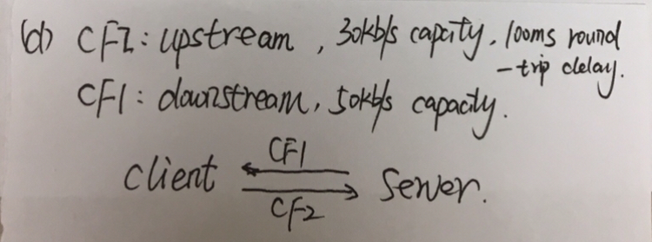

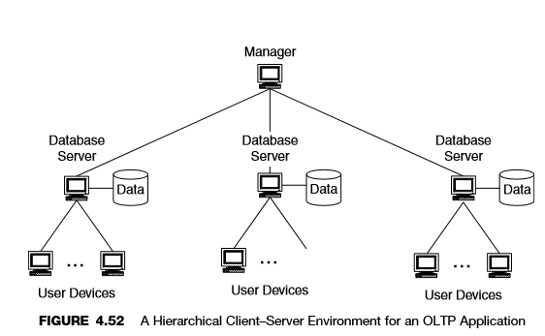
Problem 2:
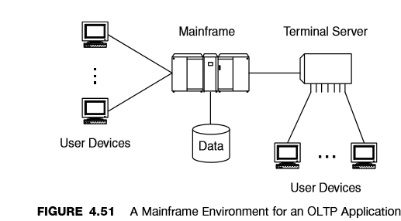
a)
For Figure 4.51:
Data Sources: Produce the data, so it is the Mainframe
Data Sinks: User Devices is the data sink.
For figure 4.52：
Data Sources: Database server
Data Sinks: manager can dump the sink into data source for each user devices.

b)
A hierarchical client–server flow model has the characteristics of a client–server flow model but also has multiple layers, or tiers, between servers.
The Internet has evolved from an early peer-to-peer flow model to a client–server flow model with the acceptance of Web applications.
This model is important in that it recognizes server-to-server and server-to-manager flows.

c)
According to the flowspec algorithm, the best-effort flows is only capacities are used and aggregated.
d) Such as this picture. In mainframe environment, if manager want to get a better performance, the client need to get easier to get the data, so the security will be decreased. On the other hand, if improve the management of manager, the database server cannot easy to access, that’s means that the flow capacity will decrease, on the contrary, the security will be increased.
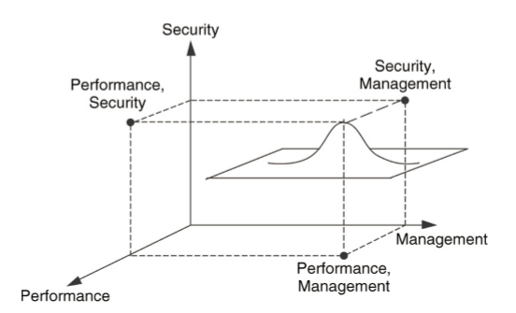
Problem 3:
The relationships between each component architectures contains internal relationship and external relationship. Internal relationships are used to optimize each component architecture for the network, external relationships are used to optimize the sum of all component architectures.
- Addressing/routing and Network management and Security
  - Based on the mechanism used in the network management and security component architectures, their traffic flows may take separate paths from user traffic flows, a capability that must be incorporated into the addressing/routing component architecture.
- Addressing/routing and performance

  - Performance can be closely coupled with routing through mechanisms such as MPLS, differentiated and integrated services, and signaling via the resource reservation protocol (RSVP).
  - Routing can be configured so that that traffic flows with differing performance requirements take separate paths through the network. (Multiprotocol label switching (MPLS) integrates routing and performance).
- Performance and network management
  - In-band network management directly impacts the performance of user traffic flows, as management traffic flows compete with user traffic flows for network resources.
  - Traffic engineering to achieve a system wide balance for bandwidth allocation
- Performance and security
  - As security is increased, by adding more mechanisms to the network, performance is decreased. Whereas capacity can sometimes be increased to offset a decrease in performance, delay is difficult to mitigate
  - Some security mechanisms interrupt or terminate and regenerate traffic flows, seriously impacting the ability to provide end-to-end performance across a security interface
- Network management and Security
  - Network management requires frequent access to network devices, and as such, is a potential security problem.
Problem 4:
- For addressing
  - For the isolate 2 network, applying this connectivity information to forward IP packets toward their destinations is the most important thing.
- For network management
  - Monitor and manage the whole network is the first duty of network management. How to connect to devices in order to access data, and how the flows of management data through the network is the most important thing.
- For performance
  - How network resources will be allocated to user and management traffic flows, which consists of prioritizing, scheduling, and conditioning traffic flows within the network.
- For security
  - Hardware and software capabilities as virtual private networks (VPNs), encryption, firewalls, routing filters, and network address translation (NAT).

Problem5:
- Potential external relationship:
  - The external relationships between the client and server in respect to addressing/routing are the client needs to be routed from a public IP to a public IP and firewalled only to the application that the client needs to be accessing.
- How the component architectures need to work together?
  - According to the Problem4, for security, the location of the DMZ has firewalls and encryption can be effectively to deal and manage the two separate system. And because of the isolated LAN for user to use traffic flow.

