Homework 3
4.9
- BST [10 Points]
- Show the result of inserting 3,1,4,6,9,2,5, 7 into an initially empty binary search tree.
- Show the result of deleting the root.
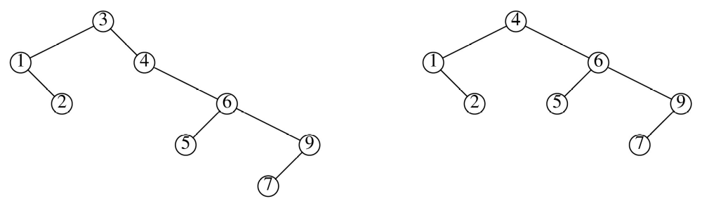

Alternate answer for 1b
2
1
5
9
6
4
7

[5 Points]
4.19
- AVL Tree
Show the result of inserting 2, 1, 4, 5,9,3,6,7
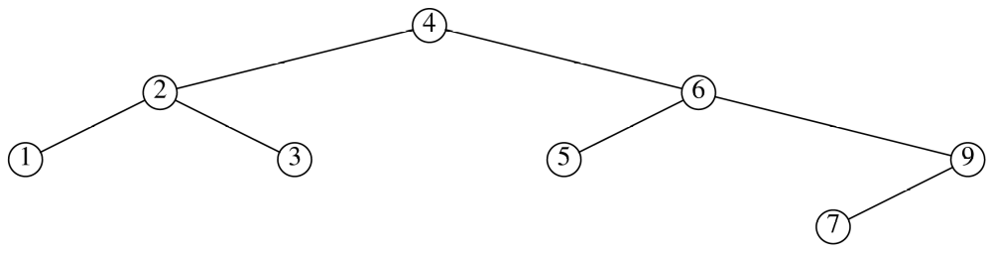

4.27 & 4.28
- Splay Tree
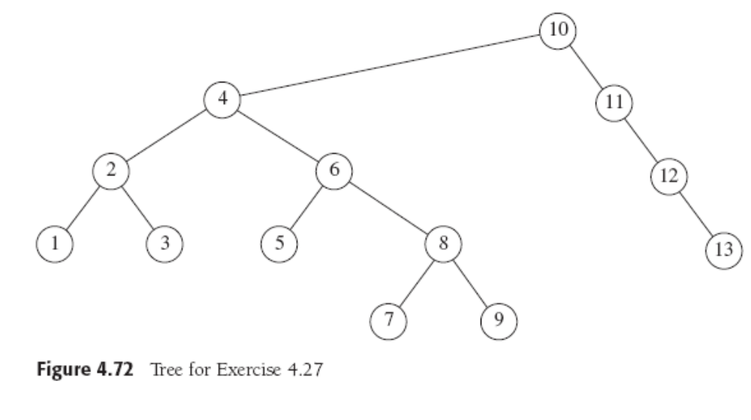

  - Show the result of accessing the keys 3,9,1,5 in order in the splay tree [5 Points]
After accessing 3,
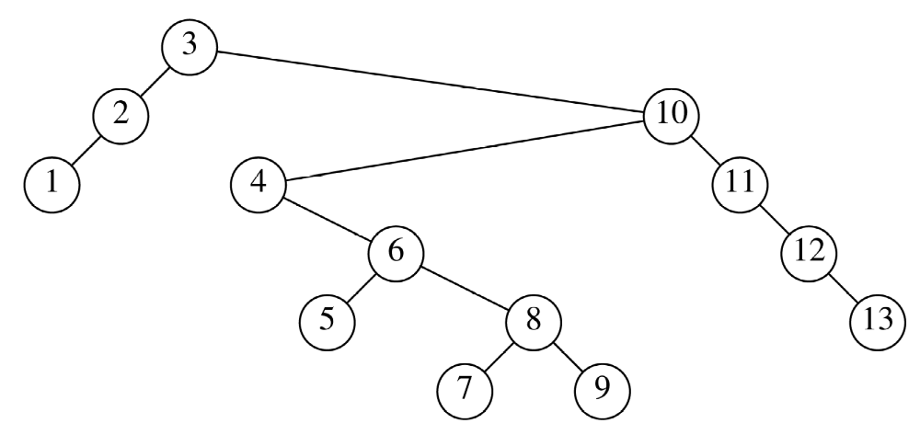
After accessing 9,
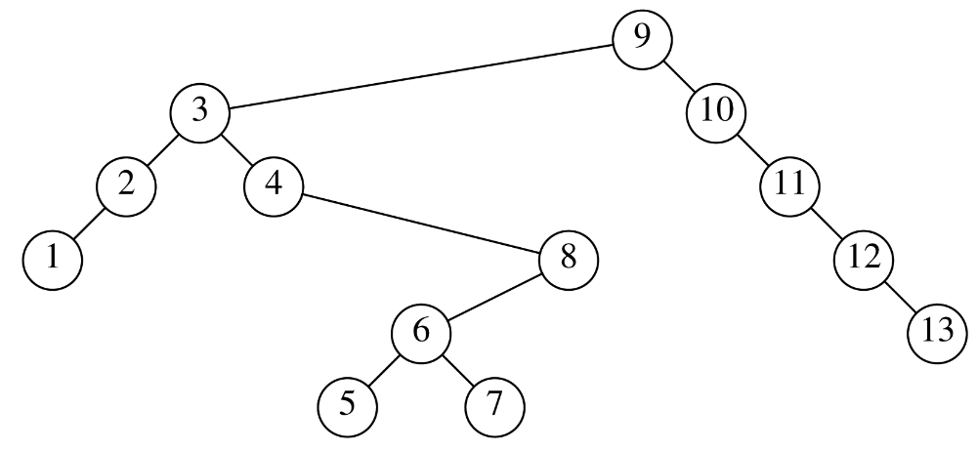After accessing 1,
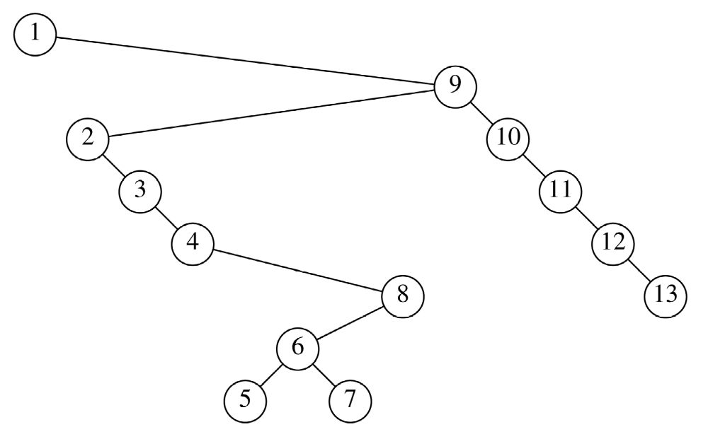
After accessing 5,
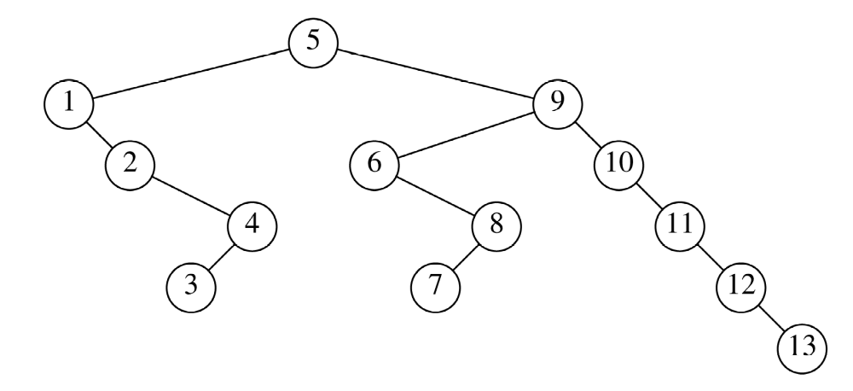

  - Show the result of deleting key 6 after doing (a). [5 Points]
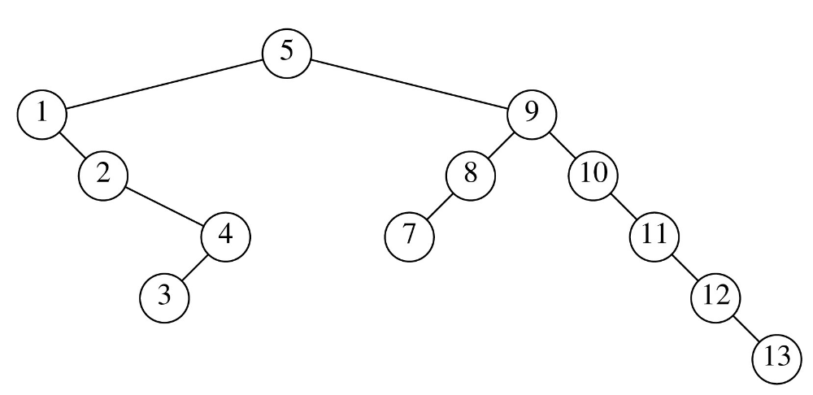

4.46
- Two binary trees are similar if they are both empty or both nonempty and have similar left and right subtree. Write a method to decide whether two binary tree are similar. What is the running time of your method? [10 Points]
The function shown here is clearly a linear time routine because in the worst case it does a traversal on both t1 and t2.
static boolean similar( Node t1, Node t2 )
{
if( t1 == NULL || t2 == NULL )
return t1 == NULL && t2 == NULL;
return similar( t1.left, t2.left ) && similar( t1.right, t2.right );
}

- Given a binary search tree and a value k, write a pseudo code to find a node in the binary search tree whose value is closest to k. [10 Points]

The routine takes as input a binary search tree ( its root node) and a value the same generic type as the value K.
AnyType Closest(BST<AnyType> root, AnyType K) {
if ( root == null) // Empty Tree
return null;

root_difference = root.element.compareTo(K);
if(root_difference == 0 ) return root.element;
//If the element at root is considered less to the value of K, either root is the closest element to K or the nearer element will be only to the right of the root.
if(root_difference<0 )
{
Closest_right = Closest(root.right, K);
right_difference = Closest_right.compareTo(K);
if(absolute_value(right_difference) <
absolute_value(root_difference))
return right.element;
else
return root.element;
}
//If the element at root is considered more to the value of K, either root is the closest element to K or the nearer element will be only to the left of the root.

if(root_difference > 0 )
{
Closest_left = Closest(root.left, K);
left_difference = Closest_left.compareTo(K);
if(absolute_value(left_difference) <
absolute_value(root_difference))
return left.element;
else
return root.element;
}

