Homework4_Key
- [20 Points] Given input {4371, 1323, 6173, 4199, 4344, 9679, 1989} and a hash function h(x) = x mod 10, show the resulting:
  - Separate Chaining hash table
  - Hash Table using linear probing
  - Hash table using quadratic probing
  - Hash table with second (Double Hashing) hash function h₂(x) = 7 – ( x mod 7)
(a) On the assumption that we add collisions to the end of the list (which is the easier way if a hash table is being built by hand), the separate chaining hash table that results is shown here.
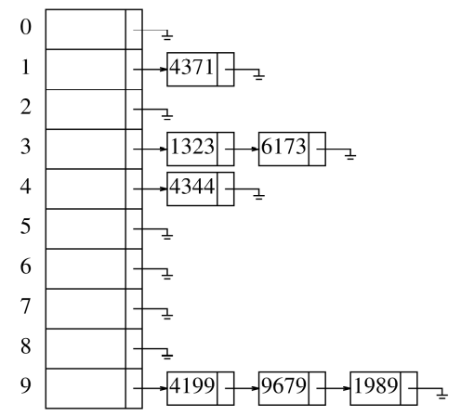
(B)
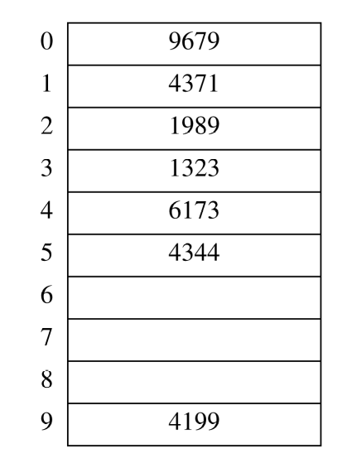

(C) hash(x) + f(i); f(i) = i* hash2(x)
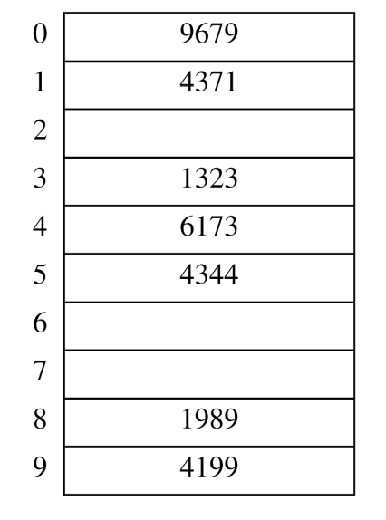
{4371, 1323, 6173, 4199, 4344, 9679, 1989}
(D) 1989 cannot be inserted into the table because hash₂(1989) = 6, and the alternative locations 5, 1, 7, and 3 are already taken. The table at this point is as follows:
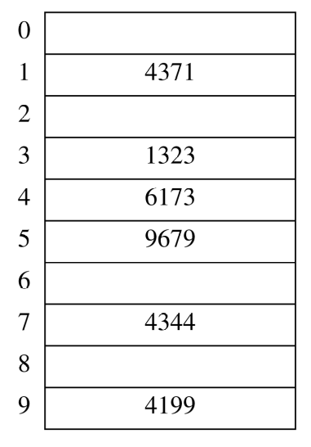

- [10 Points] Show the results of rehashing the hash table in Question 1
NOTE: When rehashing, we choose a table size that is roughly twice as large and prime

When rehashing, we choose a table size that is roughly twice as large and prime. In our case, the appropriate new table size is 19, with hash function h(x) = x(mod 19).
(a) Scanning down the separate chaining hash table, the new locations are 4371 in list 1, 1323 in list 12, 6173 in list 17, 4344 in list 12, 4199 in list 0, 9679 in list 8, and 1989 in list 13.
(b) The new locations are 9679 in bucket 8, 4371 in bucket 1, 1989 in bucket 13, 1323 in bucket 12, 6173 in bucket 17, 4344 in bucket 14 (because both 12 and 13 are already occupied), and 4199 in bucket 0.
(c) The new locations are 9679 in bucket 8, 4371 in bucket 1, 1989 in bucket 13, 1323 in bucket 12, 6173 in bucket 17, 4344 in bucket 16 (because both 12 and 13 are already occupied), and 4199 in bucket 0.
(d) The new locations are 9679 in bucket 8, 4371 in bucket 1, 1989 in bucket 13, 1323 in bucket 12, 6173 in bucket 17, 4344 in bucket 15 because 12 is already occupied, and 4199 in bucket 0.
Q5.10
- [10 Points] What are the advantages and disadvantages of the various collision resolution strategies?

- Separate chaining hashing requires the use of links, which costs some memory, and the standard method of implementing calls on memory allocation routines, which typically are expensive.
- Linear probing is easily implemented, but performance degrades severely as the load factor increases because of primary clustering.
- Quadratic probing is only slightly more difficult to implement and gives good performance in practice. An insertion can fail if the table is half empty, but this is not likely. Even if it were, such an insertion would be so expensive that it wouldn’t matter and would almost certainly point up a weakness in the hash function
- Double hashing eliminates primary and secondary clustering, but the computation of a second hash function can be costly. Gonnet and Baeza-Yates [8] compare several hashing strategies; their results suggest that quadratic probing is the fastest method.

4. What is the running time of insertion sort if all elements are equal?

O(N), because the while loop terminates immediately. Of course, accidentally changing the test to include equalities raises the running time to quadratic for this type of input.

5. Show how heap sort processes the input 142, 543, 123, 65, 453, 879, 572, 434, 111, 242, 811,
102

The input is read in as

142, 543, 123, 65, 453, 879, 572, 434, 111, 242, 811, 102

The result of the heapify is

879, 811, 572, 434, 543, 123, 142, 65, 111, 242, 453, 102

879 is removed from the heap and placed at the end. We’ll place it in italics to signal that it is not part of the heap. 102 is placed in the hole and bubbled down, obtaining
811, 543, 572, 434, 453, 123, 142, 65, 111, 242, 102, 879

Continuing the process, we obtain

572, 543, 142, 434, 453, 123, 102, 65, 111, 242, 811, 879

543, 453, 142, 434, 242, 123, 102, 65, 111, 572, 811, 879

453, 434, 142, 111, 242, 123, 102, 65, 543, 572, 811, 879

434, 242, 142, 111, 65, 123, 102, 453, 543, 572, 811, 879

242, 111, 142, 102, 65, 123, 434, 453, 543, 572, 811, 879

142, 111, 123, 102, 65, 242, 434, 453, 543, 572, 811, 879

123, 111, 65, 102, 142, 242, 434, 453, 543, 572, 811, 879

111, 102, 65, 123, 142, 242, 434, 453, 543, 572, 811, 879

102, 65, 111, 123, 142, 242, 434, 453, 543, 572, 811, 879

65, 102, 111, 123, 142, 242, 434, 453, 543, 572, 811, 879

5.Sort 3, 1, 4, 1, 5, 9, 2, 6 using merge sort

First the sequence {3, 1, 4, 1} is sorted. To do this, the sequence {3, 1} is sorted. This involves sorting

{3} and {1}, which are base cases, and merging the result to obtain {1, 3}. The sequence {4, 1} is likewise sorted into {1, 4}. Then these two sequences are merged to obtain {1, 1, 3, 4}. The second half is sorted similarly, eventually obtaining {2, 5, 6, 9}. The merged result is then easily computed as {1, 1, 2, 3, 4, 5,
6, 9}.

6.Show the result of running quicksort on the input 9, 8, 7, 6, 5, 4, 3, 2, 1 .

There will be various ways to solve this depending upon how pivot is selected.

7.Prove that any comparison-based algorithm to sort 4 elements requires 5 comparisons. Give the algorithm to sort 4 elements in 5 comparisons.
⎡log4!⎤ = 5.

Let the elements in the arrays be represented as a1, a2, a3 and a4

Step 1: Compare and exchange (if necessary) a1 and a2 so that a1 ≥ a2. Step 2: Compare and exchange (if necessary) a3 and a4.
Step 3: Compare and exchange (if necessary) a1 and a3. Step 4: Compare and exchange (if necessary) a2 and a4. Step 5: Compare and exchange (if necessary) a2 and a3.

