Homework 5 Points: 100
Due Date: on elearning
Submit: eLearning
Instructions: Include Name and Net ID. This is an individual assignment. Answers should be your own work.

- [10 Points] A min-max heap is a data Structure that supports both deleteMin and deleteMax in O(logN) per operation. The structure is identical to a binary heap, but the heap-order property is that for any node, X, at even depth, the element stored at X is smaller than the parent but larger than the grandparent ( where this makes sense), and for any node X at odd depth, the element stored at X is larger than the parent but smaller than grandparent. See Fig.
- How do we find the minimum and maximum element?
- Give an algorithm to insert a new node into the min-max heap.
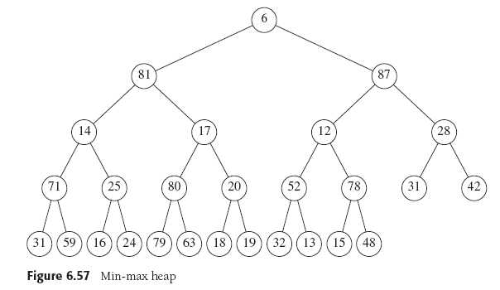
Finding minimum is easy it is at the root. The maximum is max( 2nd and 3rd ) nodes, i.e. array[1] is minimum and max(array[2], array[3]) is maximum.
To insert element X we create a hole in next available slot if X can inserted into the hole with no violation of order property then we are done. If not we percolate the hole up.

public void insert(int x){
int hole = ++currentSize;
int height = Math.log(currentSize);
boolean min = true;
if (height%2 ) min = false;

while(hole > 1){
//this boolean should help swap between whether we want to swap for the smallest element or for the largest element
if (min){
if(x > array[hole/2] ){
array[hole] = array[hole/2];
hole = hole/2}
else if( x < array[hole/4]){
array[hole] = array[hole/4];
hole = hole/4} // check if x is less than the grand parent
else { break ; }

}
else {
if(x < array[hole/2] ){
array[hole] = array[hole/2];
hole = hole/2}
else if( x > array[hole/4]){
array[hole] = array[hole/4];
hole = hole/4} // check if x is greater than the grand parent
else { break ; }
}
array[hole] = x;
}

- [20 Points]
a. Show the result of inserting 10, 12, 1, 14, 6, 5, 8, 15, 3, 9, 7, 4, 11, 13, and 2,
one at a time, into an initially empty binary heap.

b. Show the result of performing three deleteMin operations in the heap from Questions

- [10 Points] Give an algorithm to find all nodes less than some value X, in a binary heap. Your algorithm should run in O(K), where K is number of nodes output.

Perform a preorder traversal of the heap. Until reach value X or value greater than X

- Given the array below representing disjoint sets, draw the associated trees [5 points]
0 | 1 | 2 | 3 | 4 | 5 | 6 | 7
-1 | 2 | -1 | -1 | 3 | 3 | 5 | 6

1
5
7
6
4

- Given the disjoint set array below [10 points]
  - what would the array look like after a find (5) if path compression is used?

0 | 1 | 2 | 3 | 4 | 5 | 6 | 7 | 8 | 9
-1 | 0 | 0 | 2 | 3 | 3 | 1 | 6 | 5 | 5

0 | 1 | 2 | 3 | 4 | 5 | 6 | 7 | 8 | 9
-1 | 0 | 0 | 0 | 3 | 0 | 1 | 6 | 5 | 5

  - Draw trees for the final forest from part (a)

Before After
0
2
5
4
1
3
7
6
9
8
0
2
1
3
4
5
9
8
7
6

- Find a topological ordering for the graph in Figure 9.81 (show steps similar to example done in class/slide) [15 points]

The following ordering is arrived at by using a queue and assumes that vertices appear on an adjacency list alphabetically. The topological order that results is then
s, G, D, H, A, B, E, I, F, C, t

- Consider the directed graph shown in the figure below. Apply Dijkstra’s algorithm with vertex S as source and find the shortest path to all other vertices. Show all steps. [10 points]

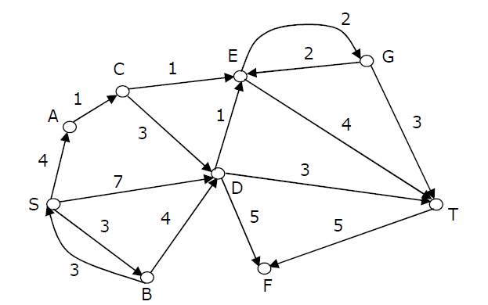

Initially make every distance ∞ other than S.

Step 1
Vertex | Known | Distance | Path
S | F | 0 | Null
A | F | ∞ | Null
B | F | ∞ | Null
C | F | ∞ | Null
D | F | ∞ | Null
E | F | ∞ | Null
F | F | ∞ | Null
G | F | ∞ | Null
T | F | ∞ | Null

Step 2
Vertex | Known | Distance | Path
S | T | 0 | Null
A | F | 4 | S
B | F | 3 | S
C | F | ∞ | Null
D | F | 7 | S
E | F | ∞ | Null
F | F | ∞ | Null
G | F | ∞ | Null
T | F | ∞ | Null

Step 3
Vertex | Known | Distance | Path
S | T | 0 | Null
A | F | 4 | S
B | T | 3 | S
C | F | ∞ | Null
D | F | 7 | S
E | F | ∞ | Null
F | F | ∞ | Null
G | F | ∞ | Null
T | F | ∞ | Null

Step 4
Vertex | Known | Distance | Path
S | T | 0 | Null
A | T | 4 | S
B | T | 3 | S
C | F | 5 | A
D | F | 7 | S
E | F | ∞ | Null
F | F | ∞ | Null
G | F | ∞ | Null
T | F | ∞ | Null

Step 5
Vertex | Known | Distance | Path
S | T | 0 | Null
A | T | 4 | S
B | T | 3 | S
C | T | 5 | A
D | F | 7 | S
E | F | 6 | C
F | F | ∞ | Null
G | F | ∞ | Null
T | F | ∞ | Null

Step 6
Vertex | Known | Distance | Path
S | T | 0 | Null
A | T | 4 | S
B | T | 3 | S
C | T | 5 | A
D | F | 7 | S
E | T | 6 | C
F | F | ∞ | Null
G | F | 8 | E
T | F | 10 | E

Step 7
Vertex | Known | Distance | Path
S | T | 0 | Null
A | T | 4 | S
B | T | 3 | S
C | T | 5 | A
D | T | 7 | S
E | T | 6 | C
F | F | 12 | D
G | F | 8 | E
T | F | 10 | E

Step 8
Vertex | Known | Distance | Path
S | T | 0 | Null
A | T | 4 | S
B | T | 3 | S
C | T | 5 | A
D | T | 7 | S
E | T | 6 | C
F | F | 12 | D
G | T | 8 | E
T | F | 10 | D

Step 9
Vertex | Known | Distance | Path
S | T | 0 | Null
A | T | 4 | S
B | T | 3 | S
C | T | 5 | A
D | T | 7 | S
E | T | 6 | C
F | F | 12 | D
G | T | 8 | E
T | T | 10 | D

Step 10
Vertex | Known | Distance | Path
S | T | 0 | Null
A | T | 4 | S
B | T | 3 | S
C | T | 5 | A
D | T | 7 | S
E | T | 6 | C
F | T | 12 | D
G | T | 8 | E
T | T | 10 | D

- Find a minimum spanning tree for the graph in Figure 9.84 using Prim’s and Kruskal’s [20 Points]
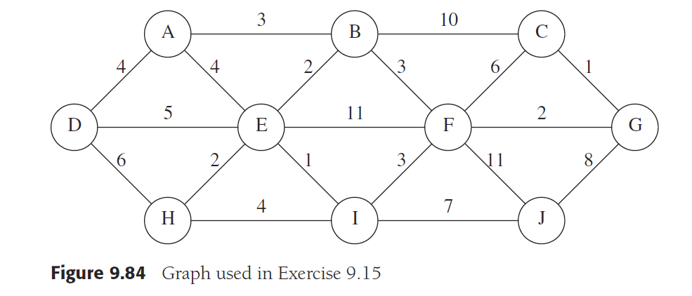
  - Prim’s algorithm (show table with v, dv, known, path values). Show all steps
Should include table as follows in the solution to show how you reached final MST
V | Dv | known | Path
A | 0 | F
B | Inf | F
C | Inf | F
D | Inf | F
E | Inf | F
F | Inf | F
G | inf | F
H
I
J

  - Kruskal’s algorithm (show table with Edge, Weight and Action values). Show all steps
Should include table as follows in the solution to show how you reached final MST
Edge | Weight | Action

One possible minimum spanning tree is shown here. This solution is not unique.

Q.10 There can be many different applications
Few are as following.
- To show organizational structure
- To show files in directory
- Game trees to show how games can be played
- Huffman coding to code
- Decision trees to show decision making

