UI/UX REFERENCE
Luma AI Screen Reference
Annotated screenshots, interaction notes and Figma handoff guidance
Based on the screenshots supplied in Luma.docx • Desktop capture • Version 1.0
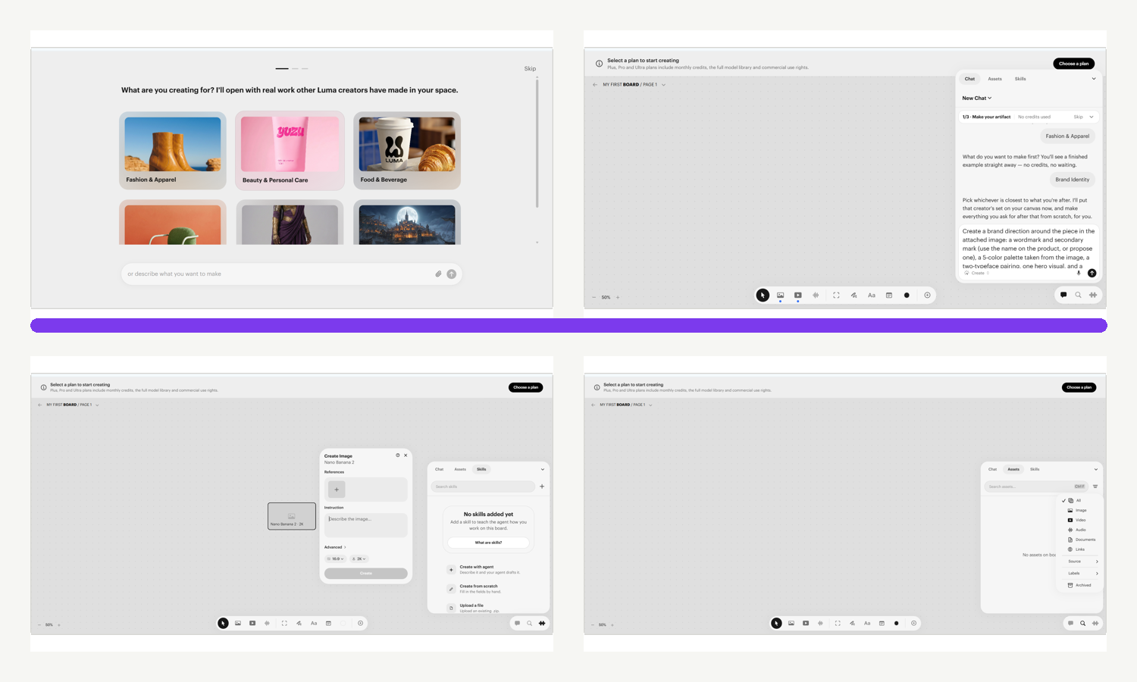
FOR DESIGNERS  Use the clean frames to reconstruct layout, components and variants in Figma. | FOR ENGINEERS  Use the screen IDs, state notes and interaction gaps as implementation references.

How to use this guide
This document restructures the uploaded screenshot collection into a screen-by-screen reference for frontend and UI/UX work. It records what is visible, adds numbered anatomy callouts, and separates observations from design assumptions.
OBSERVED Visible directly in the supplied screenshots. | VALIDATE A design or interaction detail that requires confirmation in the live product.
Recommended Figma page structure
- 00 – Cover & assumptions
- 01 – Onboarding
- 02 – Board shell & navigation
- 03 – Creation tools & model settings
- 04 – Canvas objects
- 05 – Chat / Assets / Skills
- 06 – Components & tokens
- 07 – Prototype flows & missing states
Experience map
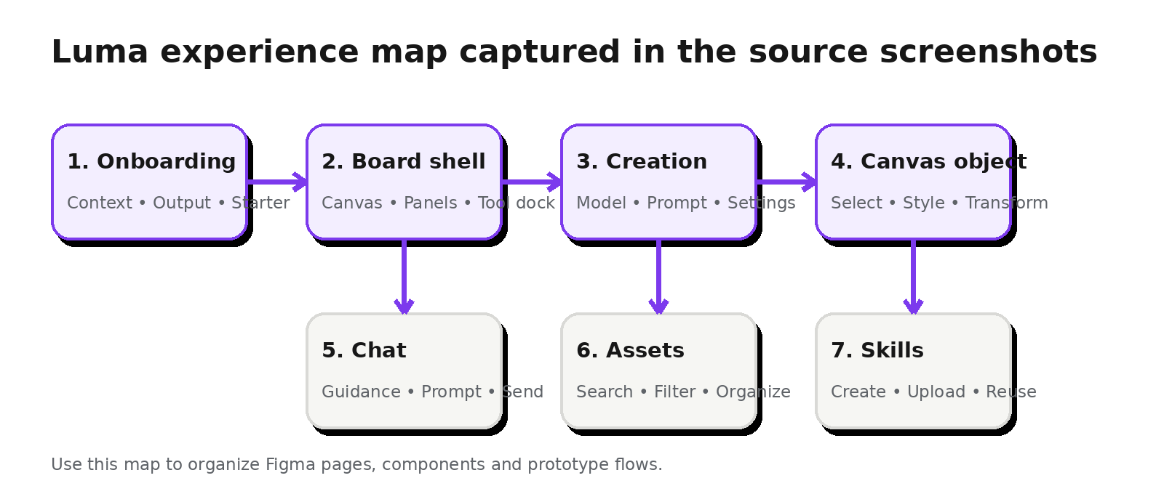

Screen index
Ctrl + click a screen name in Microsoft Word to jump to its detailed specification.
ID | Flow | Screen | Source
ONB-01 | Onboarding | Creation context selection | image1
ONB-02 | Onboarding | First artifact selection | image2
ONB-03 | Onboarding | Starter generation | image3 + image4
BOARD-01 | Board shell | Main board workspace | image5
BOARD-02 | Board shell | Board and page navigation | image9 + image10
TOOL-01 | Creation tools | Floating creation and annotation dock | image31 + toolbar states
IMG-01 | Image generation | Image model picker | image14
IMG-02 | Image generation | Create Image panel – basic settings | image17
IMG-03 | Image generation | Create Image panel – advanced settings | image18
OBJ-01 | Canvas objects | Canvas object selected and styled | image21 + image24
CHAT-01 | Right panel | Chat and guided task panel | image6
ASSET-01 | Right panel | Assets panel – empty state | image41
ASSET-02 | Right panel | Assets panel – filters | image42 + image44
SKILL-01 | Right panel | Skills panel – empty and creation paths | image47
UTIL-01 | Utilities | Panel minimize and viewport controls | image50
FIGMA PACK A companion ZIP contains clean cropped frames, annotated PNGs, diagrams and a CSV inventory.

ONB-01 | Creation context selection
← Back to screen index
PURPOSE  Capture the user’s creative domain before generation begins. | ENTRY / TRIGGER  First-run onboarding, step 1 of 3. | SOURCE  image1
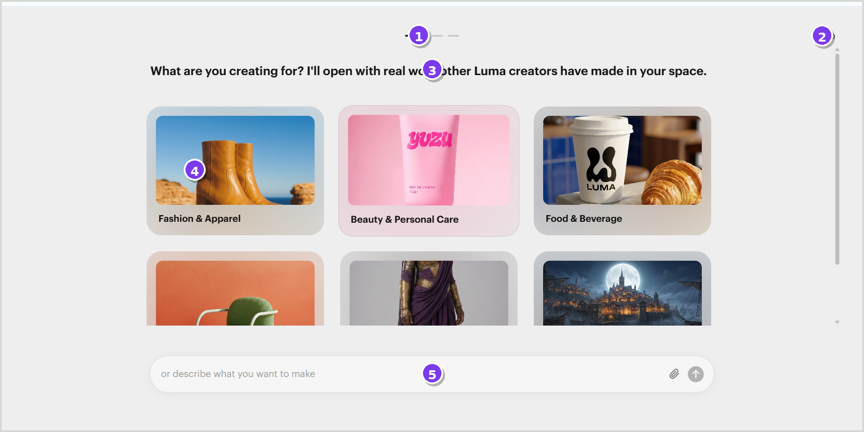
Annotated application crop • source image1
UI anatomy
1 Progress indicator — Shows a three-step onboarding sequence. | 2 Skip action — Lets the user bypass onboarding.
3 Primary question — Explains why the context is being requested. | 4 Category card grid — Image-led options combine visual preview and category label.
5 Free-form composer — Alternative path for text input, attachment and submit.
Interaction notes | Figma handoff notes
• Card selection should advance or update the next step. | • Create a reusable Selectable Card component with default, hover, selected and disabled variants.
• The content area scrolls while the composer remains visually anchored. | • Use a desktop three-column grid; define responsive fallbacks separately.
• Keyboard focus and selected-card state should be specified. | • Keep a clean screenshot frame and an annotated reference frame in Figma.
VALIDATE Selected, hover and validation states are not visible in the supplied screenshot.

ONB-02 | First artifact selection
← Back to screen index
PURPOSE  Ask what the user wants to create first and present immediate examples. | ENTRY / TRIGGER  Onboarding, step 2 of 3. | SOURCE  image2
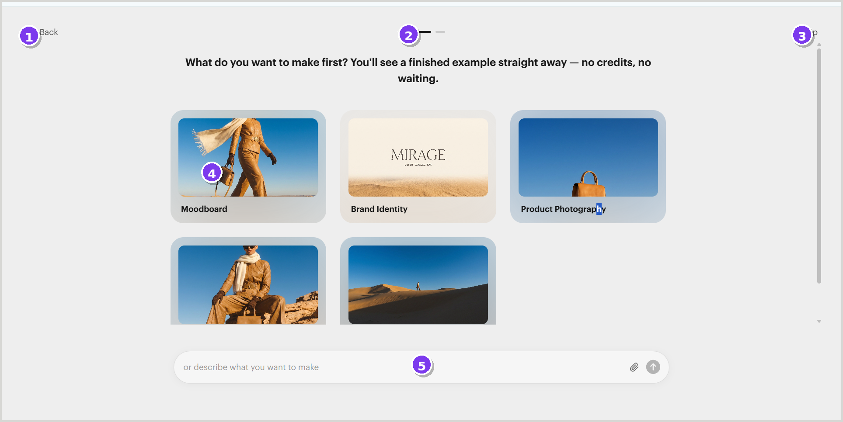
Annotated application crop • source image2
UI anatomy
1 Back action — Returns to the prior onboarding step. | 2 Progress indicator — Highlights the second position in the flow.
3 Skip action — Exits the guided onboarding path. | 4 Artifact cards — Moodboard, brand identity, photography and other outputs.
5 Prompt composer — Allows the user to describe another output directly.
Interaction notes | Figma handoff notes
• Selecting an artifact should seed the starter examples in the next step. | • Model artifact cards as a single component with image, label and selection state.
• Back and Skip require consistent focus, hover and disabled states. | • Create prototype links: back → ONB-01, card selection → ONB-03.
 | • Document card image ratios and text truncation behavior.
VALIDATE The source does not show a selected card or transition animation.

ONB-03 | Starter generation
← Back to screen index
PURPOSE  Give users a low-friction starting point using example prompts and an editable composer. | ENTRY / TRIGGER  Onboarding, step 3 of 3. | SOURCE  image3 + image4
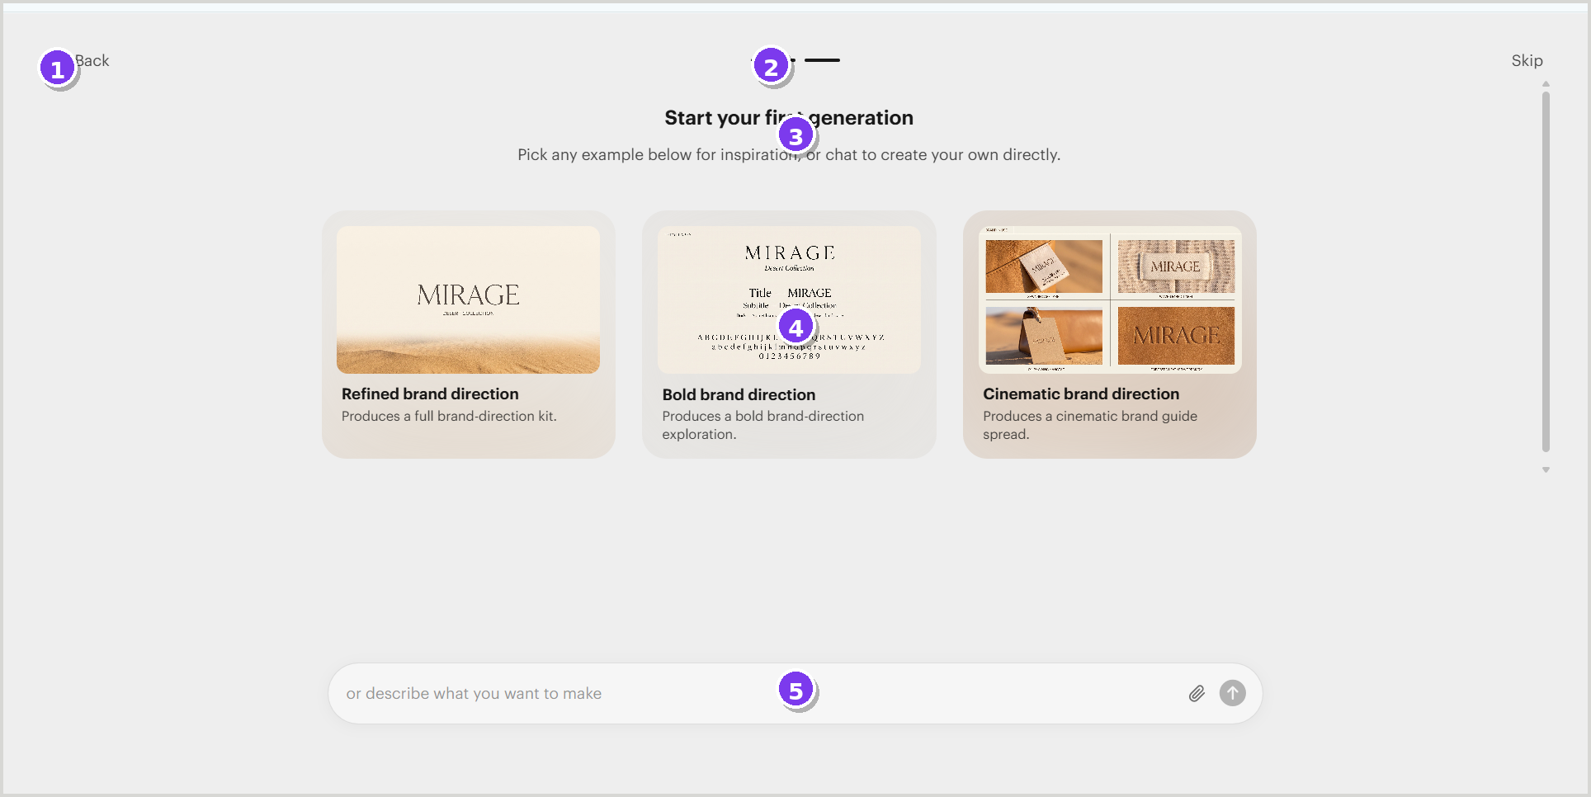
Annotated application crop • source image3 + image4
UI anatomy
1 Back action — Returns to artifact selection. | 2 Progress indicator — Marks the final onboarding step.
3 Instruction block — Explains how to start the first generation. | 4 Example prompt cards — Offers several curated starting directions.
5 Prompt composer — Shows both empty and populated prompt states.
Interaction notes | Figma handoff notes
• Example selection can prefill the composer before the user submits. | • Create separate variants for composer: empty, populated, attachment and submitting.
• The submit control should expose disabled and enabled states. | • Preserve prompt text area growth rules for long content.
 | • Use the second screenshot as the populated-state reference.
VALIDATE Loading, success and failure states after submission are not included.

BOARD-01 | Main board workspace
← Back to screen index
PURPOSE  Define the persistent desktop shell used for creation, prompting and asset management. | ENTRY / TRIGGER  Opened after onboarding or when a board is selected. | SOURCE  image5
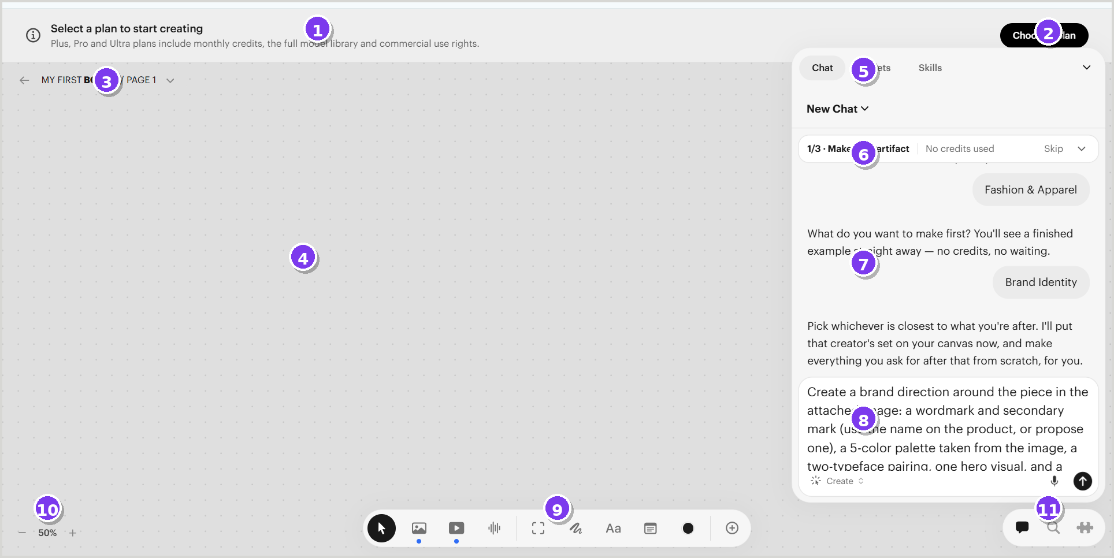
Annotated application crop • source image5
UI anatomy
1 Plan banner — Persistent informational banner with commercial-plan CTA. | 2 Primary CTA — High-contrast “Choose a plan” action.
3 Board / page header — Shows current board and page; opens navigation menu. | 4 Infinite canvas — Primary workspace with dotted grid.
5 Right-panel tabs — Switches Chat, Assets and Skills. | 6 Guided task strip — Displays current onboarding task and skip control.
7 Conversation area — Shows prompts, agent guidance and chips. | 8 Prompt composer — Multi-line input with mode, microphone and send actions.
9 Floating tool dock — Creation and annotation tools. | 10 Zoom control — Displays zoom and opens viewport menu.
11 Utility cluster — Quick access to communication/search/extensions.
Interaction notes | Figma handoff notes
• Canvas, tool dock and right panel operate independently within one shell. | • Build the shell with nested auto-layout frames, not absolute screenshots.
• The right panel can collapse; the canvas should reclaim space. | • Treat the right panel as a 3-tab component with shared header and variant content.
• Tool selection, prompt submission and panel tabs need clear active states. | • Create tokens for floating surfaces: radius, border, shadow and padding.
VALIDATE Exact responsive behavior and panel widths should be measured in the live product.

BOARD-02 | Board and page navigation
← Back to screen index
PURPOSE  Manage boards and pages without leaving the canvas. | ENTRY / TRIGGER  Open the dropdown beside the board/page title. | SOURCE  image9 + image10
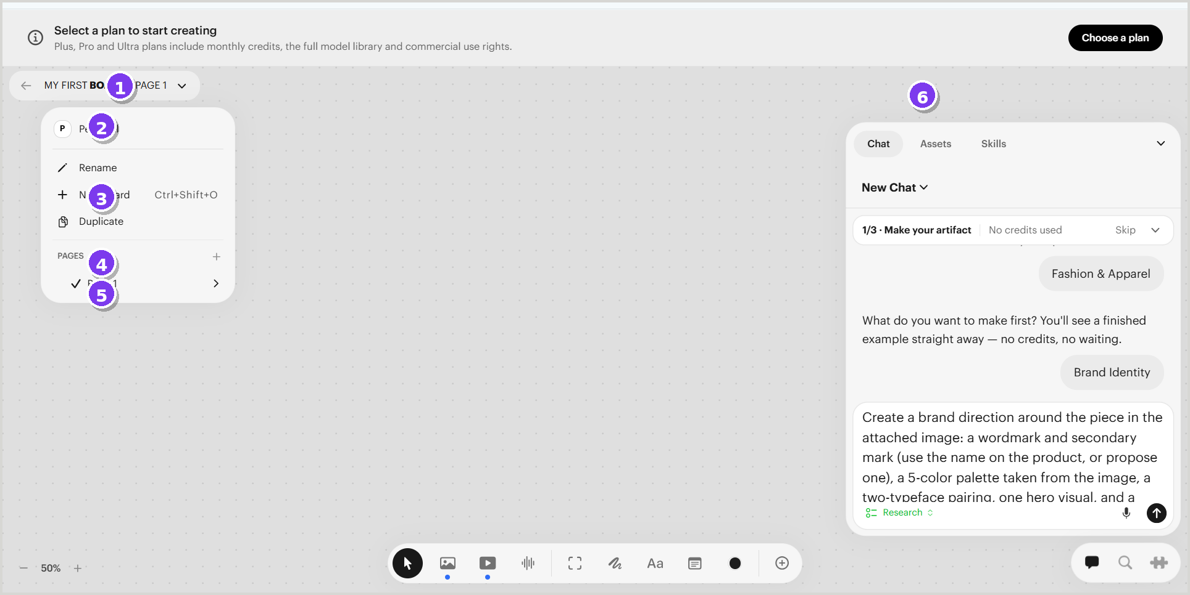
Annotated application crop • source image9 + image10
UI anatomy
1 Board/page trigger — Anchors the navigation menu to the current context. | 2 Workspace context — Shows the current personal/workspace scope.
3 Board actions — Rename, create and duplicate board. | 4 Pages section — Groups pages and provides an add action.
5 Page row — Indicates active page and exposes a nested menu. | 6 Persistent right panel — Remains available while navigation menus are open.
Interaction notes | Figma handoff notes
• Nested menus should support click-away, Escape and keyboard navigation. | • Create separate Menu, Menu Item, Nested Menu and Destructive Item components.
• Destructive actions need confirmation and disabled states where applicable. | • Prototype the page row to open the secondary action menu.
 | • Use the secondary screenshot for Copy Link, Rename, Duplicate and Delete states.
VALIDATE Confirmation dialogs for deletion are not captured.

TOOL-01 | Floating creation and annotation dock
← Back to screen index
PURPOSE  Provide rapid access to generation, media and canvas annotation tools. | ENTRY / TRIGGER  Persistent at the bottom center of the board. | SOURCE  image31 + toolbar states
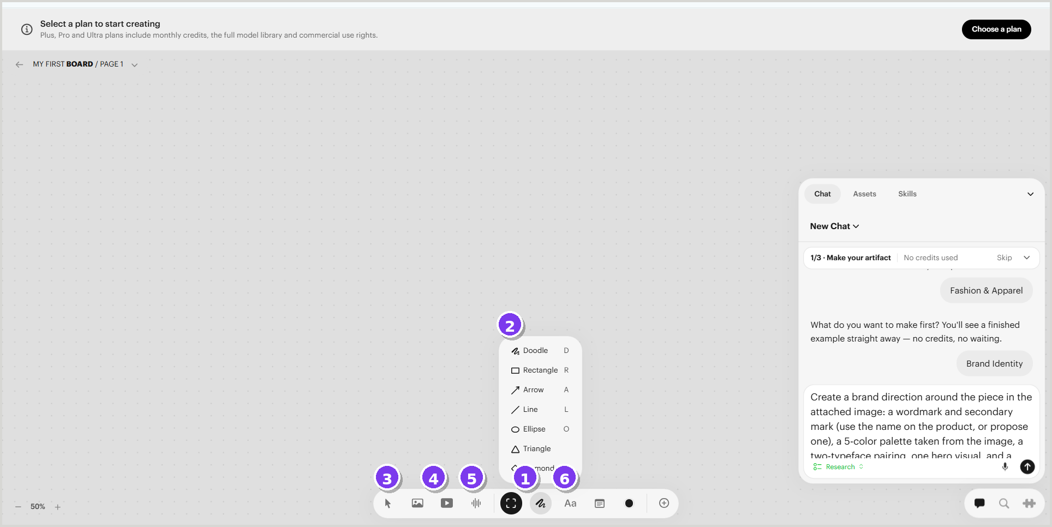
Annotated application crop • source image31 + toolbar states
UI anatomy
1 Floating dock — Rounded, centered container for tools. | 2 Shapes menu — Doodle, rectangle, arrow, line, ellipse, triangle and diamond.
3 Media generation tools — Image, video and audio entry points are grouped together. | 4 Selection / frame tools — Switches canvas interaction mode.
5 Text and note tools — Adds text and structured notes to the canvas. | 6 Color / add controls — Applies appearance or expands available tools.
Interaction notes | Figma handoff notes
• Hover shows tooltips and keyboard shortcuts. | • Create an Icon Button component with default, hover, pressed, active and disabled variants.
• Selected tools use a filled active state. | • Use component properties for tooltip, shortcut and menu presence.
• Expanded menus remain anchored to the selected tool. | • Keep menu alignment rules consistent when the dock is near viewport edges.
VALIDATE The exact ordering of all icons should be validated from the live interface.

IMG-01 | Image model picker
← Back to screen index
PURPOSE  Select an image-generation model directly from the tool dock. | ENTRY / TRIGGER  Choose the image tool in the floating dock. | SOURCE  image14
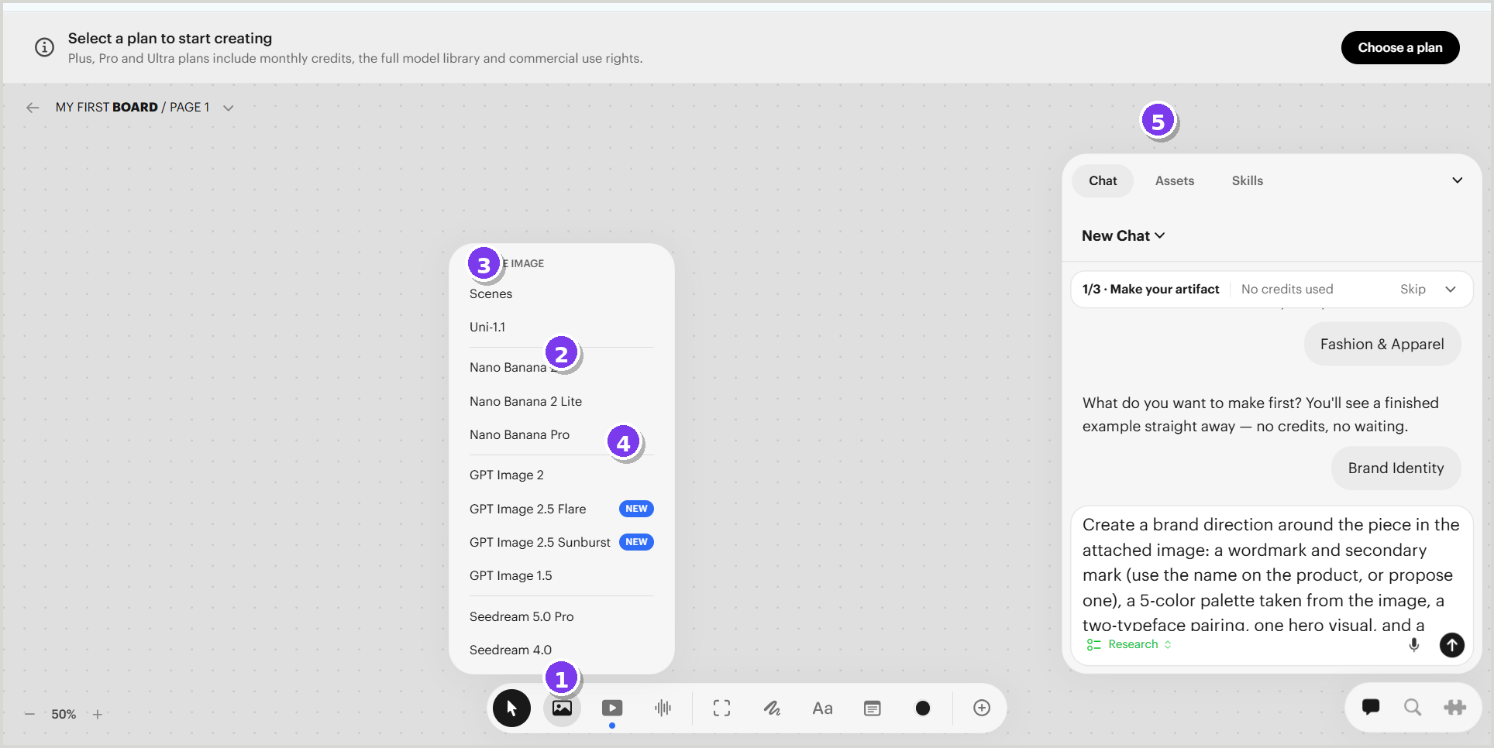
Annotated application crop • source image14
UI anatomy
1 Image tool — Active state in the bottom dock. | 2 Model picker — Anchored menu listing available image models.
3 Model groups — Visual separators organize model families. | 4 Status badges — “New” badges highlight recently added options.
5 Right utility panel — Remains open while the picker is active.
Interaction notes | Figma handoff notes
• Selecting a model should create or configure an image node. | • Build a Model Option row with provider/family, model name and optional badge.
• Long model lists should support scrolling and keyboard search. | • Use a constrained-height popover with scroll and sticky title.
 | • Add variants for availability, plan gating and recently added models.
VALIDATE Pricing, credit cost and model-detail states are not present in the screenshots.

IMG-02 | Create Image panel – basic settings
← Back to screen index
PURPOSE  Collect reference images, prompt text and output settings for an image node. | ENTRY / TRIGGER  After selecting an image model or opening an image node. | SOURCE  image17
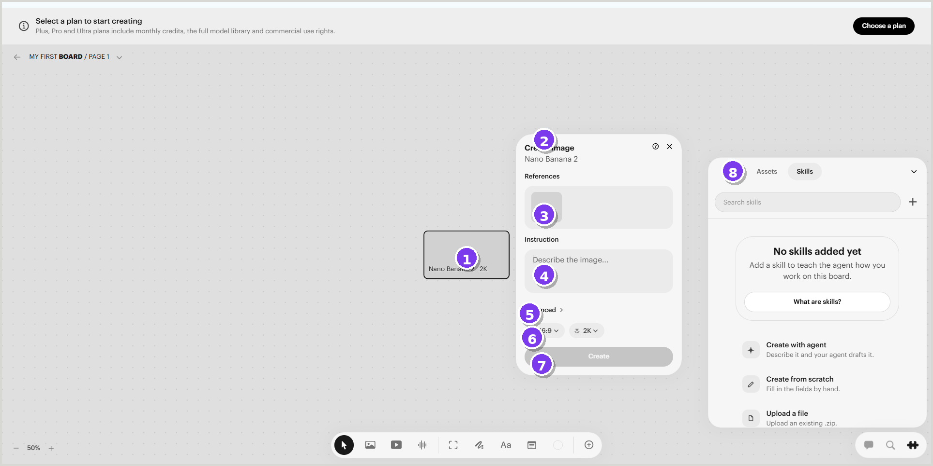
Annotated application crop • source image17
UI anatomy
1 Canvas node — Represents the pending output on the board. | 2 Panel header — Displays action name, model, help and close.
3 References — Drop zone for one or more input assets. | 4 Instruction — Prompt field for the generation request.
5 Advanced disclosure — Expands additional model controls. | 6 Output controls — Aspect ratio and resolution selectors.
7 Create button — Disabled until required input is valid. | 8 Skills panel — Independent contextual panel on the right.
Interaction notes | Figma handoff notes
• Form validation controls the Create button state. | • Use a reusable Generation Panel template with slots for model-specific controls.
• Closing the panel should not remove the canvas node without confirmation. | • Create field variants for empty, focused, populated, error and disabled.
• References may support drag-and-drop and asset selection. | • Model the canvas node and settings panel as linked components in prototypes.
VALIDATE Reference limits, validation messages and upload progress are not captured.

IMG-03 | Create Image panel – advanced settings
← Back to screen index
PURPOSE  Expose optional controls without overwhelming the basic generation form. | ENTRY / TRIGGER  Expand “Advanced” in the Create Image panel. | SOURCE  image18
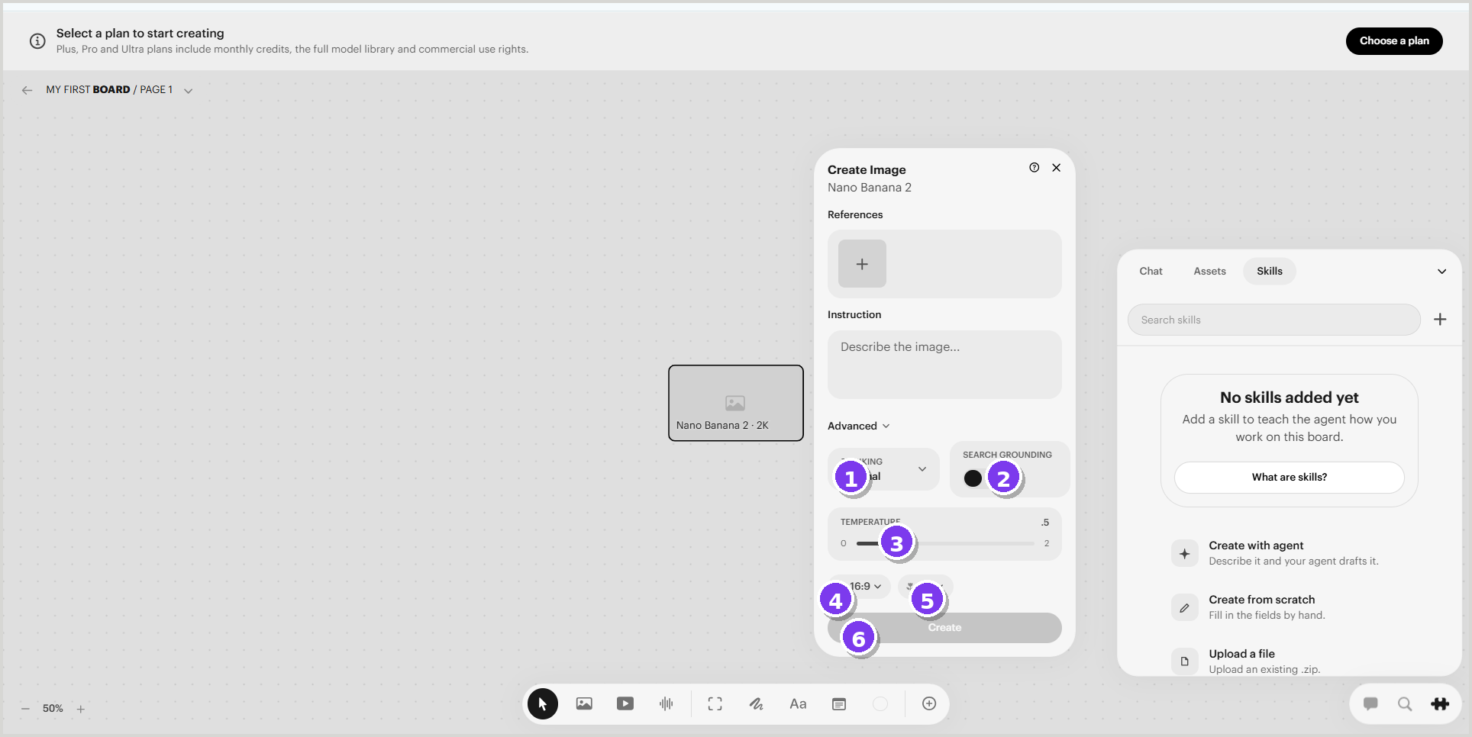
Annotated application crop • source image18
UI anatomy
1 Thinking control — Dropdown for reasoning/processing level. | 2 Search grounding — Toggle control for grounded generation behavior.
3 Temperature — Slider with numeric range and current value. | 4 Aspect ratio — Compact output-format selector.
5 Resolution — Compact output-size selector. | 6 Create button — Primary submit action; shown disabled here.
Interaction notes | Figma handoff notes
• Advanced controls should retain their values when collapsed. | • Create advanced-setting rows as reusable labeled controls.
• Slider requires keyboard support, min/max labels and visible focus state. | • Document which controls vary by model and which are global.
 | • Use component properties for expanded/collapsed and enabled/disabled states.
VALIDATE The supplied screenshot does not show validation, tooltips or successful submission.

OBJ-01 | Canvas object selected and styled
← Back to screen index
PURPOSE  Show how generated nodes are selected and edited on the canvas. | ENTRY / TRIGGER  Select an image-generation node on the board. | SOURCE  image21 + image24
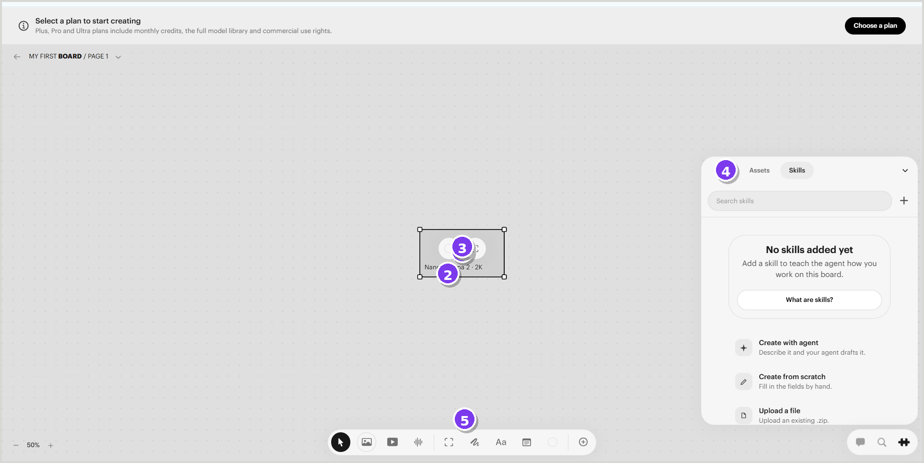
Annotated application crop • source image21 + image24
UI anatomy
1 Selection bounds — Bounding box and corner handles indicate selection. | 2 Object label — Displays model and output settings on the node.
3 Inline actions — Circular controls expose quick actions for the selected object. | 4 Context panel — Skills remains available while the node is selected.
5 Tool dock state — Image tool remains active in the dock.
Interaction notes | Figma handoff notes
• Selection should support drag, resize and keyboard movement. | • Build object states: default, hover, selected, generating, success, error.
• Inline actions appear only for the active object. | • Separate selection handles from object content to simplify responsive resizing.
• Color popover is anchored above the object in the secondary state. | • Use overlays for contextual controls and popovers.
VALIDATE Rotation, multi-select, grouping and object context menus are not shown.

CHAT-01 | Chat and guided task panel
← Back to screen index
PURPOSE  Guide the user, collect intent and coordinate generation from a persistent conversational panel. | ENTRY / TRIGGER  Chat tab selected in the right panel. | SOURCE  image6
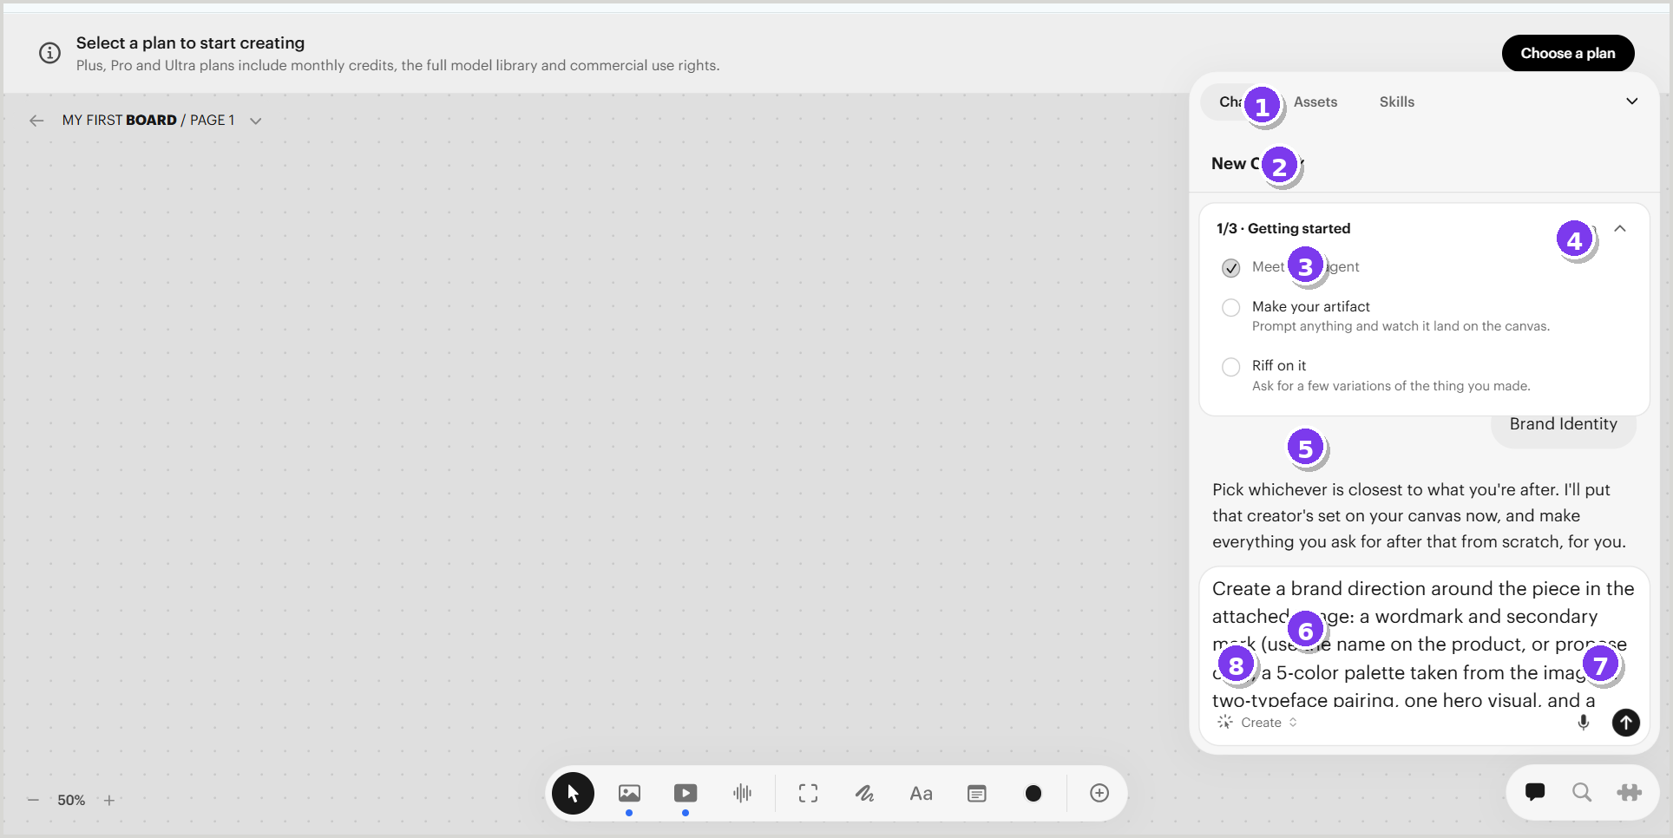
Annotated application crop • source image6
UI anatomy
1 Panel tabs — Chat is active; Assets and Skills remain available. | 2 Conversation selector — Starts or switches chat context.
3 Getting Started checklist — Shows progress across onboarding actions. | 4 Skip / collapse — Controls the guided task module.
5 Conversation stream — Agent guidance and user choices appear as messages/chips. | 6 Prompt composer — Multi-line request field.
7 Send control — Submits the prompt. | 8 Mode / attachment controls — Selects action mode and adds voice or attachments.
Interaction notes | Figma handoff notes
• Checklist expands/collapses independently of the conversation. | • Build Chat Panel as a compound component: tabs, header, task card, message list and composer.
• Composer should preserve long text and show submitting state. | • Create message variants for agent, user, system and structured choice chips.
• Panel can minimize using the top-right control. | • Specify empty, loading, streaming, error and completed response states.
VALIDATE Streaming response and error states are not included in the source.

ASSET-01 | Assets panel – empty state
← Back to screen index
PURPOSE  Provide a searchable inventory of content placed on the current board. | ENTRY / TRIGGER  Assets tab selected in the right panel. | SOURCE  image41
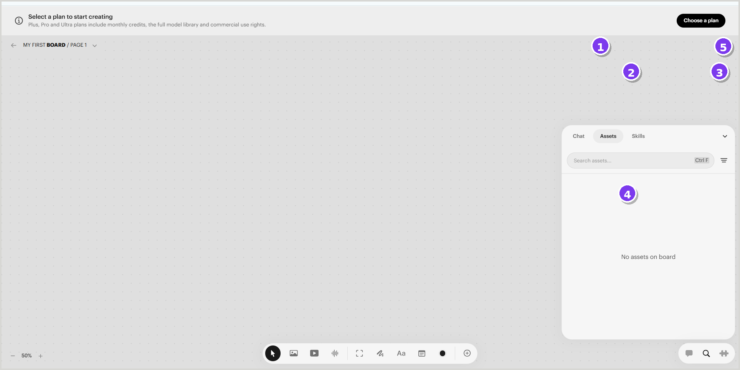
Annotated application crop • source image41
UI anatomy
1 Assets tab — Selected state within the panel tabs. | 2 Search field — Filters assets on the current board.
3 Filter trigger — Opens type, source, label and archive filters. | 4 Empty state — Communicates that no assets are currently on the board.
5 Minimize control — Collapses the full right panel.
Interaction notes | Figma handoff notes
• Search shortcut is displayed inside the field. | • Create shared Search Field and Empty State components.
• Empty state should transition to a grid/list when assets appear. | • Define asset card variants before adding populated views.
 | • Use the same panel shell as Chat and Skills to maintain alignment.
VALIDATE No populated asset grid/list is present in the supplied screenshots.

ASSET-02 | Assets panel – filters
← Back to screen index
PURPOSE  Filter assets by media type, origin, label or archive state. | ENTRY / TRIGGER  Open the filter icon in the Assets panel. | SOURCE  image42 + image44
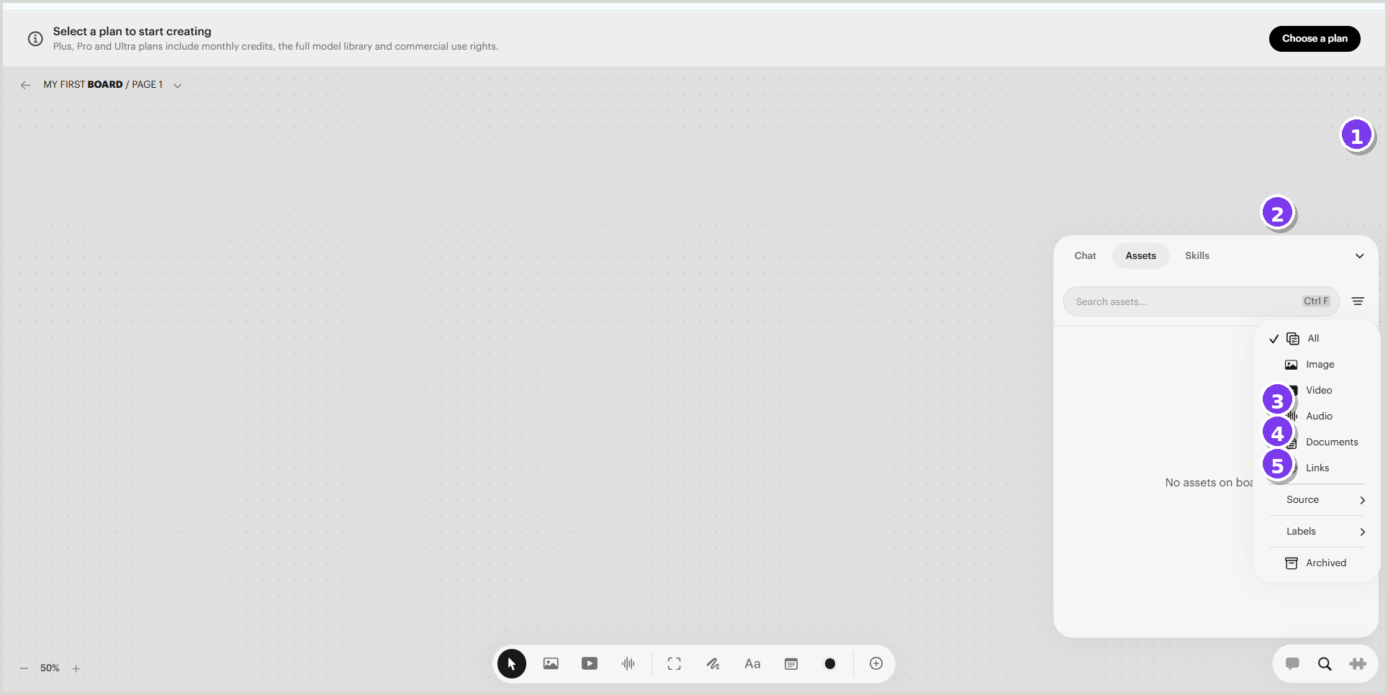
Annotated application crop • source image42 + image44
UI anatomy
1 Filter trigger — Anchors the filter menu. | 2 Media-type filters — All, Image, Video, Audio, Documents and Links.
3 Source submenu — Narrows content by where it originated. | 4 Labels submenu — Narrows content by assigned labels.
5 Archived filter — Surfaces archived items.
Interaction notes | Figma handoff notes
• Nested submenus should support hover, click, keyboard and click-away dismissal. | • Use a multi-level Menu component shared with board/page navigation.
• Active filters need chips, counts or a visible reset state. | • Add checkmark, icon, submenu and destructive/archived variants.
 | • Prototype filter application and clear-all behavior.
VALIDATE Filtered results, counts and no-match states are not captured.

SKILL-01 | Skills panel – empty and creation paths
← Back to screen index
PURPOSE  Teach or extend the agent with reusable skills attached to the board. | ENTRY / TRIGGER  Skills tab selected in the right panel. | SOURCE  image47
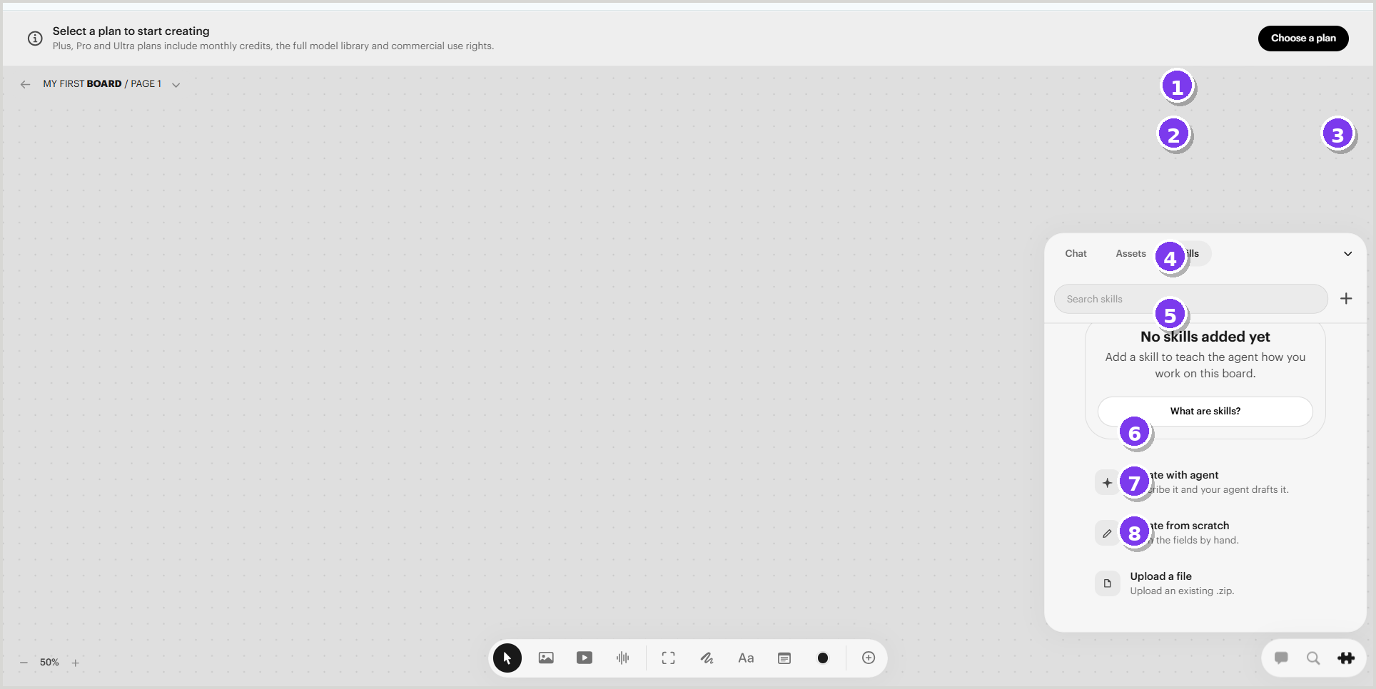
Annotated application crop • source image47
UI anatomy
1 Skills tab — Selected state within the panel shell. | 2 Search skills — Searches installed skills.
3 Add action — Opens skill creation/import options. | 4 Empty state — Explains why the list is empty.
5 Help action — Links to a “What are skills?” explanation. | 6 Create with agent — Guided skill drafting path.
7 Create from scratch — Manual skill definition path. | 8 Upload a file — Imports an existing skill package.
Interaction notes | Figma handoff notes
• The Add action and empty-state actions should converge on consistent creation flows. | • Build skill cards, empty state and create-menu patterns as reusable components.
• Uploaded files require progress, validation and failure handling. | • Add states for draft, installed, disabled, update available and error.
 | • Prototype the three creation paths from the empty state.
VALIDATE The source does not include a populated skills list or skill editor.

UTIL-01 | Panel minimize and viewport controls
← Back to screen index
PURPOSE  Control canvas scale, viewport behavior and available screen space. | ENTRY / TRIGGER  Open the zoom control or hover the right-panel minimize control. | SOURCE  image50
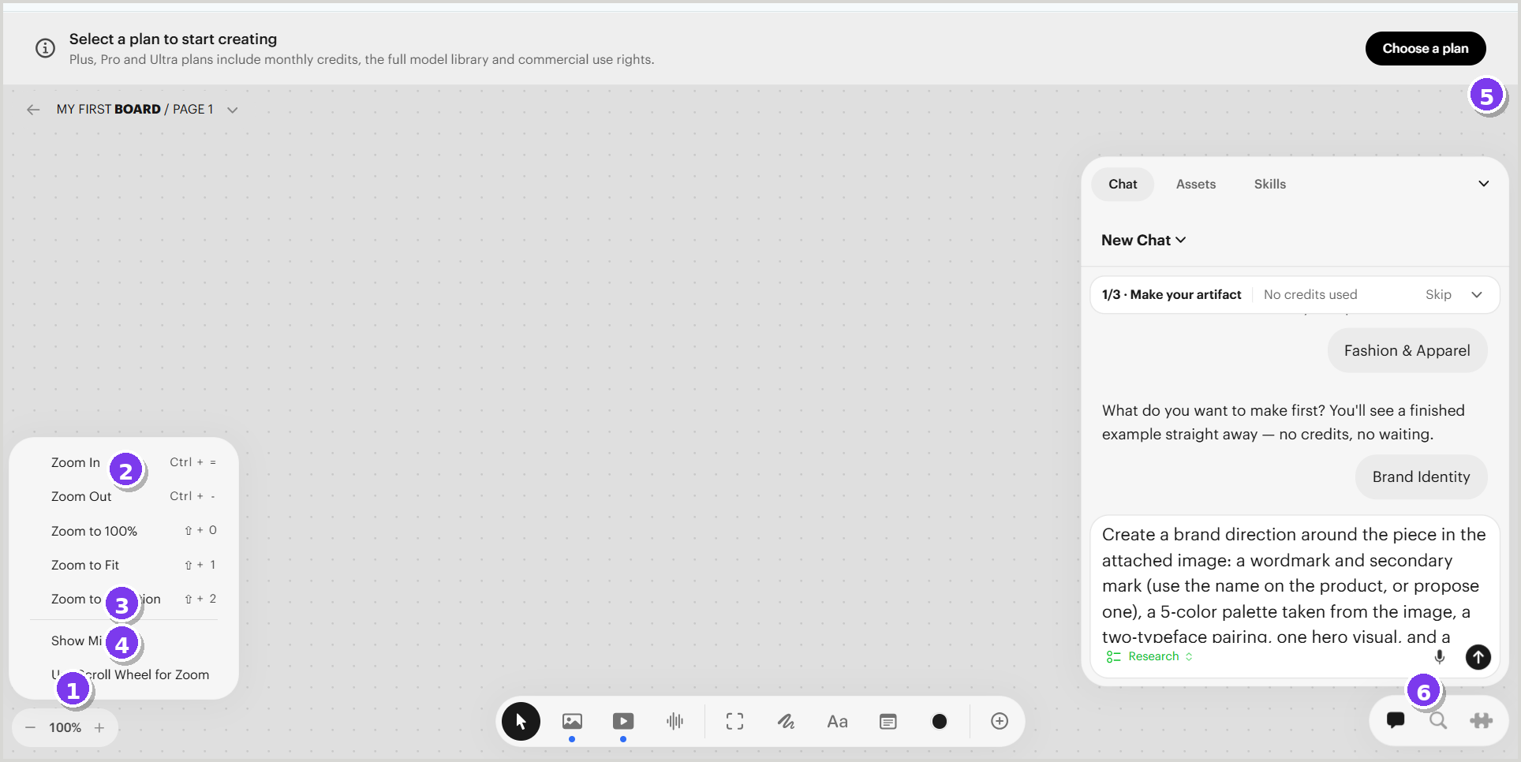
Annotated application crop • source image50
UI anatomy
1 Zoom control — Shows current percentage and increment/decrement actions. | 2 Zoom menu — Provides zoom in/out, 100%, fit and selection commands.
3 Minimap option — Toggles an overview navigator. | 4 Scroll-wheel option — Changes the input behavior for zooming.
5 Panel minimize — Collapses the right utility panel. | 6 Utility cluster — Provides quick secondary actions at the lower right.
Interaction notes | Figma handoff notes
• Keyboard shortcuts are shown alongside zoom commands. | • Create a command-menu row with label, shortcut and optional check state.
• Panel collapse should preserve the active tab and restore prior width. | • Use persistent state variables for minimap and scroll-wheel settings.
 | • Document focus order for zoom, utility cluster and panel controls.
VALIDATE Minimized-panel appearance is captured elsewhere, but restoration behavior is not shown.

Figma component model and design-system observations
The following structure is inferred from recurring UI patterns in the supplied screenshots and should be validated against the live product.
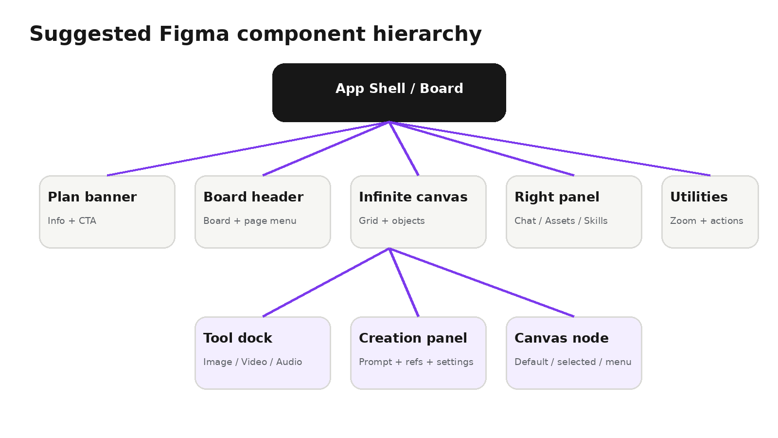
Area | Observed pattern | Figma recommendation
Surfaces | White floating panels, subtle border/shadow, large corner radii. | Create Surface/Large, Surface/Popover and Surface/Dock variants.
Actions | Black primary actions; light neutral secondary actions. | Use semantic button tokens: primary, secondary, ghost, destructive.
Navigation | Board menu, panel tabs and nested command menus recur. | Share Menu Item and Tab components across flows.
Forms | Large prompt areas plus compact selects, toggles and sliders. | Create a form library with consistent labels, help, errors and disabled states.
Canvas objects | Nodes expose selection bounds and contextual overlays. | Separate object content, selection chrome and action overlay layers.
State coverage | Default, hover, active, selected, expanded, empty and disabled are visible. | Add loading, success, error, no-results and permission states to the design system.

Recommended screenshot backlog
The uploaded file is strong on desktop board controls, but several implementation-critical states are not yet represented. Capture the following next.
Authentication & board list | Sign-in, workspace switcher, board gallery, create/open/delete board.

Plan & entitlements | Choose-a-plan modal, model gating, credit balance, insufficient-credit state.

Generation lifecycle | Queued, generating, streaming progress, success, retry, failure and cancellation.

Populated assets | Grid/list view, asset selection, drag to canvas, preview, download, archive and restore.

Skills lifecycle | Skill editor, draft/published states, install/update/remove, permissions and validation.

Canvas editing | Multi-select, group, align, duplicate, context menu, keyboard shortcuts, undo/redo.

Collaboration | Share, comments, presence, roles, read-only access and conflict handling.

Responsive behavior | Laptop, tablet and narrow-window panel behavior; dock overflow and breakpoint rules.

Accessibility | Keyboard-only navigation, focus rings, screen-reader labels, contrast and reduced motion.

Capture standard
- Use the same desktop viewport and browser zoom for every state.
- Capture one interaction state per frame: default, hover, focus, active, disabled, loading, error and success.
- Keep a clean application crop and a separate annotated copy.
- Name files with stable screen IDs and state suffixes, for example BOARD-01_default.png.
- Record the trigger, expected result, shortcut, permissions and responsive behavior alongside the image.

Appendix – source screenshot mapping
All screenshots in this guide come from the uploaded Luma.docx. Browser chrome was removed for cleaner design reference; original source files remain unchanged.
Screen ID | Primary image | Secondary image | Output file
ONB-01 | image1.png | — | annotated/ONB-01.png
ONB-02 | image2.png | — | annotated/ONB-02.png
ONB-03 | image3.png | image4.png | annotated/ONB-03.png
BOARD-01 | image5.png | — | annotated/BOARD-01.png
BOARD-02 | image9.png | image10.png | annotated/BOARD-02.png
TOOL-01 | image31.png | — | annotated/TOOL-01.png
IMG-01 | image14.png | — | annotated/IMG-01.png
IMG-02 | image17.png | — | annotated/IMG-02.png
IMG-03 | image18.png | — | annotated/IMG-03.png
OBJ-01 | image21.png | image24.png | annotated/OBJ-01.png
CHAT-01 | image6.png | — | annotated/CHAT-01.png
ASSET-01 | image41.png | — | annotated/ASSET-01.png
ASSET-02 | image42.png | image44.png | annotated/ASSET-02.png
SKILL-01 | image47.png | — | annotated/SKILL-01.png
UTIL-01 | image50.png | — | annotated/UTIL-01.png

