Si649-lab2 42070296 Hsiao Yi-Ting

1. 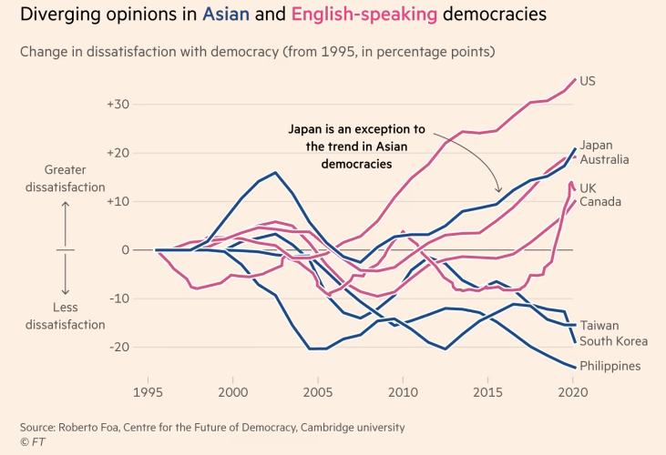

Firstly, in the title, “Asian “is marked as blue and “English-speaking” is marked as red. Thus by instinct, without reading any words, I will know that lines that are red should be English-speaking countries whereas blue lines should represent Asian. The x-axis labels are labeled every 5 years (instead of each year), which make the chart looks clean. Also, there is a constant line at 0 in the y-axis, which makes it reasonable to understand that values above 0 should be positive values (which is dissatisfaction in this case), and below should be negative values. As a result, without reading any text yet, we can retrieve the information below:

1. The values(dissatisfaction) of red lines are increasing over the time
2. The values(dissatisfaction) of blue lines, in general, are decreasing over the time.
3. And we will see one blue line that behave quite differently, once we come up with this idea then we can check the memo on the graph saying that line which represents Japan is an exception.

Here is an example of an ugly visualization. Here are the points that make it ugly:

1. The y-axis got too many zeros. I will have to count how many zeros are there in order to know the magnitude (thousands? Millions? Or billions?)
2. Secondly, the colors makes it ugly. The background is black and the words are white, which make the user hard to read.
3. There is no need 3D in this picture, and the encodings are very ugly – it is hollow and a lot of lines stick together which make it very hard to read.