# Tableau Lab Answer Sheet – Independent Activity Part 1

Use this answer sheet to answer the questions with the **red squares ⬜** from the Tableau Lab (see lab handout for the entire set of instructions). You can include partial screenshots of displays/visualizations if the entire display is too big. We just want to know that you were able to generate the answer/transformation.

**Question 6: Which movies were about dragons?**



**Question 9: Are there directors who have never directed a profitable movie? Who are they?**

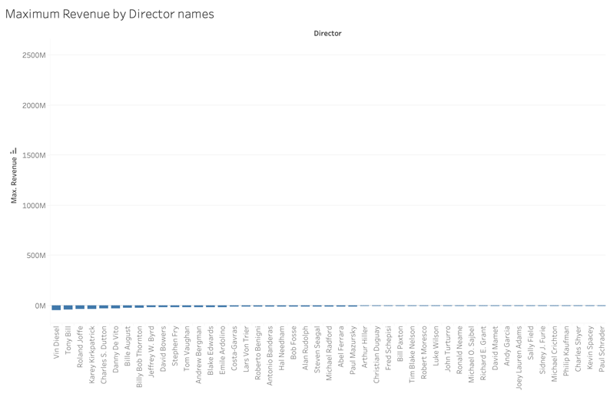

**Question 11: Which director has directed the most profitable Comedy movie?**

**Brad Bird**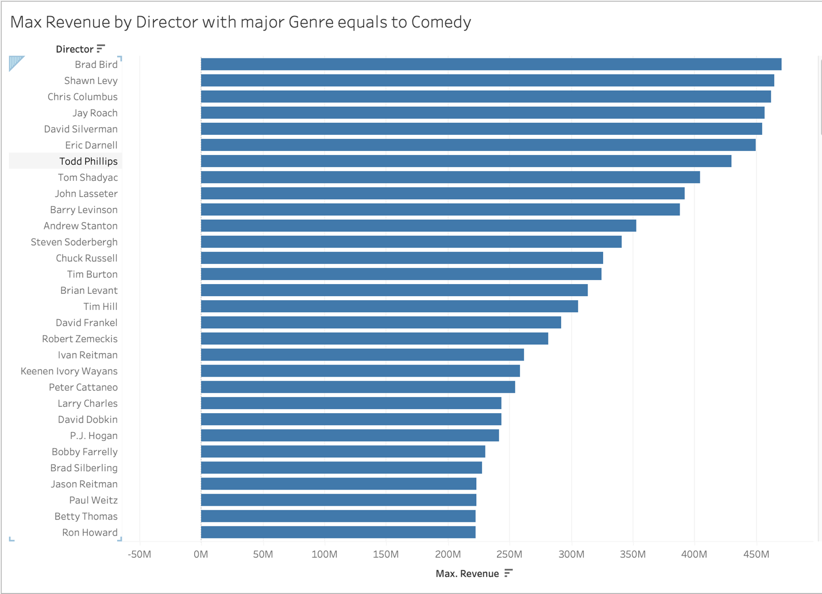

**Question 12: (bonus question): Do movies that contain the word “star” have higher average revenue than movies with “dragon” in the title?**

**Yes.**

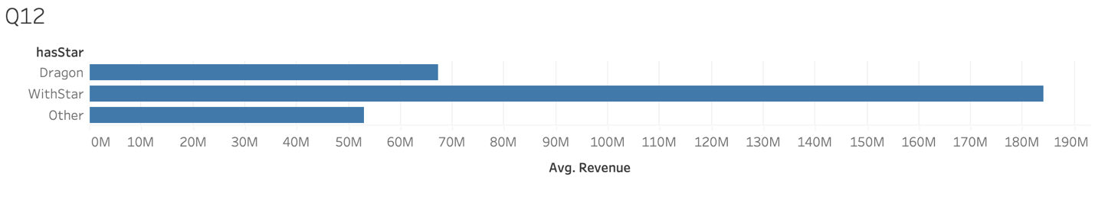

**Question 15: Is it better to invest in action movies or comedies? Which director would you invest in?**

**Action Movie.**

**James Cameron.**

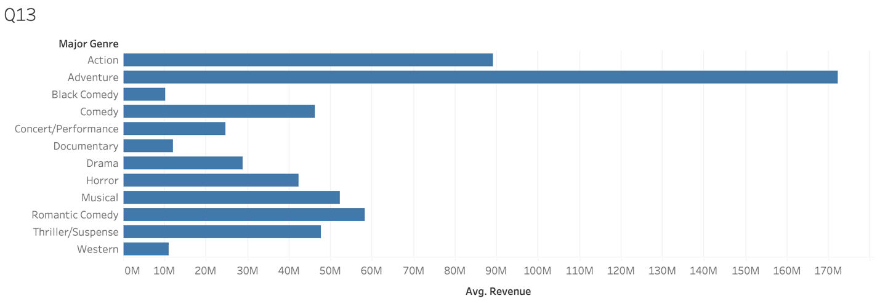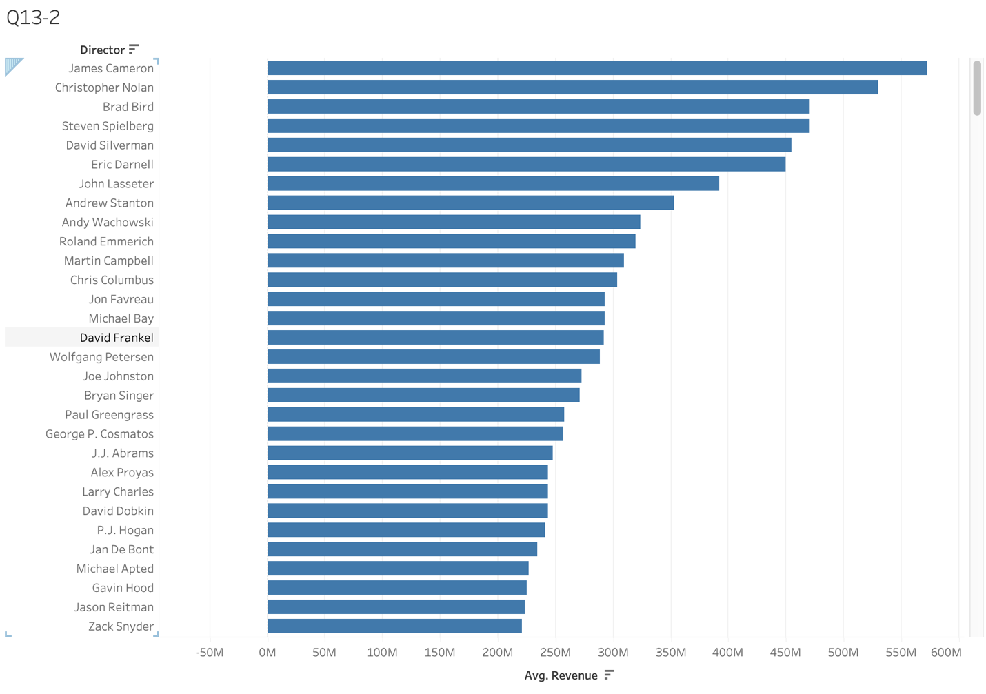

**Question 16: What’s the relationship between IMDB ratings and revenue? Are highly-rated movies more profitable?**

**The relationship between IMDB rating and revenue is somewhat correlated. In general, more profitable movies are highly-rated. But highly-rated movies may not always profitable.**

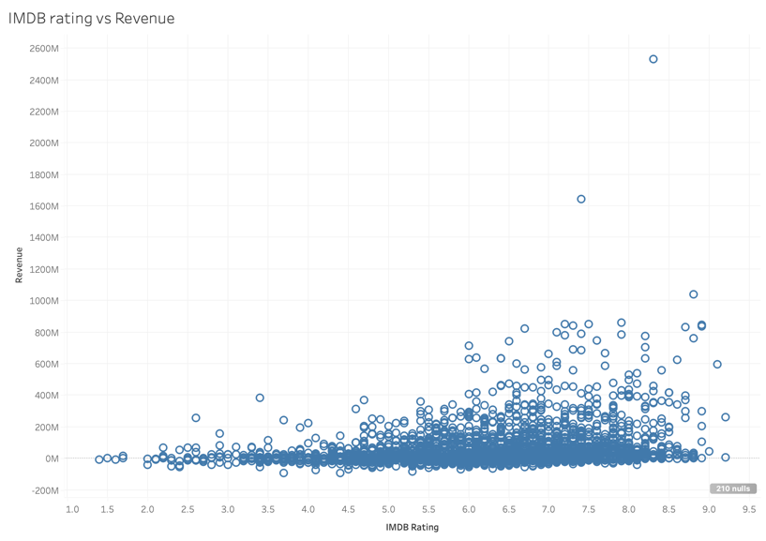

**Question 18: Who would you invest in?**

**David Yates because he has a highest average revenue which is over 700M.**