**National University of Technology**

**Computer Science Department**

**Program:** Artificial intelligence

**Course:** PFAI (LAB)

**Lab Report – 07**

|  |  |
| --- | --- |
| Submitted To: | Submitted By: |
| Lec. Umer Aftab | Mohsin Pervaiz |
|  | F23607009 |

**Exercise 1: Hello, World!**

**CODE**

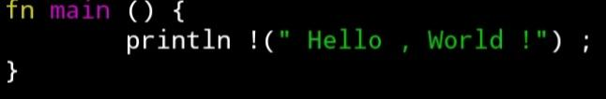

**OUTPUT**

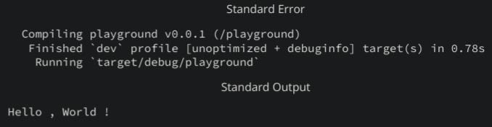

**Exercise 2: Variables & Mutability**

**CODE**

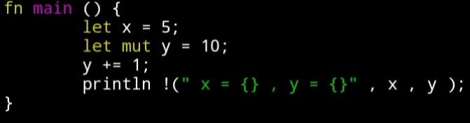

**OUTPUT**

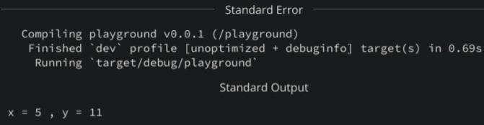

**Exercise 3: Ownership & Borrowing**

**CODE**

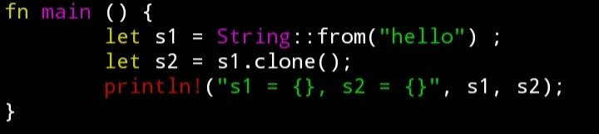

**OUTPUT**

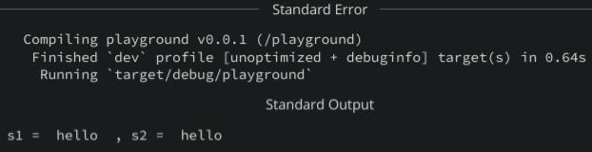

**Exercise 4: Structs & Methods**

**CODE**

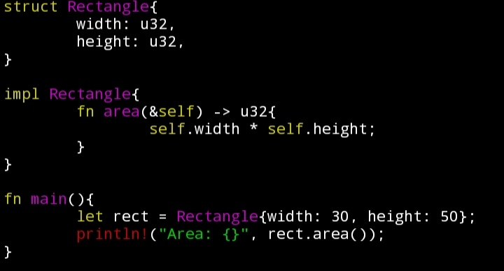

**OUTPUT**

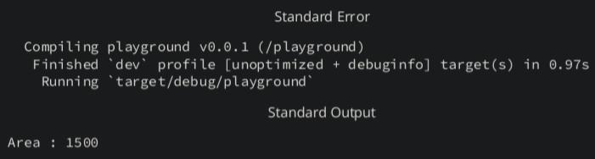

**Exercise 5: Error Handling**

**CODE**

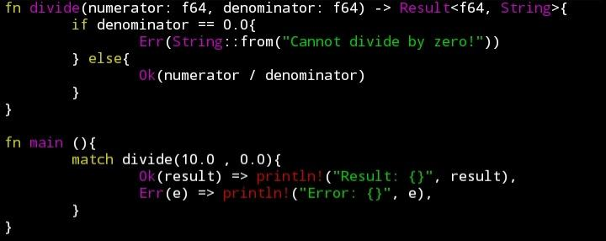

**OUTPUT**

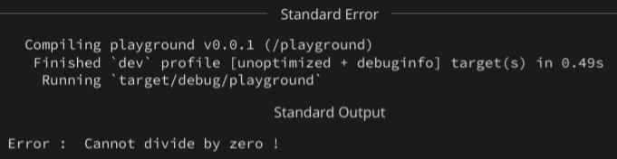

**Exercise 6: Functions & Control Flow**

**CODE**

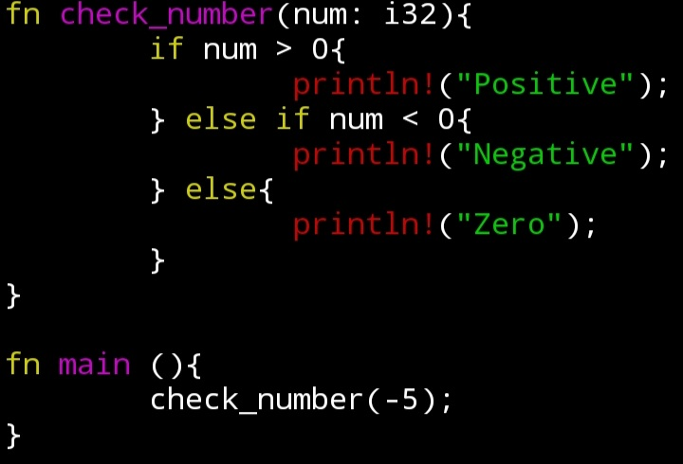

**OUTPUT**

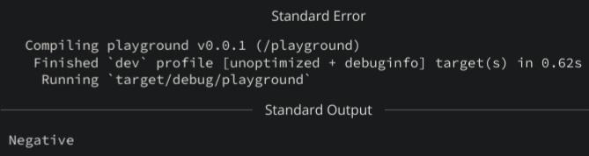

**Exercise 7: Arrays & Loops**

**CODE**

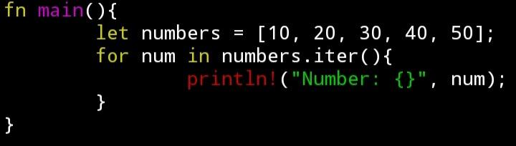

**OUTPUT**

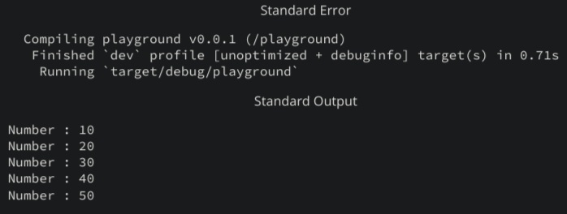

**Exercise 8: Enums & Pattern Matching**

**CODE**

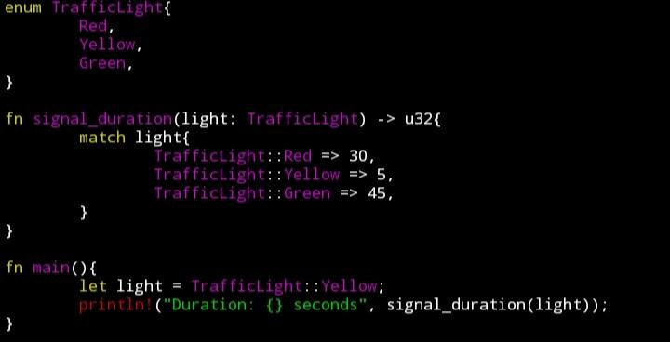

**OUTPUT**

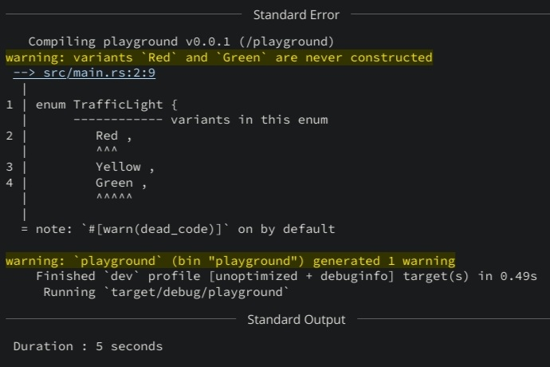

**Exercise 9: The Option Type**

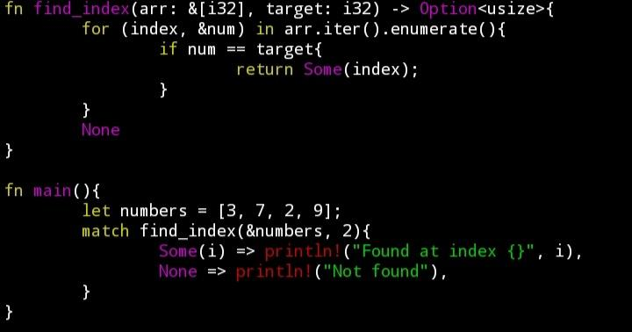**CODE**

**OUTPUT**

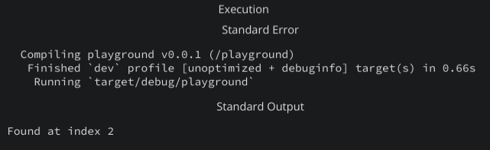

**Exercise 10: Basic File I/O**

**CODE**

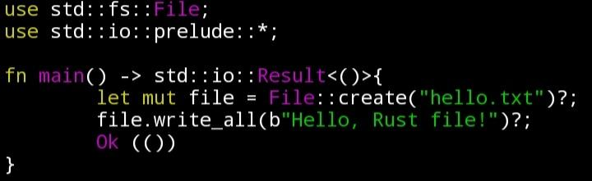

**OUTPUT**

