A
PROJECT REPORT ON
“HYBRID VEHICLE”
A Report submitted in partial fulfillment for the Degree of



B. TECH
IN
MECHANICAL ENGINEERING
SUBMITTED BY:
UNDER THE GUIDENCE OF:
PROF.SANJIV KUMAR SETHI
DEPARTMENT OF MECHANICAL ENGINEERING

2101305203 | SUDHANSU PANDA
2101305204 | SUNIL KUMAR BISWAL
2221305093 | ABHISEK RAUTA
2221305096 | AKASH SETHI
2221305097 | AKHAYA KUMAR MALIK

KALAM INSTITUTE OF TECHNOLOGY
GOVINDAVIHAR, GOVINDAPUR, LAXMIPUR, BERHAMPUR-761003
www.kit.edu.in
(BATCH: 2021-2025)

CERTIFICATE

This is to certify that the project report entitled “Hybrid Vehicle” is submitted to B.P.U.T., Rourkela in partial fulfilment of the requirements for the award of degree of Bachelor of Technology in Mechanical Engineering from Kalam
Institute of Technology, Berhampur.
It is faithful record of project work carried out by
This project report has been approved as it satisfies the academic requirements in
respect of project work prescribed for the said degree.
PROF. SANJIV KUMAR SETHI
PROJECT SUPERVISIOR
PROF. SANJIV KUMAR SETHI
HOD
DEPT OF MECHANICAL ENGINEERING
EXTERNAL EXAMINER
DR. PABITRA KUMAR TRIPATHY
PRINCIPAL
KIT, BERHAMPUR

2101305203 | SUDHANSU PANDA
2101305204 | SUNIL KUMAR BISWAL
2221305093 | ABHISEK RAUTA
2221305096 | AKASH SETHI
2221305097 | AKHAYA KUMAR MALIK

ACKNOWLEDGEMENT

It is my proud privilege to epitomize my deepest sense of gratitude to my guide Prof. Sanjiv Kumar Sethi, Dept. of Mechanical Engineering, for his valuable guidance keen and sustain interest, innovative idea and persistence endeavor. His inspiring assistance and affectionate care enabled me to complete my work successfully within prescribed time.
We are very thankful to Prof. Sanjiv Kumar Sethi, HOD, K.I.T., Berhampur, for his encourage and suggestions which helped me a lot to complete my project.
We take this opportunity to thank Mr. Kanhu Charan Choudhury, Chairman cum Director, KIT, Dr. Pabitra Kumar Tripathy, Principal, KIT and other faculty members who helped inpreparing the guidelines.
We extend my sincere thanks to one and all of KIT family for the completion of this document on the project report format guidelines.
At last, but not the least, we would like to thank my project team as well as my parents and those people who have supported me and helped me towards the completion ofproject work.

2101305203 | SUDHANSU PANDA
2101305204 | SUNIL KUMAR BISWAL
2221305093 | ABHISEK RAUTA
2221305096 | AKASH SETHI
2221305097 | AKHAYA KUMAR MALIK

DECLARATION

We declare that this written submission represents my ideas in my own words and where others' ideas or words have been included, I have adequately cited and referenced the original sources. I also declare that I have adhered to all principles of academic honesty and integrity and have not misrepresented or fabricated or falsified any idea/data/fact/source in my submission. I understand that any violation of the above will be cause for disciplinary action by the Institute and can also evoke penal action from the sources which have thus not been properly cited or from whom proper permission has not been taken when needed.

2101305203 | SUDHANSU PANDA
2101305204 | SUNIL KUMAR BISWAL
2221305093 | ABHISEK RAUTA
2221305096 | AKASH SETHI
2221305097 | AKHAYA KUMAR MALIK

Abstract
The increasing demand for pollution-free transportation has boosted the use of electricpower for transportation thereby reducing the reliance on automobiles. In present scenario, owing to the increasing number of automobiles the need for petroleum products is reaching its peak point. Petroleum products are non-renewable and may possibly get exhausted in future, so it is better to move to alternate energy sources. Crude oil prices have increased significantly over the past few years and there seems to be no turning back. Currently, there has also been a focus on the environment and it seems that the demand for cleaneralternatives for fuel has become critical.
An Electric Bicycle is a low-cost alternative to an automobile. Although the concept of electric bicycle is not new, it has not been completely explored. This project focuses on thedesign and testing of a hybrid electric bicycle. The project is challenging with respect to the conversion of the existing mechanical system to the one that incorporates both human pedaling and utilization of solar energy.

CONTENTS
Chapters
Page No.
Chapter – 1Introduction
01
Chapter – 2 History
03
Chapter – 3 Literature Survey
05

  - Solar Cross E-Bike 05
  - Solar Cross 06
  - Facts And Findings 07
Chapter – 4 Problem Statement
07
  - Domain 07
  - Solar Panel 08
  - Electric Powered Bicycle 08
  - Energy Requirement Of Cycling 09
    - Required Energy To Cycle 09
    - Human Power 10
    - Energy Cost Of Cycling 10
  - Solar Panel Roof 10
  - Wind Aspect Of Concern 11
  - PV Panel Tilt Angle Mismatch 12
  - Solar Panel Electricity 12
  - Shadow 13
  - Solar Bicycle Battery Type 13
Chapter – 5 Previous Project
14
Chapter – 6 Design Of Hybrid Bicycle
15

  - Theory 15
  - Explanation 15
  - Solar Panel To Battery Connection 16
  - Construction Details 17
    - Weight 17
    - Brakes 17
    - Frame 18
    - Construction 18

Chapters Page No.
Chapter – 7 Components Used 19
  - Battery 19
    - Charging And Discharging Of Battery 19
  - DC Electric Motor 20
    - Principle Of operation 21
      - Stator 21
      - Rotor 21
      - Brush And Commutator 22
  - Speed Controller 22
  - Brakes 25
  - Throttle 25
  - Charger 25
  - Dynamo 26
  - Solar Panel 27
  - Calculations 28
Chapter – 8 Advantages And Disadvantages 31
  - Advantages 31
  - Disadvantages 31
Chapter – 9 Conclusion 32
Bibliography 33

LIST OF FIGURES

Figure No. | Figure Label | Page No.
2.1 | Solar Power Tricycle | 04
3.1 | S Cross Model | 05
4.1 | Power Required | 09
4.2 | Human Power Required | 10
4.3 | Solar Panel Roof | 11
4.4 | Radiation Diagram | 12
4.5 | Shadows | 13
6.1 | Block Diagram | 16
6.2 | Connection Of Battery And Solar Panel | 17
7.1 | 12V Battery | 20
7.2 | DC Motor | 20
7.3 | DC Motor Block Diagram | 21
7.4 | Speed Controller | 24
7.5 | PWM Waveform When Motor Is Stopped | 24
7.6 | PWM Waveform With 50% Output | 24
7.7 | PWM Waveform With 75% Output | 24
7.8 | PWM Waveform With 100% Output | 24
7.9 | Charger | 26
7.10 | Dynamo | 26
7.11 | Solar Panel | 27

Hybrid Bicycle

CHAPTER – 1
INTRODUCTION

The world’s car usage is booming. Cars are polluting the world’s cities, dumping increasing amounts of carbon dioxide and other climate-altering greenhouse gasses into the atmosphere, and consuming vast quantities of petroleum. The alarming reality is that the automobile usage is growing at a much faster rate than the human population, with saturation nowhere in sight. If present trends continue, over 3 billion vehicles could be in operation by the year 2050, exceeding 20 cars per 100 people. Even then, world car ownership rates would fall far short of current U.S. rates of 70 cars per 100 people. Nowadays, the price of oil keeps on increasing. People want to use electricity instead of oil to operate transport. In China, the industry of electric bikes has grown rapidly in these 10 years.

In present scenario, owing to the increasing number of automobiles the need for petroleum products is reaching its peak point. Petroleum products are non-renewable and may possibly get exhausted in future, so it is better to move to alternate energy sources. Crude oil prices have increased significantly over the past few years and there seems to be no turning back. Currently, there has also been a focus on the environment and it seems that the demand for cleaner alternatives for fuel has become critical.

The increasing demand for pollution-free transportation has boosted the use of electric power for transportation thereby reducing the reliance on automobiles.

An Electric Bicycle is a low-cost alternative to an automobile. Although the concept of electric bicycle is not new, it has not been completely explored. This project focuses on the design and testing of a hybrid electric bicycle. The project is challenging with respect to the conversion of the existing mechanical system to the one that incorporates both human pedaling and utilization of solar energy.

“Hybrid” usually indicates the use of multiple energy sources to provide power to a vehicle. Energy from ac wall outlet, solar powers well as from human pedaling is utilized in

this project to charge a battery. Solar power is not only used to charge the battery, but may also be used for powering communications, controls and other auxiliary functions. The hub motor attached to the front wheel of the bicycle is charged from the battery. The project on hybrid bicycle promotes cleaner technology as well as a lesser reliance on petroleum product.

The design of electric bikes trends to more environmentally friendly. The energy from the sun can be used to run electronic devices. In this project, an electric powered bicycle was designed. The materials used are more environmentally friendly and the cost is much lower than the existing electric powered bike. The maximum speed of the bike is 20km/hr. The charging time by using electricity is 2-3 hours and 4-6 hours by using solar energy. The design fulfils the requirements of China’s government. Also, our target market is China. We have analyzed the market for of electric bikes to understand the needs of its citizens. The target customers want to have an electric bike with a light weight and don’t need to recharge frequently. They also care about the safety of the bike. Project Background A method of upgrades a conventional electric powered bicycle over to Solar-Powered Electrical Bicycle that is powered by an electric motor which gets its supply from photovoltaic (PV) panels. The PV panels must be mounted and installed at the bicycle without compromising riding comfort ability. The method employs a small electric motor that are easily connected and separated for ease of transport. A solar collector is connected to the rechargeable batteries for collecting solar energy and converting such energy to electrical power that is delivered to the rechargeable batteries for recharging thereof.

A rechargeable battery is operable connected to DC motor for providing electrical power to drive the motor. Problem Statement There is several problems that occur during upgrades a conventional electric powered bicycle to Solar-Powered Electrical Bicycle. The specifications of photovoltaic (PV) panels must be sufficient to generate the electric motor same as a conventional electric powered bicycle. The suitable connection of solar cells, rechargeable battery and DC electric motor with bicycle needed to make sure this project accomplish with more optimum energy use. The electric motor must to support the weight and size of the bicycle, size of solar panel and condition of the road surface.

CHAPTER - 2
HISTORY

Solar photovoltaic helped power India's first Quadricycle developed since 1996 in Gujarat state's Surat city. The first solar "cars" were actually tricycles or quadricycles built with bicycle technology. These were called solar mobiles at the first solar race, the Tour de Sol in Switzerland in 1985 with 72 participants, half using exclusively solar power and half solar- human-powered hybrids. A few true solar bicycles were built, either with a large solar roof, a small rear panel, or a trailer with a solar panel. Later more practical solar bicycles were built with foldable panels to be set up only during parking. Even later the panels were left at home, feeding into the electric mains and the bicycles charged from the mains. Today highly developed electric bicycles are available and these use so little power that it costs little to buy the equivalent amount of solar electricity. The "solar" has evolved from actual hardware to an indirect accounting system. The same system also works for electric motorcycles, which were also first developed for the Tour de Sol. This is rapidly becoming an era of solar production.

With today's high performance solar cells, a front and rear PV panel on the solar bike can give sufficient assistance, where the range is not limited by batteries. The Venturi Astrolabin 2006 was hailed as the world's first commercial electro-solar hybrid car, and it was originally due to be released in January 2008. In May 2007 a partnership of Canadian companies led by Hymotion altered a Toyota Prius to use solar cells to generate upto 240 watts of electrical power in full sunshine. This is reported as permitting up to 15 kmextra range on a sunny summer day while using only the electric motors. One practical application for solar powered vehicles is possibly golf carts, some of which are used relatively little but spend most of their time parked in the sun. An inventor from Michigan, USA has built a street legal, licensed, insured, solar charged electric scooter. It has a top speed controlled at a bit over 30 mph, and uses fold-out solar panels to charge the batteries while parked. A Swiss project, called "Solar taxi", has circumnavigated the world. The first time in history an electric vehicle (not self-sufficient solar vehicle) has gone around the world, covering 50000 km in 18 months and crossing 40 countries. It is a road-worthy electric.

vehicle hauling a trailer with solar panels, carrying a 6 m² sized solar array. The Solar taxi has Zebra batteries, which permit a range of 400 km without recharging. The car can also run for 200 km without the trailer. Its maximum speed is 90 km/h. The car weighs 500 kg and the trailer weighs 200 kg. According to team leader Louis Palmer, the car in mass production could be produced for 16000 Euro. Solar taxi has toured the World from July 2007 till December 2008 to show that solutions to stop global warming are available and to encourage people in pursuing alternatives to fossil fuel. Palmer suggests the most economical location for solar panels for an electric car is on building rooftops though likening it to putting money into a bank in one location and withdrawing it in another.
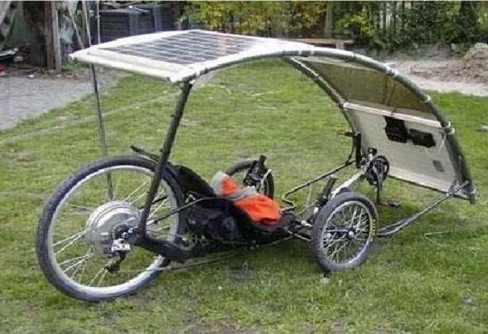
Fig. 2.1 Solar Powered Tricycle

CHAPTER – 3
LITERATURE SURVEY

Solar- Cross(E- BIKE)

This solar e-bike began as a 1998 Specialized FSR bike frame and was custom built for the inventor Terry Hope’s application. Several hardware designs are unique about this e- bike, the custom freewheel crank consists of three sprockets, starting on the outside is the 80T (tooth) chain sprocket which the electric motor drives. Then behind the 80T sprocket is another sprocket 42T and behind this is another which is just 22T. The two sprockets rotate the rear wheel by regular bike chain; the smaller 22T sprocket has a top speed of 22 kmph without any need to pedal by the operator. The larger 42T sprocket can achieve +40 kmph or over 50 kmph with operator providing pedal input. The kmph previously noted are powered by a 24 volt battery pack, basically half the voltage required of most E-bikes found in 2011.

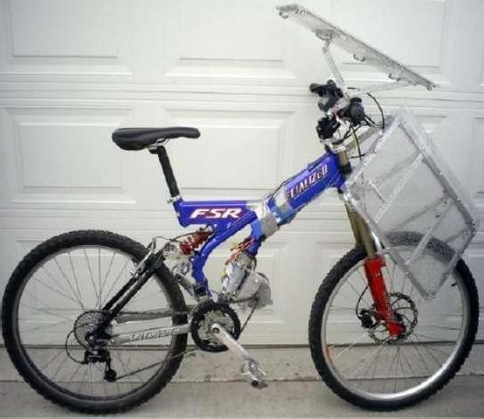

Fig. 3.1 Solar Cross Model

Solar Cross
Another unique design feature is the custom solar panels which are hand built using aluminum angle, aluminum rivets, and 1/8" polycarbonate. Built ultra-lightweight based on the high number of holes drilled through the aluminum to remove as much bulk material as possible.

Photovoltaic consist of 18x 6"x6" mono crystalline solar cells @ 3.8-4watts output each providing an est.8.7volts (9v minus diode loss) and controlled to recharge any two cells from either booster packs or main pack. The remaining 10% of the build entails installing the top sheet, a highly transparent lightweight FEP film (96%), and safety lighting. Update 9/10/2011: good news: 24v + 16v booster battery has enough torque while sitting on the e- bike to spin the back wheel and complete a donut in gravel / 5t-80t bad news: twisted the motor shaft (11mm) into two pieces, snap right before the copper windings. Both rear shock mounting bolts broke, but didn't fail. Replaced the upper, but the lower broke inside the linkage threads. Additionally, installed 6 PV cells onto top panel, these 6 cells provide enough voltage to ride and to turn the wheels without any pedaling (1-3kmph).

CHAPTER - 4
PROBLEM STATEMENT

There are several problems that occur during the upgrade of a conventional electric powered bicycle to Solar-Powered Electrical Bicycle. The specifications of photovoltaic (PV) panels must be sufficient to generate the electric motor same as a conventional electric powered bicycle. The suitable connection of solar cells rechargeable battery and DC electric motor with bicycle needed to make sure this project accomplish with more optimum energy use. The electric motor must to support the weight and size of the bicycle, size of solar panel and condition of the road surface.

Facts and Findings

Facts and findings establish what the existing system does and what the problem are, and leads to a definition of a set of options from which users may choose their required system.
In his section will be discussing about the domain of this project, the existing system and finally the other techniques that are applicable to be used while developing this project. It focuses on how to design and develop the project systematically according to the requirement to minimize the functional of conventional project. In the other situation, these will be describing any element or method which is useful to be used for the purpose of searching and gathering useful information in developing this project.

Domain

Currently, electric powered bicycle that was studied for this project only uses a battery to get the electric powered supply by recharge it using conventional way. Electric powered bicycle only depends on power that charge in battery to make it functions unless using the manual way to move it. The project is wanted to change the way a battery charge to get the electric power and generate electricity to move the bicycle with optimum energy.

  - Solar Power

Solar cells (really called “photovoltaic” or “photoelectric” cells) that convert light directly into electricity, bypassing thermodynamic cycles and mechanical generators. PV stands for photo (light) and voltaic (electricity), whereby sunlight photons free electrons from common silicon. A photovoltaic module is composed of individual PV cells. This crystalline- silicon module has an aluminum frame and glass on the front. In the field of photovoltaic, a photovoltaic module is a packaged interconnected assembly of photovoltaic cells, also known as solar cells. An installation of photovoltaic modules or panels is known as a photovoltaic array or a solar panel. A photovoltaic installation typically includes an array of photovoltaic modules or panels, an inverter, batteries (for off grid) and interconnection wiring. Solar energy is the utilization of the radiation energy from the sun. Solar power is used interchangeably with solar energy but refers more specifically to the conversion of sunlight into electricity by photovoltaic and concentrating solar thermal devices, or by one of several experimental technologies such as thermoelectric converters, solar chimneys and solar ponds. Sunlight is composed of photons, or particles of solar energy. These photons contain various amounts of energy corresponding to the different wavelengths of the solar spectrum. When photons strike a photovoltaic cell, they may be reflected, pass right through, or be absorbed. Only the absorbed photons provide energy to generate electricity. When enough sunlight (energy) is absorbed by the material (a semiconductor), electrons are dislodged from the material's atoms. Special treatment of the material surface during manufacturing makes the front surface of the cell more receptive to free electrons, so the electrons naturally migrate to the surface. When the electrons leave their position, holes are formed. When many electrons, each carrying a negative charge, travel toward the front surface of the cell, the resulting imbalance of charge between the cell's front and back surfaces creates a voltage potential like the negative and positive terminals of a battery. When the two surfaces are connected through an external load, electricity flows.

Electric Powered Bicycle
An electric powered bicycle carries batteries or fuel cells that deliver electric power to a motor that is coupled to either wheel. In most electric bicycles the rider can choose to use muscle power to deliver all, part, or none of the propulsion power required to maintain his or

her adopted travel speed. Some models even sense your pedal pressure and command the motor to deliver more power whenever you pedal hard. Many electric powered bicycles are specifically design and build for travel. Average travel speed, when compared to pedaled- only bicycles, can be increased by 8 to 10km/h (5 to 6 mph) above the speed an average person could travel by pedaling.

Energy Requirement Of Cycling

Required Energy to Cycle

It is important to know the required power for different situations such as climbing hills. In the Excel sheet / tab sheet "Power required" the required power is calculated and plotted in a speed- power graph. We can experiment with the bicycle parameters. The solar bike parameters are not known well at the moment and are estimated. The air drag is the most important factor. For the solar bike it is assumed that the reference area is in-between that of a racing bicycle and an upright bike, namely 0.5m2. The total weight of 90 kg is for a solar bike of 18 kg, a rider of 70 kg and some luggage of 2 kg.
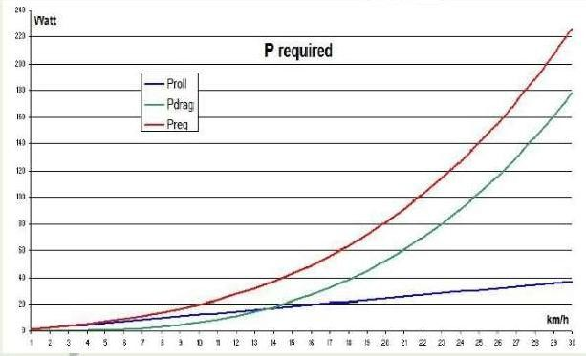
Fig. 4.1 Power Required

Human Power

The steepness of the curve points to how sensitive human are to an increase in power demands. That is the reason that climbing hills is so exhausting. In this respect, a motor power of only 100W is already helpful.

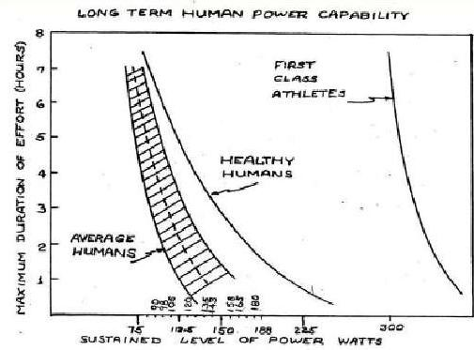

Fig. 4.2 Human Power Capability

    - Energy Costs of Cycling
Suppose, you charge your e-bike battery at a cafe. What are the costs for the cafe owner? You tend to say about Rs. 58. But amazingly, the costs are negligible. For a normal e- bike battery of 400Wh, the electricity costs are lower than Rs. 5 at a KWH price of Rs. 11. The cyclist himself, who ride 100km, converts energy of 500Wh to 750Wh. Also, the electric bike electricity costs per km are more than 50 times lower than the fuel cost of a car.

  - Solar Panel Roof Another option is a roof panel. It has some advantages:
- The panel does not suffer from shadow from the rider.
- The bike is more manageable.
- Larger solar surface area is possible The disadvantages are:
- High center of gravity.

- More wind loads.
- More weight.
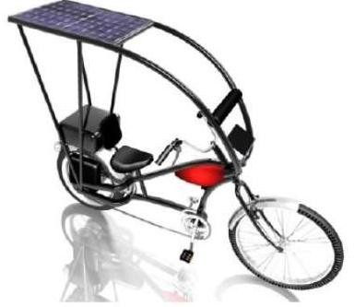

Fig. 4.3 Solar Panel Roof

  - Wind Aspectsof Concern
The air drag is low for a flat plate that is horizontal to the apparent wind. But when the panels are pitched by just a degree or two, this leads to a significant increase in force. In essence we have two inefficient aircraft wings that will generate some lift. This lift will act at a vector that is perpendicular to the apparent wind, not perpendicular to the surface of the solar panels, so will act to unbalance the bike. It will also create induced drag that is proportional to the lift generated, adding to the form drag we have from the projected frontal area of the panels. Cross winds are the problem here, or more specifically, the vector sum of the side wind and the apparent wind caused by the motion of the bike. The force needed to unbalance a bike, by taking it outside the range of corrective moments that the rider can provide by shifting body weight is pretty small. The lift force vector will change direction extremely rapidly as the bike rolls, going from a maximum positive to a maximum negative value in a short time interval as the panels go from a positive to negative angle of attack relative to any side wind component. A known issue at racing bicycles is the severe impairment of the steering that comes from using a disk wheel in a crosswind. To avoid serious problems, the panels may not exceed a certain size and the wind force may not be too large. Although, the area of the PV panels (1m2) is not much larger than the cyclist frontal area (0.5m2). So, I don't suspect much wind problems anyway.

PVPanel Tilt AngleMismatch
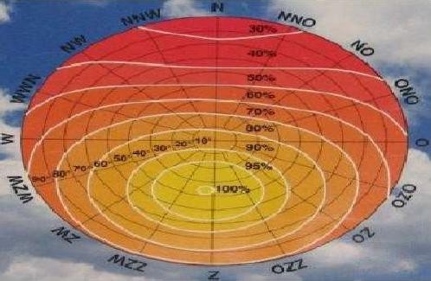
The PV panels are not pointed into the sun. But in summer, the loss due to the tilt angle mismatch is less than 20%.

Solar Panel Electricity
Fig.4.4RadiationDiagram

The power from the solar panel depends on:
- Solar cell efficiency: The power of the used solar cells is 200 W/m2 at standard test conditions (STC). These conditions are: irradiance 1000 W/m2, air mass 1.5 and cell temperature 25 °C.
- Panel angle: The angle that the sun hits the panels changes the amount of exposure. Because the solar panels are flat mounted and not faced to the sun, the power is always lower than rated. However, the fact that the sunlight is diffuse, limits this effect.
- Time of day: Because of the sun angle we can only get sufficient power from the solar panels between about 11:00 am to 4:00 pm.
- Time of year: From October to April the sunlight is not strong enough anymore to deliver energy to de bike.
- Solar cell reflection: The power will be reduced by the solar cell reflection. The protective top layer should have a low reflection coefficient
- Clouds: Clouds have such a large affect to solar panels that the solar bike can only be used at almost cloudless weather. Also veil clouds reduce the power to an insufficient value.

- Shadow: To understand the power loss effects of shadow. The solar panels will, with the above properties in mind, produce between about 120W and 150W at cloudless summer days.

Shadow
In practice the PV panel shadow isn't really so bad. The cyclist is sitting somewhat hunched over on the bike, it isn't an up-right bike. Pictures of the shadow at different sun angles were taken. In most cases, there is no shade or just a little bit. With a proper design of the PV panel, with bypass diodes, the power loss due to the shade is no serious problem.

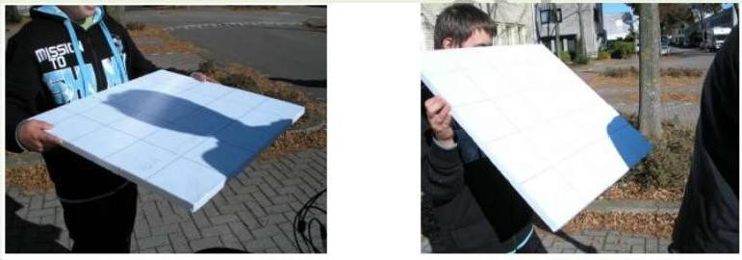
Fig.4.5Shadows

SolarBicycle Battery Type

The solar bike can be equipped with two kinds of batteries with their own specific requirements:
- Short-term storage for the solar energy. This battery is continuously charged and discharged and should therefore have a high cycle life. Also, a high charge / discharge efficiency is important here.
- Long-term storage for charging at home. This battery is not as heavily stressed as the short-term battery. Here, low weight is important.
- Both batteries must allow fast charging

CHAPTER - 5
PREVIOUS PROJECT

Early 2001, David Clay was built a solar-electric bicycle. On this solar and human powered rig, he rode from San Francisco, California, to Carbondale, Colorado, arriving just in time to start a summer of classes at Solar Energy International. In the summer of 2001, he went to China, and continued solar cycling around the world. The trip was also the ultimate test for developing the solar cycle. He realized that the bicycle needed a stronger PV mount after 30 miles traveling. Next, brakes needed for the trailer after 100 miles and after 1,000 miles the trailer needed with a spoke wheels. After 1,500 miles, powerful motor need to cover the performance of bicycle that remains constantly. Performance of the bicycle is produce by a 24V DC system. 4 to 5 A can be produced in full sun by the array of four Solarex MSX Lite modules. His trailer weighs 190 pounds (86kg) empty, and he pulled an additional 85 to 100 pounds (39–45 kg) of gear. He can cruise on the flat ground at 18 mph (29kph) without pedaling, with the motor drawing 13 amps. He then tested the range of the bike on flat ground, with an unloaded trailer and a 150-pound (68 kg) rider, from full battery to empty battery (100% SOC to 20% SOC). It can cruise in range of 25 to 30 miles (40–50 km) without pedaling and sunshine. The range is increase to 35 to 40 miles (55–65 km) when it cruises with a pedaling and sunshine. When pedaling, the rider’s fitness level becomes the onlylimit.

Hybrid Bicycle
CHAPTER – 6
DESIGN OF HYBRID VEHICLE

  - Theory

This project is a way of using the outgoing power and producing both from wind generator and solar panel. This project consists of a rechargeable battery pack which powers a light weighted motor unit over the wheel. The solar electric bicycle approach is different. It works in normal day as well as in cloudy day.

  - Explanation

A solar electric bicycle is an electric vehicle powered completely or significantly by direct solar energy. Usually, photovoltaic (PV) cells contained in solar panels convert the sun's energy directly into electric energy. The term "solar vehicle" usually implies that solar energy is used to power all or part of a vehicle's propulsion. Solar power may be also used to provide power for communications or controls or other auxiliary functions. In this project we are using a prototype DC fan as wind generator which helps it to work in cloudy day also. Rechargeable battery is used with long life for charging. DC electric motor is also used in this project.
An electric motor converts electrical energy into mechanical energy. Most electric motors operate through the interaction of magnetic fields and current-carrying conductors to generate force. The electricity generated by the solar panel is stored in the battery, enabling a rider to switch over the operation to hybrid mode anytime and control the speed of the bicycle using the accelerator. Many large metropolitan areas have implemented bicycle sharing systems to encourage the eco-friendly form of transportation while minimizing traffic log- jams.

    - Two mode biking options:
      - Only pedal power.
      - All electric power (No pedal option).

When fully implemented, the system will operate with modular stations throughout the city – much like transit stations. These stations are 100% solar powered. Solar panels absorb UV light and convert it to clean electricity which is then used to recharge the bicycle’s battery. Riding bicycles is already an eco-friendly way to commute.

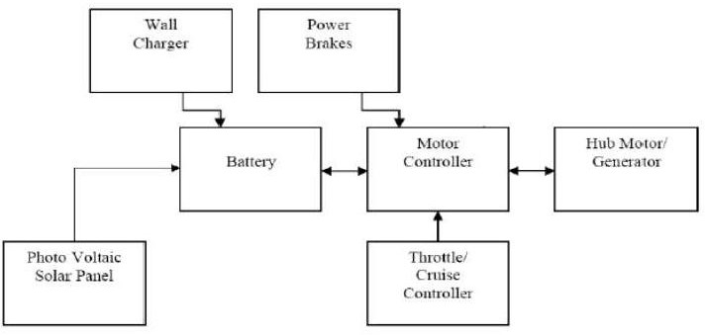
Fig. 6.1 Block Diagram

  - Solar Panelto Battery Connection

The simplest possible solar battery charging circuit is just to connect the positive wire from the solar panel to the positive battery terminal, and the negative solar panel wire to negative battery terminal. This will quite easily charge a battery. However, there is a potential problem with attaching a panel directly to a battery. At night, electricity can leak back into the panel, which will slowly discharge the battery. In fact, the amount of leakage is usually small, and not worth worrying about - but to prevent it you can easily fit a diode (a sort of one-way valve for electricity) in the line, as in this diagram:

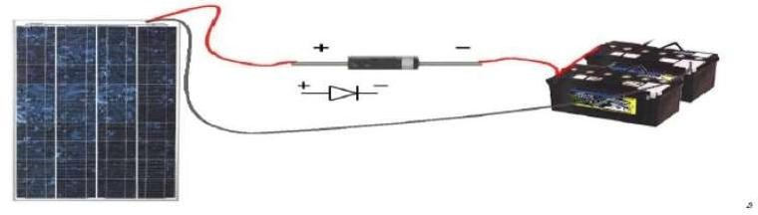
Fig. 6.2 Connection of Battery and Solar panel

  - Construction Details

It used high quality parts. Not cheap, but our new mountain bike cost more than that and you have to pedal it. You can get a turn-key electric motor kit, or a readymade e-bike for, but of course the motors and batteries are all only 1/3 as powerful as this.

- Weight – At 85 pounds, this is pretty heavy for a "bicycle," but I think of it more as an ultra-light moped. And it is a true "moped" in that you can still meaningfully pedal it. Plus, I can still lift it into my pickup or my car trunk if needed. Our old
Peugeot moped weighed twice as much at 150 pounds with similar speed capability, and pedaling it was a joke - the pedals were geared really low, purely for starting the motor.

- Brakes – The old brakes on this bike were okay for 12 mph but hair-raising at 30 mph. A new side pull "vee brake" as used on decent Modern Mountain bikes luckily bolted right onto the old brake mount posts. Regular bicycles are too light and top heavy to use the front brake as the main squeeze, but as any motorcyclist can tell you, on any heavier two-wheeler the front brake does 90% of the work. The vee-brake kit was about 25 bucks on sale at a bike dealer, and came with a new lever for the handle bar. I only replaced the front brake, as the rear posts are in the wrong place. A number of people have written to ask me where the rear brake is – it looks like there is no rear brake at all.

- Frame – The components can take the added force and weight of the motor system. Mountain bike components now are amazingly strong and durable - they are made to take off-road abuse. The wider wheels especially are much better for the additional weight and power. Also, a steel frame is easier to weld or braze motor and battery mounts onto. Stay away from aluminum unless you can figure a way to bolt or clamp everything on without welding. Welding onto an aluminum frame will likely ruin the tempering and severely weaken it. It's quite difficult to weld on thin aluminum. The peculiar geometry of the GT rear frame design actually makes a perfect place for the motor.

- Construction – We have to weld a motor mount onto the rear frame behind the seat. The chain just clears the wheel and frame and it was critical to get the motor solidly mounted. With such a powerful motor, the motor mount must be strong, and it's really pretty important to have a ball-bearing motor. The motor mount is removable from the frame with three allen head screws. We have a TIG welder and lots of metal working tools so it was not a big deal for me but we don't see why all this couldn't be done on a steel bike frame with silver solder or brazing rod and a gas torch. The batteries also have a very solid welded-on mount with a screw- down top retaining rail. The batteries are heavy and need a good solid mount with shock padding. These batteries are narrow and don't interfere at all with pedaling. In this arrangement they are also low and keep the center of gravity down.

CHAPTER – 7
COMPONENTS USED

Parts Of the Hybrid Bicycle
- Battery
- D.C. Electric motor
- A speed controller or motor controller
- V Brake
- Throttle
- Battery Charger
- Dynamo
- Solar Panel

Battery
In this project we are using LEAD ACID BATTERIES. There are 2 LA batteries of 12V each. Lead acid batteries, invented in 1859 by French physicist Galstron Plante, are the oldest type of rechargeable battery. Despite having a very low energy-to-weight ratio and a low energy-to-volume ratio, their ability to supply high surge currents means that the cells maintain a relatively large power-to-weight ratio. These features, along with their low cost, make them attractive for use in motor vehicles to provide the high current required by automobile starter motors.

Batteries use a chemical reaction to do work on charge and produce a voltage between their output terminals.

    - Charging And Discharging the Battery

The reaction of lead and lead oxide with the sulphuric acid electrolyte produces a voltage. The supplying of energy to and external resistance discharges the battery. The discharge reaction can be reversed by applying a voltage from a charging source.

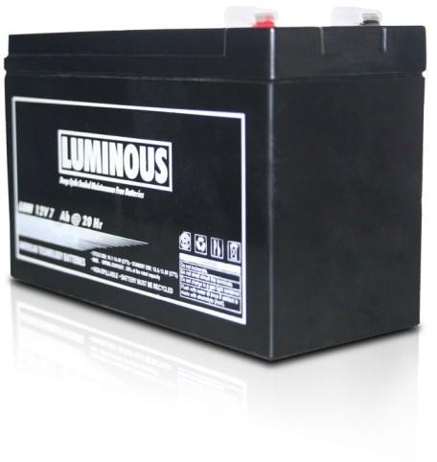

Fig. 7.112V Battery

DC Electric Motor

An electric motor converts electrical energy into mechanical energy. A 180W brush type DC motor is used in solar electric bicycle. A brushed DC motor is an internally commutated electric motor designed to be run from a direct current power source.

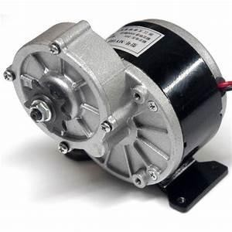
Fig. 7.2DC Geared Motor

Principle Of Operation

The construction of a simple BDC motor is shown in Figure. All BDC motors are made of the same basic components: a stator, rotor, brushes and a commutator.
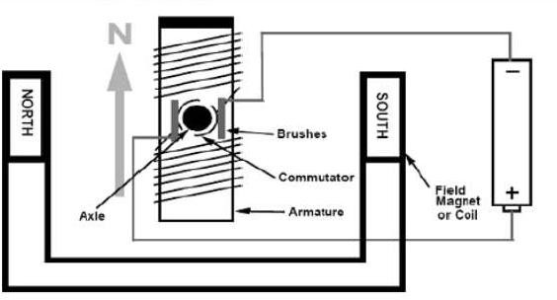
Fig. 7.3 DC Motor Block Diagram

      - Stator: The stator generates a stationary magnetic field that surrounds the rotor. This field is generated by either permanent magnets or electromagnetic windings. The different types of BDC motors are distinguished by the construction of the stator or the way the electromagnetic windings are connected to the power source.

      - Rotor: The rotor, also called the armature, is made up of one or more windings. When these windings are energized, they produce a magnetic field. The magnetic poles of this rotor field will be attracted to the opposite poles generated by the stator, causing the rotor to turn. As the motor turns, the windings are constantly being energized in a different sequence so that the magnetic poles generated by the rotor do not overrun the poles generated in the stator. This switching of the field in the rotor windings is called commutation.

      - Brushes And Commutator: Unlike other electric motor types (i.e., brushless DC, AC induction), BDC motors do not require a controller to switch current in the motor windings. Instead, the commutation of the windings of a BDC motor is done mechanically. A segmented copper sleeve, called a commutator, resides on the axle of a BDC motor. As the motor turns, carbon brushes slide over the commutator, coming in contact with different segments of the commutator. The segments are attached to different rotor windings; therefore, a dynamic magnetic field is generated inside the motor when a voltage is applied across the brushes of the motor. It is important to note that the brushes and commutator are the parts of a BDC motor that are most prone to wear because they are sliding past each other.

Examples of brush-type DC motor operations:

Figure shows an example of controlling the speed of a brush-type DC motor using a PWM waveform. These operations are outlined below:

- When the duty cycle changes, the interval between on and off of the transistor changes and the average current supplied to the motor also changes. When this average current changes, the motor rotation speed also changes.
- When the duty cycle of the PWM waveform is 50%, the motor rotates with 50%

output.

output.

- When the duty cycle of the PWM waveform is 75%, the motor rotates with 75%

- When the duty cycle of the PWM waveform is 100%, the motor rotates with 100%

output (at full speed).

Speed Controller

The speed of a BDC motor is proportional to the voltage applied to the motor. When using digital control, a pulse-width modulated (PWM) signal is used to generate an average voltage. The motor winding acts as a low pass filter so a PWM waveform of sufficient frequency will generate a stable current in the motor winding. The relation between average voltage, the supply voltage, and duty cycle is given by:

Hybrid Bicycle

Equation
Vaverage = D x Vsupply

Speed and duty cycle are proportional to one another.

For example, if a BDC motor is rated to turn at 15000 RPM at 12V, the motor will (ideally) turn at 7500 RPM when a 50% duty cycle waveform is applied across the motor.

The frequency of the PWM waveform is an important consideration. Too low a frequency will result in a noisy motor at low speeds and sluggish response to changes in duty cycle. Too high a frequency lessens the efficiency of the system due to switching losses in the switching devices. A good rule of thumb is to modulate the input waveform at a frequency in the range of 4 kHz to 20 kHz. This range is high enough that audible motor noise is attenuated and the switching losses present in the MOSFETs (or BJTs) are negligible. Generally, it is a good idea to experiment with the PWM frequency for a given motor to find a satisfactory frequency.

The CCP module (short for Capture Compare and PWM) is capable of outputting a 10- bit resolution PWM waveform on a single I/O pin. 10-bit resolution means that 210, or 1024, possible duty cycle values ranging from 0% to 100% are achievable by the module. The advantage to using this module is that it automatically generates a PWM signal on an I/O pin which frees up processor time for doing other things. The CCP module only requires that the developer configure the parameters of the module. Configuring the module includes setting the frequency and duty cycle registers.

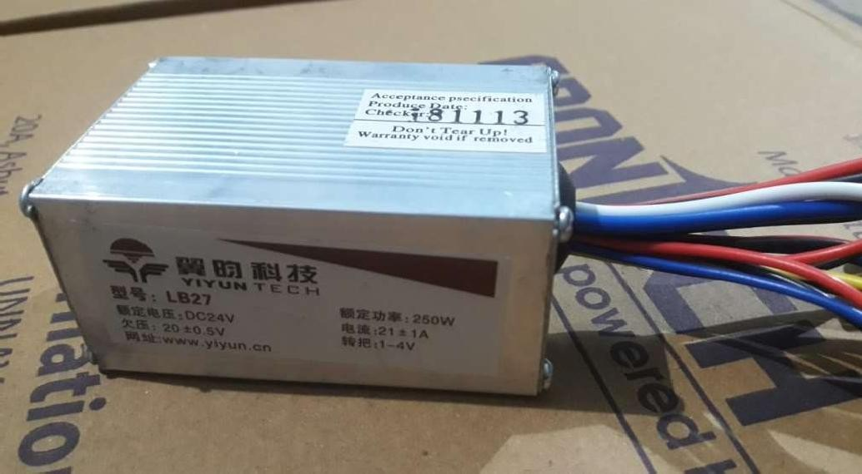
Hybrid Bicycle

Fig. 7.4 Speed Controller

- Motor Output And Pulse Width Modulation (PWM)

Fig. 7.5 PWM Waveform When Motor Is Stopped

Fig. 7.6 PWM Waveform With 50% Output

Fig.7.7 PWM Waveform With 75% Output

Fig. 7.8 PWM Waveform With 100% Output

Brushed DC motors are very simple to use and control, which makes them a short design-in item.

Hybrid Bicycle

Brakes

A bicycle brake is used to slow down or stop a bicycle.

V-brakes are a side-pull version of cantilever brakes and mount on the same frame bosses. However, the arms are longer, with the cable housing attached to one arm and the cable to the other. As the cable pulls against the housing the arms are drawn together. Because the housing enters from vertically above one arm yet force must be transmitted laterally between arms, the flexible housing is extended by a rigid tube with a 90° bend known as the "noodle". The noodle seats in a stirrup attached to the arm. A flexible bellows often covers the exposed cable.

Throttle

This solar electric bicycle throttle is easy to use and great for those that want to keep their original handlebar grip. Typically, the throttle is used on bikes that have a twist gear changing system. That said it comes down to personal choice as the thumb throttle can also be used on a bike that has a thumb gear changing system. A "Throttle" refers to a method of controlling the speed of an engine or motor. A thumb throttle is located on the right side of the handle bar and is a small lever on under side of the handle bar that is operated by pushing inwards with your palm.

Charger
In this project we have used a 220V AC, 50Hz, and 1.0A Charger with the following specifications:

INPUT: 180 – 300 V AC, 47 – 63 Hz
OUTPUT: 29.4 V DC, 2.0 A FLOAT: 27.4 V DC ± 0.4 V BOOST: 29.4 V DC ± 0.4 V

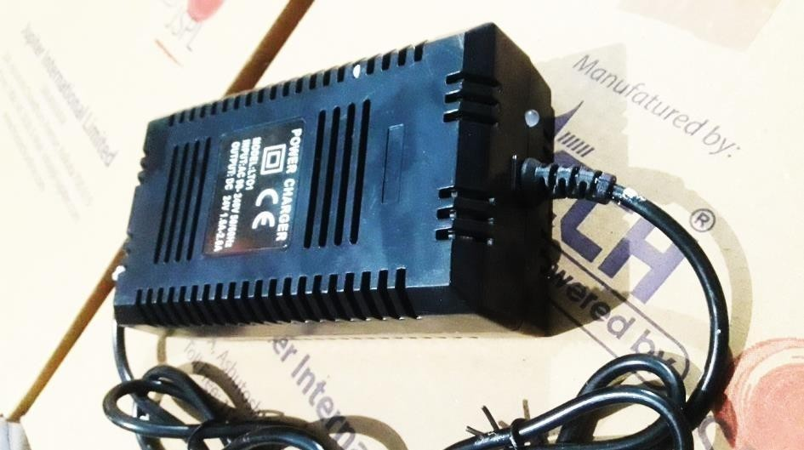
Fig. 7.9 Charger

Dynamo
A dynamo is an electrical generator that creates direct current using a commutator. Dynamos were the first electrical generators capable of delivering power for industry, and the foundation upon which many other later electric-power conversion devices were based, including the electric motor, the alternating-current alternator, and the rotary converter. Today, the simpler alternator dominates large scale power generation, for efficiency, reliability and cost reasons. A dynamo has the disadvantages of a mechanical commutator. Also, converting alternating to direct current using power rectification devices (such as vacuum tubes or more recently via solid state technology) is effective and usually economical.

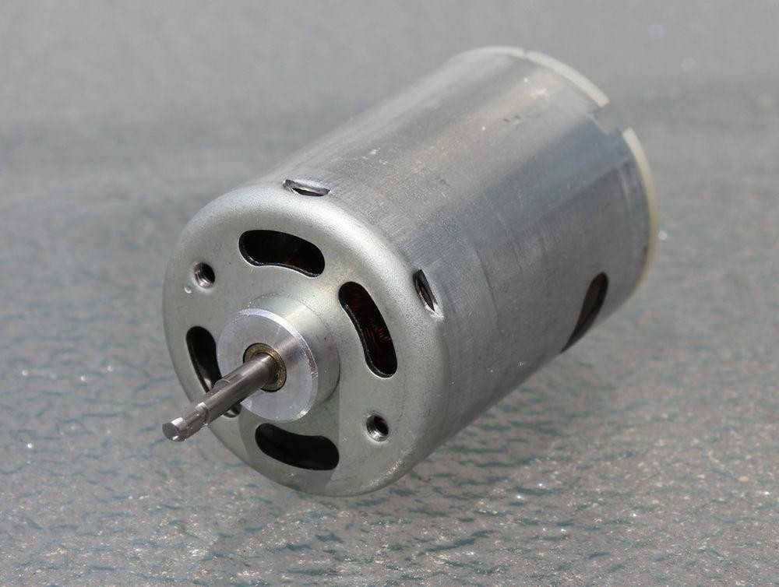
Fig. 7.10 Dynamo

  - Solar Panels
Photovoltaic modules use light energy (photons) from the Sun to generate electricity through the photovoltaic effect. The majority of modules use wafer-based crystalline silicon cells or thin-film cells. The structural (load carrying) member of a module can either be the top layer or the back layer. Cells must also be protected from mechanical damage and moisture. Most modules are rigid, but semi-flexible ones based on thin-film cells are also available. The cells must be connected electrically in series, one to another.

A PV junction box is attached to the back of the solar panel and it is its outputinterface. Externally, most of photovoltaic modules use MC4 connectors type to facilitate easy weather- proof connections to the rest of the system. Also, USB power interface can be used.

Module electrical connections are made in series to achieve a desired output voltage or in parallel to provide a desired current capability (amperes). The conducting wires that take the current off the modules may contain silver, copper or other non-magnetic conductive transition metals. Bypass diodes may be incorporated or used externally, in case of partial module shading, to maximize the output of module sections still illuminated.

Some special solar PV modules include concentrators in which light is focused by lenses or mirrors onto smaller cells. This enables the use of cells with a high cost per unit area (such as gallium arsenide) in a cost-effective way.
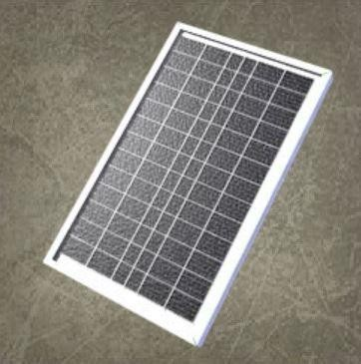
Fig. 7.11 Solar Panel

Rated Max. Power – 10W Tolerance - +3% Voltage – 18V Current – 0.56A
Nominal Operating Cell Temperature – 47 ºC Max. System Voltage – 600V
Max. Series Fuse Rating – 5A

CHAPTER - 8
ADVANTAGES & DISADVANTAGES

Advantages

    - Commuting with low fatigue at a top speed of 24 kmph.
    - Extends the riding range – 30kms on a single charge.
    - Lesser maintenance cost.
    - Normal pedaling is possible when not on power assist mode.
    - Detachable battery can be taken inside the house for charging.
    - Thumb throttle - simple to operate and less strain on hands.
    - Solar panels keep charging the batteries for our continuous use.
    - The fan produces electricity and hence the battery is charged.
    - No noise - no vibration - no smog - no smog checks.
    - No registration - no insurance – no driver's license
    - No gasoline - no oil - no tune-ups.
    - No parking hassles - no car payments - no more exercise (use the pedals) - no
brainer

Disadvantages

    - High center of gravity.
    - More wind loads.

REMEDY: In the ideal situation of the absence of side wind and where the panel is horizontal to the wind, the air drag of the PV panel is quite low. The skin friction drag is negligible with air. Theshape should be aerodynamic.

FUTURE WORKS The design and fabrication completed on this project will be done in second semester. We will manufacture a required component, support, bearing cap, pulley, selection of sprocket wheel, for the making of Electric bicycle. We will collect standard parts required for our project. We will make the assembly of the Electric bicycle with minimum space as the new machine takes. We will taking continuous effort to project work as to be 100% succession.

CONCLUSION

During this semester the electric bicycle project has provided an opportunity to grasp the full scope of what it means to Design a product. This opportunity allowed an initial idea/goal to be realized in a team environment.

The idea developed as research and various other information on the topic was obtained.

The project evolved and changed as the team limitations and financial constraints were realized. Due to a lack of funding, the initial design of an electric go-cart was downsized to the current project, the electric assisted bicycle.

The initial design, of the electric assisted bicycle, carried along with it constraints that had to be worked around. The constraints were mainly financial in nature. They represent pieces of equipment in the design that had to be carried over from other semesters. The constraints on the equipment consisted of the battery, motor, and the bicycle frame. The motor bicycle relationship could not be altered, mainly due to the type of mounting on the motor. These constraints limited, but did not totally restrict the team’s ability to design a “new” system.

Once all constraints were known, the goals for the design were clearly identified. The goals were divided among the team members. In order to meet the deadline for the final project, progress was monitored weekly and individual goals were readjusted as needed. With communication between the team, and hard work, the final objective was obtained. The design project provided the team with valuable experience in design and teamwork. It allowed the team members to develop skills that will be useful in future endeavors.

BIBLIOGRAPHY
      - http://midsummerenergy.co.uk/solar-panel- information/Utilities/SolarPanelWiringDiagrams

      - ww1.microchip.com/downloads/en/appnotes/00905a.pdf

      - documentation.renesas.com/doc/products/.../rej06b0231.pdf – Japan

      - en.wikipedia.org/wiki/Lead – acid battery

      - www.solar-facts.com/batteries/battery-charging.php

      - en.wikipedia.org/wiki/Bicycle brake

      - http://www.avdweb.nl/

      - http://en.wikipedia.org/wiki/Solar_vehicle

      - http://www.eai.in/club/users/Nitin/blogs/1594

      - http://www.builtitsolar.com/Projects/Vehicles/KevinEBike.htm

      - http://www.reegle.info/index.php?searchTerm=solar+electric+bicycle&search
=search&site=clean_energy_search&searchType=documents&searchLang=en &search Type=documents

      - http://gotwind.org/diy/solar_electric_bicycle_project.htm

      - www.nycewheels.com/solar-powered-electric-bike

Hybrid Bicycle
COST OF PROJECT

Sl. No. | Particulars | Quantity | Price
1 | E- Bike Motor | 1 | 6,750
2 | Speedometer | 1 | 500
3 | Battery | 2 | 1,600
4 | Solar Panels | 2 | 3,000
5 | Battery Charger | 1 | 400
6 | Dynamo | 1 | 1,200
7 | Cycle | 1 | 1,500
8 | Frame | 1 | 2,000
9 | Welding |  | 1,000
10 | Zip Ties |  | 60
11 | Wires |  | 160
12 | Mount Plate | 1 | 200
13 | E-Bike Kit | 1 | 1,000
 |  | Total | 19,370

