**1.(Due Wed 10/4) Create 2 Proto-Personas**

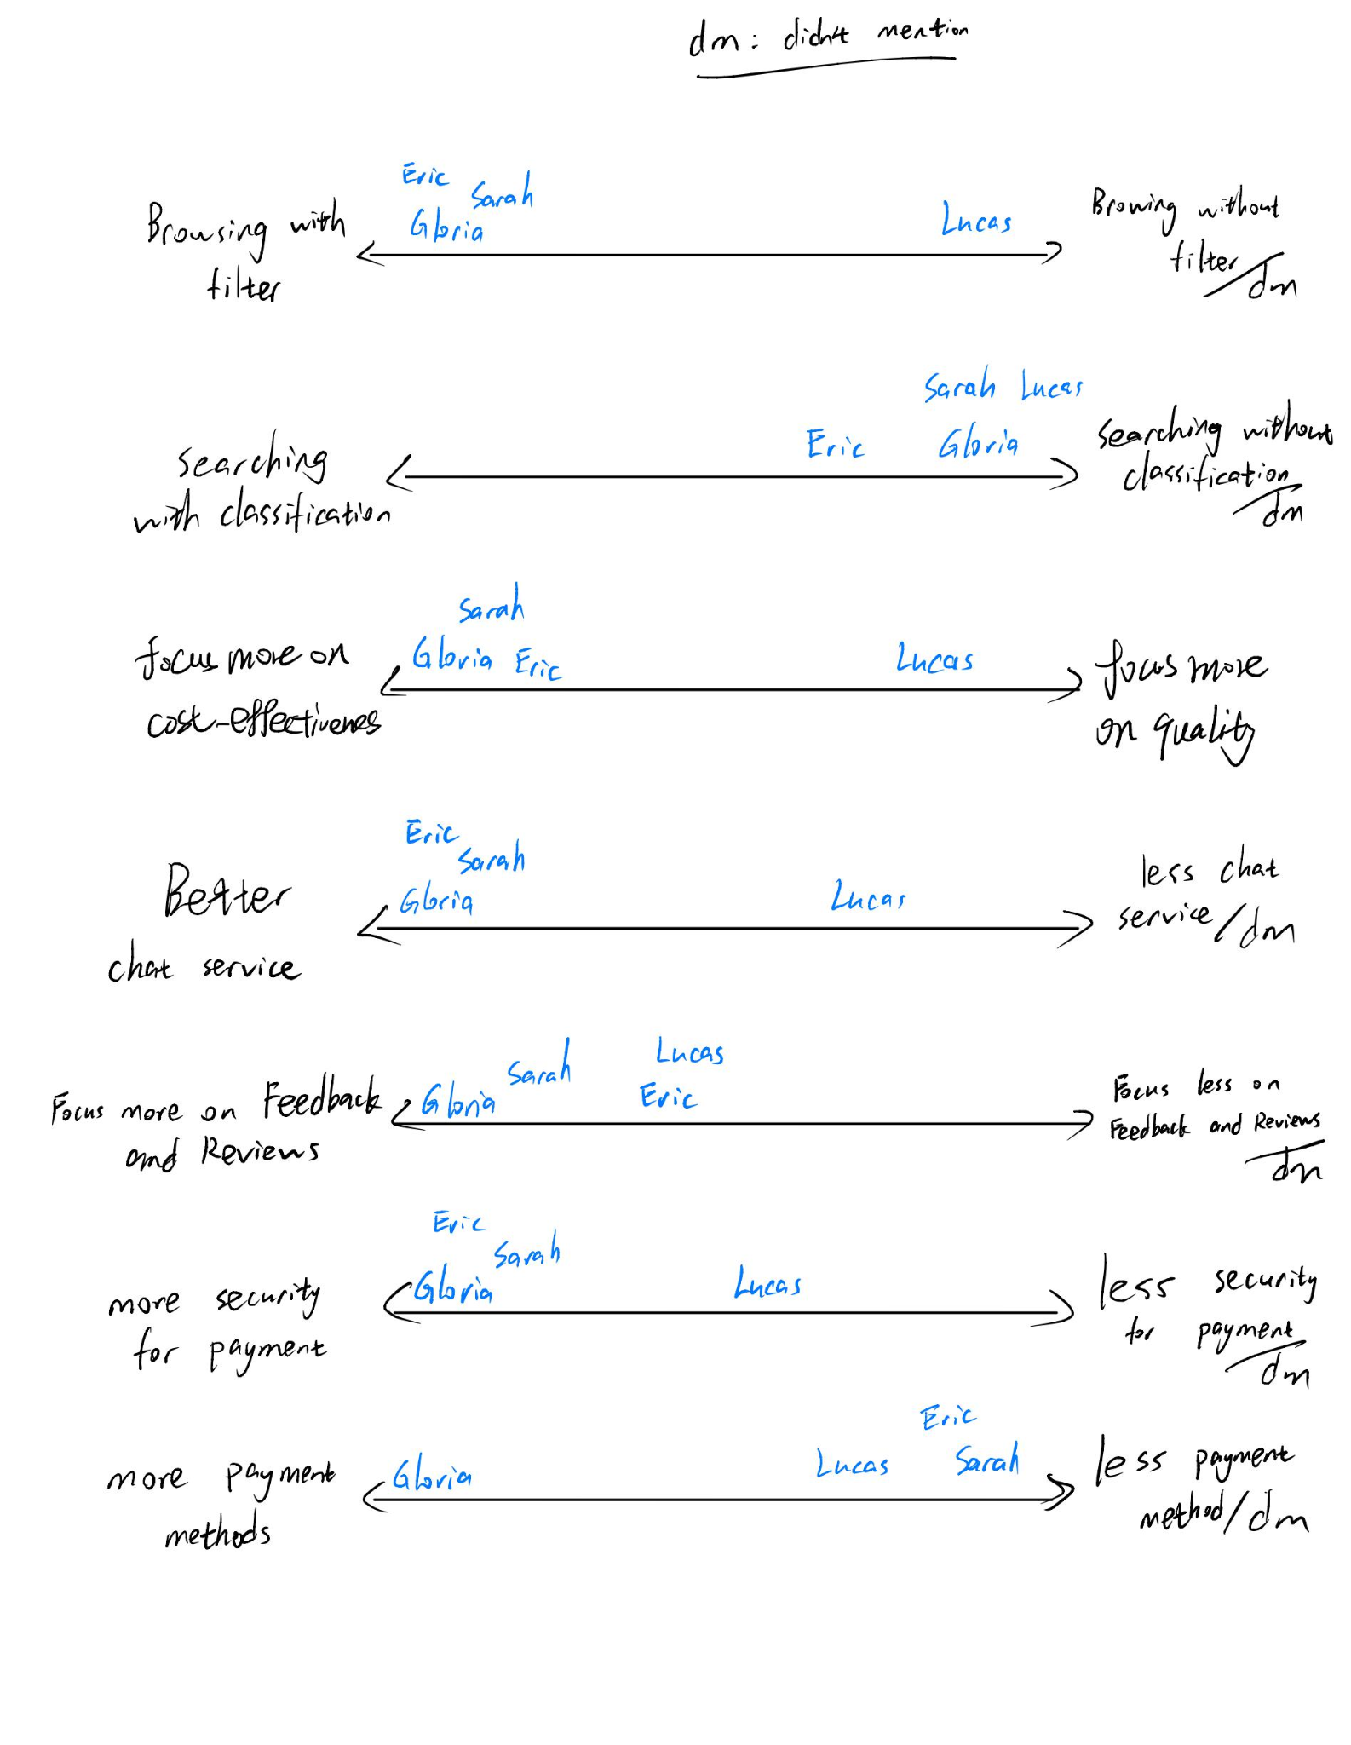

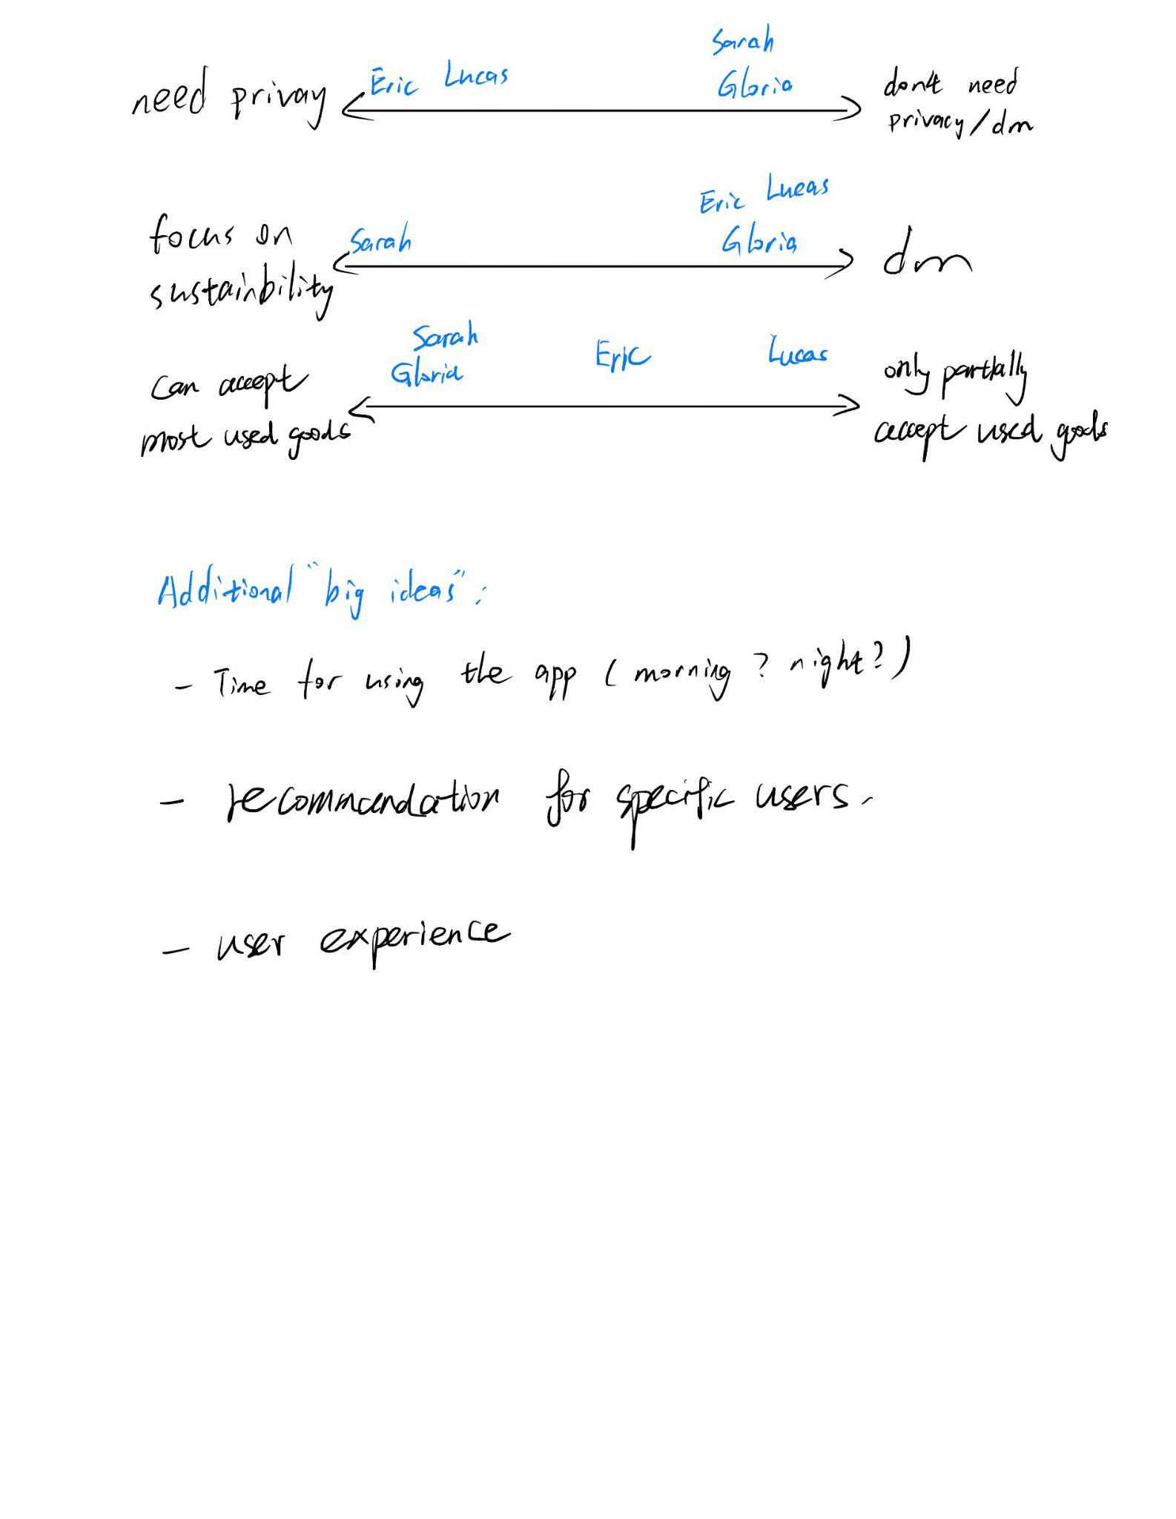

**Primary Persona:**

* Jason Jiang
* Age: 20
* Gender: Male
* Occupation: Student
* Hobby: video games, photography, music
* Secondhand Shopping: Often
* Browsing habit: filter
* Searching behavior: low price first
* Budget: limited (around 30$)
* Chatting Service : Prefers better quality and real-time chatting with sellers for inquiries and negotiations
* Product preference: electrical appliances
* Rating of sellers: help better decide whether buy the product or not
* Privacy: prefer high information privacy
* Payment: prefer multiple ways of payment with high security
* Acceptance of used goods: Good
* Preference for Web Page: prefer neat and simple web page

**Goal:**

* **Bought dream secondhand products from the website**
* **Buy used goods with quite good quality in affordable price**
* **Have chance to return a product if it does not meet requirements**
* **Having comfortable user experience and good purchase experience while using the website**



**Secondary Persona:**

* Anna Wang
* Age : 24
* Gender : Female
* Occupation : Student
* Secondhand Shopping : Occasional
* Payment Security : Values secure payment methods and looks for platforms that offer secure transactions
* Sustainability Conscious: High
* Feedback and Review : Appreciates reading comments from other users to make decisions and leaving reviews to make informed decisions
* Cost-Effectiveness : Seeks good deals and values cost-effective purchases
* Tolerance for used good: High
* Social Media : Instagram
* Community engagement : Very often
* Online Shopping Frequency: Weekly
* Product Research : Extensive and goods concerning her hobbies are the preference

**Goal:**

* **Conveniently purchase daily essentials**
* **Find connection with creative-minded individuals in the community**
* **Save time and money through online shopping**
* **Participate in online community very often for purchasing advice**



**2.(Due Wed 10/4) Create 2 Context Scenarios**

First use scenario:

Jason Jiang opened the secondhand shopping website based on his classmates’ recommendation. When he opens the website, he is first greeted with a simple but friendly word” Hello, Welcome” on a neat user interface. Then there’s a guideline which introduces some basic functions of the website to him. Jason begins to set his preference. “electrical appliances” is his primary choice .Video games, photography, music are his interests and he sets his price filter around $30. Then he starts to complete his profile “Age: 20, Gender: male, Occupation: student”.

After all set, he is finally guilded to the product area. There is a searching bar on the top of the screen. Under the search bar, there are some pictures of electrical appliances recommended by the system that he might show interest in, and they are all within his budget. He is attracted by a secondhand camera, so he clicks into it. While checking the camera's details, he sees the seller's rating and reads positive reviews from previous buyers. He can’t make a decision so he turns to real-time chatting with the owner to ask the current condition of the camera. The owner is online and he responds quickly. Jason is satisfied with it and he continues to pay for it by his preferred payment method that he considers safe. After around 2 seconds, the website confirms it and Jason is looking forward to receiving his goods. He then clearly saw the information about the shipment of his product. After the product has left the warehouse, the location and arrival time of the shipment can be displayed in detail on the website. Three days later, he received the goods at his doorstep. After confirming that the item was in good condition, he clicked the Confirm Receipt button to end the transaction.

Typical used complex scenario:  
Jason Jiang, a 20-year-old student and passionate secondhand shopper, has been using the secondhand shopping website for several months. His goal remains consistent: to find a quality smartwatch within his limited budget of around $30-$50. Jason is well-acquainted with the app's features and has curated a list of reliable sellers. He places high value on efficiency, product quality, and a seamless user experience.

Every day, Jason habitually opens the secondhand shopping website on his laptop. With a keen interest in smartwatches, he heads straight to the "Wearable Technology" category. To filter for affordable options, he applies a "low to high price" filter, swiftly narrowing down the best deals within his budget range of $30-$50. As he scrolls through the product listings, Jason uses his accumulated experience to identify offerings from sellers with whom he's had successful transactions. He also keeps an eye out for fresh listings from highly-rated sellers, prioritizing products with detailed descriptions and clear images.

Jason spots a listing that piques his interest—a smartwatch listed at an attractive price. Recognizing the seller's username from previous interactions, he initiates a real-time chat. They engage in a discussion about the smartwatch's specifications, battery life, and overall condition. Their prior interactions have fostered trust and open communication. Having negotiated a price, Jason proceeds with the purchase, selecting his preferred secure payment method. The transaction is smooth and secure, thanks to the app's reliable payment processing. He promptly receives an order confirmation email, providing him with a clear timeline for delivery.

Within a few days of waiting for the arrival of the goods, Jason every day is very much looking forward to and from time to time on the software to check the logistics status, from the confirmation of the order to the shipment of goods to the arrival of the goods, each node has a corresponding display.

Upon receiving the smartwatch, Jason meticulously inspects it to ensure it aligns with his quality standards. He examines the display for scratches, tests the watch's functionality, and assesses the battery life. Satisfied with his evaluation, he proceeds to set up the smartwatch, personalizing it with his preferred watch face and settings. After a successful transaction, Jason promptly leaves positive feedback for the seller, reinforcing their trust-based relationship. He continues to explore the website for potential future purchases, opting to follow his favorite sellers and receive notifications about new listings.

The cycle persists as Jason consistently utilizes the website to explore and secure great deals on smartwatches. He revels in the seamless, efficient, and trustworthy experience that greets him with each visit to the platform. Whether he's checking his daily steps or receiving notifications on his wrist, his secondhand smartwatch has seamlessly integrated into his daily life, making it his preferred choice for wearable technology.