Олегу привет

**прпср**спспсрп**српсрпс**

3GE70fsdfs

|  |  |  |  |  |  |  |  |
| --- | --- | --- | --- | --- | --- | --- | --- |
|  |  |  |  |  |  |  |  |
| рпарпарппсрппспсррп |  |  |  |  |  |  |  |
| онпоп | онпорпорпо |  | парпапр |  |  |  |  |
|  |  |  |  |  |  |  |  |
|  |  |  |  |  |  |  |  |
|  |  |  |  |  |  |  |  |

1?/118F5DDF811111

текст

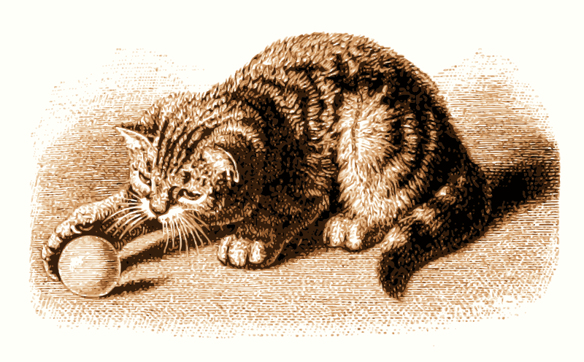

* 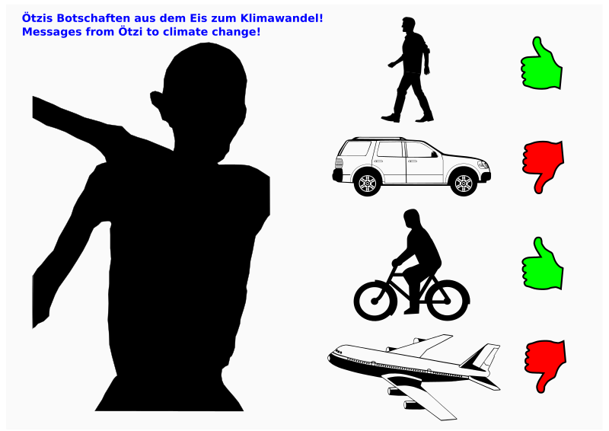ртмоммпмп

