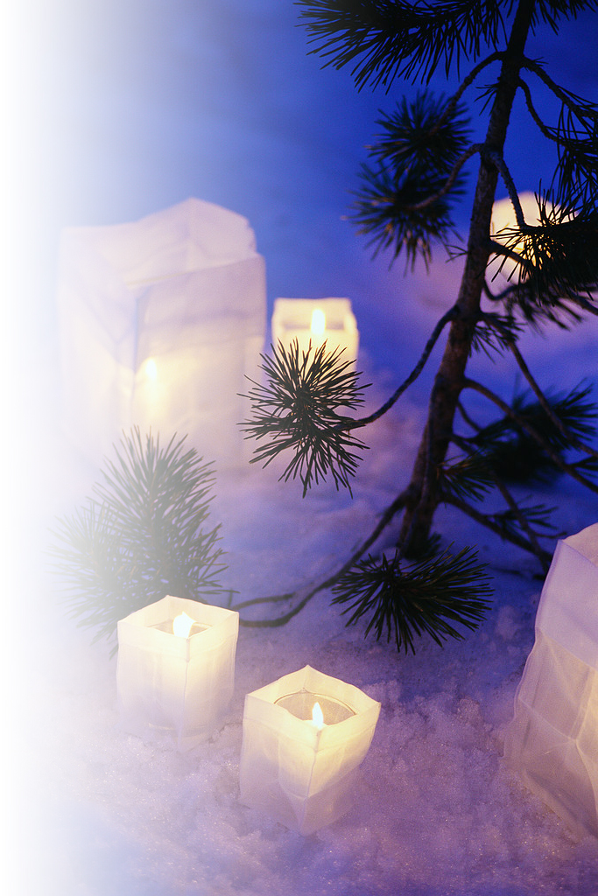

**2009**

**1**

**Февраль**

|  |  |  |  |  |  |  |
| --- | --- | --- | --- | --- | --- | --- |
| **пн** | **вт** | **ср** | **чт** | **пт** | **сб** | **вс** |
| 26 | 27 | 28 | 29 | 30 | 31 | 1 |
| 2 | 3 | 4 | 5 | 6 | 7 | 8 |
| 9 | 10 | 11 | 12 | 13 | 14 | 15 |
| 16 | 17 | 18 | 19 | 20 | 21 | 22 |
| 23  День защитника Отечества | 24 | 25 | 26 | 27 | 28 | 1 |

|  |  |  |  |  |  |  |
| --- | --- | --- | --- | --- | --- | --- |
| **пн** | **вт** | **ср** | **чт** | **пт** | **сб** | **вс** |
| 29 | 30 | 31 | 1  Новогодние каникулы | 2  Новогодние каникулы | 3  Новогодние каникулы | 4  Новогодние каникулы |
| 5  Новогодние каникулы | 6 | 7  Рождество Христово | 8 | 9 | 10 | 11 |
| 12 | 13 | 14 | 15 | 16 | 17 | 18 |
| 19 | 20 | 21 | 22 | 23 | 24 | 25 |
| 26 | 27 | 28 | 29 | 30 | 31 | 1 |

**Январь**

**2**



**Апрель**

|  |  |  |  |  |  |  |
| --- | --- | --- | --- | --- | --- | --- |
| **пн** | **вт** | **ср** | **чт** | **пт** | **сб** | **вс** |
| 30 | 31 | 1 | 2 | 3 | 4 | 5 |
| 6 | 7 | 8 | 9 | 10 | 11 | 12 |
| 13 | 14 | 15 | 16 | 17 | 18 | 19 |
| 20 | 21 | 22 | 23 | 24 | 25 | 26 |
| 27 | 28 | 29 | 30 | 1 | 2 | 3 |

|  |  |  |  |  |  |  |
| --- | --- | --- | --- | --- | --- | --- |
| **пн** | **вт** | **ср** | **чт** | **пт** | **сб** | **вс** |
| 23 | 24 | 25 | 26 | 27 | 28 | 1 |
| 2 | 3 | 4 | 5 | 6 | 7 | 8  Междуна- родный женский день |
| 9 | 10 | 11 | 12 | 13 | 14 | 15 |
| 16 | 17 | 18 | 19 | 20 | 21 | 22 |
| 23/30 | 24/31 | 25 | 26 | 27 | 28 | 29 |

**2009**

**3**

**Март**

**4**

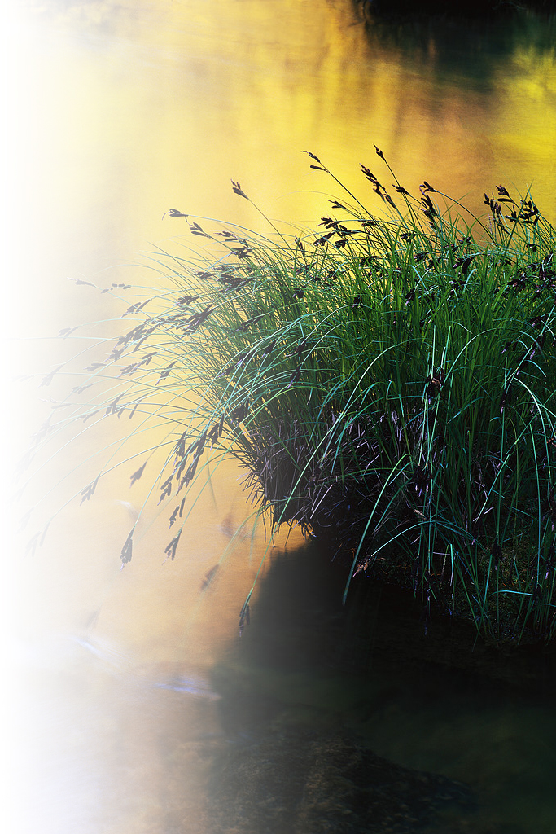

**Июнь**

|  |  |  |  |  |  |  |
| --- | --- | --- | --- | --- | --- | --- |
| **пн** | **вт** | **ср** | **чт** | **пт** | **сб** | **вс** |
| 1 | 2 | 3 | 4 | 5 | 6 | 7 |
| 8 | 9 | 10 | 11 | 12  День России | 13 | 14 |
| 15 | 16 | 17 | 18 | 19 | 20 | 21 |
| 22 | 23 | 24 | 25 | 26 | 27 | 28 |
| 29 | 30 | 1 | 2 | 3 | 4 | 5 |

|  |  |  |  |  |  |  |
| --- | --- | --- | --- | --- | --- | --- |
| **пн** | **вт** | **ср** | **чт** | **пт** | **сб** | **вс** |
| 27 | 28 | 29 | 30 | 1  Праздник Весны и Труда | 2 | 3 |
| 4 | 5 | 6 | 7 | 8 | 9  День Победы | 10 |
| 11 | 12 | 13 | 14 | 15 | 16 | 17 |
| 18 | 19 | 20 | 21 | 22 | 23 | 24 |
| 25 | 26 | 27 | 28 | 29 | 30 | 31 |

**2009**

**Май**

**5**

**6**



**Август**

|  |  |  |  |  |  |  |
| --- | --- | --- | --- | --- | --- | --- |
| **пн** | **вт** | **ср** | **чт** | **пт** | **сб** | **вс** |
| 27 | 28 | 29 | 30 | 31 | 1 | 2 |
| 3 | 4 | 5 | 6 | 7 | 8 | 9 |
| 10 | 11 | 12 | 13 | 14 | 15 | 16 |
| 17 | 18 | 19 | 20 | 21 | 22 | 23 |
| 24/31 | 25 | 26 | 27 | 28 | 29 | 30 |

|  |  |  |  |  |  |  |
| --- | --- | --- | --- | --- | --- | --- |
| **пн** | **вт** | **ср** | **чт** | **пт** | **сб** | **вс** |
| 29 | 30 | 1 | 2 | 3 | 4 | 5 |
| 6 | 7 | 8 | 9 | 10 | 11 | 12 |
| 13 | 14 | 15 | 16 | 17 | 18 | 19 |
| 20 | 21 | 22 | 23 | 24 | 25 | 26 |
| 27 | 28 | 29 | 30 | 31 | 1 | 2 |

**2009**

**Июль**

**7**

**8**



**Октябрь**

|  |  |  |  |  |  |  |
| --- | --- | --- | --- | --- | --- | --- |
| **пн** | **вт** | **ср** | **чт** | **пт** | **сб** | **вс** |
| 28 | 29 | 30 | 1 | 2 | 3 | 4 |
| 5 | 6 | 7 | 8 | 9 | 10 | 11 |
| 12 | 13 | 14 | 15 | 16 | 17 | 18 |
| 19 | 20 | 21 | 22 | 23 | 24 | 25 |
| 26 | 27 | 28 | 29 | 30 | 31 | 1 |

|  |  |  |  |  |  |  |
| --- | --- | --- | --- | --- | --- | --- |
| **пн** | **вт** | **ср** | **чт** | **пт** | **сб** | **вс** |
| 31 | 1 | 2 | 3 | 4 | 5 | 6 |
| 7 | 8 | 9 | 10 | 11 | 12 | 13 |
| 14 | 15 | 16 | 17 | 18 | 19 | 20 |
| 21 | 22 | 23 | 24 | 25 | 26 | 27 |
| 28 | 29 | 30 | 1 | 2 | 3 | 4 |

**2009**

**Сентябрь**

**10**

**8**

**9**

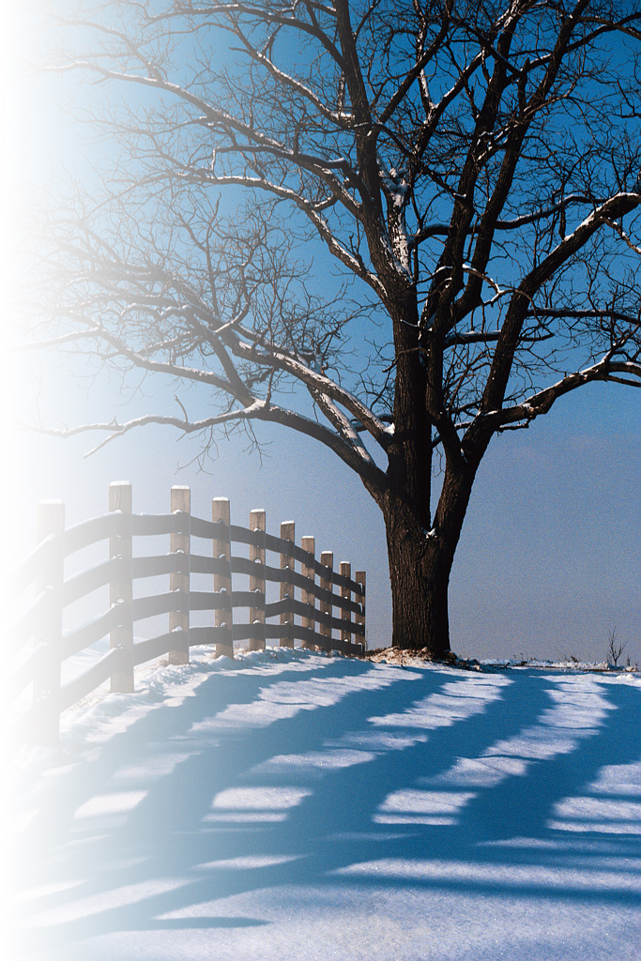

**Декабрь**

|  |  |  |  |  |  |  |
| --- | --- | --- | --- | --- | --- | --- |
| **пн** | **вт** | **ср** | **чт** | **пт** | **сб** | **вс** |
| 30 | 1 | 2 | 3 | 4 | 5 | 6 |
| 7 | 8 | 9 | 10 | 11 | 12 | 13 |
| 14 | 15 | 16 | 17 | 18 | 19 | 20 |
| 21 | 22 | 23 | 24 | 25 | 26 | 27 |
| 28 | 29 | 30 | 31 | 1 | 2 | 3 |

|  |  |  |  |  |  |  |
| --- | --- | --- | --- | --- | --- | --- |
| **пн** | **вт** | **ср** | **чт** | **пт** | **сб** | **вс** |
| 26 | 27 | 28 | 29 | 30 | 31 | 1 |
| 2 | 3 | 4  День народного единства | 5 | 6 | 7 | 8 |
| 9 | 10 | 11 | 12 | 13 | 14 | 15 |
| 16 | 17 | 18 | 19 | 20 | 21 | 22 |
| 23/30 | 24 | 25 | 26 | 27 | 28 | 29 |

**2009**

**Ноябрь**

**11**

**8**

**12**

**8**