马的疝病分析报告

牟宇超

2620160005

1. 数据摘要
2. 标称属性

|  |  |  |  |  |  |
| --- | --- | --- | --- | --- | --- |
| **surgery** | | | | | |
|  | | 频率 | 百分比 | 有效百分比 | 累积百分比 |
| 有效 | 1 | 180 | 60.0 | 60.2 | 60.2 |
| 2 | 119 | 39.7 | 39.8 | 100.0 |
| 总计 | 299 | 99.7 | 100.0 |  |
| 缺失 | 系统 | 1 | .3 |  |  |
| 总计 | | 300 | 100.0 |  |  |

|  |  |  |  |  |  |
| --- | --- | --- | --- | --- | --- |
| **Age** | | | | | |
|  | | 频率 | 百分比 | 有效百分比 | 累积百分比 |
| 有效 | 1 | 276 | 92.0 | 92.0 | 92.0 |
| 2 | 24 | 8.0 | 8.0 | 100.0 |
| 总计 | 300 | 100.0 | 100.0 |  |

|  |  |  |  |  |  |
| --- | --- | --- | --- | --- | --- |
| **Hospital Number** | | | | | |
|  | | 频率 | 百分比 | 有效百分比 | 累积百分比 |
| 有效 | 518476 | 1 | .3 | .3 | .3 |
| 521399 | 1 | .3 | .3 | .7 |
| 521681 | 1 | .3 | .3 | 1.0 |
| 522979 | 1 | .3 | .3 | 1.3 |
| 523190 | 1 | .3 | .3 | 1.7 |
| 526639 | 1 | .3 | .3 | 2.0 |
| 526802 | 1 | .3 | .3 | 2.3 |
| 527365 | 1 | .3 | .3 | 2.7 |
| 527463 | 1 | .3 | .3 | 3.0 |
| 527518 | 1 | .3 | .3 | 3.3 |
| 527524 | 1 | .3 | .3 | 3.7 |
| 527544 | 2 | .7 | .7 | 4.3 |
| 527563 | 1 | .3 | .3 | 4.7 |
| 527677 | 1 | .3 | .3 | 5.0 |
| 527698 | 1 | .3 | .3 | 5.3 |
| 527702 | 1 | .3 | .3 | 5.7 |
| 527706 | 1 | .3 | .3 | 6.0 |
| 527709 | 1 | .3 | .3 | 6.3 |
| 527734 | 1 | .3 | .3 | 6.7 |
| 527758 | 1 | .3 | .3 | 7.0 |
| 527829 | 1 | .3 | .3 | 7.3 |
| 527883 | 1 | .3 | .3 | 7.7 |
| 527916 | 2 | .7 | .7 | 8.3 |
| 527927 | 1 | .3 | .3 | 8.7 |
| 527929 | 1 | .3 | .3 | 9.0 |
| 527933 | 1 | .3 | .3 | 9.3 |
| 527940 | 1 | .3 | .3 | 9.7 |
| 527957 | 1 | .3 | .3 | 10.0 |
| 528006 | 1 | .3 | .3 | 10.3 |
| 528019 | 1 | .3 | .3 | 10.7 |
| 528031 | 1 | .3 | .3 | 11.0 |
| 528047 | 1 | .3 | .3 | 11.3 |
| 528134 | 1 | .3 | .3 | 11.7 |
| 528151 | 2 | .7 | .7 | 12.3 |
| 528169 | 1 | .3 | .3 | 12.7 |
| 528178 | 1 | .3 | .3 | 13.0 |
| 528179 | 1 | .3 | .3 | 13.3 |
| 528183 | 1 | .3 | .3 | 13.7 |
| 528214 | 1 | .3 | .3 | 14.0 |
| 528247 | 1 | .3 | .3 | 14.3 |
| 528248 | 1 | .3 | .3 | 14.7 |
| 528298 | 1 | .3 | .3 | 15.0 |
| 528299 | 1 | .3 | .3 | 15.3 |
| 528305 | 1 | .3 | .3 | 15.7 |
| 528355 | 1 | .3 | .3 | 16.0 |
| 528461 | 1 | .3 | .3 | 16.3 |
| 528469 | 2 | .7 | .7 | 17.0 |
| 528503 | 1 | .3 | .3 | 17.3 |
| 528523 | 1 | .3 | .3 | 17.7 |
| 528548 | 1 | .3 | .3 | 18.0 |
| 528570 | 1 | .3 | .3 | 18.3 |
| 528590 | 1 | .3 | .3 | 18.7 |
| 528620 | 1 | .3 | .3 | 19.0 |
| 528630 | 1 | .3 | .3 | 19.3 |
| 528638 | 1 | .3 | .3 | 19.7 |
| 528641 | 1 | .3 | .3 | 20.0 |
| 528653 | 1 | .3 | .3 | 20.3 |
| 528668 | 1 | .3 | .3 | 20.7 |
| 528682 | 1 | .3 | .3 | 21.0 |
| 528702 | 1 | .3 | .3 | 21.3 |
| 528729 | 2 | .7 | .7 | 22.0 |
| 528742 | 1 | .3 | .3 | 22.3 |
| 528743 | 1 | .3 | .3 | 22.7 |
| 528800 | 1 | .3 | .3 | 23.0 |
| 528804 | 1 | .3 | .3 | 23.3 |
| 528812 | 1 | .3 | .3 | 23.7 |
| 528872 | 1 | .3 | .3 | 24.0 |
| 528890 | 2 | .7 | .7 | 24.7 |
| 528904 | 2 | .7 | .7 | 25.3 |
| 528931 | 2 | .7 | .7 | 26.0 |
| 528964 | 1 | .3 | .3 | 26.3 |
| 528977 | 1 | .3 | .3 | 26.7 |
| 528996 | 2 | .7 | .7 | 27.3 |
| 529045 | 1 | .3 | .3 | 27.7 |
| 529126 | 1 | .3 | .3 | 28.0 |
| 529135 | 1 | .3 | .3 | 28.3 |
| 529160 | 1 | .3 | .3 | 28.7 |
| 529172 | 1 | .3 | .3 | 29.0 |
| 529183 | 1 | .3 | .3 | 29.3 |
| 529272 | 1 | .3 | .3 | 29.7 |
| 529296 | 1 | .3 | .3 | 30.0 |
| 529304 | 1 | .3 | .3 | 30.3 |
| 529340 | 1 | .3 | .3 | 30.7 |
| 529373 | 1 | .3 | .3 | 31.0 |
| 529386 | 1 | .3 | .3 | 31.3 |
| 529388 | 1 | .3 | .3 | 31.7 |
| 529399 | 1 | .3 | .3 | 32.0 |
| 529424 | 2 | .7 | .7 | 32.7 |
| 529427 | 1 | .3 | .3 | 33.0 |
| 529428 | 1 | .3 | .3 | 33.3 |
| 529461 | 2 | .7 | .7 | 34.0 |
| 529475 | 1 | .3 | .3 | 34.3 |
| 529483 | 1 | .3 | .3 | 34.7 |
| 529493 | 1 | .3 | .3 | 35.0 |
| 529498 | 1 | .3 | .3 | 35.3 |
| 529518 | 1 | .3 | .3 | 35.7 |
| 529528 | 1 | .3 | .3 | 36.0 |
| 529607 | 1 | .3 | .3 | 36.3 |
| 529628 | 1 | .3 | .3 | 36.7 |
| 529640 | 1 | .3 | .3 | 37.0 |
| 529642 | 1 | .3 | .3 | 37.3 |
| 529663 | 1 | .3 | .3 | 37.7 |
| 529667 | 1 | .3 | .3 | 38.0 |
| 529685 | 1 | .3 | .3 | 38.3 |
| 529703 | 1 | .3 | .3 | 38.7 |
| 529729 | 1 | .3 | .3 | 39.0 |
| 529736 | 1 | .3 | .3 | 39.3 |
| 529764 | 1 | .3 | .3 | 39.7 |
| 529766 | 1 | .3 | .3 | 40.0 |
| 529777 | 1 | .3 | .3 | 40.3 |
| 529796 | 2 | .7 | .7 | 41.0 |
| 529812 | 1 | .3 | .3 | 41.3 |
| 529821 | 1 | .3 | .3 | 41.7 |
| 529827 | 1 | .3 | .3 | 42.0 |
| 529840 | 1 | .3 | .3 | 42.3 |
| 529849 | 1 | .3 | .3 | 42.7 |
| 529865 | 1 | .3 | .3 | 43.0 |
| 529888 | 1 | .3 | .3 | 43.3 |
| 529893 | 1 | .3 | .3 | 43.7 |
| 529960 | 1 | .3 | .3 | 44.0 |
| 530001 | 1 | .3 | .3 | 44.3 |
| 530002 | 1 | .3 | .3 | 44.7 |
| 530028 | 1 | .3 | .3 | 45.0 |
| 530034 | 1 | .3 | .3 | 45.3 |
| 530051 | 1 | .3 | .3 | 45.7 |
| 530101 | 1 | .3 | .3 | 46.0 |
| 530157 | 1 | .3 | .3 | 46.3 |
| 530170 | 1 | .3 | .3 | 46.7 |
| 530233 | 1 | .3 | .3 | 47.0 |
| 530239 | 1 | .3 | .3 | 47.3 |
| 530242 | 1 | .3 | .3 | 47.7 |
| 530251 | 1 | .3 | .3 | 48.0 |
| 530254 | 1 | .3 | .3 | 48.3 |
| 530255 | 1 | .3 | .3 | 48.7 |
| 530276 | 1 | .3 | .3 | 49.0 |
| 530294 | 1 | .3 | .3 | 49.3 |
| 530297 | 1 | .3 | .3 | 49.7 |
| 530301 | 1 | .3 | .3 | 50.0 |
| 530310 | 1 | .3 | .3 | 50.3 |
| 530319 | 1 | .3 | .3 | 50.7 |
| 530334 | 1 | .3 | .3 | 51.0 |
| 530354 | 1 | .3 | .3 | 51.3 |
| 530360 | 1 | .3 | .3 | 51.7 |
| 530366 | 1 | .3 | .3 | 52.0 |
| 530381 | 1 | .3 | .3 | 52.3 |
| 530384 | 1 | .3 | .3 | 52.7 |
| 530401 | 1 | .3 | .3 | 53.0 |
| 530402 | 1 | .3 | .3 | 53.3 |
| 530431 | 1 | .3 | .3 | 53.7 |
| 530438 | 1 | .3 | .3 | 54.0 |
| 530439 | 1 | .3 | .3 | 54.3 |
| 530478 | 1 | .3 | .3 | 54.7 |
| 530526 | 2 | .7 | .7 | 55.3 |
| 530544 | 1 | .3 | .3 | 55.7 |
| 530561 | 1 | .3 | .3 | 56.0 |
| 530612 | 1 | .3 | .3 | 56.3 |
| 530624 | 1 | .3 | .3 | 56.7 |
| 530670 | 1 | .3 | .3 | 57.0 |
| 530693 | 2 | .7 | .7 | 57.7 |
| 532110 | 1 | .3 | .3 | 58.0 |
| 532349 | 2 | .7 | .7 | 58.7 |
| 532985 | 1 | .3 | .3 | 59.0 |
| 533692 | 1 | .3 | .3 | 59.3 |
| 533696 | 1 | .3 | .3 | 59.7 |
| 533697 | 1 | .3 | .3 | 60.0 |
| 533723 | 1 | .3 | .3 | 60.3 |
| 533736 | 1 | .3 | .3 | 60.7 |
| 533738 | 1 | .3 | .3 | 61.0 |
| 533750 | 1 | .3 | .3 | 61.3 |
| 533793 | 1 | .3 | .3 | 61.7 |
| 533836 | 1 | .3 | .3 | 62.0 |
| 533847 | 1 | .3 | .3 | 62.3 |
| 533871 | 1 | .3 | .3 | 62.7 |
| 533885 | 1 | .3 | .3 | 63.0 |
| 533886 | 1 | .3 | .3 | 63.3 |
| 533887 | 1 | .3 | .3 | 63.7 |
| 533902 | 1 | .3 | .3 | 64.0 |
| 533928 | 1 | .3 | .3 | 64.3 |
| 533942 | 1 | .3 | .3 | 64.7 |
| 533968 | 1 | .3 | .3 | 65.0 |
| 533983 | 1 | .3 | .3 | 65.3 |
| 534004 | 1 | .3 | .3 | 65.7 |
| 534053 | 1 | .3 | .3 | 66.0 |
| 534069 | 1 | .3 | .3 | 66.3 |
| 534073 | 1 | .3 | .3 | 66.7 |
| 534092 | 1 | .3 | .3 | 67.0 |
| 534115 | 1 | .3 | .3 | 67.3 |
| 534135 | 1 | .3 | .3 | 67.7 |
| 534145 | 1 | .3 | .3 | 68.0 |
| 534157 | 1 | .3 | .3 | 68.3 |
| 534163 | 1 | .3 | .3 | 68.7 |
| 534183 | 1 | .3 | .3 | 69.0 |
| 534197 | 1 | .3 | .3 | 69.3 |
| 534280 | 1 | .3 | .3 | 69.7 |
| 534293 | 1 | .3 | .3 | 70.0 |
| 534324 | 1 | .3 | .3 | 70.3 |
| 534403 | 1 | .3 | .3 | 70.7 |
| 534478 | 1 | .3 | .3 | 71.0 |
| 534491 | 1 | .3 | .3 | 71.3 |
| 534519 | 1 | .3 | .3 | 71.7 |
| 534556 | 1 | .3 | .3 | 72.0 |
| 534572 | 1 | .3 | .3 | 72.3 |
| 534579 | 1 | .3 | .3 | 72.7 |
| 534597 | 1 | .3 | .3 | 73.0 |
| 534615 | 1 | .3 | .3 | 73.3 |
| 534618 | 1 | .3 | .3 | 73.7 |
| 534624 | 1 | .3 | .3 | 74.0 |
| 534626 | 1 | .3 | .3 | 74.3 |
| 534644 | 1 | .3 | .3 | 74.7 |
| 534719 | 1 | .3 | .3 | 75.0 |
| 534753 | 1 | .3 | .3 | 75.3 |
| 534756 | 1 | .3 | .3 | 75.7 |
| 534784 | 1 | .3 | .3 | 76.0 |
| 534787 | 1 | .3 | .3 | 76.3 |
| 534788 | 1 | .3 | .3 | 76.7 |
| 534817 | 1 | .3 | .3 | 77.0 |
| 534833 | 1 | .3 | .3 | 77.3 |
| 534857 | 1 | .3 | .3 | 77.7 |
| 534885 | 1 | .3 | .3 | 78.0 |
| 534899 | 1 | .3 | .3 | 78.3 |
| 534917 | 1 | .3 | .3 | 78.7 |
| 534925 | 1 | .3 | .3 | 79.0 |
| 534933 | 1 | .3 | .3 | 79.3 |
| 534938 | 1 | .3 | .3 | 79.7 |
| 534963 | 1 | .3 | .3 | 80.0 |
| 534998 | 1 | .3 | .3 | 80.3 |
| 535029 | 1 | .3 | .3 | 80.7 |
| 535031 | 1 | .3 | .3 | 81.0 |
| 535043 | 1 | .3 | .3 | 81.3 |
| 535054 | 1 | .3 | .3 | 81.7 |
| 535085 | 1 | .3 | .3 | 82.0 |
| 535130 | 1 | .3 | .3 | 82.3 |
| 535137 | 1 | .3 | .3 | 82.7 |
| 535158 | 1 | .3 | .3 | 83.0 |
| 535163 | 1 | .3 | .3 | 83.3 |
| 535166 | 1 | .3 | .3 | 83.7 |
| 535176 | 1 | .3 | .3 | 84.0 |
| 535196 | 1 | .3 | .3 | 84.3 |
| 535208 | 1 | .3 | .3 | 84.7 |
| 535240 | 1 | .3 | .3 | 85.0 |
| 535246 | 1 | .3 | .3 | 85.3 |
| 535292 | 1 | .3 | .3 | 85.7 |
| 535314 | 1 | .3 | .3 | 86.0 |
| 535330 | 1 | .3 | .3 | 86.3 |
| 535338 | 1 | .3 | .3 | 86.7 |
| 535364 | 1 | .3 | .3 | 87.0 |
| 535381 | 1 | .3 | .3 | 87.3 |
| 535392 | 1 | .3 | .3 | 87.7 |
| 535407 | 1 | .3 | .3 | 88.0 |
| 535415 | 1 | .3 | .3 | 88.3 |
| 5262541 | 1 | .3 | .3 | 88.7 |
| 5262543 | 1 | .3 | .3 | 89.0 |
| 5275212 | 1 | .3 | .3 | 89.3 |
| 5277409 | 1 | .3 | .3 | 89.7 |
| 5278331 | 1 | .3 | .3 | 90.0 |
| 5279441 | 1 | .3 | .3 | 90.3 |
| 5279442 | 1 | .3 | .3 | 90.7 |
| 5279822 | 2 | .7 | .7 | 91.3 |
| 5281091 | 1 | .3 | .3 | 91.7 |
| 5282839 | 1 | .3 | .3 | 92.0 |
| 5283431 | 1 | .3 | .3 | 92.3 |
| 5287179 | 1 | .3 | .3 | 92.7 |
| 5287279 | 1 | .3 | .3 | 93.0 |
| 5288249 | 1 | .3 | .3 | 93.3 |
| 5289419 | 1 | .3 | .3 | 93.7 |
| 5290409 | 1 | .3 | .3 | 94.0 |
| 5290481 | 1 | .3 | .3 | 94.3 |
| 5290482 | 1 | .3 | .3 | 94.7 |
| 5290759 | 1 | .3 | .3 | 95.0 |
| 5291329 | 1 | .3 | .3 | 95.3 |
| 5291409 | 1 | .3 | .3 | 95.7 |
| 5291719 | 1 | .3 | .3 | 96.0 |
| 5292489 | 1 | .3 | .3 | 96.3 |
| 5292929 | 1 | .3 | .3 | 96.7 |
| 5294369 | 1 | .3 | .3 | 97.0 |
| 5294539 | 1 | .3 | .3 | 97.3 |
| 5297159 | 1 | .3 | .3 | 97.7 |
| 5297379 | 1 | .3 | .3 | 98.0 |
| 5299253 | 1 | .3 | .3 | 98.3 |
| 5299603 | 1 | .3 | .3 | 98.7 |
| 5299629 | 1 | .3 | .3 | 99.0 |
| 5301219 | 1 | .3 | .3 | 99.3 |
| 5305129 | 1 | .3 | .3 | 99.7 |
| 5305629 | 1 | .3 | .3 | 100.0 |
| 总计 | 300 | 100.0 | 100.0 |  |

|  |  |  |  |  |  |
| --- | --- | --- | --- | --- | --- |
| **temperature of extremities** | | | | | |
|  | | 频率 | 百分比 | 有效百分比 | 累积百分比 |
| 有效 | 1 | 78 | 26.0 | 32.0 | 32.0 |
| 2 | 30 | 10.0 | 12.3 | 44.3 |
| 3 | 109 | 36.3 | 44.7 | 88.9 |
| 4 | 27 | 9.0 | 11.1 | 100.0 |
| 总计 | 244 | 81.3 | 100.0 |  |
| 缺失 | 系统 | 56 | 18.7 |  |  |
| 总计 | | 300 | 100.0 |  |  |

|  |  |  |  |  |  |
| --- | --- | --- | --- | --- | --- |
| **peripheral pulse** | | | | | |
|  | | 频率 | 百分比 | 有效百分比 | 累积百分比 |
| 有效 | 1 | 115 | 38.3 | 49.8 | 49.8 |
| 2 | 5 | 1.7 | 2.2 | 51.9 |
| 3 | 103 | 34.3 | 44.6 | 96.5 |
| 4 | 8 | 2.7 | 3.5 | 100.0 |
| 总计 | 231 | 77.0 | 100.0 |  |
| 缺失 | 系统 | 69 | 23.0 |  |  |
| 总计 | | 300 | 100.0 |  |  |

|  |  |  |  |  |  |
| --- | --- | --- | --- | --- | --- |
| **mucous membranes** | | | | | |
|  | | 频率 | 百分比 | 有效百分比 | 累积百分比 |
| 有效 | 1 | 79 | 26.3 | 31.2 | 31.2 |
| 2 | 30 | 10.0 | 11.9 | 43.1 |
| 3 | 58 | 19.3 | 22.9 | 66.0 |
| 4 | 41 | 13.7 | 16.2 | 82.2 |
| 5 | 25 | 8.3 | 9.9 | 92.1 |
| 6 | 20 | 6.7 | 7.9 | 100.0 |
| 总计 | 253 | 84.3 | 100.0 |  |
| 缺失 | 系统 | 47 | 15.7 |  |  |
| 总计 | | 300 | 100.0 |  |  |

|  |  |  |  |  |  |
| --- | --- | --- | --- | --- | --- |
| **capillary refill time** | | | | | |
|  | | 频率 | 百分比 | 有效百分比 | 累积百分比 |
| 有效 | 1 | 188 | 62.7 | 70.1 | 70.1 |
| 2 | 78 | 26.0 | 29.1 | 99.3 |
| 3 | 2 | .7 | .7 | 100.0 |
| 总计 | 268 | 89.3 | 100.0 |  |
| 缺失 | 系统 | 32 | 10.7 |  |  |
| 总计 | | 300 | 100.0 |  |  |

|  |  |  |  |  |  |
| --- | --- | --- | --- | --- | --- |
| **pain** | | | | | |
|  | | 频率 | 百分比 | 有效百分比 | 累积百分比 |
| 有效 | 1 | 38 | 12.7 | 15.5 | 15.5 |
| 2 | 59 | 19.7 | 24.1 | 39.6 |
| 3 | 67 | 22.3 | 27.3 | 66.9 |
| 4 | 39 | 13.0 | 15.9 | 82.9 |
| 5 | 42 | 14.0 | 17.1 | 100.0 |
| 总计 | 245 | 81.7 | 100.0 |  |
| 缺失 | 系统 | 55 | 18.3 |  |  |
| 总计 | | 300 | 100.0 |  |  |

|  |  |  |  |  |  |
| --- | --- | --- | --- | --- | --- |
| **peristalsis** | | | | | |
|  | | 频率 | 百分比 | 有效百分比 | 累积百分比 |
| 有效 | 1 | 39 | 13.0 | 15.2 | 15.2 |
| 2 | 16 | 5.3 | 6.3 | 21.5 |
| 3 | 128 | 42.7 | 50.0 | 71.5 |
| 4 | 73 | 24.3 | 28.5 | 100.0 |
| 总计 | 256 | 85.3 | 100.0 |  |
| 缺失 | 系统 | 44 | 14.7 |  |  |
| 总计 | | 300 | 100.0 |  |  |

|  |  |  |  |  |  |
| --- | --- | --- | --- | --- | --- |
| **abdominal distension** | | | | | |
|  | | 频率 | 百分比 | 有效百分比 | 累积百分比 |
| 有效 | 1 | 76 | 25.3 | 31.1 | 31.1 |
| 2 | 65 | 21.7 | 26.6 | 57.8 |
| 3 | 65 | 21.7 | 26.6 | 84.4 |
| 4 | 38 | 12.7 | 15.6 | 100.0 |
| 总计 | 244 | 81.3 | 100.0 |  |
| 缺失 | 系统 | 56 | 18.7 |  |  |
| 总计 | | 300 | 100.0 |  |  |

|  |  |  |  |  |  |
| --- | --- | --- | --- | --- | --- |
| **nasogastric tube** | | | | | |
|  | | 频率 | 百分比 | 有效百分比 | 累积百分比 |
| 有效 | 1 | 71 | 23.7 | 36.2 | 36.2 |
| 2 | 102 | 34.0 | 52.0 | 88.3 |
| 3 | 23 | 7.7 | 11.7 | 100.0 |
| 总计 | 196 | 65.3 | 100.0 |  |
| 缺失 | 系统 | 104 | 34.7 |  |  |
| 总计 | | 300 | 100.0 |  |  |

|  |  |  |  |  |  |
| --- | --- | --- | --- | --- | --- |
| **nasogastric reflux** | | | | | |
|  | | 频率 | 百分比 | 有效百分比 | 累积百分比 |
| 有效 | 1 | 120 | 40.0 | 61.9 | 61.9 |
| 2 | 35 | 11.7 | 18.0 | 79.9 |
| 3 | 39 | 13.0 | 20.1 | 100.0 |
| 总计 | 194 | 64.7 | 100.0 |  |
| 缺失 | 系统 | 106 | 35.3 |  |  |
| 总计 | | 300 | 100.0 |  |  |

|  |  |  |  |  |  |
| --- | --- | --- | --- | --- | --- |
| **rectal examination** | | | | | |
|  | | 频率 | 百分比 | 有效百分比 | 累积百分比 |
| 有效 | 1 | 57 | 19.0 | 28.8 | 28.8 |
| 2 | 13 | 4.3 | 6.6 | 35.4 |
| 3 | 49 | 16.3 | 24.7 | 60.1 |
| 4 | 79 | 26.3 | 39.9 | 100.0 |
| 总计 | 198 | 66.0 | 100.0 |  |
| 缺失 | 系统 | 102 | 34.0 |  |  |
| 总计 | | 300 | 100.0 |  |  |

|  |  |  |  |  |  |
| --- | --- | --- | --- | --- | --- |
| **abdomen** | | | | | |
|  | | 频率 | 百分比 | 有效百分比 | 累积百分比 |
| 有效 | 1 | 28 | 9.3 | 15.4 | 15.4 |
| 2 | 19 | 6.3 | 10.4 | 25.8 |
| 3 | 13 | 4.3 | 7.1 | 33.0 |
| 4 | 43 | 14.3 | 23.6 | 56.6 |
| 5 | 79 | 26.3 | 43.4 | 100.0 |
| 总计 | 182 | 60.7 | 100.0 |  |
| 缺失 | 系统 | 118 | 39.3 |  |  |
| 总计 | | 300 | 100.0 |  |  |

|  |  |  |  |  |  |
| --- | --- | --- | --- | --- | --- |
| **abdominocentesis appearance** | | | | | |
|  | | 频率 | 百分比 | 有效百分比 | 累积百分比 |
| 有效 | 1 | 41 | 13.7 | 30.4 | 30.4 |
| 2 | 48 | 16.0 | 35.6 | 65.9 |
| 3 | 46 | 15.3 | 34.1 | 100.0 |
| 总计 | 135 | 45.0 | 100.0 |  |
| 缺失 | 系统 | 165 | 55.0 |  |  |
| 总计 | | 300 | 100.0 |  |  |

|  |  |  |  |  |  |
| --- | --- | --- | --- | --- | --- |
| **outcome** | | | | | |
|  | | 频率 | 百分比 | 有效百分比 | 累积百分比 |
| 有效 | 1 | 178 | 59.3 | 59.5 | 59.5 |
| 2 | 77 | 25.7 | 25.8 | 85.3 |
| 3 | 44 | 14.7 | 14.7 | 100.0 |
| 总计 | 299 | 99.7 | 100.0 |  |
| 缺失 | 系统 | 1 | .3 |  |  |
| 总计 | | 300 | 100.0 |  |  |

|  |  |  |  |  |  |
| --- | --- | --- | --- | --- | --- |
| **surgical lesion** | | | | | |
|  | | 频率 | 百分比 | 有效百分比 | 累积百分比 |
| 有效 | 1 | 191 | 63.7 | 63.7 | 63.7 |
| 2 | 109 | 36.3 | 36.3 | 100.0 |
| 总计 | 300 | 100.0 | 100.0 |  |

|  |  |  |  |  |  |
| --- | --- | --- | --- | --- | --- |
| **lesion1** | | | | | |
|  | | 频率 | 百分比 | 有效百分比 | 累积百分比 |
| 有效 | 0 | 56 | 18.7 | 18.7 | 18.7 |
| 300 | 1 | .3 | .3 | 19.0 |
| 400 | 5 | 1.7 | 1.7 | 20.7 |
| 1111 | 1 | .3 | .3 | 21.0 |
| 1124 | 1 | .3 | .3 | 21.3 |
| 1400 | 8 | 2.7 | 2.7 | 24.0 |
| 2111 | 3 | 1.0 | 1.0 | 25.0 |
| 2112 | 5 | 1.7 | 1.7 | 26.7 |
| 2113 | 6 | 2.0 | 2.0 | 28.7 |
| 2124 | 9 | 3.0 | 3.0 | 31.7 |
| 2205 | 13 | 4.3 | 4.3 | 36.0 |
| 2206 | 4 | 1.3 | 1.3 | 37.3 |
| 2207 | 3 | 1.0 | 1.0 | 38.3 |
| 2208 | 20 | 6.7 | 6.7 | 45.0 |
| 2209 | 11 | 3.7 | 3.7 | 48.7 |
| 2300 | 1 | .3 | .3 | 49.0 |
| 2305 | 1 | .3 | .3 | 49.3 |
| 2322 | 2 | .7 | .7 | 50.0 |
| 3025 | 2 | .7 | .7 | 50.7 |
| 3111 | 33 | 11.0 | 11.0 | 61.7 |
| 3112 | 3 | 1.0 | 1.0 | 62.7 |
| 3113 | 1 | .3 | .3 | 63.0 |
| 3115 | 1 | .3 | .3 | 63.3 |
| 3124 | 2 | .7 | .7 | 64.0 |
| 3133 | 1 | .3 | .3 | 64.3 |
| 3205 | 29 | 9.7 | 9.7 | 74.0 |
| 3207 | 1 | .3 | .3 | 74.3 |
| 3209 | 4 | 1.3 | 1.3 | 75.7 |
| 3300 | 1 | .3 | .3 | 76.0 |
| 3400 | 1 | .3 | .3 | 76.3 |
| 4111 | 1 | .3 | .3 | 76.7 |
| 4122 | 1 | .3 | .3 | 77.0 |
| 4124 | 3 | 1.0 | 1.0 | 78.0 |
| 4205 | 11 | 3.7 | 3.7 | 81.7 |
| 4206 | 1 | .3 | .3 | 82.0 |
| 4207 | 1 | .3 | .3 | 82.3 |
| 4300 | 4 | 1.3 | 1.3 | 83.7 |
| 5000 | 1 | .3 | .3 | 84.0 |
| 5111 | 2 | .7 | .7 | 84.7 |
| 5124 | 2 | .7 | .7 | 85.3 |
| 5205 | 1 | .3 | .3 | 85.7 |
| 5206 | 2 | .7 | .7 | 86.3 |
| 5400 | 4 | 1.3 | 1.3 | 87.7 |
| 6111 | 2 | .7 | .7 | 88.3 |
| 6112 | 2 | .7 | .7 | 89.0 |
| 6209 | 1 | .3 | .3 | 89.3 |
| 7111 | 7 | 2.3 | 2.3 | 91.7 |
| 7113 | 1 | .3 | .3 | 92.0 |
| 7209 | 3 | 1.0 | 1.0 | 93.0 |
| 7400 | 1 | .3 | .3 | 93.3 |
| 8300 | 1 | .3 | .3 | 93.7 |
| 8400 | 2 | .7 | .7 | 94.3 |
| 9000 | 1 | .3 | .3 | 94.7 |
| 9400 | 2 | .7 | .7 | 95.3 |
| 11124 | 2 | .7 | .7 | 96.0 |
| 11300 | 1 | .3 | .3 | 96.3 |
| 11400 | 1 | .3 | .3 | 96.7 |
| 12208 | 1 | .3 | .3 | 97.0 |
| 21110 | 1 | .3 | .3 | 97.3 |
| 31110 | 7 | 2.3 | 2.3 | 99.7 |
| 41110 | 1 | .3 | .3 | 100.0 |
| 总计 | 300 | 100.0 | 100.0 |  |

|  |  |  |  |  |  |
| --- | --- | --- | --- | --- | --- |
| **lesion2** | | | | | |
|  | | 频率 | 百分比 | 有效百分比 | 累积百分比 |
| 有效 | 0 | 293 | 97.7 | 97.7 | 97.7 |
| 1400 | 1 | .3 | .3 | 98.0 |
| 3111 | 3 | 1.0 | 1.0 | 99.0 |
| 3112 | 1 | .3 | .3 | 99.3 |
| 6112 | 1 | .3 | .3 | 99.7 |
| 7111 | 1 | .3 | .3 | 100.0 |
| 总计 | 300 | 100.0 | 100.0 |  |

|  |  |  |  |  |  |
| --- | --- | --- | --- | --- | --- |
| **lesion3** | | | | | |
|  | | 频率 | 百分比 | 有效百分比 | 累积百分比 |
| 有效 | 0 | 299 | 99.7 | 99.7 | 99.7 |
| 2209 | 1 | .3 | .3 | 100.0 |
| 总计 | 300 | 100.0 | 100.0 |  |

|  |  |  |  |  |  |
| --- | --- | --- | --- | --- | --- |
| **cp_data** | | | | | |
|  | | 频率 | 百分比 | 有效百分比 | 累积百分比 |
| 有效 | 1 | 99 | 33.0 | 33.0 | 33.0 |
| 2 | 201 | 67.0 | 67.0 | 100.0 |
| 总计 | 300 | 100.0 | 100.0 |  |

1. 数值属性

|  |  |  |  |  |  |
| --- | --- | --- | --- | --- | --- |
| **统计量** | | | | | |
|  | | rectal temperature | pulse | respiratory rate | nasogastric reflux PH |
| N | 有效 | 240 | 276 | 242 | 53 |
| 缺失 | 60 | 24 | 58 | 247 |
| 平均值 | | 38.1679 | 71.91 | 30.42 | 4.7075 |
| 中位数 | | 38.2000 | 64.00 | 24.50 | 5.0000 |
| 最小值 | | 35.40 | 30 | 8 | 1.00 |
| 最大值 | | 40.80 | 184 | 96 | 7.50 |
| 百分位数(P) | 25 | 37.8000 | 48.00 | 18.00 | 3.0000 |
| 50 | 38.2000 | 64.00 | 24.50 | 5.0000 |
| 75 | 38.5000 | 88.00 | 36.00 | 6.5000 |

|  |  |  |  |  |
| --- | --- | --- | --- | --- |
| **统计量** | | | | |
|  | | packed cell volume | total protein | abdomcentesis total protein |
| N | 有效 | 271 | 267 | 102 |
| 缺失 | 29 | 33 | 198 |
| 平均值 | | 46.2952 | 24.4569 | 3.0196 |
| 中位数 | | 45.0000 | 7.5000 | 2.2500 |
| 最小值 | | 23.00 | 3.30 | .10 |
| 最大值 | | 75.00 | 89.00 | 10.10 |
| 百分位数(P) | 25 | 38.0000 | 6.5000 | 2.0000 |
| 50 | 45.0000 | 7.5000 | 2.2500 |
| 75 | 52.0000 | 57.0000 | 3.9500 |

1. 数据可视化
2. 直方图

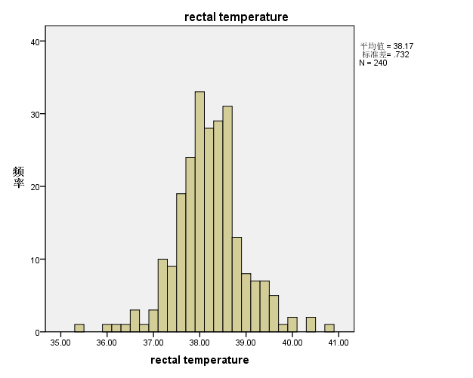

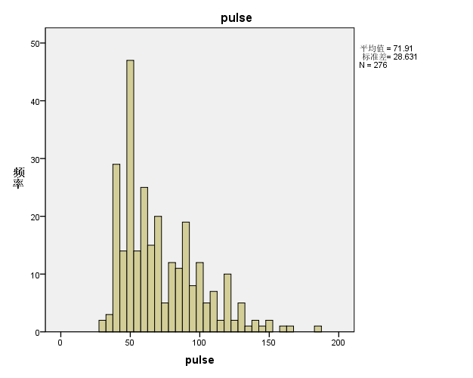

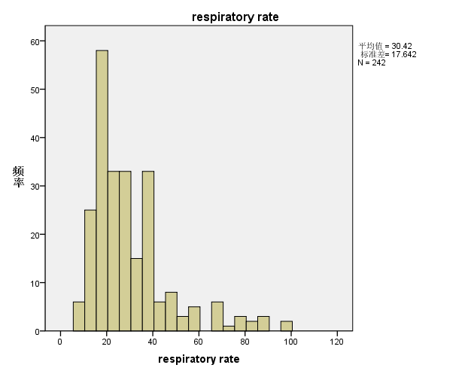

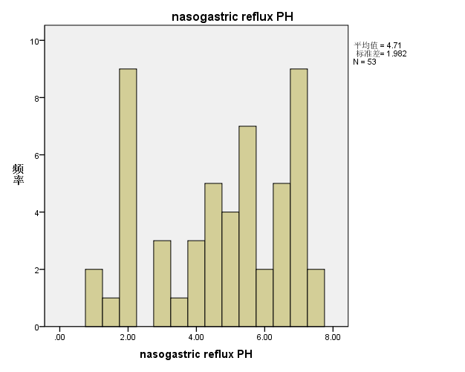

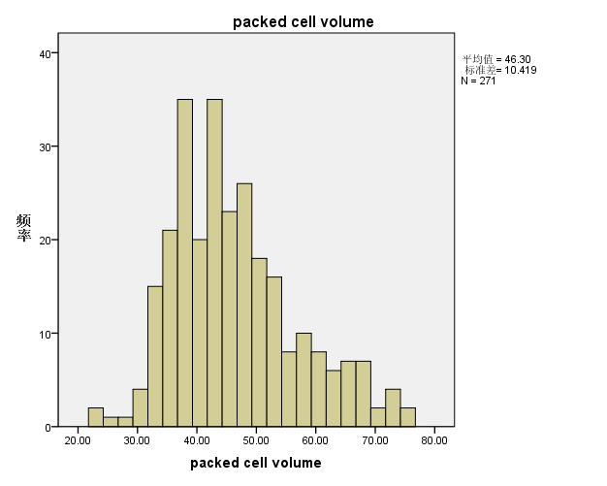

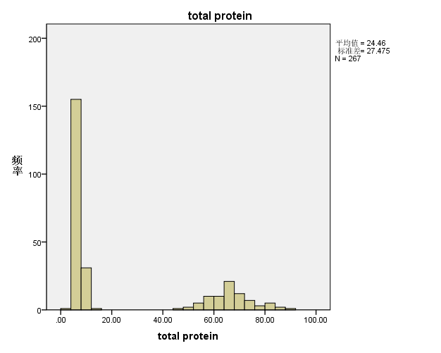

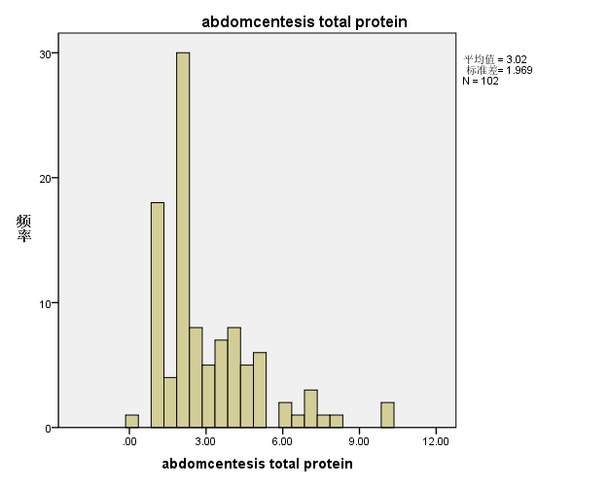

1. Q-Q图

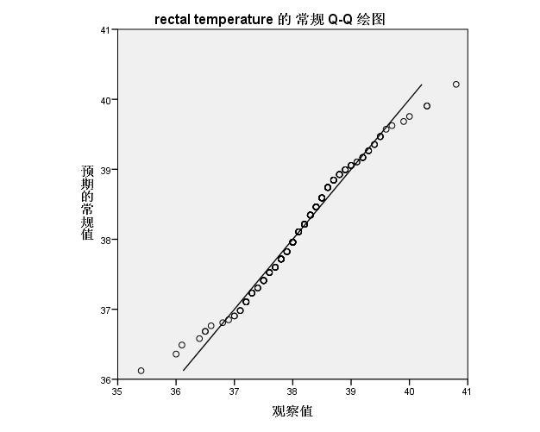

近似服从正态分布

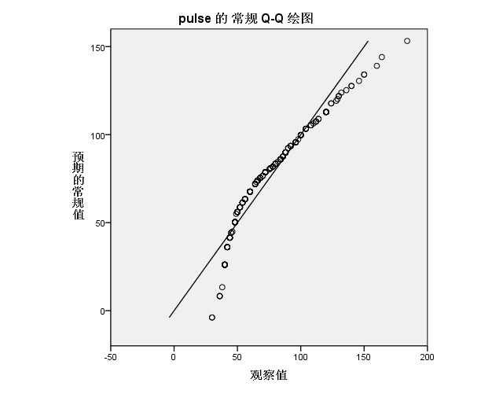

不服从正态分布

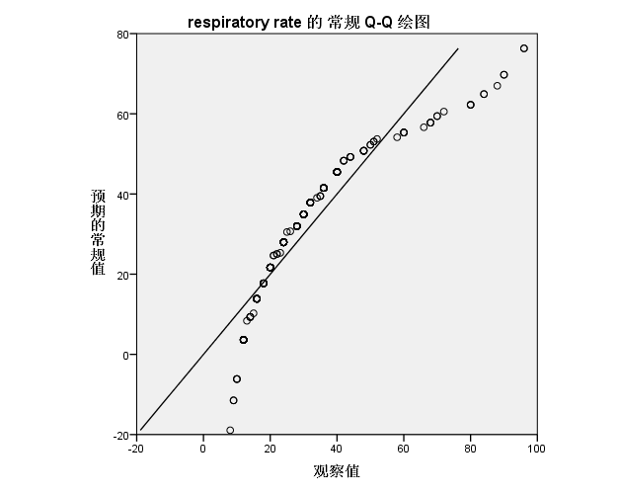

不服从正态分布

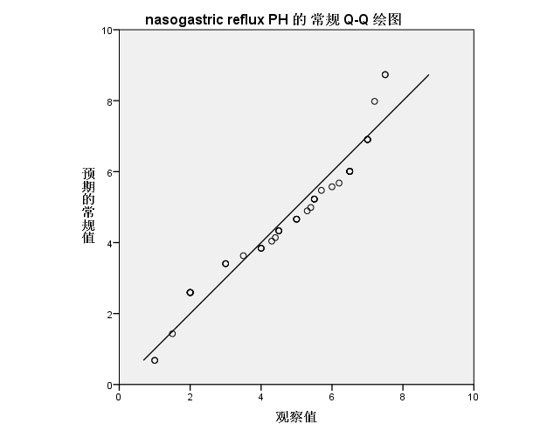

近似服从正态分布

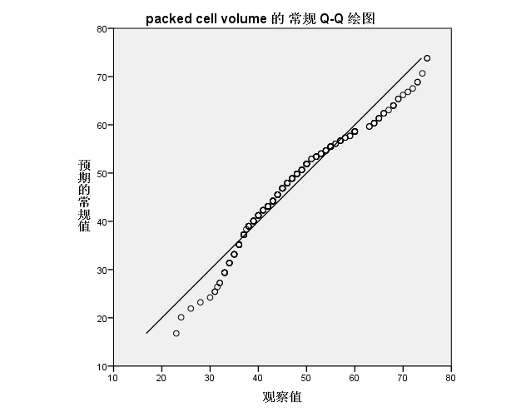

近似服从正态分布

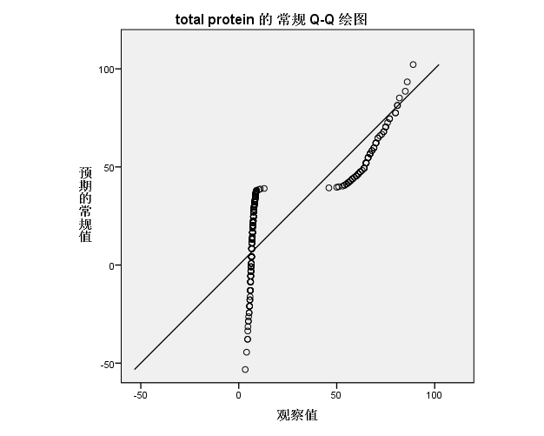

不服从正态分布

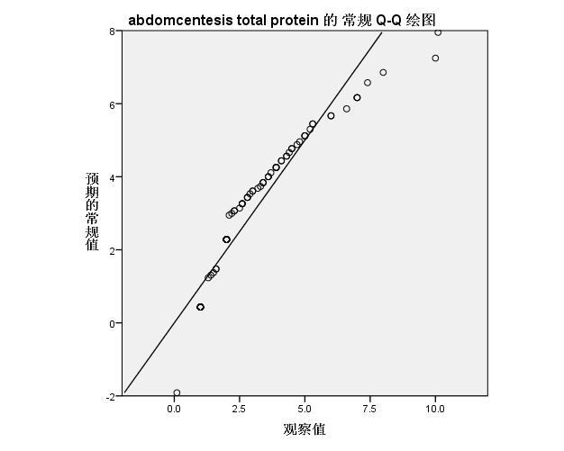

近似服从正态分布

1. 盒图

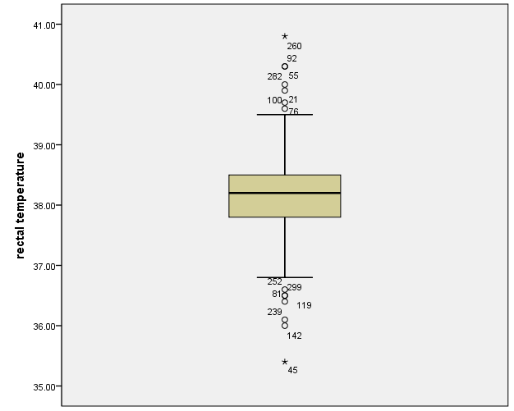

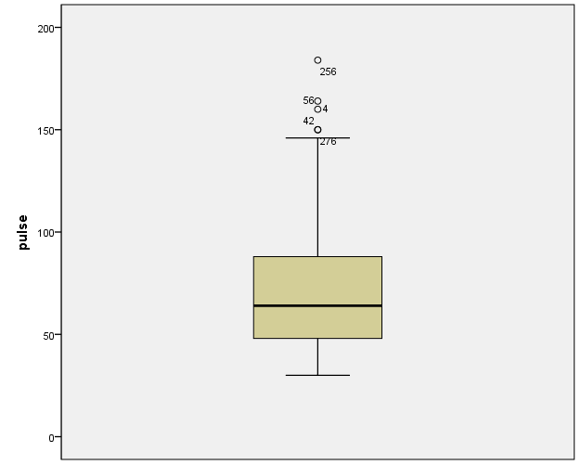

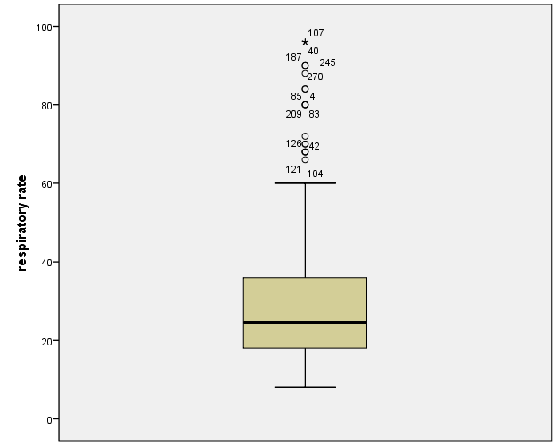

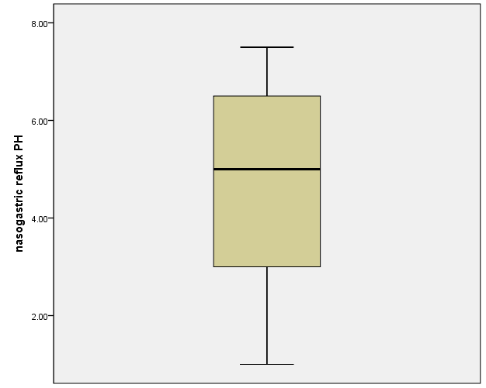

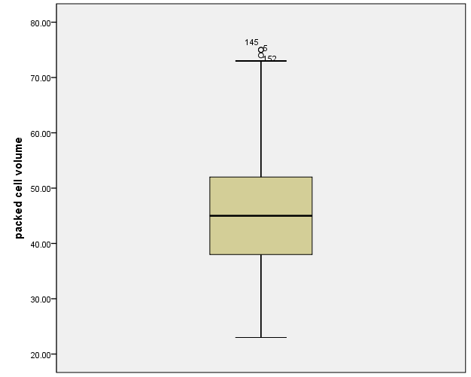

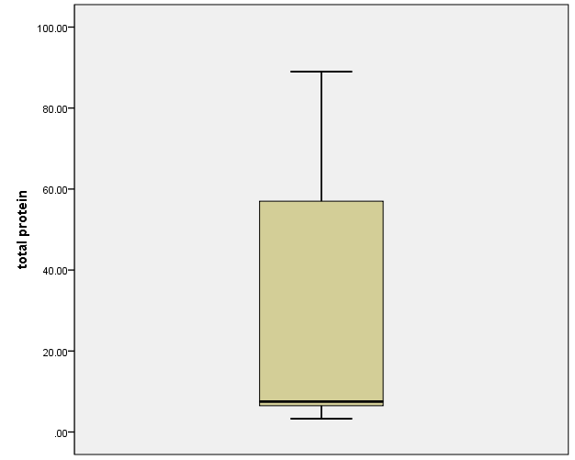

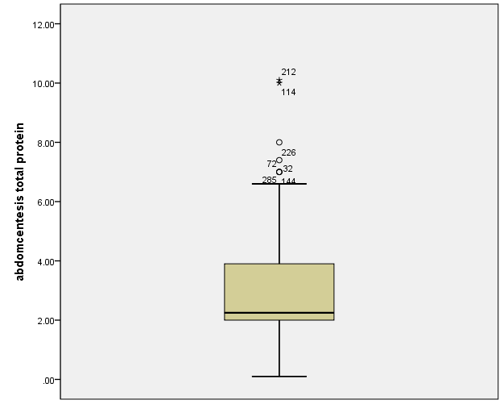

1. 数据缺失的处理
2. 用最高频率值填补

前面所得到的数据可视化结果即是在将缺失部分剔除的条件下绘出的，下面采取用最高频率值替换缺失值的方法，得到的统计结果如下：

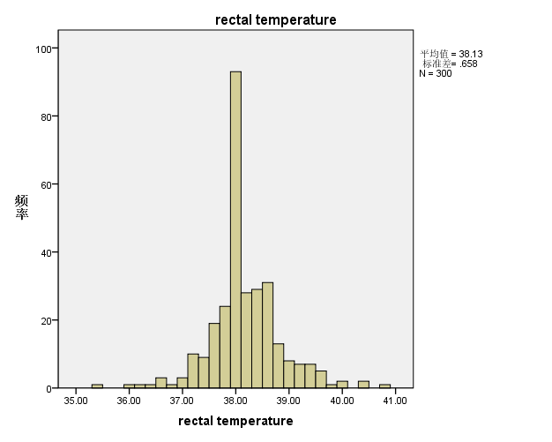

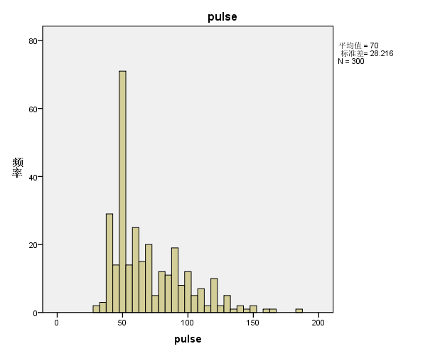

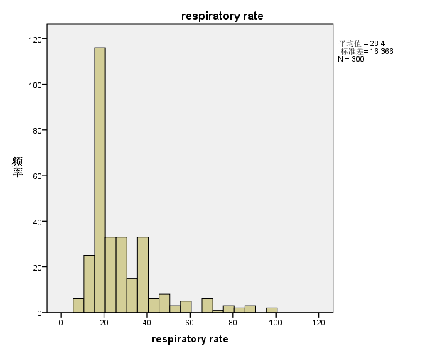

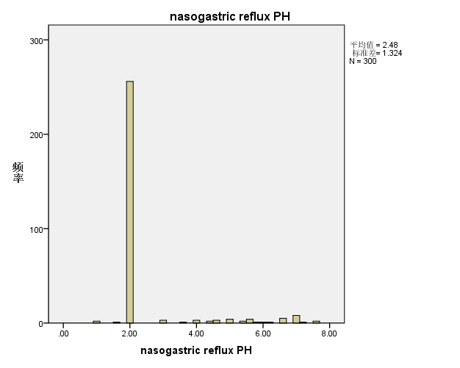

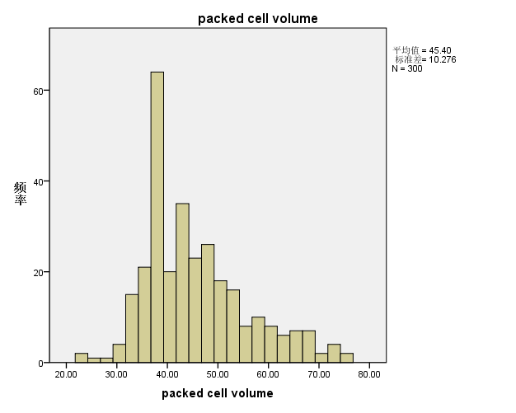

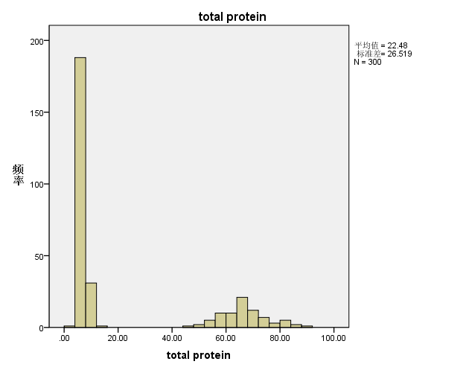

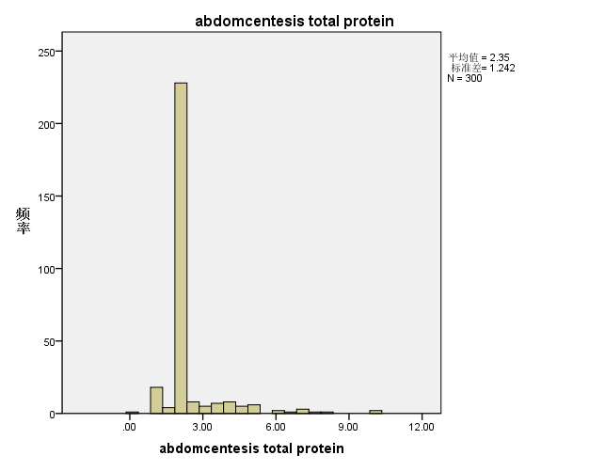

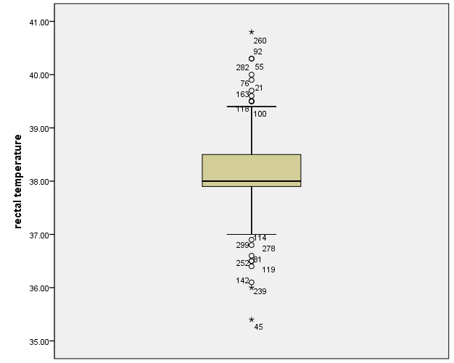

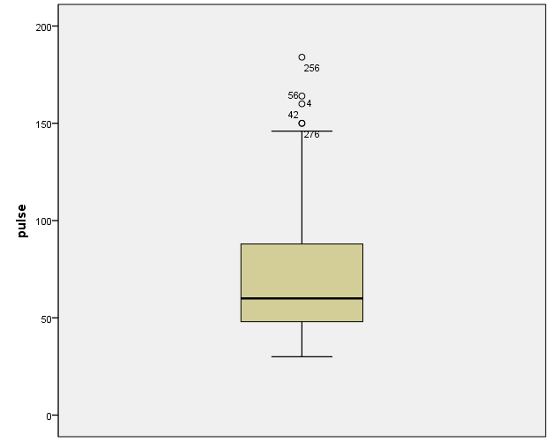

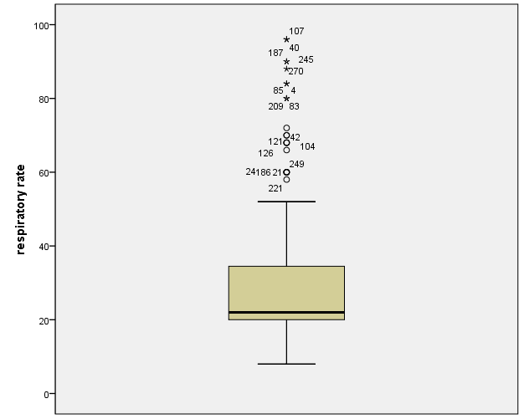

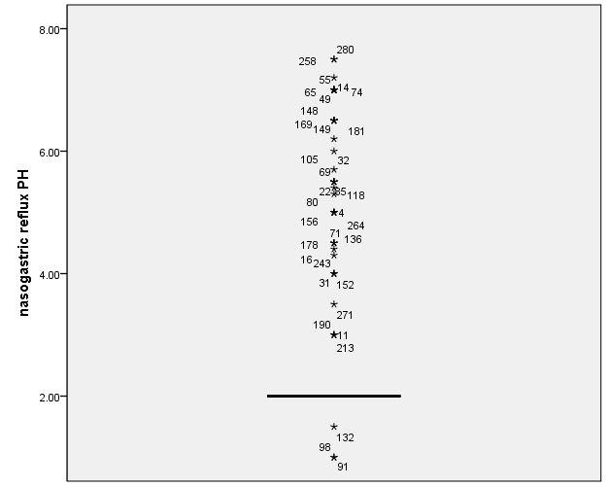

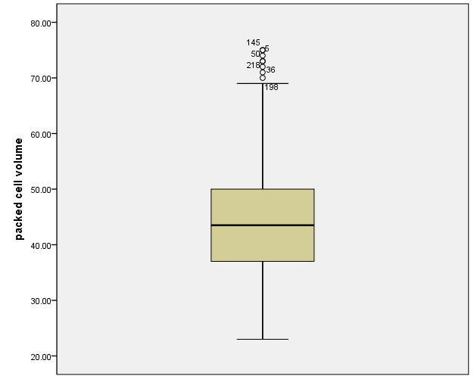

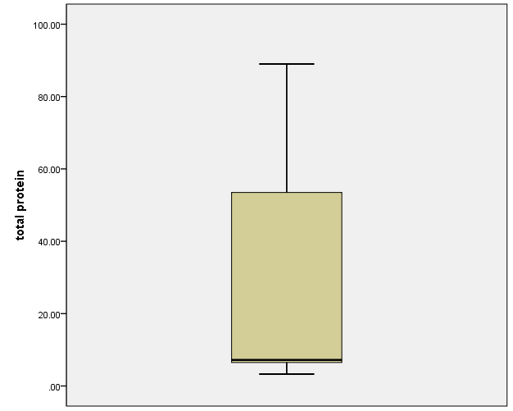

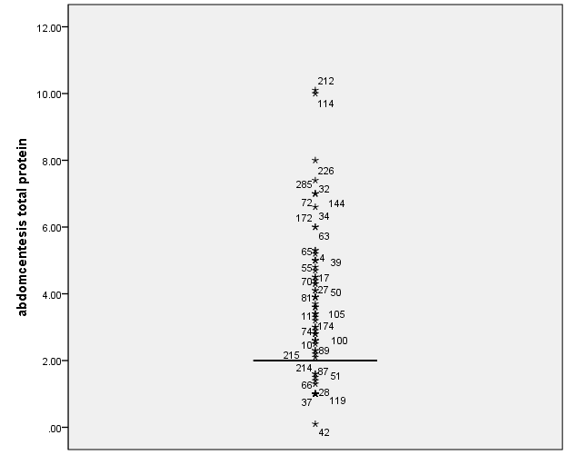

1. 通过数据对象之间的相似性来填补

对于个别数据缺失的问题，考虑到同一种群中个体之间大致是相似的，因此对不同个体可以采用线性插值的方法对缺失数据进行填补，得到的结果如下：

