  - WENJIE HE

AI Workflow
Automation Portfolio
  - Practical tools for sales and operations teams
I turn fragmented business data into prioritized actions, clearer diagnostics and repeatable reporting workflows. My approach combines business process design, AI-assisted development and explicit checks on the output.
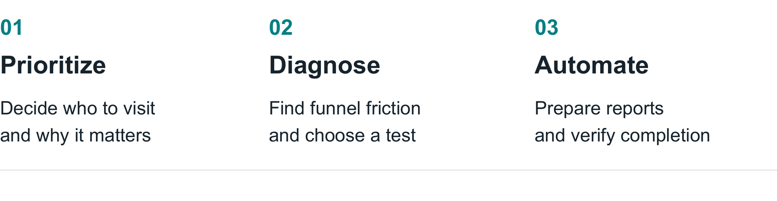
Selected internal projects built around real operating needs.

What I can help you deliver
A daily sales worklist with clear priorities; a repeatable analysis that explains where a funnel breaks; or a reporting workflow that checks the data and records what actually completed.

Why my business background matters
My automotive sales and operations experience includes Tesla, ONVO and Dongchedi. I have directly managed a 10-person team and personally managed a portfolio of 210 merchant accounts. This helps me define useful workflows, practical review steps and outputs that frontline users can act on.

My role in these projects
I defined the business problems and rules, used AI-assisted coding to build and iterate the tools, and checked their outputs against the operating process. My focus is applied automation and analytics, not model training.
The following cases are internal operating projects, not paid Upwork engagements. Employer names describe my background only. Example visuals use synthetic data unless explicitly identified as saved run results.

CASE STUDY 01

Sales Prioritization and Route Planning
An AI-assisted workbench that turns scattered account data into an explainable daily visit plan.

The business problem
Account reviews relied on separate reports and manual judgment. Sales representatives needed to know which accounts required attention, why they mattered and what to do during the visit.
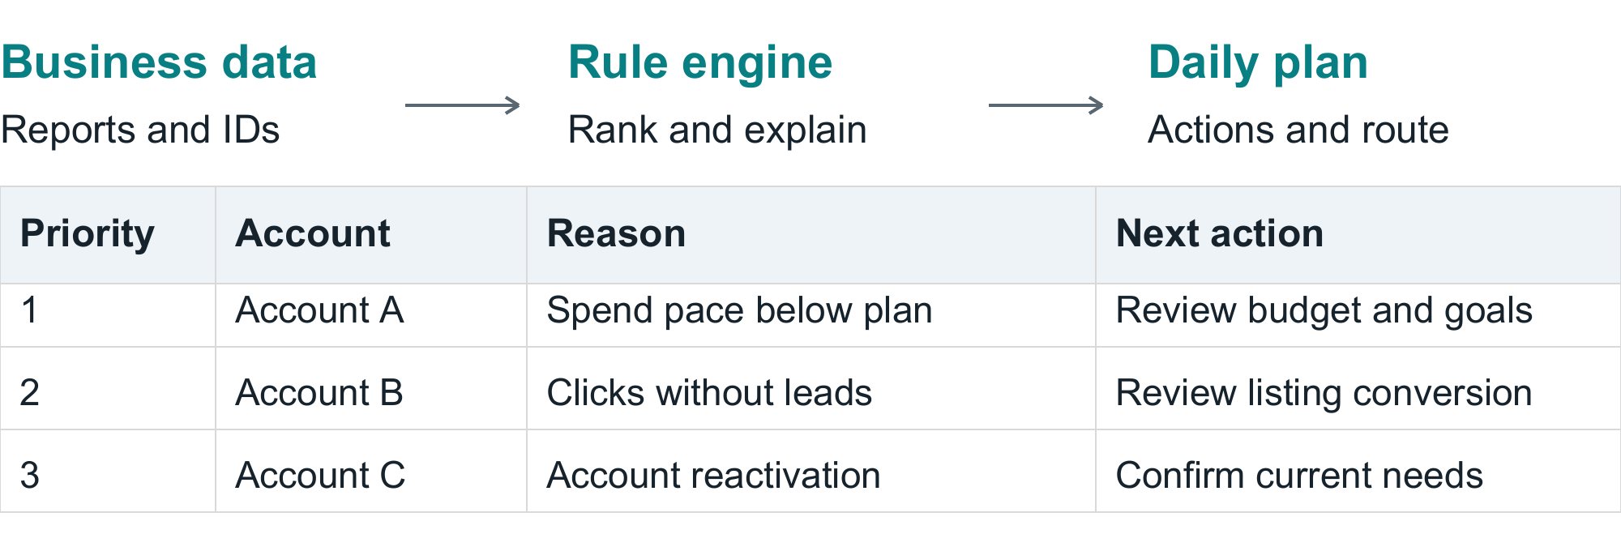
Illustrative English output using synthetic accounts. Not a production screenshot or actual client data.

What I built
I translated account-management needs into a local web workbench: Excel imports, merchant ID matching, rule-based opportunity screening, a ranked worklist and route planning. Each suggested visit carries a reason and a proposed action.
AI explains structured results and suggests next steps. Deterministic rules retain control of thresholds and ranking. Freshness checks block automated projections when linked source periods do not align.

Results and evidence
About 2 hours a day saved on my own planning and review, based on my estimate. All members of my team use the tool, based on my reported adoption. I also measured a 150% increase in my visit efficiency; this is not a team-wide benchmark.
These results are self-reported, not a controlled study. The tool supports decisions; no revenue uplift is attributed to AI alone. The reviewed implementation is local, not a deployed multi-tenant service.

Client application
Useful for field sales, account reviews and service visits. A scoped version can deliver a data import, configurable priority rules, an explained worklist and a route output.
Implementation: Python, JavaScript, HTML/CSS, Excel/JSON and map routing integration.

CASE STUDY 02

Vehicle Listing Performance Diagnostics
A repeatable analysis that separates visibility problems from conversion problems and turns them into specific tests.

The business problem
Large listing reports showed activity but did not make it easy to choose an intervention. Low click-through and low inquiry conversion require different actions; one generic recommendation is not enough.
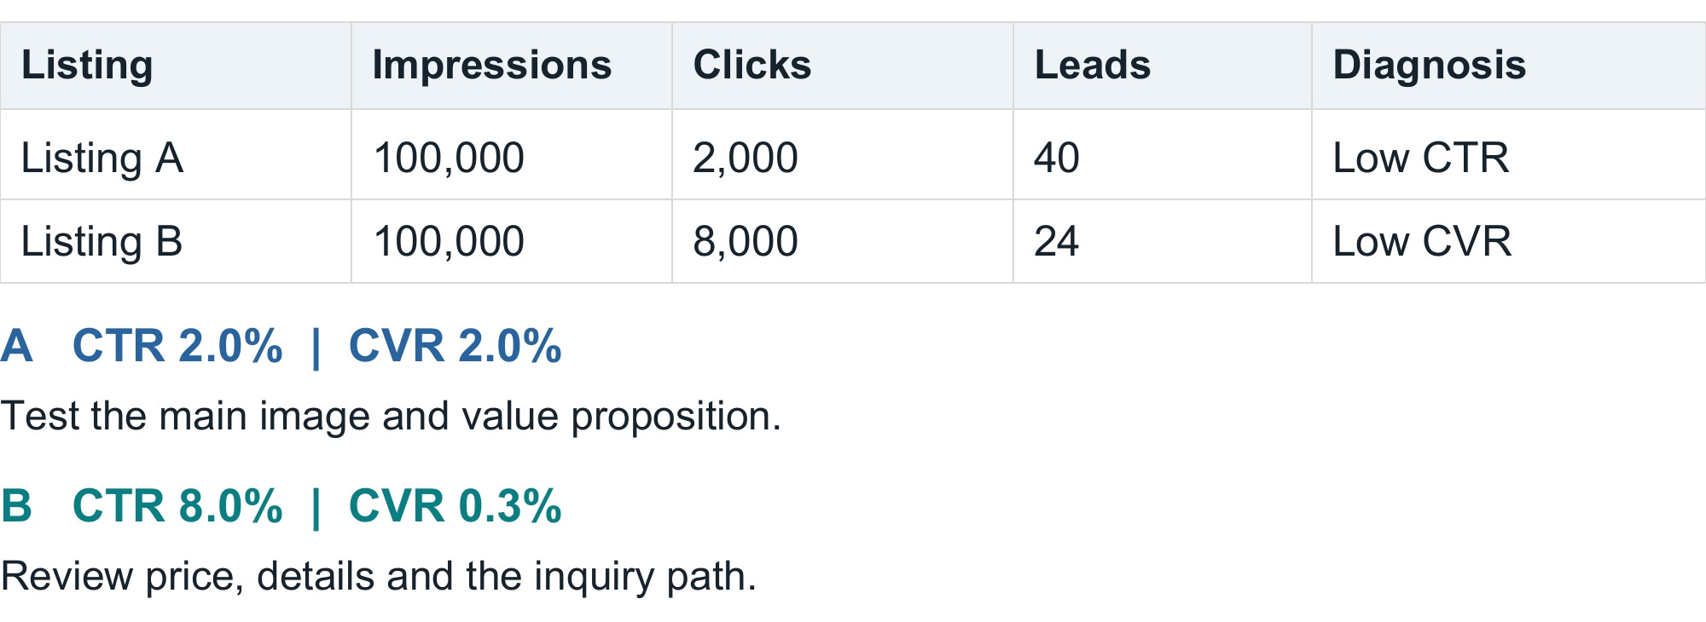
Synthetic examples. Illustrative thresholds: CTR 5%, CVR 1%. Actual report benchmarks are calculated from its own data.

What I built
I designed the diagnostic logic and an AI-assisted Python reporting pipeline. It validates source rows, groups listing performance and produces an Excel report plus an action summary. CTR is clicks divided by impressions; CVR is leads divided by clicks. Aggregate rates use summed counts, not averages of row percentages.

Documented output
91,951 valid rows covering 32,232 unique listing IDs were analyzed in one saved report. The output identified 1,807 full listing-name groups with clicks but no leads, helping focus review on pricing, listing details and the inquiry path.
Zero-conversion rows remain in the analysis. Diagnostic opportunity estimates are not realized leads. This run had no merchant lookup table, so it did not support merchant-level benchmarking.

Client application
The same approach can support marketplace listings, product catalogs and lead funnels. Deliverables include a cleaned data model, reproducible calculations, a diagnostic workbook and a prioritized test plan.
Implementation: Python, pandas, NumPy and Excel. AI-assisted development and interpretation; code calculates the metrics.

CASE STUDY 03

Auditable Reporting Automation
A controlled workflow for repetitive reporting where completeness, identity matching and visible saved state matter.

The business problem
Large reporting batches are easy to miscount or partially complete. A successful click does not prove that the right account, reporting period and values were saved.
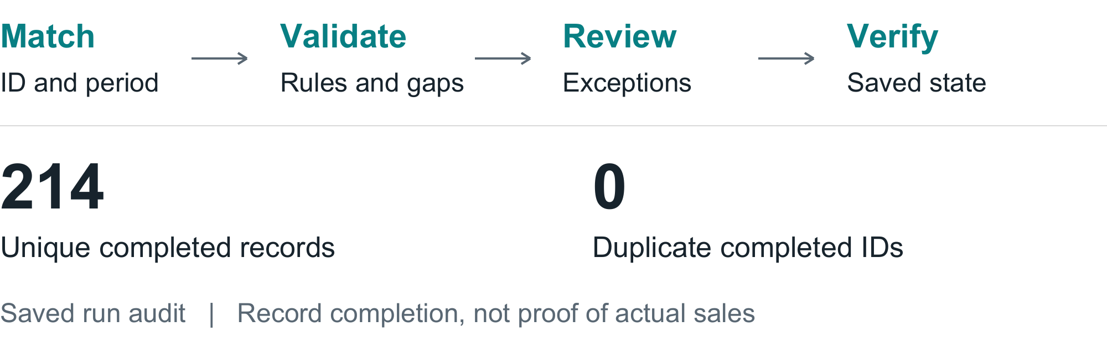
Actual aggregate counts from a saved internal run audit. No individual merchant records are shown.

What I built
I organized the reporting process into a resumable queue with exact account IDs and reporting periods. Source checks, calculation rules and reviewable exceptions precede authorized form entry. Completion is recorded only after checking the resulting saved state.
AI-assisted browser steps handle interface work; deterministic checks handle identity, duplicate detection and reconciliation. Uncertain cases remain visible for review rather than being silently treated as completed.

Documented output
The saved audit recorded 214 completed merchant records, zero duplicate completed IDs and zero pending records. Reconciliation identified 14 additional records beyond an initial interface count of 200.
This is saved run evidence, not a new live verification. Some fields in the source workflow were approved rule-based estimates, not observed transactions. Completion checks do not prove the factual accuracy of estimated sales.

Client application
Useful for recurring operational reports and structured data-entry workflows. A scoped version can include validation checks, an exception queue, a completion log and an operating guide. External writes require approval and permitted access.
Implementation: Python, Excel/JSON, browser-assisted automation and persisted verification logs.

SERVICES

What You Can Hire Me For
Start with one business process, a representative sample and a clear definition of a useful result.

Sales workflow prototype
Outcome: a repeatable way to decide which accounts need attention and what to do next.
Inputs: account exports, performance measures, business rules and location data where needed.
Deliverables: a structured import, agreed prioritization rules, an explained worklist, a lightweight interface and a usage guide. Routing is scoped to the available map provider and geography.

Funnel analysis and diagnostic reporting
Outcome: a clearer view of where performance drops and which action to test first.
Inputs: listing, product or sales-funnel exports with agreed metric definitions.
Deliverables: a data-quality check, reusable analysis script, diagnostic workbook, visual summary and prioritized recommendations. Recommendations are hypotheses to validate, not guaranteed uplift.

Recurring reporting automation
Outcome: less repetitive preparation and a clearer record of what is complete.
Inputs: recurring source files, an output template, reporting rules and access to approved systems when needed.
Deliverables: a repeatable preparation workflow, validation checks, exception handling, a completion log and a handover guide. Form submission is optional and separately approved.

Scope before scale
The first milestone is a working prototype on an agreed sample. Cloud deployment, authentication, ongoing hosting, third-party API fees and maintenance need separate scope. I do not bypass platform restrictions or promise unattended operation in systems that require human verification.

DELIVERY

How We Work Together
A small, testable workflow is the starting point. Expansion follows evidence that the output is useful and reliable.

1 Define the decision
We identify the user, the recurring task and the action the output should support. I ask for a sample input, the current output and a definition of success before proposing the automation.

2 Build a bounded prototype
I implement one agreed workflow using approved sample data. We keep business rules explicit, distinguish facts from estimates and show exceptions that need human review.

3 Validate against the source
We compare records and totals, test missing and duplicate data, and review the recommendations. Where external writes are included, we verify the saved state rather than treating a click as success.

4 Hand over a repeatable process
The handover includes the agreed scripts or interface, input requirements, an example output, a short runbook and known limitations. Maintenance and further integrations are agreed separately.

What acceptance looks like
The agreed records reconcile to source; the same inputs reproduce the same calculations; missing data is visible; and the output answers the business question. AI-generated interpretation remains reviewable and separate from numerical truth.

Tools used in the selected projects
Python, pandas, NumPy, JavaScript, HTML/CSS, Excel and JSON; AI-assisted development with Codex; browser-assisted workflows and map integrations where required. Tool choice follows the problem rather than a fixed platform stack.

Start a conversation on Upwork
Send me a short description of the repetitive task, a sanitized sample and the result you need. I can help define a focused first milestone before expanding the workflow.

