**Screenshots to show the upload and download of one of the sample files**

**Upload and download screenshot:**

Client:

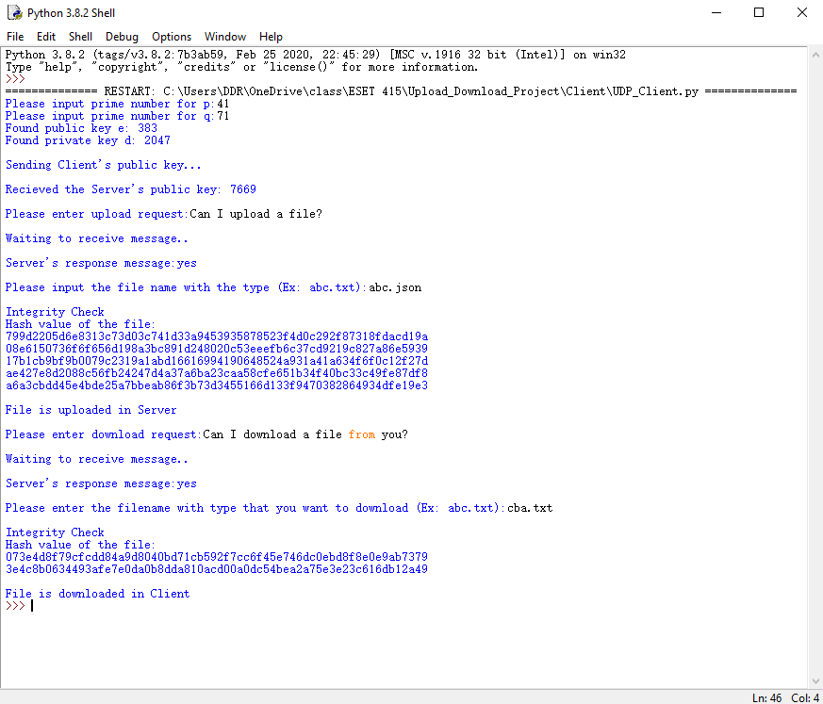

Server’s Side:

