## Experiment 2

use a editor to finish the following shell scripts, and run them in Linux system.

#### Obtain the system time, and check whether it is in the morning, afternoon, or evening.

#### sh:

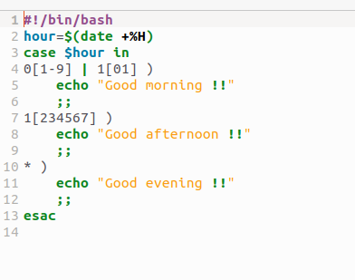

#### Output:

1

#### Input two number, check which one is greater, andoutput the result.

#### sh脚本:

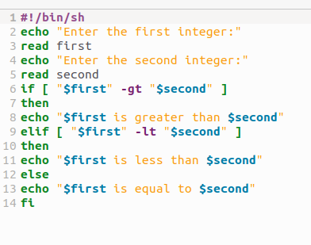

#### Output：

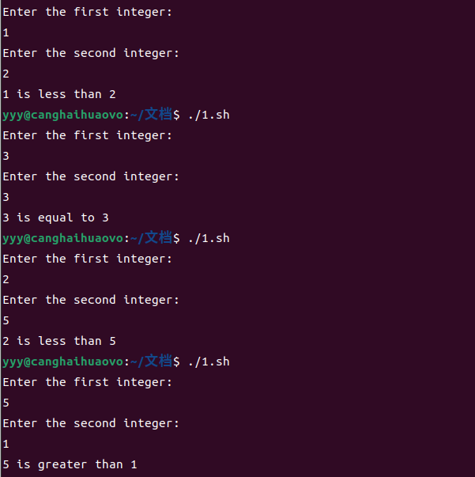

#### Find the minimal value in a given list.

#### Sh脚本：

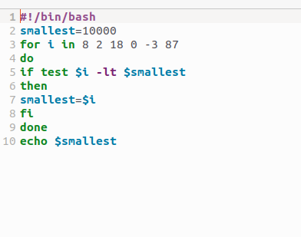

#### Output：

3

#### Calculate the number of executive file in the current directory.

#### sh脚本：

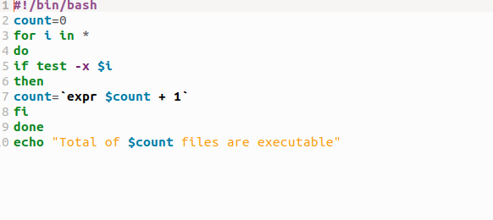

#### Output：

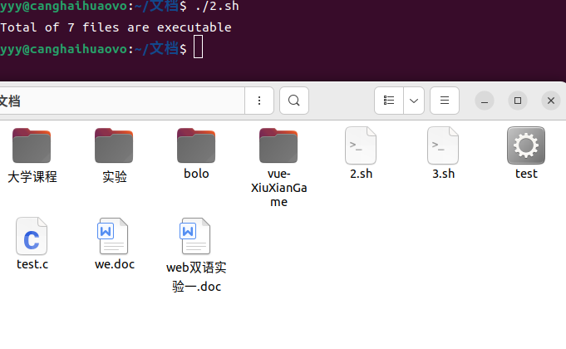

#### Check whether a given number is a prime, you have to write a function, and call the function.

sh脚本：

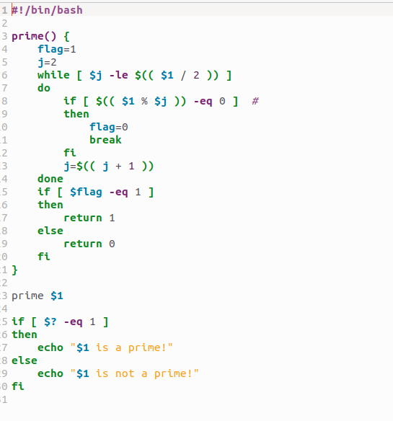

#### Output：

