### #Experiment 1

### 1. Objective

Get familiar with the Linux operating system environment through experiments and master the

use of basic Linux commands.

### 2. Requirement

Master the permission management of Linux files

Master basic file and directory operations

Linux user management

File compression and archiving

### 3. Experiment Step

**（1）Directory Operation**

**Enter the following commands in sequence:**

$pwd

$cd ~

$mkdir your_studentID

$cd your_studentID

$mkdir your_name

$ls

$rmdir your_name

$ls

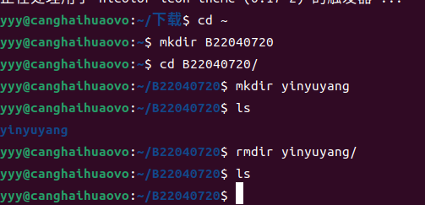

**(2) File operation**

Enter the following commands in sequence:

$cd ~

$touch yourname.txt

$ls

$echo "hello world" > yourname.txt

$cat yourname.txt

$cp yourname.txt yourname2.txt

$mv yourname.txt yourstudentid.txt

$ls

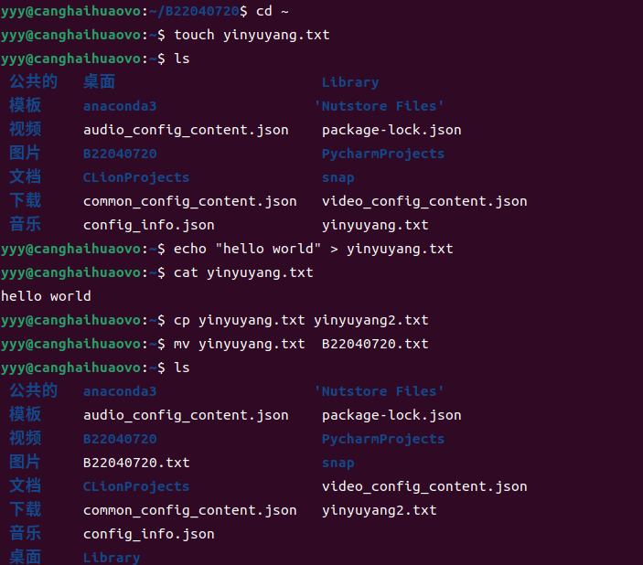

## (3)User Management

Enter the following commands in sequence:

$whoami

$sudo su root

Enter the password of the current logged-in user, not the root password, and then

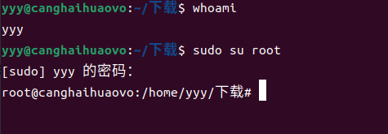

enter:

#groupadd student

#whoami

#adduser yourstudentID

#usermod -g student yourstudentID

Follow the prompts to create the user and add the user to the student group.

Switch to the user.

#su yourstudentID

$cd ~

$touch yourname.txt

$ls -l

View the properties of the file, including the owner user and the group to which the owner user

belongs.

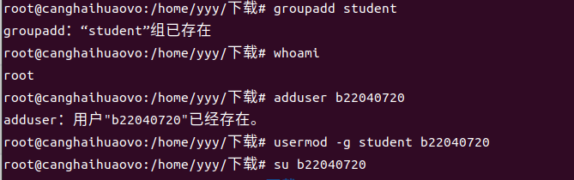

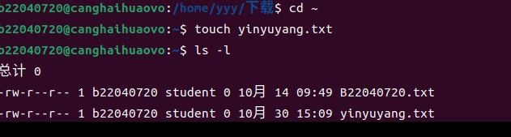

**(4) Permission management**

Enter the following commands in sequence:

$ touch demo

$ chmod 777 demo

$ chmoda-x demo# result is rw-rw-rw-

$ chmodgo-w demo# result is rw-r--r--

$ chmodg+w demo# result is rw-rw-r--

$ chmoda=$ chmod+t demo# result is --------T

$ chmodu+s demo# result is --S-----T

$ chmodu+rx demo# result is r-s-----T

$ chmodg+rws demo# result is r-srwS--T

demo

# result is ---------

After entering each line, run ls -l demo to view the result.

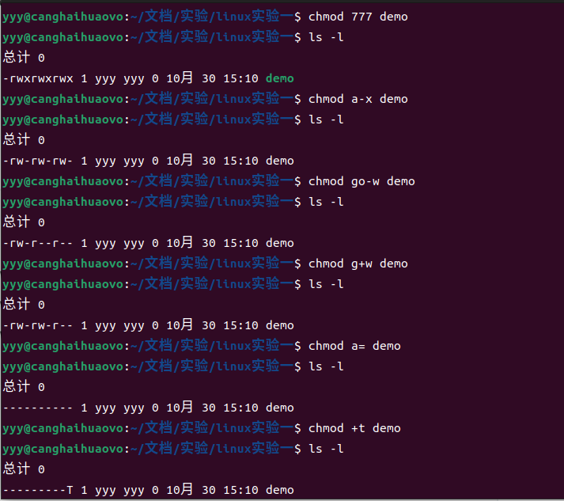

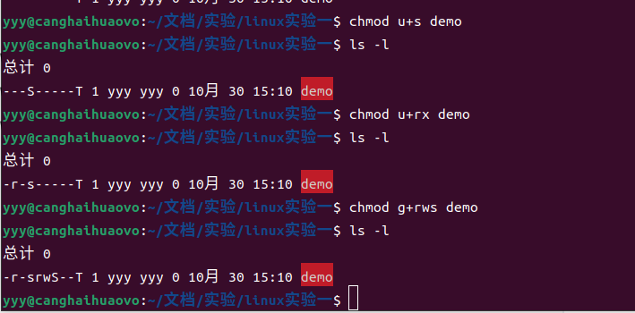

**(5) Other management**

Create folder "others" in the main directory of the user, go to the folder, and create two files with the name of any file. Then run the following commands in sequence.

$tar -czvf backup.tar.gz others

$ls -l

$tar -xzvf

$ls -l



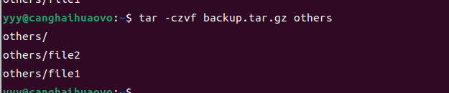

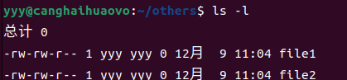

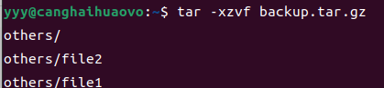

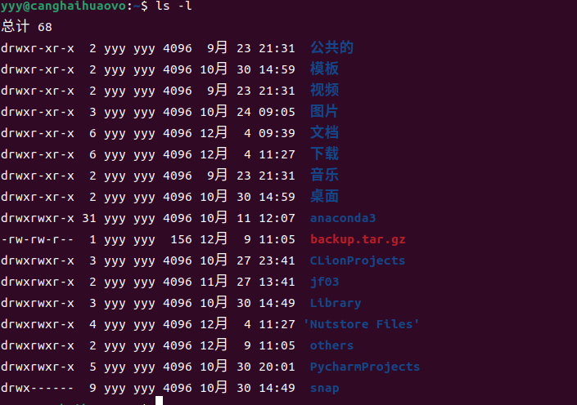

Observe changes in the process.

Create a textfile file and make it as follows:

no, I study in njupt.

this line ends with 00

this line ends with .00

I am 25 years old.

He is 15. It is 16.00

wy is the short of my name.

Search for all lines beginning with the character "n" in the file textfile

**$ grep ‘^n' textfile**

Search the textfile for all lines ending in ".00"

**$ grep '\.00$' textfile**

Search for all lines in the textfile that contain the number 5, followed by the character ".", followed by any character

**$ grep '5\..' textfile**

Search for all lines starting with the characters "w" and "y" in the file textfile

**$ grep ‘^[wy]’ textfile**

