**Experiment 2**

1.Obtain the system time, and check whether it is in the morning, afternoon, or evening.

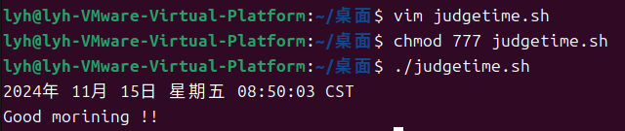

2. Input two number, check which one is greater, and output the result.

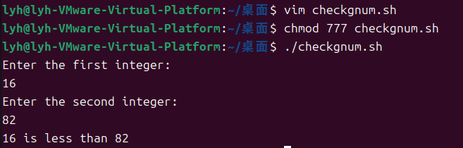

3.Find the minimal value in a given list.

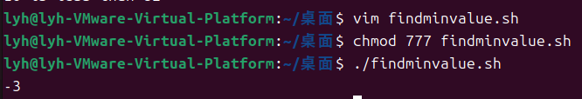

4.Calculate the number of executive file in the currentdirectory.

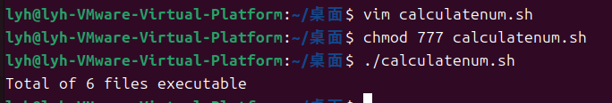

5.Check whether a given number is a prime, you have to write a function, and call the function.

