**Experiment3 C programming experiment**

**(1) Task 1**

(1) Write a C program that uses standard I/O libraries to display the contents of text files. The program is compiled and linked by the make tool, which requires the generation of the.o file first, and then the generation of the executable file, and the function of deleting the intermediate file (.o) in the makefile file.



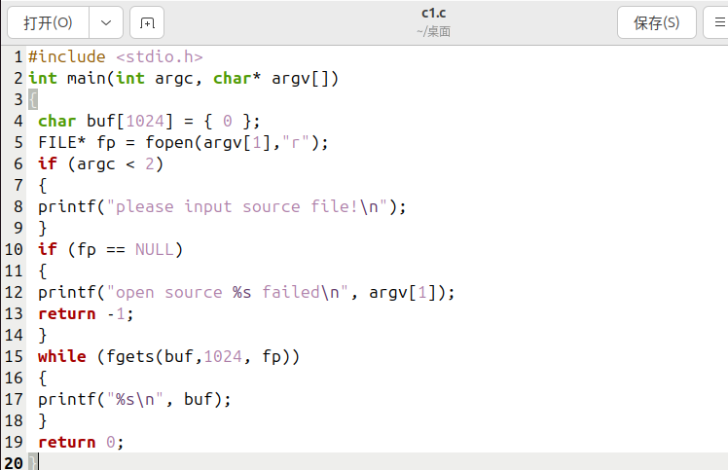

We can use the following makefile.

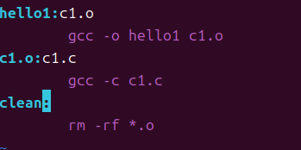

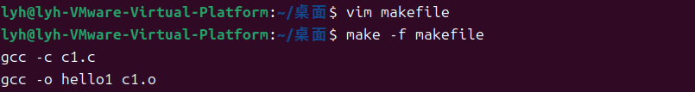

**(2) Task 2**

(2) Write a C program that displays all the file names in the current directory. The program is compiled and linked by the make tool, which requires the generation of the.o file first, and then the generation of the executable file, and the function of deleting the intermediate file (.o) in the makefile file.



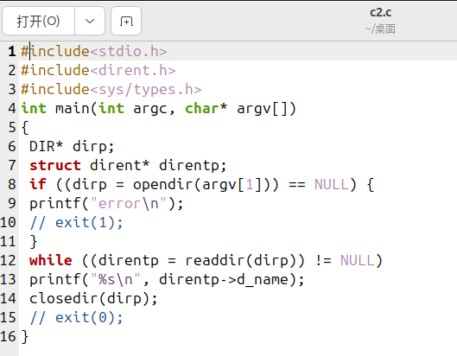

We can use the following makefile.



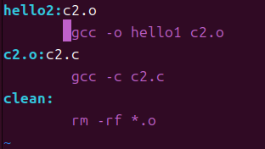

Run it

、

**(3) Task 3**

(3) Write a C program that changes the working directory of the current process. The program is compiled and linked by the make tool, which requires the generation of the.o file first, and then the generation of the executable file, and the function of deleting the intermediate file (.o) in the makefile file.

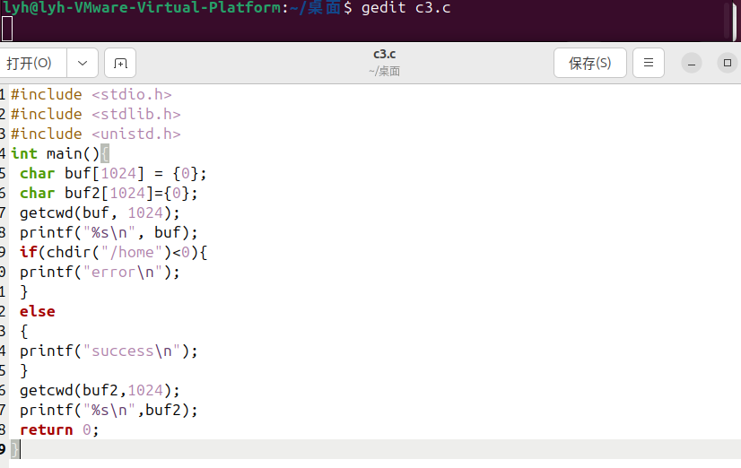

We can use the following makefile.



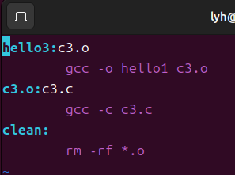

Run it

