分析33位【善終】安寧病房病人原始資料描述：

1. 病人資料：

|  |  |  |  |  |  |  |  |  |  |  |  |  |  |  |  |
| --- | --- | --- | --- | --- | --- | --- | --- | --- | --- | --- | --- | --- | --- | --- | --- |
| 編號 | 年紀 | 性別 | 總檔案數 | 開始 | 結束 | 存活天數 | Note | Admission | Weekly | ICU | CCU | Extubation | 安寧照護 | Hospice Combine | 社工師 |
| 4 | 59 | 女 | 12 | 2014/11/6 | 2015/1/5 | 60 | 9 | 1 | 2 | 0 | 0 | 0 | 0 | 0 | 0 |
| 18 | 48 | 男 | 8 | 2015/1/21 | 2015/3/19 | 57 | 6 | 1 | 0 | 0 | 0 | 0 | 1 | 0 | 0 |
| 1 | 73 | 男 | 34 | 2014/11/24 | 2015/1/6 | 43 | 26 | 1 | 2 | 0 | 0 | 0 | 2 | 0 | 3 |
| 19 | 60 | 男 | 7 | 2015/2/16 | 2015/3/25 | 37 | 5 | 0 | 1 | 0 | 0 | 0 | 1 | 0 | 0 |
| 28 | X | X | 8 | 2015/4/29 | 2015/6/1 | 33 | 6 | 0 | 2 | 0 | 0 | 0 | 0 | 0 | 0 |
| 9 | 61 | 女 | 3 | 2015/1/23 | 2015/2/22 | 30 | 1 | 1 | 0 | 0 | 0 | 0 | 1 | 0 | 0 |
| 10 | X | X | 12 | 2015/1/13 | 2015/2/9 | 27 | 10 | 0 | 2 | 0 | 0 | 0 | 0 | 0 | 0 |
| 26 | 85 | 男 | 2 | 2015/3/27 | 2015/4/22 | 26 | 0 | 0 | 1 | 0 | 0 | 0 | 1 | 0 | 0 |
| 6 | 85 | 男 | 8 | 2014/12/29 | 2015/1/23 | 25 | 4 | 0 | 2 | 0 | 0 | 0 | 2 | 0 | 0 |
| 29 | 68 | 男 | 4 | 2015/4/15 | 2015/5/8 | 23 | 4 | 0 | 0 | 0 | 0 | 0 | 0 | 0 | 0 |
| 2 | X | X | 3 | 2014/12/26 | 2015/1/15 | 20 | 0 | 0 | 1 | 0 | 0 | 0 | 2 | 0 | 0 |
| 11 | 92 | 男 | 2 | 2015/2/6 | 2015/2/26 | 20 | 1 | 1 | 0 | 0 | 0 | 0 | 0 | 0 | 0 |
| 31 | 59 | 男 | 3 | 2015/5/27 | 2015/6/8 | 12 | 3 | 0 | 0 | 0 | 0 | 0 | 0 | 0 | 0 |
| 37 | 86 | 女 | 5 | 2015/8/20 | 2015/8/31 | 11 | 3 | 0 | 0 | 0 | 0 | 1 | 1 | 0 | 0 |
| 12 | 47 | 男 | 3 | 2015/2/18 | 2015/2/26 | 8 | 2 | 1 | 0 | 0 | 0 | 0 | 0 | 0 | 0 |
| 13 | 61 | 男 | 4 | 2015/2/22 | 2015/2/28 | 6 | 0 | 0 | 0 | 0 | 4 | 0 | 0 | 0 | 0 |
| 23 | 64 | 男 | 2 | 2015/4/4 | 2015/4/10 | 6 | 1 | 0 | 0 | 0 | 0 | 0 | 1 | 0 | 0 |
| 3 | 34 | 女 | 4 | 2014/12/26 | 2014/12/31 | 5 | 3 | 0 | 0 | 0 | 0 | 0 | 0 | 1 | 0 |
| 5 | 84 | 女 | 2 | 2015/1/6 | 2015/1/9 | 3 | 0 | 1 | 0 | 0 | 0 | 0 | 1 | 0 | 0 |
| 7 | X | X | 4 | 2015/1/15 | 2015/1/18 | 3 | 3 | 0 | 1 | 0 | 0 | 0 | 0 | 0 | 0 |
| 21 | X | X | 2 | 2015/3/20 | 2015/3/23 | 3 | 2 | 0 | 0 | 0 | 0 | 0 | 0 | 0 | 0 |
| 16 | 71 | 男 | 2 | 2015/3/7 | 2015/3/9 | 2 | 0 | 0 | 1 | 0 | 0 | 0 | 1 | 0 | 0 |
| 17 | 25 | 女 | 2 | 2015/2/26 | 2015/2/28 | 2 | 0 | 0 | 0 | 2 | 0 | 0 | 0 | 0 | 0 |
| 14 | 53 | 男 | 1 | 2015/2/28 | 2015/2/28 | 0 | 0 | 1 | 0 | 0 | 0 | 0 | 0 | 0 | 0 |
| 15 | X | X | 1 | 2015/3/5 | 2015/3/5 | 0 | 1 | 0 | 0 | 0 | 0 | 0 | 0 | 0 | 0 |
| 20 | 69 | 男 | 1 | 2015/3/27 | 2015/3/27 | 0 | 0 | 0 | 1 | 0 | 0 | 0 | 0 | 0 | 0 |
| 22 | 61 | 女 | 1 | 2015/3/27 | 2015/3/27 | 0 | 0 | 0 | 0 | 0 | 0 | 0 | 1 | 0 | 0 |
| 24 | X | X | 1 | 2015/4/12 | 2015/4/12 | 0 | 1 | 0 | 0 | 0 | 0 | 0 | 0 | 0 | 0 |
| 25 | X | X | 1 | 2015/4/13 | 2015/4/13 | 0 | 1 | 0 | 0 | 0 | 0 | 0 | 0 | 0 | 0 |
| 30 | X | X | 1 | 2015/5/22 | 2015/5/22 | 0 | 0 | 0 | 1 | 0 | 0 | 0 | 0 | 0 | 0 |
| 34 | X | X | 1 | 2015/6/16 | 2015/6/16 | 0 | 0 | 0 | 0 | 0 | 0 | 0 | 1 | 0 | 0 |
| 35 | X | X | 1 | 2015/7/20 | 2015/7/20 | 0 | 0 | 0 | 0 | 0 | 0 | 0 | 1 | 0 | 0 |
| 36 | X | X | 1 | 2015/8/3 | 2015/8/3 | 0 | 0 | 0 | 0 | 0 | 0 | 1 | 0 | 0 | 0 |

1. 決定善終病人的被照顧結果樣態 (Y = 支持度 and X = 存活天數)
2. 共同照護支持度：存活天數 / 檔案數 = 每單位時段投入的照顧紀錄可提高多少存活天數
3. 畫出支持度的機率分布圖

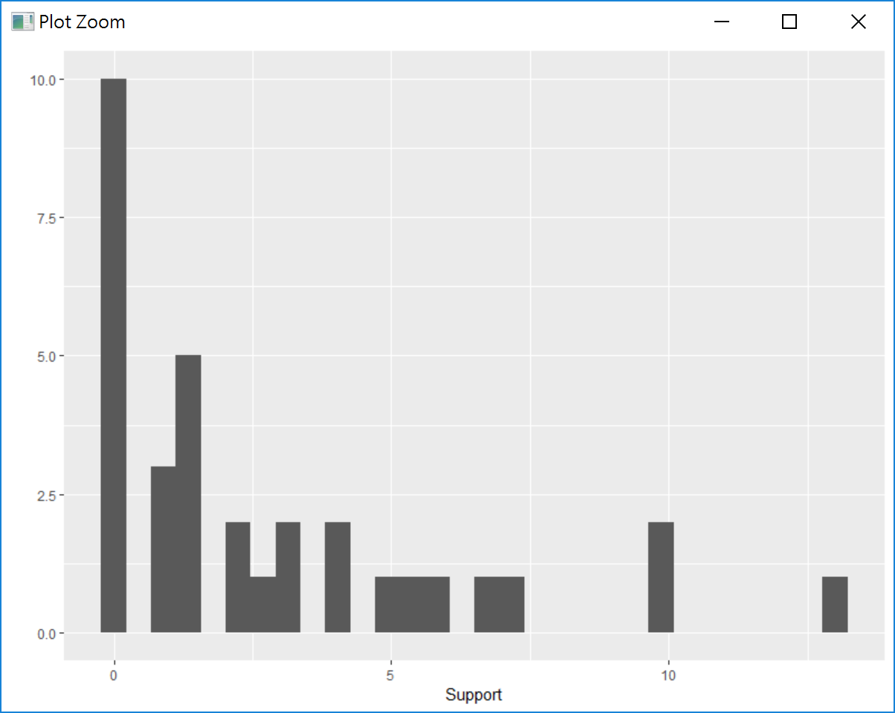

1. 將存活天數，分量成以下六類
   1. Days>=30
   2. 20<=Days<30
   3. 14<=Days<20
   4. 7<=Days<14
   5. Days<7
   6. Days=0

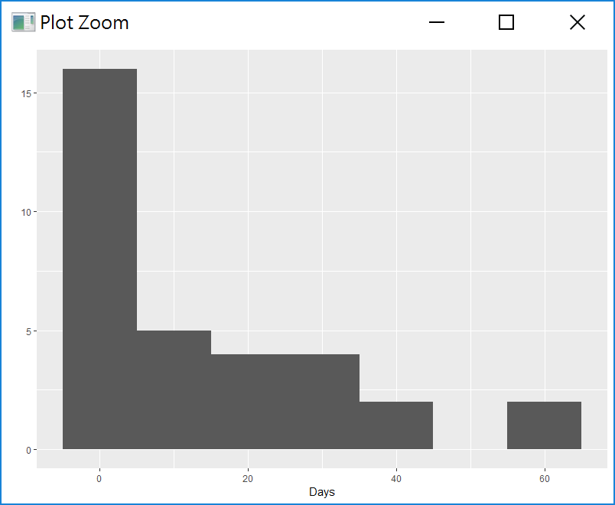

1. 綜合 Support & Days 結果。
2. 分析一：關注 Support >= 5 & Days >= 30 的紀錄，善終病例中，挑出安寧照護效率高 (低紀錄 & 存活長) 的資料

|  |  |  |  |  |  |  |  |  |  |  |  |  |  |  |  |  |
| --- | --- | --- | --- | --- | --- | --- | --- | --- | --- | --- | --- | --- | --- | --- | --- | --- |
| 編號 | 年紀 | 性別 | 總檔案數 | 開始 | 結束 | 存活天數 | Note | Admission | Weekly | ICU | CCU | Extubation | 安寧照護 | Hospice Combine | 社工師 | 支持度 |
| 9 | 61 | 女 | 3 | 2015/1/23 | 2015/2/22 | 30 | 1 | 1 | 0 | 0 | 0 | 0 | 1 | 0 | 0 | 10 |
| 18 | 48 | 男 | 8 | 2015/1/21 | 2015/3/19 | 57 | 6 | 1 | 0 | 0 | 0 | 0 | 1 | 0 | 0 | 7.125 |
| 19 | 60 | 男 | 7 | 2015/2/16 | 2015/3/25 | 37 | 5 | 0 | 1 | 0 | 0 | 0 | 1 | 0 | 0 | 5.285714286 |
| 4 | 59 | 女 | 12 | 2014/11/6 | 2015/1/5 | 60 | 9 | 1 | 2 | 0 | 0 | 0 | 0 | 0 | 0 | 5 |

1. 分析二：關注 Support < 5 & Days >= 30 的紀錄，善終病例中，挑出安寧照護付出高 (高紀錄 & 存活長) 的資料

|  |  |  |  |  |  |  |  |  |  |  |  |  |  |  |  |  |
| --- | --- | --- | --- | --- | --- | --- | --- | --- | --- | --- | --- | --- | --- | --- | --- | --- |
| 編號 | 年紀 | 性別 | 總檔案數 | 開始 | 結束 | 存活天數 | Note | Admission | Weekly | ICU | CCU | Extubation | 安寧照護 | Hospice Combine | 社工師 | 支持度 |
| 1 | 73 | 男 | 34 | 2014/11/24 | 2015/1/6 | 43 | 26 | 1 | 2 | 0 | 0 | 0 | 2 | 0 | 3 | 1.264705882 |
| 28 | X | X | 8 | 2015/4/29 | 2015/6/1 | 33 | 6 | 0 | 2 | 0 | 0 | 0 | 0 | 0 | 0 | 4.125 |

1. 分析三：關注 Support >= 5 & 20 <= Days < 30 的紀錄，善終病例中，挑出安寧照護待發揮 (低紀錄 & 存活未滿一個月) 的資料

|  |  |  |  |  |  |  |  |  |  |  |  |  |  |  |  |  |
| --- | --- | --- | --- | --- | --- | --- | --- | --- | --- | --- | --- | --- | --- | --- | --- | --- |
| 編號 | 年紀 | 性別 | 總檔案數 | 開始 | 結束 | 存活天數 | Note | Admission | Weekly | ICU | CCU | Extubation | 安寧照護 | Hospice Combine | 社工師 | 支持度 |
| 26 | 85 | 男 | 2 | 2015/3/27 | 2015/4/22 | 26 | 0 | 0 | 1 | 0 | 0 | 0 | 1 | 0 | 0 | 13 |
| 11 | 92 | 男 | 2 | 2015/2/6 | 2015/2/26 | 20 | 1 | 1 | 0 | 0 | 0 | 0 | 0 | 0 | 0 | 10 |
| 2 | X | X | 3 | 2014/12/26 | 2015/1/15 | 20 | 0 | 0 | 1 | 0 | 0 | 0 | 2 | 0 | 0 | 6.666666667 |
| 29 | 68 | 男 | 4 | 2015/4/15 | 2015/5/8 | 23 | 4 | 0 | 0 | 0 | 0 | 0 | 0 | 0 | 0 | 5.75 |

1. 分析四：關注 Support < 5 & Days < 20 的紀錄，善終病例中，挑出安寧照護待努力 (低紀錄 & 低於 20 天) 的資料

|  |  |  |  |  |  |  |  |  |  |  |  |  |  |  |  |  |
| --- | --- | --- | --- | --- | --- | --- | --- | --- | --- | --- | --- | --- | --- | --- | --- | --- |
| 編號 | 年紀 | 性別 | 總檔案數 | 開始 | 結束 | 存活天數 | Note | Admission | Weekly | ICU | CCU | Extubation | 安寧照護 | Hospice Combine | 社工師 | 支持度 |
| 31 | 59 | 男 | 3 | 2015/5/27 | 2015/6/8 | 12 | 3 | 0 | 0 | 0 | 0 | 0 | 0 | 0 | 0 | 4 |
| 37 | 86 | 女 | 5 | 2015/8/20 | 2015/8/31 | 11 | 3 | 0 | 0 | 0 | 0 | 1 | 1 | 0 | 0 | 2.2 |
| 12 | 47 | 男 | 3 | 2015/2/18 | 2015/2/26 | 8 | 2 | 1 | 0 | 0 | 0 | 0 | 0 | 0 | 0 | 2.666666667 |
| 13 | 61 | 男 | 4 | 2015/2/22 | 2015/2/28 | 6 | 0 | 0 | 0 | 0 | 4 | 0 | 0 | 0 | 0 | 1.5 |
| 23 | 64 | 男 | 2 | 2015/4/4 | 2015/4/10 | 6 | 1 | 0 | 0 | 0 | 0 | 0 | 1 | 0 | 0 | 3 |
| 3 | 34 | 女 | 4 | 2014/12/26 | 2014/12/31 | 5 | 3 | 0 | 0 | 0 | 0 | 0 | 0 | 1 | 0 | 1.25 |
| 7 | X | X | 4 | 2015/1/15 | 2015/1/18 | 3 | 3 | 0 | 1 | 0 | 0 | 0 | 0 | 0 | 0 | 0.75 |
| 5 | 84 | 女 | 2 | 2015/1/6 | 2015/1/9 | 3 | 0 | 1 | 0 | 0 | 0 | 0 | 1 | 0 | 0 | 1.5 |
| 21 | X | X | 2 | 2015/3/20 | 2015/3/23 | 3 | 2 | 0 | 0 | 0 | 0 | 0 | 0 | 0 | 0 | 1.5 |
| 16 | 71 | 男 | 2 | 2015/3/7 | 2015/3/9 | 2 | 0 | 0 | 1 | 0 | 0 | 0 | 1 | 0 | 0 | 1 |
| 17 | 25 | 女 | 2 | 2015/2/26 | 2015/2/28 | 2 | 0 | 0 | 0 | 2 | 0 | 0 | 0 | 0 | 0 | 1 |