A PPROJECT REPORT ON

***************Title of the Project***************

Submitted to ******************** University for the partial fulfillment of the Requirement for the

Award of Degree for
***********Course Name*************

Done By

Mr. /Miss *********************************************

**************Institute of Management and Computer Science

CERTIFICATE

This is to certify that Mr., /Miss ****************** bearing Roll
No. ********************** have developed software project
Titled **************** For ********************* Software
Solutions as Partial fulfillment for the award of the Degree of
**************

Head of the Department Principal
******College Name******

External

ACKNOWLEDGEMENT

At every outset I express my gratitude to almighty lord for showering his grace and blessings upon me to complete this project.
Although our name appears on the cover of this book, many people had contributed in some form or the other form to this project Development. We could not done this project without the assistance or support of each of the following we thank you all.
I wish to place on my record my deep sense of gratitude to my project guide, Mr. ******, ***** Software Solutions, for his constant motivation and valuable help through the project work. Express my gratitude to Mr. ******, Director of ******* Institute of Management & Computer Sciences for his valuable suggestions and advices throughout the ***** course. I also extend my thanks to other Faculties for their Cooperation during my Course.
Finally I would like to thank my friends for their cooperation to complete this project.

*******Your Name*********

ABSTRACT

Using this application the Customers can buy the books using internet by sitting at home. Usually the book reader if they want to buy a book they should visit the book stalls, go through the book contents and they wish to purchase the book they does the payment and gets the book to the home. To overcome this manual visit to the book stalls we can use this application to visit the book stalls virtually and make the payment of purchase.

In this system an Administrator is going to add a New Book details like ISBN Code, Book Name, Author, Publisher details into the system based on its Category, etc. The Administrator will receive the request from the Customer as Purchase of a book. The Administrator will receive the payment from Customer for the delivery of the book through Credit Card and reserves the book for the Customer. Using the Courier delivery system the Administrator dispatches the book to the Customer.

The Customer at another end will register to the site, login into the system and go through the virtual book stall. He/she will select a book based on its Author, Category, etc. If the Customer would like to purchase the book, he/she will place an order of the book. The book will delivery status can be captured by this system. If the book courier found in a bad position, the Customer can also raise a complaint to the Administrator for the action.

Preface
Table of Contents
- INTRODUCTION
  - INTRODUCTION TO PROJECT
  - ORGANIZATION PROFILE
  - PURPOSE OF THE SYSTEM
  - PROBLEMS IN EXISTING SYSTEM
  - SOLUTION OF THESE PROBLEMS
- SYSTEM ANALYSIS
  - INTRODUCTION
  - ANALYSIS MODEL
  - STUDY OF THE SYSTEM
  - SYSTEM REQUIREMENT SPECIFICATIONS
  - PROPOSED SYSTEM
  - INPUT AND OUTPUT
  - PROCESS MODULES USED WITH JUSTIFICATION
- FEASIBILITY REPORT
  - TECHNICAL FEASIBILITY
  - OPERATIONAL FEASIBILITY
  - ECONOMICAL FEASIBILTY
- SOFTWARE REQUIREMENT SPECIFICATIONS
  - FUNCTIONAL REQUIREMENTS
  - PERFORMANCE REQUIREMENTS
- SELECTED SOFTWARE
  - INTRODUCTION TO Django
  - Python
  - MySql Server
- SYSTEM DESIGN
  - INTRODUCTION
  - NORMALIZATION
  - E-R DIAGRAM
  - DATA FLOW DIAGRAMS
  - DATA DICTIONARY
  - UML DIAGRAMS
- OUTPUT SCREENS
- SYSTEM TESTING AND IMPLEMENTATION
  - INTRODUCTION
  - STRATEGIC APPROACH OF SOFTWARE TESTING
  - UNIT TESTING
  - TEST CASES
- SYSTEM SECURITY
  - INTRODUCTION
  - SECURITY IN SOFTWARE
- CONCLUSION
- FUTURE ENHANCEMENTS
- BIBLOGRAPHY

INTRODUCTION TO PROJECT

Using this application the Customers can buy the books using internet by sitting at home. Usually the book reader if they want to buy a book they should visit the book stalls, go through the book contents and they wish to purchase the book they does the payment and gets the book to the home. To overcome this manual visit to the book stalls we can use this application to visit the book stalls virtually and make the payment of purchase.

In this system an Administrator is going to add a New Book details like ISBN Code, Book Name, Author, Publisher details into the system based on its Category, etc. The Administrator will receive the request from the Customer as Purchase of a book. The Administrator will receive the payment from Customer for the delivery of the book through Credit Card and reserves the book for the Customer. Using the Courier delivery system the Administrator dispatches the book to the Customer.

The Customer at another end will register to the site, login into the system and go through the virtual book stall. He/she will select a book based on its Author, Category, etc. If the Customer would like to purchase the book, he/she will place an order of the book. The book will delivery status can be captured by this system. If the book courier found in a bad position, the Customer can also raise a complaint to the Administrator for the action.

ORGANIZATION PROFILE
Software Solutions is an IT solution provider for a dynamic environment where business and technology strategies converge. Their approach focuses on new ways of business combining IT innovation and adoption while also leveraging an organization’s current IT assets. Their work with large global corporations and new products or services and to implement prudent business and technology strategies in today’s environment.
Xxxxxxx’s RANGE OF EXPERTISE INCLUDES:
- Software Development Services
- Engineering Services
- Systems Integration
- Customer Relationship Management
- Product Development
- Electronic Commerce
- Consulting
- IT Outsourcing
We apply technology with innovation and responsibility to achieve two broad objectives:
- Effectively address the business issues our customers face today.
- Generate new opportunities that will help them stay ahead in the future.

THIS APPROACH RESTS ON:
- A strategy where we architect, integrate and manage technology services and solutions - we call it AIM for success.
- A robust offshore development methodology and reduced demand on customer resources.
- A focus on the use of reusable frameworks to provide cost and times benefits.
They combine the best people, processes and technology to achieve excellent results - consistency. We offer customers the advantages of:
SPEED:
They understand the importance of timing, of getting there before the competition. A rich portfolio of reusable, modular frameworks helps jump-start projects. Tried and tested methodology ensures that we follow a predictable, low - risk path to achieve results. Our track record is testimony to complex projects delivered within and evens before schedule.
EXPERTISE:
Our teams combine cutting edge technology skills with rich domain expertise. What’s equally important - they share a strong customer orientation that means they actually start by listening to the customer. They’re focused on coming up with solutions that serve customer requirements today and anticipate future needs.
A FULL SERVICE PORTFOLIO:
They offer customers the advantage of being able to Architect, integrate and manage technology services. This means that they can rely on one, fully accountable source instead of trying to integrate disparate multi vendor solutions.
SERVICES:
Xxx is providing its services to companies which are in the field of production, quality control etc with their rich expertise and experience and information technology they are in best position to provide software solutions to distinct business requirements.

  - PURPOSE OF THE PROJECT

The project is fully integrated with Customer Relationship Management (CRM) solution and developed in a manner that is easily manageable, time saving and relieving one form semi automated.
Using this application the Customers can buy the books using internet by sitting at home. Usually the book reader if they want to buy a book they should visit the book stalls, go through the book contents and they wish to purchase the book they does the payment and gets the book to the home. To overcome this manual visit to the book stalls we can use this application to visit the book stalls virtually and make the payment of purchase.

In this system an Administrator is going to add a New Book details like ISBN Code, Book Name, Author, Publisher details into the system based on its Category, etc. The Administrator will receive the request from the Customer as Purchase of a book. The Administrator will receive the payment from Customer for the delivery of the book through Credit Card and reserves the book for the Customer. Using the Courier delivery system the Administrator dispatches the book to the Customer.

The Customer at another end will register to the site, login into the system and go through the virtual book stall. He/she will select a book based on its Author, Category, etc. If the Customer would like to purchase the book, he/she will place an order of the book. The book will delivery status can be captured by this system. If the book courier found in a bad position, the Customer can also raise a complaint to the Administrator for the action.

  - PROBLEM IN EXISTING SYSTEM
- The existing system is a manual system. In this system user needs to save his information in the form of excel sheets or Disk Drives.
- There is no sharing is possible if the data is in the form of paper or Disk drives.
- The manual system gives us very less security for saving data; some data may be lost due to mismanagement.
- There is no rich user interface.
- In this system user manually visit the book stalls to buy the books.
- Searching of particular information is very critical it takes lot of time.
- There is no communication facility between users of this system.
- The users cannot able to restrict the information.
- There is no report generation.

SOLUTION OF THESE PROBLEMS
The development of the new system objective is to address the solutions for the drawbacks of existing problem domain.
The development of this new system contains the following activities, which try to automate the entire process keeping in the view of database integration approach.
- User Friendliness is provided in the application with various controls provided by system Rich User Interface.
- The system makes the overall project management much easier and flexible.
- It can be accessed over the Intranet.
- It provides email facility between users of this system.
- The customers, orders and books information files can be stored in centralized database which can be maintained by the system.
- In this system customer can visit the book stalls virtually and select the books.
- Authentication is provided for this application only registered users can access.
- There is no risk of data management at any level while the project development is under process.
- Report generation feature is provided to generate different kind of data reports.

SYSTEM ANALYSIS

2.1 INTRODUCTION
After analyzing the requirements of the task to be performed, the next step is to analyze the problem and understand its context. The first activity in the phase is studying the existing system and other is to understand the requirements and domain of the new system. Both the activities are equally important, but the first activity serves as a basis of giving the functional specifications and then successful design of the proposed system. Understanding the properties and requirements of a new system is more difficult and requires creative thinking and understanding of existing running system is also difficult, improper understanding of present system can lead diversion from solution.

2.2 ANALYSIS MODEL

SDLC METHDOLOGIES
This document play a vital role in the development of life cycle (SDLC) as it describes the complete requirement of the system. It means for use by developers and will be the basic during testing phase. Any changes made to the requirements in the future will have to go through formal change approval process.
SPIRAL MODEL was defined by Barry Boehm in his 1988 article, “A spiral Model of Software Development and Enhancement. This model was not the first model to discuss iterative development, but it was the first model to explain why the iteration models.
As originally envisioned, the iterations were typically 6 months to 2 years long. Each phase starts with a design goal and ends with a client reviewing the progress thus far. Analysis and engineering efforts are applied at each phase of the project, with an eye toward the end goal of the project.
The steps for Spiral Model can be generalized as follows:
- The new system requirements are defined in as much details as possible. This usually involves interviewing a number of users representing all the external or internal users and other aspects of the existing system.
- A preliminary design is created for the new system.
- A first prototype of the new system is constructed from the preliminary design. This is usually a scaled-down system, and represents an approximation of the characteristics of the final product.
- A second prototype is evolved by a fourfold procedure:
- Evaluating the first prototype in terms of its strengths, weakness, and risks.
- Defining the requirements of the second prototype.
- Planning an designing the second prototype.
- Constructing and testing the second prototype.
- At the customer option, the entire project can be aborted if the risk is deemed too great. Risk factors might involved development cost overruns, operating-cost miscalculation, or any other factor that could, in the customer’s judgment, result in a less-than-satisfactory final product.
- The existing prototype is evaluated in the same manner as was the previous prototype, and if necessary, another prototype is developed from it according to the fourfold procedure outlined above.
- The preceding steps are iterated until the customer is satisfied that the refined prototype represents the final product desired.
- The final system is constructed, based on the refined prototype.
- The final system is thoroughly evaluated and tested. Routine maintenance is carried on a continuing basis to prevent large scale failures and to minimize down time.
The following diagram shows how a spiral model acts like:

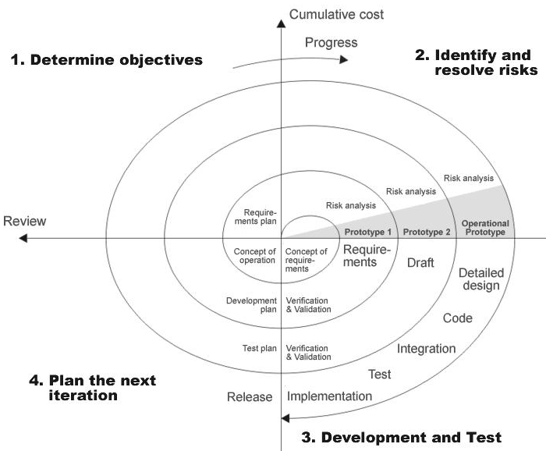

Fig 1.0-Spiral Model

2.3 STUDY OF THE SYSTEM
In the flexibility of the uses the interface has been developed a graphics concept in mind, associated through a browser interface. The GUI’S at the top level have been categorized as
- Administrative user interface
- The operational or generic user interface
The administrative user interface concentrates on the consistent information that is practically, part of the organizational activities and which needs proper authentication for the data collection. The interfaces help the administrations with all the transactional states like Data insertion, Data deletion and Data updating along with the extensive data search capabilities.
The operational or generic user interface helps the users upon the system in transactions through the existing data and required services. The operational user interface also helps the ordinary users in managing their own information helps the ordinary users in managing their own information in a customized manner as per the assisted flexibilities
NUMBER OF MODULES

The system after careful analysis has been identified to be presented with the following modules:
- Administrator
- Customers
- General Users
- Web Registration
- Search
- Reports
- Reviews
- Rating
- Authentication

Administrator

Administrator is treated as a super user in this system. He can have all the privileges to do anything in this system.
- He is the person who can Add the book Categories and courier services.
- He can Manage the book details.
- He has a facility to communicate with other Customers using email.
- He can take care of Backup of Customers, Order details and maintain history.
- He is able to generate the reports of Customers and Orders.

Customers
- They have a facility to register to the site with their Personal data.
- Being a Customer (after registration) should able to Order books
- They have a facility to communicate with Admin through email.
- They are able to see their orders.

General Public

9. General Public (i.e. Guest visitors) are able to access the site Home page, Registration Page, etc. common pages of the site.
10. This user can able to see the book details in different Categories.
11. They are able to search the books based on Author and Publisher.

Web Registration

The system has a process of registration. Every User need to submit his complete details in the form of registration. Whenever a User registration completed automatically he/she can get a user id and password. By using that user id and password he/she can log into the system.

Search:

This system provides search facility to the users. Users can search for the books based on Author and Publisher.

Reports

Different kind of reports is generated by the system.

- Customers Report
- Orders Report
- Books Report
Authentication:

Authentication is nothing but providing security to the system. Here every must enter into the system throw login page. The login page will restrict the UN authorized users. A user must provide his credential like user Id and password for log into the system. For that the system maintains data for all users. Whenever a user enters his user id and password, it checks in the database for user existence. If the user is exists he can be treated as a valid user. Otherwise the request will throw back.

2.4 System Requirement Specifications

Hardware Requirements:
- PIV 2.8 GHz Processor and Above
- RAM 512MB and Above
- HDD 40 GB Hard Disk Space and Above

Software Requirements:
- WINDOWS OS (XP / 2000 / 200 Server / 2003 Server)
- Python
- Django
- MySql
- GoogleChrome

2.5 PROPOSED SYSTEM
To debug the existing system, remove procedures those cause data redundancy, make navigational sequence proper. To provide information about users on different level and also to reflect the current work status depending on organization. To build strong password mechanism.
NEED FOR COMPUTERIZATION
We all know the importance of computerization. The world is moving ahead at lightning speed and everyone is running short of time. One always wants to get the information and perform a task he/she/they desire(s) within a short period of time and too with amount of efficiency and accuracy. The application areas for the computerization have been selected on the basis of following factors:
- Minimizing the manual records kept at different locations.
- There will be more data integrity.
- Facilitating desired information display, very quickly, by retrieving information from users.
- Facilitating various statistical information which helps in decision-making?
- To reduce manual efforts in activities that involved repetitive work.
Updating and deletion of such a huge amount of data will become easier.
FUNCTIONAL FEATURES OF THE MODEL
As far as the project is developed the functionality is simple, the objective of the proposal is to strengthen the functioning of Audit Status Monitoring and make them effective and better. The entire scope has been classified into five streams knows as Coordinator Level, management Level, Auditor Level, User Level and State Web Coordinator Level. The proposed software will cover the information needs with respect to each request of the user group viz. accepting the request, providing vulnerability document report and the current status of the audit.

2.6 INPUT AND OUTPUT
The major inputs and outputs and major functions of the system are follows:

Inputs:
- Admin enter his user id and password for login
- Admin enter the book categories and book details.
- User enters his user id and password for login.
- User Registration to order books.
- New user gives his completed personnel, address and phone details for registration.
- Administrator gives information to generate various kinds of reports.

Outputs:
- Admin get all Customers details.
- Admin can view all order details.
- Users can view their orders.
- User can search the books based on categories.
- Admin get the search details of different criteria.
- Different kind of reports is generated by administrator.

2.7 PROCESS MODEL USED WITH JUSTIFICATION

ACCESS CONTROL FOR DATA WHICH REQUIRE USER AUTHENTICAION
The following commands specify access control identifiers and they are typically used to authorize and authenticate the user (command codes are shown in parentheses)
USER NAME (USER)
The user identification is that which is required by the server for access to its file system. This command will normally be the first command transmitted by the user after the control connections are made (some servers may require this).
PASSWORD (PASS)
This command must be immediately preceded by the user name command, and, for some sites, completes the user's identification for access control. Since password information is quite sensitive, it is desirable in general to "mask" it or suppress type out.

Feasibility Report

Preliminary investigation examine project feasibility, the likelihood the system will be useful to the organization. The main objective of the feasibility study is to test the Technical, Operational and Economical feasibility for adding new modules and debugging old running system. All system is feasible if they are unlimited resources and infinite time. There are aspects in the feasibility study portion of the preliminary investigation:
- Technical Feasibility
- Operational Feasibility
- Economical Feasibility

3.1. TECHNICAL FEASIBILITY
The technical issue usually raised during the feasibility stage of the investigation includes the following:
- Does the necessary technology exist to do what is suggested?
- Do the proposed equipments have the technical capacity to hold the data required to use the new system?
- Will the proposed system provide adequate response to inquiries, regardless of the number or location of users?
- Can the system be upgraded if developed?
- Are there technical guarantees of accuracy, reliability, ease of access and data security?
Earlier no system existed to cater to the needs of ‘Secure Infrastructure Implementation System’. The current system developed is technically feasible. It is a web based user interface for audit workflow at NIC-CSD. Thus it provides an easy access to the users. The database’s purpose is to create, establish and maintain a workflow among various entities in order to facilitate all concerned users in their various capacities or roles. Permission to the users would be granted based on the roles specified. Therefore, it provides the technical guarantee of accuracy, reliability and security. The software and hard requirements for the development of this project are not many and are already available in-house at NIC or are available as free as open source. The work for the project is done with the current equipment and existing software technology. Necessary bandwidth exists for providing a fast feedback to the users irrespective of the number of users using the system.

3.2. OPERATIONAL FEASIBILITY
Proposed projects are beneficial only if they can be turned out into information system. That will meet the organization’s operating requirements. Operational feasibility aspects of the project are to be taken as an important part of the project implementation. Some of the important issues raised are to test the operational feasibility of a project includes the following: -
- Is there sufficient support for the management from the users?
- Will the system be used and work properly if it is being developed and implemented?
- Will there be any resistance from the user that will undermine the possible application benefits?

This system is targeted to be in accordance with the above-mentioned issues. Beforehand, the management issues and user requirements have been taken into consideration. So there is no question of resistance from the users that can undermine the possible application benefits.
The well-planned design would ensure the optimal utilization of the computer resources and would help in the improvement of performance status.

3.3. ECONOMICAL FEASIBILITY

A system can be developed technically and that will be used if installed must still be a good investment for the organization. In the economical feasibility, the development cost in creating the system is evaluated against the ultimate benefit derived from the new systems. Financial benefits must equal or exceed the costs.
The system is economically feasible. It does not require any addition hardware or software. Since the interface for this system is developed using the existing resources and technologies available at NIC, There is nominal expenditure and economical feasibility for certain.

SOFTWARE REQUIREMENT SPECIFICATION

The software, Site Explorer is designed for management of web sites from a remote location.
INTRODUCTION
Purpose: The main purpose for preparing this document is to give a general insight into the analysis and requirements of the existing system or situation and for determining the operating characteristics of the system.
Scope: This Document plays a vital role in the development life cycle (SDLC) and it describes the complete requirement of the system. It is meant for use by the developers and will be the basic during testing phase. Any changes made to the requirements in the future will have to go through formal change approval process.
DEVELOPERS RESPONSIBILITIES OVERVIEW:
The developer is responsible for:
- Developing the system, which meets the SRS and solving all the requirements of the system?
- Demonstrating the system and installing the system at client's location after the acceptance testing is successful.
- Submitting the required user manual describing the system interfaces to work on it and also the documents of the system.
- Conducting any user training that might be needed for using the system.
- Maintaining the system for a period of one year after installation.

4.1. FUNCTIONAL REQUIREMENTS

OUTPUT DESIGN
Outputs from computer systems are required primarily to communicate the results of processing to users. They are also used to provides a permanent copy of the results for later consultation. The various types of outputs in general are:
- External Outputs, whose destination is outside the organization.
- Internal Outputs whose destination is within organization and they are the
- User’s main interface with the computer.
- Operational outputs whose use is purely within the computer department.
- Interface outputs, which involve the user in communicating directly.
OUTPUT DEFINITION

The outputs should be defined in terms of the following points:
    - Type of the output
    - Content of the output
    - Format of the output
    - Location of the output
    - Frequency of the output
    - Volume of the output
    - Sequence of the output
It is not always desirable to print or display data as it is held on a computer. It should be decided as which form of the output is the most suitable.
For Example
    - Will decimal points need to be inserted
    - Should leading zeros be suppressed.

Output Media:
In the next stage it is to be decided that which medium is the most appropriate for the output. The main considerations when deciding about the output media are:
- The suitability for the device to the particular application.
- The need for a hard copy.
- The response time required.
- The location of the users
- The software and hardware available.
Keeping in view the above description the project is to have outputs mainly coming under the category of internal outputs. The main outputs desired according to the requirement specification are:
The outputs were needed to be generated as a hot copy and as well as queries to be viewed on the screen. Keeping in view these outputs, the format for the output is taken from the outputs, which are currently being obtained after manual processing. The standard printer is to be used as output media for hard copies.
INPUT DESIGN
Input design is a part of overall system design. The main objective during the input design is as given below:
- To produce a cost-effective method of input.
- To achieve the highest possible level of accuracy.
- To ensure that the input is acceptable and understood by the user.
INPUT STAGES:
The main input stages can be listed as below:
- Data recording
- Data transcription
- Data conversion
- Data verification
- Data control
- Data transmission
- Data validation
- Data correction

INPUT TYPES:
It is necessary to determine the various types of inputs. Inputs can be categorized as follows:
- External inputs, which are prime inputs for the system.
- Internal inputs, which are user communications with the system.
- Operational, which are computer department’s communications to the system?
- Interactive, which are inputs entered during a dialogue.
INPUT MEDIA:
At this stage choice has to be made about the input media. To conclude about the input media consideration has to be given to;
- Type of input
- Flexibility of format
- Speed
- Accuracy
- Verification methods
- Rejection rates
- Ease of correction
- Storage and handling requirements
- Security
- Easy to use
- Portability
Keeping in view the above description of the input types and input media, it can be said that most of the inputs are of the form of internal and interactive. As
Input data is to be the directly keyed in by the user, the keyboard can be considered to be the most suitable input device.
ERROR AVOIDANCE
At this stage care is to be taken to ensure that input data remains accurate form the stage at which it is recorded up to the stage in which the data is accepted by the system. This can be achieved only by means of careful control each time the data is handled.
ERROR DETECTION
Even though every effort is make to avoid the occurrence of errors, still a small proportion of errors is always likely to occur, these types of errors can be discovered by using validations to check the input data.
DATA VALIDATION
Procedures are designed to detect errors in data at a lower level of detail. Data validations have been included in the system in almost every area where there is a possibility for the user to commit errors. The system will not accept invalid data. Whenever an invalid data is keyed in, the system immediately prompts the user and the user has to again key in the data and the system will accept the data only if the data is correct. Validations have been included where necessary.
The system is designed to be a user friendly one. In other words the system has been designed to communicate effectively with the user. The system has been designed with popup menus.
USER INTERFACE DESIGN
It is essential to consult the system users and discuss their needs while designing the user interface:

USER INTERFACE SYSTEMS CAN BE BROADLY CLASIFIED AS:
- User initiated interface the user is in charge, controlling the progress of the user/computer dialogue. In the computer-initiated interface, the computer selects the next stage in the interaction.
- Computer initiated interfaces
In the computer initiated interfaces the computer guides the progress of the user/computer dialogue. Information is displayed and the user response of the computer takes action or displays further information.
USER_INITIATED INTERGFACES
User initiated interfaces fall into tow approximate classes:
- Command driven interfaces: In this type of interface the user inputs commands or queries which are interpreted by the computer.
- Forms oriented interface: The user calls up an image of the form to his/her screen and fills in the form. The forms oriented interface is chosen because it is the best choice.

COMPUTER-INITIATED INTERFACES
The following computer – initiated interfaces were used:
- The menu system for the user is presented with a list of alternatives and the user chooses one; of alternatives.
- Questions – answer type dialog system where the computer asks question and takes action based on the basis of the users reply.
Right from the start the system is going to be menu driven, the opening menu displays the available options. Choosing one option gives another popup menu with more options. In this way every option leads the users to data entry form where the user can key in the data.

ERROR MESSAGE DESIGN:
The design of error messages is an important part of the user interface design. As user is bound to commit some errors or other while designing a system the system should be designed to be helpful by providing the user with information regarding the error he/she has committed.
This application must be able to produce output at different modules for different inputs.

4.2. PERFORMANCE REQUIREMENTS
Performance is measured in terms of the output provided by the application.
Requirement specification plays an important part in the analysis of a system. Only when the requirement specifications are properly given, it is possible to design a system, which will fit into required environment. It rests largely in the part of the users of the existing system to give the requirement specifications because they are the people who finally use the system. This is because the requirements have to be known during the initial stages so that the system can be designed according to those requirements. It is very difficult to change the system once it has been designed and on the other hand designing a system, which does not cater to the requirements of the user, is of no use.
The requirement specification for any system can be broadly stated as given below:
- The system should be able to interface with the existing system
- The system should be accurate
- The system should be better than the existing system
The existing system is completely dependent on the user to perform all the duties.

SELECTED SOFTWARE

5.1 INTRODUCTION TO Django
Django is a free and open-source web framework, written in Python, which follows the model-view-template (MVT) architectural pattern. It is maintained by the Django Software Foundation (DSF), an independent organization established as a non-profit.
Django's primary goal is to ease the creation of complex, database-driven websites. Django emphasizes reusability and "pluggability" of components, less code, low coupling, rapid development, and the principle of don't repeat yourself. Python is used throughout, even for settings files and data models. Django also provides an optional administrative create, read, update and delete interface that is generated dynamically through introspection and configured via admin models. comming to the features of django it is a lightweight and standalone web server for development and testing,a form serialization and validation system that can translate between HTML forms and values suitable for storage in the database ,a template system that utilizes the concept of inheritance borrowed from object-oriented programming,a caching framework that can use any of several cache methods .support for middleware classes that can intervene at various stages of request processing and carry out custom functions, an internal dispatcher system that allows components of an application to communicate events to each other via pre-defined signals,an internationalization system, including translations of Django's own components into a variety of languages.
Django can be run in conjunction with Apache, Nginx using WSGI, Gunicorn, or Cherokee using flup (a Python module). Django also includes the ability to launch a FastCGI server, enabling use behind any web server which supports FastCGI, such as Lighttpd or Hiawatha. It is also possible to use other WSGI-compliant web servers. Django officially supports four database backends: PostgreSQL, MySQL, SQLite, and Oracle. Microsoft SQL Server can be used with django-mssql onMicrosoft operating systems, while similarly external backends exist for IBM Db2, SQL Anywhere and Firebird. There is a fork named django-nonrel, which supports NoSQL databases, such as MongoDB and Google App Engine's Datastore.^{[32]}
Django may also be run in conjunction with Jython on any Java EE application server such as GlassFish or JBoss. In this case django-jython must be installed in order to provide JDBC drivers for database connectivity, which also can provide functionality to compile Django in to a .war suitable for deployment. Google App Engine includes support for Django version 1.x.x as one of the bundled frameworks.

Principal design features

A free, rich API. With a simple command, Django automatically generates a Python API based on your models, no additional coding necessary.
Automatic database table creation. The migrate command is an elegant and distinctive feature of Django that looks at all your models and automatically creates tables in your database for any that don’t exist already.
A dynamic admin interface generator. The idea here is that, rather than requiring you to build out an entire website before you can start populating it with information, Django makes it quick and easy to set up the admin site, which allows contributors to start populating the database while the developers figure out how to display that content.
A syndication feed framework. Django also allows you to quickly and easily create RSS and Atom feeds by creating a simple Python class. These feeds can be simple (eg, a typical news feed of latest posts) or more specialized (eg, all posts in a given category or that feature a certain keyword).
A powerful cache framework for dynamic websites. This system lets you cut down on expensive calculations by caching dynamic pages. There are a few levels of granularity here: You can cache individual pages or just the most expensive views to produce.
A powerful built-in template system. Django’s templates are based on the inheritance system (similar to object-oriented programming). These templates allow Django to generate HTML dynamically while also eliminating redundancies.
Easy database migrations. Managing database workflow with Django’s migrations is simple and streamlined. Version control is managed through migration names, and Django has lots of options for merging versions or letting developers make modifications.
Security features. Django has tools to protect against XSS attacks, CSRF attacks, SQL injections, clickjacking, and more. It also allows you to easily enable SSL/HTTPS and host header validation.
Other helpful add-ons. Bundled add-ons include sitemaps, comments, user authentication, RSS feeds, and more. By including many of these standard features out-of-the-box, web developers can focus on the genuinely hard parts rather than recreating standard functionality from scratch.

Architecture

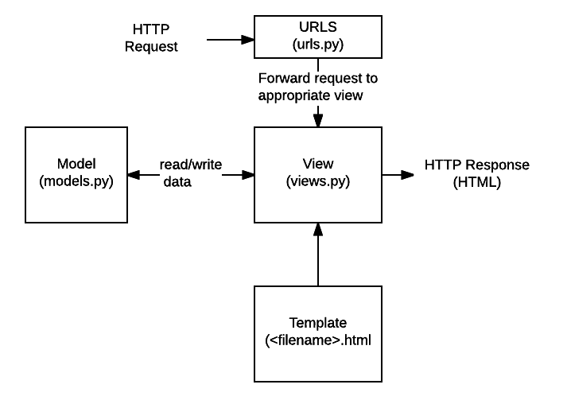
Model:-
In Django, a model is a class which is used to contain essential fields and methods. Each model class maps to a single table in the database.
Django Model is a subclass of django.db.models.Model and each field of the model class represents a database field (column).
Django provides us a database-abstraction API which allows us to create, retrieve, update and delete a record from the mapped table.Model is defined in Models.py file. This file can contain multiple models.
View:-
A view is a place where we put our business logic of the application. The view is a python function which is used to perform some business logic and return a response to the user. This response can be the HTML contents of a Web page, or a redirect, or a 404 error.
All the view function are created inside the views.py file of the Django app.
Template:-
Django provides a convenient way to generate dynamic HTML pages by using its template system.
A template consists of static parts of the desired HTML output as well as some special syntax describing how dynamic content will be inserted.

Why Django Template?
In HTML file, we can't write python code because the code is only interpreted by python interpreter not the browser. We know that HTML is a static markup language, while Python is a dynamic programming language.
Django template engine is used to separate the design from the python code and allows us to build dynamic web pages

5.2 PYTHON
Python is an interpreted high-level programming language for general-purpose programming. Created by Guido van Rossum and first released in 1991, Python has a design philosophy that emphasizes code readability, notably using significant whitespace. It provides constructs that enable clear programming on both small and large scales. In July 2018, Van Rossum stepped down as the leader in the language community after 30 years.
Python features a dynamic type system and automatic memory management. It supports multiple programmingparadigms,including objectoriented, imperative, functional and procedural, and has a large and comprehensive standard library.
Python interpreters are available for many operating systems. CPython, the reference implementation of Python, is open source software and has a community-based development model, as do nearly all of Python's other implementations. Python and CPython are managed by the non-profit Python Software Foundation. Python was conceived in the late 1980s, and its implementation began in December 1989 by Guido van Rossum at Centrum Wiskunde & Informatica (CWI) in the Netherlands as a successor to the ABC language (itself inspired by SETL) capable of exception handling and interfacing with the Amoeba operating system. Van Rossum remains Python's principal author. His continuing central role in Python's development is reflected in the title given to him by the Python community: Benevolent Dictator For Life (BDFL) – a post from which he gave himself permanent vacation on July 12, 2018.
On the origins of Python, Van Rossum wrote in 1996:^{[34]}
...In December 1989, I was looking for a "hobby" programming project that would keep me occupied during the week around Christmas. My office ... would be closed, but I had a home computer, and not much else on my hands. I decided to write an interpreter for the new scripting language I had been thinking about lately: a descendant of ABC that would appeal to Unix/C hackers. I chose Python as a working title for the project, being in a slightly irreverent mood (and a big fan of Monty Python's Flying Circus).
— Guido van Rossum
Python 2.0 was released on 16 October 2000 and had many major new features, including a cycle-detecting garbage collectorand support for Unicode. With this release, the development process became more transparent and community-backed.
Python 3.0 (initially called Python 3000 or py3k) was released on 3 December 2008 after a long testing period. It is a major revision of the language that is not completely backward-compatible with previous versions.^{[36]} However, many of its major features have been backported to the Python 2.6.x^{[37]} and 2.7.x version series, and releases of Python 3 include the 2to3 utility, which automates the translation of Python 2 code to Python 3.^{[38]}
Python 2.7's end-of-life date was initially set at 2015, then postponed to 2020 out of concern that a large body of existing code could not easily be forward-ported to Python 3. In January 2017, Google announced work on a Python 2.7 to Go transcompiler to improve performance under concurrent workloads.

5.3 MYSQL SERVER

A database management, or DBMS, gives the user access to their data and helps them transform the data into information. Such database management systems include dBase, paradox, IMS, SQL Server and SQL Server. These systems allow users to create, update and extract information from their database.
A database is a structured collection of data. Data refers to the characteristics of people, things and events. SQL Server stores each data item in its own fields. In SQL Server, the fields relating to a particular person, thing or event are bundled together to form a single complete unit of data, called a record (it can also be referred to as raw or an occurrence). Each record is made up of a number of fields. No two fields in a record can have the same field name.
During an SQL Server Database design project, the analysis of your business needs identifies all the fields or attributes of interest. If your business needs change over time, you define any additional fields or change the definition of existing fields.
SQL SERVER TABLES
SQL Server stores records relating to each other in a table. Different tables are created for the various groups of information. Related tables are grouped together to form a database.
PRIMARY KEY
Every table in SQL Server has a field or a combination of fields that uniquely identifies each record in the table. The Unique identifier is called the Primary Key, or simply the Key. The primary key provides the means to distinguish one record from all other in a table. It allows the user and the database system to identify, locate and refer to one particular record in the database.

RELATIONAL DATABASE
Sometimes all the information of interest to a business operation can be stored in one table. SQL Server makes it very easy to link the data in multiple tables. Matching an employee to the department in which they work is one example. This is what makes SQL Server a relational database management system, or RDBMS. It stores data in two or more tables and enables you to define relationships between the table and enables you to define relationships between the tables.
FOREIGN KEY
When a field is one table matches the primary key of another field is referred to as a foreign key. A foreign key is a field or a group of fields in one table whose values match those of the primary key of another table.
REFERENTIAL INTEGRITY
Not only does SQL Server allow you to link multiple tables, it also maintains consistency between them. Ensuring that the data among related tables is correctly matched is referred to as maintaining referential integrity.
DATA ABSTRACTION
A major purpose of a database system is to provide users with an abstract view of the data. This system hides certain details of how the data is stored and maintained. Data abstraction is divided into three levels.
Physical level: This is the lowest level of abstraction at which one describes how the data are actually stored.
Conceptual Level: At this level of database abstraction all the attributed and what data are actually stored is described and entries and relationship among them.
View level: This is the highest level of abstraction at which one describes only part of the database.
ADVANTAGES OF RDBMS
- Redundancy can be avoided
- Inconsistency can be eliminated
- Data can be Shared
- Standards can be enforced
- Security restrictions ca be applied
- Integrity can be maintained
- Conflicting requirements can be balanced
- Data independence can be achieved.
DISADVANTAGES OF DBMS
A significant disadvantage of the DBMS system is cost. In addition to the cost of purchasing of developing the software, the hardware has to be upgraded to allow for the extensive programs and the workspace required for their execution and storage. While centralization reduces duplication, the lack of duplication requires that the database be adequately backed up so that in case of failure the data can be recovered.
FEATURES OF MYSQL SERVER
The following list shows the most important properties of MySQL. This section is directed to the reader who already has some knowledge of relational databases. We will use some terminology from the relational database world without defining our terms exactly. On the other hand, the explanations should make it possible for database novices to understand to some extent what we are talking about.
Relational Database System: Like almost all other database systems on the market, MySQL is a relational database system.
Client/Server Architecture: MySQL is a client/server system. There is a database server (MySQL) and arbitrarily many clients (application programs), which communicate with the server; that is, they query data, save changes, etc. The clients can run on the same computer as the server or on another computer (communication via a local network or the Internet).
Almost all of the familiar large database systems (Oracle, Microsoft SQL Server, etc.) are client/server systems. These are in contrast to the file-server systems, which include Microsoft Access, dBase and FoxPro. The decisive drawback to file-server systems is that when run over a network, they become extremely inefficient as the number of users grows.
SQL compatibility: MySQL supports as its database language -- as its name suggests – SQL (Structured Query Language). SQL is a standardized language for querying and updating data and for the administration of a database. There are several SQL dialects (about as many as there are database systems). MySQL adheres to the current SQL standard (at the moment SQL:2003), although with significant restrictions and a large number of extensions.
Through the configuration setting sql-mode you can make the MySQL server behave for the most part compatibly with various database systems. Among these are IBM DB/2 and Oracle. (The setting sql-mode changes some of the syntax conventions, and performs no miracles. More details are to be had in Chapter 14.)
A readable and entertaining article on the topic of how MySQL differs from other current database systems can be found at http://sql-info.de/mysql/gotchas.html.
SubSELECTs: Since version 4.1, MySQL is capable of processing a query in the form SELECT * FROM table1 WHERE x IN (SELECT y FROM table2) (There are also numerous syntax variants for subSELECTs.)
Views: Put simply, views relate to an SQL query that is viewed as a distinct database object and makes possible a particular view of the database. MySQL has supported views since version 5.0.
Stored procedures: Here we are dealing with SQL code that is stored in the database system.
Stored procedures (SPs for short) are generally used to simplify certain steps, such as inserting or deleting a data record. For client programmers this has the advantage that they do not have to process the tables directly, but can rely on SPs. Like views, SPs help in the administration of large database projects. SPs can also increase efficiency. MySQL has supported SPs since version 5.0.
Triggers: Triggers are SQL commands that are automatically executed by the server in certain database operations (INSERT, UPDATE, and DELETE). MySQL has supported triggers in a limited form from version 5.0, and additional functionality is promised for version 5.1.
Unicode: MySQL has supported all conceivable character sets since version 4.1, including Latin-1, Latin-2, and Unicode (either in the variant UTF8 or UCS2).
User interface: There are a number of convenient user interfaces for administering a MySQL server.
Full-text search: Full-text search simplifies and accelerates the search for words that are located within a text field. If you employ MySQL for storing text (such as in an Internet discussion group), you can use full-text search to implement simply an efficient search function.
Replication: Replication allows the contents of a database to be copied (replicated) onto a number of computers. In practice, this is done for two reasons: to increase protection against system failure (so that if one computer goes down, another can be put into service) and to improve the speed of database queries.
Transactions: In the context of a database system, a transaction means the execution of several database operations as a block. The database system ensures that either all of the operations are correctly executed or none of them. This holds even if in the middle of a transaction there is a power failure, the computer crashes, or some other disaster occurs. Thus, for example, it cannot occur that a sum of money is withdrawn from account A but fails to be deposited in account B due to some type of system error.
Transactions also give programmers the possibility of interrupting a series of already executed commands (a sort of revocation). In many situations this leads to a considerable simplification of the programming process. In spite of popular opinion, MySQL has supported transactions for a long time. One should note here that MySQL can store tables in a variety of formats. The default table format is called MyISAM, and this format does not support transactions. But there are a number of additional formats that do support transactions. The most popular of these is InnoDB, which will be described extensively in this book.
Foreign key constraints: These are rules that ensure that there are no cross references in linked tables that lead to nowhere. MySQL supports foreign key constraints for InnoDB tables.
GIS functions: Since version 4.1, MySQL has supported the storing and processing of two-dimensional geographical data. Thus MySQL is well suited for GIS (geographic information systems) applications.
Programming languages: There are quite a number of APIs (application programming interfaces) and libraries for the development of MySQL applications. For client programming you can use, among others, the languages C, C++, Java, Perl, PHP, Python, and Tcl.
ODBC: MySQL supports the ODBC interface Connector/ODBC. This allows MySQL to be addressed by all the usual programming languages that run under Microsoft Windows (Delphi, Visual Basic, etc.). The ODBC interface can also be implemented under Unix, though that is seldom necessary.
Windows programmers who have migrated to Microsoft's new .NET platform can, if they wish, use the ODBC provider or the .NET interface Connector/NET.
Platform independence: It is not only client applications that run under a variety of operating systems; MySQL itself (that is, the server) can be executed under a number of operating systems. The most important are Apple Macintosh OS X, Linux, Microsoft Windows, and the countless Unix variants, such as AIX, BSDI, FreeBSD, HP-UX, OpenBSD, Net BSD, SGI Iris, and Sun Solaris.
Speed: MySQL is considered a very fast database program. This speed has been backed up by a large number of benchmark tests (though such tests -- regardless of the source -- should be considered with a good dose of skepticism).

SYSTEM DESIGN

6.1. INTRODUCTION

Software design sits at the technical kernel of the software engineering process and is applied regardless of the development paradigm and area of application. Design is the first step in the development phase for any engineered product or system. The designer’s goal is to produce a model or representation of an entity that will later be built. Beginning, once system requirement have been specified and analyzed, system design is the first of the three technical activities -design, code and test that is required to build and verify software.
The importance can be stated with a single word “Quality”. Design is the place where quality is fostered in software development. Design provides us with representations of software that can assess for quality. Design is the only way that we can accurately translate a customer’s view into a finished software product or system. Software design serves as a foundation for all the software engineering steps that follow. Without a strong design we risk building an unstable system – one that will be difficult to test, one whose quality cannot be assessed until the last stage.
During design, progressive refinement of data structure, program structure, and procedural details are developed reviewed and documented. System design can be viewed from either technical or project management perspective. From the technical point of view, design is comprised of four activities – architectural design, data structure design, interface design and procedural design.

6.2 NORMALIZATION
It is a process of converting a relation to a standard form. The process is used to handle the problems that can arise due to data redundancy i.e. repetition of data in the database, maintain data integrity as well as handling problems that can arise due to insertion, updating, deletion anomalies.
Decomposing is the process of splitting relations into multiple relations to eliminate anomalies and maintain anomalies and maintain data integrity. To do this we use normal forms or rules for structuring relation.
Insertion anomaly: Inability to add data to the database due to absence of other data.
Deletion anomaly: Unintended loss of data due to deletion of other data.
Update anomaly: Data inconsistency resulting from data redundancy and partial update
Normal Forms: These are the rules for structuring relations that eliminate anomalies.
FIRST NORMAL FORM:
A relation is said to be in first normal form if the values in the relation are atomic for every attribute in the relation. By this we mean simply that no attribute value can be a set of values or, as it is sometimes expressed, a repeating group.
SECOND NORMAL FORM:
A relation is said to be in second Normal form is it is in first normal form and it should satisfy any one of the following rules.
- Primary key is a not a composite primary key
- No non key attributes are present
- Every non key attribute is fully functionally dependent on full set of primary key.

THIRD NORMAL FORM:
A relation is said to be in third normal form if their exits no transitive dependencies.
Transitive Dependency: If two non key attributes depend on each other as well as on the primary key then they are said to be transitively dependent.
The above normalization principles were applied to decompose the data in multiple tables thereby making the data to be maintained in a consistent state.

6.3 E-R Diagrams
  - The relation upon the system is structure through a conceptual ER-Diagram, which not only specifics the existential entities but also the standard relations through which the system exists and the cardinalities that are necessary for the system state to continue.
  - The entity Relationship Diagram (ERD) depicts the relationship between the data objects. The ERD is the notation that is used to conduct the date modeling activity the attributes of each data object noted is the ERD can be described resign a data object descriptions.
  - The set of primary components that are identified by the ERD are
  - Data object
  - Relationships
  - Attributes
  - Various types of indicators.
The primary purpose of the ERD is to represent data objects and their relationships.

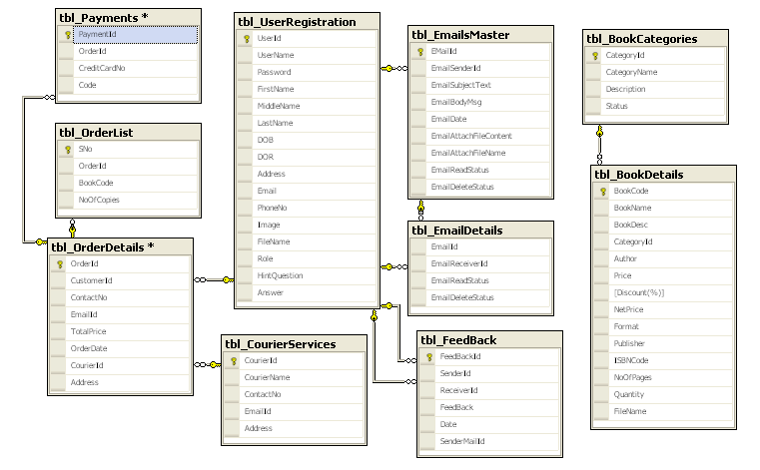

6.4 DATA FLOW DIAGRAMS
A data flow diagram is graphical tool used to describe and analyze movement of data through a system. These are the central tool and the basis from which the other components are developed. The transformation of data from input to output, through processed, may be described logically and independently of physical components associated with the system. These are known as the logical data flow diagrams. The physical data flow diagrams show the actual implements and movement of data between people, departments and workstations. A full description of a system actually consists of a set of data flow diagrams. Using two familiar notations Yourdon, Gane and Sarson notation develops the data flow diagrams. Each component in a DFD is labeled with a descriptive name. Process is further identified with a number that will be used for identification purpose. The development of DFD’S is done in several levels. Each process in lower level diagrams can be broken down into a more detailed DFD in the next level. The lop-level diagram is often called context diagram. It consists a single process bit, which plays vital role in studying the current system. The process in the context level diagram is exploded into other process at the first level DFD.
The idea behind the explosion of a process into more process is that understanding at one level of detail is exploded into greater detail at the next level. This is done until further explosion is necessary and an adequate amount of detail is described for analyst to understand the process.
Larry Constantine first developed the DFD as a way of expressing system requirements in a graphical from, this lead to the modular design.
A DFD is also known as a “bubble Chart” has the purpose of clarifying system requirements and identifying major transformations that will become programs in system design. So it is the starting point of the design to the lowest level of detail. A DFD consists of a series of bubbles joined by data flows in the system.
DFD SYMBOLS:
In the DFD, there are four symbols
- A square defines a source(originator) or destination of system data
- An arrow identifies data flow. It is the pipeline through which the information flows
- A circle or a bubble represents a process that transforms incoming data flow into outgoing data flows.
- An open rectangle is a data store, data at rest or a temporary repository of data

Process that transforms data flow.

Source or Destination of data
Data flow

Data Store

CONSTRUCTING A DFD:
Several rules of thumb are used in drawing DFD’S:
- Process should be named and numbered for an easy reference. Each name should be representative of the process.
- The direction of flow is from top to bottom and from left to right. Data traditionally flow from source to the destination although they may flow back to the source. One way to indicate this is to draw long flow line back to a source. An alternative way is to repeat the source symbol as a destination. Since it is used more than once in the DFD it is marked with a short diagonal.
- When a process is exploded into lower level details, they are numbered.
- The names of data stores and destinations are written in capital letters. Process and dataflow names have the first letter of each work capitalized.
A DFD typically shows the minimum contents of data store. Each data store should contain all the data elements that flow in and out.
Questionnaires should contain all the data elements that flow in and out. Missing interfaces redundancies and like is then accounted for often through interviews.
SAILENT FEATURES OF DFD’S
- The DFD shows flow of data, not of control loops and decision are controlled considerations do not appear on a DFD.
- The DFD does not indicate the time factor involved in any process whether the dataflow take place daily, weekly, monthly or yearly.
- The sequence of events is not brought out on the DFD.

TYPES OF DATA FLOW DIAGRAMS
- Current Physical
- Current Logical
- New Logical
- New Physical

CURRENT PHYSICAL:
In Current Physical DFD process label include the name of people or their positions or the names of computer systems that might provide some of the overall system-processing label includes an identification of the technology used to process the data. Similarly data flows and data stores are often labels with the names of the actual physical media on which data are stored such as file folders, computer files, business forms or computer tapes.
CURRENT LOGICAL:
The physical aspects at the system are removed as much as possible so that the current system is reduced to its essence to the data and the processors that transforms them regardless of actual physical form.
NEW LOGICAL:
This is exactly like a current logical model if the user were completely happy with the user were completely happy with the functionality of the current system but had problems with how it was implemented typically through the new logical model will differ from current logical model while having additional functions, absolute function removal and inefficient flows recognized.
NEW PHYSICAL:
The new physical represents only the physical implementation of the new system.

RULES GOVERNING THE DFD’S

PROCESS
- No process can have only outputs.
- No process can have only inputs. If an object has only inputs than it must be a sink.
- A process has a verb phrase label.

DATA STORE
- Data cannot move directly from one data store to another data store, a process must move data.
- Data cannot move directly from an outside source to a data store, a process, which receives, must move data from the source and place the data into data store
- A data store has a noun phrase label.
SOURCE OR SINK
The origin and /or destination of data.
- Data cannot move direly from a source to sink it must be moved by a process
- A source and /or sink has a noun phrase land

DATA FLOW
- A Data Flow has only one direction of flow between symbols. It may flow in both directions between a process and a data store to show a read before an update. The later is usually indicated however by two separate arrows since these happen at different type.
- A join in DFD means that exactly the same data comes from any of two or more different processes data store or sink to a common location.
- A data flow cannot go directly back to the same process it leads. There must be at least one other process that handles the data flow produce some other data flow returns the original data into the beginning process.
- A Data flow to a data store means update (delete or change).
- A data Flow from a data store means retrieve or use.
A data flow has a noun phrase label more than one data flow noun phrase can appear on a single arrow as long as all of the flows on the same arrow move together as one package.

DFD Diagrams
Context Level Diagram (O Level)

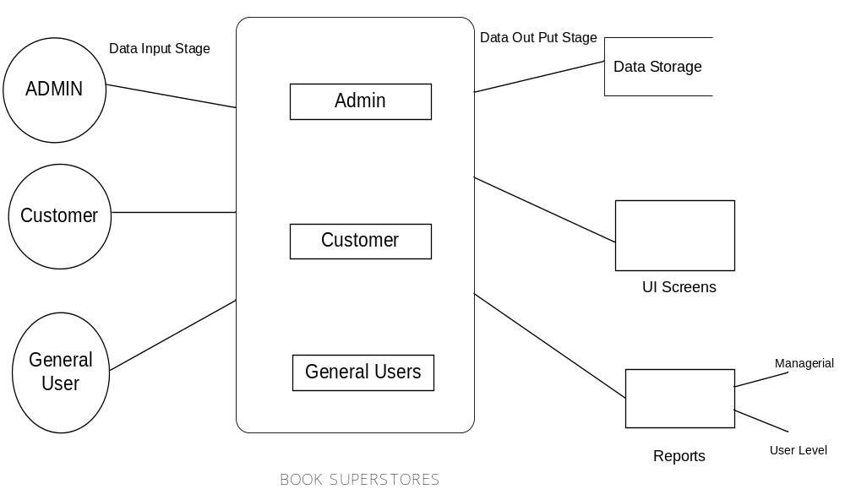

Login DFD

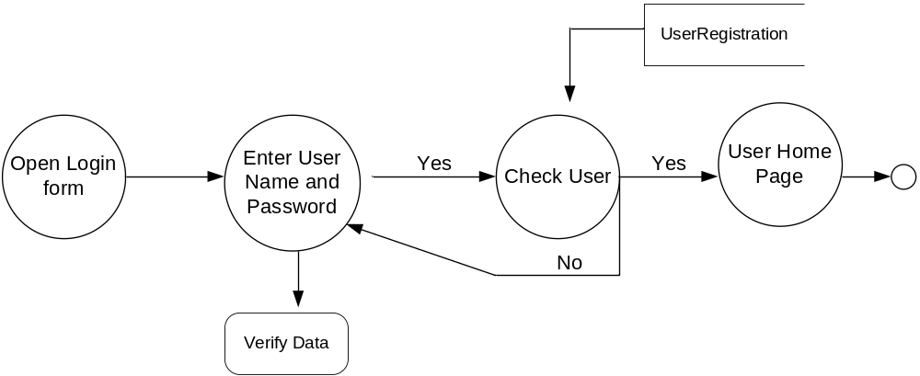
Admin Activities DFD
1st Level

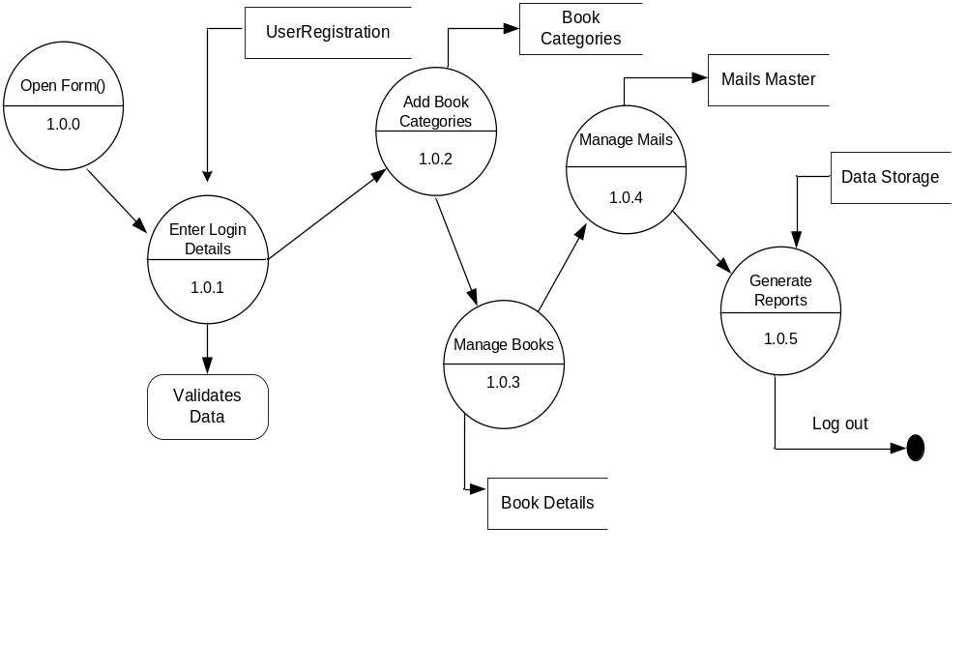2nd Level

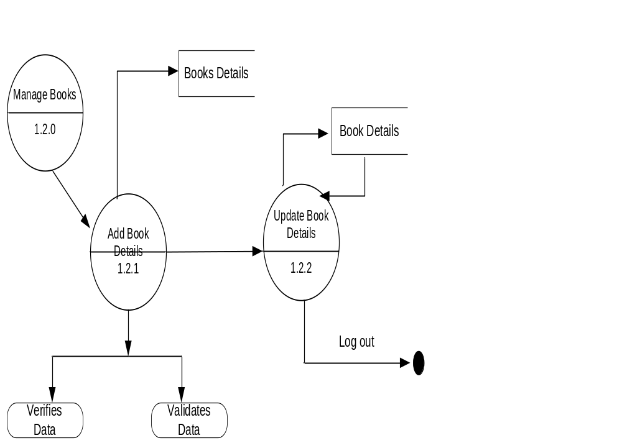

3rd Level

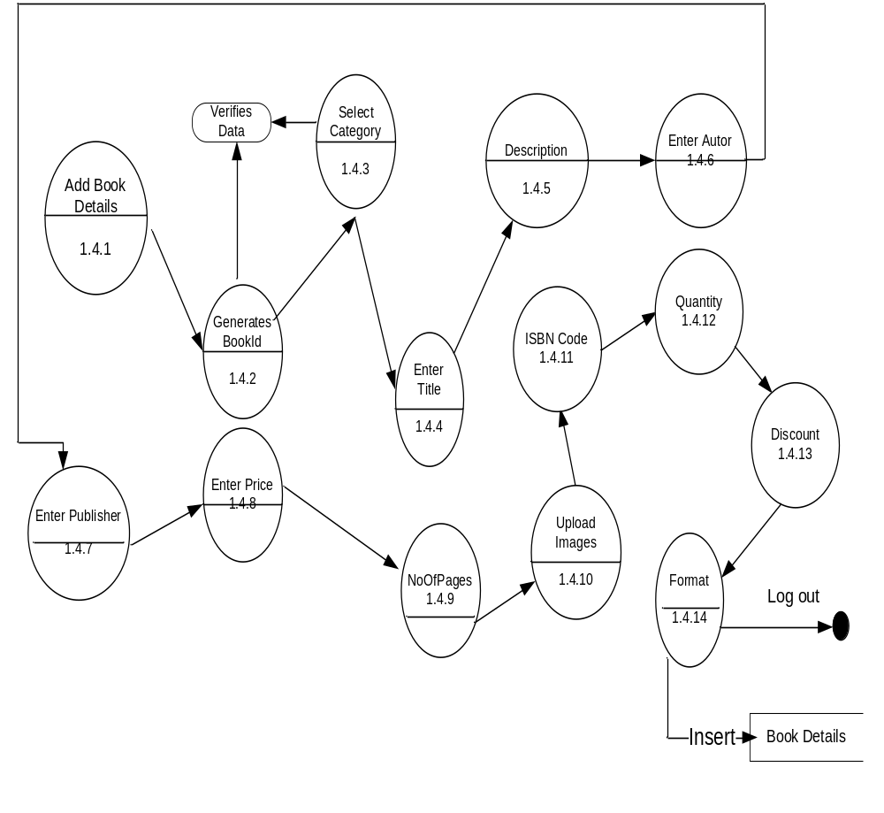

Customer Activities
1st Level

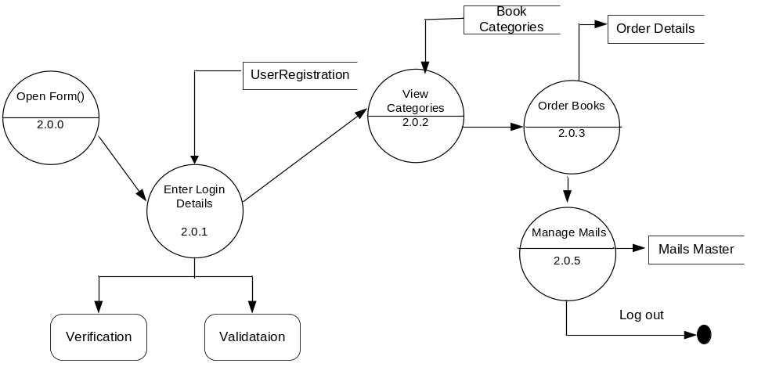

2nd Level

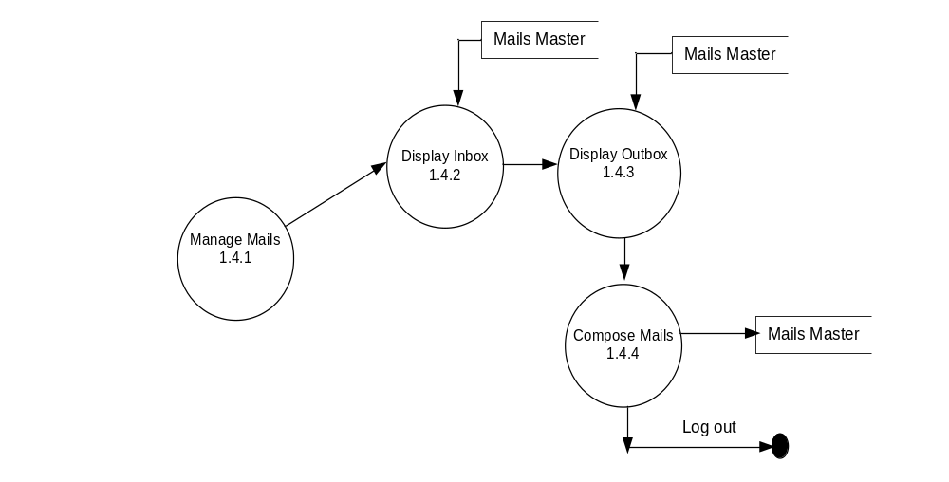

3 rd Level

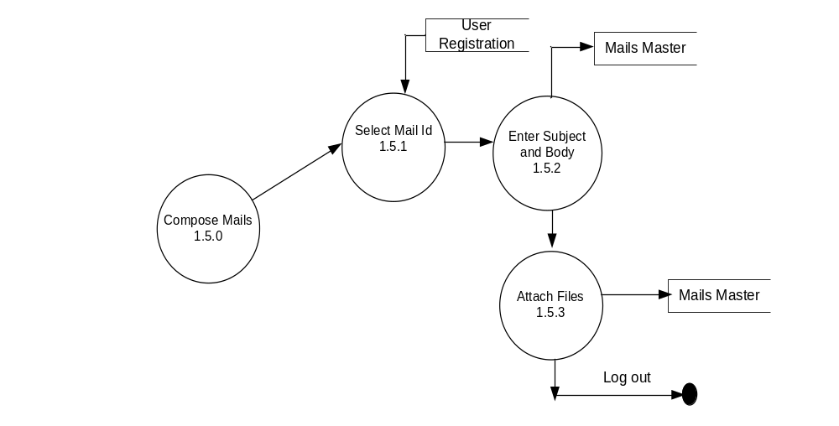

General User Activity

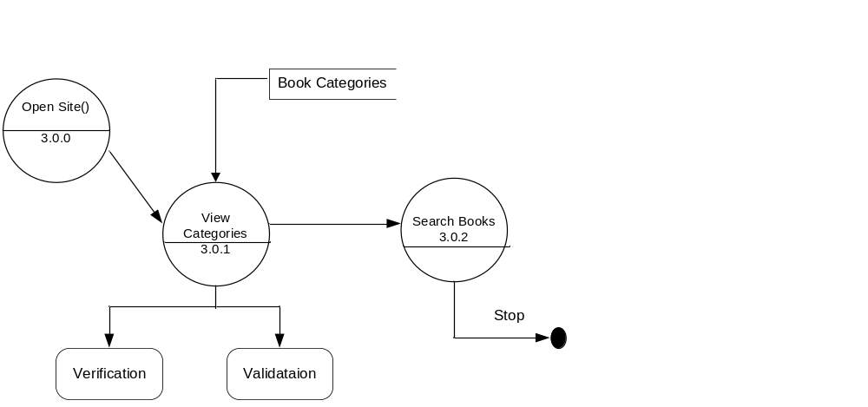

6.5 DATA DICTIONARY
After carefully understanding the requirements of the client the entire data storage requirements are divided into tables. The below tables are normalized to avoid any anomalies during the course of data entry.
Tables Design:

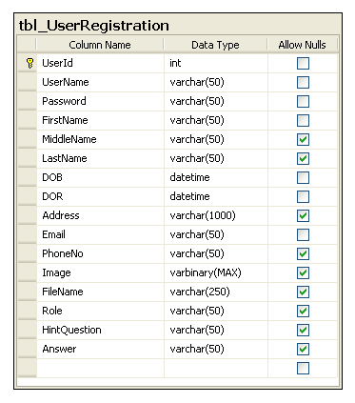
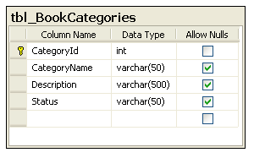
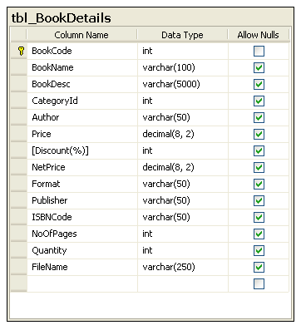
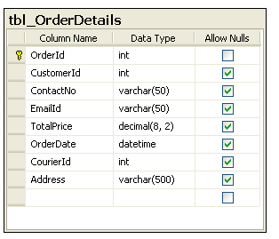

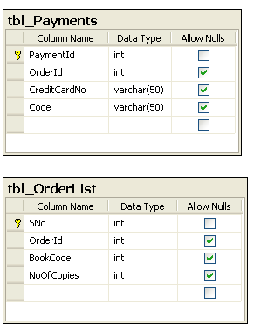

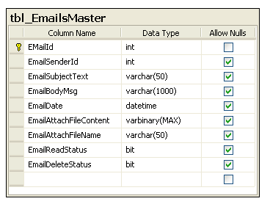
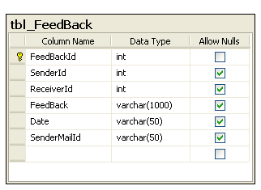
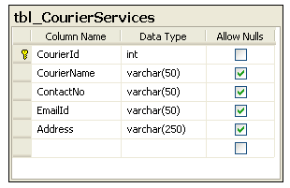
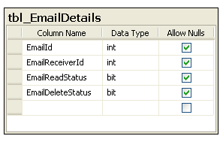

6.6 UML DIAGRAMS
Use Case Diagrams :

SYSTEM NAME

Use case 1

Use case 2

Use case n

Actor
Actor

Over All System Use Case Diagram:

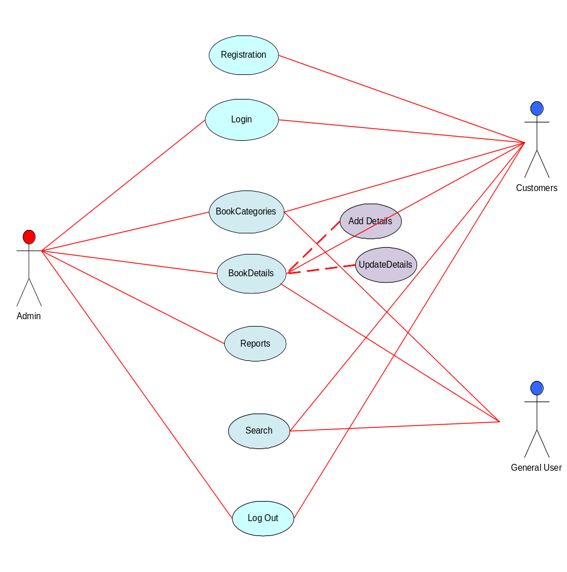

Activity Diagrams:
Registration Activity Diagram:

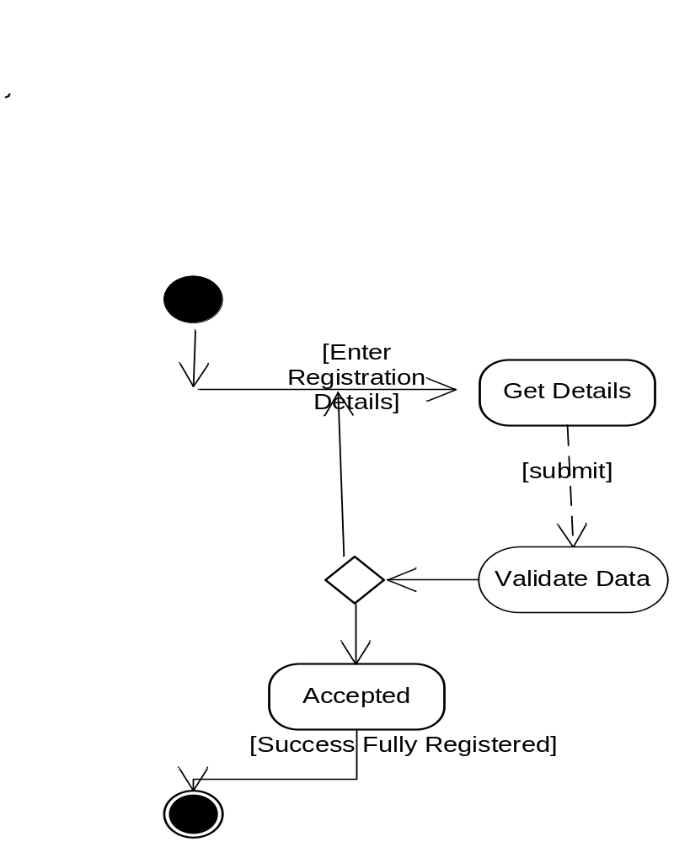

Login Activity Diagram:

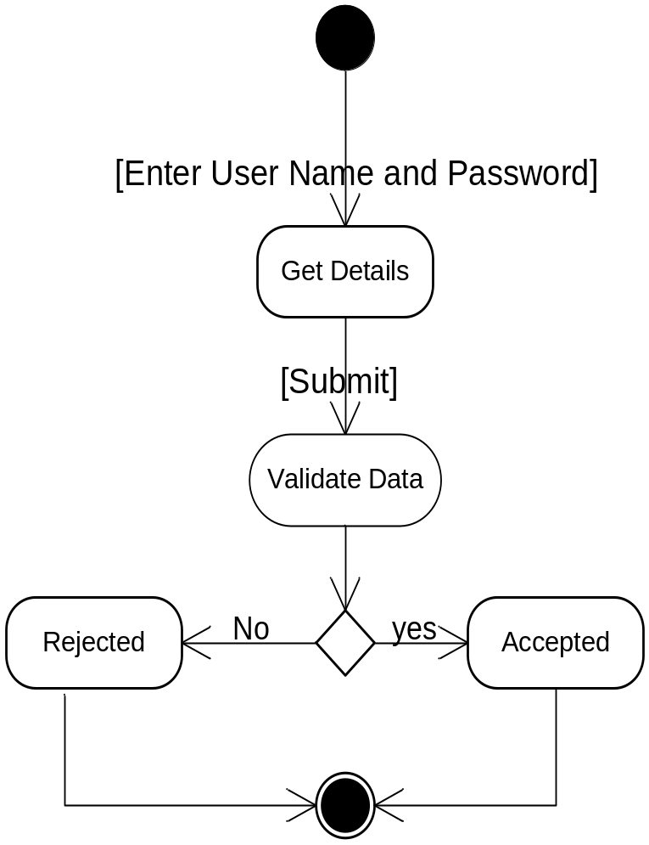

Admin Activity Diagram:
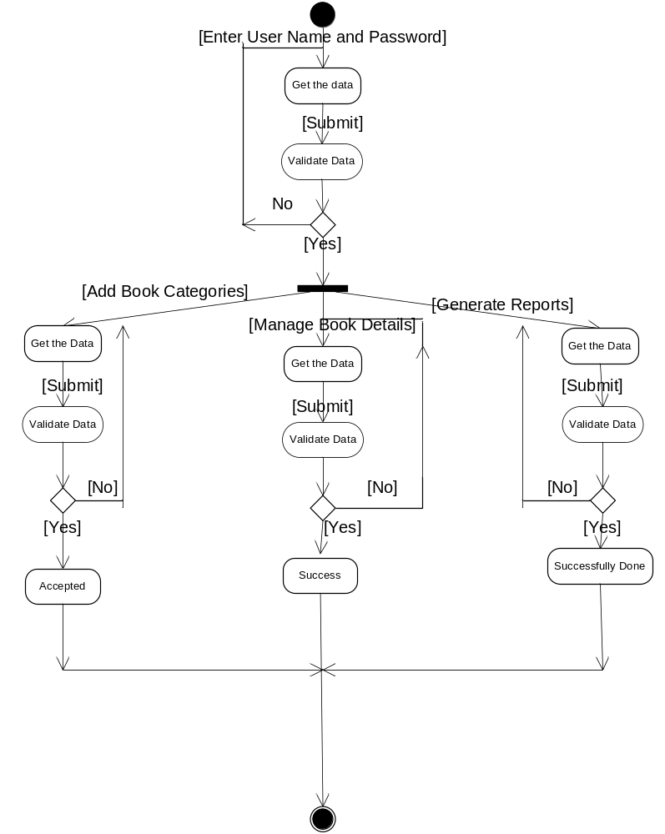

Customer Activity Diagram

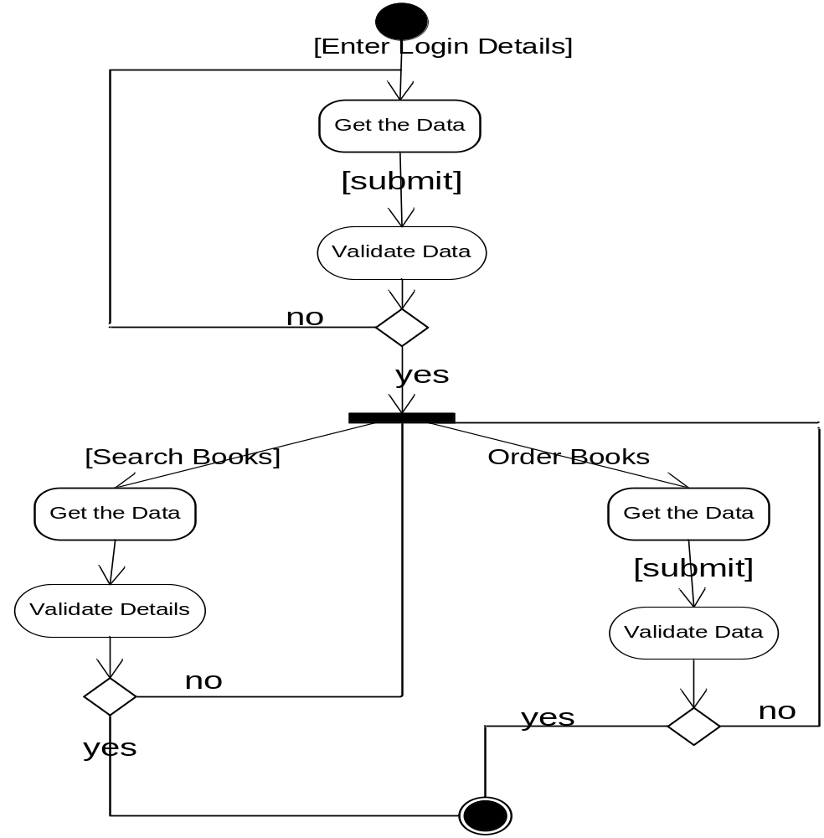

General User Activity

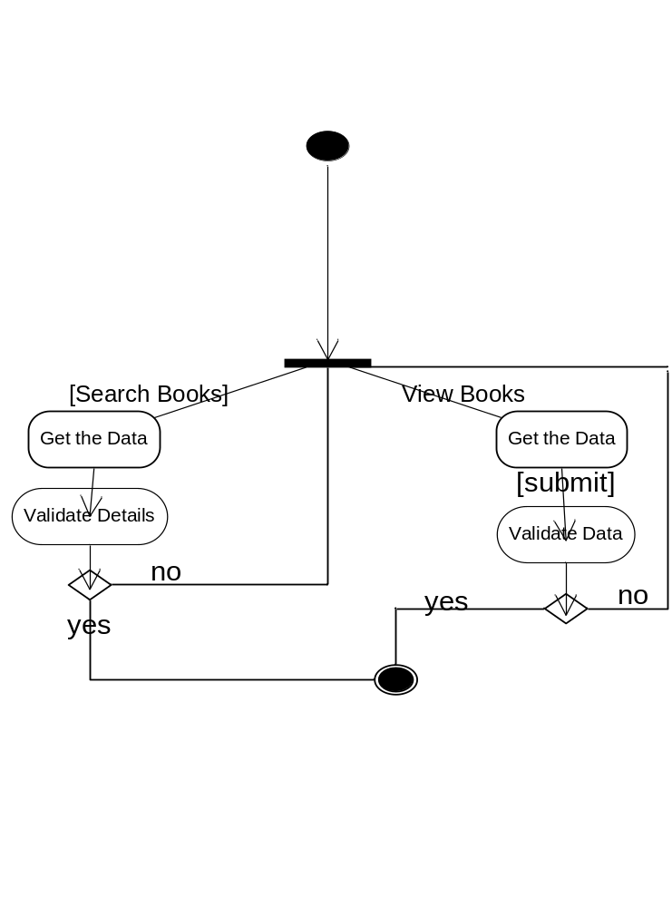

Sequence Diagrams
User Registration Sequence

User
frmRegistration
BL:cls_User
DAL:cls_SqlHelper
Database
1 : Get Registration Form
2 : insertUserData ()
3 : ExecuteNonQuery ()
4 : ExecuteStoredProcedure()
6 : Response()
7 : Response for InsertUserData()

Login Sequence

User
LoginPage
AuthenticationService()
DAL:SqlHelper()
Database
1 : Open Login Form
2 : ValidateUser()
3 : ExecuteNonQuery()
4 : ExecuteStoredProcedure()

5 : Return QueryResult()
6: ResponseForValidateUser()

Admin Sequence to Add Book Categories

Admin
frm BookCategories
BAL:clsBooks
DAL:clsSqlHelper

DataBase
1 : Enter Data
2 : Insert Category()
3 : ExecuteNonQuery()
4 : ExecuteStoredProcedure()

5 : Response()
6 : Show Result()

Admin Sequence to Add BookDetails

Admin
frmBookDetails
BAL:clsBooks
DAL:clsSqlHelper

DataBase
1 : Enter Book Details
2: Insert Book Details()
3 : ExecuteNonQuery()
4 : ExecuteStoredProcedure()

5 : Response()
6 : Show Result()

Customer Sequence to View Books

Customer
frmBooksList
BAL:clsBooks
DAL:clsSqlHelper

DataBase
1 : Select Category
2 : GetBooks()
3 : ExecuteDataset()
4 : ExecuteStoredProcedure()

5 : Response()
6 : Show Result()

Customer Sequence to Order Books

Customer
frmOrder
BAL:clsBooks
DAL:clsSqlHelper

DataBase
1 : Select Books
2 : OrderBooks()
3 : ExecuteNonQuery()
4 : ExecuteStoredProcedure()

5 : Response()
6 : Show Result()

General User Sequence to Search Books

User
frmHome
BAL:clsBooks
DAL:clsSqlHelper

DataBase
1 : Enter Title./Author/Publisher
2 : Get Books()
3 : ExecuteDataset()
4 : ExecuteStoredProcedure()

5 : Response()
6 : Show Result()

Collaboration Diagrams
Login

User
frmLogin
BAL:clsLogin
DAL:clsSqlHelper

DB
1 : Enter UserId,Pwd()
2 : Insert Data()
3 : ExecuteNonQuery()

4 : ExecuteStoredProcedure()

5 : Response()

Admin Collaboration to Add Categories

Admin
frm Book Categories
BAL:clsBooks
DAL:clsSqlHelper

DB
1 Enter Data

2 : Insert Category()
3 : ExecuteNonQuery()

4 : ExecuteStoredProcedure()

5 : Response()

Admin Collaboration to Add Book Details

4 :Execute StoredProcedure()
Admin
frmBookDetails
BAL:clsBooks
DAL:clsSqlHelper

DataBase
1 : Enter Book Details
2 : Insert BookDatails()

3 : ExecuteNonQuery()

5 : Response()

Customer Collaboration to View Books

Customer
frmBooksList
BAL:clsBooks
DAL:clsSqlHelper

DB
1 : Select Category
2 : Get Books ()
3 : ExecuteDataset()

4 : ExecuteStoredProcedure()

5 : Response()

Customer Collaboration to Order Books

Customer
frmOrder
BAL:clsBooks
DAL:clsSqlHelper

DB
1 : Select Books
2 : Order Books()
3 : ExecuteNonQuery()

4 : ExecuteStoredProcedure()

5 : Response()

General User Collaboration to Search Books

User
FrmHome
BAL:clsBooks
DAL:clsSqlHelper

DB
1 : Enter Title/Author/Publisher
2 : Get Books()
3 : ExecuteDataset()

4 : ExecuteStoredProcedure()

5 : Response()

OUTPUT SCREENS

1) HomePage (User/Admin):

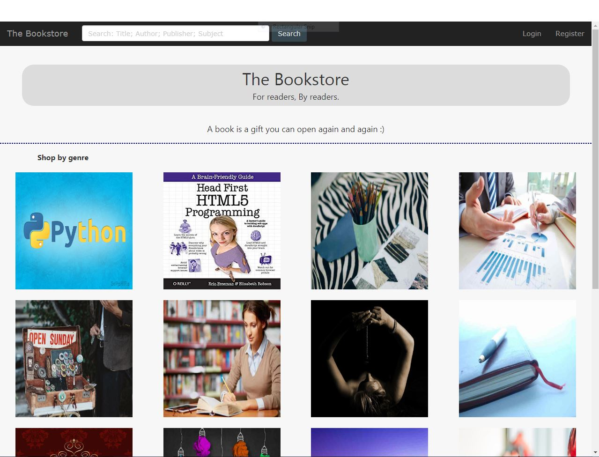


2) LoginPage(User/Admin):

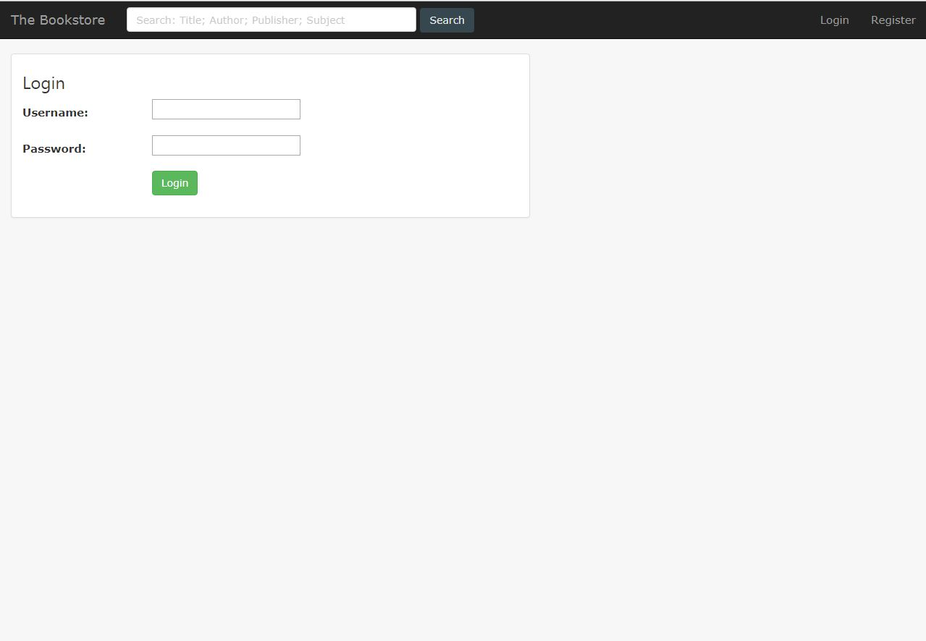

3) RegisterPage(User/Admin):

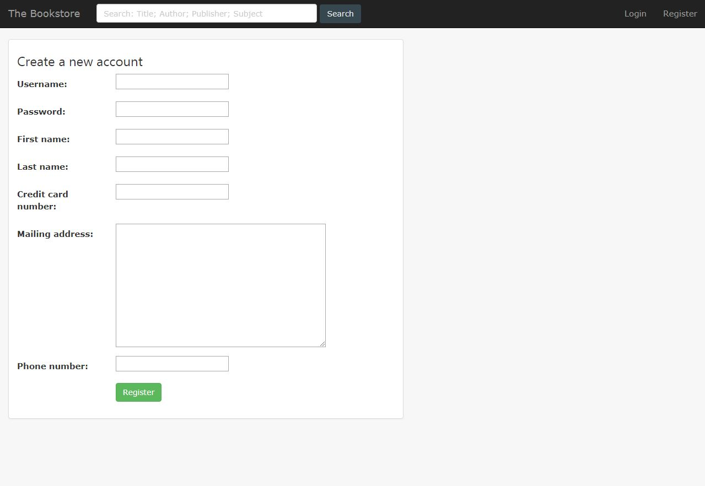

User Interface

4) Welcome page:
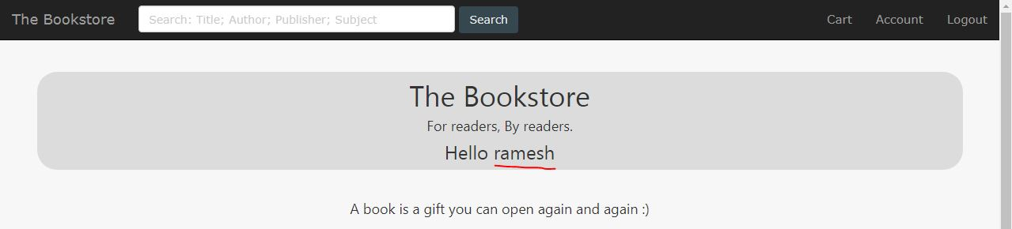

5) Search Results:

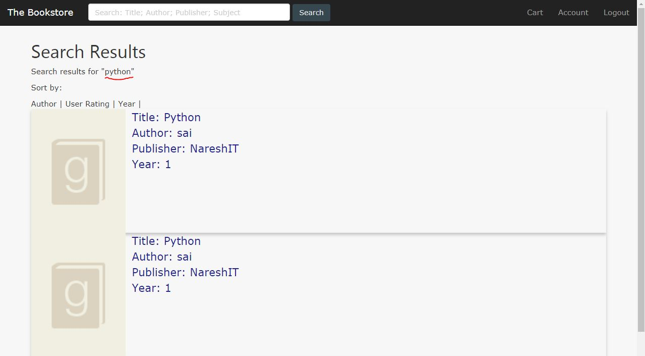

6) Search Details:
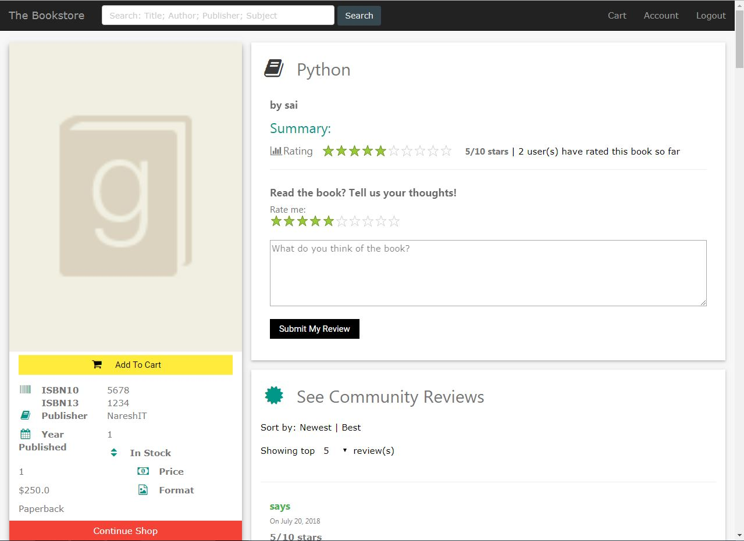

7) Success Message:
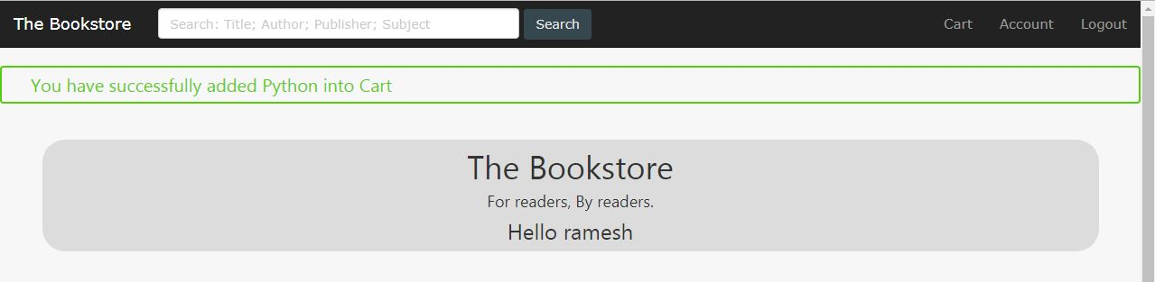

8) Cart Details:
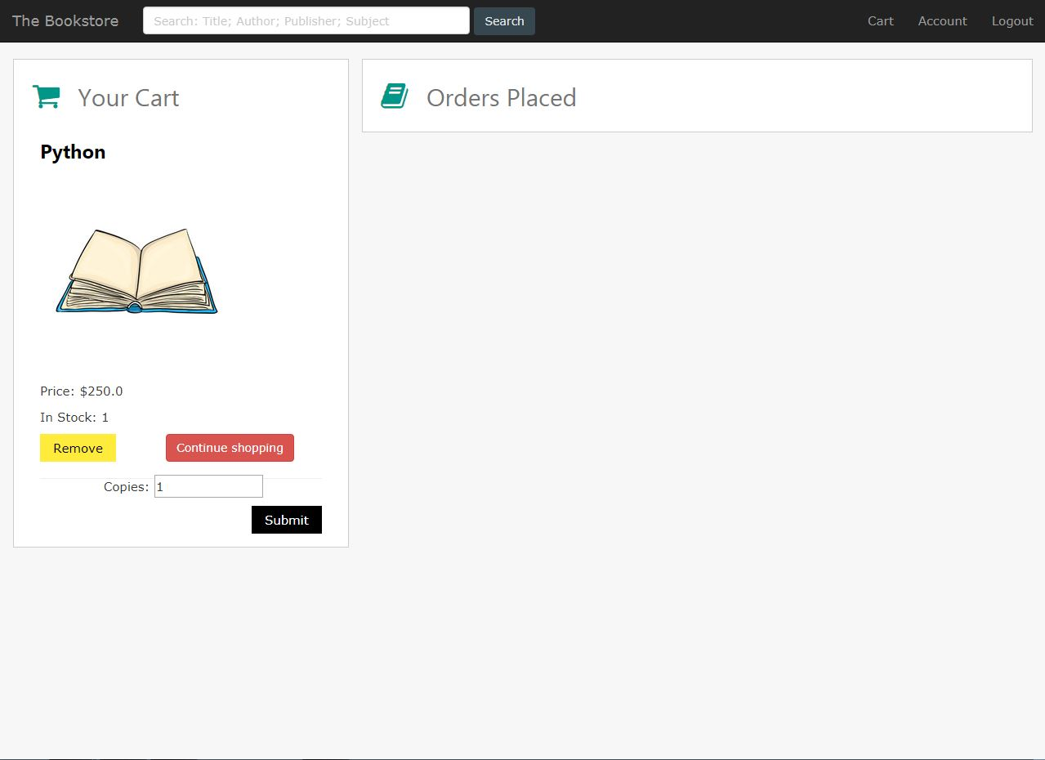

9) Account Details:
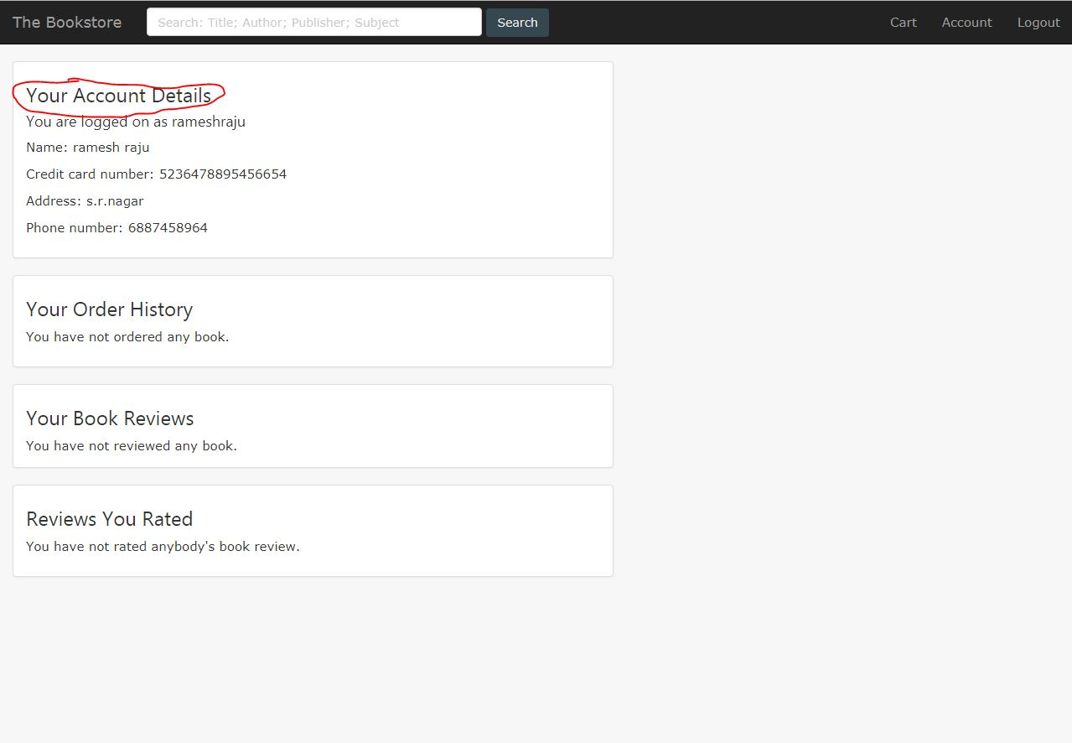

10) User Loggedout Page:
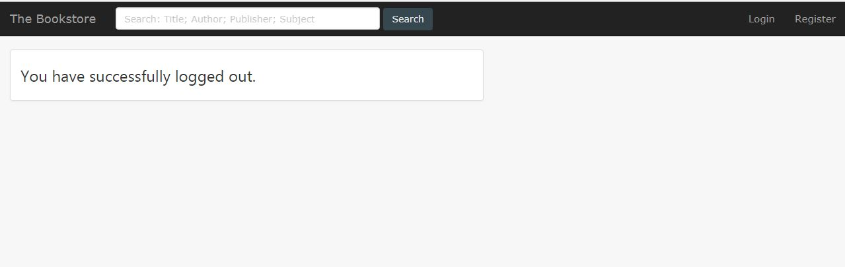

Admin Interface

11) HomePage:
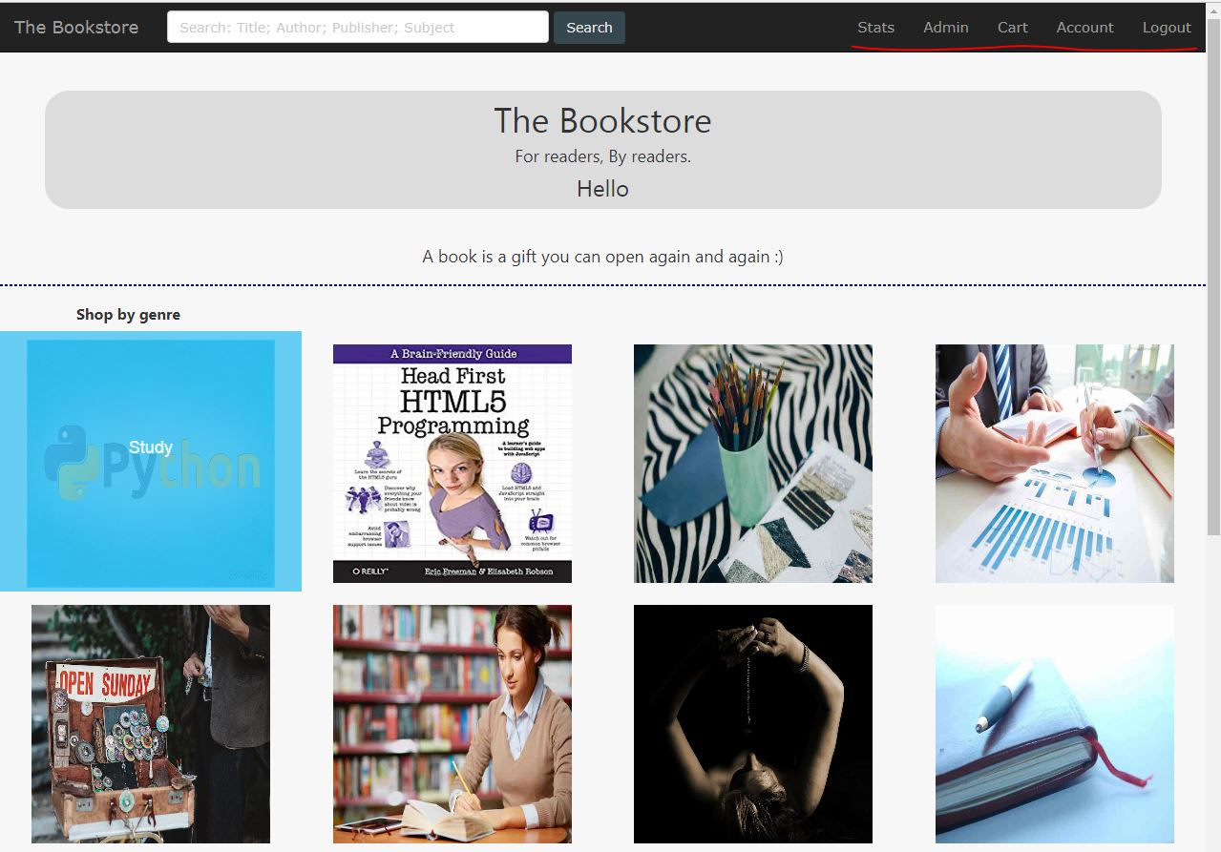

2) Search Results:
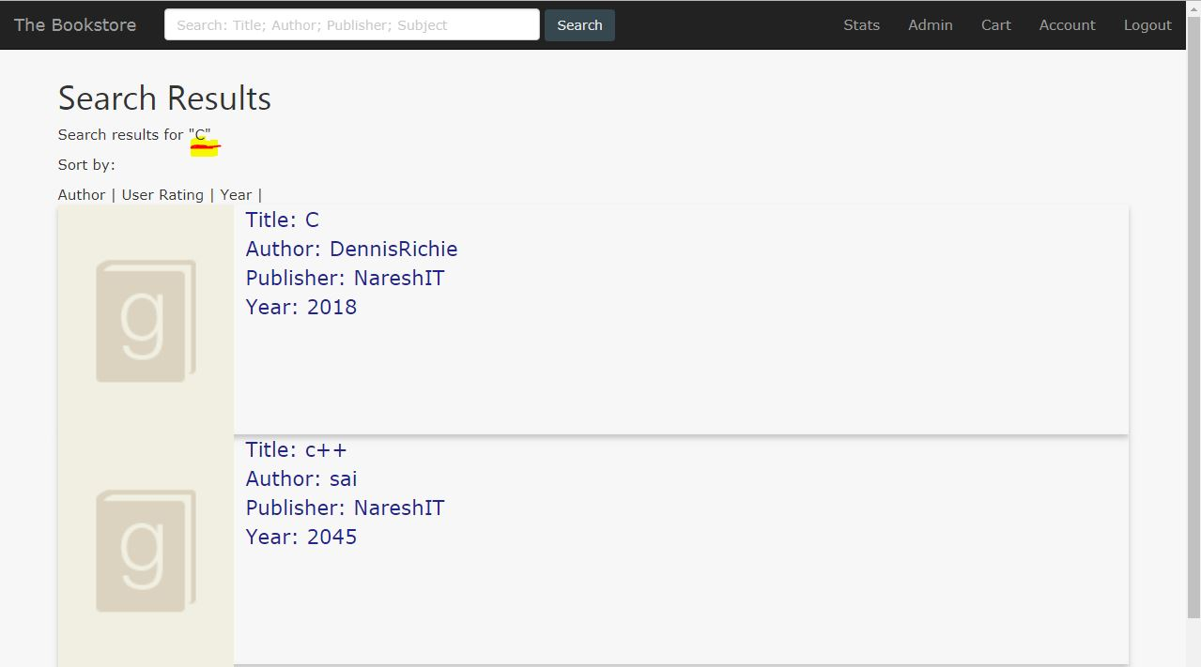

3) Search Details:
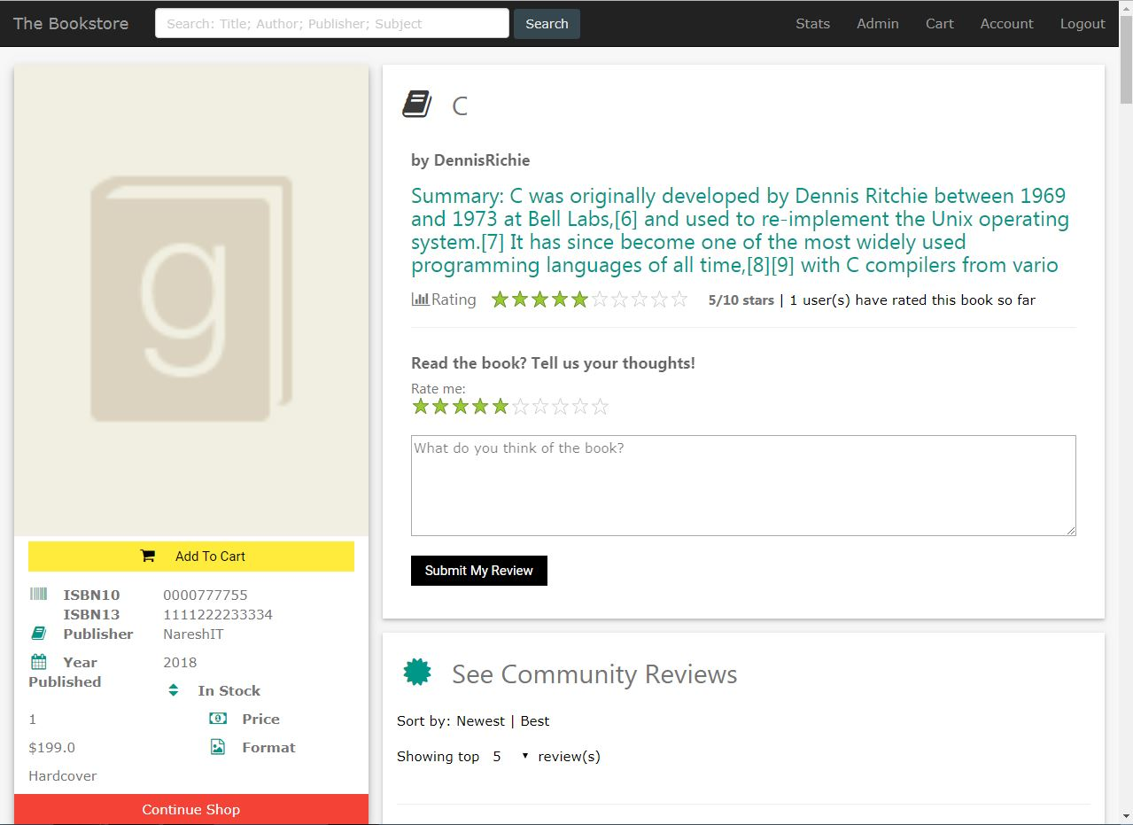

4) Success Message:
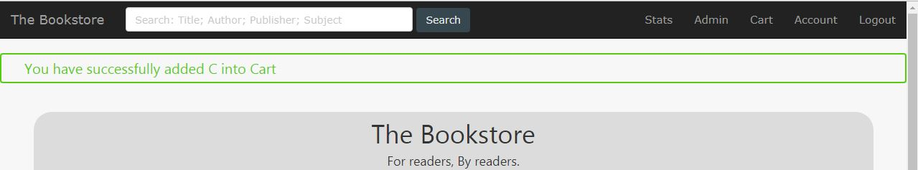

4) Cart Details:

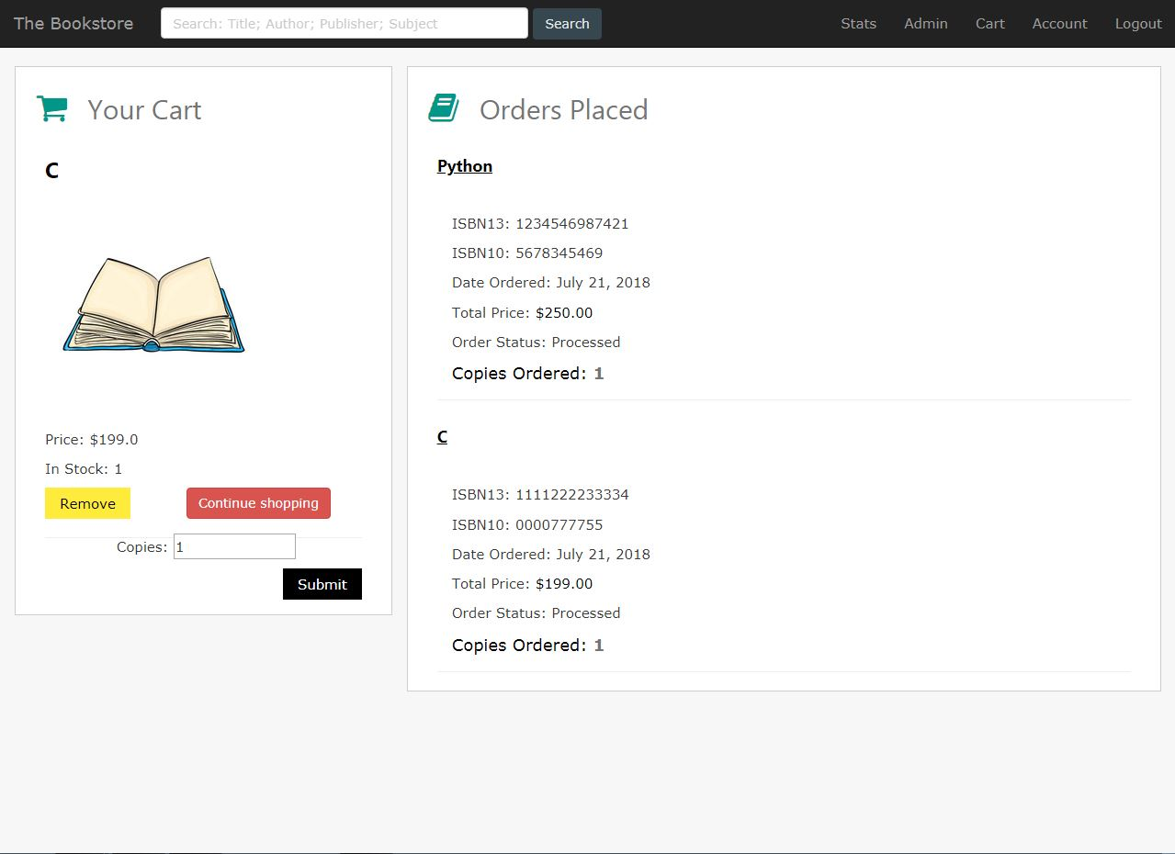

5) Account Details:

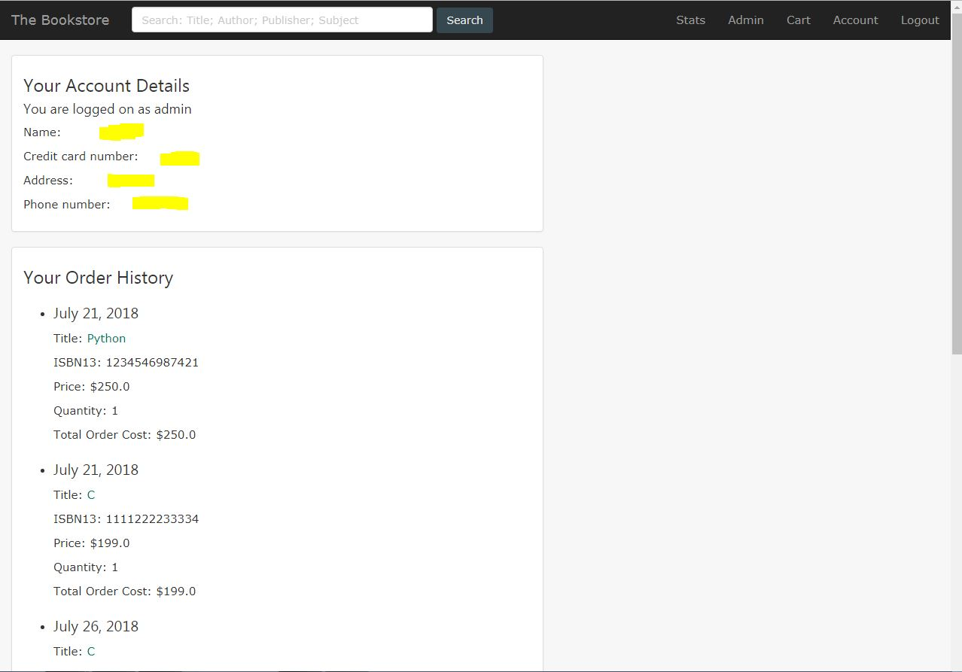

6) Adding a book:
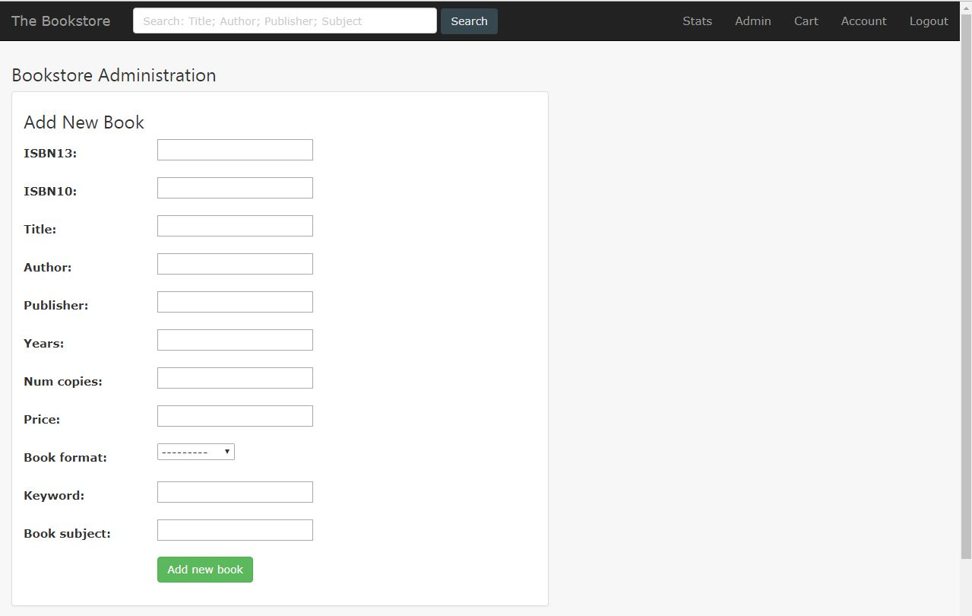

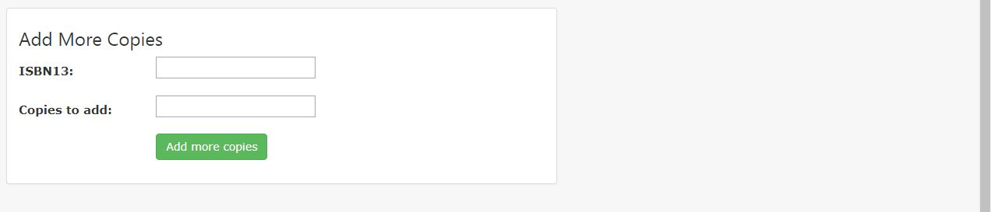

7) Statistics:
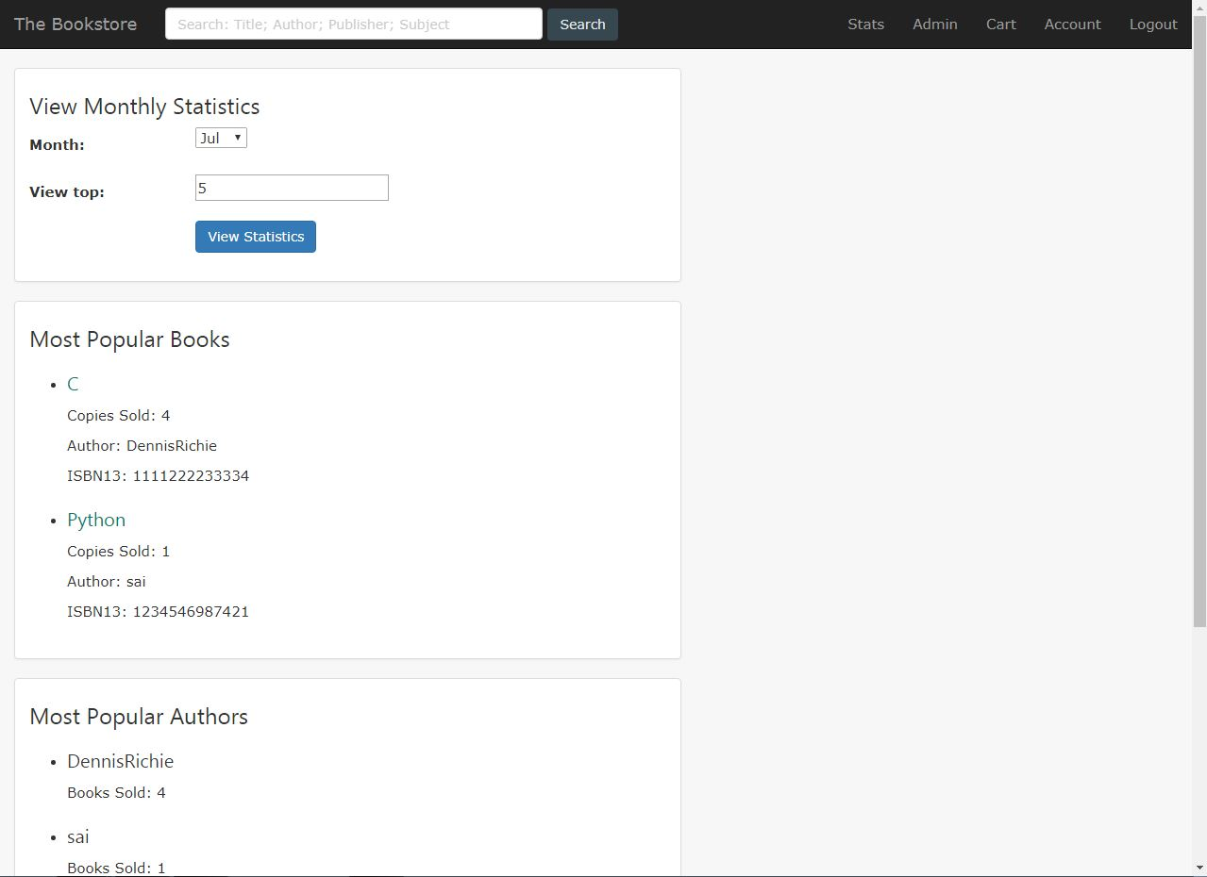

8) Logout:
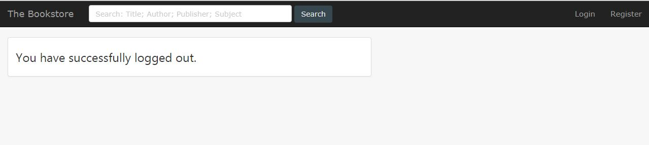

SYSTEM TESTING AND IMPLEMENTATION

  - INTRODUCTION
Software testing is a critical element of software quality assurance and represents the ultimate review of specification, design and coding. In fact, testing is the one step in the software engineering process that could be viewed as destructive rather than constructive.
A strategy for software testing integrates software test case design methods into a well-planned series of steps that result in the successful construction of software. Testing is the set of activities that can be planned in advance and conducted systematically. The underlying motivation of program testing is to affirm software quality with methods that can economically and effectively apply to both strategic to both large and small-scale systems.
8.2. STRATEGIC APPROACH TO SOFTWARE TESTING
The software engineering process can be viewed as a spiral. Initially system engineering defines the role of software and leads to software requirement analysis where the information domain, functions, behavior, performance, constraints and validation criteria for software are established. Moving inward along the spiral, we come to design and finally to coding. To develop computer software we spiral in along streamlines that decrease the level of abstraction on each turn.
A strategy for software testing may also be viewed in the context of the spiral. Unit testing begins at the vertex of the spiral and concentrates on each unit of the software as implemented in source code. Testing progress by moving outward along the spiral to integration testing, where the focus is on the design and the construction of the software architecture. Talking another turn on outward on the spiral we encounter validation testing where requirements established as part of software requirements analysis are validated against the software that has been constructed. Finally we arrive at system testing, where the software and other system elements are tested as a whole.

UNIT TESTING

MODULE TESTING

SUB-SYSTEM TESING

SYSTEM TESTING

ACCEPTANCE TESTING
Component Testing
Integration Testing
User Testing

8.3. UNIT TESTING
Unit testing focuses verification effort on the smallest unit of software design, the module. The unit testing we have is white box oriented and some modules the steps are conducted in parallel.
1. WHITE BOX TESTING
This type of testing ensures that
- All independent paths have been exercised at least once
- All logical decisions have been exercised on their true and false sides
- All loops are executed at their boundaries and within their operational bounds
- All internal data structures have been exercised to assure their validity.
To follow the concept of white box testing we have tested each form .we have created independently to verify that Data flow is correct, All conditions are exercised to check their validity, All loops are executed on their boundaries.
2. BASIC PATH TESTING
Established technique of flow graph with Cyclomatic complexity was used to derive test cases for all the functions. The main steps in deriving test cases were:
Use the design of the code and draw correspondent flow graph.
Determine the Cyclomatic complexity of resultant flow graph, using formula:
V(G)=E-N+2 or
V(G)=P+1 or
V(G)=Number Of Regions
Where V(G) is Cyclomatic complexity,
E is the number of edges,
N is the number of flow graph nodes,
P is the number of predicate nodes.
Determine the basis of set of linearly independent paths.

3. CONDITIONAL TESTING
In this part of the testing each of the conditions were tested to both true and false aspects. And all the resulting paths were tested. So that each path that may be generate on particular condition is traced to uncover any possible errors.
4. DATA FLOW TESTING
This type of testing selects the path of the program according to the location of definition and use of variables. This kind of testing was used only when some local variable were declared. The definition-use chain method was used in this type of testing. These were particularly useful in nested statements.
5. LOOP TESTING
In this type of testing all the loops are tested to all the limits possible. The following exercise was adopted for all loops:
All the loops were tested at their limits, just above them and just below them.
All the loops were skipped at least once.
For nested loops test the inner most loop first and then work outwards.
For concatenated loops the values of dependent loops were set with the help of connected loop.
Unstructured loops were resolved into nested loops or concatenated loops and tested as above.
Each unit has been separately tested by the development team itself and all the input have been validated.

8.4 TEST CASES

Test Case 1 – Login
Test 1:
- Incorrect input: An empty requirement field. (user name and password)
- Pass criteria: An appropriate error message should be displayed and the user shouldn’t be allowed to login.
- Correct input: Right user name and password.
- Pass criteria: The user should be directed to the secure web page which the user is requested.
Test 2:
- Incorrect input: Wrong user name and/or wrong password.
- Pass criteria: The user shouldn’t be allowed to login to the system and an appropriate error message should be displayed.
- Correct input: Right user name and password.
- Pass criteria: The user should be login to the system and directing to the requested secure web page.

Test Case 2 – New User Register

- Incorrect input: An empty requirement field. (first name, last name, middle name, Photo, address, Date Of Birth, phone number, user name, password, e-mail address)
- Pass criteria: An appropriate error message should be displayed and the user shouldn’t be allowed to create an account.
- Correct input: Fill in all requirement fields in correct format.
- Pass criteria: The user information should be added into the database.

Test Case 3 – Generate Report (Customer)
Test 1:
- Incorrect input: An empty requirement field. (Select Date)
- Pass criteria: An appropriate error message should be displayed and the user should not be able to generate a report.
- Correct input: Enter(Select) Correct Date
- Pass criteria: The user (admin) should be allowed to generate the report.

SYSTEM SECURITY

9.1 INTRODUCTION
The protection of computer based resources that includes hardware, software, data, procedures and people against unauthorized use or natural
Disaster is known as System Security.
System Security can be divided into four related issues:
- Security
- Integrity
- Privacy
- Confidentiality
SYSTEM SECURITY refers to the technical innovations and procedures applied to the hardware and operation systems to protect against deliberate or accidental damage from a defined threat.
DATA SECURITY is the protection of data from loss, disclosure, modification and destruction.
SYSTEM INTEGRITY refers to the power functioning of hardware and programs, appropriate physical security and safety against external threats such as eavesdropping and wiretapping.
PRIVACY defines the rights of the user or organizations to determine what information they are willing to share with or accept from others and how the organization can be protected against unwelcome, unfair or excessive dissemination of information about it.
CONFIDENTIALITY is a special status given to sensitive information in a database to minimize the possible invasion of privacy. It is an attribute of information that characterizes its need for protection.
9.3 SECURITY SOFTWARE
System security refers to various validations on data in form of checks and controls to avoid the system from failing. It is always important to ensure that only valid data is entered and only valid operations are performed on the system. The system employees two types of checks and controls:

CLIENT SIDE VALIDATION
Various client side validations are used to ensure on the client side that only valid data is entered. Client side validation saves server time and load to handle invalid data. Some checks imposed are:
- VBScript in used to ensure those required fields are filled with suitable data only. Maximum lengths of the fields of the forms are appropriately defined.
- Forms cannot be submitted without filling up the mandatory data so that manual mistakes of submitting empty fields that are mandatory can be sorted out at the client side to save the server time and load.
- Tab-indexes are set according to the need and taking into account the ease of user while working with the system.

SERVER SIDE VALIDATION
Some checks cannot be applied at client side. Server side checks are necessary to save the system from failing and intimating the user that some invalid operation has been performed or the performed operation is restricted. Some of the server side checks imposed is:
- Server side constraint has been imposed to check for the validity of primary key and foreign key. A primary key value cannot be duplicated. Any attempt to duplicate the primary value results into a message intimating the user about those values through the forms using foreign key can be updated only of the existing foreign key values.

- User is intimating through appropriate messages about the successful operations or exceptions occurring at server side.

- Various Access Control Mechanisms have been built so that one user may not agitate upon another. Access permissions to various types of users are controlled according to the organizational structure. Only permitted users can log on to the system and can have access according to their category. User- name, passwords and permissions are controlled o the server side.

- Using server side validation, constraints on several restricted operations are imposed.

CONCLUSION

It has been a great pleasure for me to work on this exciting and challenging project. This project proved good for me as it provided practical knowledge of not only programming in Python and Django web based application and no some extent Windows Application and MYSQL Server, It also provides knowledge about the latest technology used in developing web enabled application and client server technology that will be great demand in future. This will provide better opportunities and guidance in future in developing projects independently.

BENEFITS:
The project is identified by the merits of the system offered to the user. The merits of this project are as follows: -
- It’s a web-enabled project.
- This project offers user to enter the data through simple and interactive forms. This is very helpful for the client to enter the desired information through so much simplicity.
- The user is mainly more concerned about the validity of the data, whatever he is entering. There are checks on every stages of any new creation, data entry or updation so that the user cannot enter the invalid data, which can create problems at later date.
- Sometimes the user finds in the later stages of using project that he needs to update some of the information that he entered earlier. There are options for him by which he can update the records. Moreover there is restriction for his that he cannot change the primary data field. This keeps the validity of the data to longer extent.
- User is provided the option of monitoring the records he entered earlier. He can see the desired records with the variety of options provided by him.
- From every part of the project the user is provided with the links through framing so that he can go from one option of the project to other as per the requirement. This is bound to be simple and very friendly as per the user is concerned. That is, we can sat that the project is user friendly which is one of the primary concerns of any good project.
- Data storage and retrieval will become faster and easier to maintain because data is stored in a systematic manner and in a single database.
- Decision making process would be greatly enhanced because of faster processing of information since data collection from information available on computer takes much less time then manual system.
- Allocating of sample results becomes much faster because at a time the user can see the records of last years.
- Easier and faster data transfer through latest technology associated with the computer and communication.
- Through these features it will increase the efficiency, accuracy and transparency,

LIMITATIONS:
- The size of the database increases day-by-day, increasing the load on the database back up and data maintenance activity.
- Training for simple computer operations is necessary for the users working on the system.

FUTURE IMPROVEMENT

BIBLIOGRAPHY

FOR PYTHON INSTALLATION
www.python.org

- FOR MYSQL
https://dev.mysql.com/downloads/installer/
- FOR DJANGO
https://www.djangoproject.com/start/

