成都工业学院
课程设计
题目：业主管理系统

姓 名：张一鸣 1502510777
刘琪 1502510752
角有凤 1502531794
詹红运 1502510713
李思宏 1502510740
学 院：计算机工程学院
专 业：面向对象程序设计
指 导 教 师：王龙军老师

2016 年 6 月10 日

一、系统需求收集分析
1、项目调查，资料收集情况
业主管理更方便
2、项目概述
项目的背景：业主管理系统，方便管理
开发意义：加深对数据库理论、方法和技术等内容的理解。通过学生参加数据库设计与实现的完整过程，加强学习的应用性和趣味性，增加完成任务的成就感，掌握一个应用系统数据库的设计的实用技能，从而达到具有开发小型管理系统的初步能力。
开发目标：本次课程设计要构建一个业主管理系统，并示例出应该具备的功能。
- 主要任务要求
全局常量：derby驱动，数据库连接命令，数据库操作对象
界面设计：登录界面设计、主界面设计、修改添加对话框设计
类设计：业主类设计，登录类，数据库操作类
4．人员分工
系统调研、需求分析、概念及逻辑结构设计：刘琪
数据库的建立及其个功能操作：张一鸣、李思宏
连接数据库及可视化实现操作：詹红运、角有凤
论文编写：张一鸣
二．数据库系统设计
1．引言
项目名称：业主管理系统
编写本报告的目的：培养学生的组织能力，为以后适应各种论文编写做准备。
2．系统任务描述
说明所开发系统的基本任务、功能要求及业务流程说明,确定系统相关的人员或角色。
主要功能描述：
登录，
业主管理：显示全部、添加、修改、删除、查询
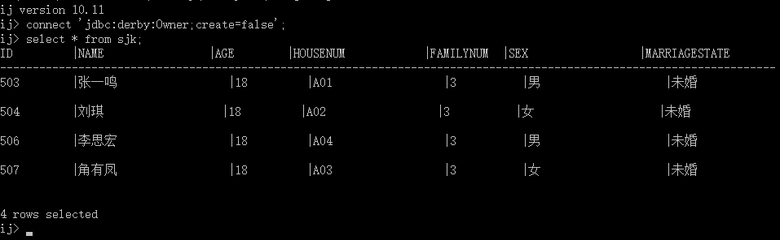
3.数据库概念结构设计

4．数据库逻辑结构设计
将E-R模型转换为关系模式。
属性 | 属性说明 | 数据类型长度 | 完整性约束条件 | 备注
ID | 递增 | Int | PRIMARY KEY
业主姓名 | 不为空 | CHAR(20) | NOT NULL
年龄 | 不为空 | INT | INT NOT NULL
门牌号 | 不为空 | CHAR(50) | NOT NULL
家庭成员数 | 不为空 | Int | NOT NULL
性别 | 不为空 | CHAR(20) | NOT NULL
婚姻状态 | 不为空 | CHAR(20) | NOT NULL
5．数据库物理结构设计
具体截图见:6问：
6．主要功能实现
包括用户界面、数据库对象编程（显示全部、添加、修改、删除、查询等）。

结果截图：
登录界面：
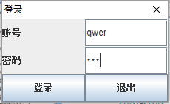
主界面：
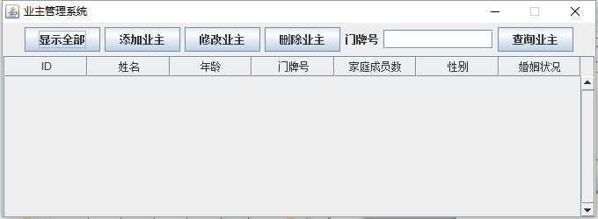

显示全部：
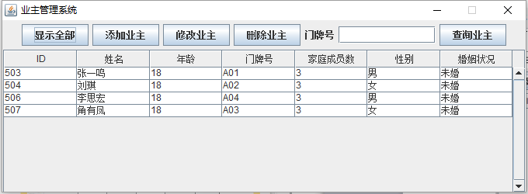
添加业主：
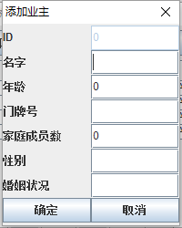
修改业主：
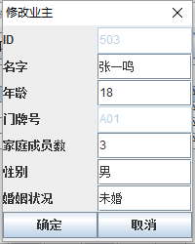

查询业主：
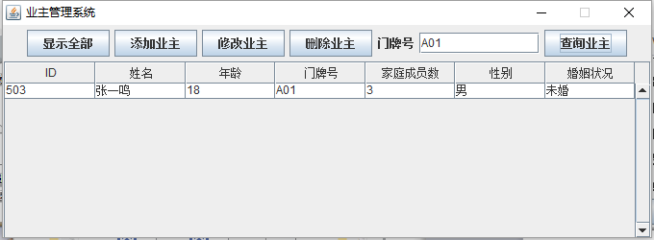
Java代码:
frame包：
loginDialog.java:
package frame;

import java.awt.GridLayout;
import java.awt.event.ActionEvent;
import java.awt.event.ActionListener;

import javax.swing.JButton;
import javax.swing.JDialog;
import javax.swing.JFrame;
import javax.swing.JLabel;
import javax.swing.JOptionPane;
import javax.swing.JPasswordField;
import javax.swing.JTextField;

import resource.resource;

public class loginDialog extends JDialog implements ActionListener, resource {
public static JLabel L_account = new JLabel("账号");
public static JLabel L_password = new JLabel("密码");
public static JTextField account = new JTextField(10);
public static JPasswordField password = new JPasswordField(10);
public static JButton button_confirm = new JButton("登录");
public static JButton button_exit = new JButton("退出");
int amount = 3;

public loginDialog(JFrame p, String title) {
super(p, title);
setResizable(false);
setModal(true);
setLayout(new GridLayout(3, 2));
add(L_account);
add(account);
add(L_password);
add(password);
add(button_confirm);
add(button_exit);
setBounds(500, 200, 230, 140);
button_confirm.addActionListener(this);
button_exit.addActionListener(this);
setDefaultCloseOperation(DO_NOTHING_ON_CLOSE);
setVisible(true);
}

@Override
public void actionPerformed(ActionEvent e) {
if (e.getSource() == button_confirm) {
if (account.getText().equals("") || password.getText().equals("")) {
JOptionPane.showMessageDialog(this, "不能为空", "警告", JOptionPane.WARNING_MESSAGE);
} else if (account.getText().equals(sqlOp.getAccount()) && password.getText().equals(sqlOp.getPassword())) {
setVisible(false);
} else {
amount--;
JOptionPane.showMessageDialog(this, "账户不存在或密码错误 可重试次数:" + amount, "警告", JOptionPane.WARNING_MESSAGE);
if (amount == 0) {
System.exit(0);
}
}
} else if (e.getSource() == button_exit) {
System.exit(0);
}
}

}
mainFrame.java:
package frame;

import java.awt.Dimension;
import java.awt.FlowLayout;
import java.awt.event.ActionEvent;
import java.awt.event.ActionListener;
import java.sql.ResultSet;
import java.sql.SQLException;

import javax.swing.JButton;
import javax.swing.JFrame;
import javax.swing.JLabel;
import javax.swing.JOptionPane;
import javax.swing.JScrollPane;
import javax.swing.JTable;
import javax.swing.JTextField;
import javax.swing.table.DefaultTableModel;

import OwnerInfo.OwnerInfo;
import resource.resource;

public class mainFrame extends JFrame implements resource, ActionListener {
String d[][] = {
// { "ID", "NAME", "AGE", "HOUSE_NUM", "FAMILY_NUM", "SEX",
// "MARRIAGE_STATE" },
{ "1", "67", "18", "A01", "3", "女", "未婚" } };

static String d1[] = { "ID", "姓名", "年龄", "门牌号", "家庭成员数", "性别", "婚姻状况" };
private static JButton button_showAll = new JButton("显示全部");
private static JButton button_addOwner = new JButton("添加业主");
private static JButton button_changeOwner = new JButton("修改业主");
private static JButton button_findOwner = new JButton("查询业主");
private static JButton button_deleteOwner = new JButton("删除业主");
private static JTextField text_Num = new JTextField(11);
public static JTable jt;
private static MyDialog dia;
private static loginDialog logindia;
public static DefaultTableModel tableModel = new DefaultTableModel(null, d1);

public mainFrame() {

INIT();
logindia=new loginDialog(this, "登录");
dia=new MyDialog(this, "添加");
dia.setModal(true);
setVisible(true);
}

private void INIT() {
setTitle("业主管理系统");
setBounds(200, 200, 680, 250);
setLayout(new FlowLayout());
add(button_showAll);
add(button_addOwner);
add(button_changeOwner);
add(button_deleteOwner);
add(new JLabel("门牌号"));
add(text_Num);
add(button_findOwner);

setResizable(false);

jt = new JTable(tableModel) {
public boolean isCellEditable(int row, int column) {
return false;
}
};
jt.setAutoResizeMode(2);
jt.setSelectionMode(0);
jt.setPreferredScrollableViewportSize(new Dimension(655, 160));
JScrollPane jsp = new JScrollPane(jt);
jsp.setVerticalScrollBarPolicy(JScrollPane.VERTICAL_SCROLLBAR_ALWAYS);
button_showAll.addActionListener(this);
button_findOwner.addActionListener(this);
button_addOwner.addActionListener(this);
button_changeOwner.addActionListener(this);
button_deleteOwner.addActionListener(this);
// jt.setEnabled(false);
add(jsp);
// sqlOp.addOwner(new OwnerInfo( "67", 18, "A01", 3, "女", "未婚"));
// add(jt, BorderLayout.PAGE_END);
setDefaultCloseOperation(EXIT_ON_CLOSE);
}

public static void refresh(){
ResultSet rs = sqlOp.getAll();
tableModel.setRowCount(0);
try {
while (rs.next()) {
tableModel.addRow(new String[] { rs.getString(1), rs.getString(2), rs.getString(3), rs.getString(4),
rs.getString(5), rs.getString(6), rs.getString(7) });
}
} catch (SQLException e1) {
}
}

@Override
public void actionPerformed(ActionEvent e) {
if (e.getSource() == button_showAll) {
refresh();
} else if (e.getSource() == button_findOwner) {
if (!text_Num.getText().equals("")) {
OwnerInfo oi = sqlOp.getOwner(text_Num.getText());
if (oi != null) {
tableModel.setRowCount(0);
tableModel.addRow(new String[] { oi.getID() + "", oi.getName(), oi.getAge() + "", oi.getHouseNum(),
oi.getFamilyNum() + "", oi.getSex(), oi.getMarriageState() });
} else {
JOptionPane.showMessageDialog(this, "不存在该门牌号业主", "错误", JOptionPane.WARNING_MESSAGE);
}
} else {
JOptionPane.showMessageDialog(this, "请输入具体门牌号", "错误", JOptionPane.WARNING_MESSAGE);
}
}else if(e.getSource()==button_addOwner){
dia.setTitle("添加业主");
dia.text_HouseNum.setEnabled(true);
dia.setText(new OwnerInfo(0,"",0,"",0,"",""));
dia.setVisible(true);
}else if(e.getSource()==button_changeOwner){
if(jt.getSelectedRow()!=-1){
dia.text_HouseNum.setEnabled(false);
dia.setText(new OwnerInfo(
Integer.valueOf((String)tableModel.getValueAt(jt.getSelectedRow(), 0)),
(String)tableModel.getValueAt(jt.getSelectedRow(), 1),
Integer.valueOf((String)tableModel.getValueAt(jt.getSelectedRow(), 2)),
(String)tableModel.getValueAt(jt.getSelectedRow(), 3),
Integer.valueOf((String)tableModel.getValueAt(jt.getSelectedRow(), 4)),
(String)tableModel.getValueAt(jt.getSelectedRow(), 5),
(String)tableModel.getValueAt(jt.getSelectedRow(), 6)));
dia.setTitle("修改业主");
dia.setVisible(true);
}else{
JOptionPane.showMessageDialog(this, "请选择业主", "错误", JOptionPane.WARNING_MESSAGE);
}

}else if(e.getSource()==button_deleteOwner){
if(jt.getSelectedRow()!=-1){
sqlOp.deleteOwner((String)tableModel.getValueAt(jt.getSelectedRow(), 3));
refresh();
}else{
JOptionPane.showMessageDialog(this, "请选择业主", "错误", JOptionPane.WARNING_MESSAGE);
}
}
}

}

MyDialog.java:
package frame;

import java.awt.GridLayout;
import java.awt.event.ActionEvent;
import java.awt.event.ActionListener;

import javax.swing.JButton;
import javax.swing.JDialog;
import javax.swing.JFrame;
import javax.swing.JLabel;
import javax.swing.JOptionPane;
import javax.swing.JTextField;

import OwnerInfo.OwnerInfo;
import resource.resource;

public class MyDialog extends JDialog implements ActionListener, resource {

public static JLabel Label_ID = new JLabel("ID");
public static JLabel Label_Name = new JLabel("名字");;
public static JLabel Label_Age = new JLabel("年龄");;
public static JLabel Label_HouseNum = new JLabel("门牌号");;
public static JLabel Label_FamilyNum = new JLabel("家庭成员数");;
public static JLabel Label_Sex = new JLabel("性别");;
public static JLabel Label_MarriageState = new JLabel("婚姻状况");;
public static JTextField text_ID = new JTextField(10);
public static JTextField text_Name = new JTextField(10);
public static JTextField text_Age = new JTextField(10);
public static JTextField text_HouseNum = new JTextField(10);
public static JTextField text_FamilyNum = new JTextField(10);
public static JTextField text_Sex = new JTextField(10);
public static JTextField text_MarriageState = new JTextField(10);
public static JButton button_confirm = new JButton("确定");
public static JButton button_cancle = new JButton("取消");

public MyDialog(JFrame jf, String title) {
super(jf, title);
setLayout(new GridLayout(8, 2));
setResizable(false);
text_ID.setEnabled(false);
text_HouseNum.setEnabled(false);
add(Label_ID);
add(text_ID);
add(Label_Name);
add(text_Name);
add(Label_Age);
add(text_Age);
add(Label_HouseNum);
add(text_HouseNum);
add(Label_FamilyNum);
add(text_FamilyNum);
add(Label_Sex);
add(text_Sex);
add(Label_MarriageState);
add(text_MarriageState);
add(button_confirm);
add(button_cancle);
setBounds(200, 200, 200, 250);
button_confirm.addActionListener(this);
button_cancle.addActionListener(this);
}

@Override
public void actionPerformed(ActionEvent e) {
if (e.getSource() == button_confirm) {
if (!(text_Age.getText().equals("") || text_FamilyNum.getText().equals("")
|| text_HouseNum.getText().equals("") || text_MarriageState.getText().equals("")
|| text_Name.getText().equals("") || text_Sex.getText().equals(""))) {
if (text_HouseNum.isEnabled() == false) {// 修改模式
sqlOp.setOwner(new OwnerInfo(Integer.valueOf(text_ID.getText()), text_Name.getText(),
Integer.valueOf(text_Age.getText()), text_HouseNum.getText(),
Integer.valueOf(text_FamilyNum.getText()), text_Sex.getText(),
text_MarriageState.getText()));
setVisible(false);
mainFrame.refresh();
} else {// 添加模式
if (sqlOp.getOwner(text_HouseNum.getText()) == null) {
sqlOp.addOwner(new OwnerInfo(Integer.valueOf(text_ID.getText()), text_Name.getText(),
Integer.valueOf(text_Age.getText()), text_HouseNum.getText(),
Integer.valueOf(text_FamilyNum.getText()), text_Sex.getText(),
text_MarriageState.getText()));
setVisible(false);
mainFrame.refresh();
} else {
JOptionPane.showMessageDialog(this, "已存在该门牌号业主", "警告", JOptionPane.WARNING_MESSAGE);
}
}
} else {
JOptionPane.showMessageDialog(this, "不能为空", "警告", JOptionPane.WARNING_MESSAGE);
}
} else if (e.getSource() == button_cancle) {
setVisible(false);
}
}

public void setText(OwnerInfo oi) {
text_ID.setText(oi.getID() + "");
text_Name.setText(oi.getName() + "");
text_Age.setText(oi.getAge() + "");
text_HouseNum.setText(oi.getHouseNum() + "");
text_FamilyNum.setText(oi.getFamilyNum() + "");
text_Sex.setText(oi.getSex() + "");
text_MarriageState.setText(oi.getMarriageState() + "");
}
}
login包：
Login.java:
package login;

import resource.resource;

public class login implements resource {
public static boolean loginAccount(String account, String password) {
int wrongTime=3;//登陆可尝试次数
if (wrongTime>=0&&sqlOp.getAccount().equals(account)
&& sqlOp.getPassword().equals(password)) {
return true;
}else if(wrongTime>=0){//登陆账号密码错误
wrongTime-=1;
return false;
}else{//尝试次数为0
return false;
}
}
}
MAIN包：
MAIN.java:
package MAIN;

import frame.mainFrame;

public class MAIN {
public static void main(String args[]){
new mainFrame();
}
}
OwnerInfo包：
OwnerInfo.java:
package OwnerInfo;

public class OwnerInfo
{
private int id;
// 业主名字
private String name;
// 业主年龄
private int age;
// 房子门牌号
private String houseNum;
// 家庭成员数量
private int familyNum;
// 性别
private String sex;
// 婚姻状况
private String marriageState;

// 构造函数
public OwnerInfo(int id,String name, int age, String houseNum, int familyNum,
String sex, String marriageState) {
this.id=id;
this.name = name;
this.age = age;
this.houseNum = houseNum;
this.familyNum = familyNum;
this.sex = sex;
this.marriageState = marriageState;
}
// 获取业主ID
public int getID() {
return id;
}

// 获取业主名字
public String getName() {
return name;
}

// 获取年龄
public int getAge() {
return age;
}

// 获取房子门牌号
public String getHouseNum() {
return houseNum;
}

// 获取家庭成员数量
public int getFamilyNum() {
return familyNum;
}

// 获取性别
public String getSex() {
return sex;
}

// 获取婚姻状况
public String getMarriageState() {
return marriageState;
}

// 设置业主名字
public void setName(String n) {
name = n;
}

// 设置年龄
public void setAge(int a) {
age = a;
}

// 设置房子门牌号
public void setHouseNum(String hn) {
houseNum = hn;
}

// 设置家庭成员数量
public void setFamilyNum(int fn) {
familyNum = fn;
}

// 设置性别
public void setSex(String s) {
sex = s;
}

// 设置婚姻状况
public void setMarriageState(String ms) {
marriageState = ms;
}
}
resource包:
resource.java:
package resource;

import sql.sqlOperation;

public interface resource {
public static final sqlOperation sqlOp = new sqlOperation();
// 数据库驱动
public static final String sqlClass = "org.apache.derby.jdbc.EmbeddedDriver";
//数据库连接
public static final String sqlConnection="jdbc:derby:Owner;create=false";
}
sql包：
sqlOperation.java:
package sql;

import java.sql.Connection;
import java.sql.DriverManager;
import java.sql.ResultSet;
import java.sql.SQLException;
import java.sql.Statement;

import resource.resource;
import OwnerInfo.OwnerInfo;

public class sqlOperation implements resource {
public Connection con;
public Statement sta;
public sqlOperation() {
// 连接数据库
getConnection();
}

public void getConnection() {
try {
Class.forName(sqlClass);
con = DriverManager.getConnection(sqlConnection);
sta = con.createStatement();
} catch (Exception e) {
e.printStackTrace();
System.exit(-1);
}
try {
sta.executeUpdate("create table sjk("
+ "id int generated always as identity,"
+ "name VARCHAR(20),"
+ "age INT,"
+ "houseNum VARCHAR(20),"
+ "familyNum INT,"
+ "sex VARCHAR(20),"
+ "marriageState VARCHAR(20)" + ")");
} catch (SQLException e) {
//e.printStackTrace();
System.out.println("表已经存在");
}
}

public void addOwner(OwnerInfo oi) {
try {
sta.executeUpdate("INSERT INTO sjk(name,age,houseNum,familyNum,sex,marriageState) "
+ "VALUES ("
+"'"+oi.getName()+"',"
+oi.getAge()
+",'"+oi.getHouseNum()+"',"
+oi.getFamilyNum()
+",'"+oi.getSex()+"',"
+"'"+oi.getMarriageState()+"'"
+")");

} catch (SQLException e) {
e.printStackTrace();
}
}

public void setOwner(OwnerInfo oi) {
try {
sta.executeUpdate("DELETE FROM sjk WHERE houseNum = '"+oi.getHouseNum()+"'");
sta.executeUpdate("INSERT INTO sjk(name,age,houseNum,familyNum,sex,marriageState) "
+ "VALUES ("
+"'"+oi.getName()+"',"
+oi.getAge()+","
+"'"+oi.getHouseNum()+"'"+","
+oi.getFamilyNum()+","
+"'"+oi.getSex()+"'"+","
+"'"+oi.getMarriageState()+"'"
+")");
} catch (SQLException e) {
e.printStackTrace();
}
}

public void deleteOwner(String houseNum){
try {
sta.executeUpdate("DELETE FROM sjk WHERE houseNum = '"+houseNum+"'");
} catch (SQLException e) {
e.printStackTrace();
}
}

// 通过门牌号获取业主信息
public OwnerInfo getOwner(String houseNum) {
ResultSet rs = null;
try {

rs = sta.executeQuery("select * from sjk where houseNum = '"
+ houseNum + "'");
rs.next();
return new OwnerInfo(rs.getInt(1),rs.getString(2), rs.getInt(3),
rs.getString(4), rs.getInt(5), rs.getString(6),
rs.getString(7));
} catch (SQLException e) {
System.out.println("不存在Owner");
}
return null;
}

// 获取业主信息
public ResultSet getAll() {
ResultSet rs = null;
try {

rs = sta.executeQuery("select * from sjk");
return rs;
} catch (SQLException e) {
e.printStackTrace();
}
return null;
}
public String getAccount() {
return "qwer";
}

public String getPassword() {
return "zym";
}
}

三．收获和体会
我爱学习学习爱我

