Урок 6. SQL – Транзакции. Временные таблицы, управляющие конструкции, циклы

1) Написать функцию, которая удаляет всю информацию об указанном пользователе из БД vk.
Пользователь задается по id.
Удалить нужно все сообщения, лайки, медиа записи, профиль и запись из таблицы users.
Функция должна возвращать номер пользователя.

1) создаем таблицу vk2

DROP DATABASE IF EXISTS vk2;
CREATE DATABASE vk2;
USE vk2;

DROP TABLE IF EXISTS users;
CREATE TABLE users (
id BIGINT UNSIGNED NOT NULL AUTO_INCREMENT PRIMARY KEY,
firstname VARCHAR(50),
lastname VARCHAR(50) COMMENT 'Фамиль',
email VARCHAR(120) UNIQUE,
phone BIGINT,
INDEX users_phone_idx(phone),
INDEX users_firstname_lastname_idx(firstname, lastname)
) COMMENT 'юзеры';
INSERT INTO `users` (`id`, `firstname`, `lastname`, `email`, `phone`) VALUES ('1', 'Reuben', 'Nienow', 'arlo50@example.org', '9374071116');
INSERT INTO `users` (`id`, `firstname`, `lastname`, `email`, `phone`) VALUES ('2', 'Reuben', 'Nienow', 'terrence.cartwright@example.org', '9127498182');
INSERT INTO `users` (`id`, `firstname`, `lastname`, `email`, `phone`) VALUES ('3', 'Reuben', 'Windler', 'rupert55@example.org', '9921090703');
INSERT INTO `users` (`id`, `firstname`, `lastname`, `email`, `phone`) VALUES ('4', 'Reuben', 'West', 'rebekah29@example.net', '9592139196');
INSERT INTO `users` (`id`, `firstname`, `lastname`, `email`, `phone`) VALUES ('5', 'Frederick', 'Effertz', 'von.bridget@example.net', '9909791725');
INSERT INTO `users` (`id`, `firstname`, `lastname`, `email`, `phone`) VALUES ('6', 'Frederick', 'Medhurst', 'sstehr@example.net', '9456642385');
INSERT INTO `users` (`id`, `firstname`, `lastname`, `email`, `phone`) VALUES ('7', 'Frederick', 'Braun', 'itzel.beahan@example.com', '9448906606');
INSERT INTO `users` (`id`, `firstname`, `lastname`, `email`, `phone`) VALUES ('8', 'Frederick', 'Kilback', 'johnathan.wisozk@example.com', '9290679311');
INSERT INTO `users` (`id`, `firstname`, `lastname`, `email`, `phone`) VALUES ('9', 'Frederick', 'Orn', 'missouri87@example.org', '9228624339');
INSERT INTO `users` (`id`, `firstname`, `lastname`, `email`, `phone`) VALUES ('10', 'Jordyn', 'Jerde', 'edach@example.com', '9443126821');

DROP TABLE IF EXISTS messages;
CREATE TABLE messages (
id SERIAL,
from_user_id BIGINT UNSIGNED NOT NULL,
to_user_id BIGINT UNSIGNED NOT NULL,
body TEXT,
created_at DATETIME DEFAULT NOW(),
INDEX messages_from_user_id (from_user_id),
INDEX messages_to_user_id (to_user_id),
FOREIGN KEY (from_user_id) REFERENCES users(id),
FOREIGN KEY (to_user_id) REFERENCES users(id)
);
INSERT INTO `messages` VALUES
('1','1','2','Voluptatem ut quaerat quia. Pariatur esse amet ratione qui quia. In necessitatibus reprehenderit et. Nam accusantium aut qui quae nesciunt non.','1995-08-28 22:44:29'),
('2','2','1','Sint dolores et debitis est ducimus. Aut et quia beatae minus. Ipsa rerum totam modi sunt sed. Voluptas atque eum et odio ea molestias ipsam architecto.',now()),
('3','3','1','Sed mollitia quo sequi nisi est tenetur at rerum. Sed quibusdam illo ea facilis nemo sequi. Et tempora repudiandae saepe quo.','1993-09-14 19:45:58'),
('4','1','3','Quod dicta omnis placeat id et officiis et. Beatae enim aut aliquid neque occaecati odit. Facere eum distinctio assumenda omnis est delectus magnam.','1985-11-25 16:56:25'),
('5','1','5','Voluptas omnis enim quia porro debitis facilis eaque ut. Id inventore non corrupti doloremque consequuntur. Molestiae molestiae deleniti exercitationem sunt qui ea accusamus deserunt.','1999-09-19 04:35:46'),
('6','1','6','Rerum labore culpa et laboriosam eum totam. Quidem pariatur sit alias. Atque doloribus ratione eum rem dolor vitae saepe.','1973-11-09 08:12:04'),
('7','1','7','Perspiciatis temporibus doloribus debitis. Et inventore labore eos modi. Quo temporibus corporis minus. Accusamus aspernatur nihil nobis placeat molestiae et commodi eaque.','1998-04-09 00:00:26'),
('8','8','8','Suscipit dolore voluptas et sit vero et sint. Rem ut ratione voluptatum assumenda nesciunt ea. Quas qui qui atque ut. Similique et praesentium non voluptate iure. Eum aperiam officia quia dolorem.','2005-08-20 18:40:27'),
('9','9','9','Et quia libero aut vitae minus. Rerum a blanditiis debitis sit nam. Veniam quasi aut autem ratione dolorem. Sunt quo similique dolorem odit totam sint sed.','2013-03-19 04:10:10'),
('10','10','10','Praesentium molestias quia aut odio. Est quis eius ut animi optio molestiae. Amet tempore sequi blanditiis in est.','1976-05-22 14:38:15');

DROP TABLE IF EXISTS friend_requests;
CREATE TABLE friend_requests (
-- id SERIAL PRIMARY KEY, -- changed to combined primary key (initiator_user_id, target_user_id)
initiator_user_id BIGINT UNSIGNED NOT NULL,
target_user_id BIGINT UNSIGNED NOT NULL,
-- `status` TINYINT UNSIGNED,
`status` ENUM('requested', 'approved', 'unfriended', 'declined'),
requested_at DATETIME DEFAULT NOW(),
confirmed_at DATETIME,
INDEX (initiator_user_id),
INDEX (target_user_id),
PRIMARY KEY (initiator_user_id, target_user_id),
FOREIGN KEY (initiator_user_id) REFERENCES users(id),
FOREIGN KEY (target_user_id) REFERENCES users(id)
);
INSERT INTO `friend_requests` (`initiator_user_id`, `target_user_id`, `status`, `requested_at`, `confirmed_at`) VALUES ('1', '10', 'approved', '1970-08-21 06:40:37', '2003-12-29 23:20:55');
INSERT INTO `friend_requests` (`initiator_user_id`, `target_user_id`, `status`, `requested_at`, `confirmed_at`) VALUES ('1', '2', 'requested', '1987-10-10 07:33:23', '1983-01-18 01:56:05');
INSERT INTO `friend_requests` (`initiator_user_id`, `target_user_id`, `status`, `requested_at`, `confirmed_at`) VALUES ('1', '3', 'approved', '2015-02-07 01:53:07', '2015-09-14 16:17:12');
INSERT INTO `friend_requests` (`initiator_user_id`, `target_user_id`, `status`, `requested_at`, `confirmed_at`) VALUES ('4', '1', 'approved', '1983-04-08 15:57:26', '1976-12-28 23:54:58');
INSERT INTO `friend_requests` (`initiator_user_id`, `target_user_id`, `status`, `requested_at`, `confirmed_at`) VALUES ('5', '2', 'unfriended', '1976-03-03 18:22:00', '1996-12-03 11:29:04');
INSERT INTO `friend_requests` (`initiator_user_id`, `target_user_id`, `status`, `requested_at`, `confirmed_at`) VALUES ('6', '3', 'unfriended', '2008-12-06 17:07:59', '2015-11-01 08:03:23');
INSERT INTO `friend_requests` (`initiator_user_id`, `target_user_id`, `status`, `requested_at`, `confirmed_at`) VALUES ('7', '1', 'requested', '1989-10-26 06:20:23', '2001-08-05 16:01:03');
INSERT INTO `friend_requests` (`initiator_user_id`, `target_user_id`, `status`, `requested_at`, `confirmed_at`) VALUES ('8', '6', 'unfriended', '1987-12-30 01:50:03', '2001-07-09 07:39:50');
INSERT INTO `friend_requests` (`initiator_user_id`, `target_user_id`, `status`, `requested_at`, `confirmed_at`) VALUES ('9', '7', 'requested', '2003-12-27 22:52:09', '1998-04-18 04:41:46');

DROP TABLE IF EXISTS communities;
CREATE TABLE communities(
id SERIAL,
name VARCHAR(150),
INDEX communities_name_idx(name)
);
/*!40000 ALTER TABLE `communities` DISABLE KEYS */;
INSERT INTO `communities` VALUES (2,'atque'),(1,'beatae'),(9,'est'),(5,'eum'),(7,'hic'),(6,'nemo'),(8,'quis'),(4,'rerum'),(10,'tempora'),(3,'voluptas');
/*!40000 ALTER TABLE `communities` ENABLE KEYS */;

DROP TABLE IF EXISTS users_communities;
CREATE TABLE users_communities(
user_id BIGINT UNSIGNED NOT NULL,
community_id BIGINT UNSIGNED NOT NULL,
PRIMARY KEY (user_id, community_id),
FOREIGN KEY (user_id) REFERENCES users(id),
FOREIGN KEY (community_id) REFERENCES communities(id)
);
INSERT INTO `users_communities` (`user_id`, `community_id`) VALUES ('1', '1');
INSERT INTO `users_communities` (`user_id`, `community_id`) VALUES ('1', '2');
INSERT INTO `users_communities` (`user_id`, `community_id`) VALUES ('1', '3');
INSERT INTO `users_communities` (`user_id`, `community_id`) VALUES ('2', '4');
INSERT INTO `users_communities` (`user_id`, `community_id`) VALUES ('2', '5');
INSERT INTO `users_communities` (`user_id`, `community_id`) VALUES ('6', '6');
INSERT INTO `users_communities` (`user_id`, `community_id`) VALUES ('7', '7');
INSERT INTO `users_communities` (`user_id`, `community_id`) VALUES ('8', '8');
INSERT INTO `users_communities` (`user_id`, `community_id`) VALUES ('9', '9');
INSERT INTO `users_communities` (`user_id`, `community_id`) VALUES ('10', '10');

DROP TABLE IF EXISTS media_types;
CREATE TABLE media_types(
id SERIAL,
name VARCHAR(255),
created_at DATETIME DEFAULT NOW()
);
/*!40000 ALTER TABLE `media_types` DISABLE KEYS */;
INSERT INTO `media_types` VALUES
(1,'Photo','2003-07-09 10:08:05'),
(2,'Music','2009-06-19 20:08:09'),
(3,'Video','1984-04-18 01:55:09'),
(4,'Post','2001-04-17 06:47:52');
/*!40000 ALTER TABLE `media_types` ENABLE KEYS */;

DROP TABLE IF EXISTS media;
CREATE TABLE media(
id SERIAL,
media_type_id BIGINT UNSIGNED NOT NULL,
user_id BIGINT UNSIGNED NOT NULL,
body text,
filename VARCHAR(255),
size INT,
metadata JSON,
created_at DATETIME DEFAULT NOW(),
updated_at DATETIME DEFAULT CURRENT_TIMESTAMP ON UPDATE CURRENT_TIMESTAMP,
INDEX (user_id),
FOREIGN KEY (user_id) REFERENCES users(id),
FOREIGN KEY (media_type_id) REFERENCES media_types(id)
);
INSERT INTO media (media_type_id,user_id,body,filename,`size`,metadata,created_at,updated_at) VALUES
(1,1,'Est aut aliquid est. Soluta eveniet doloribus ipsam ut id assumenda quam. Consequuntur et velit aperiam error corporis rem corporis. Est similique quisquam quia maxime eaque possimus facere officiis. Odio magni atque dicta voluptatibus hic iste delectus.','user1_avatar.jpg',5,NULL,'1991-11-16 08:14:38.000','2019-06-19 18:11:58.000')
,(2,2,'Laborum dolorem magni unde vero sit hic. Pariatur quia voluptas magnam. Blanditiis dolorem et molestias veniam facere provident.','asperiores.mp4',4510,NULL,'1986-12-10 19:34:26.000','2019-06-19 18:11:58.000')
,(1,3,'A quam ea ullam reiciendis vel et reiciendis. Delectus iure mollitia est. Eum dolores dolores sed officia vitae qui. Sed repudiandae voluptatem voluptatibus libero culpa quo.','sapiente.avi',763116,NULL,'1978-09-18 17:07:49.000','2019-06-19 18:11:58.000')
,(4,4,'Velit commodi in veniam occaecati. Tenetur temporibus ullam enim officiis aut illum. In maiores velit nobis soluta molestias maiores tempora. Quisquam et ut et sequi.','rerum.mp4',740,NULL,'1984-10-21 04:41:15.000','2019-06-19 18:11:58.000')
,(1,5,'Est eaque est qui et omnis rerum. Expedita porro nesciunt inventore consequatur quos. Inventore aut rerum voluptas. Dicta vel ut quibusdam cupiditate tempore.','user5-profile-image.mp4',40813,NULL,'2014-06-20 03:34:11.000','2019-06-19 18:11:58.000')
,(2,6,'Atque et nam nulla et aliquid. Vel repellendus aut natus odit quibusdam quis atque et. Laudantium minima velit dolores eos voluptate nostrum.','quasi.jpg',119422,NULL,'1991-11-02 07:50:45.000','2019-06-19 18:11:58.000')
,(3,1,'Nihil ut et reprehenderit et. Numquam veniam quis impedit. Voluptas saepe rerum illo vel omnis. Aliquam illum ut quo saepe ea unde est.','non.mp4',704558,NULL,'1988-09-17 20:56:38.000','2019-06-19 18:11:58.000')
,(3,1,'Sint quod fugit molestiae dolore repellendus est. Quis corporis necessitatibus commodi placeat temporibus doloremque voluptatem. Nemo maxime sit dolorem perferendis repellat. Et impedit deleniti eaque pariatur ut quia voluptatibus.','earum.mp4',65108,NULL,'1995-10-07 10:19:53.000','2019-06-19 18:11:58.000')
,(3,1,'Optio sed aperiam veniam eum. Rerum placeat soluta iusto perspiciatis quibusdam dolorem eos. Ea pariatur optio est ut.','ullam.avi',83717449,NULL,'2003-08-05 05:55:25.000','2019-06-19 18:11:58.000')
,(3,10,'Facere nostrum facilis aperiam quisquam dolor. Minima omnis est nam.','maiores.avi',75,NULL,'1984-05-17 07:37:30.000','2019-06-19 18:11:58.000')
;
INSERT INTO media (media_type_id,user_id,body,filename,`size`,metadata,created_at,updated_at) VALUES
(3,1,'A omnis ratione non. Et velit sed incidunt corporis ut rerum nemo. Ut pariatur tempora ea incidunt praesentium ut. Eligendi et et rerum sequi ut.','non.mp4',0,NULL,'2010-05-07 19:13:09.000','2019-06-19 18:11:58.000')
,(4,1,'Quo minus harum debitis debitis quis sunt. Dolores suscipit placeat dolorum non voluptate et. Non eos odio esse tempore. Illum minus quidem temporibus porro.','earum.jpg',1826766,NULL,'2013-08-25 22:49:45.000','2019-06-19 18:11:58.000')
,(1,1,'Et aliquid sit natus vitae fuga enim repudiandae. Quis ab et debitis est accusantium labore. Exercitationem delectus eaque necessitatibus.','hic.jpg',979,NULL,'2015-11-02 00:11:31.000','2019-06-19 18:11:58.000')
,(2,1,'Nobis est sed blanditiis assumenda incidunt explicabo. Facere rem assumenda odio explicabo ad enim repellat quia. Dolor mollitia fugiat officia nihil animi.','iste.jpg',18,NULL,'2006-05-11 12:11:06.000','2019-06-19 18:11:58.000')
,(3,1,'Tempora ad et aspernatur laborum ut dolor et. Exercitationem quaerat corporis placeat et.','quia.jpg',7,NULL,'2000-03-29 04:01:57.000','2019-06-19 18:11:58.000')
,(4,1,'Accusantium est ea fuga omnis mollitia. Dolores officia et consequatur iste est quo. Ullam laborum qui ut quo delectus temporibus.','omnis.jpg',2058670,NULL,'1971-10-08 06:43:32.000','2019-06-19 18:11:58.000')
,(1,1,'Quasi itaque atque ut aliquam debitis. Qui consequuntur maiores sit ad perspiciatis quaerat assumenda repudiandae. Necessitatibus placeat quaerat aut voluptatem ratione voluptate expedita. Nulla doloremque aut molestiae nam.','aperiam.jpg',3489253,NULL,'1973-12-19 09:20:43.000','2019-06-19 18:11:58.000')
,(2,1,'Deserunt voluptatem quia voluptatem sit. Qui omnis distinctio optio voluptatem veniam atque dolorem. Repellat laboriosam illo consequatur nesciunt voluptas magni rerum. Saepe quos qui doloremque.','commodi.jpg',8,NULL,'1989-03-01 17:19:42.000','2019-06-19 18:11:58.000')
,(3,5,'Fugiat consequuntur voluptatem odit omnis. Quia aut voluptate officia rerum. Cumque voluptatem eaque dolorum voluptas sed. Et autem atque est minus veritatis explicabo eos.','id.avi',1,NULL,'1970-11-04 03:06:33.000','2019-06-19 18:11:58.000')
,(4,2,'Autem dolore beatae aut corporis fugit ratione. Ex beatae qui at. Est deleniti asperiores temporibus perferendis est.','fugiat.jpg',82,NULL,'2017-06-08 03:23:04.000','2019-06-19 18:11:58.000')
;

DROP TABLE IF EXISTS `profiles`;
CREATE TABLE `profiles` (
user_id BIGINT UNSIGNED NOT NULL UNIQUE,
gender CHAR(1),
birthday DATE,
photo_id BIGINT UNSIGNED NULL,
created_at DATETIME DEFAULT NOW(),
hometown VARCHAR(100),
FOREIGN KEY (user_id) REFERENCES users(id) ON UPDATE CASCADE ON DELETE restrict,
FOREIGN KEY (photo_id) REFERENCES media(id)
);
INSERT INTO `profiles` VALUES
('1','f','1976-11-08','1','1970-01-18 03:54:01','Adriannaport'),
('2','f','2011-12-20','2','1994-11-06 23:56:10','North Nettieton'),
('3','m','1994-06-15','3','1975-11-27 02:27:11','Padbergtown'),
('4','f','1979-11-07','4','1994-04-12 04:31:49','Port Rupertville'),
('5','f','1976-04-19','5','1976-07-05 02:25:30','Spencerfort'),
('6','f','1983-09-07','6','1981-06-20 15:54:43','South Woodrowmouth'),
('7','m','2014-07-31','7','1997-06-21 07:52:05','South Jeffereyshire'),
('8','f','1975-03-26','8','2008-08-18 18:23:25','Howeside'),
('9','f','1982-11-01','9','2014-09-29 01:22:26','Loweborough'),
('10','m','1977-05-14','10','1980-03-17 18:17:45','New Nellaside');

DROP TABLE IF EXISTS likes;
CREATE TABLE likes(
id SERIAL,
user_id BIGINT UNSIGNED NOT NULL,
media_id BIGINT UNSIGNED NOT NULL,
created_at DATETIME DEFAULT NOW()
, FOREIGN KEY (user_id) REFERENCES users(id) ON UPDATE CASCADE ON DELETE restrict
, FOREIGN KEY (media_id) REFERENCES media(id)
);
INSERT INTO `likes` VALUES
('4','4','1','1991-05-12 20:32:08'),
('5','5','2','1978-09-10 14:36:01'),
('6','6','2','1992-04-15 01:27:31'),
('7','7','2','2003-02-03 04:56:27'),
('8','8','8','2017-04-24 09:30:19'),
('9','9','9','1974-02-07 20:53:55'),
('10','10','10','1973-05-11 03:21:40');

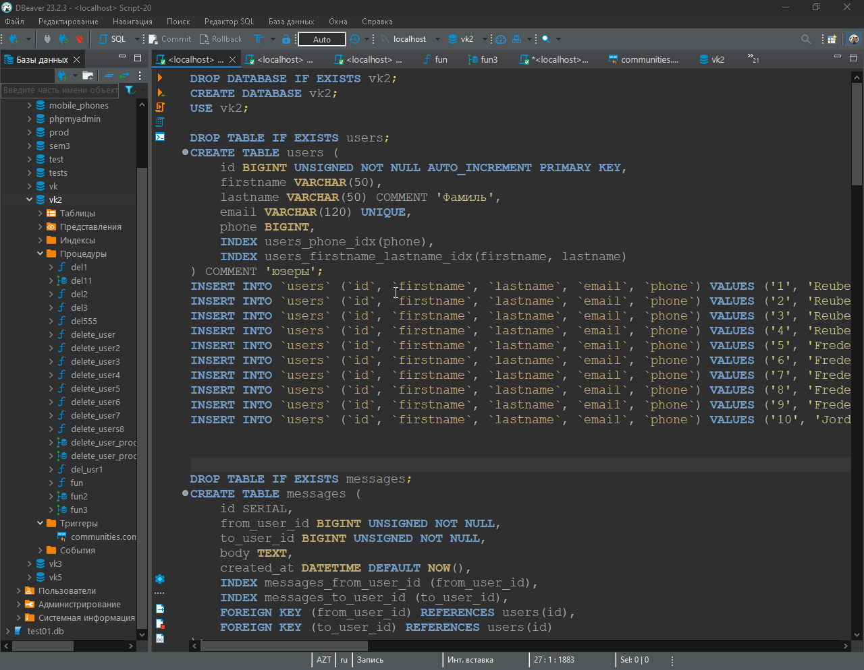

2) создаем функцию

-- DROP FUNCTION IF EXISTS vk2.fun;

-- DELIMITER $$
-- $$

CREATE FUNCTION vk2.fun(user_id_to_delete BIGINT UNSIGNED)
RETURNS BIGINT UNSIGNED MODIFIES SQL DATA
BEGIN
-- Удаление из таблицы friend_requests
DELETE FROM friend_requests WHERE initiator_user_id = user_id_to_delete OR target_user_id = user_id_to_delete;

-- Удаление из таблицы messages
DELETE FROM messages WHERE from_user_id = user_id_to_delete OR to_user_id = user_id_to_delete;

-- Удаление из таблицы likes
DELETE FROM likes WHERE media_id IN (SELECT id FROM media WHERE user_id = user_id_to_delete);

-- Удаление из таблицы media
DELETE FROM media WHERE user_id = user_id_to_delete;

-- Удаление из таблицы profiles
DELETE FROM profiles WHERE user_id = user_id_to_delete;

-- Удаление из таблицы users_communities
DELETE FROM users_communities WHERE user_id = user_id_to_delete;

-- Удаление из таблицы users
DELETE FROM users WHERE id = user_id_to_delete;

-- Возвращение ID удаленного пользователя
RETURN user_id_to_delete;
END -- $$
-- DELIMITER ;

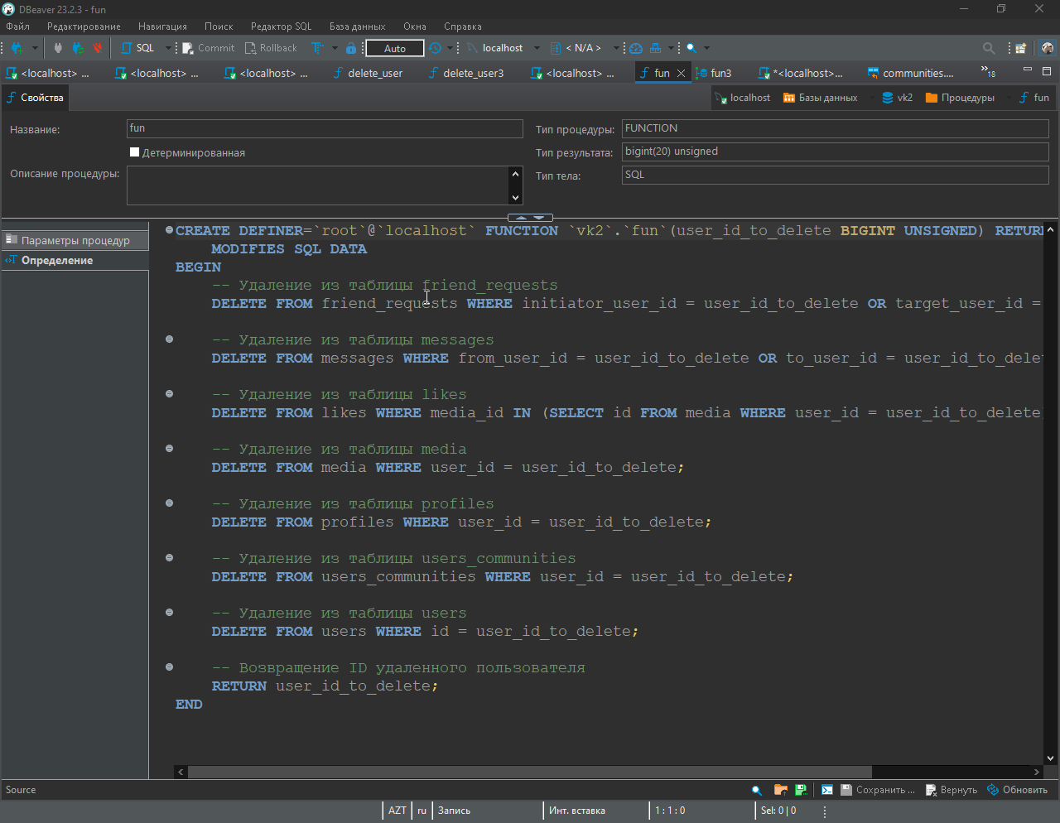

2) Предыдущую задачу решить с помощью процедуры и обернуть используемые команды в
транзакцию внутри процедуры.

-- DROP PROCEDURE IF EXISTS vk2.fun;

-- DELIMITER $$
-- $$

CREATE PROCEDURE vk2.fun3(user_id_to_delete BIGINT UNSIGNED)
BEGIN
DECLARE user_exists INT;

-- Проверка наличия user_id_to_delete в таблице users
SELECT COUNT(*) INTO user_exists FROM users WHERE id = user_id_to_delete;

IF user_exists > 0 THEN
-- Если user_id_to_delete найден, выполняем удаление
START TRANSACTION;

-- Удаление из таблицы friend_requests
DELETE FROM friend_requests WHERE initiator_user_id = user_id_to_delete OR target_user_id = user_id_to_delete;

-- Удаление из таблицы messages
DELETE FROM messages WHERE from_user_id = user_id_to_delete OR to_user_id = user_id_to_delete;

-- Удаление из таблицы likes
DELETE FROM likes WHERE media_id IN (SELECT id FROM media WHERE user_id = user_id_to_delete);

-- Удаление из таблицы media
DELETE FROM media WHERE user_id = user_id_to_delete;

-- Удаление из таблицы profiles
DELETE FROM profiles WHERE user_id = user_id_to_delete;

-- Удаление из таблицы users_communities
DELETE FROM users_communities WHERE user_id = user_id_to_delete;

-- Удаление из таблицы users
DELETE FROM users WHERE id = user_id_to_delete;

COMMIT;

-- Возвращение ID удаленного пользователя
SELECT user_id_to_delete;
ELSE
-- Если user_id_to_delete не найден, выдаем сообщение
SELECT 'ТАКОГО ID НЕТ';
END IF;
END -- $$
-- DELIMITER ;

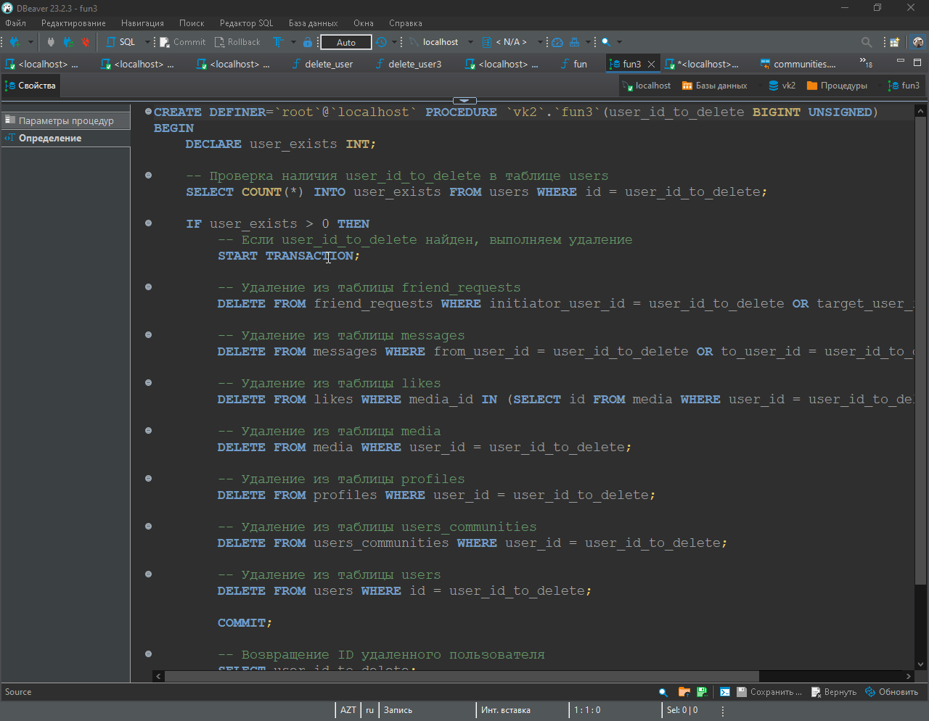

3) * Написать триггер, который проверяет новое появляющееся сообщество.
Длина названия сообщества (поле name) должна быть не менее 5 символов.
Если требование не выполнено, то выбрасывать исключение с пояснением.

use vk2;

DELIMITER //

CREATE TRIGGER community_name_length_trigger
BEFORE INSERT ON communities FOR EACH ROW
BEGIN
IF CHAR_LENGTH(NEW.name) < 5 THEN
SIGNAL SQLSTATE '45000' SET MESSAGE_TEXT = 'Длина названия сообщества должна быть не менее 5 символов';
END IF;
END //

DELIMITER ;

