GIT_ASSIGNMENT

1.Create a directory’project_dir’ & cd ‘project_dir’.

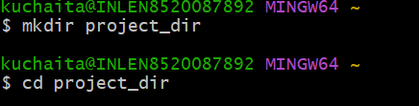

2.Intialize git version database.(git init)

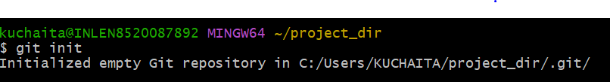

3.Create a new file index.html



4.Check the git status .you should find index.html as untracked file.

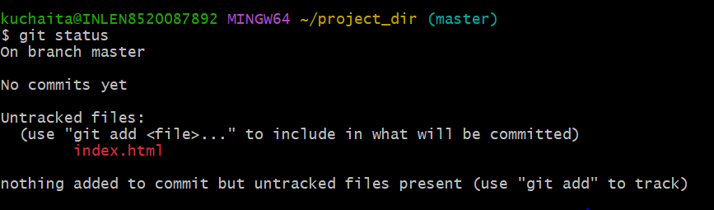

5.Stage the index.html file.



6.commit index.html.

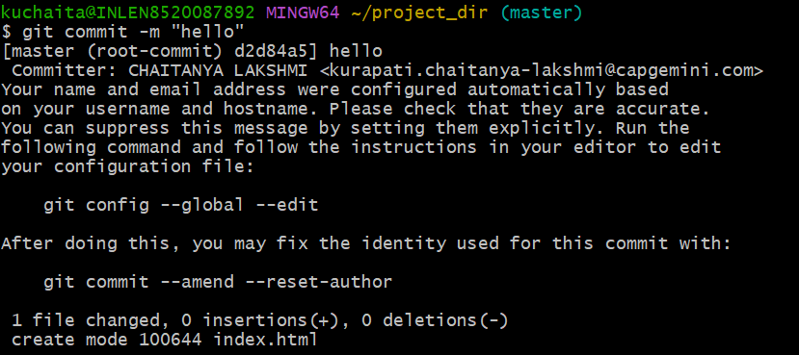

7.Make few changes in index.html & create a new file info.txt file.

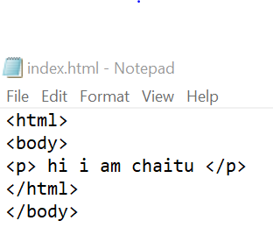

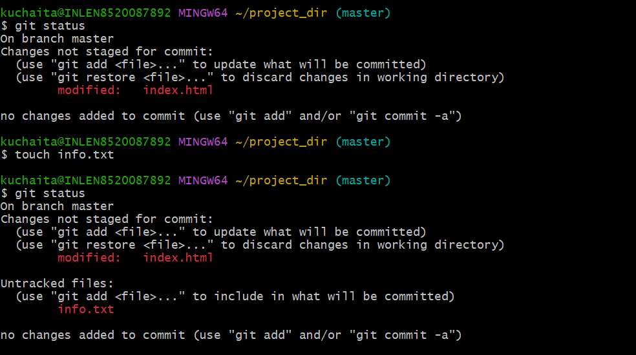

8.Check git status.you should find index.html & info.txt as untracted files.

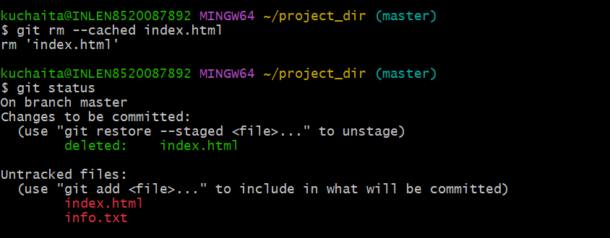

9.Configure GIT to ignore all txt files.

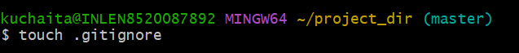

10.Again check the git status.You should find only index.html as untraced file.

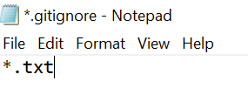

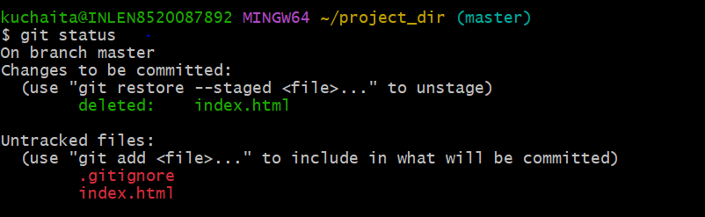

11.State & commit index.html.

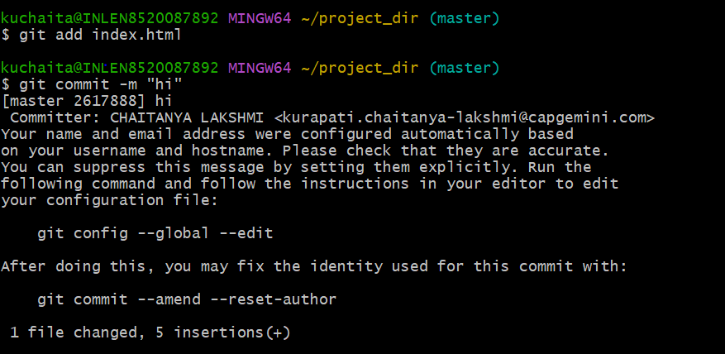

12.Log all your comments so far.

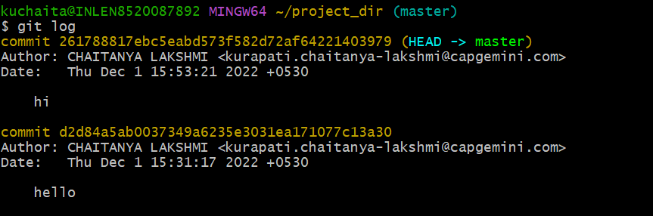

13.Make some changes in index.html.

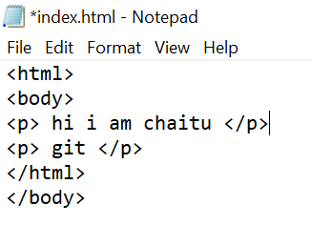

14.Revert the change made in the previsious step using git command.



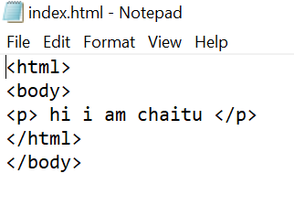

15.Again change index.html.

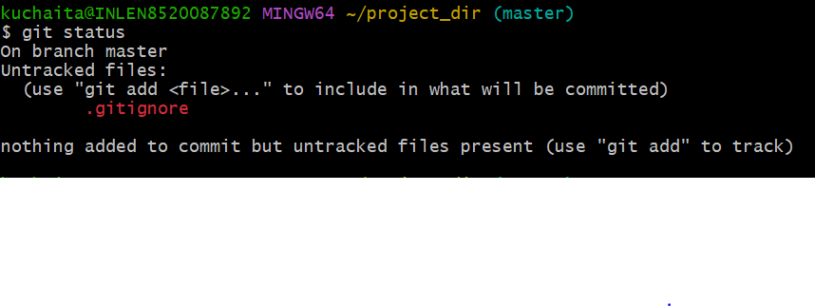16.Stage index.html.

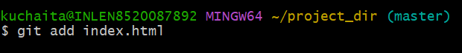

17.Revert back the last stage.

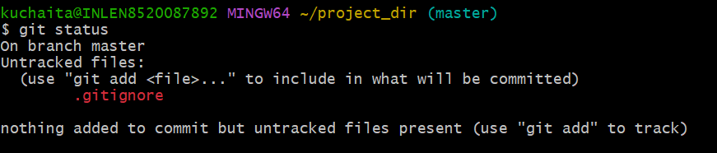

18.Rename ‘add’ command to ‘my-add’.



19.Using my_add command Stage index.html again & commit the charges.

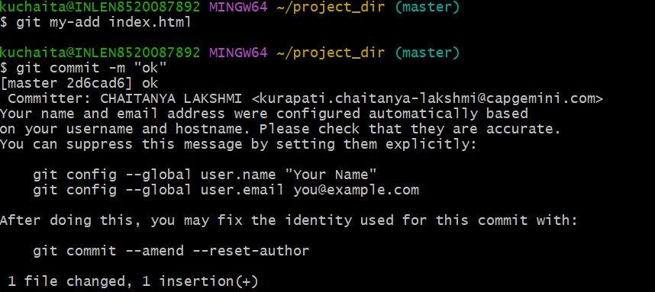

20.Revert the last commit.

