02_CSS_Assignment1

Code snippets:

CSS Style sheet included

**Index.html:**

<!DOCTYPE HTML>

<html>

<head>

<meta charset="UTF-8">

<title>Vertical Navigation Menu</title>

<link href="style.css" rel="stylesheet">

</head>

<body>

<main>

<header>

<h1>Vertical Navigation Menu</h1>

</header>

<nav>

<ul id="mainMenu">

<li><a href="profile Highlights.html">Profile</a></li>

<li><a href="project.html">Project</a></li>

<li><a href="Experience.html">Experince</a></li>

<li><a href="Personal Biography.html">Biography</a></li>

<li><a href="contact.html">Contact Me</a></li>

</ul>

</nav>

</main>

</body>

</html>

style.css:

#mainMenu {

margin:10px;

width:900px;

font-family: sans-serif;

}

#mainMenu li {

display:block;

width:120px;

float:left;

margin-left:2px;

border:1px solid #000;

}

#mainMenu a {

display:block;

padding:3px;

text-decoration:none;

background-color:#fff;

color:#009;

}

#mainMenu a:hover {

background-color:#009;

color:#fff;

}

Output screenshot:

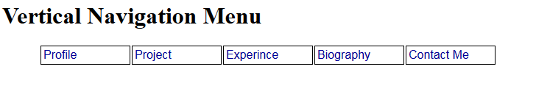

**Contact.html:**

<!DOCTYPE HTML>

<html>

<head>

<meta charset="UTF-8">

<title>Vertical Navigation Menu</title>

<link href="style.css" rel="stylesheet">

</head>

<body>

<form action="/sucess.htmltarget="sucess" method="GET">

First name:<br>

<input type="text" name="visitors name" required="required"><br>

Mobile:<br>

<input type="text" name="mobile" required="required" ><br>

Mail Id:<br>

<input type="text" name="Mail Id" required="required" ><br>

Remarks:<br>

<input type="text" name="Remarks" required="required" ><br><br>

<input type="submit" value="Submit">

</form>

</body>

</html>

o/p:

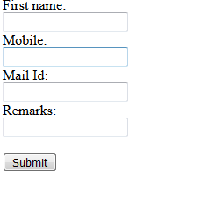

Validation screenshot:

