**Data base creation script:-**

**mysql> CREATE DATABASE DEMOABC;**

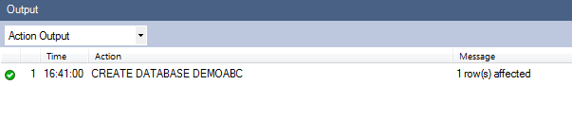

**Scipt for Table creation for Book :**

CREATE TABLE `demoabc`.`Book` (

`bookId` INT NOT NULL ,

`title` VARCHAR(45) NULL ,

`price` DOUBLE NULL ,

`volume` INT NULL ,

`publishDate` DATETIME NULL ,

PRIMARY KEY (`bookId`) );

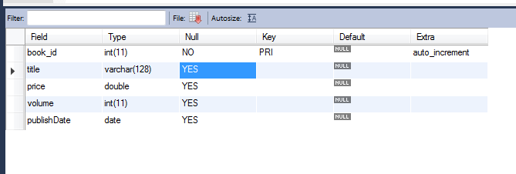

**Scipt for table creation for Subject:-**

CREATE TABLE `demoabc`.`Subject` (

`subjectId` INT NOT NULL ,

`subtitle` VARCHAR(45) NULL ,

`durationInHours` INT NULL ,

`book_ref_id` INT NULL ,

PRIMARY KEY (`subjectId`) ,

INDEX `book_ref_id_idx` (`book_ref_id` ASC) ,

CONSTRAINT `book_ref_id`

FOREIGN KEY (`book_ref_id` )

REFERENCES `demoabc`.`book` (`bookId` )

ON DELETE CASCADE

ON UPDATE CASCADE);

**Insert query for Book:**

INSERT INTO `demoabc`.`book` (`bookId`, `title`, `price`, `volume`, `publishDate`) VALUES ('101', 'Physics1', '120', '5', '2038-01-19');

INSERT INTO `demoabc`.`book` (`bookId`, `title`, `price`, `volume`, `publishDate`) VALUES ('102', 'Physics1', '125', '4', '2038-01-20');

**Insert query for Subject:**

INSERT INTO `demoabc`.`subject` (`subjectId`, `subtitle`, `durationInHours`, `book_ref_id`) VALUES ('201', 'Accelatarion', '40', '101');

**Update script for Book and Subject:**

UPDATE `demoabc`.`book` SET `price`='150' WHERE `bookId`='102';

UPDATE `demoabc`.`subject` SET `durationInHours`='14' WHERE `subjectId`='201';

Delete script for book and subject:

DELETE FROM `book` WHERE `bookId` = 102;

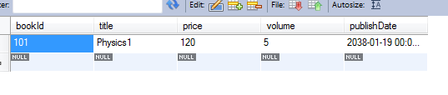

DELETE FROM `subject` WHERE `subjectId` = 201;

