Write a query to retrieve the book and its

subject details using inner join

SELECT

b1.bookId,

b1.title,

b1.price,

b1.volume,

s2.subtitle

FROM

book b1

INNER JOIN

subject s2 ON b1.bookId = s2.book_ref_id;

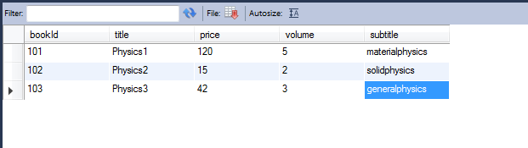

Write a query to retrieve the books list published in a given specific date

interval

SELECT

b1.bookId,

b1.title,

b1.price,

b1.volume

FROM

book b1 where b1.publishDate between '2011-01-19 00:00:00' and '2014-01-19 00:00:00';

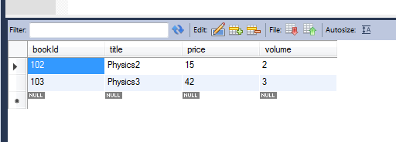

Write a query to retrieve the number of books referred by each subject

where the subject tite starts with a specific character (say ‘j’ f

or instance).

SELECT

count(*)

FROM

book b1,subject s2

where b1.bookId = s2.book_ref_id and b1.title like 'p%';

