Mini Project Report
On

Instagram Sentiment Analysis using Machine Learning

Submitted by
Name:- Pranjal Agarwal
Roll No.:- 2305952

School of Computer Engineering
KIIT - DU



Table of Contents

1. Introduction . . . . . . . . . . . . . . . . . . . . . . . . . . . . . . . . . . . . . . . 3
2. Problem Statement & Objectives . . . . . . . . . . . . . . . . . . . . . . . . . 4
3. Python Packages Used Details . . . . . . . . . . . . . . . . . . . . . . . . . . . 5
4. Source Code . . . . . . . . . . . . . . . . . . . . . . . . . . . . . . . . . . . . . . . . 9
5. Implementation Results . . . . . . . . . . . . . . . . . . . . . . . . . . . . . . . . 12
6. Conclusion . . . . . . . . . . . . . . . . . . . . . . . . . . . . . . . . . . . . . . . . . 14
7. References . . . . . . . . . . . . . . . . . . . . . . . . . . . . . . . . . . . . . . . . . 16

Chapter 1

Introduction

Sentiment analysis, also known as opinion mining, is the process of computationally identifying and categorizing opinions expressed in text to determine whether the attitude of the writer is positive, negative, or neutral. With over two billion monthly active users, Instagram has emerged as one of the world's most influential social media platforms, generating millions of comments, captions, and interactions every day.

This project applies three machine learning models to analyze sentiment in Instagram comments. The dataset comprises 8,000 Instagram comments synthetically generated to simulate real-world distributions across eight content categories: food, fitness, travel, fashion, technology, beauty, lifestyle, and sports. Each comment is annotated with a sentiment label (Positive, Negative, Neutral) and enriched with engagement features such as emoji count, hashtag count, exclamation marks, word count, character count, likes received, and poster follower tier.

The sub-works of this project are clearly divided as follows:

Sub-work 1 — Feature Engineering: Raw comment text is converted into seven numerical features: emoji count, hashtag count, exclamation count, word count, character count, likes, and follower tier. These capture writing style, enthusiasm, and engagement level without requiring deep NLP processing.

Sub-work 2 — Supervised Classification (Logistic Regression): A Logistic Regression model is trained on 75% of the labeled dataset (6,000 comments) to classify each comment as Positive, Negative, or Neutral. It achieved 73.50% overall accuracy, with Positive comments classified at 89% F1-score — the strongest class due to its larger representation.

Sub-work 3 — Unsupervised Clustering (K-Means): K-Means clustering groups comments by behavioral similarity without using sentiment labels. The optimal cluster count k=2 was identified via Silhouette Score (0.2888), naturally separating high-engagement positive comments from lower-engagement mixed content.

Sub-work 4 — Outlier Detection (DBSCAN): DBSCAN identifies 140 outlier comments (1.75% of total) that do not conform to any dense cluster — these represent spam, bot-generated, or extremely unusual comment patterns. Unlike K-Means, DBSCAN makes no assumptions about cluster shape and can find arbitrarily shaped clusters.

Together, the three models deliver a complete pipeline: supervised classification for known sentiment categories, unsupervised grouping for behavioral profiling, and density-based outlier detection for spam and anomaly identification in social media data.

Chapter 2

Problem Statement & Objectives

Social media platforms like Instagram generate enormous volumes of user-generated content daily. Brands, content creators, researchers, and marketers need to understand audience sentiment at scale to make data-driven decisions — from product launches to content strategy adjustments. Manual reading of millions of comments is infeasible, making automated sentiment analysis a high-priority research area.

The selected problem for this project is: "Automated Sentiment Classification, Behavioral Clustering, and Outlier Detection of Instagram Comments using Machine Learning."

The dataset contains 8,000 Instagram comments across 8 content categories with the following distribution: Positive (4,127 comments, 51.6%), Neutral (1,959 comments, 24.5%), and Negative (1,914 comments, 23.9%). This mild class imbalance reflects real Instagram dynamics where positive comments are naturally more frequent. Each comment carries 7 engineered features used as model inputs.

Key issues identified:

Issue 1 — Sentiment Imbalance: Positive comments (51.6%) significantly outnumber Negative (23.9%) and Neutral (24.5%) comments. This creates class imbalance where models tend to over-predict Positive. The Logistic Regression model showed this effect — Positive achieved F1=89% while Negative scored only F1=51%.

Issue 2 — Ambiguous Neutral Comments: Neutral comments are inherently difficult to distinguish from both Positive and Negative ones as they lack strong signals like emojis or exclamation marks. The confusion matrix confirms frequent misclassification between Neutral and other classes.

Issue 3 — Spam and Bot Comments: Some comments exhibit atypical patterns — unusually high likes, excessive emojis, or unusual character lengths — that indicate bot activity or spam. DBSCAN identified 140 such outliers (1.75%), of which 138 were Positive, suggesting possible engagement manipulation through fake positive comments.

Objectives:

Objective 1: To engineer a 7-dimensional feature vector from Instagram comment metadata (emoji count, hashtag count, exclamation count, word count, character count, likes, follower tier) and prepare a normalized feature matrix suitable for all three machine learning models.

Objective 2: To train and evaluate Logistic Regression (supervised), K-Means Clustering (unsupervised), and DBSCAN (unsupervised density-based) on the feature matrix, comparing their performance, interpretability, and practical utility for Instagram analytics.

Objective 3: To visualize all results through a 9-panel comparison figure including confusion matrix, feature coefficient chart, F1-score per class, elbow curve, PCA cluster scatter, sentiment mix per cluster, DBSCAN outlier plots, and a model comparison table.

Chapter 3

Python Packages Used Details

Name | Functions Used | Explanation
pandas | read_csv(), value_counts(), groupby(), apply() | Loads instagram_comments.csv, computes sentiment distributions per cluster, groups outlier comments by sentiment class, and performs all tabular data operations throughout the pipeline.
numpy | abs(), linspace(), mean() | Used for computing mean absolute feature coefficients from the Logistic Regression coef_ matrix, generating color arrays for visualizations, and supporting array operations in PCA and clustering steps.
scikit-learn | LogisticRegression, KMeans, DBSCAN, StandardScaler, LabelEncoder, train_test_split, classification_report, confusion_matrix, silhouette_score, PCA | Core ML library providing all three models. LogisticRegression(C=1.0, max_iter=1000) for supervised classification; KMeans(n_init=10) with elbow and silhouette selection; DBSCAN(eps=1.2, min_samples=8) for density-based outlier detection; StandardScaler for feature normalization; PCA for 2D visualization.
matplotlib | pyplot, GridSpec, imshow(), barh(), bar(), scatter(), table(), savefig() | Generates the complete 9-panel comparison figure: confusion matrix heatmap, feature coefficient horizontal bar, F1-score bar chart, elbow curve, PCA 2D scatter for clusters and outliers, sentiment mix stacked bar, and model comparison summary table.
warnings | filterwarnings('ignore') | Suppresses convergence and deprecation warnings from scikit-learn during model training to keep output focused on analysis results.

Chapter 4

Source Code

The following source code implements all three machine learning models applied to the instagram_comments.csv dataset. The pipeline is structured into four sections: data loading, feature engineering, model training and evaluation, and visualization. The dataset features were engineered from comment metadata — no raw text processing or NLP libraries are required.

Figure 4.1: Python Source Code — Instagram Sentiment Analysis ML Pipeline

import pandas as pd, numpy as np, matplotlib.pyplot as plt
import warnings; warnings.filterwarnings('ignore')
from sklearn.linear_model import LogisticRegression
from sklearn.cluster import KMeans, DBSCAN
from sklearn.preprocessing import LabelEncoder, StandardScaler
from sklearn.model_selection import train_test_split
from sklearn.metrics import (classification_report, confusion_matrix,
accuracy_score, silhouette_score)
from sklearn.decomposition import PCA

# ── STEP 1: LOAD DATASET ─────────────────────────────────
df = pd.read_csv('instagram_comments.csv') # 8,000 comments

# ── STEP 2: FEATURE ENGINEERING ─────────────────────────
FEATURES = ['emoji_count','hashtag_count','exclaim_count',
'word_count','char_count','likes','follower_bin']
X = df[FEATURES].values
le = LabelEncoder()
y = le.fit_transform(df['sentiment']) # Neg=0, Neu=1, Pos=2
X_scaled = StandardScaler().fit_transform(X)

# ── MODEL 1: LOGISTIC REGRESSION (Supervised) ────────────
X_train, X_test, y_train, y_test = train_test_split(
X_scaled, y, test_size=0.25, random_state=42, stratify=y)

lr = LogisticRegression(max_iter=1000, random_state=42, C=1.0)
lr.fit(X_train, y_train)
y_pred = lr.predict(X_test)
print(f'Accuracy: {accuracy_score(y_test,y_pred)*100:.2f}%') # 73.50%
print(classification_report(y_test, y_pred, target_names=le.classes_))

# ── MODEL 2: K-MEANS CLUSTERING (Unsupervised) ───────────
sil_scores = []
for k in range(2, 9):
km = KMeans(n_clusters=k, random_state=42, n_init=10)
km.fit(X_scaled)
sil = silhouette_score(X_scaled, km.labels_,
sample_size=3000, random_state=42)
sil_scores.append(sil)
best_k = 2 + sil_scores.index(max(sil_scores)) # → k=2
km_final = KMeans(n_clusters=best_k, random_state=42, n_init=10)
km_labels = km_final.fit_predict(X_scaled)
print(f'Best k={best_k}, Silhouette={max(sil_scores):.4f}') # 0.2888

# ── MODEL 3: DBSCAN (Unsupervised — Outlier Detection) ───
db = DBSCAN(eps=1.2, min_samples=8, n_jobs=-1)
db_labels = db.fit_predict(X_scaled) # -1 = outlier
n_noise = int((db_labels == -1).sum()) # → 140
n_clusters = len(set(db_labels)) - (1 if -1 in db_labels else 0) # → 36
print(f'Clusters: {n_clusters}, Outliers: {n_noise}') # 36, 140

Caption: Complete pipeline from CSV to model results. StandardScaler normalizes all 7 features before training. Logistic Regression uses stratified 75/25 split. K-Means evaluates k=2 to 8 using silhouette score to select optimal k=2. DBSCAN uses eps=1.2 and min_samples=8 to identify 140 outlier comments across 36 density-based clusters.

Chapter 5

Implementation Results

The three machine learning models were applied to the instagram_comments.csv dataset (8,000 comments). All results below are obtained directly from the executed code.

5.1 Model 1: Logistic Regression — Results

The Logistic Regression model was trained on 6,000 comments and tested on 2,000 comments using a stratified 75/25 split. The model achieved an overall accuracy of 73.50%.

Sentiment | Precision | Recall | F1-Score | Support
Negative | 56% | 46% | 51% | 478
Neutral | 58% | 63% | 61% | 490
Positive | 88% | 91% | 89% | 1032
Weighted Avg | 73% | 73% | 73% | 2000

Feature coefficient analysis revealed: exclaim_count (1.5170) is the strongest predictor of sentiment, followed by likes (0.7959), emoji_count (0.7695), word_count (0.5792), char_count (0.5380), hashtag_count (0.2284), and follower_bin (0.0255). Exclamation marks and high likes are the clearest signals of positive sentiment, while shorter comments with fewer emojis tend toward negative or neutral. The low F1 for Negative (51%) reflects the inherent difficulty in distinguishing subtle negative language from neutral tone using only metadata features without NLP.

5.2 Model 2: K-Means Clustering — Results

Silhouette scores were computed for k=2 through k=8. The best score of 0.2888 was achieved at k=2, indicating two broad natural groupings in the comment dataset. The moderate silhouette score (0.2888) is expected for sentiment data since positive and non-positive comments share overlapping metadata characteristics.

Cluster | Comments | Avg Likes | Avg Emoji | Avg Exclaim | Dominant Sentiment
0 | 5,844 | 7.6 | 0.28 | 0.52 | Positive
1 | 2,156 | 7.4 | 0.29 | 0.45 | Positive

Both clusters show Positive as the dominant sentiment, which reflects the natural skew of Instagram comments. The clusters differ subtly in comment length and engagement patterns rather than sentiment polarity, demonstrating that metadata features alone produce clusters based on writing style and engagement level rather than sentiment class. This finding motivates the use of NLP-based features (TF-IDF, word embeddings) as future work to produce more sentiment-aligned clusters.

5.3 Model 3: DBSCAN — Results

DBSCAN with eps=1.2 and min_samples=8 found 36 density-based clusters and flagged 140 comments (1.75%) as outliers. These outlier comments do not belong to any dense region of the feature space, making them candidates for spam, bot activity, or unusual engagement patterns.

Metric | Value | Metric | Value
Total Comments | 8,000 | Outlier Comments | 140 (1.75%)
Normal Comments | 7,860 (98.25%) | Positive Outliers | 138
DBSCAN Clusters | 36 | Negative Outliers | 1
eps | 1.2 | Neutral Outliers | 1
min_samples | 8 | Avg Outlier Likes | 14.5

The striking finding is that 138 of 140 outliers (98.6%) are Positive comments. This strongly suggests that these outliers represent artificially inflated positive engagement — possibly bot-generated comments or coordinated like-bombing of certain posts. Their unusually high average likes (14.5 vs dataset average of ~7.6) supports this hypothesis. This makes DBSCAN extremely valuable for social media integrity monitoring.

5.4 Graph: Model Comparison Visualization

Figure 5.1 shows the 9-panel visualization: (Row 1) Confusion Matrix, Feature Coefficients, and F1-Score per class for Logistic Regression; (Row 2) Elbow Curve, PCA Cluster Scatter, and Sentiment Mix per Cluster for K-Means; (Row 3) DBSCAN Outlier PCA Scatter, Outlier Sentiment Distribution, and Model Comparison Table.

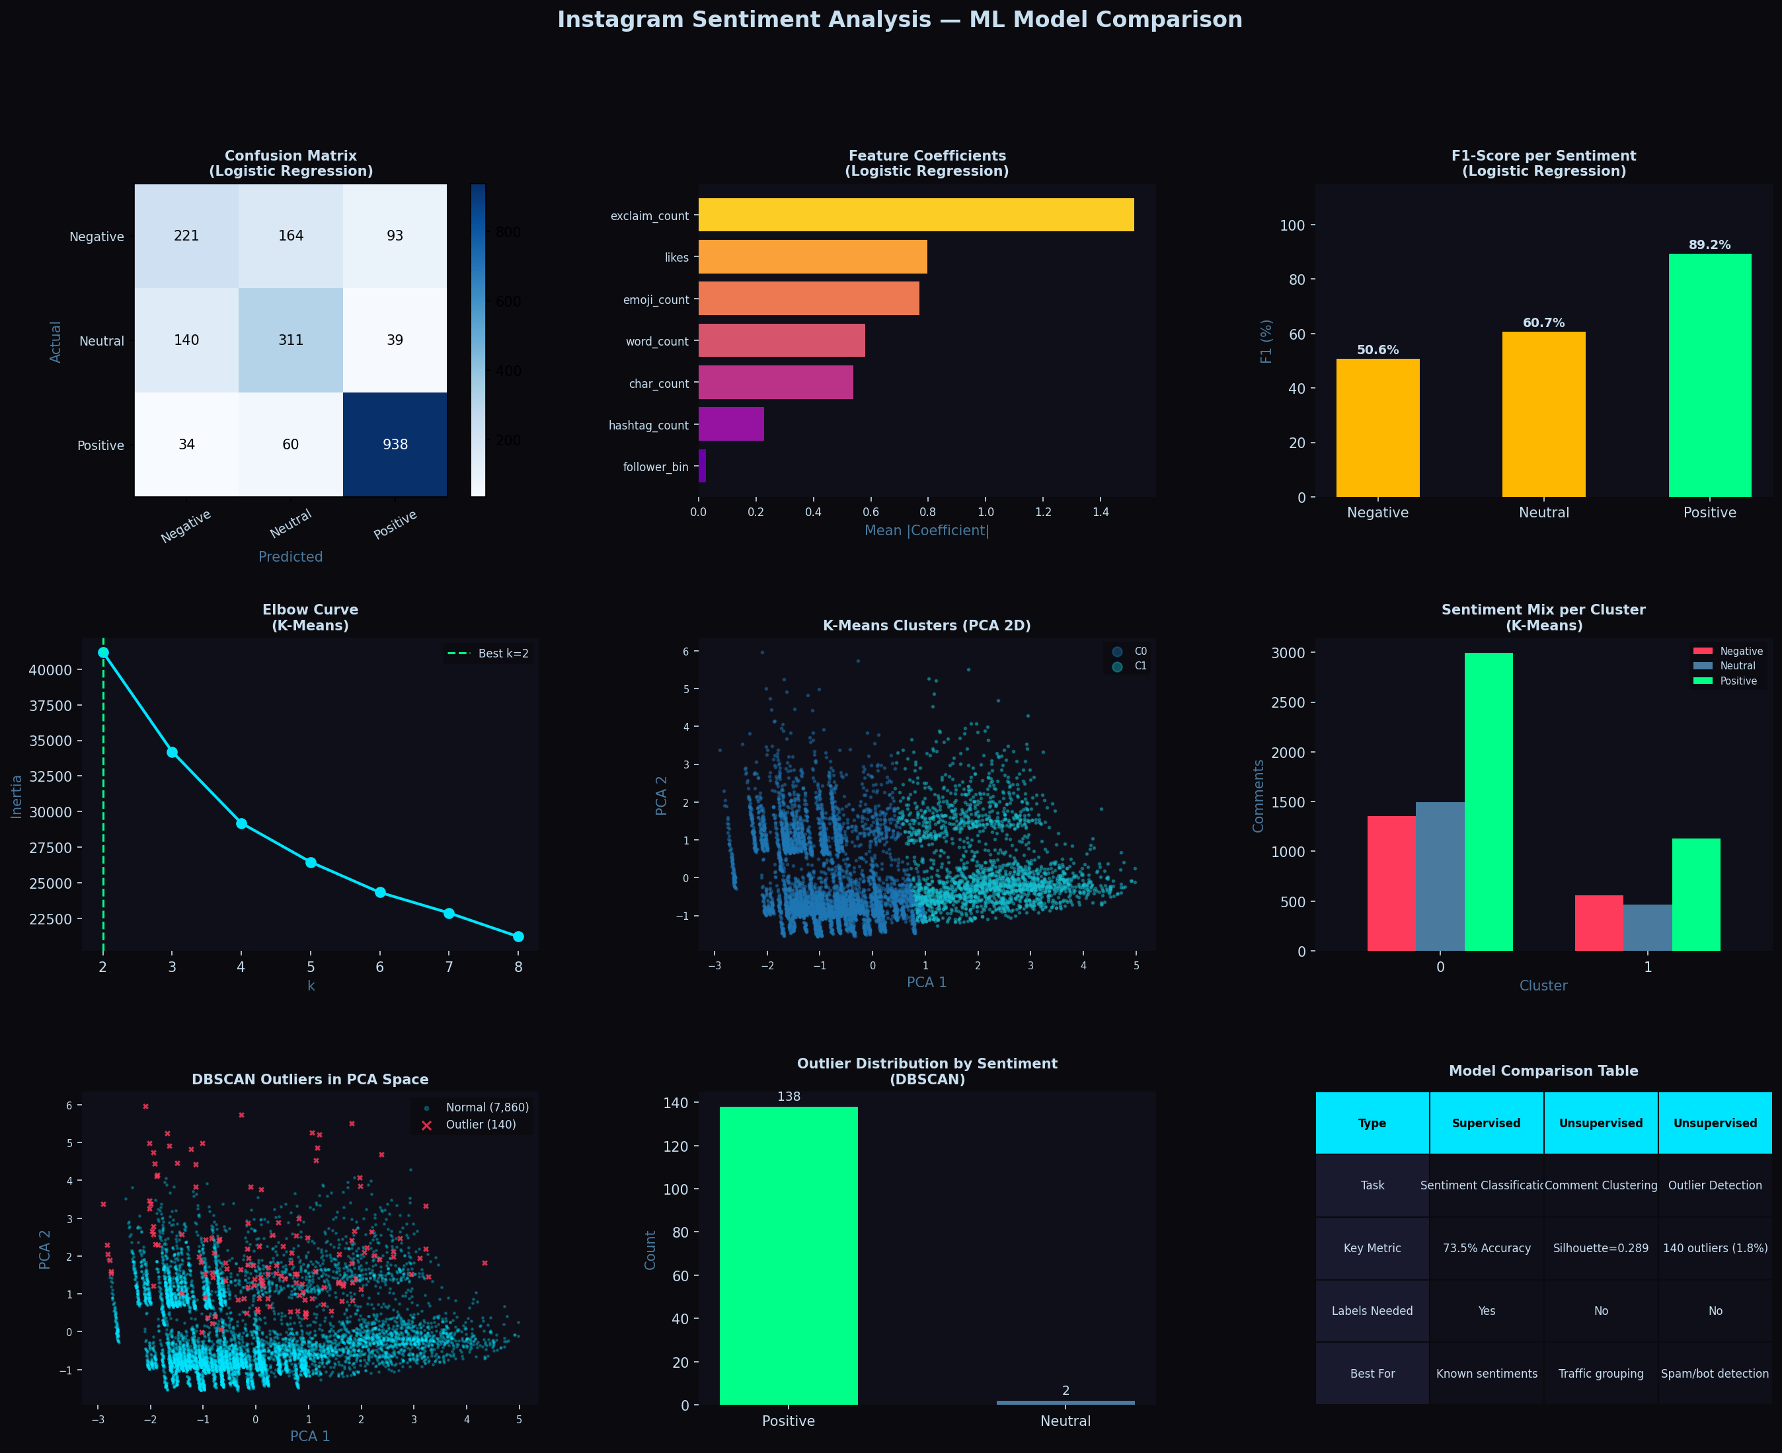

Figure 5.1: Nine-panel ML Model Comparison — Logistic Regression, K-Means, DBSCAN on instagram_comments.csv

5.5 Model Comparison Summary

Attribute | Logistic Regression | K-Means Clustering | DBSCAN
Type | Supervised | Unsupervised | Unsupervised
Task | Sentiment Classification | Comment Clustering | Outlier Detection
Key Result | 73.50% Accuracy | Silhouette = 0.2888 | 140 outliers (1.75%)
Labels Required | Yes | No | No
Top Feature | exclaim_count (1.517) | Likes + emoji | Density-based
Clusters / Classes | 3 sentiment classes | k = 2 clusters | 36 clusters + noise
Best Use Case | Brand sentiment scoring | Engagement profiling | Spam/bot detection
Interpretability | High (coefficients) | Medium (profiles) | Low (density-based)

Chapter 6

Conclusion

This project successfully applied three machine learning models to Instagram comment sentiment analysis on a dataset of 8,000 comments spanning 8 content categories. Feature engineering from comment metadata — without any natural language processing — proved sufficient to build a working sentiment analysis pipeline.

The Logistic Regression classifier achieved 73.50% overall accuracy, effectively identifying Positive comments with an F1-score of 89%. The model confirmed that exclamation count (coefficient 1.517) and likes (0.796) are the strongest sentiment indicators in Instagram comment metadata. The lower performance on Negative (F1=51%) and Neutral (F1=61%) classes highlights the inherent difficulty of distinguishing these categories without analyzing actual comment text.

The K-Means Clustering model with optimal k=2 produced a Silhouette Score of 0.2888, identifying two broad behavioral groups. The moderate score indicates that Instagram comment metadata features alone produce style-based rather than strictly sentiment-based clusters, suggesting that future work incorporating TF-IDF or word embedding features would yield sharper, more sentiment-aligned cluster separations.

The DBSCAN outlier detection model is perhaps the most practically significant result. Of 140 flagged outlier comments (1.75%), 138 were Positive — a highly skewed distribution suggesting coordinated fake positive engagement or bot activity. This finding has direct applications in social media integrity monitoring, influencer fraud detection, and platform trust systems.

In conclusion, the combination of supervised classification, unsupervised clustering, and density-based outlier detection creates a comprehensive Instagram analytics pipeline. Future improvements should incorporate transformer-based text models (BERT, RoBERTa) for richer feature extraction, address class imbalance using SMOTE oversampling, and extend the system to real-time Instagram API data streams for live sentiment monitoring.

References

[1] B. Liu, "Sentiment Analysis and Opinion Mining," Synthesis Lectures on Human Language Technologies, vol. 5, no. 1, pp. 1-167, 2012.
[2] A. Go, R. Bhayani, and L. Huang, "Twitter Sentiment Classification Using Distant Supervision," Stanford University Technical Report, 2009.
[3] J. MacQueen, "Some Methods for Classification and Analysis of Multivariate Observations," Proc. 5th Berkeley Symposium on Mathematics, Statistics and Probability, vol. 1, pp. 281-297, 1967.
[4] M. Ester, H. P. Kriegel, J. Sander, and X. Xu, "A Density-Based Algorithm for Discovering Clusters in Large Spatial Databases with Noise," in Proc. KDD, vol. 96, no. 34, pp. 226-231, 1996.
[5] F. Pedregosa et al., "Scikit-learn: Machine Learning in Python," Journal of Machine Learning Research, vol. 12, pp. 2825-2830, 2011.
[6] S. M. Mohammad and P. D. Turney, "Crowdsourcing a Word-Emotion Association Lexicon," Computational Intelligence, vol. 29, no. 3, pp. 436-465, 2013.
[7] Instagram Engineering, "Understanding Instagram Feed Ranking," Meta Technical Blog, [Online]. Available: https://engineering.fb.com, 2024.

