# DAC_PHASE4

# Project Title: Public Health Awareness Campaign Analysis

## Introduction

In this, we are building upon our analysis efforts by utilizing IBM Cognos for data visualization and integrating code, potentially in Python, for advanced data analysis. Our primary objective remains the assessment of the public health awareness campaign's effectiveness and impact. We will design interactive dashboards and reports in IBM Cognos to visually represent campaign reach, awareness levels, and impact metrics, offering valuable insights for stakeholders. Furthermore, we will use code to perform in-depth analysis, including calculating engagement rates, conducting demographic analysis, and running statistical tests, enabling us to provide comprehensive findings that can inform decisions and contribute to the betterment of our communities.

## Import necessary libraries

import pandas as pd import numpy as np import seaborn as sns

import matplotlib.pyplot as plt print('Successfully imported')

This dataset contains the following data:

* Timestamp
* Age
* Gender
* Country
* state: If you live in the United States, which state or territory do you live in?
* self_employed: Are you self-employed?
* family_history: Do you have a family history of mental illness?
* treatment: Have you sought treatment for a mental health condition?
* work_interfere: If you have a mental health condition, do you feel that it interferes with your work?
* no_employees: How many employees does your company or organization have?
* remote_work: Do you work remotely (outside of an office) at least 50% of the time?
* tech_company: Is your employer primarily a tech company/organization?
* benefits: Does your employer provide mental health benefits?
* care_options: Do you know the options for mental health care your employer provides?
* wellness_program: Has your employer ever discussed mental health as part of an employee wellness program?
* seek_help: Does your employer provide resources to learn more about mental health issues and how to seek help?
* anonymity: Is your anonymity protected if you choose to take advantage of mental health or substance abuse treatment resources?
* leave: How easy is it for you to take medical leave for a mental health condition?
* mental_health_consequence: Do you think that discussing a mental health issue with your employer would have negative consequences?
* phys_health_consequence: Do you think that discussing a physical health issue with your employer would have negative consequences?
* coworkers: Would you be willing to discuss a mental health issue with your coworkers?
* supervisor: Would you be willing to discuss a mental health issue with your direct supervisor(s)?
* mental_health_interview: Would you bring up a mental health issue with a potential employer in an interview?
* phys_health_interview: Would you bring up a physical health issue with a potential employer in an interview?
* mental_vs_physical: Do you feel that your employer takes mental health as seriously as physical health?
* obs_consequence: Have you heard of or observed negative consequences for coworkers with mental health conditions in your workplace?
* comments: Any additional notes or comments

## Program

import pandas as pd

import seaborn as sns

import matplotlib.pyplot as plt

from sklearn.impute import SimpleImputer

# Load your dataset (replace 'your_dataset.csv' with your actual dataset file)

data = pd.read_csv('survey.csv')

# Check for missing data

if data.isnull().sum().sum() == 0:

print('There is no missing data in our dataset')

else:

print('There is {} missing data in our dataset'.format(data.isnull().sum().sum()))

# Drop unnecessary columns

data = data.drop(columns=['state', 'comments', 'Timestamp'])

# Fill in missing values in 'work_interfere' and 'self_employed' columns

data['work_interfere'] = SimpleImputer(strategy='most_frequent').fit_transform(data['work_interfere'].values.reshape(-1, 1))

data['self_employed'] = SimpleImputer(strategy='most_frequent').fit_transform(data['self_employed'].values.reshape(-1, 1))

# Visualization using Seaborn

sns.set(style="whitegrid")

# Age distribution

plt.figure(figsize=(10, 5))

sns.histplot(data['Age'], bins=20, kde=True)

plt.title('Age Distribution')

plt.xlabel('Age')

plt.ylabel('Count')

plt.show()

# Gender distribution

plt.figure(figsize=(8, 6))

sns.countplot(data=data, x='Gender')

plt.title('Gender Distribution')

plt.xticks(rotation=45)

plt.xlabel('Gender')

plt.ylabel('Count')

plt.show()

## Output

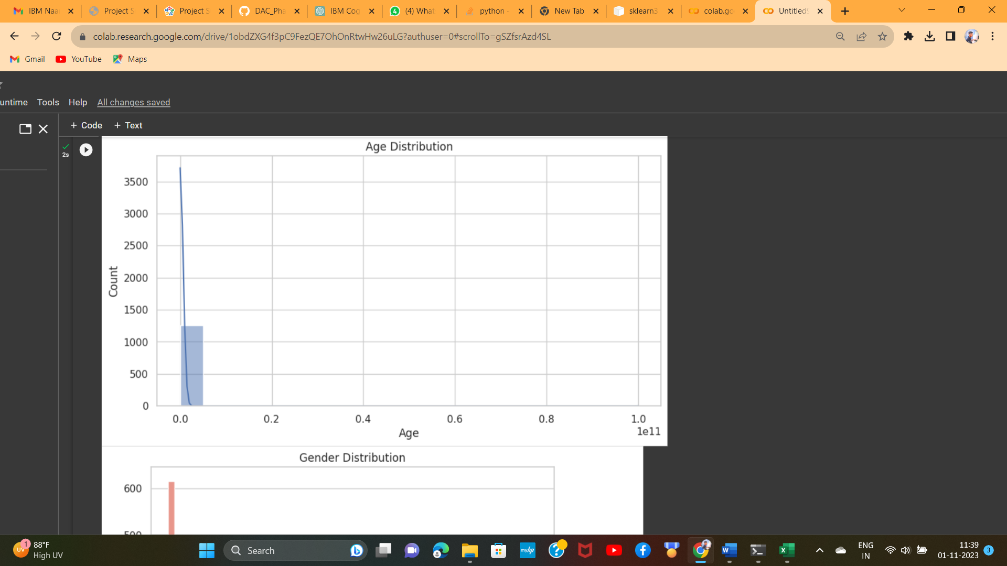

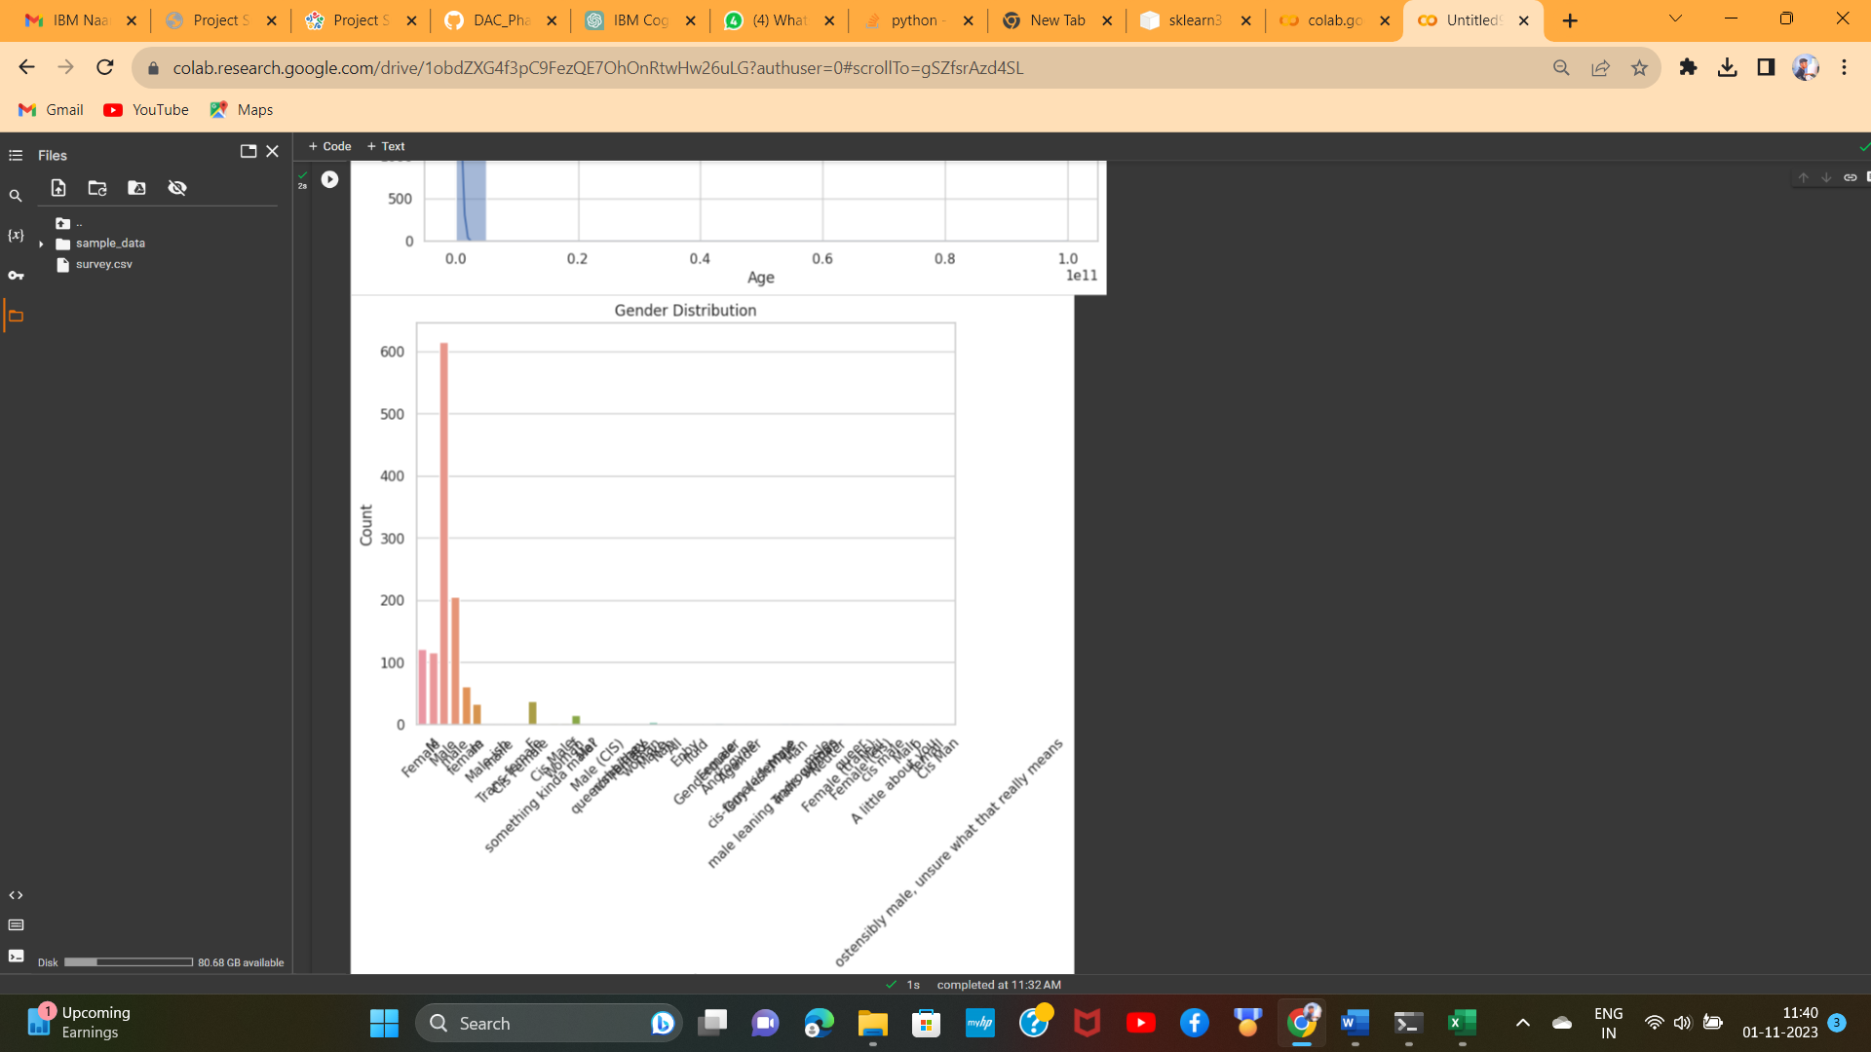

## Dashboard and Report in IBM COGNOS

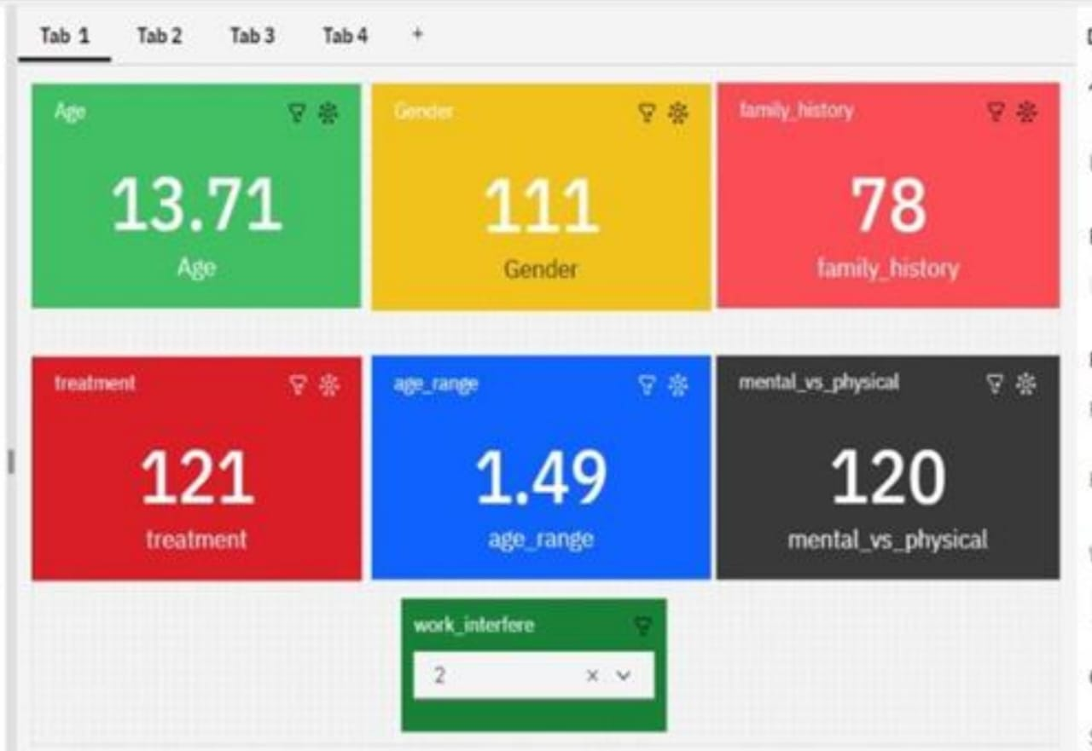

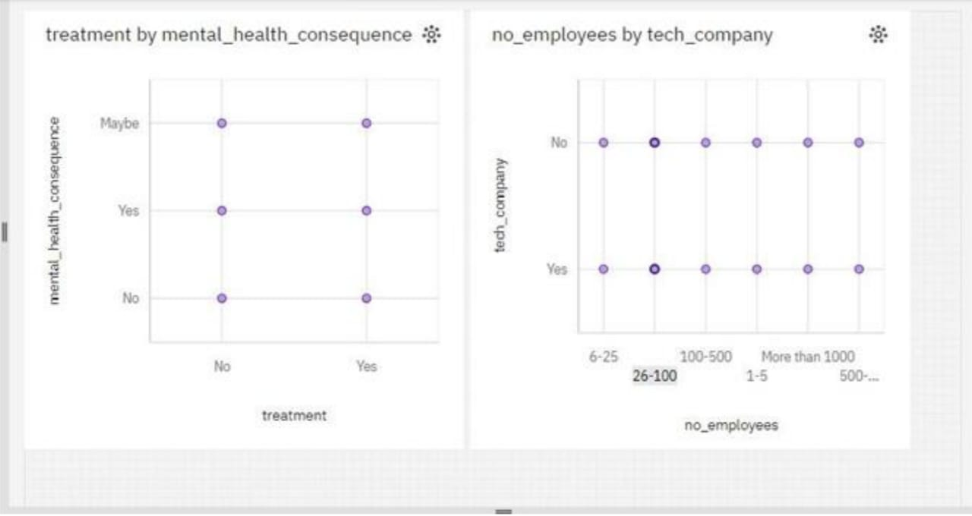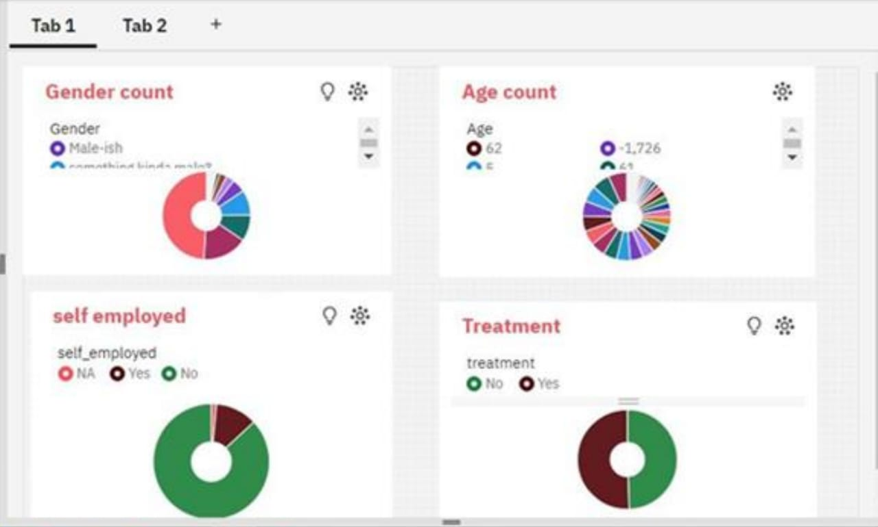

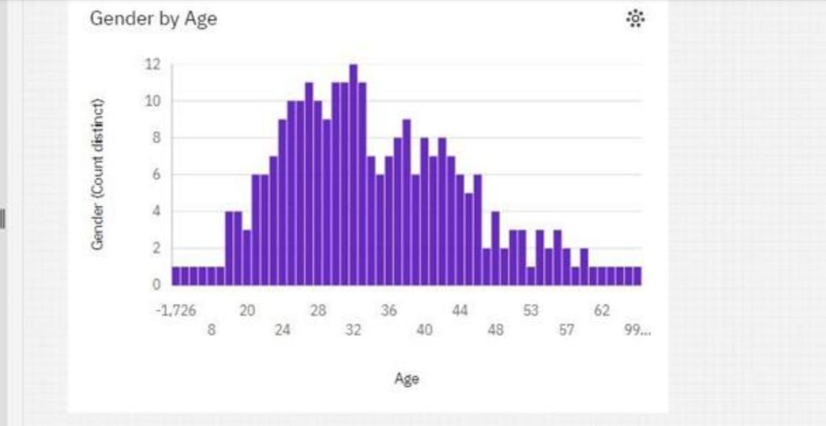

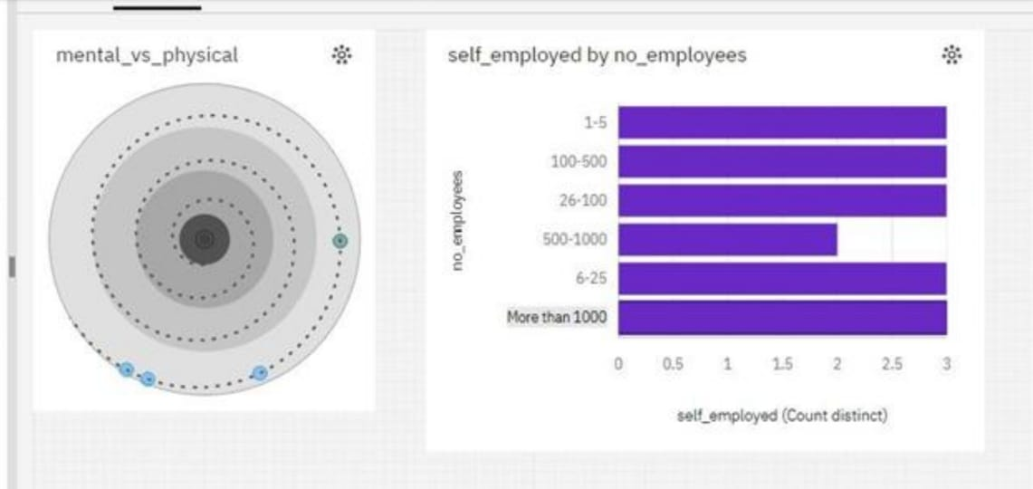

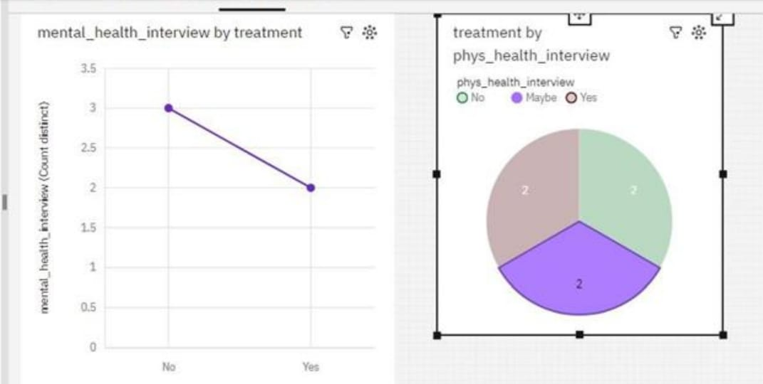

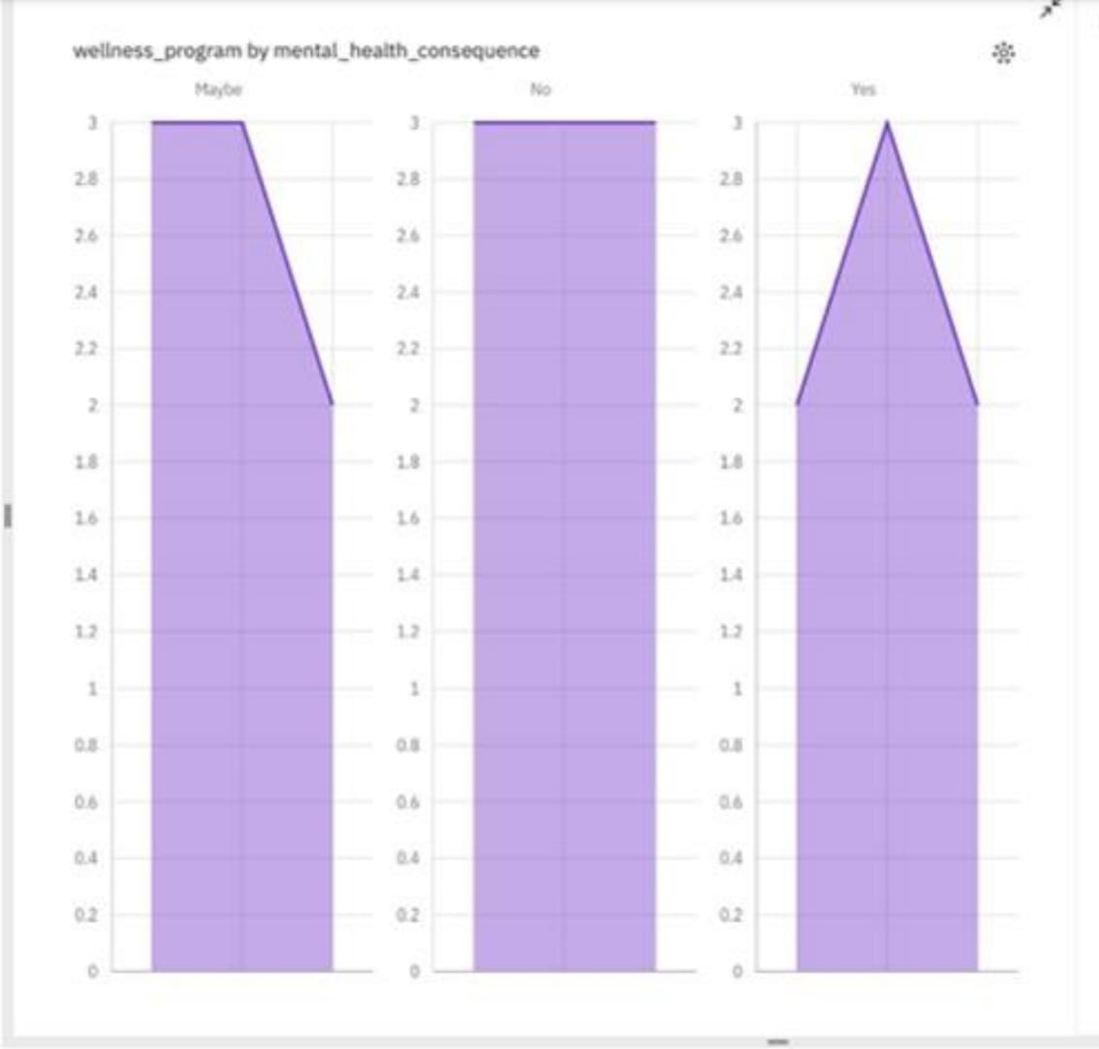

## CAMPAIGN REACH

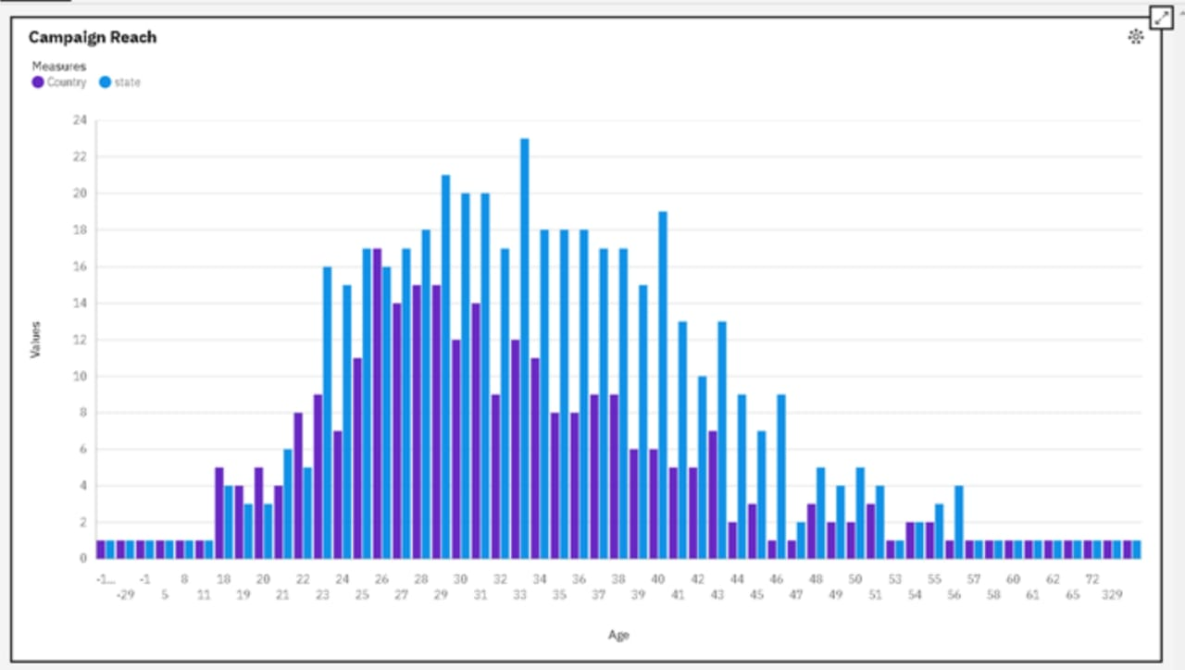

**Conclusion:**

It has focused on the assessment of a public health awareness campaign's effectiveness and impact. We have employed IBM Cognos for data visualization and integrated code, possibly in Python, for advanced data analysis. Through the creation of interactive dashboards and reports, we have effectively visualized campaign reach, awareness levels, and impact metrics, providing actionable insights for campaign organizers, healthcare professionals, and policymakers. Additionally, our use of code for in-depth analysis, including calculating engagement rates, conducting demographic analysis, and running statistical tests, has yielded comprehensive findings. This combined approach equips us to contribute to healthier communities by supporting informed decision-making and promoting public health initiatives.