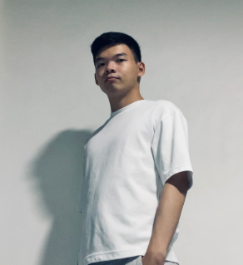

**Roger Ng Zi Liang**

* **Phone**: 9021 2299
* **Email**: rogerng71@gmail.com
* **Portfolio**: <https://5603roger.github.io/ePortfolio/>
* **LinkedIn**: <https://shorturl.at/GA9YK>
* **Address:** Blk 717 Tampines Street 72 #02-75

**Professional Summary**

A highly motivated and detail-oriented engineering student with a strong background in robotics systems, proficient in SolidWorks, Python, and C programming. Experienced in systems engineering, data analysis, and project management. Seeking an engineering internship to leverage my technical skills and contribute to innovative projects. Refer to ePortfolio to view projects done.

**Education**

**Bachelor of Engineering with Honors in Robotics Systems**  
*Apr 2022 – Present*

* Proficient in SolidWorks
* Basic proficiency in Python and C programming
* Knowledge of Systems Engineering practices (SEBOK)
* Exposure to ROS and C++
* Experience in project management

**Diploma in Business Process & Systems Engineering, Temasek Polytechnic**  
*Apr 2017 – Apr 2020*

* GPA: 3.15/4
* Edusave Merit Bursary 2020 (Top 25%)
* Good Progress Award 2019 (Top 10% most improved)
* Major Project and Student Internship: Grade A
* Key modules: Engineering Analytics, Marketing Research, Supply Chain Management (Grade A)

**Relevant Work Experience**

**Intern, Destination Services & Intercruises**  
*Apr – Jul 2019*

* Conducted data analysis using Excel Macro and Microsoft Access
* Collaborated on projects to improve processes
* Enhanced IT-related skills through research

**Technical Projects**

* **Robotics System Design Project**: Designed and implemented a robotic arm using SolidWorks, integrated with a Python-based control system.
* **Data Analysis Project**: Utilized Rapid Miner for data mining and analysis, leading to improved project outcomes.
* **Systems Engineering Project**: Applied SEBOK practices to develop a comprehensive engineering project, focusing on system requirements and lifecycle management.

**Skills**

**Technical Skills**

* Data mining software: Rapid Miner
* Microsoft Office: Word, Excel, PowerPoint
* SolidWorks
* Basic Python and C programming
* Systems Engineering (SEBOK)
* Project management

**Workplace Skills**

* Fluent in English and Chinese
* Strong teamwork and analytical skills
* Responsible, meticulous, and self-motivated
* Effective interpersonal and communication skills
* Able to work independently

**Awards & Achievements**

**Leadership / Service**

* **Temasek Polytechnic:**
  + ENG Pre-SIP workshop on Resume & Interview (participant)
  + Camp ENGenium 2018 for EAE (student facilitator)
  + Mazegium in Camp ENGenium for EAE 2018 (Sub-Organizing Committee member)
  + TP Open House (ENG) 2018 (Event helper)
  + TP Open House 2018 (E-Guide)
  + ETC 2017/2018 camp (participant)
  + Singapore Police Force career talk (2017) (participant)
  + TPOF 2018 (participant)