Phase 03 // Chapters 9-12

1. **Custom Nodes** 
   1. Custom Node introduction
      1. UI Design - Cleaning up your Graph
      2. Development - Create your own tools
   2. **Creating a Custom Node - Efficiency in a Graph** 
      1. **Example – UV Mapping**
   3. **Adding to your Library - Efficiency in your workflow** 
      1. **Example – UV Mapping Continued**
   4. Python
      1. Expanding Visual Programming
         1. Loops
         2. Platform Specific APIs

1.4.1.2.1 Revit Example

1. **Packages** 
   1. Package Introduction
      1. Dynamo Custom Node Package

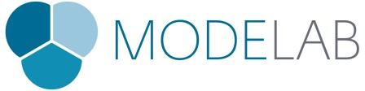

* + 1. Zero-Touch DLLs
       1. Importing AForge
  1. Dynamo Package Manager
     1. Navigating the UI
     2. Navigating the Website
  2. **Package Case Study – Mesh Toolkit** 
     1. **Fundamentals of Meshes**
     2. **Example – Importing and Editing a Mesh**
  3. Publishing
     1. Creating a package from custom nodes
        1. Example – UV Mapping Continued
     2. Creating a Zero-Touch DLL Package
        1. Developer Resources and Wiki
     3. **.Open call for community submission – Zero touch and Dynamo Packages**

Mode Lab  Dynamo Primer Outline  August 24, 2015 1