Group16_Testing

CLI-Kanban

Version 1.1

Printing Date:

Group 16

Project Members:

SID | Name
1155214510 | Lo Ho Man
1155212332 | Tam Ryan Pok Man
1155192095 | Fung Cheuk Nam
1155194128 | Wong Yeuk Yin

Table of Contents
Table of Contents 2
1. Introduction 4
1.1 Testing Objectives 4
1.2 Scope 4
2. Test Plan 4
2.1 Components Covered 4
2.2 Components Not Covered 6
2.3 Test Types 6
3. Requirements Coverage 6
3.1 Functional Requirements Covered 7
3.2 Non-Functional Requirements Covered 8
4. Test Strategy 8
4.1 Test Conditions 8
4.1.1 Normal Tests Conditions 8
4.1.2 Boundary Tests Conditions 8
4.1.3 Error Conditions 8
4.2 Test Case Generation 9
4.2.1 Equivalence Partitioning 9
4.2.2 Boundary Value Analysis 9
4.2.3 State-Based Testing 9
4.2.4 Permission-Based Testing 9
4.3 Test Data Strategy 10
5. Test Cases 10
5.1 Representative Test Cases 10
5.2 Test Case Summary 11
6. Tools and Techniques 11
6.1 Fixtures and Test Data 11
6.5 Testing Techniques 11
6.5.1 Arrange-Act-Assert (AAA) Pattern 11
6.5.2 Parametrized Tests 12
6.5.3 Exception Testing 12
6.5.4 Performance Measurement 12
7. Test Execution 12
7.1 Running Tests 12
Run All Tests 12
Run Specific Test Suite 12
Run with Coverage 12
Generate HTML Coverage Report 12
Run Performance Benchmarks 12
7.2 Test Frequency 13
7.3 Pre-requisites 13
7.4 Expected Output 13
8. Results and Metrics 14
Conclusion 14
Reflection of using AI tools 14

Document revision history

Version Revised by Revision Date Comments

1.0 All Group 16 members 21 Dec 2025 Initial draft

1.1 Lo Ho Man 22 Dec 2025 Edited body content,
deleted redundant sections,
formatting

1. Introduction
This document describes the testing approach for the CLI Kanban Task Management System. The system is a command-line application built with Python and MongoDB that provides role-based task management functionality with three user roles: Members, Hashira, and Boss.

1.1 Testing Objectives
- Verify functional correctness of all system components
- Ensure role-based permissions are properly enforced
- Validate data integrity and security
- Measure system performance under various conditions
- Identify and prevent regressions during development

1.2 Scope
Testing covers:
- Authentication services
- Board and task management operations
- Search functionality
- Licence key validation and redemption
- Database operations and data persistence
- Performance and scalability

2. Test Plan

2.1 Components Covered
The following components are thoroughly tested:
Fully Covered Components:
- Authentication Service (services/auth_services.py)
  - Valid role registration with matching licence
  - Duplicate username prevention
  - Email format validation
  - Reject used licence key
  - Successful login
  - Invalid username or password rejection
  - User not found handling
- Licence Service (services/licence_service.py)
  - Format validation
  - Valid licence existence, redeem status validation
  - Creation
  - Redemption
  - Redemption life cycle from create to redeemed
- Board Service (services/board_services.py)
  - Boss creates boards correctly, duplicate prevention, default columns check
  - Permission enforcement
  - Board properties correctly gettable (FR7)
  - Board visibility to different users
  - List board functionality for Boss and Members
  - Board deletion, w/wo tasks, is/is not by Boss
- Task Service (services/task_service.py)
  - Task creation permissions
  - Priority management
  - Task attributes getting and column assigning
  - Task editing and movement (FR-10, FR-11, FR-12)
  - Task deletion (FR-12)
  - Task workflow (create, edit, move, delete)
- Search Service (services/search_service.py)
  - Case insensitive keyword search (FR-13)
  - Partial matches
  - Empty board return no result
- Repository Layer
  - All repository classes (User, Board, Task, Licence)
  - MongoDB adapter operations
  - Data persistence and retrieval

2.2 Components Not Covered
The following components are not covered in automated tests:
- CLI (cli/parser.py, cli/formatter.py), Main Application Loop (main.py)
  - Manual testing required for confirming standard I/O
- Schema Setup (setup_schema.py, setup_license_keys.py)
  - One-time setup scripts tested manually
- Configuration (config.py)
  - Simple configuration, tested implicitly by repositories/mongodb_adapter.py

2.3 Test Types
- Integration Tests: Test interactions between multiple components
- Performance Benchmarks: Measure system performance
- Manual Tests: CLI interaction and end-to-end workflows

3. Requirements Coverage
Y - Covered; P - Partially Covered; N- Not Covered
FR1 | FR2 | FR3 | FR4 | FR5 | FR6 | FR7 | FR8 | FR9
Y | Y | Y | Y | Y | N | P | N | Y
FR10 | FR11 | FR12 | FR13 | FR14 | NFR1 | NFR2 | NFR3
Y | Y | Y | Y | N | Y | N | Y
FR6, FR7, FR8, FR14: Need manual testing to ensure correct output messages
NFR2: Very hard or impossible to implement tests, not tested at time of writing

3.1 Functional Requirements Covered
Requirement | Test File
FR-1: User Registration | test_auth_service.py
Valid role registration with matching licence | Lines 16-82, 102-151
Duplicate username prevention | Lines 84-100
Email format validation | Lines 153-169
Reject used licence key | Lines 171-188
FR-2: User Authentication | test_auth_service.py
Successful login | Lines 190-201
Invalid username or password rejection | Lines 203-219
User not found handling | Lines 221-242
FR-3: Licence Creation | test_licence_service.py
Format validation | Lines 15-41
Valid licence existence, redeem status validation | Lines 43-109
Creation | Lines 139-193
FR-4: Licence Redemption | test_licence_service.py
Redemption | Lines 111-137
Redemption life cycle from create to redeemed | Lines 195-221
FR-5 Board Management | test_board_service.py
Boss creates boards correctly, duplicate prevention, default columns check | Lines 17-30, 50-57, 216-226
Permission enforcement | Lines 32-48
Board properties correctly gettable (FR7) | Lines 59-91
Board visibility to different users | Lines 93-124
List board functionality for Boss and Members | Lines 126-164
Board deletion, w/wo tasks, is/is not by Boss | Lines 166-214
FR-9: Task Management | test_task_service.py
Task creation permissions | Lines 15-69
Priority management | Lines 71-119
Task attributes getting and column assigning | Lines 121-148
Task editing and movement (FR-10, FR-11, FR-12) | Lines 150-243
Task deletion (FR-12) | Lines 245-278
Task workflow (create, edit, move, delete) | Lines 280-309
FR-13: Search | test_search_service.py
Case insensitive keyword search (FR-13) | Lines 15-70
Partial matches | Lines 85-96
Empty board return no result | Lines 98-107

3.2 Non-Functional Requirements Covered

Requirement | Test File
NFR-1: Performance | test_benchmarks.py
Bulk operations | Lines 15-116, 165-229
Search performance | Lines 118-163
login | Lines 231-254
NFR-3: Security | Multiple
Password hashing | test_auth_service.py Lines 244-267
Permission enforcement | test_integration.py Lines 264-315
Role-based function access | All service tests

4. Test Strategy

4.1 Test Conditions
All tests assume the following condition:
- Available database connection
- Sufficient system resources
Then different tests are designed under the following conditions:

4.1.1 Normal Tests Conditions
- Valid user inputs
- Proper authentication
- Correct role assignments

4.1.2 Boundary Tests Conditions
- Empty databases
- Maximum data limits (100+ tasks, 50+ boards)
- Null/None values where applicable

4.1.3 Error Conditions
- Invalid credentials/licences (non-existent credentials or licences etc.)
- Permission violations
- Duplicate data( board name, username etc.)
- Missing required fields
- Invalid data formats(incorrect licence formats etc.)

4.2 Test Case Generation
Test cases are generated using the following approaches:

4.2.1 Equivalence Partitioning
- Valid vs. invalid inputs
- Different user roles (Members, Hashira, Boss)
- Different task priorities (low, medium, high)
- Different task columns (TODO, DOING, DONE)

4.2.2 Boundary Value Analysis
- Minimum and maximum string lengths
- Edge cases for licence key formats
(AAAA-BBBB-CCCC vs AAAA-BBBB-CCCC-DDDD)
(former has missing segment)
- Empty and full datasets

4.2.3 State-Based Testing
- User authentication states (logged in/out)
- Task workflow states (TODO → DOING → DONE)
- Licence states (unclaimed → claimed)

4.2.4 Permission-Based Testing
- Operations tested with all three roles
- Verify proper access grants and denials
- Cross-role interaction scenarios

4.3 Test Data Strategy
Test Database Setup
- Each test uses a clean test database (cli-kanban-test)
- Fixtures provide reusable test data
- Database is reset before and after each test
- No interference between test executions
Sample Data
- Predefined users for each role
- Sample boards with various configurations
- Tasks with different priorities and states
- Licences for all role types

5. Test Cases

5.1 Representative Test Cases
Test Case 1: Complete User Registration Workflow
Category: Service Test
File: test_auth_service.py::test_login_success
Priority: Critical
Objective: Verify correct functioning of auth_service.login
Rationale: Users need to login before they can actually use the system, hence in crucial priority
Test Design: Assume sample_member_user already registered, then pass credentials to auth_service.login and save Members object in logged_in_user. Finally check username and user id with assertion
Expected Results: username is testmember, and user id is same as preconfigured value in conftest.py
Actual Implementation:
def test_login_success(self, user_repo, sample_member_user):
"""Test successful login."""
# Arrange
auth_service = AuthService(user_repo=user_repo)
# Act
logged_in_user = auth_service.login(sample_member_user.username, "password123")
# Assert
assert logged_in_user is not None
assert logged_in_user.username == sample_member_user.username
assert logged_in_user._id == sample_member_user._id

5.2 Test Case Summary
Total test cases: 90 tests across all test files
Test Suite | Test Count | Focus Area
test_auth_service.py | 16 tests | Authentication, registration, passwords
test_board_service.py | 18 tests | Board CRUD, permissions
test_task_service.py | 19 tests | Task CRUD, move, permissions
test_licence_service.py | 16 tests | Licence validation, redemption
test_search_service.py | 6 tests | Search operations
test_integration.py | 8 tests | Overall workflows
test_benchmarks.py | 7 tests | Performance measurements

6. Tools and Techniques
- Testing Framework: pytest (v9.0.1)
- Coverage Analysis: pytest-cov (v6.3.0)
- Test Database: MongoDB Test Instance “cli-kanban-test”, Separate test database isolated from production data, clean slate for each test
  - Configuration:
TEST_DATABASE_NAME = "cli-kanban-test
# Each test gets fresh database via fixtures

6.1 Fixtures and Test Data
pytest Fixtures (defined in conftest.py):
- test_db: Clean database connection
- adapter: MongoDB adapter instance
- Repository fixtures: user_repo, board_repo, task_repo, licence_repo
- Sample data fixtures: sample_member_user, sample_board, sample_task
Benefits: - DRY principle - write once, use everywhere - Automatic setup and teardown - Composable test dependencies - Clear test intentions

6.5 Testing Techniques

6.5.1 Arrange-Act-Assert (AAA) Pattern
All tests follow the AAA pattern:
def test_example():
# Arrange: Set up test preconditions
user = create_test_user()
# Act: Execute the operation
result = service.perform_operation(user)
# Assert: Verify results
assert result is not None

6.5.2 Parametrized Tests
For testing multiple similar scenarios:
@pytest.mark.parametrize("priority", ["high", "medium", "low"])
def test_all_priorities(priority):
task = create_task(priority=priority)
assert task.priority == priority

6.5.3 Exception Testing
Verify error handling:
with pytest.raises(ValueError, match="expected error message"):
service.invalid_operation()

6.5.4 Performance Measurement
start_time = time.time()
perform_bulk_operation()
duration = time.time() - start_time
assert duration < threshold

7. Test Execution

7.1 Running Tests

Run All Tests
python run_tests.py

Run Specific Test Suite
python run_tests.py auth
python run_tests.py board

Run with Coverage
python run_tests.py coverage

Generate HTML Coverage Report
python run_tests.py coverage-html

Run Performance Benchmarks
python run_tests.py benchmarks

7.2 Test Frequency
Manual user input testing was carried out throughout the entire development process, tests described in this document are based on the release product version (v6.1) at the time of writing this document.

7.3 Pre-requisites
Before running tests:
- Install dependencies:
pip install -r requirements.txt
pip install -r test_requirements.txt
- MongoDB running:
MongoDB must be running on localhost: “mongodb://localhost:27017/”
Or set MONGO_URI environment variable
- Python environment:
Python 3.9+ required

7.4 Expected Output
Successful test run:
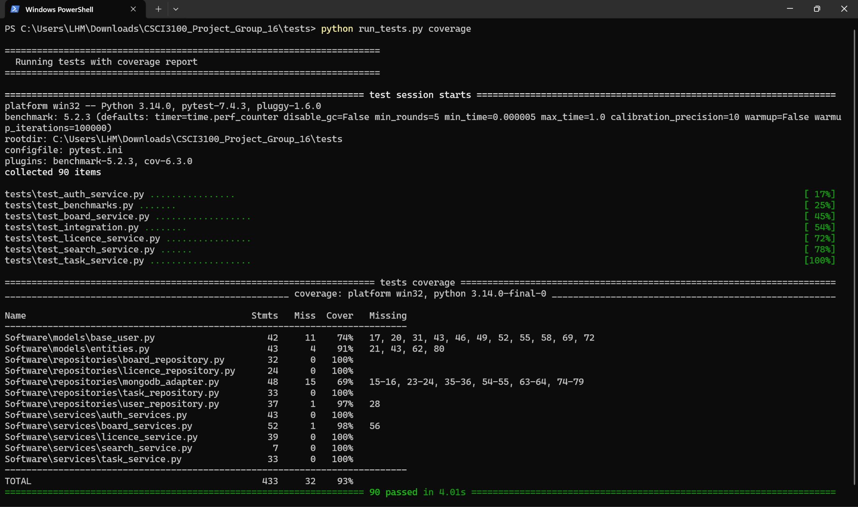

8. Results and Metrics
- Pass Rate: 100% (90 tests passing)
- Coverage: 93%

Conclusion
This testing strategy provides comprehensive coverage of the CLI Kanban system’s functional and non-functional requirements. With 90 automated tests achieving 94% code coverage, the system is well-validated for correctness, security, and performance.
The combination of unit tests, integration tests, and performance benchmarks ensures the system behaves correctly under normal conditions, edge cases, and load scenarios. Regular test execution during development prevents regressions and maintains code quality.

Reflection of using AI tools
In this document,
We acknowledge the use of ChatGPT (https://chat.openai.com/) and Grok (https://grok.com/) to
- Plan this document
- Correct grammar
- Improve sentence structure
- Ensure that our ideas are expressed more clearly and cohesively
- Accelerate coding & format coding style
All contents are reviewed to ensure the originality.

