Group16_Design_Implementation

CLI-Kanban

Version 1.0

Printing Date:

Group 16

Project Members:

SID | Name
1155214510 | Lo Ho Man
1155212332 | Tam Ryan Pok Man
1155192095 | Fung Cheuk Nam
1155194128 | Wong Yeuk Yin

Table of Contents
Table of Contents 2
1. Overview & Context (purpose, target users, external dependencies) 3
1.1 Business Context (who uses it, external systems) 3
1.2 Technical Context (how it integrates with MongoDB, filesystem, OS) 4
2. System Architecture (diagram + component responsibilities + interactions) 4
3. Data Model & Persistence (Entity Relationship + MongoDB collections/indexes + key constraints) 4
4. Design Decisions (only high-impact decisions + alternatives) 4
5. Developer Setup & Repo Guide (how to build/run/test + folder structure + where to find in-code docs) 5
6. GitHub Link (required) 5

Document revision history

Version Revised by Revision Date Comments

1.0 All Group 16 members 20 Dec 2025 Initial draft

1. Overview & Context (purpose, target users, external dependencies)
CLI-Kanban is an application for small software development teams to schedule tasks and collaborate work. This document aims to act as a developer’s guide to document architectural design, component interactions, and algorithm explanations in the application.

1.1 Business Context (who uses it, external systems)
This application is designed for small software development teams with junior developers (members), senior developers (Hashira) and a manager (Boss). Junior developers can only see what boards there are, tasks on different boards and what are the tasks’ status (TODO/DOING/DONE). Senior developers can create, edit and delete tasks in addition to viewing tasks, they can also change the status. Finally, manager(s) have all the power of senior developers, and can also create or delete boards.
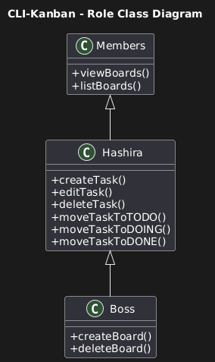

The application relies on MongoDB to store the user credentials, the task attributes like its name, description, status, and the boards’ attributes like name, its columns. tasks on each board.
It also relies on the terminal provided by the operating system to perform standard text inputs and outputs.
The application runs locally and does not depend on internet access or remote servers.

1.2 Technical Context (how it integrates with MongoDB, filesystem, OS)
CLI-Kanban is built in Python 3.8+, running cross-platform on Windows, and macOS via standard terminals. It integrates with MongoDB (local instance at mongodb://localhost:27017/) for persistent storage of users, boards, and tasks, using PyMongo for queries and updates. Filesystem interactions are minimal: optional license key files are read for validation, and configuration could be extended via text files. OS dependencies include access to stdin/stdout for CLI input/output, with no advanced hardware needs beyond basic computing resources (e.g., 8GB RAM). This setup demonstrates SE integration patterns, ensuring portability and ease of deployment.

2. System Architecture (diagram + component responsibilities + interactions)

2.1 UML Component Diagram
The component relationships in the system are described using the following UML Component Diagram.
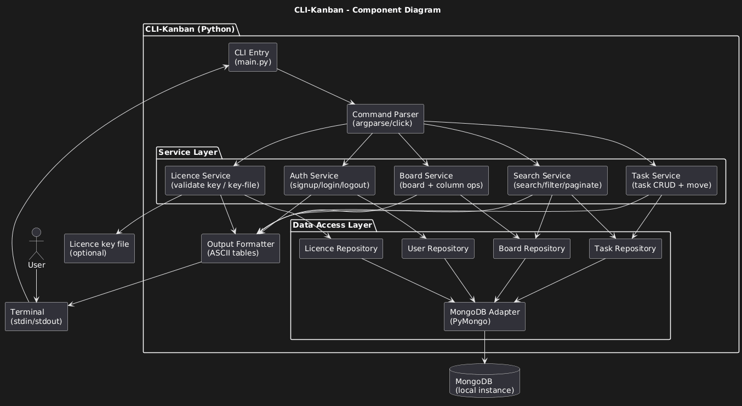
The user interacts with the whole system through the terminal provided by the operating system.
The CLI Entry acts as an input loop to receive commands inputted by the user in the terminal, it then passes the input string to a command parser. The command parser will decide which service to access based on the command input string.

2.2 Component Responsibilities

2.3 Component Interactions

3. Data Model & Persistence (Entity Relationship + MongoDB collections/indexes + key constraints)
Data Model (ER Description):

User (1:N) owns Boards
Board (1:N) contains Tasks
User (1:N) assigned to Tasks (via assignee)

MongoDB Collections:

users: {_id: ObjectId, username: str (unique), password: hash, role: str ('boss'/'hashira'/'member'), license_key: hash, licensed: bool}
Indexes: username (unique) for fast lookups.
boards: {_id: ObjectId, name: str (unique per owner), owner_id: ObjectId, columns: [str]}
Indexes: owner_id for ownership queries.
tasks: {_id: ObjectId, title: str, board_id: ObjectId, column: str, desc: str, due: datetime, priority: str ('low'/'medium'/'high'), assignee: str}
Indexes: board_id (for board-specific fetches), assignee (for user filters).

4. Design Decisions (only high-impact decisions + alternatives)
- Setup.py must be ran as part of installation process:
The application assumes that license keys are already present in the MongoDB license repository. To ensure the license keys are encrypted and secure, the Setup.py takes input from command prompt or an input text file to enter into the database where it is immediately encrypted.

5. Developer Setup & Repo Guide (how to build/run/test + folder structure + where to find in-code docs)

6. GitHub Link (required)

