Continuous Delivery:  
Lab 1

Tennis Smith

Table of Contents

Overview 2

Prerequisites 2

Lab 1 3

Step 1: Login to GitHub 3

Step 2: Fork the lab1 repo 3

Step 3: Clone a copy of the lab1 repo 3

Step 4: Update the Jenkinsfile 3

Step 5: Commit Changes and Push to Central Repository 3

Step 6: Setup a Jenkins pipeline 4

Step 7: Verify your docker image uploaded to the registry 8

# Overview

Lab 1 will cause a new docker image to be built. Jenkins will poll GitHub (1 below). If there has been a source update (or if someone manually builds the pipeline), then Jenkins will pull the latest source (2 below) and build the image (3 below). Once built, the image is then pushed to the docker registry (4 below).

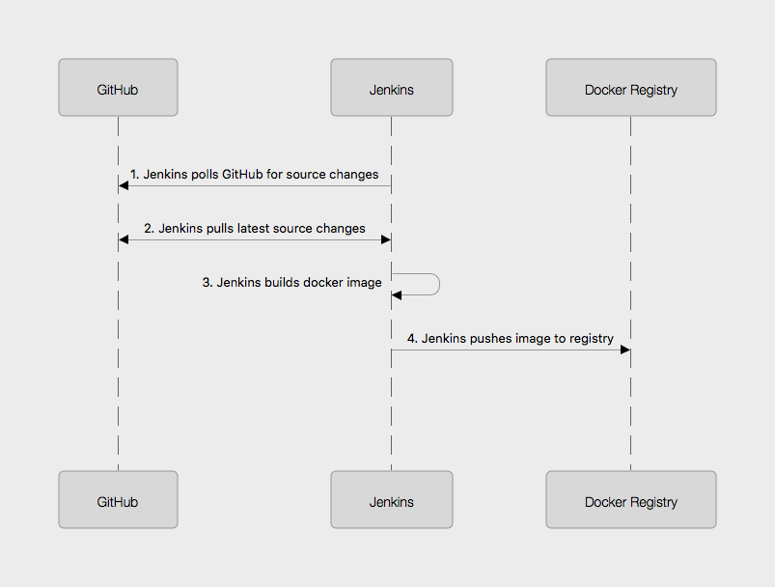

# Prerequisites

Students will need a computer with:

* An Amazon Workspaces login (see your instructor for details)

# Lab 1

## Step 1: Login to GitHub

* In your workspaces session, open a web browser and login to github: <http://github.com>

**Tip**

If you don’t have a GitHub account, go to <http://github.com> and create a free account

## Step 2: Fork the lab1 repo

* Go to this url: <https://github.com/RoundTower-io/cd_workshop_lab1>
* Fork the repo by clicking on the "Fork" button in the upper right of the screen.
* This will create a copy of the lab1 repo under your own GitHub id

## Step 3: Clone a copy of the lab1 repo

* In your workspace session, open a new terminal window by clicking on the Powershell icon. 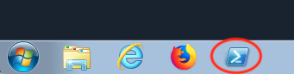
* Make a local copy of the repo by cloning it with the following command

git clone https://github.com/<your user name>/cd_workshop_lab1.git lab1

## Step 4: Update the Jenkinsfile

* Go to the home directory of your new repo
* cd lab1
* Now edit the file Jenkinsfile
* atom Jenkinsfile
* Change every occurrence of training99 to your training ID (assigned by the instructor).
* Save and exit the file

## Step 5: Commit Changes and Push to Central Repository

* First, change the working directory.

cd ~/lab1

* Next, add all altered files to the change set.

git add .

* Next, commit the changes.

git commit -m "Updated Jenkinsfile"

* Last, push the change to GitHub.

git push

## Step 6: Setup a Jenkins pipeline

* Login to Jenkins at <http://jenkins.roundtower.io>
* Login using your assigned training id (get it from your instructor).
* Click on the "New Item" option on the main menu

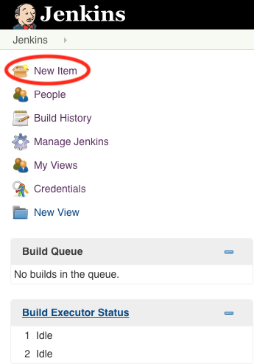

* Name your new pipeline <your training id>_lab1 and select pipeline as the type. Then click ok to save it.

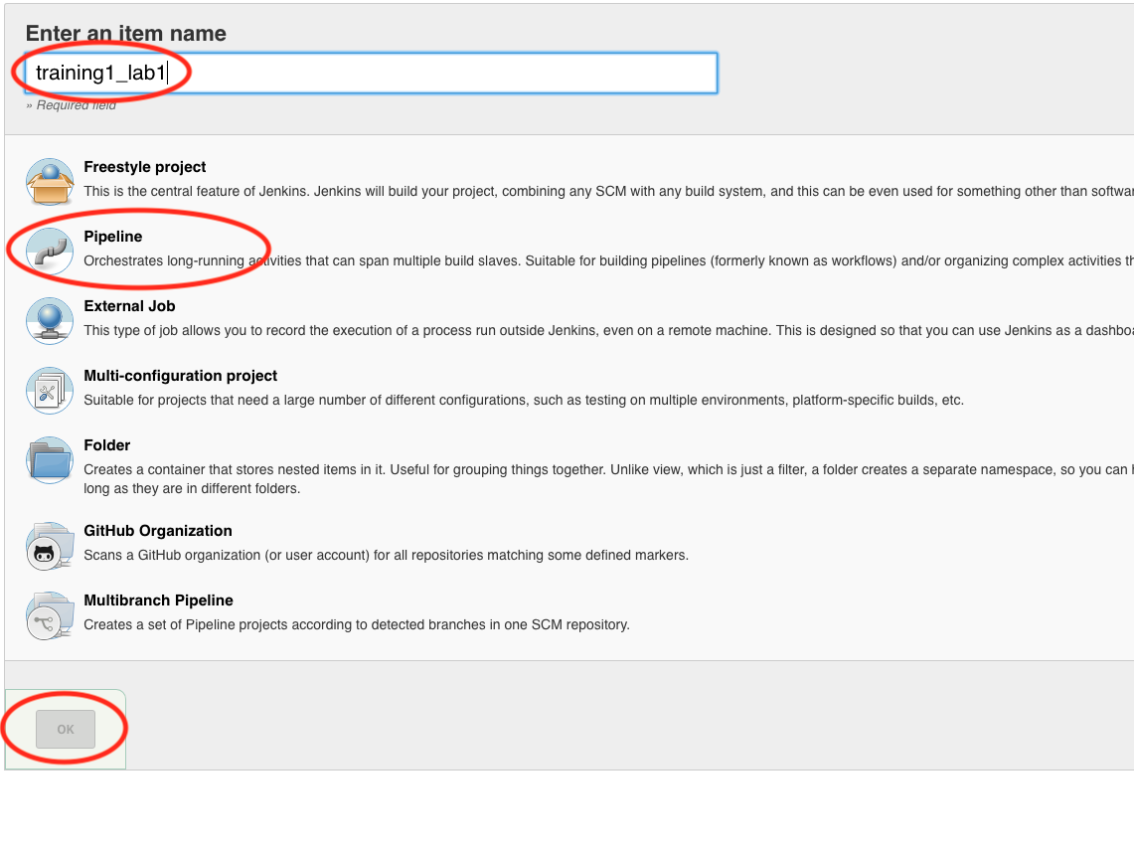

* Next, click on the Poll SCM option (about halfway down the page) and enter 5 asterisks (with 1 space between each) in the field. This will cause Jenkins to look at GitHub once per minute for changes. If changes are found, then the pipeline will run.

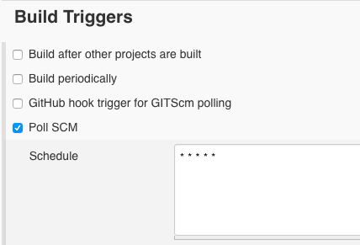

* At the bottom of the page, set the Definition field to Pipeline script from SCM, then set the SCM field to Git. Put your lab1 url in the Repository URL field. Finally, click on Save to save all your work.

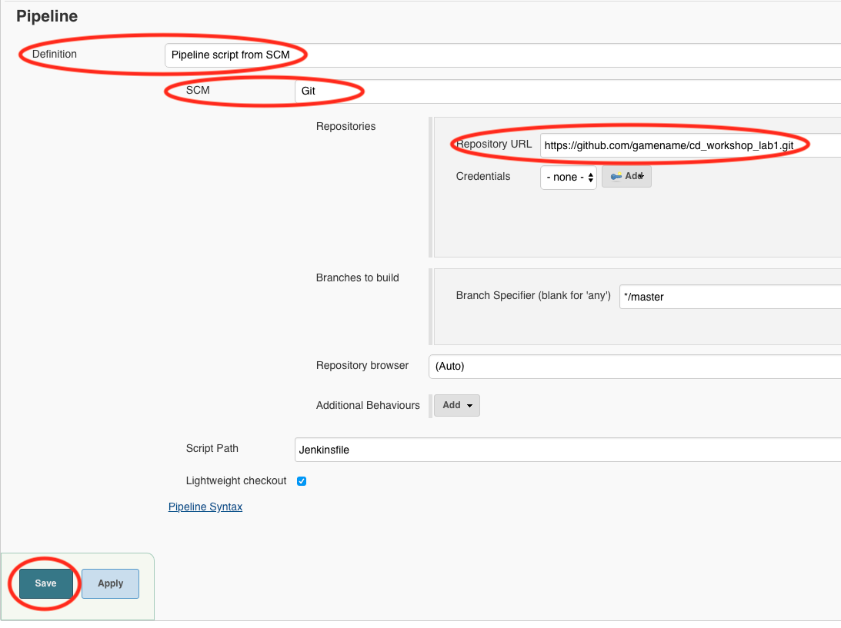

* At this point, you should see your pipeline run automatically. If not, click on Build Now on the upper left of the screen.
* After the build, click on your trainingX_lab1 link on the dashboard. You should see output something like this:

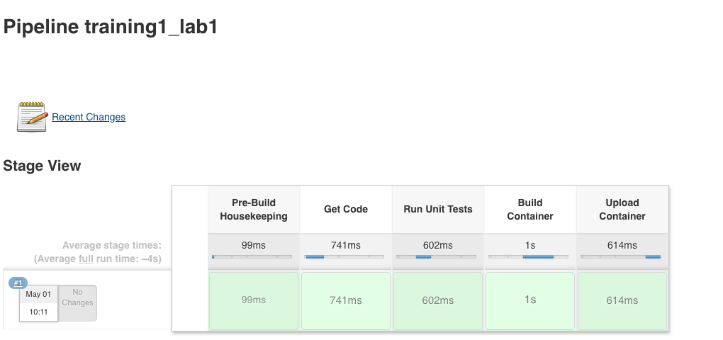

## Step 7: Verify your docker image uploaded to the registry

* Create a new pipeline by clicking on New Item on the Dashboard

TIP | You can always get to the Dashboard by clicking on the word Jenkins in the upper left of the web page

* Name your new pipeline trainingX_lab1_check (where 'X' is your training ID number)
* Select Pipeline option.
* Click OK
* Scroll to the bottom of the next screen until you get to the Pipeline section
* Leave the Definition field set to Pipeline script
* Paste (or write) the following in the Script field

node {  
 sh 'curl http://registry.roundtower.io:5000/v2/training99/lab1/tags/list'  
}

* Be sure to change training99 to your training ID 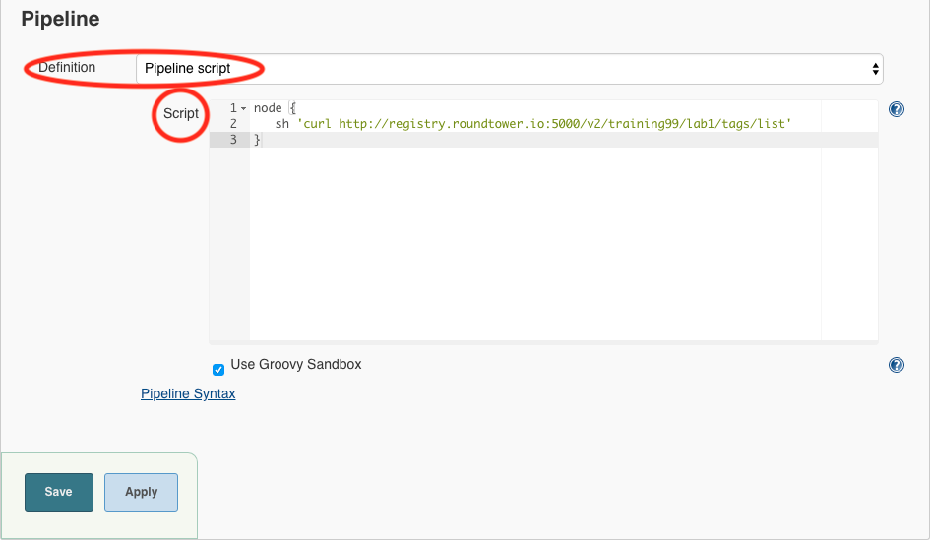
* Click the Save button to exit
* Click on the Build Now button on the left.
* Once the build completes, click on the build number in the Build History on the lower left of the screen. 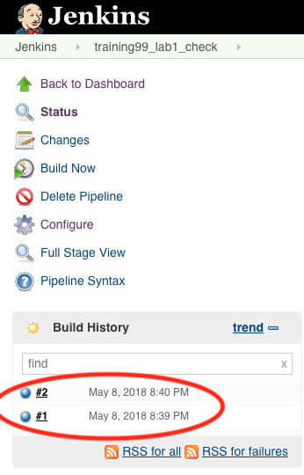
* Click on the Console Output on the left of the screen 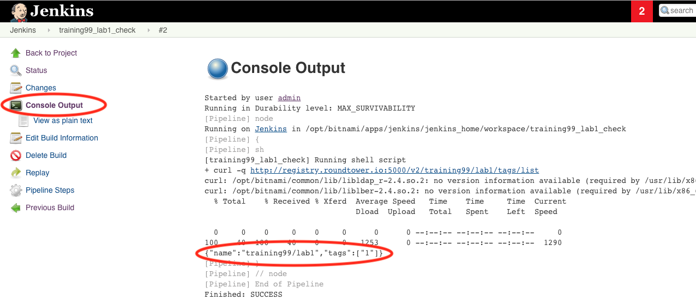
* You should see in the output provided something like the following with your training ID in it.

Started by user admin  
Running in Durability level: MAX_SURVIVABILITY  
[Pipeline] node  
Running on Jenkins in /opt/bitnami/apps/jenkins/jenkins_home/workspace/training99_lab1_check  
[Pipeline] sh  
[training99_lab1_check] Running shell script  
...  
{"name":"training99/lab1","tags":["1"]}  
...  
Finished: SUCCESS

* The line {"name":"training99/lab1","tags":["1"]} means that version 1 of training99/lab1 is in the registry. This verifies your docker image uploaded properly.