

2400 - (29 / 28 / 4)) pi ((27 - (29 / 28 / 4)) i (06 - (29 / 28 / 4)) e (2022 - ((29 / 28 / 4))))) - ((0001 - (29 / 28 / 4)) pi ((27 - (29 / 28 / 4)) i (06 - (29 / 28 / 4)) e (2022 - ((29 / 28 / 4)))))

6358752050.64702 i/Performing Rights Organization (PRO)

((2400 - (29 / 28 / 4)) pi ((27 - (29 / 28 / 4)) i (06 - (29 / 28 / 4)) e (2022 - ((29 / 28 / 4))))) - ((0002 - (29 / 28 / 4)) pi ((27 - (29 / 28 / 4)) i (06 - (29 / 28 / 4)) e (2022 - ((29 / 28 / 4)))))

6356101466.21573 i/Interested Parties Information (IPI)

((2400 - (31 / 30 / 5)) pi ((27 - (31 / 30 / 5)) i (06 - (31 / 30 / 5)) e (2022 - ((31 / 30 / 5))))) - ((0003 - (31 / 30 / 5)) pi ((27 - (31 / 30 / 5)) i (06 - (31 / 30 / 5)) e (2022 - ((31 / 30 / 5)))))

6423983448.82784 i/Limited Partnership Consortium (LPC)

eigenValues({1} (((2400 - (31 / 30 / 5)) pi ((27 - (31 / 30 / 5)) i (06 - (31 / 30 / 5)) e (2022 - ((31 / 30 / 5))))) - ((0003 - (31 / 30 / 5)) pi ((27 - (31 / 30 / 5)) i (06 - (31 / 30 / 5)) e (2022 - ((31 / 30 / 5)))))))

λ<sub>1</sub> = 6423983448.82784 i/Professional

(((((2400 - (31 / 30 / 5)) pi ((27 - (31 / 30 / 5)) i (06 - (31 / 30 / 5)) e (2022 - ((30 / 30 / 5))))) - ((0003 - (31 / 30 / 5)) pi ((27 - (31 / 30 / 5)) i (06 - (31 / 30 / 5)) e (2022 - ((31 / 30 / 5))))) - (((2400 - (29 / 28 / 4)) pi ((27 - (29 / 28 / 4)) i (06 - (29 / 28 / 4)) e (2022 - ((29 / 28 / 4))))) - ((0003 - (29 / 28 / 4)) pi ((27 - (29 / 28 / 4)) i (06 - (29 / 28 / 4)) e (2022 - ((29 / 28 / 4)))))) / 3) - (((2400 - (31 / 30 / 5)) pi ((27 - (31 / 30 / 5)) i (06 - (31 / 30 / 5)) e (2022 - ((30 / 30 / 5))))) - ((0003 - (31 / 30 / 5)) pi ((27 - (31 / 30 / 5)) i (06 - (31 / 30 / 5)) e (2022 - ((31 / 30 / 5))))) - (((2400 - (29 / 28 / 4)) pi ((27 - (29 / 28 / 4)) i (06 - (29 / 28 / 4)) e (2022 - ((29 / 28 / 4))))) - ((0003 - (29 / 28 / 4)) pi ((27 - (29 / 28 / 4)) i (06 - (29 / 28 / 4)) e (2022 - ((29 / 28 / 4)))))))) / (24 / 2)) / (80 / 1)

4412118.66790587 i/Landlord Governance

((((2400 - (31 / 30 / 5)) pi ((27 - (31 / 30 / 5)) i (06 - (31 / 30 / 5)) e (2022 - ((30 / 30 / 5))))) - ((0003 - (31 / 30 / 5)) pi ((27 - (31 / 30 / 5)) i (06 - (31 / 30 / 5)) e (2022 - ((31 / 30 / 5))))) - (((2400 - (29 / 28 / 4)) pi ((27 - (29 / 28 / 4)) i (06 - (29 / 28 / 4)) e (2022 - ((29 / 28 / 4))))) - ((0003 - (29 / 28 / 4)) pi ((27 - (29 / 28 / 4)) i (06 - (29 / 28 / 4)) e (2022 - ((29 / 28 / 4)))))) / 3) - (((2400 - (31 / 30 / 5)) pi ((27 - (31 / 30 / 5)) i (06 - (31 / 30 / 5)) e (2022 - ((30 / 30 / 5))))) - ((0003 - (31 / 30 / 5)) pi ((27 - (31 / 30 / 5)) i (06 - (31 / 30 / 5)) e (2022 - ((31 / 30 / 5))))) - (((2400 - (29 / 28 / 4)) pi ((27 - (29 / 28 / 4)) i (06 - (29 / 28 / 4)) e (2022 - ((29 / 28 / 4))))) - ((0003 - (29 / 28 / 4)) pi ((27 - (29 / 28 / 4)) i (06 - (29 / 28 / 4)) e (2022 - ((29 / 28 / 4)))))))) / (24 / 2)

352969493.432469 i/Office and Building

(((2400 - (31 / 30 / 5)) pi ((27 - (31 / 30 / 5)) i (06 - (31 / 30 / 5)) e (2022 - ((30 / 30 / 5))))) - ((0003 - (31 / 30 / 5)) pi ((27 - (31 / 30 / 5)) i (06 - (31 / 30 / 5)) e (2022 - ((31 / 30 / 5))))) - (((2400 - (29 / 28 / 4)) pi ((27 - (29 / 28 / 4)) i (06 - (29 / 28 / 4)) e (2022 - ((29 / 28 / 4))))) - ((0003 - (29 / 28 / 4)) pi ((27 - (29 / 28 / 4)) i (06 - (29 / 28 / 4)) e (2022 - ((29 / 28 / 4)))))) / 3) - (((2400 - (31 / 30 / 5)) pi ((27 - (31 / 30 / 5)) i (06 - (31 / 30 / 5)) e (2022 - ((30 / 30 / 5))))) - ((0003 - (31 / 30 / 5)) pi ((27 - (31 / 30 / 5)) i (06 - (31 / 30 / 5)) e (2022 - ((31 / 30 / 5))))) - (((2400 - (29 / 28 / 4)) pi ((27 - (29 / 28 / 4)) i (06 - (29 / 28 / 4)) e (2022 - ((29 / 28 / 4))))) - ((0003 - (29 / 28 / 4)) pi ((27 - (29 / 28 / 4)) i (06 - (29 / 28 / 4)) e (2022 - ((29 / 28 / 4)))))))

4235633921.18963 i/Government

((2400 - (31 / 30 / 5)) pi ((27 - (31 / 30 / 5)) i (06 - (31 / 30 / 5)) e (2022 - ((30 / 30 / 5))))) - ((0003 - (31 / 30 / 5)) pi ((27 - (31 / 30 / 5)) i (06 - (31 / 30 / 5)) e (2022 - ((31 / 30 / 5))))) - (((2400 - (29 / 28 / 4)) pi ((27 - (29 / 28 / 4)) i (06 - (29 / 28 / 4)) e (2022 - ((29 / 28 / 4))))) - ((0003 - (29 / 28 / 4)) pi ((27 - (29 / 28 / 4)) i (06 - (29 / 28 / 4)) e (2022 - ((29 / 28 / 4)))))) / 3

4306187695.37787 i/Adtous

((2400 - (31 / 30 / 5)) pi ((27 - (31 / 30 / 5)) i (06 - (31 / 30 / 5)) e (2022 - ((30 / 30 / 5))))) - ((0003 - (31 / 30 / 5)) pi ((27 - (31 / 30 / 5)) i (06 - (31 / 30 / 5)) e (2022 - ((31 / 30 / 5))))) - (((2400 - (29 / 28 / 4)) pi ((27 - (29 / 28 / 4)) i (06 - (29 / 28 / 4)) e (2022 - ((29 / 28 / 4))))) - ((0003 - (29 / 28 / 4)) pi ((27 - (29 / 28 / 4)) i (06 - (29 / 28 / 4)) e (2022 - ((29 / 28 / 4))))))

70553774.1882345 i/World Tax Adtous Building (Worth)

((2400 - (29 / 28 / 4)) pi ((27 - (29 / 28 / 4)) i (06 - (29 / 28 / 4)) e (2022 - ((29 / 28 / 4))))) - ((0003 - (29 / 28 / 4)) pi ((27 - (29 / 28 / 4)) i (06 - (29 / 28 / 4)) e (2022 - ((29 / 28 / 4)))))

6353450881.78445 i/Composer Author and Publisher (CAP)

((2400 - (31 / 30 / 5)) pi ((27 - (31 / 30 / 5)) i (06 - (31 / 30 / 5)) e (2022 - ((30 / 30 / 5))))) - ((0003 - (31 / 30 / 5)) pi ((27 - (31 / 30 / 5)) i (06 - (31 / 30 / 5)) e (2022 - ((31 / 30 / 5)))))

6424004655.97268 i/Exhibition (E)

Edition 1: Spring and Summer

ＦＯＺＩＮＤＯＮ

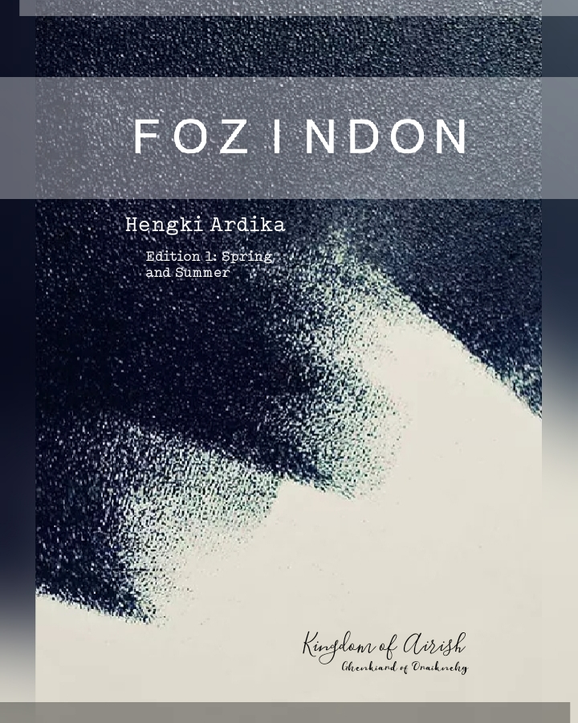

(((2400 - (31 / 30 / 5)) pi ((14 - (31 / 30 / 5)) i (08 - (31 / 30 / 5)) e (2022 - ((30 / 30 / 5))))) - ((0003 - (31 / 30 / 5)) pi ((14 - (31 / 30 / 5)) i (08 - (31 / 30 / 5)) e (2022 - ((31 / 30 / 5)))))) - (((2400 - (29 / 28 / 4)) pi ((14 - (29 / 28 / 4)) i (08 - (29 / 28 / 4)) e (2022 - ((29 / 28 / 4))))) - ((0003 - (29 / 28 / 4)) pi ((14 - (29 / 28 / 4)) i (08 - (29 / 28 / 4)) e (2022 - ((29 / 28 / 4))))))

46705023.90210461 i/translator

1270 1013 ©

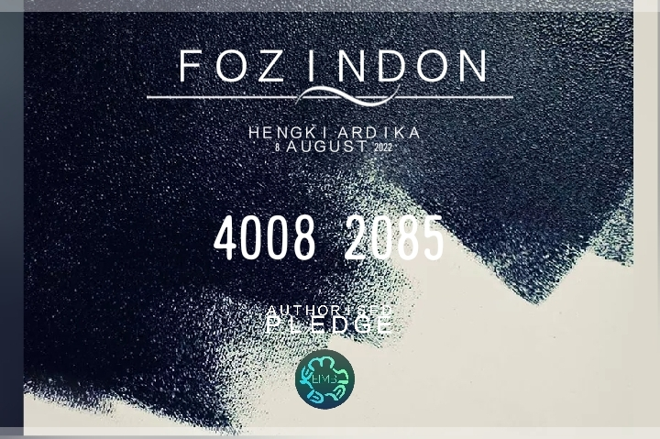

1986010807433913.4



((log((1986010807433913.4 * 195402022 - 1444)) ln(2015)) * 196701956) - 081815.51

35302660607.45006



Airish: 13.4

Fozindon: 4242

Authorised pledge: 1270 1013

Biography

Statistician at University of Aceh Tamiang, mathematician, computer science, educational technology, Indonesia, Journalist at The Stanford Journal of Science, Technology, and Society, Premiere Profrevha Organisation prominent chairman, Accrediting Commission for Community and Junior Colleges (ACCJC) member

Autobiography

National Mathematical Olympiad contestant of 1995, 2002, and 2003 from Indonesia; gold, gold, and silver achieved, SINTA journalist, statistician at Universitas Sumatera Utara, laureate, international student academia, professional teacher development and english speaking teacher, Diablo Valley College, Pleasant Hill, California

Online school, institution properties, and library

University of Aceh Tamiang, Kikouks Paok, One publication Corporate, Nine Business Market incorporate, Premiere Profrevha Organisation, Profrev ®, Profrevha ™, Profrevha One, Spy Agent Intelligent, Kikouks Paok ©, LLC, Tripped Nitch and Intelligence Kappa Agency, Hengkiardois, Ogrn & Ipp, Vae Vs Tnuc, Hengkiard Global Owner Office, Grn Acme, X; Mss and Lsimodse, Ghostlink, Cyberspace, Cyberservices, Maximus, Olympian, GrnX, Ispc, Toas, One Publication, Profrevha Trademark 740, Office 24, Building 24, Landlord, Tmdp, Wtab, Product, Plaintiff, Production, Eimb, Iaiiot, Uaeio, Airish, Supreme, Kp2tsp2m, Proportional Property, Lunar, Wednesday743ish, Hengki Ardika, Blockchain, and Blockchains.

E-books

1. University of Aceh Tamiang

2. Kikouks Paok II

3. GRN Acme

4. Kikouks Paok I, Enabler 2020

5. the Physicians | Neurodevelopmental Specialist (Neuromuscular and Neuro-oncology Subspecialties)

6. University College (the University Hengki Ardika Neurodevelopmental)

7. European Supreme Court for Australasian

8. Kikouks Paok Limited

9. Students Loan

10. Micro Sustainable System

11. Ghostlink

12. Simdif Kikouks Paok

13. Prenuptial Agreement

14. Ghenkiard of Draiknehg University College

15. International ISRC Agency

ISRC Manager Application Form, Kikouks Paok- Blockchains

16. IFPI- W

17. ISPC/International Standard Public Consumer

18. Professional Political Champagne

19. Global Demographic

20. Whole Government

21. John Tyler University College

22. Tripped Nitch

23. Profrevha Trademark

24. TNUC

25. Lunatic

26. The Laureates

27. Lid of Jar

28. Maximus

Publishes

1. profrevhaone@gmail.com
2. Profrevha One
3. Profrevha Trademark 740
4. Government
5. Governance
6. Ghenkiard of Draiknehg University College
7. Blockchains
8. Prenuptial Agreement
9. kikoukspaokonepublication@gmail.com
10. One publication corporation
11. Adtous
12. Career
13. Cyberspace
14. EIMB
15. ISPC
16. Production
17. kikoukspaok@gmail.com
18. UAEIO
19. BODH
20. GRN Acme
21. Hengkiardois
22. Indonesia
23. Kikouks Paok
24. Tripped Nitch
25. premiereprofrevhaorganisation@gmail.com
26. Airish
27. Premiere Profrevha Organisation
28. wednesday743ish@gmail.com
29. Tikibar
30. Hengki Ardika
31. John Tyler University College
32. Micro Sustainable System
33. OGRN
34. Profrevha
35. University of Aceh Tamiang
36. ardikahengki@gmail.com
37. Airbnb
38. Building 24
39. Landlord
40. TMDP
41. Office 24
42. WTAB
43. ardikahengki@yahoo.com
44. KP2TSP2M
45. Proportional Property
46. Supreme
47. wednesday743ish@yandex.com
48. TOAS
49. Cyberservices
50. One Publication
51. Maximus
52. wednesday743ish@vk.com
53. Olympian
54. Fozindon
55. Publication
56. pesan.untuk.saya@gmail.com
57. University of Profdorha
58. The Neuroscience University College
59. University of Profrevha
60. University of Indonesia
61. University College North Sumatera
62. Wednesday743ish University College
63. profrevhatm740@gmail.com
64. Profrevha Bank Central
65. Blockchain
66. Wednesday743ish Bank Central
67. Etcetera
68. profrevha@gmail.com
69. Profdorha
70. Cilukba Peekaboo
71. Lunar
72. Plaintiff
73. Produk
74. Profrev
75. Wednesday743ish
76. wednesday743ish@cyberservices.com
77. ~

Premiere Profrevha Organisation/PPO

pi i eigenValues({13.4}) e

8.539734222673567 i λ<sub>1</sub> + 114.4324385838258 i

X & Y/MSS (Small) & LSIMODSE (Big)/Mother and Father/Leader and Laureate

sgn(log(ln(2))) + 1

0

£13.4

A information services firm helping small businesses succeed/Commercial

Bank/Cyberspace/Etcetera Bank/Little Brother/Worker

Fundraising/Investment Banking/Conventional/ISPC/Profrevha Bank Central/Little Sister/Government Officer

Fundraiser/Bank/Constitutional/GrnX/Wednesday743ish Bank/Big Sister/Public Speaker, Submitter

Kikouks Paok Bank/Wednesday743ish/Hengki Ardika/Founder, CEO, Chairman

Gk 533

Republic Democratic Independence

[Premiere Profrevha Organisation](https://www.linkedin.com/company/premiereprofrevhaorganisation/" \o "https://www.linkedin.com/company/premiereprofrevhaorganisation/)

https://www.linkedin.com/company/premiereprofrevhaorganisation/

[Medium](https://medium.com/@EmsieLeij/list/premiere-profrevha-organisation-73a612e55e53" \o "https://medium.com/@EmsieLeij/list/premiere-profrevha-organisation-73a612e55e53)

https://medium.com/@EmsieLeij/list/premiere-profrevha-organisation-73a612e55e53

Airish

Philanthropy

1. X & Y/MSS (Small) & LSIMODSE (Big)/Mother and Father/Leader and Laureate
2. Fundraiser/Bank/Constitutional/GrnX/Wednesday743ish Bank/Big Sister/Public Speaker, Submitter
3. Kikouks Paok Bank/Wednesday743ish/Hengki Ardika/Founder, CEO, Chairman
4. Fundraising/Investment Banking/Conventional/ISPC/Profrevha Bank Central/Little Sister/Government Officer
5. Bank/Cyberspace/Etcetera Bank/Little Brother/Worker

As Laureate I have 5 or 6 coleslaw, I mend it for public

#6 Closing

People say dishonest is living,

To this world people keep use it in

It is actually from the life

Why you keep it up to live

Oh the option that given,

as present to gift, is used for right one

Oh

Ohhh

Why you don't know

What you left in this world only

Something that we never wanted to hear

You are dishonest to live up human

Oh

My life that I've know I received

is letting you to be in

for known you are

never been closing to me

Independent

π= 22/7

Π= 1

πΔ

δΠ

Πηενγκιαρδ

Πλανετ

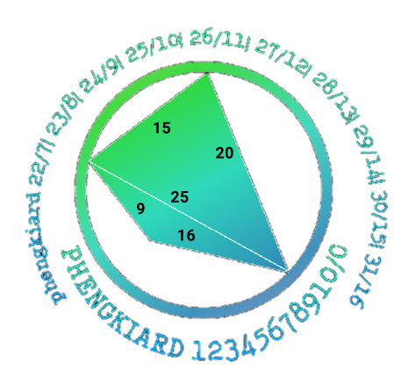

ςΟΛΑΤ

Βοδη

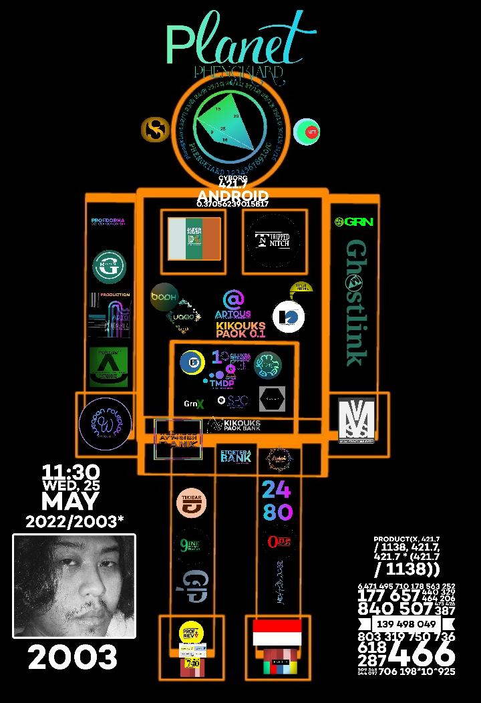

Ghenkiard Draiknehg

((2022 / 2003 * 1138) / 1148.794807788317523714428357463804293559660509236145781328007988017973040439340988517224163754368447) / 10

0.1

((2022 / 2003 * 1138) / 1148.794807788317523714428357463804293559660509236145781328007988017973040439340988517224163754368447) / 9

0.(1)

ςηαλατχ

Σ

I'm down, pi

This ring gives me peace, integral

The Peace's

The peaceful

Prenuptial Agreement/Russia

Publisher

Ardika Hengki, Philanthropist

((product(x, 0, 31, 8) sum(x, 0, 12, 1) integral(0, 2021, 1986, x)) eigenValues({13.4}) adjugate({{27, 38, 49}, {50, 61, 72}, {83, 94, 5}}) sgn(log(ln(16)))) x y

{{-2.671792027768194*10^40 x y λ<sub>1</sub> - 3.58020131720938*10^41 x y, 1.825566083030225*10^40 x y λ<sub>1</sub> + 2.446258551260501*10^41 x y, -1.0458972350694*10^39 x y λ<sub>1</sub> - 1.401502294992996*10^40 x y}, {2.367117615813195*10^40 x y λ<sub>1</sub> + 3.171937605189681*10^41 x y, -1.625481394582166*10^40 x y λ<sub>1</sub> - 2.178145068740102*10^41 x y, 2.091794470138799*10^39 x y λ<sub>1</sub> + 2.803004589985991*10^40 x y}, {-1.500635163360443*10^39 x y λ<sub>1</sub> - 2.010851118902994*10^40 x y, 2.546532398429843*10^39 x y λ<sub>1</sub> + 3.412353413895989*10^40 x y, -1.0458972350694*10^39 x y λ<sub>1</sub> - 1.401502294992996*10^40 x y}}

2.436000510490557*10^121 x^3 y^3 λ<sub>1</sub> + 4.522166240607702*10^118 x^3 y^3 λ<sub>1</sub>^3 + 1.817910828724296*10^120 x^3 y^3 λ<sub>1</sub>^2 + 1.088080228019115*10^122 x^3 y^3

-4.401863145857299*10^40 x y λ<sub>1</sub> - 5.898496615448781*10^41 x y

3

2.436000510490557*10^121 x^3 y^3 λ<sub>1</sub> + 4.522166240607702*10^118 x^3 y^3 λ<sub>1</sub>^3 + 1.817910828724296*10^120 x^3 y^3 λ<sub>1</sub>^2 + 1.088080228019115*10^122 x^3 y^3 - 1.077643841112435*10^81 x^2 y^2 λ λ<sub>1</sub> - 4.02105910862849*10^79 x^2 y^2 λ λ<sub>1</sub>^2 - 7.220213735453317*10^81 x^2 y^2 λ - 4.401863145857299*10^40 x y λ^2 λ<sub>1</sub> - 5.898496615448781*10^41 x y λ^2 - λ^3

{{-2.671792027768194*10^40 x y λ<sub>1</sub> - 3.58020131720938*10^41 x y, 1.825566083030225*10^40 x y λ<sub>1</sub> + 2.446258551260501*10^41 x y, -1.0458972350694*10^39 x y λ<sub>1</sub> - 1.401502294992996*10^40 x y}, {2.367117615813195*10^40 x y λ<sub>1</sub> + 3.171937605189681*10^41 x y, -1.625481394582166*10^40 x y λ<sub>1</sub> - 2.178145068740102*10^41 x y, 2.091794470138799*10^39 x y λ<sub>1</sub> + 2.803004589985991*10^40 x y}, {-1.500635163360443*10^39 x y λ<sub>1</sub> - 2.010851118902994*10^40 x y, 2.546532398429843*10^39 x y λ<sub>1</sub> + 3.412353413895989*10^40 x y, -1.0458972350694*10^39 x y λ<sub>1</sub> - 1.401502294992996*10^40 x y}}

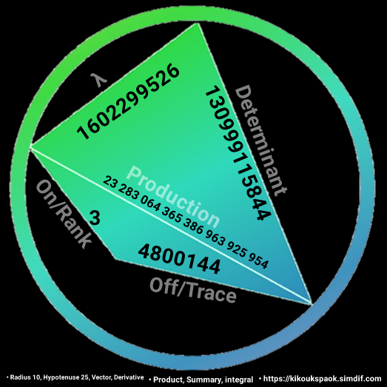

(75000000 * 11) / 20000

41250

(75000000 * 11)

825000000

Country

XY

pi i eigenValues({13.4}) e

i pi e λ<sub>1</sub> + ((67 i pi e)/5)

i pi e (λ<sub>1</sub> + (67/5))

(i (5 pi e λ<sub>1</sub> + 67 pi e))/5

8.539734222673567 i λ<sub>1</sub> + 114.4324385838258 i

8.539734222673567 i λ<sub>1</sub> + 114.4324385838258 i

8.539734222673567 i

((8.539734222673567 i λ<sub>1</sub>^2)/2) + 114.4324385838258 i λ<sub>1</sub>

Communication

Organisation

* Google
* Simdif
* Microsoft
* Xiaomi
* Fujitsu
* ~~OPPO~~

75000000 / 25

3000000

(75000000 / 25) / 5

600000

5 / 13.4 * 1.94

0.723880597014925

Company

(6166 International Standard Organization)

100000013011 * 6.166

616600080225.83

* 616600080226/Wednesday743ish

100000013011 * 6.1661

616610080227.13

* 616610080227/Profrevha Trademark

/Kikouks Paok Bank/Great Britain



Fozindon works with a series of basic triggers, which will usually trigger your build order.

The first trigger is the mouse position after which you select your build.

This is a basic build to get your bank and build the basics of a bot, Fozindon’s bots require slightly more upgrades to become really competitive, but are mostly suitable for beginners.

Using Fozindon’s bot

If you want to see some basic gameplay, then check out my channel, I stream regularly, feel free to drop in. I usually play anything from some AoT bot to Botball 2 and 2v2 bots.

[{(Hypotenuse 25)-3},{sgn(log(ln(2)))}+ 1]

Using Fozindon’s bot as an attacker

-XY

If you want to use Fozindon’s bot to attack a base, the first thing you need to do is to find the mineral blocks of your opponent. If they have a base near you, use the following steps:

Check the mineral block levels (lighter and darker represent higher levels of mineral). First, scan the area (you will get a map) and see where the main areas are where your opponent could build his main, gas and mineral nodes. Then select the actual location (you will get a map) and scan. After that, select where your own mineral nodes are located and where your opponent’s are located. That is where you will build your bot, where you will scan. For attacking your opponent’s main, check the mineral blocks of his main, gas and mineral nodes. Then select where your opponent’s main, gas and mineral nodes are located. After that, select the actual location. Then, you will need to build the correct infrastructure for the attack. Fozindon’s bots require a fairly heavy amount of investment for two, three or four attackers, depending on how far your enemy’s resources are. You will not just rush in and destroy everything, but rather wait for the right moment to use the right tactics. And of course, keep watching out for your opponent. Always try to find the weak spots and make sure that you use them at exactly the right moment.

You can check out a basic map to understand how the path of a typical attack looks like in some areas:

Fozindon’s bot as a defender

XY is Currency

Nominal is Sustainable

If you want to defend yourself with Fozindon’s bot, you first need to build it on your enemy’s base. But here is the tricky part: if your enemy is around you (you have the shortest path to your base), then you can use the same detection routes (lighter and darker areas) to find out exactly where your enemy is. This means that if you did not kill them, you will not be able to find out exactly where they are, so you will have to build the path to your base, the way you want to defend yourself, and then build your bot in that way. It will help you a lot and you will be quite secure with your investment.

If your enemy is close to you, then you can use the same steps to find the right route to your base. You will get a map in some areas, so you will have to focus on the path of least resistance, the closest one to your base. Then, you will select where your own mineral nodes are located

Fozindon’s bot as a neutral

Cybernetics 2

eucDist({25 - 3}, {sgn(log(ln(2))) + 1}) x y

22 x y

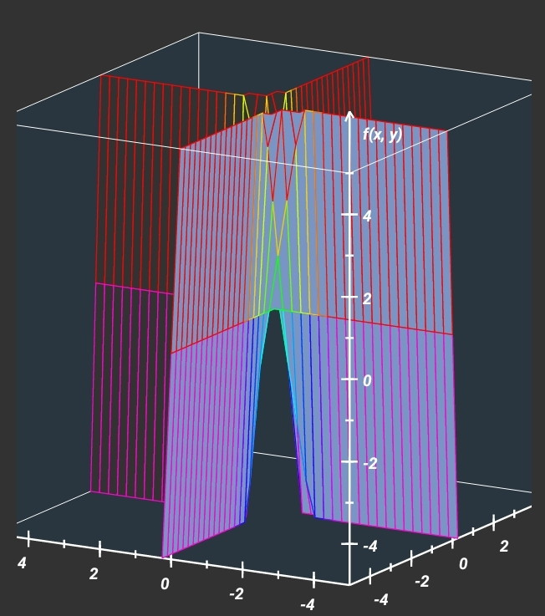

22 x y

22 x y

22 y

22 x

11 x^2 y

11 x y^2

Courtesy Lunar and Ghostlink

= Biography =

{{Infobox person

| name = Hengki Ardika

| image = Hengkiardika.jpg

| birth_date = 08 January 1986

| birth_place = Rantau

| nationality = Indonesian

| education = Diploma III

| alma_mater = Universitas Sumatera Utara

| occupation = Author and Journalist

| organization = Premiere Profrevha Organisation

| awards = Gold, gold, silver National Mathematical Olympiad

| signature = Hengki Ardika signature.png

| footnotes = A good god to dadties and all weighing to the biggest

}}

Statistician at [https://universityofacehtamiang.simdif.com University of Aceh Tamiang], mathematician, computer science, educational technology, Indonesia, Journalist at [https://ojs.stanford.edu/ojs/index.php/intersect/authorDashboard/submission/2332 The Stanford Journal of Science, Technology, and Society] , [https://universityofacehtamiang.simdif.com Premiere Profrevha Organisation] prominent chairman, [https://accjc.com Accrediting Commission for Community and Junior Colleges (ACCJC) member]

= Autobiography =

National Mathematical Olympiad contestant of 1995, 2002, and 2003 from Indonesia; gold, gold, and silver achieved, SINTA journalist, statistician at Universitas Sumatera Utara, laureate, international student academia, professional teacher development and english speaking teacher, [https://dvc.academia.edu/HengkiArdika Diablo Valley College, Pleasant Hill, California]

= Online school, institution properties, and library =

[https://kikoukspaok.simdif.com Kikouks Paok], [https://grnacme.simdif.com GRN Acme], [https://onepublication.simdif.com One publication], [https://profrevha.simdif.com Profrevha Trademark], [https://hengkiardika.simdif.com Hengki Ardika (Dermawan)], [https://airish.simdif.com Airish (Philanthropist)

= E-books =

[https://issuu.com/kikoukspaokltd/docs/uoat_university_of_aceh_tamiang_.docx University of Aceh Tamiang], [https://issuu.com/kikoukspaokltd/docs/kikouks_paok_ii.docx Kikouks Paok II], [https://issuu.com/kikoukspaokltd/docs/grn_acme_cover-wps_office.docx, GRN Acme]

[https://issuu.com/kikoukspaokltd/docs/img_20201230_094335 Kikouks Paok I, Enabler 2020], [https://issuu.com/kikoukspaokltd/docs/neurodevelopmental_specialist_neuromuscular_and_n the Physicians | Neurodevelopmental Specialist (Neuromuscular and Neuro-oncology Subspecialties)], [https://issuu.com/kikoukspaokltd/docs/university_college_the_university_hengki_ardika_n University College (the University Hengki Ardika Neurodevelopmental)], [https://issuu.com/kikoukspaokltd/docs/black_forhead_and_islamic_centre.docx European Supreme Court for Australasian], [https://issuu.com/kikoukspaokltd/docs/kikouks_paok_limited.docx Kikouks Paok Limited], [https://issuu.com/kikoukspaokltd/docs/students_loan.docx Students Loan], [https://issuu.com/kikoukspaokltd/docs/micro_sustainable_system.docx Micro Sustainable System], [https://issuu.com/kikoukspaokltd/docs/_hengki_ardika_.docx Ghostlink], [https://issuu.com/kikoukspaokltd/docs/simdif_press_release Simdif Kikouks Paok], [https://issuu.com/kikoukspaokltd/docs/prenup.docx Prenuptial Agreement], [https://issuu.com/kikoukspaokltd/docs/ghenkiard_of_draiknehg_university_college.docx Ghenkiard of Draiknehg University College], [https://issuu.com/kikoukspaokltd/docs/isrc_manager_application_form_rev_1_25_.docx International ISRC Agency], ISRC Manager Application Form, Kikouks Paok- Blockchains], [https://issuu.com/kikoukspaokltd/docs/wednesday743ish.docx IFPI- W], [https://issuu.com/kikoukspaokltd/docs/_ispc_international_standard_public_consumer.docx ISPC/International Standard Public Consumer], [https://issuu.com/kikoukspaokltd/docs/professional_political_champagne.docx Professional Political Champagne], [https://issuu.com/kikoukspaokltd/docs/the_philanthropist.docx Global Demographic], [https://issuu.com/kikoukspaokltd/docs/whole_government.docx Whole Government], [https://issuu.com/kikoukspaokltd/docs/the_diplomats_john_tyler_university_college_foun John Tyler University College], [https://issuu.com/kikoukspaokltd/docs/premiere_profrevha_organisation.docx Tripped Nitch], [https://issuu.com/kikoukspaokltd/docs/profrevha_trademark Profrevha Trademark], [https://issuu.com/kikoukspaokltd/docs/tnuc TNUC], [https://issuu.com/kikoukspaokltd/docs/lunatic Lunatic], [https://issuu.com/kikoukspaokltd/docs/the_laureates.docx The Laureates], https://play.google.com/books/reader?id=1Vy5LgAAAEAJ&pg=GBS.PA0 Lid of Jar], <nowiki>[https://issuu.com/kikoukspaokltd/docs/maximus.docx Maximus]</nowiki>

= Reference =

<ref>[https://sinta.kemdikbud.go.id/profile/books Whole Government ] Government </ref>

<references />

<ref>{{Cite web|last=Ardika|first=Hengki|date=13 July 2022|title=Wednesday743ish|url=https://issuu.com/kikoukspaokltd?issuu_product=header&issuu_subproduct=publisher-suite-workflow&issuu_context=link&issuu_cta=profile|website=Issuu|access-date=23 August 2022}}</ref><ref>{{Cite web|last=Ardika|first=Hengki|date=24 August 2022|title=Tracer Study|url=https://tracerstudy.usu.ac.id/survey/answer/1?category_id=0|website=Tracer Study|access-date=24 August 2022}}</ref>

<references />

<ref>{{Cite web|last=Ardika|first=Hengki|date=24 August 2022|title=Alumni, Hengki Ardika|url=https://direktori.usu.ac.id/|website=Direktori USU|access-date=24 August 2022}}</ref><ref>{{Cite web|last=Ardika|first=Hengki|date=13 July 2022|title=The Laureates|url=https://ojs.stanford.edu/ojs/index.php/intersect/submissions#archive|website=The Stanford Journal of Science Technology and Society|access-date=24 August 2022}}</ref>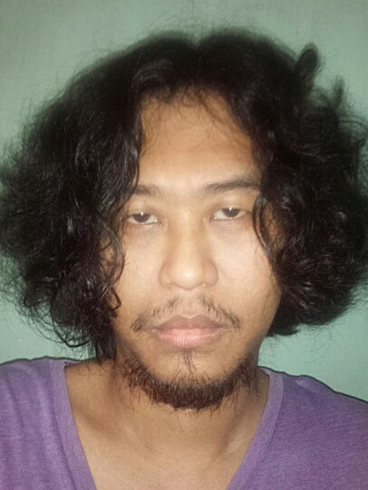/Fozindon/Romania

315 /35 = 9/MSS

857 - 726= 131/LSIMODSE

(x,y) = (1.1)

(xy) = 3

TOAS

One Publication= 1/2 LP net-worth

36 / 9 * 131

524

FOZ

One house

(((524 * 523 * 524)^524) / 524 / 524)

8.230214448231197456424350663350164286768155758845572487917388193904415196611803574379678886053442923*10^4268

(1.616255*10^-35 * 10^50) / 22 x y

73466136363636.(36) x y

734661 / 36

20407.25

Eminent/TOAS (Applied Planck Length Implementation)

315 /35 = 9/MSS

857 - 726= 131/LSIMODSE

(x,y) = (1.1)

(xy) = 3

TOAS

One Publication= 1/2 LP net-worth

36 / 9 * 131

524

FOZ

One house

(((524 * 523 * 524)^524) / 524 / 524)

8.230214448231197456424350663350164286768155758845572487917388193904415196611803574379678886053442923*10^4268

(1.616255*10^-35 * 10^50) / 22 x y

73466136363636.(36) x y

734661 / 36

20407.25 is Fozindon (Virtual Private Network)

Courtesy of Profrevha Trademark

{{Infobox pengguna

|nama = Hengki Ardika

|status = Penulis

|gambar = Hengkiardika.jpg

|caption = Hengki Ardika

|nama lahir = Hengki Ardika

|alias = H.A

|ttd = Hengki Ardika signature.png

|laki/perempuan = laki

|tanggal lahir = 1986

|tempat lahir = Rantau

|pekerjaan = Penulis dan jurnalis

|darah = A

|IQ = 326

|kepribadian = introver

|hobi = melengkapi ensiklopedia

|orientasi = hetero

|ras = Asia

|etnis = Aceh

|tinggi = 174 cm

|massa = 60 kg

|kulit = putih

|rambut = hitam

|mata = hitam

|lokasi = Aceh Tamiang

|zona = UTC

|negara = Indonesia

|menikah = singel

|pasangan = --

|anak = --

|pacar = --

|pendidikan = diploma 3

|sekolah = Indonesia

|SD = Indonesia

|SMP = Indonesia

|SMA = Indonesia

|universitas = Sumatera Utara

|agama = Islam

|ideologi = Pendalaman

|politik = pendiri

|situs = https://hengkiardika.simdif.com

|surel = hardika593@insite.4cd.edu

|interests = aktif menulis dan menyunting

artikel ensiklopedia, membaca buku,

mengurus perpustakaan, dan segala hal

yang berkaitan dengan buku dan

pengetahuan ;)

|subpages=

|userboxes=

{{User id-2}}

}}

Statistikawan di [https://universityofacehtamiang.simdif.com University of Aceh Tamiang], matematikawan, ilmu komputer, pendidikan teknologi, Indonesia, Jurnalis di [https://ojs.stanford.edu/ojs/index.php/intersect/authorDashboard/submission/2332 The Stanford Journal of Science, Technology, and Society] , [https://universityofacehtamiang.simdif.com Premiere Profrevha Organisation] ketua keanggotaan, [https://accjc.org Accrediting Commission for Community and Junior Colleges (ACCJC) keanggotaan]]

Philanthropist at [https://universityofacehtamiang.simdif.com University of Aceh Tamiang], mathematician, computer science, educational technology, Indonesia, Journalist at [https://ojs.stanford.edu/ojs/index.php/intersect/authorDashboard/submission/2332 The Stanford Journal of Science, Technology, and Society] , [https://universityofacehtamiang.simdif.com Premiere Profrevha Organisation] prominent chairman, [https://accjc.org Accrediting Commission for Community and Junior Colleges (ACCJC) apprenticeship member]

= Autobiography =

National Mathematical Olympiad contestant of 1995, 2002, and 2003 from Aceh Timur, Aceh Tamiang; Indonesia; gold, gold, and silver achieved, SINTA journalist, statistician at Universitas Sumatera Utara, laureate, [https://dvc.academia.edu/HengkiArdika international student academia, professional teacher development and english speaking teacher, Diablo Valley College, Pleasant Hill, California]

= Online school, institution properties, and library =

[https://kikoukspaok.simdif.com Kikouks Paok], [https://grnacme.simdif.com GRN Acme], [https://onepublication.simdif.com One publication], [https://profrevha.simdif.com Profrevha Trademark], [https://hengkiardika.simdif.com Hengki Ardika (Dermawan)], [https://airish.simdif.com Airish (Philanthropist)]

= E-books =

[[Berkas:Whole Government, book's cover.png|al=Whole Government book's cover |jmpl|whole government book]]

[https://issuu.com/kikoukspaokltd/docs/uoat_university_of_aceh_tamiang_.docx University of Aceh Tamiang], [https://issuu.com/kikoukspaokltd/docs/kikouks_paok_ii.docx Kikouks Paok II], [https://issuu.com/kikoukspaokltd/docs/grn_acme_cover-wps_office.docx, GRN Acme]

[https://issuu.com/kikoukspaokltd/docs/img_20201230_094335 Kikouks Paok I, Enabler 2020], [https://issuu.com/kikoukspaokltd/docs/university_college_the_university_hengki_ardika_n University College (the University Hengki Ardika Neurodevelopmental)], [https://issuu.com/kikoukspaokltd/docs/black_forhead_and_islamic_centre.docx European Supreme Court for Australasian], [https://issuu.com/kikoukspaokltd/docs/kikouks_paok_limited.docx Kikouks Paok Limited], [https://issuu.com/kikoukspaokltd/docs/students_loan.docx Students Loan], [https://issuu.com/kikoukspaokltd/docs/micro_sustainable_system.docx Micro Sustainable System], [https://issuu.com/kikoukspaokltd/docs/_hengki_ardika_.docx Ghostlink],

[https://issuu.com/kikoukspaokltd/docs/simdif_press_release Simdif Kikouks Paok],

[https://issuu.com/kikoukspaokltd/docs/prenup.docx Prenuptial Agreement], [https://issuu.com/kikoukspaokltd/docs/ghenkiard_of_draiknehg_university_college.docx Ghenkiard of Draiknehg University College], [https://issuu.com/kikoukspaokltd/docs/isrc_manager_application_form_rev_1_25_.docx International ISRC Agency, ISRC Manager Application Form-Kikouks Paok-Blockchains], [https://issuu.com/kikoukspaokltd/docs/wednesday743ish.docx IFPI- W], [https://issuu.com/kikoukspaokltd/docs/_ispc_international_standard_public_consumer.docx ISPC/International Standard Public Consumer], [https://issuu.com/kikoukspaokltd/docs/professional_political_champagne.docx Professional Political Champagne], [https://issuu.com/kikoukspaokltd/docs/the_philanthropist.docx Global Demographic], [https://issuu.com/kikoukspaokltd/docs/whole_government.docx Whole Government], [https://issuu.com/kikoukspaokltd/docs/the_diplomats_john_tyler_university_college_foun John Tyler University College], [https://issuu.com/kikoukspaokltd/docs/premiere_profrevha_organisation.docx Tripped Nitch],

[https://issuu.com/kikoukspaokltd/docs/profrevha_trademark Profrevha Trademark],

[https://issuu.com/kikoukspaokltd/docs/tnuc TNUC], [https://issuu.com/kikoukspaokltd/docs/lunatic Lunatic], [https://issuu.com/kikoukspaokltd/docs/the_laureates.docx The Laureates], [https://play.google.com/books/reader?id=1Vy5LgAAAEAJ&pg=GBS.PA0 Lid of Jar],

[https://issuu.com/kikoukspaokltd/docs/maximus.docx Maximus]

= Application =

[[Berkas:Kikouks Paok.png|al=Kikouks Paok Logo |jmpl|Kikouks Paok]]

[https://appsgeyser.io/15201665/Kikouks-Paok Kikouks Paok]

[https://appsgeyser.io/15201602/GRN-Acme GRN Acme]

[https://appsgeyser.io/15201799/Cilukba-Peekaboo Cilukba Peekaboo]

= Reference =

<ref>[https://sinta.kemdikbud.go.id/profile/books Whole Government ] SINTA book </ref>

<references />

<ref>{{Cite web|last=Ardika|first=Hengki|date=13 July 2022|title=Wednesday743ish|url=https://issuu.com/kikoukspaokltd?issuu_product=header&issuu_subproduct=publisher-suite-workflow&issuu_context=link&issuu_cta=profile|website=Issuu|access-date=23 August 2022}}</ref><ref>{{Cite web|last=Ardika|first=Hengki|date=24 August 2022|title=Tracer Study|url=https://tracerstudy.usu.ac.id/survey/answer/1?category_id=0|website=Tracer Study|access-date=24 August 2022}}</ref>

<references />

<ref>{{Cite web|last=Ardika|first=Hengki|date=24 August 2022|title=Alumni, Hengki Ardika|url=https://direktori.usu.ac.id/|website=Direktori USU|access-date=24 August 2022}}</ref><ref>{{Cite web|last=Ardika|first=Hengki|date=13 July 2022|title=The Laureates|url=https://ojs.stanford.edu/ojs/index.php/intersect/submissions#archive|website=The Stanford Journal of Science Technology and Society|access-date=24 August 2022}}</ref>

<references />

<ref>{{Cite web|last=Ardika|first=Hengki|date=24 August 2022|title=Hengki Ardika|url=https://sman1kejuruanmuda.sch.id/read/2/profil|website=SMA 1 Kejuruan Muda|access-date=24 August 2022}}</ref>

<references />

<ref>{{Cite web|last=Ardika|first=Hengki|date=24 August 2022|title=Hengki Ardika|url=https://dapo.kemdikbud.go.id/sekolah/3BE0D4C6F8BD13EC8AA9|website=SMP Dharma Patra|access-date=24 August 2022}}</ref><ref>{{Cite web|last=Ardika|first=Hengki|date=24 August 2022|title=Hengki Ardika|url=https://data.sekolah-kita.net/sekolah/SD%20SWASTA%20DHARMA%20PATRA_165711|website=SD Dharma Patra|access-date=24 August 2022}}</ref><ref>{{Cite web|last=Ardika|first=Hengki|date=24 August 2022|title=Hengki Ardika|url=https://sekolah.data.kemdikbud.go.id/index.php/chome/profil/C7135D1C-46F7-4315-BF0C-6CE33561821A|website=Taman Kanak Kanak|access-date=24 August 2022}}</ref>

<references />

[[Kategori:Student Nonviolent Coordinating Committee]]