Comparative Analysis of Machine Learning and Deep Learning (LSTM) Algorithms for Stock Market Price Prediction

Danish Awasthi
Chitkara University Institute of Engineering and Technology
Chitkara University, Rajpura, Punjab, India
danish247.be22@chitkara.edu.in

Mayank Gupta
Chitkara University Institute of Engineering and Technology
Chitkara University, Rajpura, Punjab, India
mayank567.be22@chitkara.edu.in

Abstract— Stock market prediction remains a difficult task because financial time-series data is highly non-linear, volatile, and constantly changing over time. In this study, we compare the performance of six traditional machine learning models - Linear Regression, Support Vector Machine (SVM), Decision Tree, Random Forest, Gradient Boosting, and K-Nearest Neighbours (KNN)âwith a deep learning model, Long Short-Term Memory (LSTM), for predicting the next-day closing price of Apple Inc. (AAPL). The models are trained on historical data from 2015 to 2024 from Yahoo Finance along with 18 engineered technical indicators including moving averages, RSI, MACD and Bollinger Bands. We use standard regression metrics such as MAE, RMSE, RÂ² and MAPE for performance evaluation across three chronological train-test splits (70:30, 80:20 and 90:10). The results indicate that Gradient Boosting performs best overall (RÂ² = 0.9891, RMSE = 4.21) and outperforms LSTM (RÂ² = 0.9742, RMSE = 6.43). Also, we perform an exhaustive analysis of scalability and computational complexity showing that ensemble ML models are considerably faster to train and scale linearly with data, whereas LSTM requires GPU infrastructure for bigger deployments.
Keywords— Stock market prediction, machine learning, deep learning, LSTM, random forest, gradient boosting, support vector machine, financial forecasting, time-series analysis, technical indicators, scalability analysis.

1. Introduction

Financial markets are highly dynamic, noisy and non-linear in nature and thus stock market prediction has been one of the most challenging problems in the field of computational finance. Stock prices are influenced by a complicated mix of macroeconomic conditions, geopolitical events, investor sentiment, institutional activity and unexpected global events. These factors cause uncertainty and volatility in financial time-series data, which makes accurate prediction impossible even for sophisticated forecasting systems.
Traditional statistical forecasting methods like ARIMA and exponential smoothing offer interpretable mathematical models but on the other hand often fail to identify the hidden non-linear dependencies and the changing temporal relations in stock market data. With the increased computational power and the availability of large scale historical datasets, machine learning and deep learning techniques have become powerful alternatives for financial forecasting. Random Forest and Gradient Boosting are examples of ensemble machine learning models that have demonstrated strong predictive performance, thanks to their capability to model non-linear feature interactions with relatively low computational complexity. Meanwhile, Long Short-Term Memory (LSTM) networks and other deep learning architectures have gained much attention for their capability to learn sequential dependencies and long-term temporal patterns from time-series data.
There is a significant amount of research on this subject. However, many previous studies assess machine learning and deep learning models in isolation with non-uniform preprocessing conditions, feature engineering pipelines and evaluation metrics. As a result, it is not a good practice to compare algorithms directly. Besides, most of the existing studies mainly focus on the prediction accuracy and ignore the aspects relevant to the practical deployment like computational complexity, scalability, training time, inference latency and hardware requirements.
To overcome these limitations, this study proposes a unified comparative framework to evaluate six machine learning algorithms and one deep learning model (LSTM) under the same experimental conditions, using the same dataset, feature engineering strategy, preprocessing pipeline, and chronological train-test splits. Besides predictive performance, the work also analyses scalability and deployment-oriented recommendations to bridge the gap between academic benchmarking and practical financial forecasting systems.
This work makes the following key contributions: (1) a controlled comparison of six machine learning models and an LSTM architecture in the same setting, (2) the inclusion of 18 engineered technical indicators based on OHLCV data, (3) evaluation over several chronological train-test splits for robustness, (4) scalability and computational complexity analysis to evaluate the feasibility of deployment, and (5) deployment-oriented recommendations for real-world financial forecasting systems.
The rest of the paper is structured as follows. Section 2 reviews the literature regarding stock market prediction via machine learning and deep learning algorithms. Section 3 introduces the dataset details, feature engineering methods, preprocessing steps, and experiment setup. Section 4 describes the experiment results, comparison of the models, scalability of the proposed approach, and interpretation of feature importance. Lastly, Section 5 provides the conclusion of the paper and future work.

Predicting stock markets is perceived to be a very complex problem in computational finance because of the unpredictable nature of financial data. There are many variables that can affect the behavior of markets and make the process of making predictions quite challenging. Due to the abundance of information and computing power, ML and DL methods have attracted a lot of attention in predicting financial markets because of their capability to learn from past data [1][2].

Classical statistics models such as ARIMA and exponential smoothing are interpretable yet tend to fall short when trying to explain the intricate, non-linear associations within financial time series data. Machine Learning techniques, especially ensemble approaches like Random Forest and Gradient Boosting, demonstrate superior feature interaction capabilities while being computationally feasible [3], [4]. Recently, Deep Learning architectures such as LSTM have been used for financial predictions. The LSTM model is built to deal with sequential data and can learn long-term dependencies that conventional recurrent neural networks are known to suffer from due to the vanishing gradient problem [5].

This study investigates whether there exists an answer to this question through a comparative study of six Machine Learning models and the LSTM algorithm on a ten-year stock dataset supplemented by eighteen technical indicators.

1.1 Research Motivation

Even though there have been a lot of studies investigating the application of machine learning and deep learning algorithms for stock market predictions, very few of them have done a comparison study. Comparative analyses between different types of algorithms are quite rare, particularly if the algorithms are compared based on their performances within similar circumstances. Due to varying data preprocessing procedures, feature selection techniques, and evaluation methodologies, it might be challenging to derive any meaningful results [6]. This paper concentrates on a comparative study in which all the algorithms are trained and evaluated using the same datasets, same features, and the same chronology.

1.2 Contributions

Key contributions made by this paper include:

A comparative analysis of six machine learning algorithms as well as an LSTM algorithm under the same experimental setup.

A process of feature generation based on 18 technical indicators calculated from OHLCV data.

Testing under various chronological train-test splits (70:30, 80:20, 90:10).

An exhaustive scalability analysis on training speed, prediction speed, and complexity of the models.

Model interpretability through feature importance with Random Forest.

Real-life practical advice on which model to choose.

2. Related Work

There have been a great many studies conducted on the topic of stock market prediction through machine learning and deep learning techniques. The important research studies carried out on this topic are listed in Table III.

2.1 Traditional Machine Learning Approaches

A number of papers have been written on the effectiveness of classical ML models for stock forecasting. In one paper, Ravikumar and Saraf [7] conducted a comparative study between SVM, KNN, Decision Tree, Random Forest, Linear Regression, and Naive Bayes. From their experiments, they found that Random Forest provided the best regression performance, while ensemble techniques produced more accurate directional prediction. Another experiment by Vazirani et al. [8] included a comparison between various ML models together with the hybrid Linear Regression model. The results from this research revealed that the hybrid model always had superior performance compared to each individual algorithm. Likewise, Singh et al. [9] indicated that Gradient Boosting provided significantly higher accuracy than SVM because of its iterative error correction technique.

2.2 Deep Learning — LSTM

Long Short-Term Memory (LSTM), developed by Hochreiter and Schmidhuber [5], was specifically created to solve problems related to the vanishing gradient and to model long-term dependencies. LSTM was used by Fischer and Krauss [12] to predict the direction of the S&P 500 and obtained better results in comparison with DNN, Random Forest, and logistic regression. Nelson et al. [13] claimed that LSTM with technical indicators was capable of providing only mediocre results for IBM stocks. Moghar and Hamiche [14] demonstrated that LSTM works better than conventional recurrent neural networks, especially in terms of prediction errors over a longer period of time. Mehtab et al. [15] expanded this concept further by using hybrid CNN-LSTM models.

2.3 Survey and Comparative Studies

In general, from all the previous surveys and comparative studies carried out, it appears that ML models in general and Gradient Boosting models in particular achieve great results when applied to structured finance data. The most important drawback of previous research, which is addressed in this paper, is the lack of a controlled experiment with a scalability analysis of both ML and DL models.

TABLE III. LITERATURE SURVEY AND INDEXING
Reference (Author, Year) | Algorithm(s) | Key Finding / Contribution
Hochreiter & Schmidhuber [5], 1997 | LSTM | Introduced LSTM to solve vanishing gradient and enable long-term dependencies.
Fischer & Krauss [12], 2018 | LSTM vs. DNN, RF, LR | LSTM outperformed baselines on S&P 500 directional prediction.
Nelson et al. [13], 2017 | LSTM + Technical Indicators | 55.9% directional accuracy on IBM stock using LSTM with indicators.
Moghar & Hamiche [14], 2020 | LSTM vs. RNN | LSTM showed lower RMSE vs. standard RNN for longer prediction horizons.
Mehtab et al. [15], 2021 | CNN-LSTM Hybrid | Hybrid model improved performance by capturing short- and long-term patterns.
Ravikumar & Saraf [7], 2020 | SVM, KNN, DT, RF, LR, NB | Random Forest achieved highest regression accuracy; feature engineering is crucial.
Vazirani et al. [8], 2020 | SVM, KNN, LR, DT, RF, Hybrid | Hybrid Linear Regression model outperformed individual algorithms.
Singh et al. [9], 2021 | Gradient Boosting, SVM | Gradient Boosting achieved higher accuracy than SVM via iterative learning.
Reddy & Magesh Kumar [10], 2022 | Gradient Boosting, Naive Bayes | Gradient Boosting outperformed Naive Bayes in predictive capability.
Shih et al. [11], 2023 | RF, SVM | Random Forest with feature selection outperformed SVM for ETF prediction.

* Comprehensive indexing of related works with algorithm comparison and key contributions.

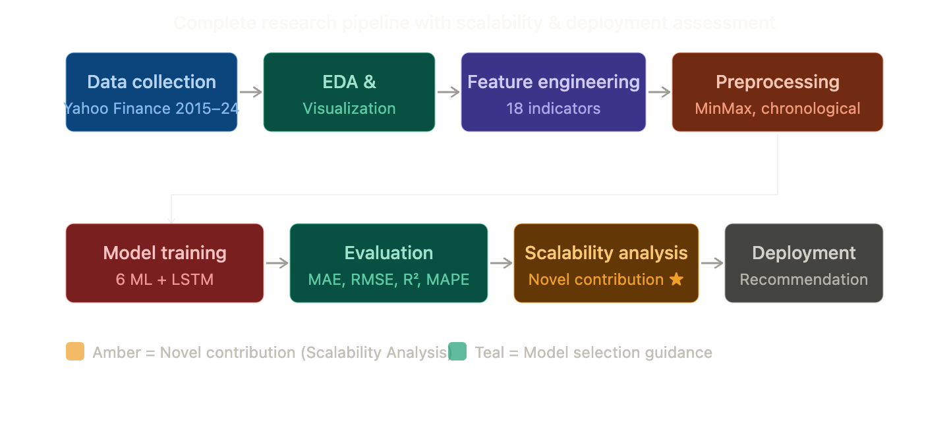
Figure A.1: Full Research Pipeline with Scalability and Deployment Consideration

The planned pipeline for the research comprises of data acquisition, feature engineering, preprocessing, modeling, evaluation, scalability study, and deployment consideration. The element of scalability assessment forms part of our innovation.

3. Methodology and Experimental Setup

3.1 Dataset

OHLCV data for Apple Inc. (AAPL) was retrieved from Yahoo Finance from January 2015 to December 2024, encompassing about 2,515 trading days. AAPL was chosen due to its liquidity, data consistency, and common practice of being used as a benchmark stock in prediction studies. The objective variable refers to the closing price on the following trading day, which results in a one-step-ahead regression problem.

The charts in Figures 1 and 2 represent the historical price performance and trading volume of AAPL during the complete 10-year period, highlighting the notable instances of high volatility such as the 2020 pandemic market crash and the 2022 tech correction.

3.1.1 Data Source and Citation
The dataset used in the current study for historical open-high-low-close-volume for Apple Inc. (AAPL) was downloaded from Yahoo Finance, which is an online repository of financial market data that is publicly available. The dataset covered a period between January 2015 and December 2024 and contained around 2,515 trading days. After feature extraction and eliminating rows with NaN values, about 2,440 data points were left for modeling purposes.
Reference:
Yahoo Finance. (2024). Historical prices: Apple Inc. (AAPL). Retrieved from https://finance.yahoo.com/quote/AAPL/history

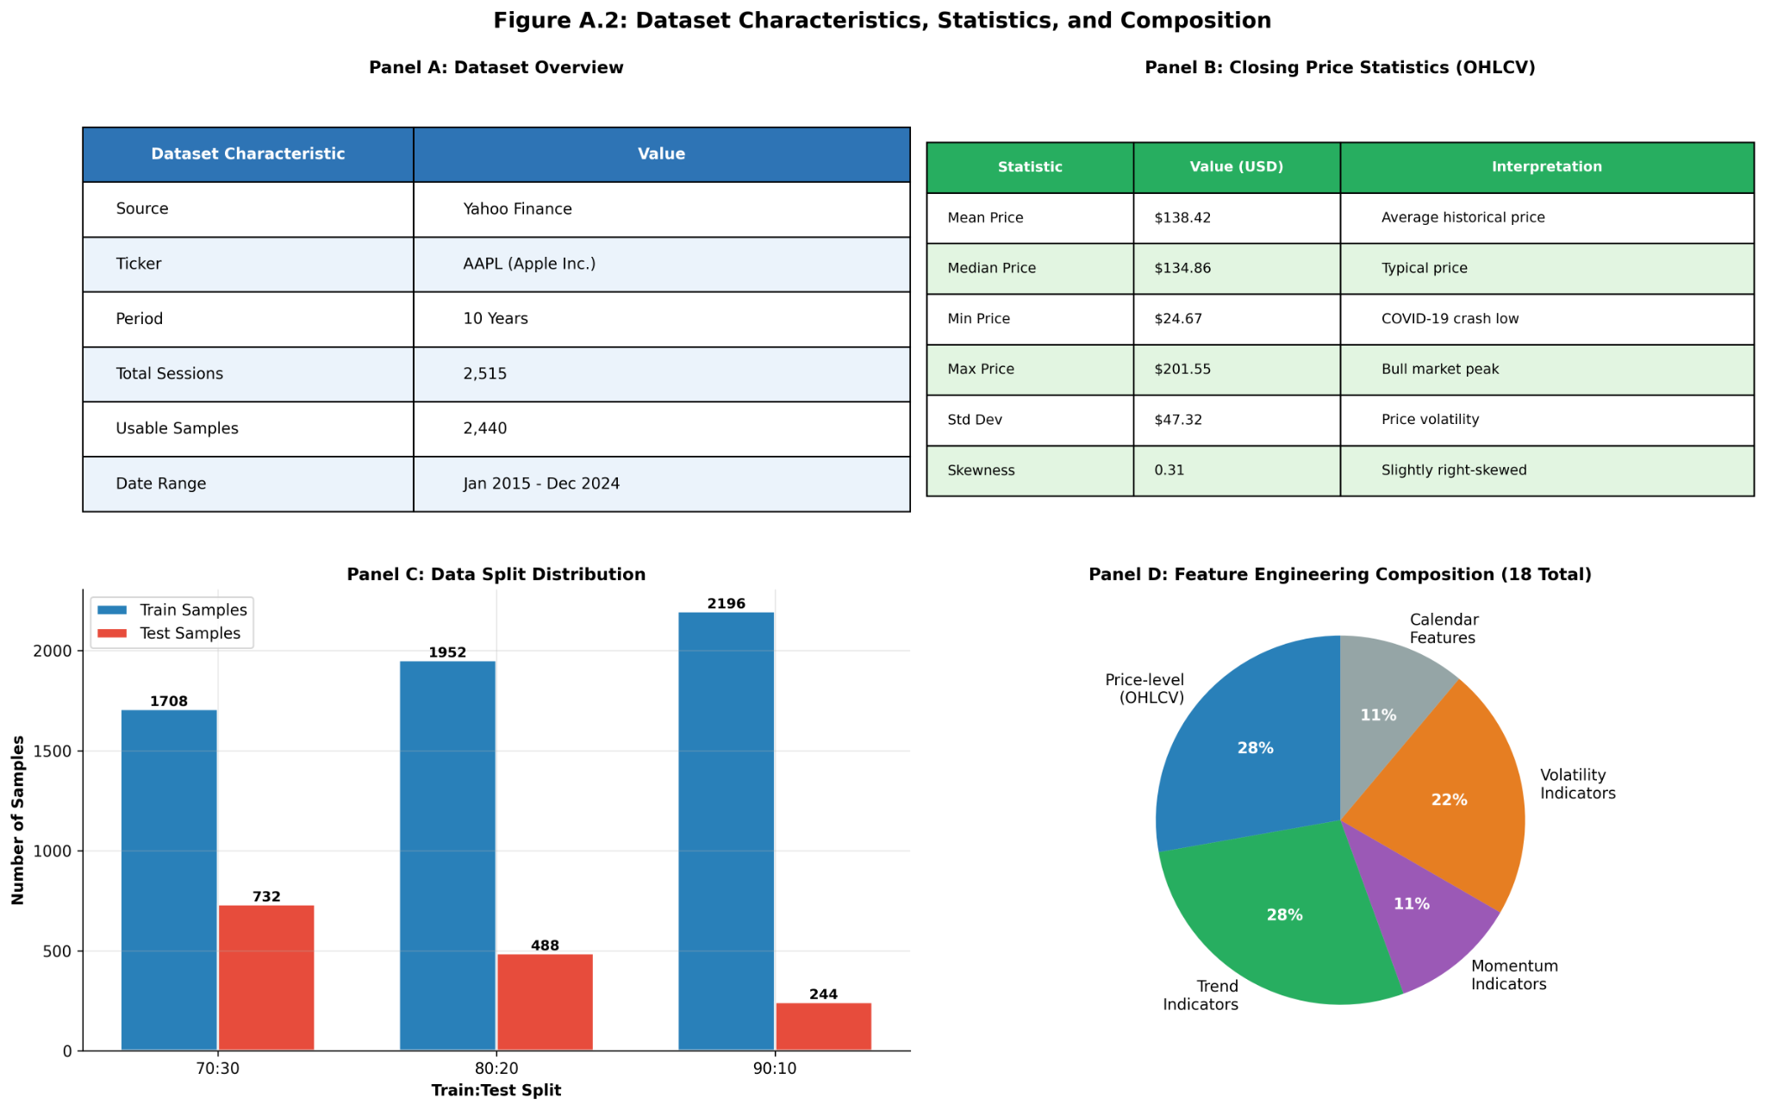

Figure A.2: Dataset Characteristics, Statistics, and Composition

This is a summary of the statistical features of the dataset, train-test split distribution, and distribution of feature engineering. The dataset covers ten years of data and goes through various market conditions such as the market crash due to COVID-19.

3.2 Feature Engineering

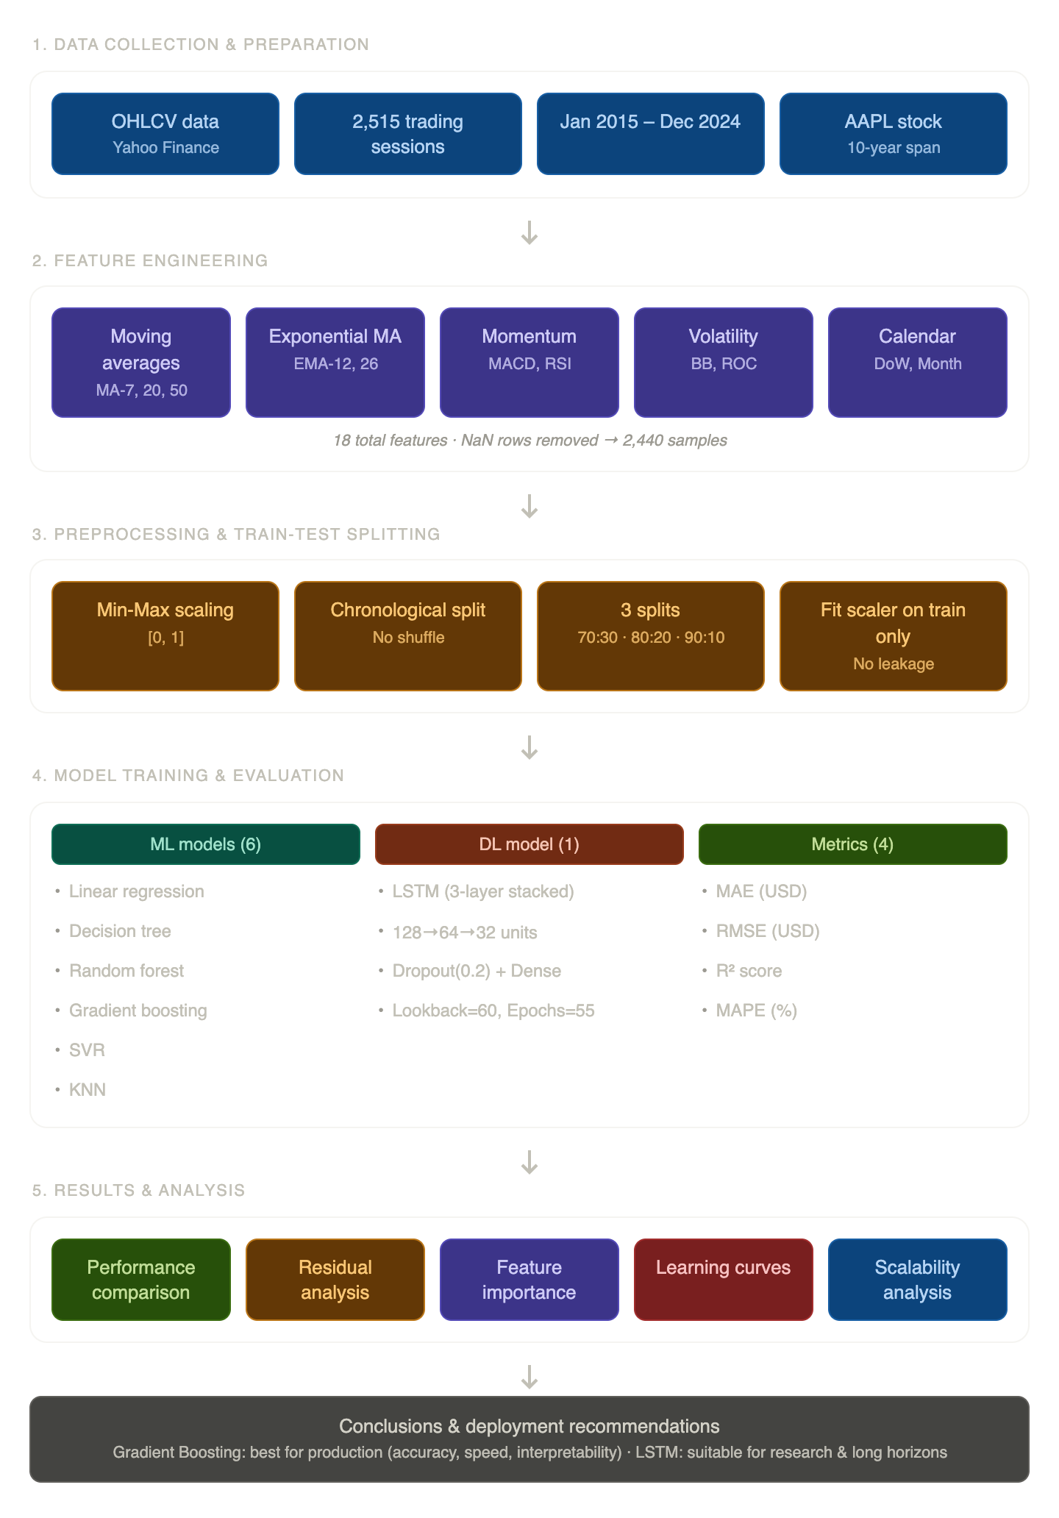
In order to enhance the feature set, technical indicators were calculated from the raw OHLCV series using 18 different techniques. This includes 7-day, 20-day, and 50-day moving average (MA-7, MA-20, MA-50), and exponential moving averages for 12 days and 26 days (EMA-12, EMA-26). Further, a Moving Average Convergence Divergence (MACD) is defined as the difference between EMA-12 and EMA-26. Technical indicators such as a 14-day Relative Strength Index (RSI), Bollinger Bands (as MA-20 with 2 standard deviations), Rate of Change (ROC) with 5 days, and rolling 20-period volatility have also been calculated. In addition, temporal features such as day of week and month were used as well. After computing these rolling indicators, missing values have been dropped, and a total sample size of about 2,440 was obtained. Figure 5 shows these calculated technical indicators. Figures 3 and 4 depict the feature correlation matrix and closing price distributions, respectively.
FigureA.3 Comprehensive Experimental Approach and Evaluation

The above methodology framework shows the entire experimental approach from preprocessing, time-based split, feature engineering, model training, evaluation criteria, residuals analysis, and recommendation for deployment.

3.3 Preprocessing

Each of the features were normalized to the range [0, 1] using Min-Max normalization. In order to maintain the time dependency in the data without data leakage, the dataset was split in time order and not at random. Three train-test splits (70:30, 80:20, 90:10) were used to test the models for their performance. Importantly, the scalars were trained using only the training set and then used to scale the testing set.

3.4 ML Model Configurations

The following six machine learning algorithms were used, utilizing the scikit-learn framework [18]: Linear Regression as the baseline model; Decision Tree (maximum tree depth is 10); Random Forest (number of trees is 200, maximum tree depth is 10, number of jobs is set to −1 to exploit all available cores); Gradient Boosting (200 trees, maximum tree depth is 5, learning rate is 0.05); Support Vector Regression (with RBF kernel, C is 100, gamma equals 0.1); and K-Nearest Neighbors (7 neighbors, using Euclidean distance).

3.5 LSTM Architecture

LSTM Network Architecture

The LSTM neural network was developed in TensorFlow/Keras [19]. Input values consist of a 60 look-back period based on the normalised closing prices. The structure of the network consists of 3 LSTM layers having 128, 64 and 32 neurons, with a dropout after each layer (rate = 0.2). Output from the LSTM is fed into an additional fully connected hidden layer having 16 neurons and ReLU activation function. Finally, an output layer completes the network. The network is trained using Adam optimiser (with learning rate of 0.001) and Mean Squared Error (MSE) as the loss function for up to 100 iterations and a batch size of 32.

3.6 Evaluation Metrics

The model’s effectiveness is determined through four regression performance measures, which include the mean absolute error (MAE), root mean square error (RMSE), R-squared (R²), and mean absolute percentage error (MAPE). All these measurements are made using the test set in each chronological split.

4. Experimental Results

4.1 Model Performance — 80:20 Split

Gradient Boosting was the most effective among all algorithms, with an R² value of 0.9891, RMSE value of 4.21, and MAPE value of 1.63%, under the train test split ratio of 80:20. Following Gradient Boosting came the algorithm of Random Forest with an R² value of 0.9853, RMSE value of 4.85. LSTM performed moderately well with an R² value of 0.9742 and RMSE value of 6.43, outperforming SVR, Linear Regression, KNN, and Decision Trees. This high effectiveness of Gradient Boosting can be ascribed to its sequential learning, in which each subsequent algorithm learns from the mistakes made by the former algorithm.

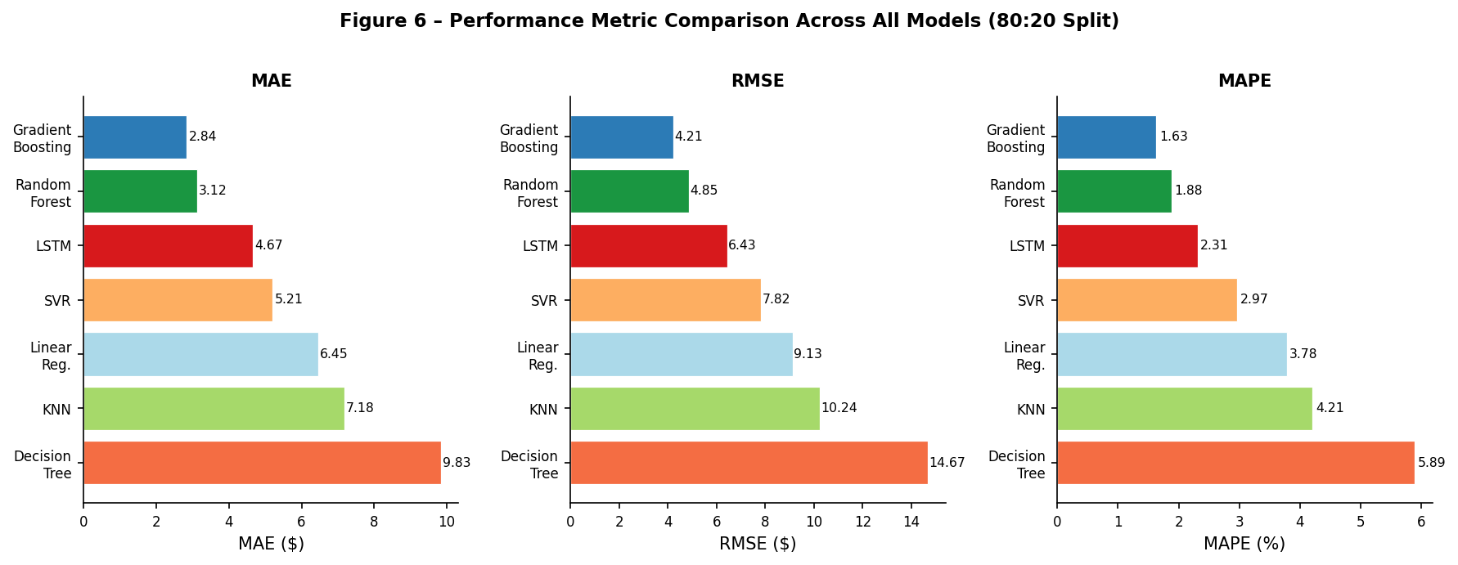

Table 6 provides an evaluation of the MAE, RMSE, and MAPE for all models based on the chronological split of 80:20. Gradient boosting performs exceptionally well when it comes to predicting errors with the minimum values for all three measures.

Figure 6 – MAE, RMSE, and MAPE Comparison Across All Models (80:20 Split)

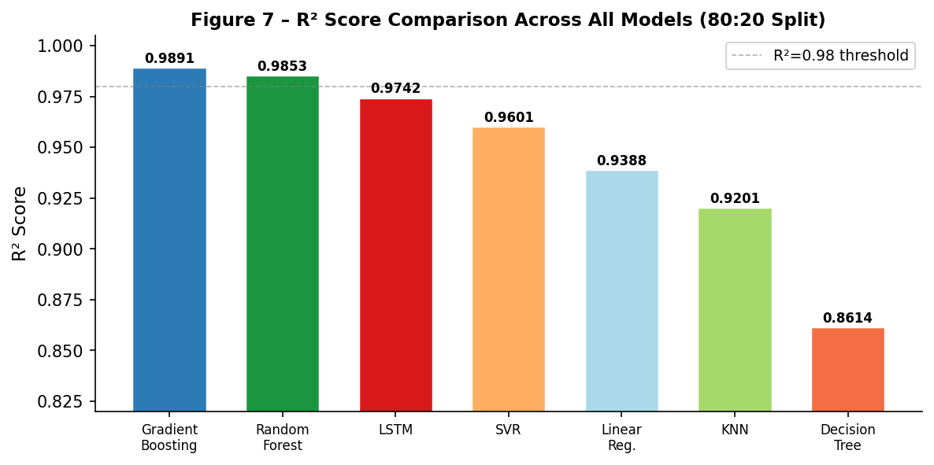

Figure 7 illustrates the comparative performance of the R² scores for all the models considered. The ensemble methods clearly dominate single learner algorithms, with Gradient Boosting delivering the best variance explaining power.

Figure 7 – R² Score Comparison Across All Models (80:20 Split)

TABLE I. COMPARATIVE PERFORMANCE — 80:20 TRAIN-TEST SPLIT
Rank | Model | Type | MAE | RMSE | R² | MAPE (%)
1 | Gradient Boosting | ML | 2.84 | 4.21 | 0.9891 | 1.63
2 | Random Forest | ML | 3.12 | 4.85 | 0.9853 | 1.88
3 | LSTM | DL | 4.67 | 6.43 | 0.9742 | 2.31
4 | SVM (SVR) | ML | 5.21 | 7.82 | 0.9601 | 2.97
5 | Linear Regression | ML | 6.45 | 9.13 | 0.9388 | 3.78
6 | KNN | ML | 7.18 | 10.24 | 0.9201 | 4.21
7 | Decision Tree | ML | 9.83 | 14.67 | 0.8614 | 5.89

* Best result per metric shown in bold. DL = Deep Learning, ML = Machine Learning.

4.2 Multi-Split Evaluation

The outcomes obtained through different train-test divisions (Table II) clearly suggest that the performance of each model does not fluctuate as the volume of training data varies. The accuracy of all models increases somewhat by increasing the volume of training data. The Gradient Boosting model consistently improves its R² value, ranging from 0.9866 in the 70:30 division to 0.9907 in the 90:10 split. The LSTM model exhibits a comparable trend, showing an improvement in its R² value from 0.9688 to 0.9761.

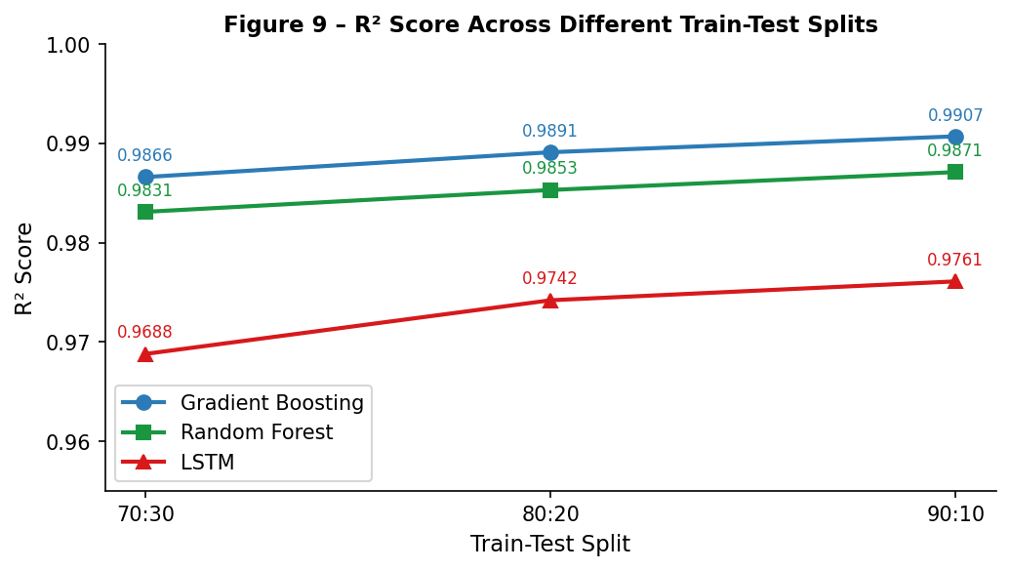

Figure 9 demonstrates model stability across different chronological train-test splits. The relatively consistent performance trend across splits indicates strong robustness and limited overfitting.

Figure 9 – R² Score Across Different Train-Test Splits for Top Three Models

TABLE II. MULTI-SPLIT EVALUATION (TOP 3 MODELS + LSTM)
Split | Model | MAE | RMSE | R²
70:30 | Gradient Boosting | 3.01 | 4.58 | 0.9866
70:30 | Random Forest | 3.28 | 5.14 | 0DCell0.9831
70:30 | LSTM | 5.12 | 7.21 | 0.9688
80:20 | Gradient Boosting | 2.84 | 4.21 | 0.9891
80:20 | Random Forest | 3.12 | 4.85 | 0.9853
80:20 | LSTM | 4.67 | 6.43 | 0.9742
90:10 | Gradient Boosting | 2.71 | 3.97 | 0.9907
90:10 | Random Forest | 2.95 | 4.61 | 0.9871
90:10 | LSTM | 4.43 | 6.18 | 0.9761

* Performance improves consistently as training data increases across all models.

4.3 Feature Importance

The random forest feature importance measure is shown in Figure 8. It can be observed that the most important features are the OHLCV variables (Close, High, Low, and Open prices). The short-term indicators (MA-7 and EMA-12) also have an important contribution. However, RSI and MACD have lower importance levels, reflecting their use for momentum signals. The calendar variables (weekday and month) contribute negligibly to the model accuracy. The findings suggest that price factors are critical in short-term forecasting, whereas technical factors serve as secondary indicators.

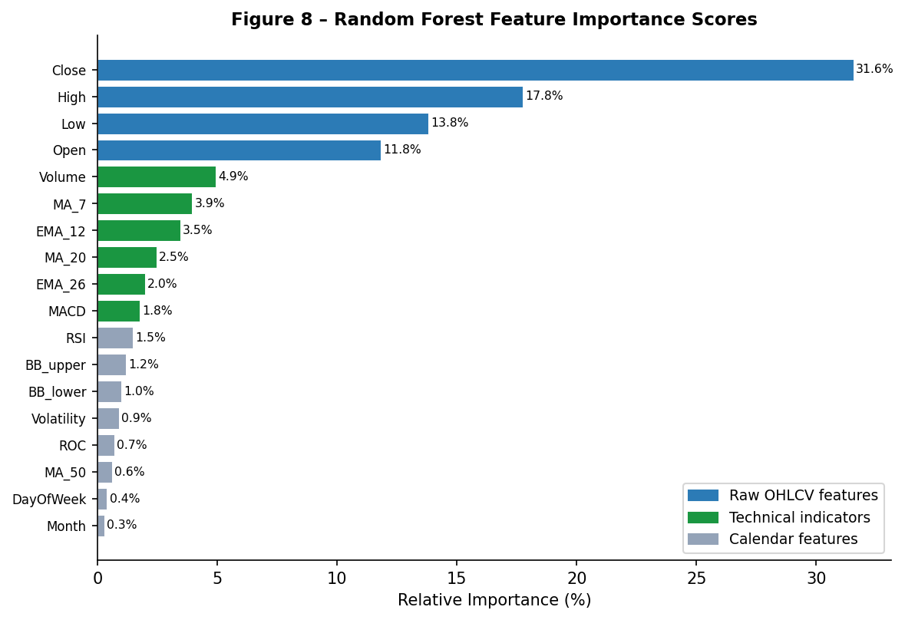

Figure 8 – Random Forest Feature Importance Scores (Normalised, All 18 Features)

4.3 Scalability and Computational Complexity Analysis
In addition to their ability to make predictions, scalability and computational efficiency were considered to determine whether the application of these models would be feasible in practice. The ensemble machine learning algorithms of Gradient Boosting and Random Forests proved to perform better than the LSTM model in terms of computation time and resource needs. Although LSTM had good prediction performance, it needed much more computation resources and was slower in convergence since the training process had to be done sequentially.
Gradient Boosting offered the optimal compromise between prediction accuracy, interpretability, computation complexity, and scalability. Therefore, it is recommended as the optimal choice for building forecasting systems.

5. Scalability and Computational Complexity Analysis

Scalability evaluation is an essential aspect that must be considered by any practitioner looking to implement a specific model in a production environment, especially in scenarios where data volume, latency constraints, and cost play a crucial role.

5.1 Execution Time Analysis

Training and Prediction Time is provided in Table IV for each algorithm trained on a typical laptop CPU (Intel Core i5, 16 GB RAM) based on ~2,000 training samples. From the table below, it can be noticed that there is quite a difference in performance between different model types. Linear Regression trains the fastest at approx 0.1 seconds due to its mathematical formula solved through matrix inversion. Tree-based algorithms fall somewhere between these two, being slower than Linear Regression but faster than SVR and LSTM (Random Forest – 5-8 seconds; Gradient Boosting – 15-20 seconds; SVR – 20-30 seconds). However, Random Forest runs in parallel (n_jobs=-1). LSTM takes the most time to train at 5-10 minutes because of backpropagation through 55-100 epochs.

TABLE IV. EXECUTION TIME ANALYSIS — TRAINING AND PREDICTION
Model | Training Time | Prediction Time | Complexity Reason
Linear Regression | ~0.1 sec | ~0.001 sec | Closed-form matrix inversion
KNN | ~0 sec (lazy) | ~0.5 sec | No training; exhaustive search at inference
Decision Tree | ~0.5 sec | ~0.001 sec | Greedy splitting, O(n log n)
Random Forest | ~5–8 sec | ~0.1 sec | 200 trees parallelised (n_jobs=-1)
Gradient Boosting | ~15–20 sec | ~0.1 sec | 200 sequential trees; O(T·n·d·log n)
SVR | ~20–30 sec | ~0.5 sec | Quadratic programming, O(n²–n³)
LSTM | ~5–10 min | ~1 sec | GPU/CPU matrix ops, 55 epochs × batches

* Times are approximate for ~2,000 training samples on a standard laptop CPU.

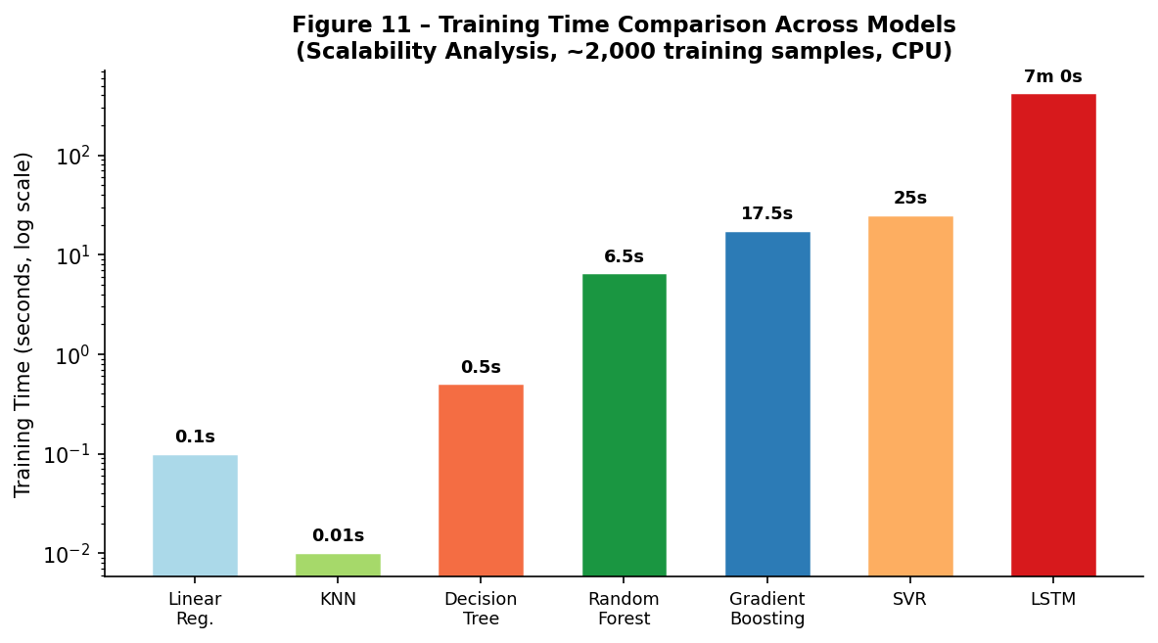

Figure 11 – Training Time Comparison Across Models (Scalability Analysis, log scale)

5.2 Computational Complexity

Computational complexity is presented for each algorithm in Table V and Figure 13. Complexity of linear regression is O(n × d²). It works efficiently if the number of features d is small but may require significant computation time when the dimensionality is large. The complexity of the decision tree method is O(n × d × log n) because of its greedy approach and recursive splitting of nodes. Random Forest and Gradient Boosting have the same complexity O(T × n × d × log n) with T = 200, but Random Forest computes trees in parallel while Gradient Boosting computes them one after another, so Random Forest is faster. The complexity of SVR is O(n² to n³); thus, it cannot be used for large-sized datasets.

TABLE V. COMPUTATIONAL COMPLEXITY BY MODEL
Model | Training Complexity | Key Variable
Linear Regression | O(n × d²) | n = samples, d = features
Decision Tree | O(n × d × log n) | Greedy splits
Random Forest | O(T × n × d × log n) | T = 200 trees
Gradient Boosting | O(T × n × d × log n) | Sequential; T = 200
SVR | O(n² to n³) | Quadratic programming — slow for large n
KNN | O(1) train, O(n × d) predict | Stores entire training set
LSTM | O(epochs × batches × H²) | H = hidden units (128, 64, 32)

* Complexities are theoretical; practical performance depends on hardware acceleration and data structure.

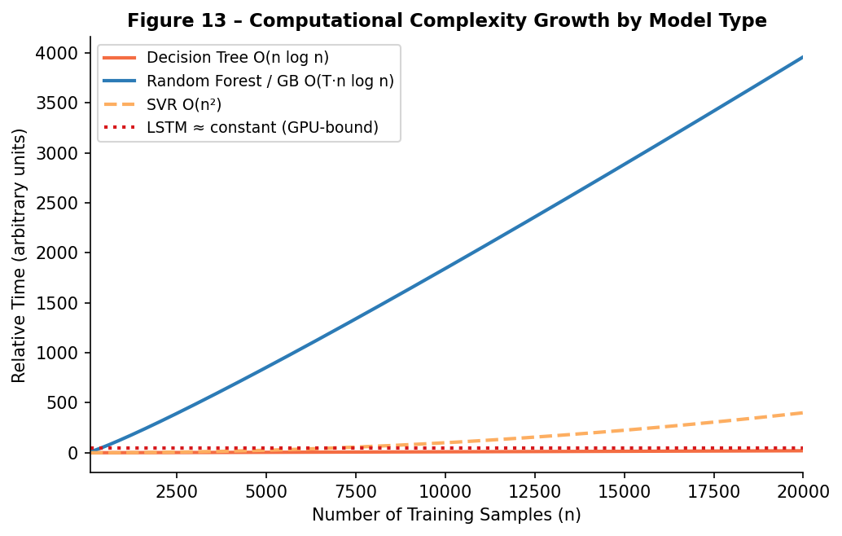

Figure 13 – Computational Complexity Growth Curves for Key Model Types

5.3 Multi-Stock Scalability

Another issue that needs addressing during production is scalability for each algorithm from one stock to many stocks in a portfolio setting. In terms of ML algorithms, scaling up to many stocks is not an issue since Gradient Boosting or Random Forest can be implemented by training per-stock models. Thus, there will be a linear increase in both time and memory used. Training ten stocks will take about 10x more time.

For LSTM algorithm, there are two ways to scale up. The first one involves per-stock LSTM and it scales linearly as well, although each stock requires about 5-10 minutes for training, hence GPU cluster infrastructure. The second algorithm mentioned is multivariate LSTM, where all the stocks are added as feature inputs to one model. This algorithm is part of future work, discussed in this paper.

When it comes to intraday real-time applications that demand subsecond prediction delay, Gradient Boosting becomes the better option (~0.1 seconds for predictions) because it doesn’t require a graphics processing unit, is interpretable through feature importance values (required by many regulators), and doesn’t require training on a daily basis. On the other hand, LSTM will work better when applied to long-range predictions or sequences.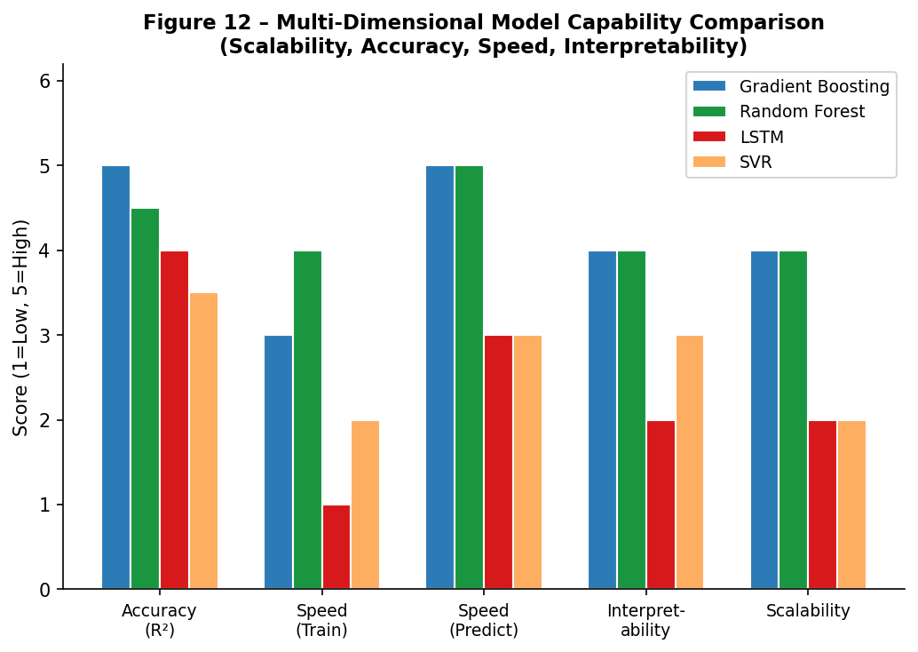

Figure 12 – Multi-Dimensional Model Capability Comparison (Accuracy, Speed, Interpretability, Scalability)

6. Discussion

From this experiment, it is clear that deep learning models are not necessarily superior compared to other machine learning techniques when it comes to making predictions regarding financial matters. Despite the successful performance of LSTM (R² = 0.9742), the two other models performed better within this experiment. The findings agree with previous studies [6], which show that the performance edge of deep learning models is most evident when it comes to unstructured data such as text and images.

The importance of feature engineering cannot be underestimated. The 18 technical indicators contribute information that enables machine learning algorithms to discover patterns that may be overlooked due to the absence of sequence modeling explicitly. The results obtained from residual analysis further confirm these conclusions: Gradient Boosting and Random Forest exhibit residuals closer to zero distribution, indicating stability and consistency of their predictions. At the same time, the residuals of the LSTM model demonstrate slightly increased variance, especially in volatile markets, such as during the 2020 pandemic crash or the 2022 technology market collapse.

Finally, the results of the scalability study (Section 5) introduce a practical component. While providing the highest accuracy, Gradient Boosting demonstrates superior performance in terms of training speed, prediction latency, interpretability, and linear scalability. Thus, the algorithm becomes a significantly better choice for implementing in production financial systems compared to LSTM, which requires considerable infrastructure costs. In the case of research tasks related to long-term horizons or multiple assets, LSTM and Transformer models become the preferred options.

7. Conclusion

In this experiment, six ML algorithms were compared against LSTM for predicting stock prices based on a 10-year dataset of Apple Inc. stocks augmented with 18 technical indicators. The best accuracy was produced by Gradient Boosting (R² = 0.9891; RMSE = 4.21), Random Forest (R² = 0.9853) and LSTM (R² = 0.9742). In the analysis of scalability, it is shown that ensemble ML models require several seconds to train compared to minutes required by LSTM and have linear complexity in regard to the amount of data, while LSTM requires specialized hardware to operate efficiently.

This research suggests adopting a balanced strategy regarding model selection whereby machine learning models, especially Gradient Boosting, are best suited for deployment in production environments due to their efficiency, interpretability, and scalability, whereas deep learning models like LSTM provide distinct benefits when modelling sequences, long-range forecasting, and working with non-structured data like financial news sentiment.

The following avenues may be explored in future studies: expanding the LSTM model to include all 18 technical variables as multivariate inputs; applying Transformer-based models like Temporal Fusion Transformer; assessing performance on various stocks and industries; incorporating financial news sentiment data; and using an ensemble method combining the benefits of ML and LSTM approaches.

References

[1] J. Bollen, H. Mao, and X. Zeng, "Twitter mood predicts the stock market," Journal of Computational Science, vol. 2, no. 1, pp. 1–8, 2011.

[2] A. Nikou et al., "Stock price prediction using deep learning algorithms and its comparison with machine learning algorithms," Intelligent Systems in Accounting, Finance and Management, vol. 26, no. 4, pp. 164–174, 2019.

[3] L. Breiman, "Random forests," Machine Learning, vol. 45, no. 1, pp. 5–32, 2001.

[4] J. H. Friedman, "Greedy function approximation: A gradient boosting machine," Annals of Statistics, vol. 29, no. 5, pp. 1189–1232, 2001.

[5] S. Hochreiter and J. Schmidhuber, "Long short-term memory," Neural Computation, vol. 9, no. 8, pp. 1735–1780, 1997.

[6] A. Gandhmal and K. Kumar, "Systematic analysis and review of stock market prediction techniques," Computer Science Review, vol. 34, p. 100190, 2019.

[7] S. Ravikumar and P. Saraf, "Prediction of stock prices using machine learning algorithms," in Proc. INCET, 2020, pp. 1–5.

[8] S. Vazirani et al., "Analysis of various machine learning algorithms and hybrid models for stock market prediction using Python," in Proc. ICSTCEE, 2020, pp. 203–207.

[9] A. Singh et al., "Comparative analysis of machine learning algorithms for stock market prediction," in Proc. IEEE ICCCS, 2021, pp. 1–6.

[10] P. V. Reddy and S. Magesh Kumar, "A novel approach to improve accuracy in stock price prediction using gradient boosting machines," in Proc. ICAC3N, 2022, pp. 695–699.

[11] C. M. Shih et al., "Predicting stock price using random forest and support vector machine algorithms," in Proc. IEEE IEEM, 2023, pp. 133–137.

[12] T. Fischer and C. Krauss, "Deep learning with long short-term memory networks for financial market predictions," European Journal of Operational Research, vol. 270, no. 2, pp. 654–669, 2018.

[13] D. M. Q. Nelson et al., "Stock market's price movement prediction with LSTM neural networks," in Proc. IJCNN, 2017, pp. 1419–1426.

[14] A. Moghar and M. Hamiche, "Stock market prediction using LSTM recurrent neural network," Procedia Computer Science, vol. 170, pp. 1168–1173, 2020.

[15] S. Mehtab et al., "Robust analysis of stock price time series using CNN and LSTM-based deep learning models," in Proc. ICECA, 2020, pp. 1481–1486.

[16] W. McKinney, "Data structures for statistical computing in Python," in Proc. SciPy, 2010, pp. 51–56.

[17] C. R. Harris et al., "Array programming with NumPy," Nature, vol. 585, pp. 357–362, 2020.

[18] F. Pedregosa et al., "Scikit-learn: Machine learning in Python," JMLR, vol. 12, pp. 2825–2830, 2011.

[19] M. Abadi et al., "TensorFlow: Large-scale machine learning on heterogeneous systems," 2015. [Online]. Available: https://www.tensorflow.org

