

**Course Code: CSE360**

**Course Title: Computer Interfacing**

**Vehicle Crash Detection System using Arduino**

**Group Members:**

|  |  |
| --- | --- |
| **Name** | ID |
| MD. Minhazul Billah | 17101389 |
| Nazifa Khanom | 17101334 |
| Adnan-Bin-Zahir | 17101421 |
| Puja Roy Rini | 18201213 |

Submitted to

**Mr. Nazmus Sakeef**

**Lecturer**

**BRAC University**

**Index:**

1. Introduction
2. Application Area
3. Technology and tools
4. Language
5. Working mechanism of Sensors
6. Connection with ICs
7. Data flow from sensors through ICs to I/O devices
8. Code
9. Pseudo Code
10. Circuit Diagram
11. Schematic
12. Estimated cost analysis
13. Conclusion

**Vehicle Crash Detection System**

**Introduction:**

In the twentieth century, the number of vehicles is increasing due to growth in the automobile industry. So, as the vehicles increases therefore, accidents are also seen very frequently. Most of the road accidents occur due to heterogeneous traffic and lack of traffic separation. Therefore, it is an intelligent way to develop an adept crash detection system, which will notify the drivers by alerting both the cars about their closeness, and determining whichever driver is active so that he can take necessary steps. Here we have used three types of sensors, Vibration Sensor, Shock Sensor and Ultrasonic Sonar Sensor. We have taken an Arduino Uno and for I/O devices, we have taken a Buzzer and an LCD.

**Application Area:**

Our project falls under Security and Defense System Application Area. The crash detection system is fully functional and working. The three sensors attached works upon their principles to send an alert to alert system completing the crash detection process. The sensitivity of model is excellent with having back up sensors for confirmation. The model is strong and simple explicitly built upon the concepts of electronics. This project can also be applied in determining volcanic eruptions, earthquakes that can be detected primarily by the vibration sensor, and for alerting against theft, which is primarily detected by the shock sensor.

**Technology and Tools**

1. Arduino Uno
2. Shock Sensor
3. Vibration Sensor
4. Ultrasonic Sensor
5. Buzzer
6. LCD
7. Jumper Wires
8. Breadboard

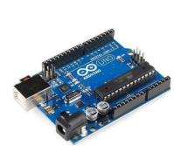

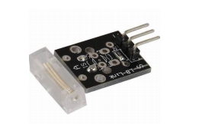

**1) Arduino Uno 2) Shock Sensor**

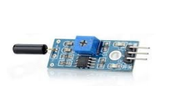

**3) Vibration Sensor**

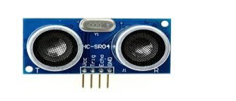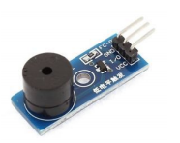

**4) Ultrasonic Sensor**

**5) Buzzer**

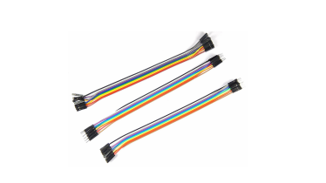

**6) Jumper Wires**

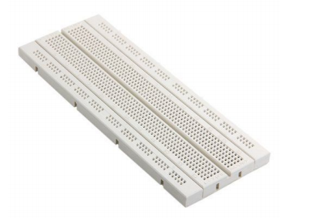

**7) Breadboard**

**Language:**

We will use C programming Language for coding or implementing the command.

**Working mechanism of Sensors:**

1. **Arduino Uno**

The Arduino is an open-source microcontroller development board. It is used to read sensors and control things like motors and lights, which allows us to upload programs to this board, which can then interact with things in the real world. Since it is an open-source so the hardware is reasonably priced and development software is free. The microcontroller used on the UNO board is Atmega328P by Atmel(a major microcontroller manufacturer).It has 14 digital input/output pins(of which 6 can be used as PWM outputs), 6 analog inputs, a 16 MHz ceramic resonator, a USB connection, a power jack, an ICSP header, and a reset button.It contains everything needed to support the microcontroller. For starting it, it only needs to be simply connectedto a computer with a USB cable or it should be powered with a AC-to-DC adapter or battery. The Arduino project was started in Italy to develop low cost hardware for interaction design. An overview is given on the Wikipedia entry for Arduino. Programs can be written and interface circuits can be created to read switches and other sensors, and to control motors and lights with very little effort with the Arduino board. The following is the Arduino board:

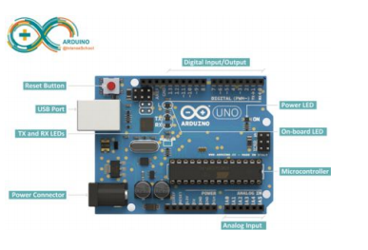

Summary Microcontroller ATmega328

Operating Voltage 5V

Input Voltage (recommended) 7-12V

Input Voltage (limits) 6-20V

Digital I/O Pins 14 (of which 6 provide PWM output)

Analog Input Pins 6

DC Current per I/O Pin 40 Ma

Flash Memory 32 KB (ATmega328) SRAM 2 KB (ATmega328) Clock Speed 16 MHz

1. **HR-SR04 Ultrasonic Sensor**

The transmitter emits a 8 bursts of a directional 40KHz ultrasonic wave when triggered and starts a timer. The ultrasonic pulses travel outward until they encounter an object. The object causes the wave to be reflected back towards the unit. The ultrasonic receiver would detect the reflected wave and stop the stop timer. The velocity of the ultrasonic burst is 340m/sec. in air. The distance can be calculated between the object and transmitter based on the number of counts by the timer. The TRD Measurement formula is expressed as: D= C*T which is known as the time/rate/distance measurement formula where, D is the measured distance, and R is the propagation velocity (Rate) in air (speed of sound) and T represents time. In this application, T is divided by 2 as T is double the time value from transmitter to object back to receiver.

So, Test distance = high level time×velocity of sound (340M/S) )/ 2

**Component Views**

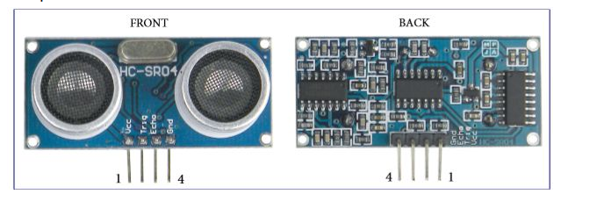

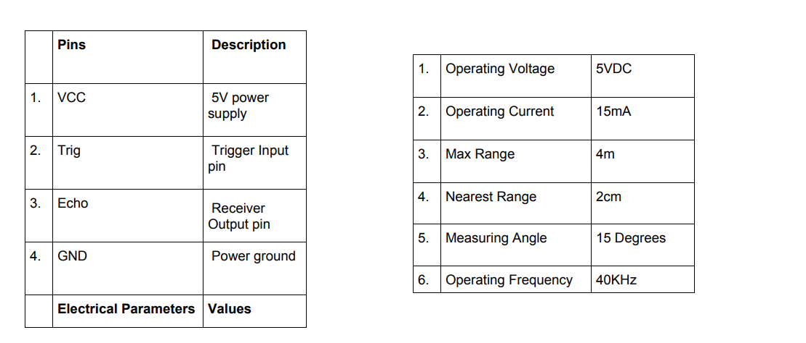

1. **SW-420 Vibration Sensor**

The vibration sensor SW-420 comes with breakout board that includes comparator LM 393 and Adjustable on board potentiometer for sensitivity threshold selection, and signal indication LED. This sensor module produce logic states depending on vibration and external force applied on it. When there is no vibration then this module gives logic LOW output. When vibration is felt then output of this module goes to logic HIGH.

* It is an on-board LM393 chip
* It is an on-board indicator LED to show results
* The working bias of this circuit is between 3.3V to 5V DC.
* Digital output Supply voltage:3.3V-5V
* Default state of the switch is close.
* It is SW-420 based sensor and a normally closed type vibration sensor

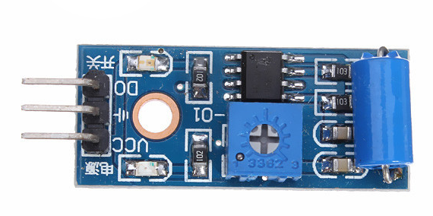

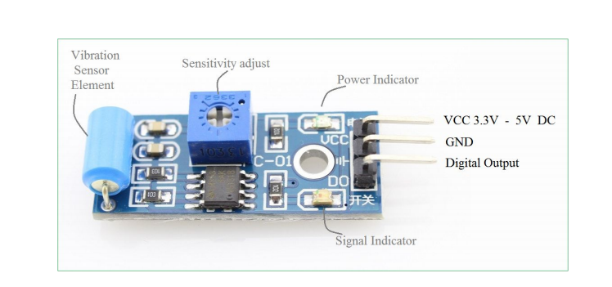

1. **KY-031 Shock Sensor**

Based on the Gaoxin SW-18010P vibration switch, the Keyes-031 Vibration Sensor allows to use an Arduino to detect impacts, shocks or shaking. When a jolt is detected, the output of the module is sent low.

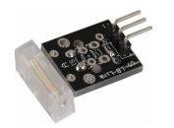

The KY-031 Vibration Switch Module consists of a conductive vibration spring and a 10k resistor. It will react to shock and vibration by closing the circuit.

The switch primarily consists of a terminal that forms a center post and a second terminal that is a spring that surrounds the center post.

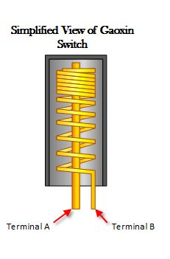

The terminal consisting of the spring moves and shorts both terminals together when a sufficient force is transferred to the switch.

Positioning of the switch is also very important. The switch should be physically located as close as possible to the area being monitored otherwise, the vibration being detected may be dampened by other structural components in the project.

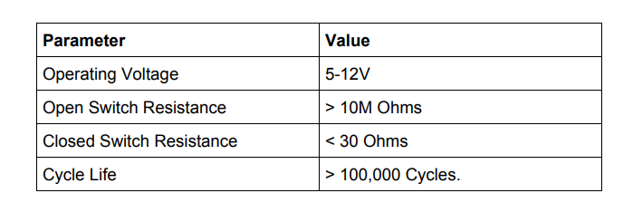

The module only has three connections. They consist of a power input, a ground and an output as shown below:

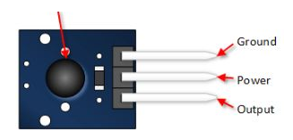

The module is nothing more than the switch and a pull up resistor. In fact it is easy to build with the Gaoxin switch alone.

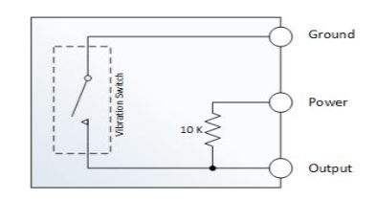

**Connection with ICs:**

**Ultrasonic** sensor is connected to Arduino Uno with its four pins VCC, Trig, Echo & GND. VCC is connected with the power source & GND is connected to the ground. Trig PIN is connected Arduino Uno’s PIN 10 and Echo PIN is connected to Uno’s PIN 9. **Vibration** sensor is connected to Arduino Uno with its Digital Output PIN. VCC is connected to the power source, ground is connected to GND PIN and DO PIN is connected Uno’s PIN 11. **Buzzer** is connected with ground, and the power source same as others and Output pin in connected to Arduino’s PIN 3. **Shock** sensor connected to ground and power source as same as others and Output in connected to Arduino’s PIN 6. **Arduino Uno’s** GND and VCC PINs are connected to ground. RS pin of the **LCD** module is connected to digital pin 12 of the Arduino. R/W pin of the LCD is grounded. Enable pin of the LCD module is connected to digital pin 12 of the Arduino through breadboard. In this project, the LCD module and Arduino are interfaced in the 4-bit mode. This means only four of the digital input lines (DB4 to DB7) of the LCD are used. This method is very simple, requires less connections and full potential of the LCD module can be utilized. Digital lines DB4, DB5, DB6 and DB7 are interfaced to digital pins 5, 4, 3 and 2 of the Arduino with breadboard. The 10k potentiometer is used for adjusting the contrast of the display. A 560-ohm resistor R1 limits the current through the backlight LED. The Arduino can be powered through the external power jack provided on the board. +5V required in some other parts of the circuit can be tapped from the 5V source on the Arduino board. The Arduino can be also powered from the PC through the USB.

**I/O Devices:**

**1) Buzzer:**

A buzzer or beeper is an audio signaling device which may be mechanical, electrochemical, or piezoelectric. Typically, buzzer is used in alarm devices, timers, and confirmation of user input such as a mouse click or keystroke.

Buzzer is used to warn the people at railway crossing that train is coming. It is also used at critical situations if gate is not closed to warn people.

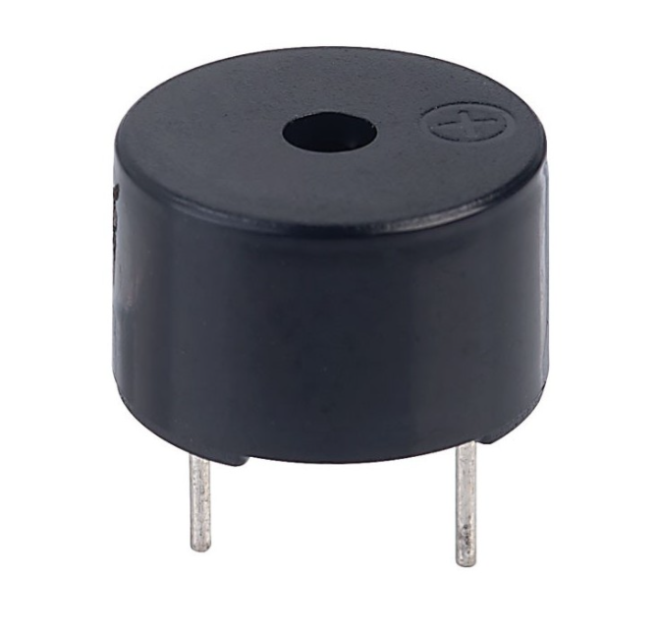

**2) LCD:**

A Liquid Crystal Display commonly abbreviated, as LCD is basically a display unit build using Liquid Crystal technology. When we build real/life world electronics based projects, we need a medium/device to display output values and messages. The most basic form of electronic display available is 7-segment display-which has his own limitations. The next best available option is 7 segment Crystal displays which comes in different size specifications. Out of all available LCD modules in market, the most commonly used one is 16x2 LCD Module, which can display 32 ASCII, characters in two lines (16 characters in 1 line).

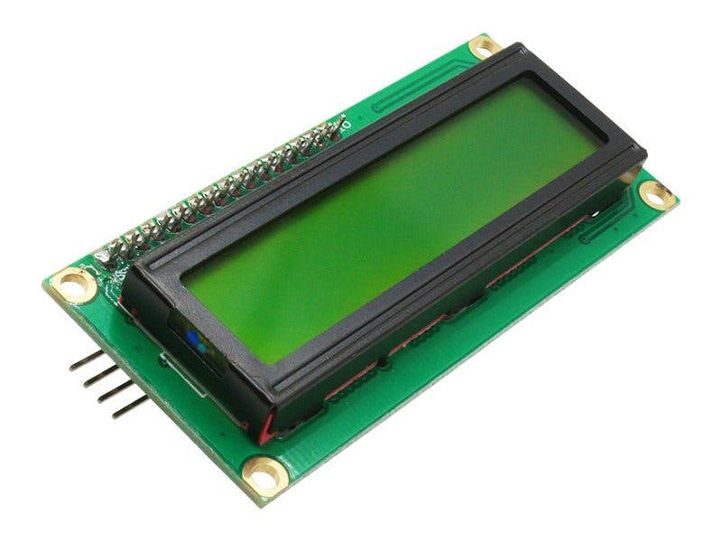

**Data flow from sensors through ICs to I/O devices:**

Arduino Uno is used as a controlling unit in the project with three different sensors resulting detecting a crash successfully. When some shock waves are generated due to some reasons, the shock sensor activates by detecting the shockwaves that are associated with a window or a door being broken. When a large shock wave is detected, the shock sensor actives. This will tell the shock sensor to send an alert to the alarm system to let it know about the situation. Similarly, the vibration sensor attached in the vehicle will detect vibrations with very high sensitivity compared to shock sensor. Ultrasonic Sensor measures the distance between them by measuring the time between the emission and the reception when the object will come closer to the vehicle. As soon as the distance is less than zero, ultrasonic sensor is activated sending an alert to the alert system. With the confirmation, from all the three sensors, one can surely know that the crash has taken place.

**Code:**

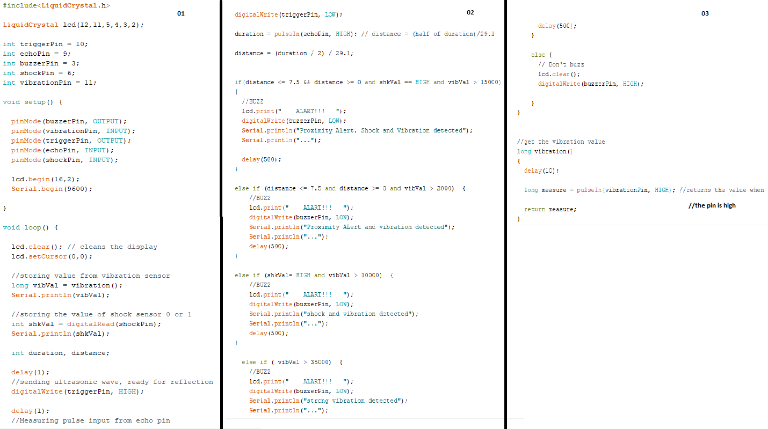

**Pseudo Code:**

1. #include, #define, constants, etc.

LiquidCrystal.h

1. void setup( )

set buzzerPin to OUTPUT

set vibrationPin to INPUT

set triggerPin to OUTPUT

set echoPin to INPUT

set shockPin to INPUT

start lcd

start console

1. void loop( )

clear LCD

set cursor at 0,0

vibrationValue = vibration()

shkVal = digitalRead(shockPin)

wait 1ms

digitalWrite(triggerPin, HIGH)

wait 1ms

digitalWrite(triggerPin, LOW)

duration = pulseIn(echoPin, HIGH)

distance = (duration / 2) / 29.1

if distance <= 7.5 && distance >= 0 and shkVal == HIGH and vibVal > 15000

Proximity Alert, Shock and Vibration detected

buzz and display alert

wait 500ms

else if distance <= 7.5 and distance >= 0 and vibVal > 2000)

Proximity Alert and vibration detected

buzz and display alert

wait 500ms

else if shkVal= HIGH and vibVal > 10000

shock and vibration detected

buzz and display alert

wait 500ms

else if vibVal > 35000

strong vibration detected

buzz and display alert

wait 500ms

else

Don't buzz

clear display

1. User-functions

vibration()

Wait 10ms

measure = pulseIn(vibrationPin, HIGH)

return measure

**Circuit Diagram:**

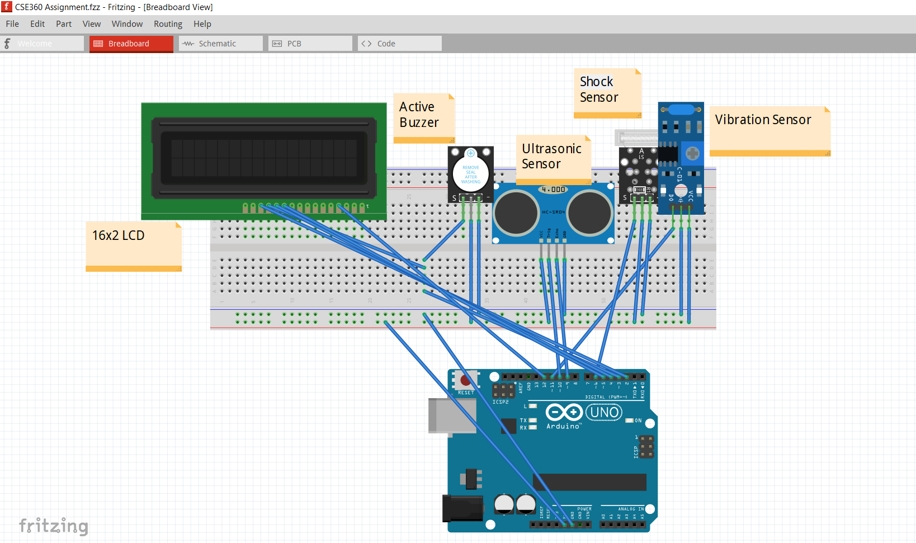

**Schematic:**

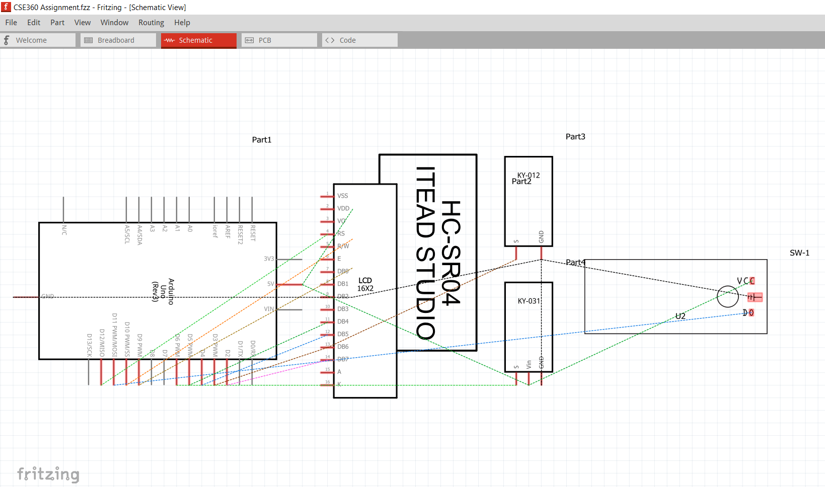

**Estimated cost analysis:**

|  |  |  |
| --- | --- | --- |
| **Component** | **Quantity** | **Price** |
| Arduino Uno | 1 | 400 |
| Shock Sensor | 1 | 380 |
| Vibration Sensor | 1 | 110 |
| Ultrasonic sensor | 1 | 118 |
| Buzzer | 1 | 16 |
| LCD | 1 | 160 |
| Jumper Wires | Set | 140 |
| Breadboard | 1 | 100 |
|  |  | **Total 1424 Taka** |

**Conclusion:**

Therefore, finally by using the knowledge of electronic circuits and with the intensive effort of group members, we have designed a fully functional and efficient crash detection system. This model is very simple. There are 3 sensors. The sensors are attached to send an alert to alert system by completing the crash detection process. It can also be used in :

* Vehicle accident detection system
* Earthquake/Landslide predictive alarm system
* Smart/Autonomous Car
* Collision predictive detection and prevention

Automated crash alarm systems are already implemented in most of the vehicles today. Our project is just a try for understanding the basic level of how these small but crucial systems work.

**References:**

<https://www.youtube.com/watch?v=twBpU_pfFbI>

[www.elecrow.com](http://www.elecrow.com)

<https://www.youtube.com/watch?v=cduPQs6iZVU> <https://www.murata.com/products/sensor/shock/basic>

<https://www.youtube.com/watch?v=ZejQOX69K5M> <https://cdn.sparkfun.com/datasheets/Sensors/Proximity/HCSR04.pdf>

<https://www.farnell.com/datasheets/1682209.pdf>