**Chapter 3**

This chapter focus on analysis and design of Cooperative education and industrial training system that provide of idea and logical of how the system was built and how about system workflow. It also describe all components, processes, and sub-process in the system and how they are connected with each other.

**3.1 System architecture overview**

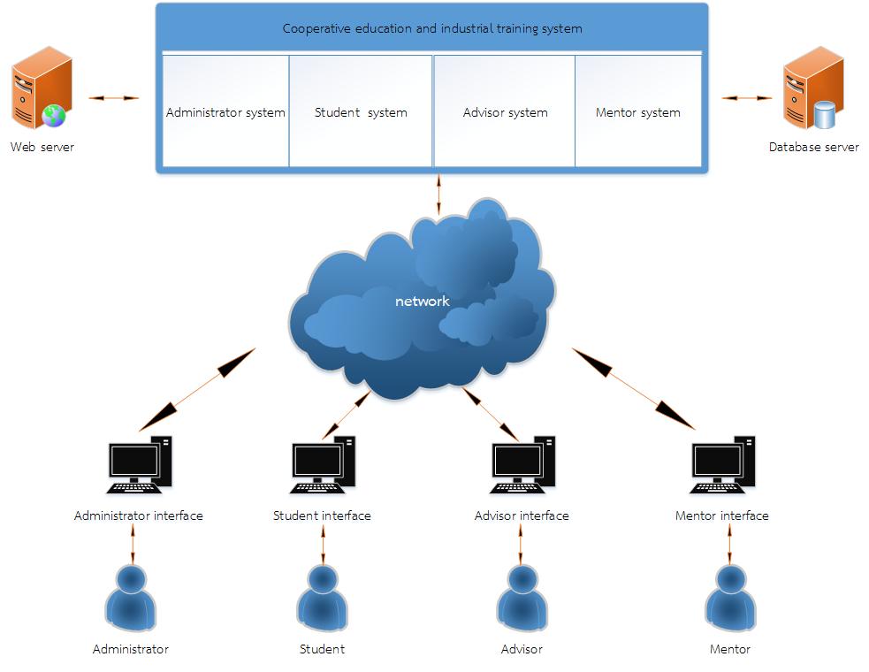

|  |  |
| --- | --- |
| **Project** : Cooperative education and industrial training system  **System** : Online tracking system | Major advisor : Mr.Faosan Mapa |
| **Description** : System overview diagram | |

Figure 3-1: System overview diagram

System overview will explain about the function as following:

**3.1.2 Web server description:**

A Web server is a program that uses HTTP (Hypertext Transfer Protocol) to serve files form web page to user, in response to their requests, which are forwarded by their computers' HTTP clients. Web server transmits the information to the request in the form of text, image, audio, and web services to open port 80 (HTTP port) to request connection through browsers such as Google chrome, Internet explorer, Firefox. Cooperative education and industrial training system also use a web server, because it’s online system that provide all user to control the system through the internet. More over the webserver provide the connectivity between users on the system as well.

**3.1.3 Database server description:**

Database server is the term used to refer to the back-end system of a database application (such as XAMPP, Appserve) using client/server architecture. The back-end, sometimes called a database server, performs tasks such as data analysis, storage, data manipulation, archiving, and other non-user specific tasks. Database server provide database service and allow user to add, delete, or modify. This system use database server system to store data information of students, advisors, and so on.

**3.1.4 User interface description:**

User Interface (UI) Design focuses on anticipating what users might need to do and ensuring that the interface has elements that are easy to access, understand, and use to facilitate those actions. Cooperative education and industrial training system have 4 types of user that have different ability to access include student, advisor, mentor, and administrator. This system also provide for different user session to access by using computer or laptop through web browser.

**3.2 System structure chart**



Figure 3-2: System structure chart

This system structure chart will be covered all the function following;

**3.2.1 Student description:**

Online tracking system provide in term of web service. For all student function will divide by the period during they are the internee or cooperative student as following;

**Pre- student industrial training or cooperative student ability for:**

* To view and modify personal information by themselves such as edit the name, contact information, phone number, and email.

**During be a student industrial training or cooperative student ability for:**

* To record their performance.
* To report problem that facing during work.

**Post student industrial training or cooperative student ability for:**

* To complete for the report experience profession**.**

**3.2.2 Advisor description:**

The functional in term of advisor will be divided by the period as following;

**Pre- advisor ability for:**

* To view the student information

**During advisor ability for:**

* To view student profile.
* To record the supervision.
* To give some suggestion to student.

**Post advisor ability for:**

* To estimate student performance.

**3.2.3 Mentor description:**

The functional in term of mentorwill be divided by the period as following;

**Pre- Mentor ability for:**

* To view the student information

**During Mentor ability for:**

* To view student profile.
* To record the supervision.

**Post Mentor ability for:**

* To estimate student performance.

**3.2.4 Administrator ability for:**

The functional in term of administratorwill be divided by the period as following;

**Pre- administrator ability for:**

* To insert all user such as student, advisor, and mentor information to the system.

**During administrator ability for:**

* To store and update student, apprenticeship location, and news relate with their work.
* To give some suggestion to student.

**Post administrator ability for:**

* To make conclusion and make a student report experience profession**.**

**3.3 Process analysis and design**

This part will covered on analysis and design that descript the system requirement as following;

**3.3.1 Functional requirement**

* The system be able to manage users account (administration, advisor, student, and mentor)
* The system be able to display student profile.
* The system be able to manage apprenticeship location.
* The system be able to manage supervision schedule.
* The system be able tomanage student performance record.
* The system be able to manage supervision record.
* The system be able to manage industrial training and corporative information.
* The system be able to provide for student recommendation.
* The system be able to manage evaluation of training

3.3.1.2 Non-functional requirement

* The system should be available 24 hours.
* The website should simply design and easily to access.
* The system should provide user credential interface for the user.
* The website should provide for normal person to see the website and also interact with them.

**List of requirements**

1. List of Requirements

F – Functional Requirements (System must have)

N – Nonfunctional Requirements (System nice to have)

|  |  |  |  |
| --- | --- | --- | --- |
| **No.** | **Requirements ID** | **Requirements Description** | **Priority** |
|  | **CEITS.01** | **Login account** |  |
| 1 | CEITS.01.01 | Administrator login | F |
| 2 | CEITS.01.02 | Student login | F |
| 3 | CEITS.01.03 | Advisor login | F |
| 4 | CEITS.01.04 | Mentor login | F |
|  |  |  |  |
|  | **CEITS.02** | **Manage user account** |  |
| 5 | CEITS.02.01 | Administrator can add new advisor, student, and mentor | F |
| 6 | CEITS.02.02 | Administrator can update advisor, student, and mentor information | F |
| 7 | CEITS.02.03 | Admin and officer can advisor, student, and mentor information | F |
|  | **CEITS.03** | **Manage apprenticeship location** |  |
| 8 | CEITS.03.01 | Administrator can determine apprenticeship location | F |
| 9 | CEITS.03.02 | Administrator can update apprenticeship location | F |
|  |  |  |  |
|  | **CEITS.04** | **Manage supervision schedule** |  |
| 10 | CEITS.04.01 | Administrator can add the supervision schedule | F |
| 11 | CEITS.04.02 | Administrator can update the supervision schedule | F |
|  |  |  |  |
|  | **CEITS.05** | **Manage student recommendation** |  |
| 13 | CEITS.05.01 | Administrator can reply and update student recommendation | F |
| 14 | CEITS.05.02 | advisor can reply and update student recommendation | F |
|  |  |  |  |
|  | **CEITS.06** | **Manage performance record** |  |
| 15 | CEITS.06.01 | Student can add their performance | F |
| 16 | CEITS.06.02 | Student can update their performance | F |
|  |  |  |  |
|  |  |  |  |
|  | **CEITS.07** | **Manage supervision record** |  |
| 17 | CEITS.07.01 | Advisor can record the supervision | F |
| 18 | CEITS.07.02 | Mentor can record the supervision | F |
|  |  |  |  |
|  |  |  |  |
|  | **CEITS.08** | **Manage evaluation of Training** |  |
| 19 | CEITS.08.01 | Advisor can make evaluation of training | F |
| 20 | CEITS.08.02 | Mentor can make evaluation of training | F |
|  |  |  |  |
|  | **CEITS.09** | **Manage industrial training and corporative information** |  |
| 21 | CEITS.09.01 | Administrator can add the information and upload the document | F |
| 22 | CEITS.09.02 | Administrator can update the information and document | F |
|  | CEITS.09.03 | Administrator can delete the information and document | F |
|  |  |  |  |
|  | **CEITS.10** | **Manage the recommendation** |  |
| 23 | CEITS.10.01 | Student can post recommendation | F |
| 24 | CEITS.10.02 | Student can reply recommendation | F |
| 25 | CEITS.10.03 | Advisor can reply student recommendation | F |
|  |  |  |  |
|  | **ER.11** | **View the recommendation** |  |
| 26 | CEITS.11.01 | Administrator can view the recommendation | N |
| 27 | CEITS.11.02 | Lecturer can view the recommendation | N |
| 28 | CEITS.11.03 | Student can view the recommendation | N |
|  |  |  |  |
|  | **CEITS.12** | **View student information** |  |
| 29 | CEITS.12.01 | Administrator can view student information | N |
| 30 | CEITS.12.02 | Lecturer can view student information | N |
| 31 | CEITS.12.03 | Mentor can view student information | N |
|  |  |  |  |
|  | **CEITS.13** | **Performance** |  |
| 32 | CEITS.13.01 | The system will provide user credential interface for the user | N |
| 33 | CEITS.13.02 | The system should be able to run on different browser such as Google chrome, Fire Fox, Opera, Maxthon Cloud Browser | N |
|  |  |  |  |
|  | **CEITS.14** | **User interface** |  |
| 34 | ER.14.01 | The system should be able to provide Thai language. | N |
| 35 | ER.14.01 | The system should be able to provide for normal people to see and interact with them. | N |