**WMS_TO_ERP接口说明文档**

# 1、概述

接口地址：<http://192.168.40.141/WMS_To_ERP_Svc>

# 2、服务接口详细

## 2.1物料档案接口（M001）

### 2.1.1接口定义文档

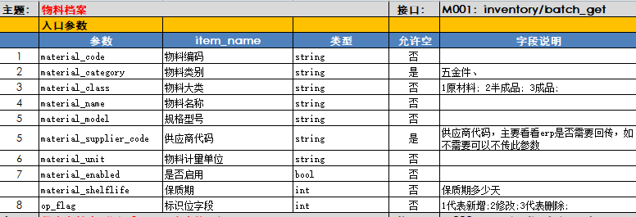

### 2.1.2服务接口

|  |  |  |  |
| --- | --- | --- | --- |
| **接口名称** | **MaterialInfo** | | |
| **参数名称** | **参数描述** | **示例** | **备注** |
| **返回值** | Json字符串 | {"Status":true, "Describe":"物料基础数据导入成功！”} | Status字段为true表示接口执行成功，否则执行失败；Describe表示接口执行情况说明 |
| **参数1** | materialInfoJson | {"material_code":"1234tyt","material_category":"螺丝","material_class":"成品","material_name":"螺母","material_model":"gp2343","material_supplier_code":"","material_unit":"个","material_enabled":true,"material_shelflife":3,"op_flag":1} | 参数详细参见接口定义文档 |
| **参数2** | operateType | 字符串类型 | 1为增加，2为更新，3为删除 |

### 2.1.3http调用示例

<http://192.168.40.141/WMS_To_ERP_Svc>/MaterialInfo/{"material_code":"1234tyt","material_category":"螺丝","material_class":"成品","material_name":"螺母","material_model":"gp2343","material_supplier_code":"","material_unit":"个","material_enabled":true,"material_shelflife":3,"op_flag":1}/1

## 2.2供应商档案接口（M003）

### 2.2.1接口定义文档

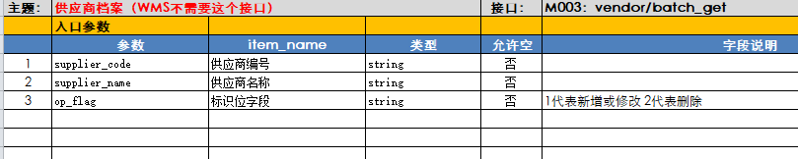

### 2.2.2服务接口

|  |  |  |  |
| --- | --- | --- | --- |
| **接口名称** | **SupplierInfo** | | |
| **参数名称** | **参数描述** | **示例** | **备注** |
| **返回值** | Json字符串 | {"Status":true, "Describe":"供应商基础数据导入成功！”} | Status字段为true表示接口执行成功，否则执行失败；Describe表示接口执行情况说明 |
| **参数1** | supplierInfoJson | {"supplier_code":"sst23","supplier_name":"京东","op_flag":1} | 参数详细参见接口定义文档 |
| **参数2** | operateType | 字符串类型 | 1为增加，2为更新，3为删除 |

### 2.1.3http调用示例

<http://192.168.40.141/WMS_To_ERP_Svc>/SupplierInfo/{"supplier_code":"sst23","supplier_name":"京东","op_flag":1}/1

## 2.3计量单位接口（M004）

### 2.3.1接口定义文档

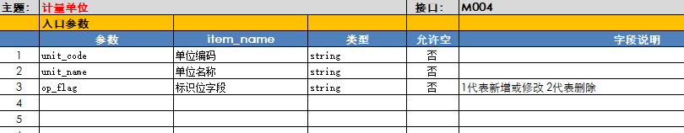

### 2.3.2服务接口

|  |  |  |  |
| --- | --- | --- | --- |
| **接口名称** | **MaterialUnit** | | |
| **参数名称** | **参数描述** | **示例** | **备注** |
| **返回值** | Json字符串 | {"Status":true, "Describe":"计量单位基础数据导入成功！”} | Status字段为true表示接口执行成功，否则执行失败；Describe表示接口执行情况说明 |
| **参数1** | materialUnitJson | {"unit_code":"test22","unit_name":"个","op_flag":1} | 参数详细参见接口定义文档 |
| **参数2** | operateType | 字符串类型 | 1为增加，2为更新，3为删除 |

### 2.3.3http调用示例

<http://192.168.40.141/WMS_To_ERP_Svc>/MaterialUnit/{"unit_code":"test22","unit_name":"个","op_flag":1}/1

## 2.4仓库档案（M005）

### 2.4.1接口定义文档

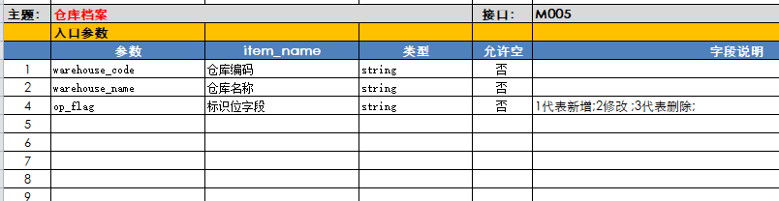

### 2.4.2服务接口

|  |  |  |  |
| --- | --- | --- | --- |
| **接口名称** | **WareHouseInfo** | | |
| **参数名称** | **参数描述** | **示例** | **备注** |
| **返回值** | Json字符串 | {"Status":true, "Describe":"计量单位基础数据导入成功！”} | Status字段为true表示接口执行成功，否则执行失败；Describe表示接口执行情况说明 |
| **参数1** | wareHouseInfoJson | {"unit_code":"test22","unit_name":"个","op_flag":1} | 参数详细参见接口定义文档 |
| **参数2** | operateType | 字符串类型 | 1为增加，2为更新，3为删除 |

### 2.4.3http调用示例

<http://192.168.40.141/WMS_To_ERP_Svc>/WareHouseInfo/{"warehouse_code":"A1","warehouse_name":"A1库房","op_flag":1}/1

## 2.5出入库订单（W009、W010）

### 2.5.1接口定义文档

出入库订单通过InOut_Flag区分出入库，order_voucherType具体订单类型

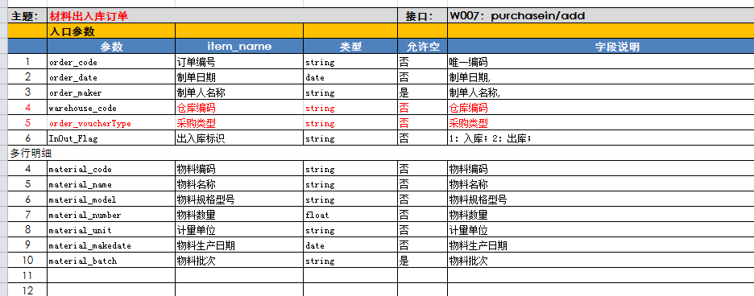

### 2.5.2服务接口

|  |  |  |  |
| --- | --- | --- | --- |
| **接口名称** | MaterialPlanOrder | | |
| **参数名称** | **参数描述** | **示例** | **备注** |
| **返回值** | Json字符串 | {"Status":true, "Describe":"订单数据导入成功！”} | Status字段为true表示接口执行成功，否则执行失败；Describe表示接口执行情况说明 |
| **参数1** | materialPlanOrderJson | {"materialPlanOrderJson":"{\"order_code\":\"343\",\"order_date\":\"2019-05-12 10:03:11\",\"order_maker\":\"admin\",\"warehouse_code\":\"A1\",\"order_voucherType\":\"入库\",\"InOut_Flag\":\"1\",\"MaterilaList\":[{\"material_code\":\"LSTL0001\",\"material_name\":\"极片\",\"material_model\":\"TB009\",\"material_unit\":\"片\",\"material_makedate\":\"2019-05-12 10:03:11\",\"material_batch\":\"b123\",\"material_number\":\"2\"},{\"material_code\":\"KS-60001\",\"material_name\":\"极片\",\"material_model\":\"TB009\",\"material_unit\":\"片\",\"material_makedate\":\"2019-05-12 10:03:11\",\"material_batch\":\"b123\",\"material_number\":\"2.3\"}]}"} | 参数详细参见接口定义文档 |

### 2.5.3http post调用示例

* URL部分

http://192.168.40.141/WMS_To_ERP_Svc/MaterialPlanOrder/

* 数据：{"materialPlanOrderJson":"{\"order_code\":\"343\",\"order_date\":\"2019-05-12 10:03:11\",\"order_maker\":\"admin\",\"warehouse_code\":\"A1\",\"order_voucherType\":\"入库\",\"InOut_Flag\":\"1\",\"MaterilaList\":[{\"material_code\":\"LSTL0001\",\"material_name\":\"极片\",\"material_model\":\"TB009\",\"material_unit\":\"片\",\"material_makedate\":\"2019-05-12 10:03:11\",\"material_batch\":\"b123\",\"material_number\":\"2\"},{\"material_code\":\"KS-60001\",\"material_name\":\"极片\",\"material_model\":\"TB009\",\"material_unit\":\"片\",\"material_makedate\":\"2019-05-12 10:03:11\",\"material_batch\":\"b123\",\"material_number\":\"2.3\"}]}"}