**Project: Type Wizard**

This game is a Role-Playing-Game. Player is a wizard that can use spell by typing spell in different word. This game is Endless Mode that player can play until the wizard die, wizard has level and status that affected to his strength ,for the enemies it’s strength increasing by the level of the wizard too.

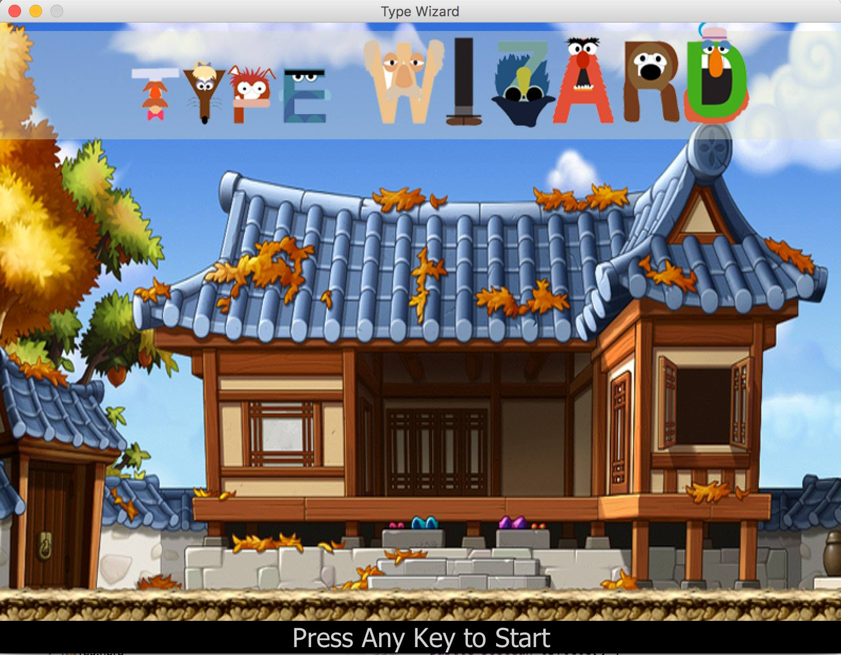

Figure 1 showing main menu. You can press any key to start the game.

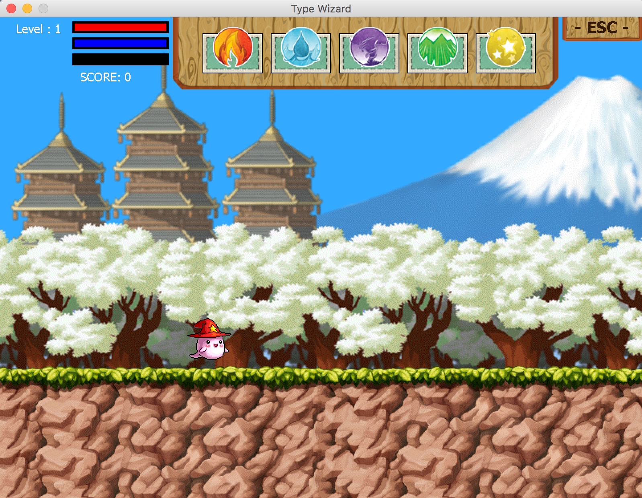

Figure 2 showing map and user interface in game.

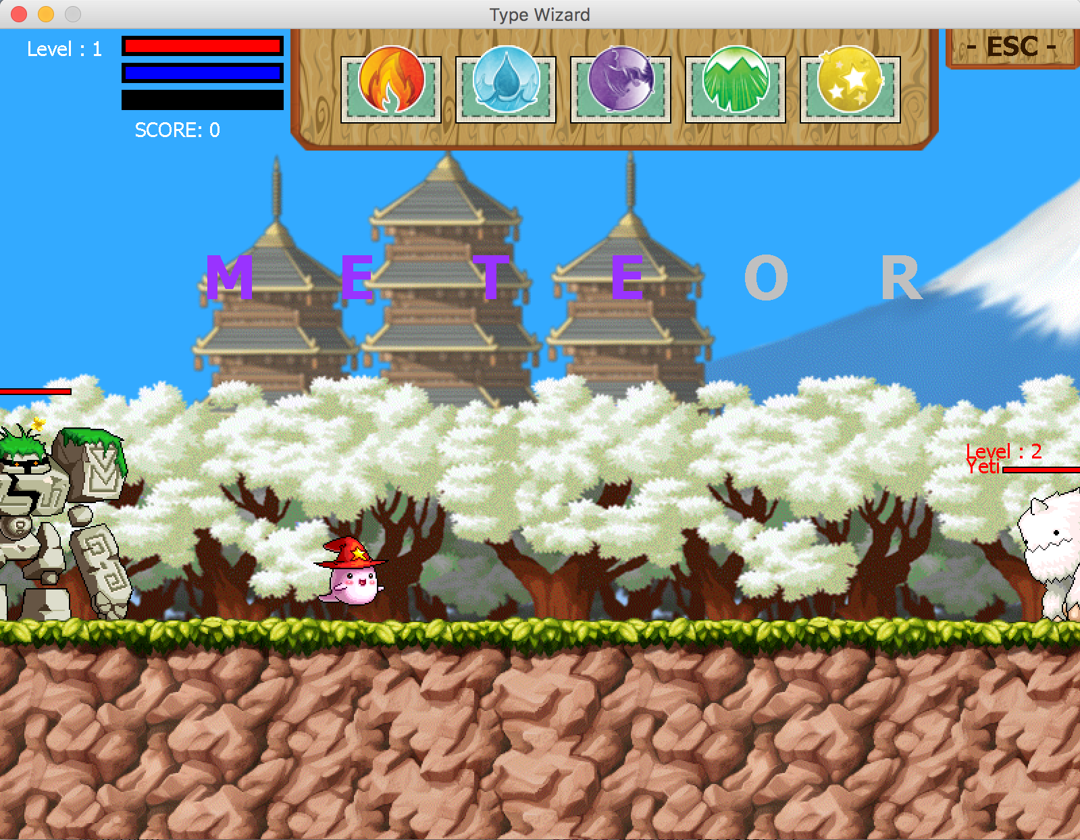

Figure 3 showing how wizard cast spell.

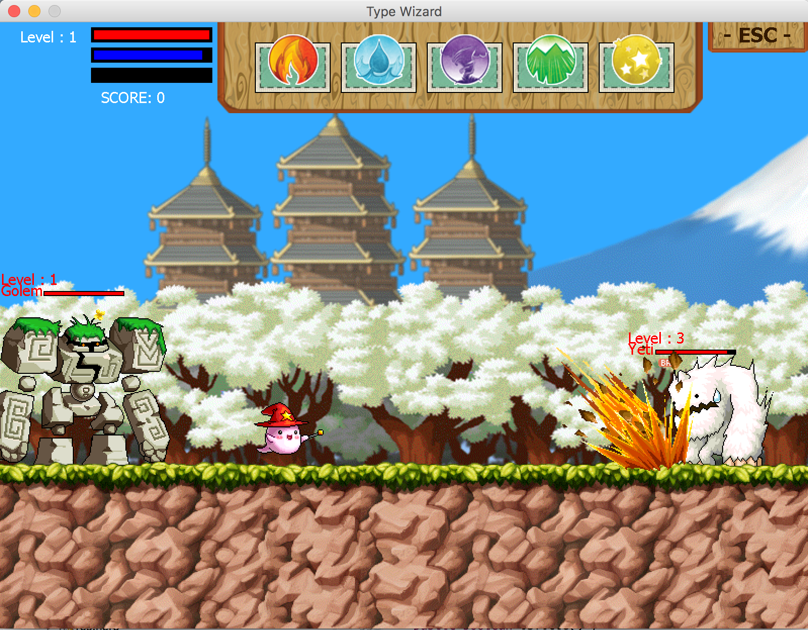

Figure 4 showing monster Yeti get hit by meteor skill.

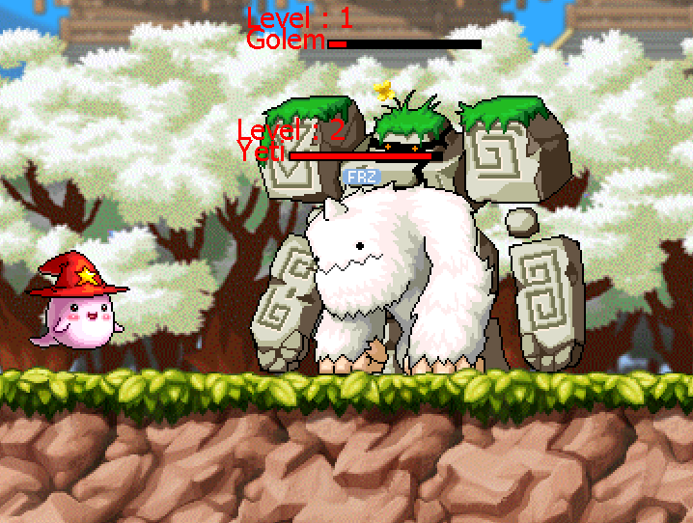

Figure 5 showing monster Yeti effected by Freezing de-buff.

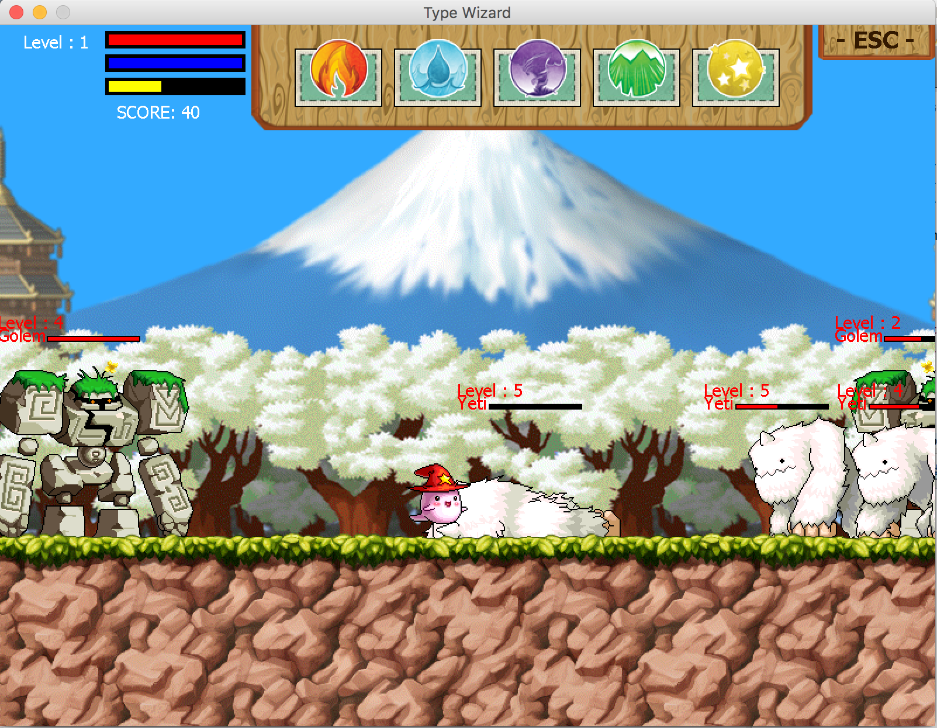

Figure 6 showing monster Yeti has fallen.

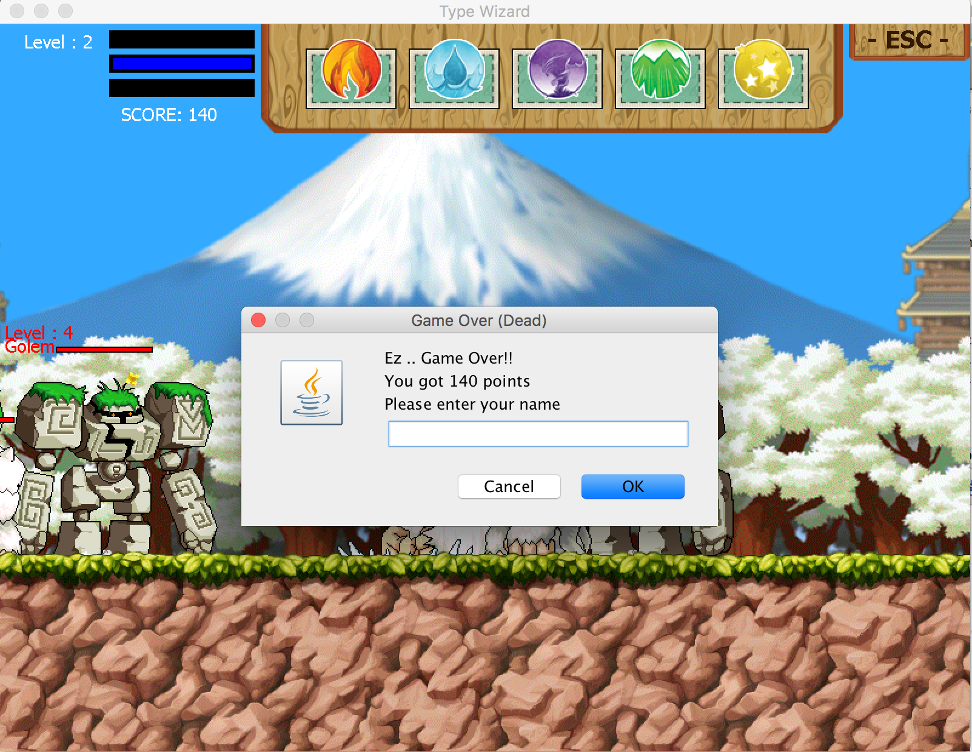

Figure 7 showing GameOver Screen.