Put data into a database from your Node.js Application

1 In your web browser, go to IBM Bluemix™ at https://ace.ng.bluemix.net and LOG IN.
2 On a separate tab in your browser, go to DevOps Services rewillen | NodeJS_Simple_3.
3 Click on EDIT CODE
4 FORK the Application, Enter a Name for your project, and Save.
5 Click on app.js to open the code for the application.
6 Find the client.incrby line. This is the statement that is incrementing a DBuserCountBy1 variable in Redis, and returning the updated value in a variable, replyBy1.
7 Add a second Redis counter, DBuserCountBy2. Use another client.incrby statement to increment it by 2, and return the value in a new variable, replyBy2. To ensure that the calls to Redis are synchronized, this statement needs to be nested inside the increment of the DBuserCountBy1. Be sure to add the closing } also.

8 Next, update the render to also pass the DBuserCountby2 which was returned in the replyBy2 variable from the Redis function call.
res.render('index', {userCount: userCount, DBuserCountBy1: replyBy1, DBuserCountBy2: replyBy2});
Your app.get code block should now look like this:
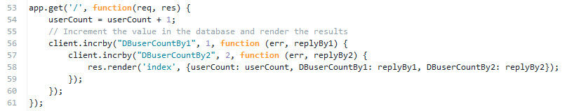
9 In the views directory, open index.ejs.
10 Update the index.ejs HTML page to render to DbuserCountBy2 like this: <p>The stored user count by two in my redis database is <%= DBuserCountBy2 %></p>.

11 DEPLOY the application and use Manual Deployment like you did on card 1. You should see your changes in the browser. Hit the refresh button.
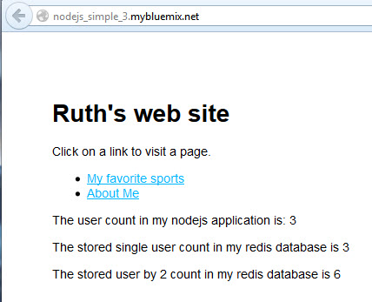
12 There are a lot of things you can now do on your own. I'll add some more ideas here when I have time. For example, perhaps some additional experiments with Redis such as using strings instead of numbers, or some basic array processing?

