Add a Database to your Application

1 In your web browser, go to IBM Bluemix™ at https://bluemix.net and LOG IN.
2 On a separate tab in your browser, go to DevOps Services at https://hub.jazz.net/ and SIGN IN.
3 Open the sample application rewillen | NodeJS_Simple_3.
4 Click on EDIT CODE
5 DEPLOY the Application and follow Manual Deployment to the application like you did on card 1. Refresh the application in the browser. * What happens? Both counters should be incremented. The counters should have the same value.
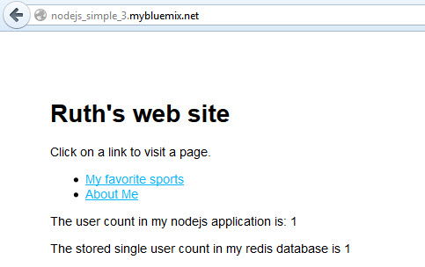

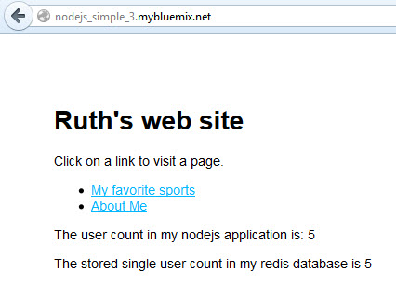
6 Return to the Manual Deployment page, click on your deployment, and Stop your application.
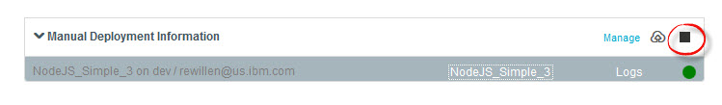
7 Click on your deployment again, and Start your application.
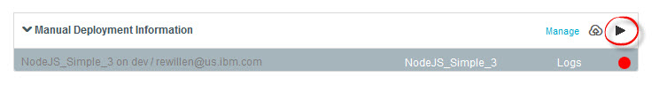
8 Follow the link again to the application running in a separate tab. * What happens to the count? The user count should be reset to 1 visit, but the database count should continue to increment across restarts.
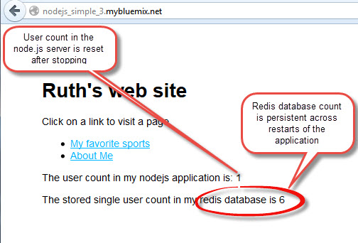
9 From the Manual Deployments page, click the Manage link. This takes you to the Bluemix user interface where you can work with the application and the Redis Service.
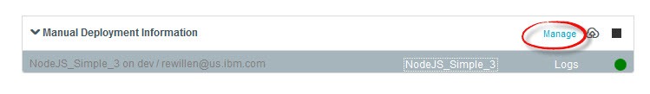
10 In the Bluemix User Interface, Delete the deployed application and the Redis Service from Bluemix using the button in the top right corner, and then selecting “Delete App”.
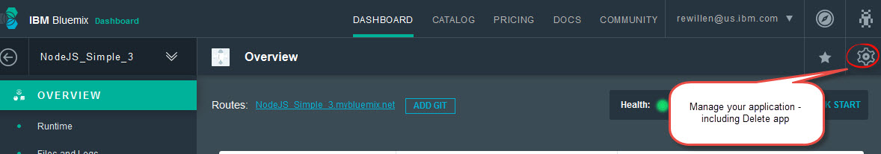
11 Be sure to select to delete the redis service.
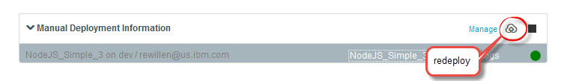
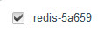
12 Back under Manual Deployment, use button to redeploy the application. *What happens? This time, the Redis database count should also be reset to 1.

