Kill’em All!!

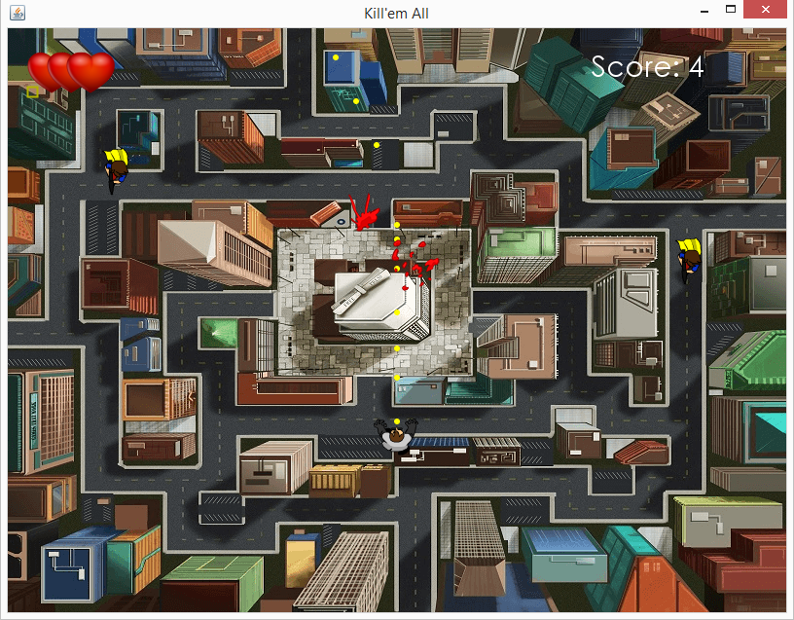

This is a top-down shooting game which object is to kill all enemies on the screen. There are 10 stages. Each stages consists of various kinds of enemies such as zombies, maniacs, Rottweiler’s, witches, crows etc. Some enemies can spawn another kind of enemies. The player will move by arrow keys and shoot by ‘z’ key. We also make a small chance of power ups such as life up, time slow down, ammo levels. The score and lives are displayed on top of the screen. When the player get ammos, the player will get the level up. If level of the player is 2-4 the player will shoot two bullets per press. If level of the player is 5 (which is max) ,the player will shoot 3 bullets (spread). If the player lose a life while level is more than 1, level of the player will decrease by 1.

Package: Beginner

Class: Animation